 | crop estimates committee | 
 | oesskattingskomitee
From/Van: Mr Baldwin Netshifhefhe
Tel: 012 319 8043/32  Fax/Faks: 012 319 8031  E-mail/E-pos: BaldwinN@dalrrd.gov.za
Web page/Webblad: www.dalrrd.gov.za/statistics and economic reports or
www.sagis.org.za/CEC: Crop Estimates EMBARGO: 14:30

The preliminary area planted estimate for summer crops for 2022 is hereby released.
Hiermee word die voorlopige oppervlakteskatting vir somergewasse vir 2022 vrygestel.

SUMMER CROPS – PRELIMINARY AREA PLANTED ESTIMATE: 2022
SOMERGEWASSE – VOORLOPIGE OPPERVLAKSKATTING: 2022
CROP/GEWAS | Area planted/  Opp beplant  2022 | Intentions^{1)/}  Voorneme¹⁾  2022 | Area planted/  Opp beplant  2021 | Final estimate/  Finale skatting  2021 | Change/  Verandering/  2021 vs 2022
CROP/GEWAS | Ha | Ha | Ha | Tons | %
CROP/GEWAS | (A) | (B) | (C) | (D) | (A) ÷ (C)
Commercial/Kommersieël:
White maize/Witmielies | 1 575 700 | 1 644 200 | 1 691 900 | 8 608 815 | -6,87
Yellow maize/Geelmielies | 1 034 000 | 1 081 000 | 1 063 500 | 7 625 450 | -2,77
Total Maize/Totale Mielies | 2 609 700 | 2 725 200 | 2 755 400 | 16 234 265 | -5,29
Sunflower seed/Sonneblomsaad | 580 000 | 555 800 | 477 800 | 677 240 | +21,39
Soybeans/Sojabone | 910 000 | 924 800 | 827 100 | 1 890 450 | +10,02
Groundnuts/Grondbone | 34 000 | 37 000 | 38 550 | 59 950 | -11,80
Sorghum | 35 000 | 45 000 | 49 200 | 213 645 | -28,86
Dry beans/Droëbone | 42 450 | 54 250 | 47 390 | 57 672 | -10,42
TOTAL/TOTAAL | 4 211 150 | 4 342 050 | 4 195 440 | 19 133 222 | +0,37
- Soos middel Oktober 2021/ As mid October 2021
Note: Estimate is for calendar year, e.g. production season 2021/22 = 2022
Nota: Skatting is vir kalenderjaar, bv. produksie-seisoen 2021/22 = 2022
The Crop Estimates Committee comprises officials of the following institutions:
Department of Agriculture, Land Reform and Rural Development; Provincial Departments of Agriculture; various ARC-Institutes (Soil, Climate and Water; Small Grains Institute; and
Grain Crops Institute); BFAP and Statistics SA.
27 January / Januarie 2022
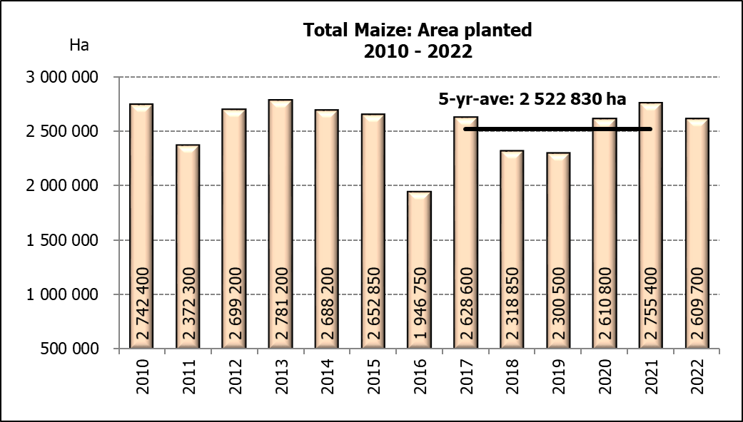

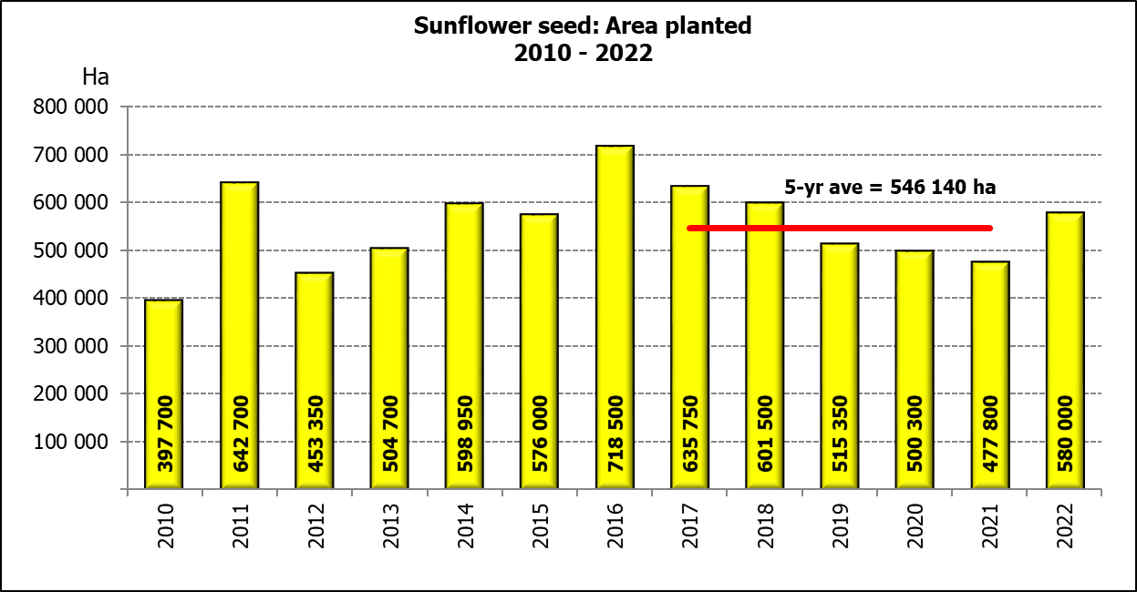
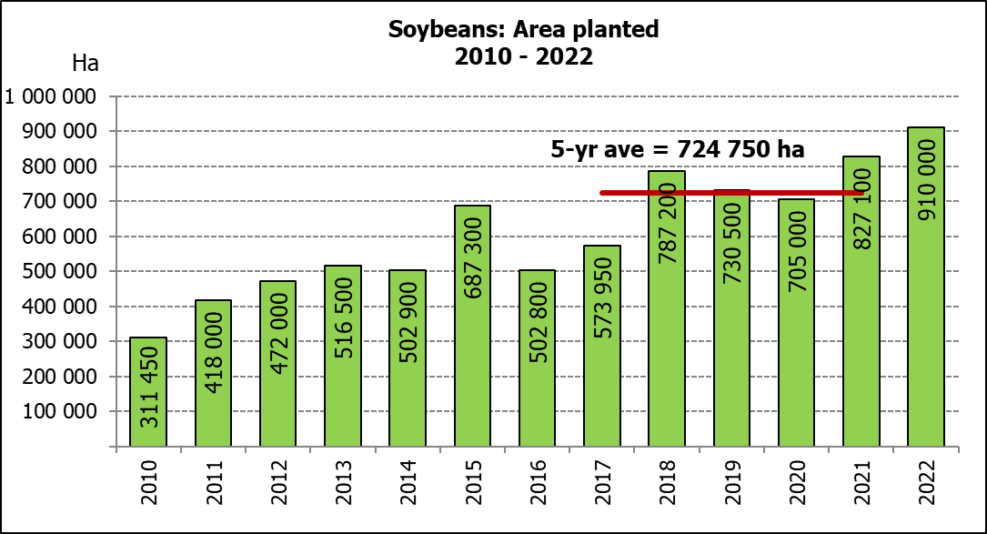

WHITE AND YELLOW MAIZE – PRELIMINARY AREA PLANTED ESTIMATE: 2022
WIT- EN GEELMIELIES – VOORLOPIGE OPPERVLAKTESKATTING: 2022
Province/  Provinsie | Preliminary area planted  Voorlopige oppervlakte beplant  2022 |  |  | Area planted/  Oppervlakte beplant  2021 |  |  | Final estimate¹⁾/  Finale skatting¹⁾  2021
Province/  Provinsie | White/  Wit  Ha | Yellow/  Geel  Ha | Totaal/  Total  Ha | White/  Wit  Ha | Yellow/  Geel  Ha | Totaal/  Total  Ha | White/  Wit  Tons | Geel/  Yellow  Tons | Totaal/  Total  Tons
Western Cape/Wes-Kaap | 500 | 3 500 | 4 000 | 500 | 3 500 | 4 000 | 4 500 | 31 500 | 36 000
Northern Cape/Noord-Kaap | 2 700 | 40 000 | 42 700 | 3 400 | 41 000 | 44 400 | 40 290 | 627 300 | 667 590
Free State/Vrystaat | 840 000 | 395 000 | 1 235 000 | 907 500 | 420 000 | 1 327 500 | 4 492 125 | 2 499 000 | 6 991 125
Eastern Cape/Oos-Kaap | 6 000 | 19 500 | 25 500 | 6 000 | 18 000 | 24 000 | 39 000 | 133 200 | 172 200
KwaZulu-Natal | 48 000 | 57 000 | 105 000 | 50 000 | 55 000 | 105 000 | 310 000 | 451 000 | 761 000
Mpumalanga | 160 000 | 350 000 | 510 000 | 165 000 | 360 000 | 525 000 | 1 105 500 | 2 790 000 | 3 895 500
Limpopo | 15 500 | 25 000 | 40 500 | 16 500 | 21 000 | 37 500 | 112 200 | 172 200 | 284 400
Gauteng | 58 000 | 54 000 | 112 000 | 58 000 | 50 000 | 108 000 | 371 200 | 375 000 | 746 200
North West/Noordwes | 445 000 | 90 000 | 535 000 | 485 000 | 95 000 | 580 000 | 2 134 000 | 546 250 | 2 680 250
Total/Totaal | 1 575 700 | 1 034 000 | 2 609 700 | 1 691 900 | 1 063 500 | 2 755 400 | 8 608 815 | 7 625 450 | 16 234 265
- 26 November 2020

SUNFLOWER SEED – PRELIMINARY AREA PLANTED ESTIMATE: 2022
SONNEBLOMSAAD – VOORLOPIGE OPPERVLAKTESKATTING: 2022

Province/  Provinsie | Prel area planted  Voorl opp beplant  Ha | Area planted/  Opp beplant  Ha | Final estimate/  Finale skatting  Tons
Province/  Provinsie | 2022 | 2021 | 2021
Western Cape/Wes-Kaap | - | - | -
Northern Cape/Noord-Kaap | 900 | 1 100 | 1 320
Free State/Vrystaat | 310 000 | 235 000 | 352 500
Eastern Cape/Oos-Kaap | 100 | 300 | 450
KwaZulu-Natal | - | - | -
Mpumalanga | 3 000 | 3 500 | 5 250
Limpopo | 80 000 | 76 500 | 76 500
Gauteng | 4 000 | 4 400 | 5 720
North West/Noordwes | 182 000 | 157 000 | 235 500
Total/Totaal | 580 000 | 477 800 | 677 240
SOYBEANS – PRELIMINARY AREA PLANTED ESTIMATE: 2022
SOJABONE – VOORLOPIGE OPPERVLAKTESKATTING: 2022

Province/  Provinsie | Prel area planted  Voorl opp beplant  Ha | Area planted/  Opp beplant  Ha | Final estimate/  Finale skatting  Tons
Province/  Provinsie | 2022 | 2021 | 2021
Western Cape/Wes-Kaap | - | - | -
Northern Cape/Noord-Kaap | 1 000 | 1 000 | 3 500
Free State/Vrystaat | 410 000 | 365 000 | 766 500
Eastern Cape/Oos-Kaap | 2 500 | 3 100 | 9 300
KwaZulu-Natal | 38 000 | 36 000 | 129 600
Mpumalanga | 306 000 | 290 000 | 638 000
Limpopo | 20 500 | 20 500 | 71 750
Gauteng | 42 000 | 42 000 | 105 000
North West/Noordwes | 90 000 | 69 500 | 166 800
Total/Totaal | 910 000 | 827 100 | 1 890 450

PRELIMINARY AREA ESTIMATE OF SUMMER CROPS (2022 PRODUCTION SEASON)/
VOORLOPIGE OPPERVLAKTESKATTING VIR SOMERGEWASSE (2022 PRODUKSIE-SEISOEN)
27 JANUARY / JANUARIE 2022

Summer field crops – 2022  The preliminary area estimate of today is mainly based on the results of a non-probability survey conducted by the Directorate: Statistics and Economic Analysis of the Department of Agriculture, Land Reform and Rural Development. Please note that the area planted to crops refers to the area already planted for all purposes, including grain, silage and crop damaged area(s).  The CEC also take note of the delayed plantings in some regions, as well as crops damaged due to the recent excessive rains. The situation will be monitored throughout the season, therefore, the CEC would like to thank all producers and industry role-players who provided information on a regular basis to improve the accuracy of the crop estimates.  Commercial maize: The preliminary area estimate for maize is 2,610 mill. ha, which is 5,29% or 145 700 ha less than the 2,755 mill. ha planted for the previous season, and also 4,24% or 115 500 ha less than the intentions to plant figure of 2,725 mill. ha released in October 2021.  The preliminary area estimate for white maize is 1,576 mill. ha, which represents a decrease of 6,87% or 116 200 ha compared to the 1,692 mill. ha planted last season. In the case of yellow maize the area estimate is 1,034 mill. ha, which is 2,77% or 29 500 ha less than the 1,064 mill. ha planted last season.  Other summer crops:  Please note that only provisional national area planted figures of groundnuts, sorghum and dry beans for the current production season are being released today.  Sunflower seed: The preliminary area estimate for sunflower seed is 580 000 ha, which is 21,39% or 102 200 ha more than the 477 800 ha planted the previous season.  It is estimated that 910 000 ha have been planted to soybeans, which represents an increase of 10,02% or 82 900 ha compared to the 827 100 ha planted last season. This is the highest area planted to soybeans in the history of SA.  For groundnuts, the area estimate is 34 000 ha, which is 11,80% or 4 550 ha less than the 38 550 ha planted for the previous season.  The area estimate for sorghum decreased by 28,86% or 14 200 ha, from 49 200 ha to 35 000 ha against the previous season.  For dry beans, the area estimate is 42 450 ha, which is 10,42% or 4 940 ha less than the 47 390 ha planted for the previous season.  The revised area planted and production figures, which will be released by the Crop Estimates Committee on 28 February 2022, will mainly be based on information obtained from the Producer Independent Crop Estimation System (PICES) survey for the Free State, KwaZulu-Natal, Mpumalanga, Limpopo, Gauteng and North West provinces. |  | Somergewasse – 2022  Die voorlopige oppervlakteskatting van vandag is hoofsaaklik gebaseer op die resultate van ’n nie-ewekansige opname onderneem deur die Direktoraat: Statistiek en Ekonomiese Analise van die Departement van Landbou, Grondhervorming en Landelike Ontwikkeling. Neem asseblief kennis dat die oppervlakte aangeplant met gewasse na die area verwys wat alreeds vir alle doeleindes geplant is, insluitende vir graan, kuilvoer en gewas beskadigde area(s).  Die Oesskattingskomitee neem ook kennis van die laat aanplantings in sommige streke, asook oeste wat beskadig is weens die onlangse oormatige reën. Die situasie sal deur die seisoen gemonitor word, daarom wil die Komitee alle produsente en bedryfsrolspelers bedank wat gereeld inligting aan die Komitee verskaf om die akkuraatheid van oesskattings te verbeter.  Kommersiële mielies: Die voorlopige skatting van die oppervlakte onder mielies beloop 2,610 milj. ha, wat 5,29% of 145 700 ha minder is as die 2,755 milj. ha wat verlede seisoen aangeplant is, en ook 4,24% of 115 500 ha minder as die voornemens om te plant syfer van 2,725 milj. ha soos vrygestel in Oktober 2021.  Die voorlopige oppervlak onder witmielies is 1,576 milj. ha, wat ’n afname van 6,87% of 116 200 ha verteenwoordig vergeleke met die 1,692 milj. ha die vorige seisoen. In die geval van geelmielies is die oppervlakteskatting 1,034 milj. ha, wat 2,77% of 29 500 ha minder is as die 1,064 milj. ha geplant die vorige seisoen.  Ander somergewasse:  Let asb. daarop dat net die nasionale aangeplante area vir die voorlopige oppervlakte van die grondbone, sorghum en droëbone vir die huidige produksieseisoen vandag vrygestel word.  Sonneblomsaad: Die voorlopige oppervlakteskatting vir sonneblomsaad is 580 000 ha, wat 21,39% of 102 200 ha meer is as die 477 800 ha aangeplant die vorige seisoen.  Die geskatte oppervlakte beplant met sojabone is 910 000 ha, wat ’n toename van 10,02% of 82 900 ha verteenwoordig vergeleke met die 827 100 ha geplant die vorige seisoen. Dit is die hoogste oppervlakte beplant met sojabone in die geskiedenis van SA.  Vir grondbone is die oppervlakteskatting 34 000 ha, wat 11,80% of 4 550 ha minder is as die 38 550 ha geplant vir die vorige seisoen.  Die oppervlakteskatting vir sorghum het afgeneem met 28,86% of 14 200 ha, van 49 200 ha tot 35 000 ha teenoor die vorige seisoen.  Vir droëbone is die geskatte oppervlakte beplant 42 450 ha, wat 10,42% of 4 940 ha minder is as die 47 390 ha geplant vir die vorige seisoen.  Die hersiene aangeplante oppervlakte en produksiesyfers sal deur die Oesskattingskomitee op 28 Februarie 2022 vrygestel word en sal hoofsaaklik gebaseer wees op inligting verkry vanaf die “PICES”-opname vir die Vrystaat, KwaZulu-Natal, Mpumalanga, Limpopo, Gauteng en Noordwes provinsies.
The area estimate and sixth production forecast for winter cereals for the 2021 is hereby released. /
Hiermee word die oppervlakte- en sesde produksieskatting vir wintergewasse vir 2021 vrygestel.

WINTER CEREALS – AREA PLANTED AND SIXTH PRODUCTION FORECAST: 2021 PRODUCTION SEASON
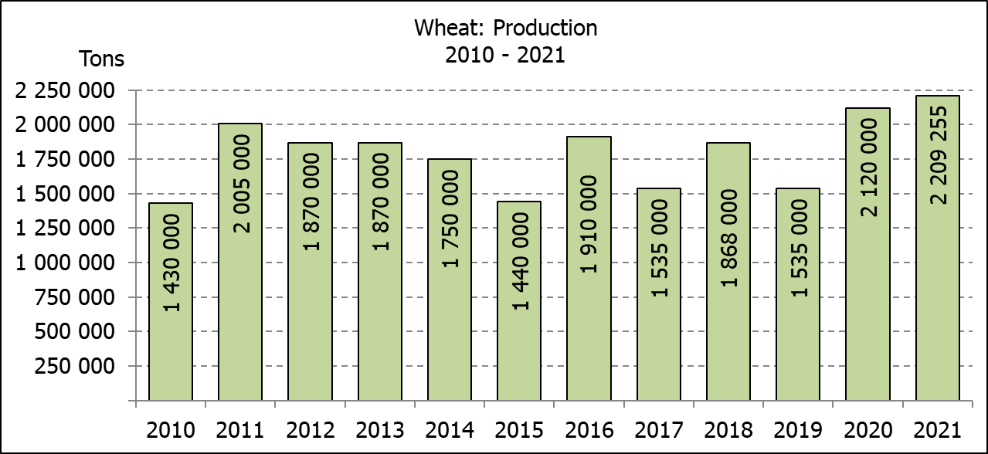
WINTERGEWASSE - OPPERVLAKTE- EN SESDE PRODUKSIESKATTING: 2021 PRODUKSIE-SEISOEN
CROP/GEWAS | Area planted/  Opp beplant  2021 | 6th forecast/  6de skatting  2021 | 5th forecast/  5de skatting  2021 | Area planted/  Opp beplant  2020 | Final crop/  Finale oes  2020 | Change/  Verandering
CROP/GEWAS | Ha | Tons | Tons | Ha | Tons | %
CROP/GEWAS | (A) | (B) | (C) | (D) | (E) | (B) ÷ (C)
Commercial/Kommersieel:
Wheat/Koring | 523 500 | 2 209 255 | 2 153 435 | 509 800 | 2 120 000 | +2,59
Malting barley/Moutgars | 94 730 | 331 100 | 339 800 | 141 690 | 588 000 | -2,56
Canola/Kanola | 100 000 | 197 000 | 190 000 | 74 120 | 165 200 | +3,68
Cereal oats/Hawermout | 36 250 | 69 950 | 80 450 | 26 200 | 57 000 | -13,05
Sweet lupines/Soetlupine | 22 000 | 28 600 | 29 700 | N/a | N/a | -3,70
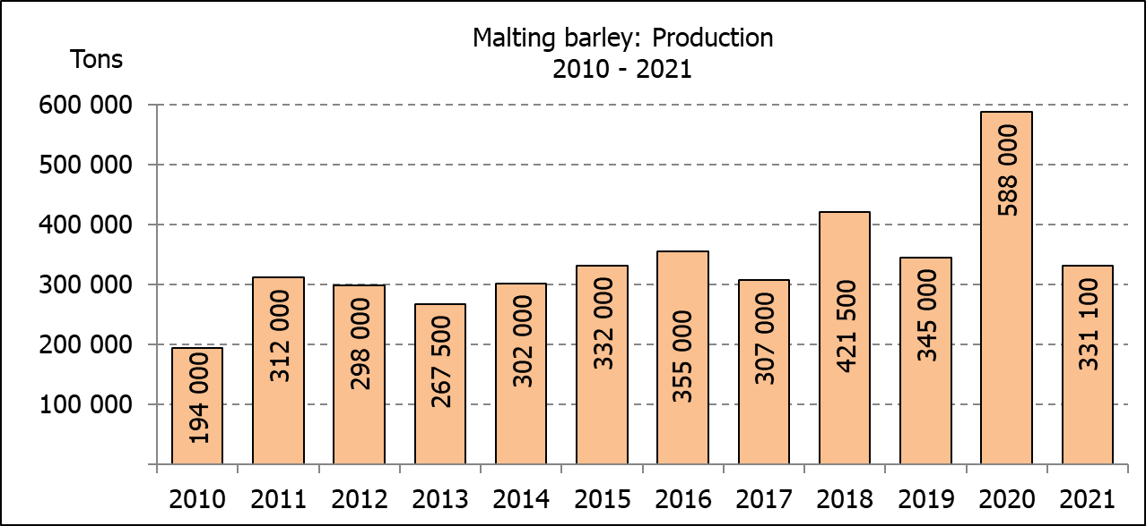
* Note: Estimate is for calendar year, e.g. production season 2021/22 = 2021
* Nota: Skatting is vir kalenderjaar, bv. produksie-seisoen 2021/22 = 2021

WHEAT – AREA PLANTED AND SIXTH PRODUCTION FORECAST: 2021
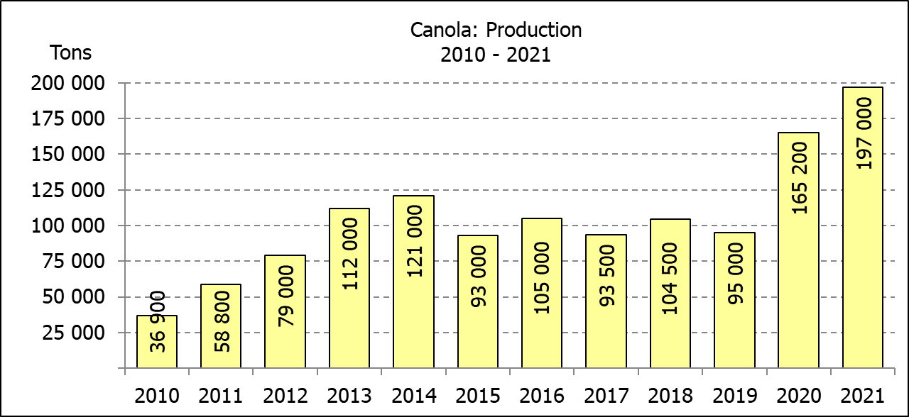
KORING – OPPERVLAKTE- EN SESDE PRODUKSIESKATTING: 2021
Province/  Provinsie | Area planted/  Opp beplant  Ha | 6th forecast/  6de skatting  Tons | Area planted/  Opp beplant  Ha | Final crop/  Finale oes  Tons
Province/  Provinsie | 2021 | 2021 | 2020 | 2020
Western Cape/Wes-Kaap | 360 000 | 1 224 000 | 326 000 | 1 103 000
Northern Cape/Noord-Kaap | 35 500 | 266 250 | 37 000 | 271 950
Free State/Vrystaat | 70 000 | 346 500 | 94 000 | 413 600
Eastern Cape/Oos-Kaap | 3 800 | 25 080 | 4 000 | 26 000
KwaZulu-Natal | 8 500 | 53 975 | 7 800 | 48 360
Mpumalanga | 4 100 | 27 470 | 3 000 | 19 500
Limpopo | 26 500 | 172 250 | 23 000 | 147 200
Gauteng | 1 100 | 6 930 | 1 300 | 8 190
North West/Noordwes | 14 000 | 86 800 | 13 700 | 82 200
Total/Totaal | 523 500 | 2 209 255 | 509 800 | 2 120 000

AREA ESTIMATE AND SIXTH PRODUCTION FORECAST OF WINTER CROPS (2021) /
OPPERVLAKTE- EN SESDE PRODUKSIESKATTING VAN WINTERGEWASSE (2021)
27 JANUARY/JANUARIE 2022
Winter cereal crops - 2021 production season  Wheat: The expected production of wheat is 2,209 mill. tons, which is 2,59% or 55 820 tons more than the previous forecast of 2,153 mill. tons, whilst the expected yield is 4,22 t/ha. This is the largest expected wheat crop produced since 2002, when it was 2,427 mill. tons.  The expected production in the Western Cape is 1,224 mill. tons (55%), in the Free State 346 500 tons (16%) and in the Northern Cape 266 250 tons (12%).  Other crops: The production forecast for malting barley is 331 100 tons, which is 8 700 tons or 2,56% less than the previous forecast of 339 800 tons. The area planted is estimated at 94 730 ha, while the expected yield is 3,50 t/ha.  The expected canola crop increased by 7 000 tons or 3,68% from 190 000 tons to 197 000 tons. This is the largest expected canola crop produced in the history of SA. The area estimate for canola is 100 000 ha, with an expected yield of 1,97 t/ha.  The expected crop for oats (cereals) for the 2021 season is 69 950 tons and the area planted is 36 250 ha. The expected yield is 1,93 t/ha.  In the case of sweet lupines, the production forecast decreased slightly by 3,70% or 1 100 tons, from 29 700 tons to 28 600 tons. The area estimate of sweet lupines is 22 000 ha, with an expected yield of 1,30 t/ha.  Please note that the final production estimate for winter cereals for 2021 will be released on 28 February 2022. |  | Wintergewasse - 2021 produksie-seisoen  Koring: Die verwagte produksie vir koring is 2,209 milj. ton, wat 2,59% of 55 820 ton meer is as die vorige skatting van 2,153 milj. ton, terwyl die verwagte opbrengs 4,22 t/ha is. Dit is die grootste verwagte koringoes sedert 2002, toe dit 2,427 milj. ton was.  Die verwagte produksie in die Wes-Kaap is 1,224 milj. ton (55%), in die Vrystaat 346 500 ton (16%) en in die Noord-Kaap 266 250 ton (12%).  Ander gewasse: Die produksieskatting vir moutgars is 331 100 ton, wat 8 700 ton of 2,56% minder is as die vorige skatting van 339 800 ton. Die oppervlakte beplant word beraam op 94 730 ha, terwyl die verwagte opbrengs 3,50 t/ha beloop.  Die verwagte kanola-oes is verhoog met 7 000 ton of 3,68% van 190 000 ton na 197 000 ton. Dit is die grootste kanola-oes wat nόg geproduseer is in die geskiedenis van SA. Die oppervlakteskatting vir kanola is 100 000 ha, met ŉ verwagte opbrengs van 1,97 t/ha.  Die verwagte oes vir hawer (ontbytgraan) vir die 2021-seisoen is 69 950 ton en die oppervlakteskatting is 36 250 ton. Die verwagte opbrengs is 1,93 t/ha.  In die geval van soetlupine is die produksieskatting effens verlaag met 3,70% of 1 100 ton, van 29 700 ton na 28 600 ton. Die oppervlakte beplant met soetlupine is 22 000 ha, en die verwagte opbrengs is 1,30 t/ha.  Neem asseblief kennis dat die finale produksieskatting vir wintergewasse vir 2021 op 28 Februarie 2022 vrygestel sal word.
Information is available on the internet at http://www.daff.gov.za/links/crop estimates or http://www.sagis.org.za, as from 14:30 on the date of the relevant meeting of the Crop Estimates Committee. |  | Inligting is beskikbaar op die internet by http://www.daff.gov.za/links/crop estimates of by http://www.sagis.org.za, vanaf 14:30 op die dag van die toepaslike vergadering van die Oesskattingskomitee.
CONFIDENTIALITY ISSUES that CEC members are committed to adhere to on the day of the meeting
- Personal items such as laptops, handbags, cell phones, etc. are not allowed in the venue during the meeting.
- No member is allowed to leave the meeting before 12:00 in order to prevent disclosure of the information. The embargo time for the release of crop estimates information is 14:30.
- No member is allowed to discuss crop estimates information with anyone other than a member of the Committee before the embargo time. Only the Chairperson, or a member appointed by the Chairperson, may release the figures to the media.
- Members must regard the detail of any information that was collected for and/or discussed during the meeting, as confidential. Individual information received for crop estimate purposes is treated strictly confidential, and is not divulged for any other purposes.

