 | crop estimates committee
 | oesskattingskomitee
From/Van: Mr Baldwin Netshifhefhe  Tel: 012 319 8043/32  Fax/Faks: 012 319 8031  E-mail/E-pos: BaldwinN@dalrrd.gov.za  Web page/Webblad: www.dalrrd.gov.za/statistics and economic reports or  www.sagis.org.za/CEC: Crop Estimates EMBARGO: 14:30 |  |  | 

The area planted estimate and third production forecast for summer crops for 2022 is hereby released.
Hiermee word die oppervlakte- en derde produksieskatting vir somergewasse vir 2022 vrygestel.

SUMMER CROPS – AREA PLANTED AND THIRD PRODUCTION FORECAST: 2022
SOMERGEWASSE – OPPERVLAKTE- EN DERDE PRODUKSIESKATTING: 2022
CROP/GEWAS | Area planted/  Opp beplant  2022 | 3rd forecast/  3de skatting  2022 | 2nd forecast/  2de skatting  2022 | Area planted/  Opp beplant  2021 | Final crop/  Finale oes  2021 | Change/  Verandering/
CROP/GEWAS | Ha | Tons | Tons | Ha | Tons | %
CROP/GEWAS | (A) | (B) | (C) | (D) | (E) | (B) ÷ (C)
Commercial/Kommersieel:
White maize/Witmielies | 1 575 000 | 7 553 050 | 7 569 550 | 1 691 900 | 8 600 000 | -0,22
Yellow maize/Geelmielies | 1 048 000 | 7 170 300 | 7 114 500 | 1 063 500 | 7 715 000 | +0,78
Total Maize/Totale Mielies | 2 623 000 | 14 723 350 | 14 684 050 | 2 755 400 | 16 315 000 | +0,27
Sunflower seed/Sonneblomsaad | 670 700 | 963 000 | 959 450 | 477 800 | 678 000 | +0,37
Soybeans/Sojabone | 925 300 | 1 885 850 | 1 885 850 | 827 100 | 1 897 000 | -
Groundnuts/Grondbone | 43 400 | 70 400 | 74 250 | 38 550 | 64 300 | -5,19
Sorghum | 37 200 | 137 220 | 137 220 | 49 200 | 215 000 | -
Dry beans/Droëbone | 42 900 | 55 995 | 59 690 | 47 390 | 57 672 | -6,19
Non-Commercial Maize/Nie-Kommersiële Mielies
Total Maize/Totale Mielies | 368 040 | 656 225 | N/A | 362 900 | 636 440 | N/A
Maize/Mielies: Commercial/Kommersieël + Non-Commercial/Nie-Kommersieël
Total Maize RSA/Totaal Mielies RSA | 2 991 040 | 15 379 575 | N/A | 3 118 300 | 16 951 440 | N/A

Note: Estimate is for calendar year, e.g. production season 2021/22 = 2022
Nota: Skatting is vir kalenderjaar, bv. produksie-seisoen 2021/22 = 2022

26 April 2022

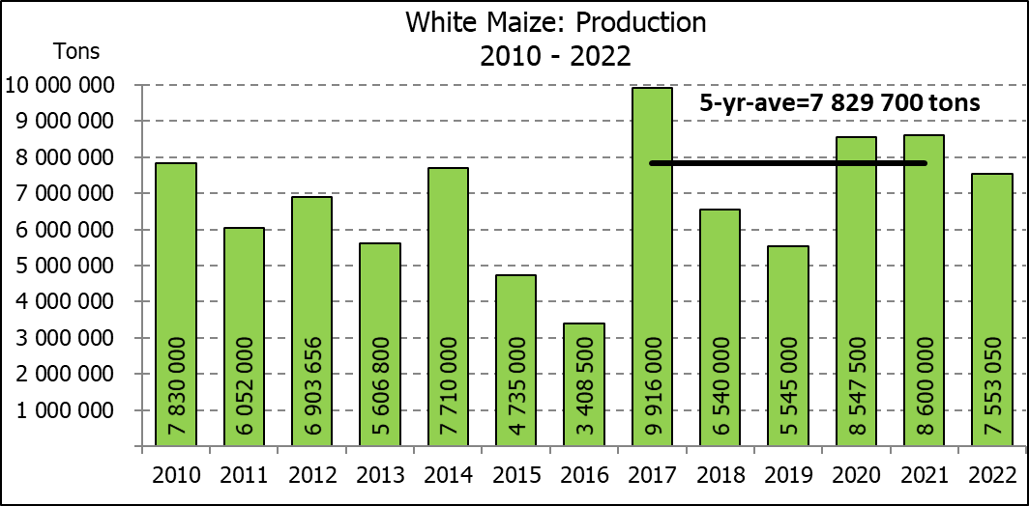

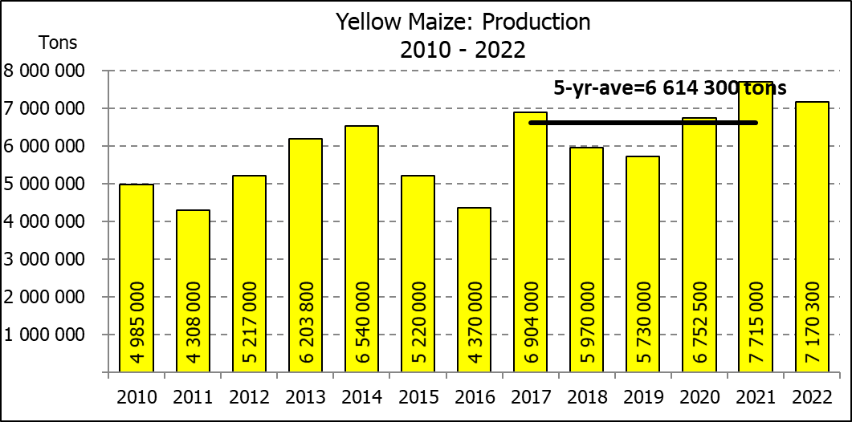
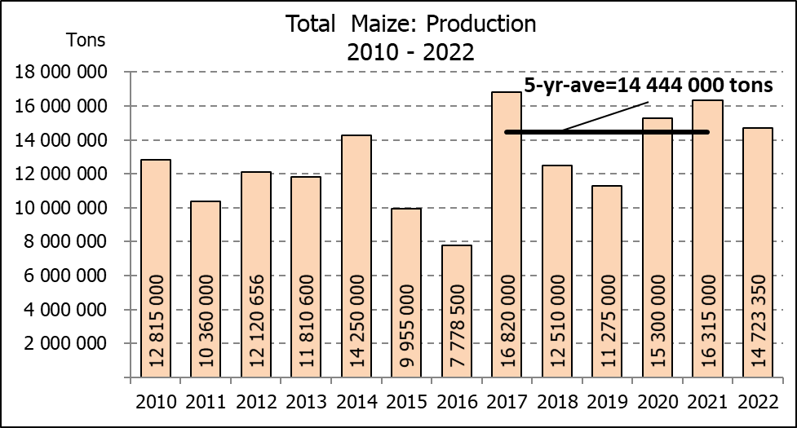

WHITE AND YELLOW MAIZE – AREA PLANTED AND THIRD PRODUCTION FORECAST: 2022
WIT- EN GEELMIELIES – OPPERVLAKTE EN DERDE PRODUKSIESKATTING: 2022

Provinsie/  Province | Area planted/  Oppervlakte beplant  2022 |  |  | 3rd forecast/  3r^{de} skatting  2022 |  |  | Area planted/  Oppervlakte beplant  2021 |  |  | Final crop/  Finale oes  2021
Provinsie/  Province | White/  Wit  Ha | Yellow/  Geel  Ha | Total/  Totaal  Ha | White/  Wit  Tons | Yellow/  Geel  Tons | Total/  Totaal  Tons | White/  Wit  Ha | Yellow/  Geel  Ha | Total/  Totaal  Ha | White/  Wit  Tons | Yellow/  Geel  Tons | Total/  Totaal  Tons
Western Cape/Wes-Kaap | 500 | 3 500 | 4 000 | 4 750 | 32 900 | 37 650 | 500 | 3 500 | 4 000 | 4 800 | 33 300 | 38 100
Northern Cape/Noord-Kaap | 3 000 | 42 000 | 45 000 | 36 000 | 651 000 | 687 000 | 3 400 | 41 000 | 44 400 | 40 300 | 627 300 | 667 600
Free State/Vrystaat | 826 500 | 398 000 | 1 224 500 | 3 719 250 | 2 467 600 | 6 186 850 | 907 500 | 420 000 | 1 327 500 | 4 492 000 | 2 542 000 | 7 034 000
Eastern Cape/Oos-Kaap | 6 000 | 20 500 | 26 500 | 39 000 | 147 600 | 186 600 | 6 000 | 18 000 | 24 000 | 39 000 | 133 200 | 172 200
KwaZulu-Natal | 52 000 | 59 000 | 111 000 | 312 000 | 460 200 | 772 200 | 50 000 | 55 000 | 105 000 | 310 000 | 451 000 | 761 000
Mpumalanga | 165 000 | 350 000 | 515 000 | 1 056 000 | 2 327 500 | 3 383 500 | 165 000 | 360 000 | 525 000 | 1 100 500 | 2 820 000 | 3 920 500
Limpopo | 15 500 | 25 000 | 40 500 | 100 750 | 202 500 | 303 250 | 16 500 | 21 000 | 37 500 | 112 200 | 172 200 | 284 400
Gauteng | 56 500 | 56 000 | 112 500 | 350 300 | 364 000 | 714 300 | 58 000 | 50 000 | 108 000 | 371 200 | 380 000 | 751 200
North West/Noordwes | 450 000 | 94 000 | 544 000 | 1 935 000 | 517 000 | 2 452 000 | 485 000 | 95 000 | 580 000 | 2 130 000 | 556 000 | 2 686 000
Total/Totaal | 1 575 000 | 1 048 000 | 2 623 000 | 7 553 050 | 7 170 300 | 14 723 350 | 1 691 900 | 1 063 500 | 2 755 400 | 8 600 000 | 7 715 000 | 16 315 000

SUNFLOWER SEED – AREA PLANTED AND THIRD PRODUCTION FORECAST: 2022
SONNEBLOMSAAD – OPPERVLAKTE EN DERDE PRODUKSIESKATTING: 2022

Province/  Provinsie | Area planted/  Opp beplant  Ha | 3rd forecast/  3r^{de} skatting  Tons | Area planted/  Opp beplant  Ha | Final crop/  Finale oes  Tons
Province/  Provinsie | 2022 | 2022 | 2021 | 2021
Western Cape/Wes-Kaap | - | - | - | -
Northern Cape/Noord-Kaap | 2 500 | 6 250 | 1 100 | 1 320
Free State/Vrystaat | 357 000 | 535 500 | 235 000 | 352 500
Eastern Cape/Oos-Kaap | 300 | 750 | 300 | 450
KwaZulu-Natal | - | - | - | -
Mpumalanga | 3 500 | 5 250 | 3 500 | 5 250
Limpopo | 110 000 | 110 000 | 76 500 | 76 500
Gauteng | 2 400 | 3 000 | 4 400 | 5 720
North West/Noordwes | 195 000 | 302 250 | 157 000 | 236 260
Total/Totaal | 670 700 | 963 000 | 477 800 | 678 000
SOYBEANS – AREA PLANTED AND THIRD PRODUCTION FORECAST: 2022
SOJABONE – OPPERVLAKTE EN DERDE PRODUKSIESKATTING: 2022

Province/  Provinsie | Area planted/  Opp beplant  Ha | 3rd forecast/  3r^{de} skatting  Tons | Area planted/  Opp beplant  Ha | Final crop/  Finale oes  Tons
Province/  Provinsie | 2022 | 2022 | 2021 | 2021
Western Cape/Wes-Kaap | - | - | - | -
Northern Cape/Noord-Kaap | 800 | 2 800 | 1 000 | 3 500
Free State/Vrystaat | 415 000 | 788 500 | 365 000 | 766 500
Eastern Cape/Oos-Kaap | 3 000 | 9 000 | 3 100 | 9 300
KwaZulu-Natal | 39 000 | 134 550 | 36 000 | 129 600
Mpumalanga | 300 000 | 570 000 | 290 000 | 644 550
Limpopo | 22 500 | 76 500 | 20 500 | 71 750
Gauteng | 45 000 | 94 500 | 42 000 | 105 000
North West/Noordwes | 100 000 | 210 000 | 69 500 | 166 800
Total/Totaal | 925 300 | 1 885 850 | 827 100 | 1 897 000

GROUNDNUTS – AREA PLANTED AND THIRD PRODUCTION FORECAST: 2022
GRONDBONE – OPPERVLAKTE EN DERDE PRODUKSIESKATTING: 2022

Province/  Provinsie | Area planted/  Opp beplant  Ha | 3rd forecast/  3r^{de} skatting  Tons | Area planted/  Opp beplant  Ha | Final crop/  Finale oes  Tons
Province/  Provinsie | 2022 | 2022 | 2021 | 2021
Western Cape/Wes-Kaap | - | - | - | -
Northern Cape/Noord-Kaap | 2 400 | 7 200 | 1 500 | 3 900
Free State/Vrystaat | 19 000 | 30 400 | 16 000 | 26 450
Eastern Cape/Oos-Kaap | - | - | - | -
KwaZulu-Natal | - | - | 50 | 50
Mpumalanga | - | - | - | -
Limpopo | 2 000 | 5 800 | 3 000 | 6 900
Gauteng | - | - | - | -
North West/Noordwes | 20 000 | 27 000 | 18 000 | 27 000
Total/Totaal | 43 400 | 70 400 | 38 550 | 64 300

SORGHUM – AREA PLANTED AND THIRD PRODUCTION FORECAST: 2022
SORGHUM – OPPERVLAKTE EN DERDE PRODUKSIESKATTING: 2022

Province/  Provinsie | Area planted/  Opp beplant  Ha | 3rd forecast/  3r^{de} skatting  Tons | Area planted/  Opp beplant  Ha | Final crop/  Finale oes  Tons
Province/  Provinsie | 2022 | 2022 | 2021 | 2021
Western Cape/Wes-Kaap | - | - | - | -
Northern Cape/Noord-Kaap | - | - | - | -
Free State/Vrystaat | 7 800 | 28 080 | 10 500 | 45 675
Eastern Cape/Oos-Kaap | - | - | - | -
KwaZulu-Natal | 200 | 840 | 500 | 2 300
Mpumalanga | 9 000 | 45 000 | 9 400 | 57 325
Limpopo | 15 000 | 45 000 | 17 000 | 61 200
Gauteng | 200 | 800 | 300 | 1 350
North West/Noordwes | 5 000 | 17 500 | 11 500 | 47 150
Total/Totaal | 37 200 | 137 220 | 49 200 | 215 000

DRY BEANS – AREA PLANTED AND THIRD PRODUCTION FORECAST: 2022
DROëBONE – OPPERVLAKTE EN DERDE PRODUKSIESKATTING: 2022

Province/  Provinsie | Area planted/  Opp beplant  Ha | 3rd forecast/  3r^{de} skatting  Tons | Area planted/  Opp beplant  Ha | Final crop/  Finale oes  Tons
Province/  Provinsie | 2022 | 2022 | 2021 | 2021
Western Cape/Wes-Kaap | 100 | 150 | 100 | 150
Northern Cape/Noord-Kaap | 600 | 1 200 | 350 | 700
Free State/Vrystaat | 15 500 | 14 725 | 22 000 | 16 500
Eastern Cape/Oos-Kaap | 200 | 300 | 200 | 300
KwaZulu-Natal | 2 300 | 2 760 | 3 000 | 3 900
Mpumalanga | 6 000 | 7 200 | 6 500 | 9 750
Limpopo | 10 400 | 19 760 | 8 000 | 16 000
Gauteng | 800 | 800 | 840 | 1 092
North West/Noordwes | 7 000 | 9 100 | 6 400 | 9 280
Total/Totaal | 42 900 | 55 995 | 47 390 | 57 672

CONFIDENTIALITY ISSUES that CEC members are committed to adhere to on the day of the meeting
- Personal items such as laptops, handbags, cell phones, etc. are not allowed in the venue during the meeting
- No member is allowed to leave the meeting before 12:00 in order to prevent disclosure of the information
- The embargo time for the release of crop estimates information is 14:30
- No member is allowed to discuss crop estimates information with anyone other than a member of the Committee before the embargo time
- Only the Chairperson, or a member appointed by the Chairperson, may release the figures to the media
- Members must regard the detail of any information that was collected for and/or discussed during the meeting, as confidential
- Individual information received for crop estimate purposes is treated strictly confidential, and is not divulged for any other purposes

AREA ESTIMATE AND THIRD PRODUCTION FORECAST OF SUMMER CROPS (2022 PRODUCTION SEASON)/
OPPERVLAKTE- EN DERDE PRODUKSIESKATTING VIR SOMERGEWASSE (2022 PRODUKSIE-SEISOEN)
26 APRIL 2022

Summer field crops – 2022  Commercial maize: The size of the expected commercial maize crop has been set at 14,723 mill. tons, which is 0,27% or 39 300 tons more than the previous forecast of 14,684 mill. tons. The area estimate for maize is 2,623 mill. ha, while the expected yield is 5,61 t/ha.  The estimated maize crop is 10% smaller than the 2021 crop. The three main maize producing areas, namely the Free State, Mpumalanga and North West provinces are expected to produce 82% of the 2022 crop.  The area estimate for white maize is 1,575 mill. ha and for yellow maize the area estimate is 1,048 mill. ha.  The production forecast of white maize is 7,553 mill. tons, which is 0,22% or 16 500 tons less than the 7,570 mill. tons of the previous forecast. The yield for white maize is 4,80 t/ha. In the case of yellow maize the production forecast is 7,170 mill. tons, which is 0,78% or 55 800 tons more than the 7,114 mill. tons of the previous forecast. The yield for yellow maize is 6,84 t/ha.  The yield per ha for the Mpumalanga province was based on scientific and objective results provided by the ARC. Please note that the objective results for the Free State and North West provinces will be available in May 2022.  Sunflower seed: The production forecast for sunflower seed is 963 000 tons, which is 0,37% or 3 550 tons more than the previous forecast of 959 450 tons. The area estimate for sunflower seed is 670 700 ha, while the expected yield is 1,44 t/ha.  Other crops: The production forecast for soybeans remained unchanged at 1,886 mill. tons. The estimated area planted to soybeans is 925 300 ha and the expected yield is 2,04 t/ha.  The expected groundnut crop has been set at 70 400 tons, which is 5,19% or 3 850 tons less than the previous forecast of 74 250 tons. For groundnuts, the area estimate is 43 400 ha, with an expected yield of 1,62 t/ha.  The production forecast for sorghum remained unchanged at 137 220 tons. The area estimate for sorghum is 37 200 ha and the expected yield is 3,69 t/ha.  In the case of dry beans, the production forecast is 55 995 tons. The area estimate of dry beans is 42 900 ha, with an expected yield of 1,31 t/ha.  Please note that the fourth production forecast for summer field crops for 2022 will be released on 26 May 2022. |  | Somergewasse – 2022  Kommersiële mielies: Die grootte van die verwagte kommersiële mielie-oes is op 14,723 milj. ton gestel, wat 0,27% of 39 300 ton meer is as die vorige skatting van 14,684 milj. ton. Die skatting van die oppervlakte onder mielies is 2,623 milj. ha, terwyl die verwagte opbrengs 5,61 t/ha is.  Die geskatte mielie-oes is 10% kleiner as die 2021-oes. Die drie belangrikste mielieproduserende gebiede, nl. die Vrystaat, Mpumalanga en Noordwes provinsies, gaan na verwagting 82% van die 2022-oes produseer.  Die oppervlak onder witmielies is 1,575 milj. ha en vir geelmielies is die oppervlak 1,048 milj. ha.  Die produksieskatting van witmielies is 7,553 milj. ton, 0,22% of 16 500 ton minder as die 7,570 milj. ton van die vorige skatting. Die opbrengs van witmielies is 4,80 t/ha. In die geval van geelmielies is die produksieskatting 7,170 milj. ton, wat 0,78% of 55 800 ton meer is as die 7,114 milj. ton van die vorige skatting. Die opbrengs van geelmielies is 6,84 t/ha.  Die opbrengs-bepaling per ha vir die Mpumalanga provinsie is gebaseer op wetenskaplike en objektiewe resultate verstrek deur die LNR. Neem kennis dat die objektiewe resultate vir die Vrystaat en Noordwes provinsies, in Mei 2022 gerapporteer sal word.  Sonneblomsaad: Die produksieskatting vir sonneblomsaad is 963 000 ton, wat 0,37% of 3 550 ton meer is as die vorige skatting van 959 450 ton. Die oppervlakteskatting vir sonneblomsaad is 670 700 ha, terwyl die verwagte opbrengs 1,44 t/ha is.  Ander gewasse: Die produksieskatting van sojabone is onveranderd gelaat op 1,886 milj. ton. Die geskatte oppervlakte beplant van sojabone is 925 300 ha en die verwagte opbrengs is 2,04 t/ha.  Die verwagte grondbone-oes is op 70 400 ton gestel, wat 5,19% of 3 850 ton minder is as die vorige skatting van 74 250 ton. Vir grondbone is die oppervlakteskatting 43 400 ha, terwyl the verwagte opbrengs 1,62 t/ha is.  Die produksieskatting van sorghum is onveranderd gelaat op 137 220 ton. Die oppervlakteskatting vir sorghum is 37 200 ha, en die verwagte opbrengs is 3,69 t/ha.  In die geval van droëbone is die produksieskatting 55 995 ton. Die oppervlakte beplant met droëbone is 42 900 ha, en die verwagte opbrengs is 1,31 t/ha.  Neem asseblief kennis dat die vierde produksieskatting vir somergewasse vir 2022, op 26 Mei 2022 vrygestel sal word.

The preliminary non-commercial agricultural sectors’ production estimate for maize for 2022 is hereby released. /
Hiermee word die voorlopige nie-kommersiële landbou-sektor se produksieskatting vir mielies vir 2022 vrygestel.

NON-COMMERCIAL MAIZE – PRELIMINARY AREA PLANTED AND PRODUCTION ESTIMATE: 2022
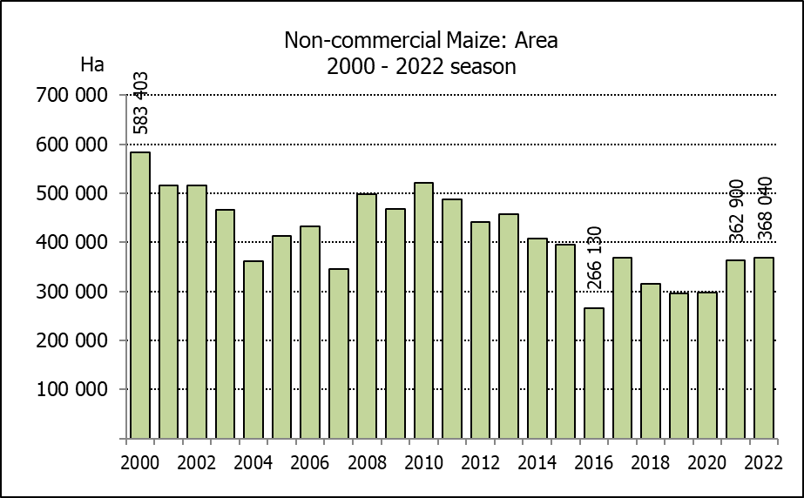
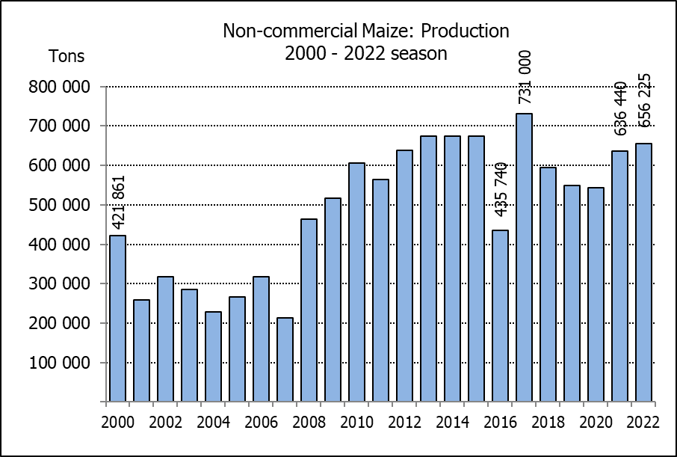
NIE-KOMMERSIëLE MIELIES – VOORLOPIGE OPPERVLAKTE- EN PRODUKSIESKATTING: 2022
CROP/GEWAS | Area planted/  Opp beplant  2022 | Production/  Produksie  2022 | Area planted/  Opp beplant  2021 | Final crop/  Finale oes  2021 | Change/  Verandering
CROP/GEWAS | Ha | Tons | Ha | Tons | %
CROP/GEWAS | (A) | (B) | (C) | (D) | (B) ÷ (D)
Non-commercial agriculture/Nie-kommersiële landbou:
White maize/Witmielies | 279 240 | 461 080 | 276 100 | 445 335 | +3,54
Yellow maize/Geelmielies | 88 800 | 195 145 | 86 800 | 191 105 | +2,11
Maize/Mielies | 368 040 | 656 225 | 362 900 | 636 440 | +3,11
The preliminary area planted to maize in the non-commercial agricultural sector is estimated at 368 040 ha, which represents an increase of 1,42%, compared to the 362 900 ha of the previous season. The expected maize crop for this sector is 656 225 tons, which is 3,11% more than the 636 440 tons of last season. It is important to note that about 51% of the maize produced in the non-commercial sector, is planted in the Eastern Cape, followed by KwaZulu-Natal with 23%.
Die voorlopige oppervlakte beplant met mielies in die nie-kommersiële landbou-sektor word geskat op 368 040 ha, wat ’n toename van 1,42% verteenwoordig in vergelyking met die 362 900 ha van die vorige seisoen. Die verwagte mielie-oes van dié sektor is 656 225 ton, wat 3,11% meer is as die 636 440 ton van die vorige seisoen. Dit is belangrik om daarop te let dat ongeveer 51% van die mielies wat geproduseer word in die nie-kommersiële sektor, in die Oos-Kaap geplant word, gevolg deur KwaZulu-Natal met 23%.

The intentions to plant winter cereals for the 2022 production season is hereby released. /
Hiermee word die voorneme om wintergewasse te plant vir die 2022 produksie-seisoen vrygestel.
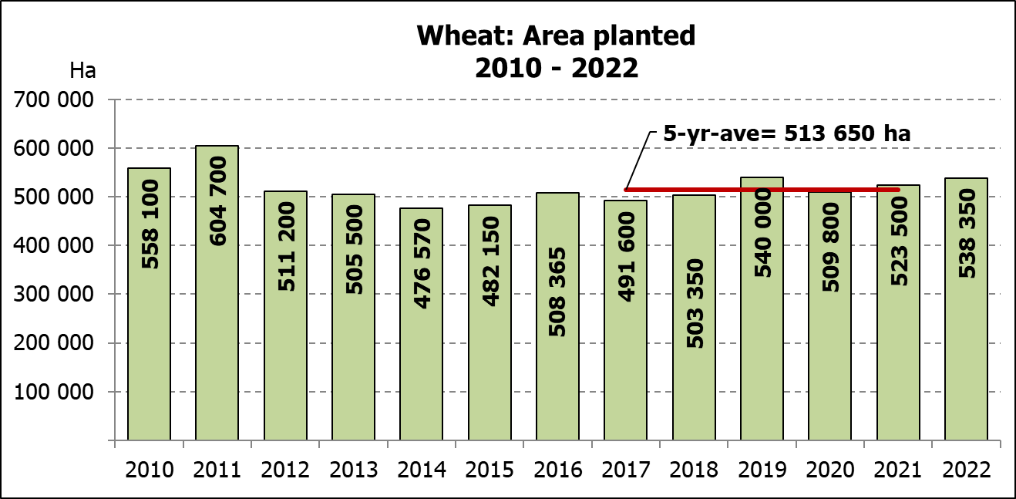
WINTERGEWASSE – VOORNEME OM TE PLANT: 2022
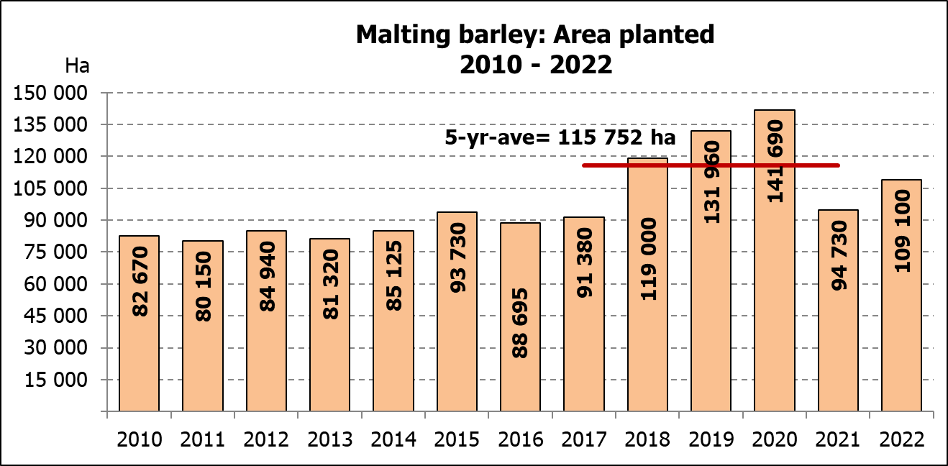
WINTER CEREALS –INTENTIONS TO PLANT: 2022
GEWAS/CROP | Voorneme/  Intentions*  2022 | Opp beplant/  Area planted  2021 | Finale skatting/  Final estimate  2021 | Verandering/  Change
GEWAS/CROP | Ha | Ha | Tons | %
GEWAS/CROP | (A) | (B) | (C) | (A) ÷ (B)
Wheat/Koring | 538 350 | 523 500 | 2 257 205 | +2,84
Malting barley/Moutgars | 109 100 | 94 730 | 331 100 | +15,17
Canola/Kanola | 120 000 | 100 000 | 197 000 | +20,00
Cereal oats/Hawermout | 29 150 | 36 250 | 69 950 | -19,59
Sweet lupines/Soetlupine | 25 000 | 22 000 | 28 600 | +13,64
Total winter cereals/Totaal wintergewasse | 821 600 | 776 480 | 2 883 855 | +5,81

* Based on conditions at the middle of April 2022 / Gebaseer op toestande soos teen middel April 2022.
KORING – VOORNEME OM TE PLANT: 2022
WHEAT – INTENTIONS TO PLANT: 2022
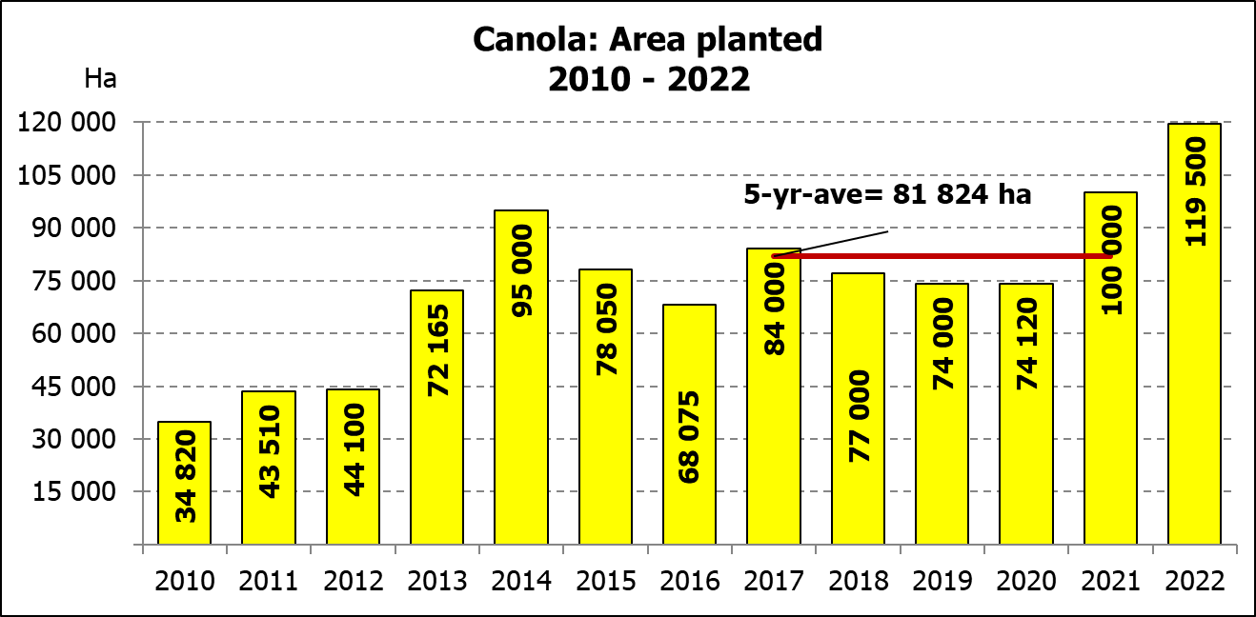
Provinsie/  Province | Voorneme/  Intentions  Ha | Opp beplant/  Area planted  Ha | Finale skatting/  Final estimate  Tons
Provinsie/  Province | 2022 | 2021 | 2021
Wes-Kaap/Western Cape | 350 000 | 360 000 | 1 260 000
Noord-Kaap/Northern Cape | 35 250 | 35 500 | 269 800
Vrystaat/Free State | 95 000 | 70 000 | 353 500
Oos-Kaap/Eastern Cape | 4 000 | 3 800 | 25 080
KwaZulu-Natal | 8 500 | 8 500 | 53 975
Mpumalanga | 4 000 | 4 100 | 27 470
Limpopo | 26 500 | 26 500 | 172 250
Gauteng | 1 100 | 1 100 | 6 930
Noordwes/North West | 14 000 | 14 000 | 88 200
Totaal/Total | 538 350 | 523 500 | 2 257 205

INTENTIONS TO PLANT WINTER CROPS FOR 2022 / VOORNEME OM WINTERGEWASSE AAN TE PLANT VIR 2022

Winter cereal crops – 2022  Producers’ intentions to plant winter cereals are mainly based on the results of a non-probability survey conducted by the Directorate: Statistics and Economic Analysis of the Department of Agriculture, Land Reform and Rural Development and reflects the position as at the middle of April 2022. Inputs were also received from the representatives of the respective Provincial Departments of Agriculture and the Bureau for Food and Agricultural Policy (BFAP).  The figures for wheat represent the total number of hectares that are intended to be planted for grain, excluding any hectares that will be planted for fodder and grazing.  Early indications are that producers intend to plant 538 350 ha of wheat for the 2022 production season. This is 2,84% or 14 850 ha more than the 523 500 ha planted to wheat in 2021.  The main producing areas are within the Western Cape with 350 000 ha (65%), followed by the Free State with 95 000 ha (18%) and the Northern Cape with 35 250 ha (7%).  The expected area planted to malting barley is 109 100 ha, which is 15,17% or 14 370 ha more than the 94 730 ha of the previous year. The expected area planted to canola is also 120 000 ha, which is 20,00% or 20 000 ha more than the 100 000 ha planted in 2021. Producers intend to plant 29 150 ha of cereal oats, which is 19,59 or 7 100 ha less than the 36 250 ha of the previous season. The expected area planted to sweet lupines is 25 000 ha.  Please note that the preliminary area estimate of winter crops for 2022 will be released on 27 July 2022. |  | Wintergewasse – 2022  Produsente se voorneme om wintergewasse te plant is hoofsaaklik gebaseer op die resultate van ’n nie-ewekansige opname onderneem deur die Direktoraat: Statistiek en Ekonomiese Analise van die Departement van Landbou, Grondhervorming en Landelike Ontwikkeling en weerspieël die situasie teen die middel van April 2022. Insette is ook ontvang vanaf die verteenwoordigers van die onderskeie Provinsiale Departemente van Landbou en die Buro vir Voedsel- en Landboubeleid (BFAP).  Die syfers vir koring verteenwoordig die totale aantal hektare wat werklik beplant gaan word vir graan, uitgesluit alle hektare wat beplant gaan word vir groenvoer en weiding.  Vroeë aanduidings is dat produsente van voorneme is om 538 350 ha koring te plant vir die 2022-produksie-seisoen. Dit is 2,84% of 14 850 ha meer koring aangeplant as die 523 500 ha in 2021.  Die grootste produserende gebiede is in die Wes-Kaap, met 350 000 ha (65%), gevolg deur die Vrystaat met 95 000 ha (18%) en die Noord-Kaap met  35 250 ha (7%).  Die verwagte aanplantings van moutgars is 109 100 ha – 15,17% of 14 370 ha meer as die 94 730 ha van die vorige jaar. Die verwagte aanplantings van kanola is ook 120 000 ha, wat 20,00% of 20 000 ha meer is as die 100 000 ha wat aangeplant was in 2021. Produsente is van voorneme om 29 150 ha hawermout te plant, wat 19,59% of 7 100 ha minder is as die 36 250 ha van die vorige seisoen. Die verwagte aanplantings van soetlupine is 25 000 ha.  Neem asseblief kennis dat die voorlopige oppervlakteskatting vir wintergewasse vir 2022 op 27 Julie 2022 vrygestel sal word.
Information is available on the internet at http:// www.dalrrd.gov.za/statistics or http://www.sagis.org.za, as from 14:30 on the date of the relevant meeting of the Crop Estimates Committee. |  | Inligting is beskikbaar op die internet by http://www.dalrrd.gov.za/statistics of by http://www.sagis.org.za, vanaf 14:30 op die dag van die toepaslike vergadering van die Oesskattingskomitee.

