 | crop estimates committee | 
 | oesskattingskomitee
From/Van: Rodney D. Dredge
Tel: 012 319 6507  Fax/Faks: 012 319 6211  E-mail/E-pos: CDESS@daff.gov.za
Web page/Webblad: www.daff.gov.za/crop estimates or www.sagis.org.za/CEC: Crop Estimates
EMBARGO: 14:30

The sixth production forecast for summer crops for the 2009/10 production season is hereby released. /
Hiermee word die sesde produksieskatting vir somergewasse vir die 2009/10 produksie-seisoen vrygestel.

SUMMER CROPS – AREA PLANTED AND SIXTH PRODUCTION FORECAST: 2009/10 PRODUCTION SEASON
SOMERGEWASSE – OPPERVLAKTE- EN SESDE PRODUKSIESKATTING: 2009/10-PRODUKSIESEISOEN
CROP/GEWAS | Area planted/  Opp beplant  2009/10 | 6th forecast/  6e skatting  2009/10 | 5th forecast/  5e skatting  2009/10 | Area planted/  Opp beplant  2008/09 | Finale oes/  Final crop  2008/09 | Change/  Verande-ring
CROP/GEWAS | Ha | Tons | Tons | Ha | Tons | %
CROP/GEWAS | (A) | (B) | (C) | (D) | (E) | (B) ÷ (C)
Commercial/Kommersieël:
White maize/Witmielies | 1 719 700 | 7 999 250 | 7 999 250 | 1 489 000 | 6 775 000 | -
Yellow maize/Geelmielies | 1 022 700 | 5 317 800 | 5 317 800 | 938 500 | 5 275 000 | -
Maize/Mielies | 2 742 400 | 13 317 050 | 13 317 050 | 2 427 500 | 12 050 000 | -
Sunflower seed/Sunflower seed | 397 700 | 528 765 | 528 765 | 635 800 | 801 000 | -
Soya-beans/Sojabone | 311 450 | 567 200 | 567 200 | 237 750 | 516 000 | -
Groundnuts/Grondbone | 57 450 | 87 880 | 87 880 | 54 550 | 99 500 | -
Sorghum | 86 675 | 241 593 | 241 593 | 85 500 | 276 500 | -
Dry beans/Droëbone | 44 100 | 52 255 | 52 255 | 43 800 | 67 030 | -
TOTAL/TOTAAL | 3 639 775 | 14 794 743 | 14 794 743 | 3 484 900 | 13 810 030 | -

22 July/Julie 2010

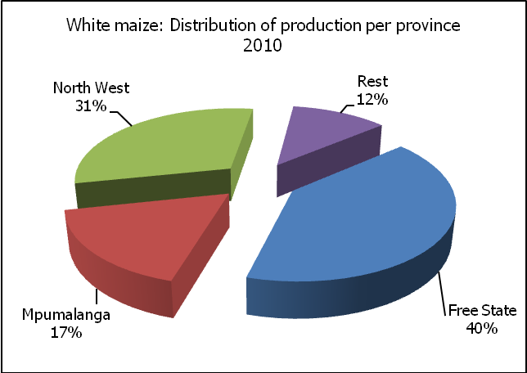

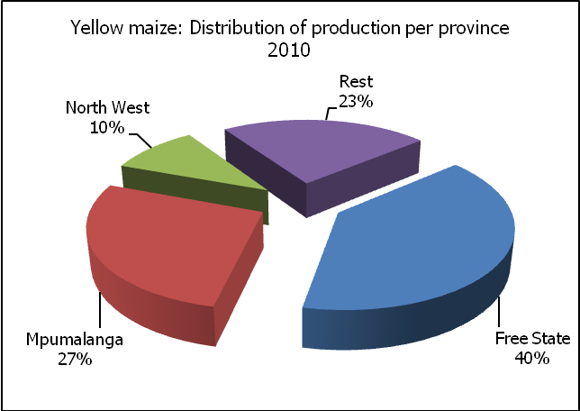

The Crop Estimates Committee comprises of the following officials:
Department of Agriculture, Forestry and Fisheries; Provincial Departments of Agriculture; various ARC-Institutes (Soil, Climate and Water; Small Grains Institute; and Grain Crops Institute),
Statistics SA

WHITE AND YELLOW MAIZE – AREA PLANTED AND SIXTH PRODUCTION FORECAST: 2009/10 PRODUCTION SEASON
WIT- EN GEELMIELIES – OPPERVLAKTE- EN SESDE PRODUKSIESKATTING: 2009/10-PRODUKSIESEISOEN

Provinsie/  Province | Area planted/  Oppervlakte beplant  2009/10 |  |  | 6th forecast/  6e skatting  2009/10 |  |  | Area planted/  Oppervlakte beplant  2008/09 |  |  | Final crop/  Finale oes  2008/09
Provinsie/  Province | White/  Wit  Ha | Yellow/  Geel  Ha | Total/  Totaal  Ha | White/  Wit  Tons | Yellow/  Geel  Tons | Total/  Totaal  Tons | White/  Wit  Ha | Yellow/  Geel  Ha | Total/  Totaal  Ha | White/  Wit  Tons | Yellow/  Geel  Tons | Total/  Totaal  Tons
Western Cape/Wes-Kaap | 500 | 2 000 | 2 500 | 3 500 | 16 000 | 19 500 | 1 500 | 3 500 | 5 000 | 15 000 | 35 000 | 50 000
Northern Cape/Noord-Kaap | 2 000 | 51 000 | 53 000 | 23 000 | 599 250 | 622 250 | 2 500 | 48 000 | 50 500 | 28 750 | 605 000 | 633 750
Free State/Vrystaat | 690 000 | 466 000 | 1 156 000 | 3 243 000 | 2 097 000 | 5 340 000 | 565 000 | 390 000 | 955 000 | 2 627 250 | 1 900 000 | 4 527 250
Eastern Cape/Oos-Kaap | 3 200 | 13 200 | 16 400 | 14 400 | 66 000 | 80 400 | 3 000 | 13 000 | 16 000 | 15 900 | 76 500 | 92 400
KwaZulu-Natal | 46 000 | 42 000 | 88 000 | 273 700 | 258 300 | 532 000 | 40 000 | 42 000 | 82 000 | 248 000 | 273 000 | 521 000
Mpumalanga | 232 000 | 250 000 | 482 000 | 1 380 400 | 1 450 000 | 2 830 400 | 215 000 | 262 000 | 477 000 | 1 290 000 | 1 580 000 | 2 870 000
Limpopo | 26 000 | 18 500 | 44 500 | 123 500 | 83 250 | 206 750 | 33 000 | 15 000 | 48 000 | 171 550 | 75 000 | 246 550
Gauteng | 85 000 | 40 000 | 125 000 | 493 000 | 216 000 | 709 000 | 69 000 | 30 000 | 99 000 | 358 800 | 175 500 | 534 300
North West/Noordwes | 635 000 | 140 000 | 775 000 | 2 444 750 | 532 000 | 2 976 750 | 560 000 | 135 000 | 695 000 | 2 019 750 | 555 000 | 2 574 750
Total/Totaal | 1 719 700 | 1 022 700 | 2 742 400 | 7 999 250 | 5 317 800 | 13 317 050 | 1 489 000 | 938 500 | 2 427 500 | 6 775 000 | 5 275 000 | 12 050 000

SUNFLOWER SEED – AREA PLANTED AND SIXTH PRODUCTION FORECAST: 2009/10 PRODUCTION SEASON
SONNEBLOMSAAD – OPPERVLAKTE- EN SESDE PRODUKSIESKATTING: 2009/10 PRODUKSIESEISOEN

Province/  Provinsie | Area planted/  Opp beplant  Ha | 6th forecast/  6e skatting  Tons | Area planted/  Opp beplant  Ha | Final crop/  Finale oes  Tons
Province/  Provinsie | 2009/10 | 2009/10 | 2008/09 | 2008/09
Western Cape/Wes-Kaap | 200 | 200 | 700 | 700
Northern Cape/Noord-Kaap | 850 | 1 700 | 500 | 1 000
Free State/Vrystaat | 175 000 | 245 000 | 280 000 | 363 000
Eastern Cape/Oos-Kaap | 150 | 165 | 600 | 780
KwaZulu-Natal | - | - | - | -
Mpumalanga | 8 000 | 12 800 | 27 000 | 37 700
Limpopo | 75 000 | 75 000 | 90 000 | 90 000
Gauteng | 3 500 | 4 900 | 7 000 | 9 820
North West/Noordwes | 135 000 | 189 000 | 230 000 | 298 000
Total/Totaal | 397 700 | 528 765 | 635 800 | 801 000

SOYA-BEANS – AREA PLANTED AND SIXTH PRODUCTION FORECAST: 2009/10 PRODUCTION SEASON
SOJABONE – OPPERVLAKTE- EN SESDE PRODUKSIESKATTING: 2009/10 PRODUKSIESEISOEN

Province/  Provinsie | Area planted/  Opp beplant  Ha | 6th forecast/  6e skatting  Tons | Area planted/  Opp beplant  Ha | Final crop/  Finale oes  Tons
Province/  Provinsie | 2009/10 | 2009/10 | 2008/09 | 2008/09
Western Cape/Wes-Kaap | - | - | - | -
Northern Cape/Noord-Kaap | 650 | 1 950 | 750 | 2 250
Free State/Vrystaat | 95 000 | 152 000 | 55 000 | 99 000
Eastern Cape/Oos-Kaap | 800 | 1 200 | 800 | 1 600
KwaZulu-Natal | 30 000 | 75 000 | 27 000 | 75 600
Mpumalanga | 145 000 | 239 250 | 125 000 | 262 500
Limpopo | 18 000 | 50 400 | 16 000 | 44 000
Gauteng | 12 000 | 20 400 | 6 700 | 12 525
North West/Noordwes | 10 000 | 27 000 | 6 500 | 18 525
Total/Totaal | 311 450 | 567 200 | 237 750 | 516 000

GROUNDNUTS – AREA PLANTED AND SIXTH PRODUCTION FORECAST: 2009/10 PRODUCTION SEASON
GRONDBONE – OPPERVLAKTE- EN SESDE PRODUKSIESKATTING: 2009/10 PRODUKSIESEISOEN

Province/  Provinsie | Area planted/  Opp beplant  Ha | 6th forecast/  6e skatting  Tons | Area planted/  Opp beplant  Ha | Final crop/  Finale oes  Tons
Province/  Provinsie | 2009/10 | 2009/10 | 2008/09 | 2008/09
Western Cape/Wes-Kaap | - | - | - | -
Northern Cape/Noord-Kaap | 10 000 | 27 000 | 10 000 | 31 000
Free State/Vrystaat | 25 000 | 35 000 | 21 500 | 33 690
Eastern Cape/Oos-Kaap | - |  | -
KwaZulu-Natal | 200 | 300 | - | -
Mpumalanga | - | - | - | -
Limpopo | 2 200 | 3 520 | 3 000 | 6 750
Gauteng | 50 | 60 | 50 | 60
North West/Noordwes | 20 000 | 22 000 | 20 000 | 28 000
Total/Totaal | 57 450 | 87 880 | 54 550 | 99 500

SORGHUM – AREA PLANTED AND SIXTH PRODUCTION FORECAST: 2009/10 PRODUCTION SEASON
SORGHUM – OPPERVLAKTE- EN SESDE PRODUKSIESKATTING: 2009/10 PRODUKSIESEISOEN

Province/  Provinsie | Area planted/  Opp beplant  Ha | 6th forecast/  6e skatting  Tons | Area planted/  Opp beplant  Ha | Final crop/  Finale oes  Tons
Province/  Provinsie | 2009/10 | 2009/10 | 2008/09 | 2008/09
Western Cape/Wes-Kaap | - | - | - | -
Northern Cape/Noord-Kaap | 25 | 63 | - | -
Free State/Vrystaat | 50 000 | 130 000 | 55 000 | 170 500
Eastern Cape/Oos-Kaap | - | - | - | -
KwaZulu-Natal | 150 | 480 | 300 | 900
Mpumalanga | 15 000 | 52 500 | 16 500 | 66 000
Limpopo | 15 000 | 41 250 | 8 000 | 23 000
Gauteng | 1 000 | 3 000 | 700 | 2 100
North West/Noordwes | 5 500 | 14 300 | 5 000 | 14 000
Total/Totaal | 86 675 | 241 593 | 85 500 | 276 500

DRY BEANS – AREA PLANTED AND SIXTH PRODUCTION FORECAST: 2009/10 PRODUCTION SEASON
DROëBONE – OPPERVLAKTE- EN SESDE PRODUKSIESKATTING: 2009/10 PRODUKSIESEISOEN

Province/  Provinsie | Area planted/  Opp beplant  Ha | 6th forecast/  6e skatting  Tons | Area planted/  Opp beplant  Ha | Final crop/  Finale oes  Tons
Province/  Provinsie | 2009/10 | 2009/10 | 2008/09 | 2008/09
Western Cape/Wes-Kaap | 100 | 300 | 100 | 280
Northern Cape/Noord-Kaap | 600 | 1 200 | 100 | 250
Free State/Vrystaat | 16 000 | 14 400 | 18 000 | 28 800
Eastern Cape/Oos-Kaap | 400 | 480 | 200 | 300
KwaZulu-Natal | 3 000 | 4 500 | 3 000 | 4 800
Mpumalanga | 10 500 | 12 075 | 10 500 | 15 750
Limpopo | 5 500 | 9 350 | 4 500 | 6 750
Gauteng | 3 500 | 4 550 | 3 400 | 5 100
North West/Noordwes | 4 500 | 5 400 | 4 000 | 5 000
Total/Totaal | 44 100 | 52 255 | 43 800 | 67 030

CONFIDENTIALITY ISSUES that CEC members are committed to adhere to on the day of the meeting
- Personal items such as laptops, handbags, cell phones, etc. are not allowed in the venue during the meeting
- No member is allowed to leave the meeting before 12:00 in order to prevent disclosure of the information
- The embargo time for the release of crop estimates information is 14:30
- No member is allowed to discuss crop estimates information with anyone other than a member of the Committee before the embargo time
- Only the Chairperson, or a member appointed by the Chairperson, may release the figures to the media
- Members must regard the detail of any information that was collected for and/or discussed during the meeting, as confidential
- Individual information received for crop estimate purposes is treated strictly confidential, and is not divulged for any other purposes

SIXTH PRODUCTION FORECAST OF SUMMER CROPS/
SESDE PRODUKSIESKATTING VIR SOMERGEWASSE
22 JULY/JULIE 2010
Summer field crops – 2009/10 production season  Commercial maize: The maize production forecast remained unchanged at 13,3 million tons due to the fact that just more than 50% of the maize crop has been harvested as a result of delays caused by late rains. The area estimate for maize also remained unchanged at 2,742 mill. ha, with an expected average yield of 4,86 t/ha.  The area estimate for white maize is 1,720 mill. ha, and for yellow maize it is 1,023 mill. ha.  The production forecast of white maize is 7,999 mill. tons, with a yield of 4,65 t/ha. In the case of yellow maize the production forecast is 5,318 mill. tons, with a yield of 5,20 t/ha.  Sunflower seed: The production forecast for sunflower seed remained unchanged at 528 765 tons. The estimated area planted to sunflower seed is 397 700 ha and the yield is 1,33 t/ha.  Other crops: The production forecast for soya-beans remained unchanged at 567 200 tons, while the estimated area planted to soya-beans is 311 450 ha. The expected yield is 1,82 t/ha.  The expected groundnut crop remained unchanged at 87 880 tons, with an estimated area of 57 450 ha, and an expected yield of 1,53 t/ha.  The production forecast for sorghum remained unchanged at 241 593 tons. The area estimate for sorghum is 86 675 ha and the expected yield is 2,79 t/ha.  In the case of dry beans, the production forecast remained unchanged at 52 255 tons. The area estimate is 44 100 ha, with an expected yield of 1,18 t/ha.  Please note that the seventh production forecast of summer field crops for the 2009/10 production season will be released on 24 August 2010. |  | Somergewasse – 2009/10 produksie-seisoen  Kommersiële mielies: Die verwagte kommersiële mielie-oes is onveranderd gelaat op 13,3 miljoen ton weens die feit dat slegs meer as 50% van die mielieoes gestroop is as gevolg van laat reëns wat die oesproses vertraag het. Die skatting van die oppervlakte onder mielies is ook onveranderd gelaat op 2,742 milj. ha, met ’n verwagte gemiddelde opbrengs van 4,86 t/ha.  Die oppervlak onder witmielies is 1,720 milj. ha en vir geelmielies is dit 1,023 milj. ha.  Die produksieskatting van witmielies is 7,999 miljoen ton en die verwagte opbrengs is 4,65 t/ha. In die geval van geelmielies is die produksieskatting 5,318 miljoen ton en die verwagte opbrengs is 5,20 t/ha.  Sonneblomsaad: Die produksieskatting vir sonneblomsaad is onveranderd gelaat op 528 765 ton. Die geskatte oppervlakte beplant met sonneblomsaad is 397 700 ha en die verwagte opbrengs is 1,33 t/ha.  Ander gewasse: Die produksieskatting van sojabone is onveranderd gelaat op 567 200 ton, terwyl die verwagte oppervlakte beplant met sojabone 311 450 ha is. Die verwagte opbrengs is 1,82 t/ha.  Die verwagte grondbone-oes is onveranderd gelaat op 87 880 ton, met ‘n oppervlakte beplant van 57 450 ha en ‘n verwagte opbrengs van 1,53 t/ha.  Die produksieskatting van sorghum is onveranderd gelaat op 241 593 ton. Die oppervlakteskatting vir sorghum is 86 675 ha en die verwagte opbrengs is 2,79 t/ha.  In die geval van droëbone is die produksieskatting onveranderd gelaat op 52 255 ton. Die oppervlakte beplant is 44 100 ha, met ‘n verwagte opbrengs van 1,18 t/ha.  Neem asseblief kennis dat die sewende produksieskatting vir somergewasse vir 2009/10 produksieseisoen op 24 Augustus 2010 vrygestel sal word.

Information is available on the internet at http://www.daff.gov.za/links/crop estimates or http://www.sagis.org.za, as from 14:30 on the date of the relevant meeting of the Crop Estimates Committee. |  | Inligting is beskikbaar op die internet by http://www.daff.gov.za/links/crop estimates of by http://www.sagis.org.za, vanaf 14:30 op die dag van die toepaslike vergadering van die Oesskattingskomitee.

The non-commercial agricultural sectors’ production estimate for maize for the 2009/10 production season is hereby released. /
Hiermee word die nie-kommersiële landbou-sektor se produksieskatting vir mielies vir die 2009/10 produksie-seisoen vrygestel.

NON-COMMERCIAL MAIZE – AREA PLANTED AND PRODUCTION ESTIMATE: 2009/10 PRODUCTION SEASON
NIE-KOMMERSIëLE MIELIES – OPPERVLAKTE- EN PRODUKSIESKATTING: 2009/10-PRODUKSIESEISOEN
CROP/GEWAS | Area planted/  Opp beplant  2009/10 | Estimate/  Skatting  2009/10 | Area planted/  Opp beplant  2008/09 | Final crop/  Finale oes  2008/09 | Change/  Verandering
CROP/GEWAS | Ha | Tons | Ha | Tons | %
CROP/GEWAS | (A) | (B) | (C) | (D) | (B) ÷ (D)
Non-commercial agriculture/Nie-kommersiële landbou:
White maize/Witmielies | 371 861 | 421 969 | 356 276 | 378 576 | +11,46
Yellow maize/Geelmielies | 149 079 | 183 895 | 112 407 | 138 057 | +33,20
Maize/Mielies | 520 940 | 605 864 | 468 683 | 516 633 | +17,27
The area planted to maize in the non-commercial agricultural sector is estimated at 520 940 ha, which represents an increase of 11,1 % compared to the 468 683 ha of the previous season. Due to favourable production conditions, the expected maize crop for this sector is 605 864 tons, which is 17,3 % higher than the 516 633 tons of last season.
Die oppervlakte beplant met mielies in die nie-kommersiële landbou-sektor word geskat op 520 940 ha, wat ‘n toename van 11,1 % verteenwoordig in vergelyking met die 468 683 ha van die vorige seisoen. Weens gunstige produksie toestande, is die verwagte mielie-oes van dié sektor 605 864 ton, wat 17,3 % hoër is as die 516 633 ton van die vorige seisoen.

The preliminary area estimate for winter cereals for the 2010 production season is hereby released. /
Hiermee word die voorlopige oppervlakteskatting vir wintergewasse vir die 2010 produksie-seisoen vrygestel.

WINTER CEREALS – PRELIMINARY AREA PLANTED ESTIMATE: 2010 PRODUCTION SEASON
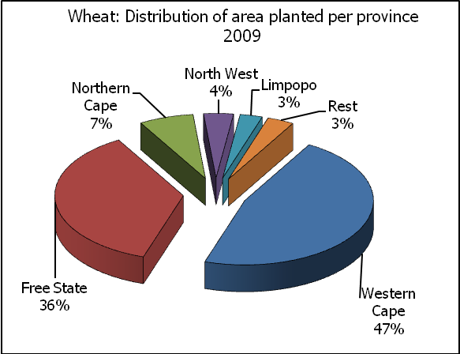
WINTERGEWASSE – VOORLOPIGE OPPERVLAKTESKATTING: 2010-PRODUKSIESEISOEN
CROP/GEWAS | Area planted/  Opp beplant  2010 | Intentions/  Voorneme*  Mid April 2010 | Area planted/  Opp beplant  2009 | Final crop/  Finale oes  2009 | Change/  Verandering
CROP/GEWAS | Ha | Ha | Ha | Tons | %
CROP/GEWAS | (A) | (B) | (C) | (D) | (A) ÷ (C)
Commercial/Kommersieel:
Wheat/Koring | 570 000 | 548 000 | 642 500 | 1 958 000 | -11,28
Malting barley/Moutgars | 84 670 | 85 000 | 74 760 | 216 000 | +13,26
Canola/Kanola | 33 500 | 37 500 | 35 060 | 40 350 | -4,45
Total/Totaal | 688 170 | 670 500 | 752 320 | 2 214 350 | -8,53
* Intentions based on conditions at the middle of April 2010 / Voorneme gebaseer op toestande soos teen middel April 2010.
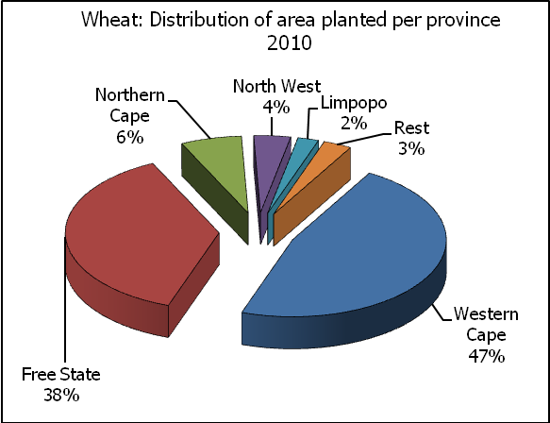
WHEAT – PRELIMINARY AREA PLANTED ESTIMATE: 2010 PRODUCTION SEASON
KORING – VOORLOPIGE OPPERVLAKTESKATTING: 2010-PRODUKSIESEISOEN

Province/  Provinsie | Area planted/  Opp beplant  Ha | Intentions/  Voorneme*  Ha | Area planted/  Opp beplant  Ha | Final crop/  Finale oes  Tons
Province/  Provinsie | 2010 | Mid April 2010 | 2009 | 2009
Western Cape/Wes-Kaap | 268 000 | 277 000 | 300 000 | 714 000
Northern Cape/Noord-Kaap | 36 500 | 38 000 | 44 000 | 277 200
Free State/Vrystaat | 214 000 | 180 000 | 235 000 | 622 000
Eastern Cape/Oos-Kaap | 4 500 | 4 200 | 5 000 | 20 000
KwaZulu-Natal | 6 500 | 6 000 | 7 000 | 35 000
Mpumalanga | 4 500 | 5 000 | 7 500 | 41 200
Limpopo | 12 500 | 14 000 | 18 000 | 99 000
Gauteng | 1 500 | 1 800 | 2 000 | 12 800
North West/Noordwes | 22 000 | 22 000 | 24 000 | 136 800
Total/Totaal | 570 000 | 548 000 | 642 500 | 1 958 000
* Intentions based on conditions at the middle of April 2010 / Voorneme gebaseer op toestande soos teen middel April 2010.

PRELIMINARY AREA ESTIMATE OF WINTER CROPS (2010 PRODUCTION SEASON) /
VOORLOPIGE OPPERVLAKTEKSKATTING VAN WINTERGEWASSE (2010 PRODUKSIE-SEISOEN)
22 JULY/ JULIE 2010

Winter cereal crops - 2010 production season  The preliminary area estimate is based on the results of a non-probability survey conducted by the Directorate: Agricultural Statistics and reflects the position as at the middle of July 2010. Please note that information from the Producer Independent Crop Estimation System (PICES) as conducted by the National Crop Statistics Consortium (NCSC) for the Western Cape and Northern Cape provinces, will be available in August 2010; and for the Free State in September 2010.  Wheat: The preliminary area estimate for wheat is 570 000 ha, which is 11,3% or 72 500 ha less than the 642 500 ha planted for the previous season.  According to producers the decrease in the expected planting of wheat can mainly be attributed to unfavourable prices for the crop.  An estimated 268 000 ha is planted in the Western Cape, which is 32 000 ha less than the 300 000 ha planted for the previous season. In the Free State, 214 000 ha is planted, which is 21 000 ha less than the 235 000 ha planted for the previous season. The area planted in the Northern Cape decreased by 7 500 ha to 36 500 ha.  Other crops: The preliminary area estimate for malting barley is 84 670 ha, which is 13,3% or 9 910 ha more than the 74 760 ha of last season. The area planted to canola is 33 500 ha, or 4,4% less than the 35 060 ha planted for the previous season.  Please note that the revised area planted estimate and first production forecast for winter cereals for the 2010 production season will be released on 24 August 2010. |  | Wintergewasse - 2010 produksie-seisoen  Die voorlopige oppervlakteskatting is gebaseer op die resultate van ’n nie-ewekansige opname onderneem deur die Direktoraat: Landboustatistiek en weerspieël die situasie teen die middel van Julie 2010. Let wel, inligting van die Produsente Onafhanklike Oesskattingstelsel (“PICES”), soos deur die Nasionale Oesskattingskonsortium gerapporteer vir die Wes-Kaap en Noord-Kaap provinsies, sal in Augustus 2010 gerapporteer word en vir die Vrystaat in September 2010.  Koring: Die voorlopige skatting van die oppervlakte onder koring beloop 570 000 ha, wat 11,3% of 72 500 ha minder is as die 642 500 ha wat verlede seisoen aangeplant is.  Volgens produsente kan die afname in verwagte aanplantings van koring hoofsaaklik toegeskryf word aan ongunstige pryse vir dié gewas.  Die beraamde oppervlakte beplant in die Wes-Kaap is 268 000 ha, wat 32 000 ha minder is as die 300 000 ha wat verlede seisoen aangeplant is. Vir die Vrystaat is die aanplantings 214 000 ha, wat 21 000 ha minder is as die 235 000 ha wat verlede seisoen aangeplant is. Die oppervlakte beplant in die Noord-Kaap het met 7 500 ha afgeneem tot 36 500 ha.  Ander gewasse: Die voorlopige oppervlakskatting vir moutgars is 84 670 ha, wat 13,3% of 9 910 ha meer is as die 74 760 ha van verlede seisoen. Die oppervlakte onder kanola is 33 500 ha, wat 4,4% minder is as die 35 060 ha wat verlede seisoen aangeplant is.  Neem asseblief kennis dat die hersiene oppervlakte beplant en eerste produksieskatting vir wintergewasse vir die 2010 produksieseisoen op 24 Augustus 2010 vrygestel sal word.

Information is available on the internet at http://www.daff.gov.za/links/crop estimates or http://www.sagis.org.za, as from 14:30 on the date of the relevant meeting of the Crop Estimates Committee. |  | Inligting is beskikbaar op die internet by http://www.daff.gov.za/links/crop estimates of by http://www.sagis.org.za, vanaf 14:30 op die dag van die toepaslike vergadering van die Oesskattingskomitee.

