 | crop estimates committee | 
 | oesskattingskomitee
From/Van: Rodney D. Dredge
Tel: 012 319 6507  Fax/Faks: 012 319 6211  E-mail/E-pos: CDESS@daff.gov.za
Web page/Webblad: www.daff.gov.za/crop estimates or www.sagis.org.za/CEC: Crop Estimates
EMBARGO: 15:30

21 December / Desember 2010

The fifth production forecast for winter cereals for the 2010 production season is hereby released. /
Hiermee word die vyfde produksieskatting vir wintergewasse vir die 2010 produksie-seisoen vrygestel.
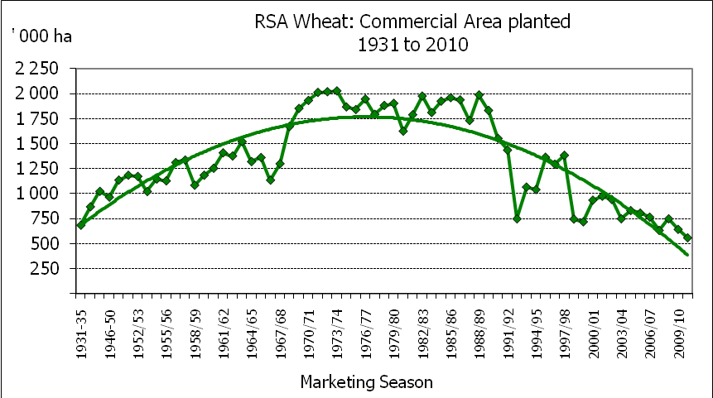
WINTER CEREALS – AREA PLANTED AND FIFTH PRODUCTION FORECAST: 2010 PRODUCTION SEASON
WINTERGEWASSE – OPPERVLAK- EN VYFDE PRODUKSIESKATTING: 2010-PRODUKSIESEISOEN
CROP/GEWAS | Area planted/  Opp beplant  2010 | 5th forecast/  5e skatting  2010 | 4th forecast/  4e skatting  2010 | Area planted/  Opp beplant  2009 | Final crop/  Finale oes  2009 | Change/  Verandering
CROP/GEWAS | Ha | Tons | Tons | Ha | Tons | %
CROP/GEWAS | (A) | (B) | (C) | (D) | (E) | (B) ÷ (C)
Commercial/Kommersieel:
Wheat/Koring | 558 100 | 1 571 340 | 1 571 030 | 642 500 | 1 958 000 | +0,02
Malting barley/Moutgars | 82 670 | 213 814 | 214 766 | 74 760 | 216 000 | -0,44
Canola/Kanola | 34 820 | 37 950 | 39 650 | 35 060 | 40 350 | 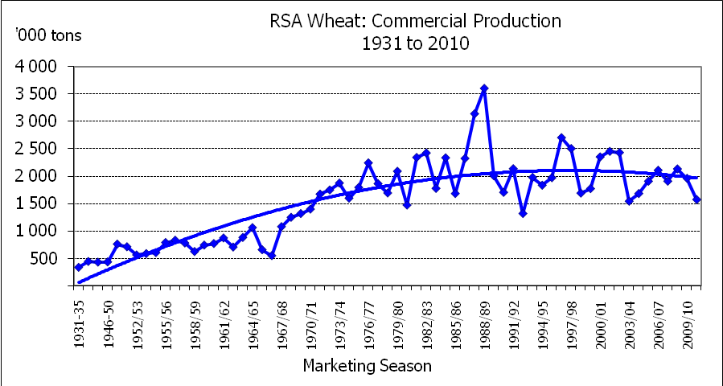  -4,29
Total/Totaal | 675 590 | 1 823 104 | 1 825 446 | 752 320 | 2 214 350 | -0,13

The Crop Estimates Committee comprises of the following officials:
Department of Agriculture, Forestry and Fisheries; Provincial Departments of Agriculture; various ARC-Institutes (Soil, Climate and Water; Small Grains Institute; and Grain Crops Institute),
Statistics SA

WHEAT – AREA PLANTED AND FIFTH PRODUCTION FORECAST: 2010 PRODUCTION SEASON
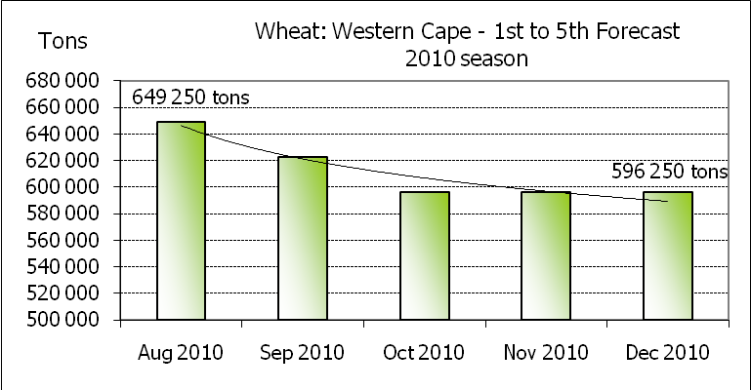
KORING – OPPERVLAK- EN VYFDE PRODUKSIESKATTING: 2010-PRODUKSIESEISOEN

Province/  Provinsie | Area planted/  Opp beplant  Ha | 5th forecast/  5e skatting  Tons | Area planted/  Opp beplant  Ha | Final crop/  Finale oes  Tons
Province/  Provinsie | 2010 | 2010 | 2009 | 2009
Western Cape/Wes-Kaap | 265 000 | 596 250 | 300 000 | 714 000
Northern Cape/Noord-Kaap | 38 000 | 262 200 | 44 000 | 277 200
Free State/Vrystaat | 204 000 | 428 400 | 235 000 | 622 000
Eastern Cape/Oos-Kaap | 4 500 | 19 350 | 5 000 | 20 000
KwaZulu-Natal | 6 100 | 32 940 | 7 000 | 35 000
Mpumalanga | 4 500 | 25 650 | 7 500 | 41 200
Limpopo | 12 500 | 72 500 | 18 000 | 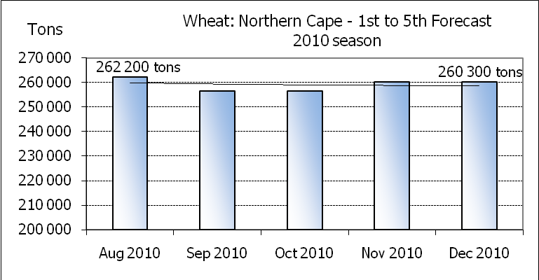  99 000
Gauteng | 1 500 | 9 750 | 2 000 | 12 800
North West/Noordwes | 22 000 | 124 300 | 24 000 | 136 800
Total/Totaal | 558 100 | 1 571 340 | 642 500 | 1 958 000

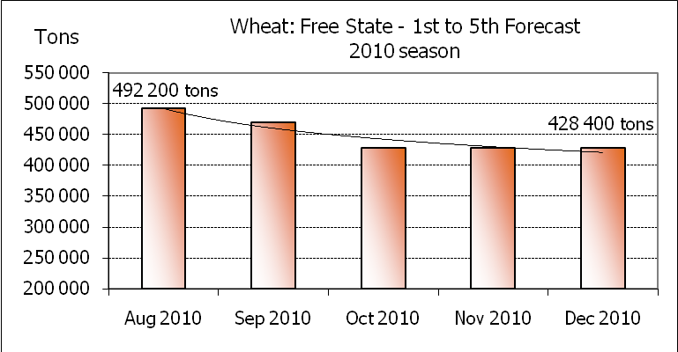
CONFIDENTIALITY ISSUES that CEC members are committed to adhere to on the day of the meeting
- Personal items such as laptops, handbags, cell phones, etc. are not allowed in the venue during the meeting
- No member is allowed to leave the meeting before 12:00 in order to prevent disclosure of the information
- The embargo time for the release of crop estimates information is 15:30
- No member is allowed to discuss crop estimates information with anyone other than a member of the Committee before the embargo time
- Only the Chairperson, or a member appointed by the Chairperson, may release the figures to the media
- Members must regard the detail of any information that was collected for and/or discussed during the meeting, as confidential
- Individual information received for crop estimate purposes is treated strictly confidential, and is not divulged for any other purposes

FIFTH PRODUCTION FORECAST OF WINTER CROPS (2010 PRODUCTION SEASON) /
VYFDE PRODUKSIESKATTING VAN WINTERGEWASSE (2010 PRODUKSIE-SEISOEN)
21 DECEMBER / DESEMBER 2010

Winter cereal crops - 2010 production season  Wheat: The expected production of wheat is 1,571 mill. tons, which is 310 tons more than the previous forecast, with an expected yield of 2,82 t/ha. The expected production in the Western Cape is 596 250 tons, which is the same than the previous forecast. The expected production in the Free State also remained unchanged at 428 400 tons, and in the Northern Cape, the expected production is 262 200 tons, which is 1 900 tons higher than the previous forecast. The expected production in the North West province is adjusted downward with 1,74 % or 2 200 tons.  The area estimate for wheat remained unchanged at 558 100 ha.  Other crops: The production forecast for malting barley is 213 814 tons, which is 0,44 % or 952 tons lower than the previous forecast of 214 766 tons. The area planted is estimated at 82 670 ha, while the expected yield is 2,59 t/ha.  The expected canola crop is 37 950 tons, which is 4,29 % or 1 700 tons less than the previous forecast. The area estimate for canola remained unchanged at 34 820 ha, while the expected yield is 1,09 t/ha.  Please note that the sixth production forecast for winter cereals for the 2010 production season, as well as the preliminary area estimate for summer crops for the 2010/11 production season will be released on 25 January 2011 at 15:30. |  | Wintergewasse - 2010 produksie-seisoen  Koring: Die verwagte produksie vir koring is 1,571 milj. ton, wat 310 ton meer is as die vorige skatting, met ’n verwagte opbrengs van 2,82 t/ha. Die verwagte produksie in die Wes-Kaap is 596 250 ton, wat dieselfde is as die vorige skatting. Die verwagte produksie in die Vrystaat is ook onveranderd gelaat op 428 400 ton, en in die Noord-Kaap is die verwagte produksie 262 200 ton, wat 1 900 ton hoër is as die vorige skatting. Die verwagte produksie in die Noordwes provinsie is afwaarts aangepas met 1,74 % of 2 200 ton.  Die oppervlakteskatting vir koring is onveranderd gelaat op 558 100 ha.  Ander gewasse: Die produksieskatting vir moutgars is 213 814 ton, wat 0,44 % of 952 ton laer is as die vorige skatting van 214 766 ton. Die oppervlakte beplant word beraam op 82 670 ha, terwyl die verwagte opbrengs 2,59 t/ha beloop.  Die verwagte kanola-oes is 37 950 ton, wat 4,29 % of 1 700 ton minder is as die vorige skatting. Die oppervlakteskatting vir kanola is onveranderd gelaat op 34 820 ha, terwyl die verwagte opbrengs 1,09 t/ha beloop.  Neem asseblief kennis dat die sesde produksieskatting vir wintergewasse vir die 2010 produksieseisoen, sowel as die voorlopige oppervlakte beplant vir somergewasse vir die 2010/11 produksieseisoen op 25 Januarie 2011 om 15:30 vrygestel sal word.

Information is available on the internet at:  http://www.daff.gov.za/links/crop estimates or http://www.sagis.org.za. |  | Inligting is beskikbaar op die internet by:  http://www.daff.gov.za/links/crop estimates of http://www.sagis.org.za.

