 | crop estimates committee | 
 | oesskattingskomitee
From/Van: Mr Baldwin Netshifhefhe
Tel: 012 319 8043  Fax/Faks: 012 319 8031  E-mail/E-pos: BaldwinN@daff.gov.za
Web page/Webblad: www.daff.gov.za/statistics and economic reports or www.sagis.org.za/CEC: Crop Estimates
EMBARGO: 14:30

The area planted estimate and eighth production forecast for summer crops for 2019 is hereby released.
Hiermee word die oppervlakte- en agtste produksieskatting vir somergewasse vir 2019 vrygestel.

SUMMER CROPS – AREA PLANTED AND EIGHTH PRODUCTION FORECAST: 2019
SOMERGEWASSE – OPPERVLAKTE- EN AGTSTE PRODUKSIESKATTING: 2019  CROP/GEWAS | Area planted/  Opp beplant  2019 |  | 8th forecast/  8ste skatting  2019 | 7th forecast/  7de skatting  2019 |  | Area planted/  Opp beplant  2018 |  |  | Final crop/  Finale oes  2018 |  |  | Change/  Verandering/
 | Ha |  | Tons | Tons |  | Ha |  |  | Tons |  |  | %
 | (A) |  | (B) | (C) |  | (D) |  |  | (E) |  |  | (B) ÷ (C)
Commercial/Kommersieël:
White maize/Witmielies | 1 298 400 |  | 5 538 240 | 5 572 240 |  | 1 268 100 |  |  | 6 540 000 |  |  | -0,61
Yellow maize/Geelmielies | 1 002 100 |  | 5 542 720 | 5 444 420 |  | 1 050 750 |  |  | 5 970 000 |  |  | +1,81
Total Maize/Totale Mielies | 2 300 500 |  | 11 080 960 | 11 016 660 |  | 2 318 850 |  |  | 12 510 000 |  |  | +0,58
Sunflower seed/Sonneblomsaad | 515 350 |  | 680 940 | 680 940 |  | 601 500 |  |  | 862 000 |  |  | -
Soybeans/Sojabone | 730 500 |  | 1 170 345 | 1 170 345 |  | 787 200 |  |  | 1 540 000 |  |  | -
Groundnuts/Grondbone | 20 050 |  | 19 455 | 18 880 |  | 56 300 |  |  | 57 000 |  |  | +3,05
Sorghum | 50 500 |  | 139 850 | 147 300 |  | 28 800 |  |  | 115 000 |  |  | -5,06
Dry beans/Droëbone | 59 300 |  | 66 355 | 66 355 |  | 53 360 |  |  | 69 360 |  |  | -
Non-Commercial Maize/Nie-Kommersiële Mielies
Total Maize/Totaal Mielies | 296 000 |  | 549 180 | 549 180 |  | 314 835 |  | 593 975 |  |  | -
Maize/Mielies: Commercial/Kommersieël + Non-Commercial/Nie-Kommersieël
Total Maize RSA/Totaal Mielies RSA |  | 2 596 500 | 11 630 140 |  | 11 565 840 |  | 2 633 685 |  |  | 13 103 975 |  |  | +0,56
Note: Estimate is for calendar year, e.g. production season 2018/19 = 2019
Nota: Skatting is vir kalenderjaar, bv. produksie-seisoen 2018/19 = 2019

26 September 2019
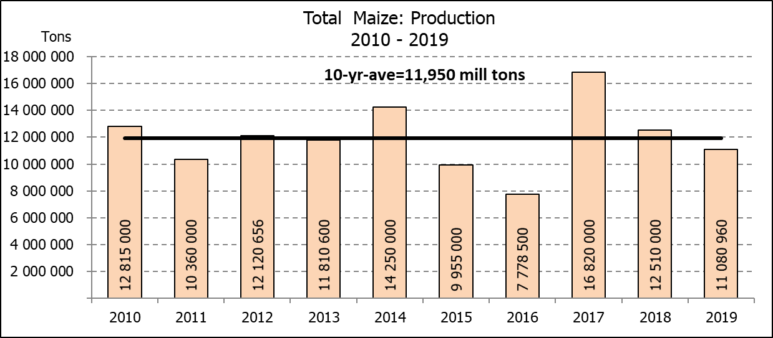

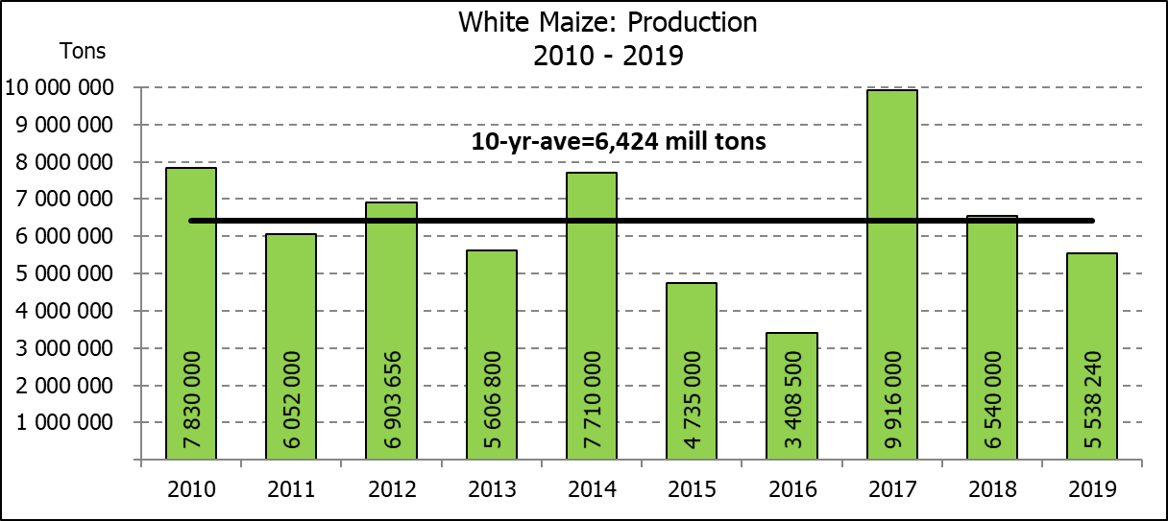
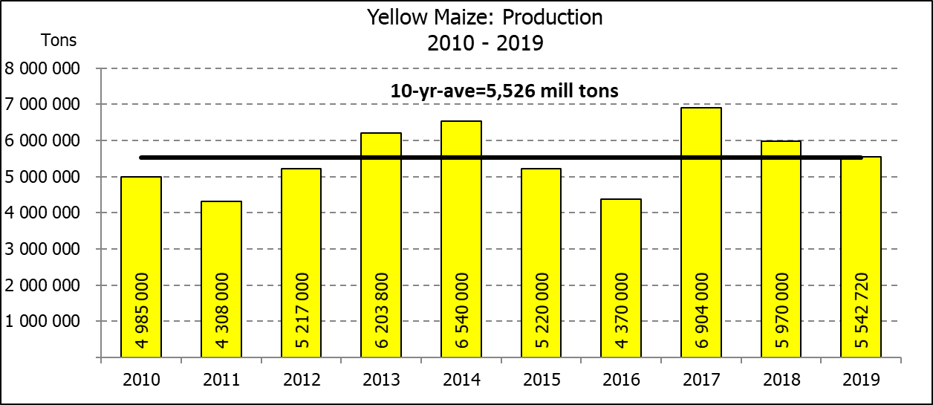

WHITE AND YELLOW MAIZE – AREA PLANTED AND EIGHTH PRODUCTION FORECAST: 2019
WIT- EN GEELMIELIES – OPPERVLAKTE EN AGTSTE PRODUKSIESKATTING: 2019

Provinsie/  Province | Area planted/  Oppervlakte beplant  2019 |  |  | 8th forecast/  8ste skatting  2019 |  |  | Area planted/  Oppervlakte beplant  2018 |  |  | Final crop/  Finale oes  2018
Provinsie/  Province | White/  Wit  Ha | Yellow/  Geel  Ha | Total/  Totaal  Ha | White/  Wit  Tons | Yellow/  Geel  Tons | Total/  Totaal  Tons | White/  Wit  Ha | Yellow/  Geel  Ha | Total/  Totaal  Ha | White/  Wit  Tons | Yellow/  Geel  Tons | Total/  Totaal  Tons
Western Cape/Wes-Kaap | 400 | 3 400 | 3 800 | 3 600 | 30 600 | 34 200 | 0 | 3 750 | 3 750 | 0 | 33 750 | 33 750
Northern Cape/Noord-Kaap | 3 400 | 43 500 | 46 900 | 39 440 | 630 750 | 670 190 | 3 600 | 43 000 | 46 600 | 41 300 | 628 000 | 669 300
Free State/Vrystaat | 650 000 | 380 000 | 1 030 000 | 2 795 000 | 1 634 000 | 4 429 000 | 644 000 | 410 000 | 1 054 000 | 3 350 000 | 1 925 000 | 5 275 000
Eastern Cape/Oos-Kaap | 3 800 | 10 200 | 14 000 | 22 800 | 67 320 | 90 120 | 3 500 | 11 000 | 14 500 | 21 700 | 71 500 | 93 200
KwaZulu-Natal | 45 000 | 54 000 | 99 000 | 270 000 | 394 200 | 664 200 | 45 000 | 50 000 | 95 000 | 280 000 | 380 000 | 660 000
Mpumalanga | 145 000 | 338 000 | 483 000 | 797 500 | 1 926 600 | 2 724 100 | 140 000 | 340 000 | 480 000 | 812 000 | 2 005 000 | 2 817 000
Limpopo | 12 800 | 18 000 | 30 800 | 83 200 | 117 000 | 200 200 | 12 000 | 21 000 | 33 000 | 90 000 | 141 700 | 231 700
Gauteng | 48 000 | 60 000 | 108 000 | 259 200 | 348 000 | 607 200 | 50 000 | 62 000 | 112 000 | 275 000 | 356 500 | 631 500
North West/Noordwes | 390 000 | 95 000 | 485 000 | 1 267 500 | 394 250 | 1 661 750 | 370 000 | 110 000 | 480 000 | 1 670 000 | 428 550 | 2 098 550
Total/Totaal | 1 298 400 | 1 002 100 | 2 300 500 | 5 538 240 | 5 542 720 | 11 080 960 | 1 268 100 | 1 050 750 | 2 318 850 | 6 540 000 | 5 970 000 | 12 510 000

SUNFLOWER SEED – AREA PLANTED AND EIGHTH PRODUCTION FORECAST: 2019
SONNEBLOMSAAD – OPPERVLAKTE EN AGTSTE PRODUKSIESKATTING: 2019

Province/  Provinsie | Area planted/  Opp beplant  Ha | 8th forecast/  8ste skatting  Tons | Area planted/  Opp beplant  Ha | Final crop/  Finale oes  Tons
Province/  Provinsie | 2019 | 2019 | 2018 | 2018
Western Cape/Wes-Kaap | - | - | 100 | 100
Northern Cape/Noord-Kaap | 950 | 1 140 | 1 600 | 1 920
Free State/Vrystaat | 270 000 | 391 500 | 314 000 | 490 000
Eastern Cape/Oos-Kaap | 100 | 250 | - | -
KwaZulu-Natal | - | - | - | -
Mpumalanga | 4 500 | 4 500 | 2 300 | 2 180
Limpopo | 61 000 | 61 000 | 45 000 | 36 000
Gauteng | 3 800 | 3 800 | 5 500 | 5 600
North West/Noordwes | 175 000 | 218 750 | 233 000 | 326 200
Total/Totaal | 515 350 | 680 940 | 601 500 | 862 000
SOYBEANS – AREA PLANTED AND EIGHTH PRODUCTION FORECAST: 2019
SOJABONE – OPPERVLAKTE EN AGTSTE PRODUKSIESKATTING: 2019

Province/  Provinsie | Area planted/  Opp beplant  Ha | 8th forecast/  8ste skatting  Tons | Area planted/  Opp beplant  Ha | Final crop/  Finale oes  Tons
Province/  Provinsie | 2019 | 2019 | 2018 | 2018
Western Cape/Wes-Kaap | 100 | 10 | 800 | 1 200
Northern Cape/Noord-Kaap | 1 550 | 5 425 | 3 000 | 10 500
Free State/Vrystaat | 301 000 | 391 300 | 345 000 | 552 000
Eastern Cape/Oos-Kaap | 1 150 | 1 380 | 2 400 | 2 900
KwaZulu-Natal | 33 000 | 99 000 | 40 000 | 124 000
Mpumalanga | 310 000 | 511 500 | 310 000 | 672 700
Limpopo | 16 200 | 46 980 | 20 000 | 54 000
Gauteng | 31 500 | 66 150 | 30 000 | 61 500
North West/Noordwes | 36 000 | 48 600 | 36 000 | 61 200
Total/Totaal | 730 500 | 1 170 345 | 787 200 | 1 540 000

GROUNDNUTS – AREA PLANTED AND EIGHTH PRODUCTION FORECAST: 2019
GRONDBONE – OPPERVLAKTE EN AGTSTE PRODUKSIESKATTING: 2019

Province/  Provinsie | Area planted/  Opp beplant  Ha | 8th forecast/  8ste skatting  Tons | Area planted/  Opp beplant  Ha | Final crop/  Finale oes  Tons
Province/  Provinsie | 2019 | 2019 | 2018 | 2018
Western Cape/Wes-Kaap | - | - | - | -
Northern Cape/Noord-Kaap | 1 200 | 2 520 | 2 800 | 7 000
Free State/Vrystaat | 11 500 | 9 200 | 22 000 | 21 150
Eastern Cape/Oos-Kaap | - | - | - | -
KwaZulu-Natal | - | - | - | -
Mpumalanga | - | - | - | -
Limpopo | 1 850 | 3 885 | 3 500 | 7 350
Gauteng | - | - | - | -
North West/Noordwes | 5 500 | 3 850 | 28 000 | 21 500
Total/Totaal | 20 050 | 19 455 | 56 300 | 57 000

SORGHUM – AREA PLANTED AND EIGHTH PRODUCTION FORECAST: 2019
SORGHUM – OPPERVLAKTE EN AGTSTE PRODUKSIESKATTING: 2019

Province/  Provinsie | Area planted/  Opp beplant  Ha | 8th forecast/  8ste skatting  Tons | Area planted/  Opp beplant  Ha | Final crop/  Finale oes  Tons
Province/  Provinsie | 2019 | 2019 | 2018 | 2018
Western Cape/Wes-Kaap | - | - | - | -
Northern Cape/Noord-Kaap | - | - | - | -
Free State/Vrystaat | 8 000 | 24 800 | 6 300 | 25 200
Eastern Cape/Oos-Kaap | - | - | - | -
KwaZulu-Natal | 500 | 1 500 | 500 | 2 200
Mpumalanga | 7 500 | 37 500 | 7 500 | 40 500
Limpopo | 25 000 | 55 000 | 5 000 | 15 500
Gauteng | 1 000 | 3 200 | 1 500 | 4 950
North West/Noordwes | 8 500 | 17 850 | 8 000 | 26 650
Total/Totaal | 50 500 | 139 850 | 28 800 | 115 000

DRY BEANS – AREA PLANTED AND EIGHTH PRODUCTION FORECAST: 2019
DROëBONE – OPPERVLAKTE EN AGTSTE PRODUKSIESKATTING: 2019

Province/  Provinsie | Area planted/  Opp beplant  Ha | 8th forecast/  8ste skatting  Tons | Area planted/  Opp beplant  Ha | Final crop/  Finale oes  Tons
Province/  Provinsie | 2019 | 2019 | 2018 | 2018
Western Cape/Wes-Kaap | 100 | 180 | 20 | 30
Northern Cape/Noord-Kaap | 1 000 | 1 400 | 540 | 1 080
Free State/Vrystaat | 27 000 | 28 350 | 26 000 | 28 600
Eastern Cape/Oos-Kaap | 400 | 720 | 300 | 450
KwaZulu-Natal | 3 500 | 4 025 | 3 000 | 3 600
Mpumalanga | 7 500 | 6 750 | 7 000 | 9 800
Limpopo | 7 800 | 12 480 | 7 500 | 15 000
Gauteng | 1 500 | 1 950 | 1 000 | 1 200
North West/Noordwes | 10 500 | 10 500 | 8 000 | 9 600
Total/Totaal | 59 300 | 66 355 | 53 360 | 69 360

CONFIDENTIALITY ISSUES that CEC members are committed to adhere to on the day of the meeting
- Personal items such as laptops, handbags, cell phones, etc. are not allowed in the venue during the meeting
- No member is allowed to leave the meeting before 12:00 in order to prevent disclosure of the information
- The embargo time for the release of crop estimates information is 14:30
- No member is allowed to discuss crop estimates information with anyone other than a member of the Committee before the embargo time
- Only the Chairperson, or a member appointed by the Chairperson, may release the figures to the media
- Members must regard the detail of any information that was collected for and/or discussed during the meeting, as confidential
- Individual information received for crop estimate purposes is treated strictly confidential, and is not divulged for any other purposes

AREA ESTIMATE AND EIGHTH PRODUCTION FORECAST OF SUMMER CROPS (2019 PRODUCTION SEASON)/
OPPERVLAKTE- EN AGTSTE PRODUKSIESKATTING VIR SOMERGEWASSE (2019 PRODUKSIE-SEISOEN)
26 SEPTEMBER 2019

Summer field crops – 2019  Commercial maize: The size of the expected commercial maize crop has been set at 11,081 mill. tons, which is 0,58% or 64 300 tons more than the previous forecast of 11,017 mill. tons. The area estimate for maize is 2,301 mill. ha, while the expected yield is 4,82 t/ha.  The estimated maize crop is 11% smaller than the 2018 crop. The three main maize producing areas, namely the Free State, Mpumalanga and North West provinces are expected to produce 80% of the 2019 crop.  The area estimate for white maize is 1,298 mill. ha & for yellow maize the area estimate is 1,002 mill. ha.  The production forecast of white maize decreased by 0,61% or 34 000 tons, from 5,572 mill. tons to 5,538 mill. tons. The yield for white maize is 4,27 t/ha. In the case of yellow maize the production forecast is 5,543 mill. tons, which is 1,81% or 98 300 tons more than the 5,444 mill. tons of the previous forecast. The yield for yellow maize is 5,53 t/ha.  Sunflower seed: The production forecast for sunflower seed remained unchanged at 680 940 tons. The area estimate for sunflower seed is 515 350 ha, while the expected yield is 1,32 t/ha.  Other crops: The production forecast for soybeans also remained unchanged at 1,170 mill. tons. The estimated area planted to soybeans is 730 500 ha and the expected yield is 1,60 t/ha.  The expected groundnut crop increased by 3,05% or 575 tons to 19 455 tons, with an expected yield of 0,97 t/ha. The area estimate for groundnuts is 20 050 ha.  The production forecast for sorghum decreased by 5,06% or 7 450 tons, from 147 300 tons to 139 850 tons. The area estimate for sorghum is 50 500 ha and the expected yield is 2,77 t/ha.  In the case of dry beans, the production forecast remained unchanged at 66 355 tons. The area estimate of dry beans is 59 300 ha, with an expected yield of 1,12 t/ha.  Please note that the ninth production forecast for summer field crops for 2019 will be released on 24 October 2019. |  | Somergewasse – 2019  Kommersiële mielies: Die grootte van die verwagte kommersiële mielie-oes is op 11,081 milj. ton gestel, wat 0,58% of 64 300 ton meer is as die vorige skatting van 11,017 milj. ton. Die skatting van die oppervlakte onder mielies is 2,301 milj. ha, terwyl die verwagte opbrengs 4,82 t/ha is.  Die geskatte mielie-oes is 11% kleiner as die 2018-oes. Die drie belangrikste mielieproduserende gebiede, nl. die Vrystaat, Mpumalanga en Noordwes provinsies, gaan na verwagting 80% van die 2019-oes produseer.  Die oppervlak onder witmielies is 1,298 milj. ha en vir geelmielies is die oppervlak 1,002 milj. ha.  Die produksieskatting van witmielies het afgeneem met 0,61% of 34 000 ton, van 5,572 mill. ton na 5,538 milj. ton. Die opbrengs van witmielies is 4,27 t/ha. In die geval van geelmielies is die produksieskatting 5,543 milj. ton, wat 1,81% of 98 300 ton meer is as die 5,444 milj. ton van die vorige skatting. Die opbrengs van geelmielies is 5,53 t/ha.  Sonneblomsaad: Die produksieskatting vir sonneblomsaad is onveranderd gelaat op 680 940 ton. Die oppervlakteskatting vir sonneblomsaad is 515 350 ha, terwyl die verwagte opbrengs 1,32 t/ha is.  Ander gewasse: Die produksieskatting van sojabone is ook onveranderd gelaat op 1,170 milj. ton. Die geskatte oppervlakte beplant van sojabone is 730 500 ha en die verwagte opbrengs is 1,60 t/ha.  Die verwagte grondbone-oes het toegeneem met 3,05% of 575 ton na 19 455 ton, met ’n verwagte opbrengs van 0,97 t/ha. Die oppervlakteskatting vir grondbone is 20 050 ha.  Die produksieskatting van sorghum het afgeneem met 5,06% of 7 450 ton, van 147 300 ton tot 139 850 ton. Die oppervlakteskatting vir sorghum is 50 500 ha, en die verwagte opbrengs is 2,77 t/ha.  In die geval van droëbone is die produksieskatting onveranderd gelaat op 66 355 ton. Die oppervlakte beplant met droëbone is 59 300 ha, en die verwagte opbrengs is 1,12 t/ha.  Neem asseblief kennis dat die negende produksieskatting vir somergewasse vir 2019, op 24 Oktober 2019 vrygestel sal word.
Information is available on the internet at http://www.daff.gov.za/statistics and economic reports or http://www.sagis.org.za, as from 14:30 on the date of the relevant meeting of the Crop Estimates Committee. |  | Inligting is beskikbaar op die internet by http://www.daff.gov.za/statistics and economic reports of by http://www.sagis.org.za, vanaf 14:30 op die dag van die toepaslike vergadering van die Oesskattingskomitee.

The non-commercial agricultural sectors’ production estimate for maize for 2019 is hereby released. /
Hiermee word die nie-kommersiële landbou-sektor se produksieskatting vir mielies vir 2019 vrygestel.

NON-COMMERCIAL MAIZE – AREA PLANTED AND PRODUCTION ESTIMATE: 2019
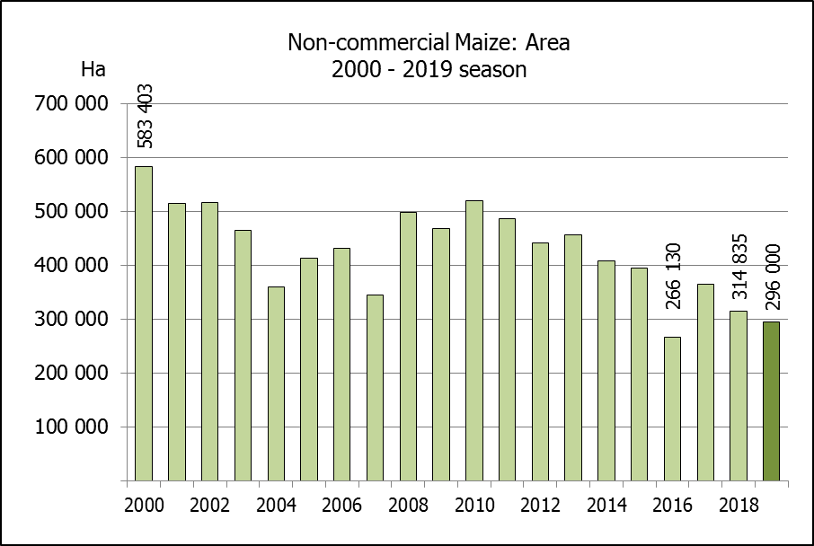
NIE-KOMMERSIëLE MIELIES – OPPERVLAKTE- EN PRODUKSIESKATTING: 2019
CROP/GEWAS | Area planted/  Opp beplant  2019 | Production/  Produksie  2019 | Area planted/  Opp beplant  2018 | Final crop/  Finale oes  2018 | Change/  Verandering
CROP/GEWAS | Ha | Tons | Ha | Tons | %
CROP/GEWAS | (A) | (B) | (C) | (D) | (B) ÷ (D)
Non-commercial agriculture/Nie-kommersiële landbou:
White maize/Witmielies | 221 300 | 379 460 | 236 644 | 414 162 | -8,38
Yellow maize/Geelmielies | 74 700 | 169 720 | 78 191 | 179 813 | -5,61
Maize/Mielies | 296 000 | 549 180 | 314 835 | 593 975 | -7,54
The area planted to maize in the non-commercial agricultural sector is estimated at 296 000 ha, which represents a decrease of 5,98%, compared to the 314 835 ha of the previous season. The expected maize crop for this sector is 549 180 tons, which is 7,54% less than the 593 975 tons of last season. It is important to note that about 43% of the maize produced in the non-commercial sector, is planted in the Eastern Cape, followed by KwaZulu-Natal with 27%.
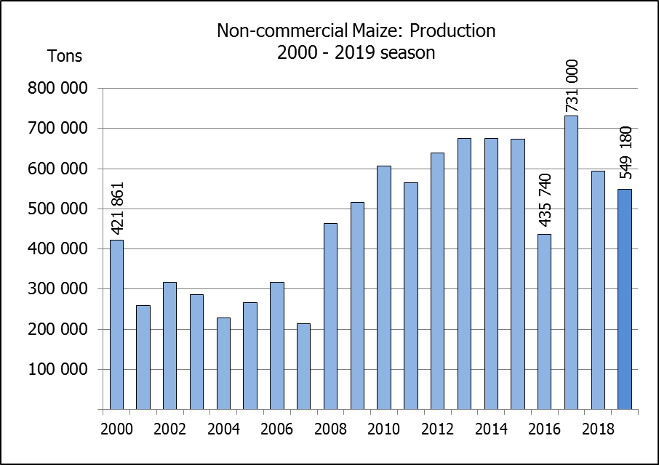
Die oppervlakte beplant met mielies in die nie-kommersiële landbou-sektor word geskat op 296 000 ha, wat ‘n afname van 5,98 % verteenwoordig in vergelyking met die 314 835 ha van die vorige seisoen. Die verwagte mielie-oes van dié sektor is 549 180 ton, wat 7,54% minder is as die 593 975 ton van die vorige seisoen. Dit is belangrik om daarop te let dat ongeveer 43% van die mielies wat geproduseer word in die nie-kommersiële sektor, in die Oos-Kaap geplant word, gevolg deur KwaZulu-Natal met 27%.

The revised area estimate and second production forecast for winter cereals for the 2019 is hereby released. /
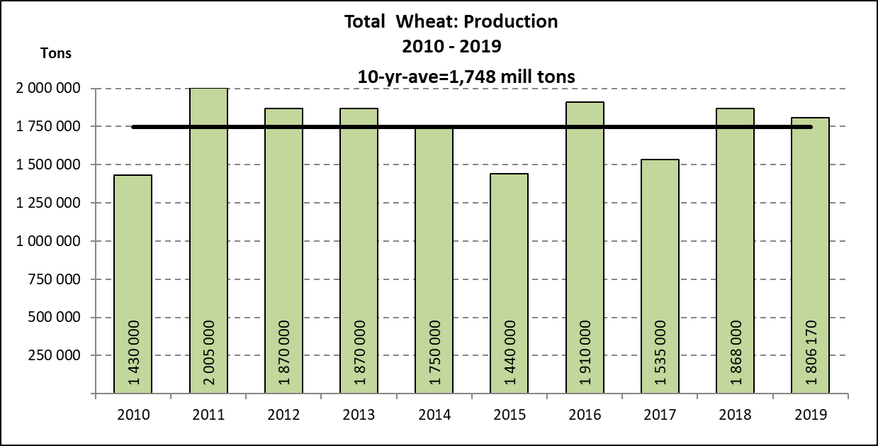
Hiermee word die hersiene oppervlakte- en tweede produksieskatting vir wintergewasse vir 2019 vrygestel.

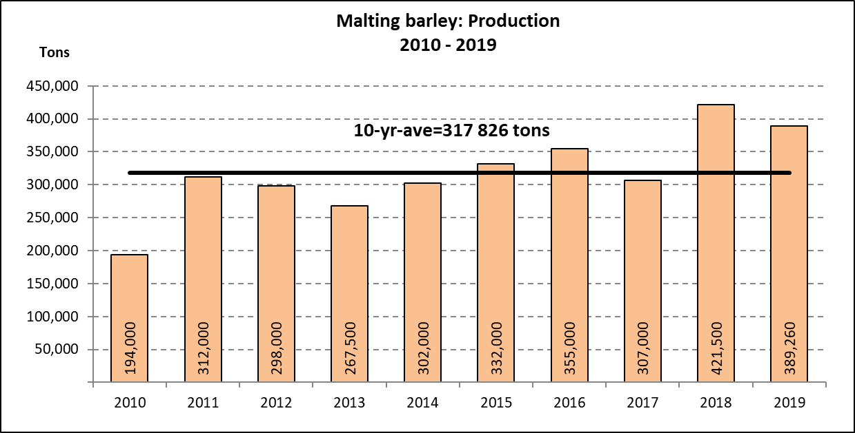
WINTER CEREALS – REVISED AREA PLANTED AND SECOND PRODUCTION FORECAST: 2019 PRODUCTION SEASON
WINTERGEWASSE – HERSIENE OPPERVLAKTE- EN TWEEDE PRODUKSIESKATTING: 2019-PRODUKSIESEISOEN  CROP/GEWAS | Area planted/  Opp beplant  2019 | 2nd forecast/  2de skatting  2019 | 1st forecast/  1ste skatting  2019 | Area planted/  Opp beplant  2018 | Final crop/  Finale oes  2018 | Change/  Verandering
 | Ha | Tons | Tons | Ha | Tons | %
 | (A) | (B) | (C) | (D) | (E) | (B) ÷ (C)
Commercial/Kommersieel:
Wheat/Koring | 540 000 | 1 806 170 | 1 915 650 | 503 350 | 1 868 000 | -5,72
Malting barley/Moutgars | 131 960 | 389 260 | 401 460 | 119 000 | 421 500 | -3,04
Canola/Kanola | 74 000 | 88 800 | 103 600 | 77 000 | 104 500 | -14,29
Cereal oats/Hawermout | 27 200 | 36 460 | 40 000 | 19 235 | 32 700 | -8,85
* Note: Estimate is for calendar year, e.g. production season 2019/20 = 2019
* Nota: Skatting is vir kalenderjaar, bv. produksie-seisoen 2019/20 = 2019

WHEAT – REVISED AREA PLANTED AND SECOND PRODUCTION FORECAST: 2019
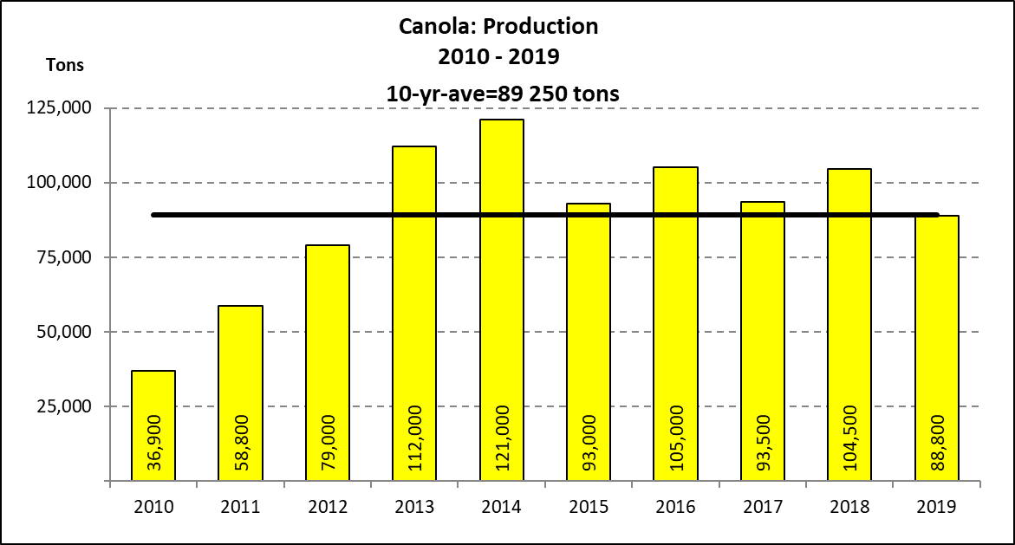
KORING – HERSIENE OPPERVLAKTE- EN TWEEDE PRODUKSIESKATTING: 2019
Province/  Provinsie | Area planted/  Opp beplant  Ha | 2nd forecast/  2de skatting  Tons | Area planted/  Opp beplant  Ha | Final crop/  Finale oes  Tons
Province/  Provinsie | 2019 | 2019 | 2018 | 2018
Western Cape/Wes-Kaap | 325 000 | 780 000 | 318 000 | 890 500
Northern Cape/Noord-Kaap | 37 500 | 281 250 | 38 000 | 294 500
Free State/Vrystaat | 128 000 | 435 200 | 100 000 | 385 000
Eastern Cape/Oos-Kaap | 3 100 | 19 220 | 1 650 | 10 730
KwaZulu-Natal | 7 500 | 45 750 | 7 000 | 43 400
Mpumalanga | 4 000 | 26 000 | 3 500 | 22 740
Limpopo | 20 000 | 128 000 | 20 000 | 128 000
Gauteng | 1 400 | 8 400 | 1 200 | 7 800
North West/Noordwes | 13 500 | 82 350 | 14 000 | 85 330
Total/Totaal | 540 000 | 1 806 170 | 503 350 | 1 868 000

REVISED AREA ESTIMATE AND SECOND PRODUCTION FORECAST OF WINTER CROPS (2019) /
HERSIENE OPPERVLAKTEKSKATTING EN TWEEDE PRODUKSIESKATTING VAN WINTERGEWASSE (2019)
26 SEPTEMBER 2019
Winter cereal crops - 2019 production season  Wheat: The expected production of wheat is 1,806 mill. tons, which is 5,72% or 109 480 tons less than the previous forecast of 1,916 mill. tons, whilst the expected yield is 3,34 t/ha.  The expected production in the Western Cape is 780 000 tons (43%), in the Free State 435 200 tons (24%) and in the Northern Cape 281 250 tons (16%).  The area estimate for wheat was revised to 540 000 ha, which is 3 000 ha higher than the 537 000 ha of the previous forecast. An estimated 325 000 ha or 60 % is planted in the Western Cape, 128 000 ha or 24 % in the Free State and 37 500 ha or 7 % in the Northern Cape.  Other crops: The production forecast for malting barley is 389 260 tons, which is 3,04% or 12 200 tons less than the previous forecast of 401 460 tons. The area planted is estimated at 131 960 ha, while the expected yield is 2,95 t/ha.  The expected canola crop is 88 800 tons, which is 14,29% or 14 800 tons less than the previous forecast of 103 600 tons. The area estimate for canola is 74 000 ha, with an expected yield of 1,20 t/ha.  The revised area estimate for oats (cereals) for the 2019 season is 27 200 ha and the expected crop is 36 460 tons. The expected yield is 1,34 t/ha.  Please note that the third production forecast for winter cereals for 2019 will be released on 24 October 2019. |  | Wintergewasse - 2019 produksie-seisoen  Koring: Die verwagte produksie vir koring is 1,806 milj. ton, wat 5,72% of 109 480 ton minder is as die vorige skatting van 1,916 milj. ton, terwyl die verwagte opbrengs 3,34 t/ha is.  Die verwagte produksie in die Wes-Kaap is 780 000 ton (43%), in die Vrystaat 435 200 ton (24%) en in die Noord-Kaap 281 250 ton (16%).  Die oppervlakteskatting vir koring is hersien na 540 000 ha, wat 3 000 ha hoër is as die 537 000 ha teenoor die vorige skatting. Die beraamde oppervlakte geplant in die Wes-Kaap is 325 000 ha of 60 %, die Vrystaat is 128 000 ha of 24 % en 37 500 ha of 7 % is in die Noord-Kaap.  Ander gewasse: Die produksieskatting vir moutgars is 389 260 ton, wat 3,04% of 12 200 ton minder is as die vorige skatting van 401 460 ton. Die oppervlakte beplant word beraam op 131 960 ha, terwyl die verwagte opbrengs 2,95 t/ha beloop.  Die verwagte kanola-oes is 88 800 ton, wat 14,29% of 14 800 ton minder is as die vorige skatting van 103 600 ton. Die oppervlakteskatting vir kanola is 74 000 ha, met ŉ verwagte opbrengs van 1,20 t/ha.  Die hersiene oppervlakteskatting vir hawer (ontbytgraan) vir die 2019-seisoen is 27 200 ha en die verwagte oes is 36 460 ton. Die verwagte opbrengs is 1,34 t/ha.  Neem asseblief kennis dat die derde produksieskatting vir wintergewasse vir 2019 op 24 Oktober 2019 vrygestel sal word.

Information is available on the internet at http://www.daff.gov.za/links/crop estimates or http://www.sagis.org.za, as from 14:30 on the date of the relevant meeting of the Crop Estimates Committee. |  | Inligting is beskikbaar op die internet by http://www.daff.gov.za/links/crop estimates of by http://www.sagis.org.za, vanaf 14:30 op die dag van die toepaslike vergadering van die Oesskattingskomitee.

