 | crop estimates committee | 
 | oesskattingskomitee
From/Van: M. Ellen Matsei
Tel: 012 319 8454  Fax/Faks: 012 319 8031  E-mail/E-pos: DAS@daff.gov.za
Web page/Webblad: www.daff.gov.za/statistics and economic reports or www.sagis.org.za/CEC: Crop Estimates
EMBARGO: 15:30

The area planted and final production estimate for summer crops for 2018 is hereby released.
Hiermee word die oppervlakte- en finale produksieskatting vir somergewasse vir 2018 vrygestel.

SUMMER CROPS – AREA PLANTED AND FINAL PRODUCTION ESTIMATE: 2018
SOMERGEWASSE – OPPERVLAKTE- EN FINALE PRODUKSIESKATTING: 2018
CROP/GEWAS | Area planted/  Opp beplant  2018 | Final estimate/  Finale skatting  2018 | 7th forecast/  7de skatting  2018 | Area planted/  Opp beplant  2017 | Final crop/  Finale oes  2017 | Change/  Verandering
CROP/GEWAS | Ha | Tons | Tons | Ha | Tons | %
CROP/GEWAS | (A) | (B) | (C) | (D) | (E) | (B) ÷ (C)
Commercial/Kommersieel:
White maize/Witmielies | 1 268 100 | 6 801 560 | 6 879 960 | 1 643 100 | 9 916 000 | -1,14
Yellow maize/Geelmielies | 1 050 750 | 6 129 650 | 6 327 350 | 985 500 | 6 904 000 | -3,12
Total Maize/Totale Mielies | 2 318 850 | 12 931 210 | 13 207 310 | 2 628 600 | 16 820 000 | -2,09
Sunflower seed/Sonneblomsaad | 601 500 | 858 605 | 858 605 | 635 750 | 874 000 | -
Soybeans/Sojabone | 787 200 | 1 550 800 | 1 550 800 | 573 950 | 1 316 000 | -
Groundnuts/Grondbone | 56 300 | 53 750 | 52 000 | 56 000 | 92 050 | +3,37
Sorghum | 28 800 | 109 855 | 105 120 | 42 350 | 152 000 | +4,50
Dry beans/Droëbone | 53 360 | 69 360 | 65 610 | 45 050 | 68 525 | +5,72
Non-Commercial Maize/Nie-Kommersiële Mielies
Total Maize/Totaal Mielies | 314 835 | 593 975 | 593 975 | 366 650 | 731 000 | -
Maize/Mielies: Commercial/Kommersieël + Non-Commercial/Nie-Kommersieël
Total Maize RSA/Totaal Mielies RSA | 2 633 685 | 13 525 185 | 13 801 285 | 2 995 250 | 17 551 000 | -2,00
Note: Estimate is for calendar year, e.g. production season 2017/18 = 2018
Nota: Skatting is vir kalenderjaar, bv. produksie-seisoen 2017/18 = 2018

The Crop Estimates Committee comprises officials of the following institutions:
Department of Agriculture, Forestry and Fisheries; Provincial Departments of Agriculture; various ARC-Institutes (Soil, Climate and Water; Small Grains Institute;
and Grain Crops Institute); BFAP, Statistics SA and CSIR.
26 September 2018

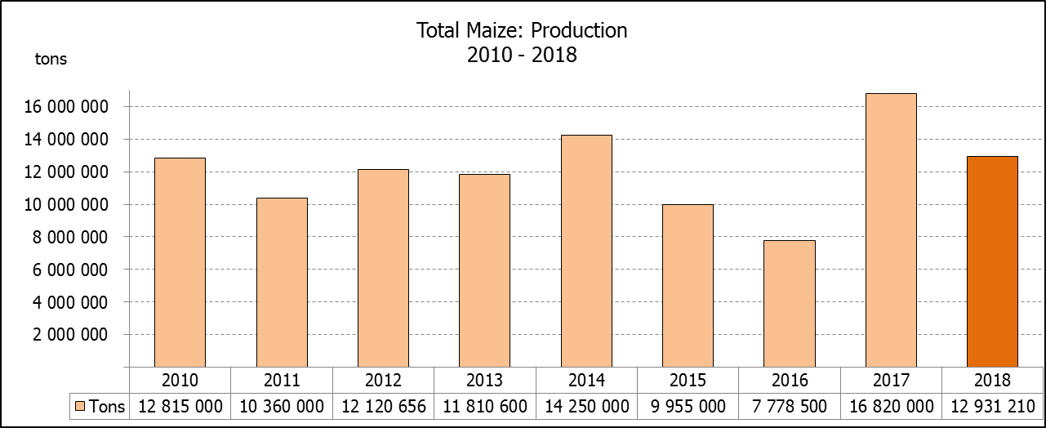

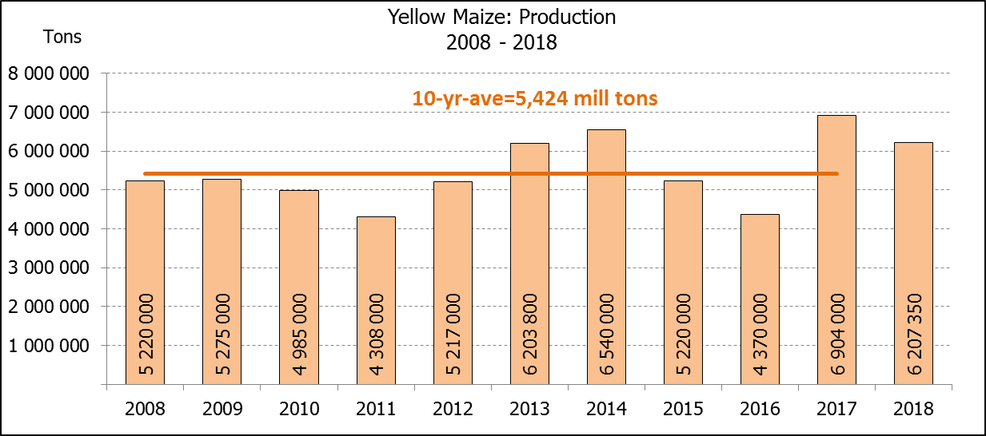

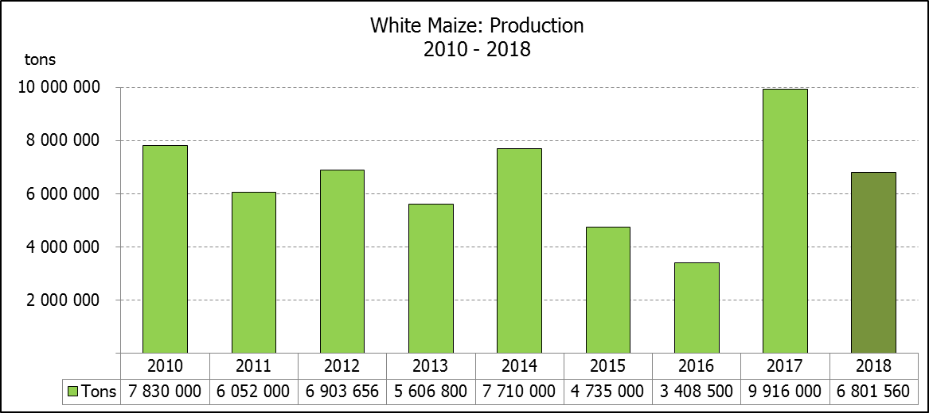

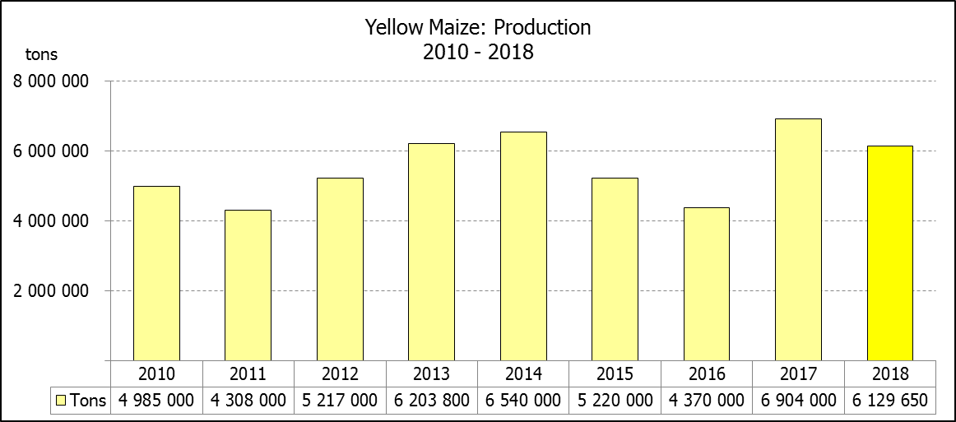

WHITE AND YELLOW MAIZE – AREA PLANTED AND FINAL PRODUCTION ESTIMATE: 2018
WIT- EN GEELMIELIES – OPPERVLAKTE EN FINALE PRODUKSIESKATTING: 2018

Provinsie/  Province | Area planted/  Oppervlakte beplant  2018 |  |  | Final estimate/  Finale skatting  2018 |  |  | Area planted/  Oppervlakte beplant  2017 |  |  | Final crop/  Finale oes  2017
Provinsie/  Province | White/  Wit  Ha | Yellow/  Geel  Ha | Total/  Totaal  Ha | White/  Wit  Tons | Yellow/  Geel  Tons | Total/  Totaal  Tons | White/  Wit  Ha | Yellow/  Geel  Ha | Total/  Totaal  Ha | White/  Wit  Tons | Yellow/  Geel  Tons | Total/  Totaal  Tons
Western Cape/Wes-Kaap | 0 | 3 750 | 3 750 | 0 | 33 750 | 33 750 | 200 | 2 000 | 2 200 | 2 000 | 20 000 | 22 000
Northern Cape/Noord-Kaap | 3 600 | 43 000 | 46 600 | 41 760 | 636 400 | 678 160 | 3 500 | 45 000 | 48 500 | 46 200 | 666 000 | 712 200
Free State/Vrystaat | 644 000 | 410 000 | 1 054 000 | 3 477 600 | 2 009 000 | 5 486 600 | 805 000 | 355 000 | 1 160 000 | 5 110 000 | 2 252 000 | 7 362 000
Eastern Cape/Oos-Kaap | 3 500 | 11 000 | 14 500 | 21 700 | 71 500 | 93 200 | 4 400 | 9 500 | 13 900 | 30 800 | 66 500 | 97 300
KwaZulu-Natal | 45 000 | 50 000 | 95 000 | 301 500 | 380 000 | 681 500 | 50 000 | 50 000 | 100 000 | 350 000 | 390 000 | 740 000
Mpumalanga | 140 000 | 340 000 | 480 000 | 840 000 | 2 040 000 | 2 880 000 | 160 000 | 330 000 | 490 000 | 1 088 000 | 2 342 500 | 3 430 500
Limpopo | 12 000 | 21 000 | 33 000 | 90 000 | 147 000 | 237 000 | 40 000 | 24 000 | 64 000 | 300 000 | 192 000 | 492 000
Gauteng | 50 000 | 62 000 | 112 000 | 290 000 | 372 000 | 662 000 | 60 000 | 60 000 | 120 000 | 390 000 | 414 000 | 804 000
North West/Noordwes | 370 000 | 110 000 | 480 000 | 1 739 000 | 440 000 | 2 179 000 | 520 000 | 110 000 | 630 000 | 2 599 000 | 561 000 | 3 160 000
Total/Totaal | 1 268 100 | 1 050 750 | 2 318 850 | 6 801 560 | 6 129 650 | 12 931 210 | 1 643 100 | 985 500 | 2 628 600 | 9 916 000 | 6 904 000 | 16 820 000

SUNFLOWER SEED – AREA PLANTED AND FINAL PRODUCTION ESTIMATE: 2018
SONNEBLOMSAAD – OPPERVLAKTE EN FINALE PRODUKSIESKATTING: 2018

Province/  Provinsie | Area planted/  Opp beplant  Ha | Final estimate/  Finale skatting  Tons | Area planted/  Opp beplant  Ha | Final crop/  Finale oes  Tons
Province/  Provinsie | 2018 | 2018 | 2017 | 2017
Western Cape/Wes-Kaap | 100 | 100 | - | -
Northern Cape/Noord-Kaap | 1 600 | 1 920 | 250 | 400
Free State/Vrystaat | 314 000 | 486 700 | 330 000 | 478 000
Eastern Cape/Oos-Kaap | - | - | - | -
KwaZulu-Natal | - | - | 300 | 300
Mpumalanga | 2 300 | 2 185 | 2 200 | 2 300
Limpopo | 45 000 | 36 000 | 90 000 | 85 500
Gauteng | 5 500 | 5 500 | 3 000 | 3 000
North West/Noordwes | 233 000 | 326 200 | 210 000 | 304 500
Total/Totaal | 601 500 | 858 605 | 635 750 | 874 000

SOYBEANS – AREA PLANTED AND FINAL PRODUCTION ESTIMATE: 2018
SOJABONE – OPPERVLAKTE EN FINALE PRODUKSIESKATTING: 2018

Province/  Provinsie | Area planted/  Opp beplant  Ha | Final estimate/  Finale skatting  Tons | Area planted/  Opp beplant  Ha | Final crop/  Finale oes  Tons
Province/  Provinsie | 2018 | 2018 | 2017 | 2017
Western Cape/Wes-Kaap | 800 | 1 200 | 700 | 1 050
Northern Cape/Noord-Kaap | 3 000 | 10 500 | 3 000 | 10 500
Free State/Vrystaat | 345 000 | 552 000 | 240 000 | 504 000
Eastern Cape/Oos-Kaap | 2 400 | 2 400 | 1 850 | 2 775
KwaZulu-Natal | 40 000 | 124 000 | 30 500 | 89 605
Mpumalanga | 310 000 | 682 000 | 241 000 | 554 300
Limpopo | 20 000 | 56 000 | 8 500 | 29 750
Gauteng | 30 000 | 61 500 | 25 400 | 71 120
North West/Noordwes | 36 000 | 61 200 | 23 000 | 52 900
Total/Totaal | 787 200 | 1 550 800 | 573 950 | 1 316 000
GROUNDNUTS – AREA PLANTED AND FINAL PRODUCTION ESTIMATE: 2018
GRONDBONE – OPPERVLAKTE EN FINALE PRODUKSIESKATTING: 2018

Province/  Provinsie | Area planted/  Opp beplant  Ha | Final estimate/  Finale skatting Tons | Area planted/  Opp beplant  Ha | Final crop/  Finale oes  Tons
Province/  Provinsie | 2018 | 2018 | 2017 | 2017
Western Cape/Wes-Kaap | - | - | - | -
Northern Cape/Noord-Kaap | 2 800 | 7 000 | 4 000 | 14 000
Free State/Vrystaat | 22 000 | 19 800 | 22 000 | 34 100
Eastern Cape/Oos-Kaap | - | - | - | -
KwaZulu-Natal | - | - | - | -
Mpumalanga | - | - | - | -
Limpopo | 3 500 | 7 350 | 3 000 | 4 800
Gauteng | - | - | - | -
North West/Noordwes | 28 000 | 19 600 | 27 000 | 39 150
Total/Totaal | 56 300 | 53 750 | 56 000 | 92 050

SORGHUM – AREA PLANTED AND FINAL PRODUCTION ESTIMATE: 2018
SORGHUM – OPPERVLAKTE EN FINALE PRODUKSIESKATTING: 2018

Province/  Provinsie | Area planted/  Opp beplant  Ha | Final estimate/  Finale skatting Tons | Area planted/  Opp beplant  Ha | Final crop/  Finale oes  Tons
Province/  Provinsie | 2018 | 2018 | 2017 | 2017
Western Cape/Wes-Kaap | - | - | - | -
Northern Cape/Noord-Kaap | - | - | - | -
Free State/Vrystaat | 6 300 | 22 680 | 7 700 | 24 640
Eastern Cape/Oos-Kaap | - | - | - | -
KwaZulu-Natal | 500 | 2 100 | 400 | 1 520
Mpumalanga | 7 500 | 40 125 | 12 000 | 62 400
Limpopo | 5 000 | 15 500 | 18 000 | 50 400
Gauteng | 1 500 | 4 650 | 750 | 2 400
North West/Noordwes | 8 000 | 24 800 | 3 500 | 10 640
Total/Totaal | 28 800 | 109 855 | 42 350 | 152 000
DRY BEANS – AREA PLANTED AND FINAL PRODUCTION ESTIMATE: 2018
DROëBONE – OPPERVLAKTE EN FINALE PRODUKSIESKATTING: 2018

Province/  Provinsie | Area planted/  Opp beplant  Ha | Final estimate/  Finale skatting Tons | Area planted/  Opp beplant  Ha | Final crop/  Finale oes  Tons
Province/  Provinsie | 2018 | 2018 | 2017 | 2017
Western Cape/Wes-Kaap | 20 | 30 | 100 | 150
Northern Cape/Noord-Kaap | 540 | 1 080 | 650 | 1 300
Free State/Vrystaat | 26 000 | 28 600 | 20 000 | 32 000
Eastern Cape/Oos-Kaap | 300 | 450 | 300 | 450
KwaZulu-Natal | 3 000 | 3 600 | 4 500 | 5 400
Mpumalanga | 7 000 | 9 800 | 5 500 | 8 525
Limpopo | 7 500 | 15 000 | 7 000 | 12 950
Gauteng | 1 000 | 1 200 | 1 500 | 2 250
North West/Noordwes | 8 000 | 9 600 | 5 500 | 5 500
Total/Totaal | 53 360 | 69 360 | 45 050 | 68 525

CONFIDENTIALITY ISSUES that CEC members are committed to adhere to on the day of the meeting
- Personal items such as laptops, handbags, cell phones, etc. are not allowed in the venue during the meeting
- No member is allowed to leave the meeting before 12:00 in order to prevent disclosure of the information
- The embargo time for the release of crop estimates information is 15:30
- No member is allowed to discuss crop estimates information with anyone other than a member of the Committee before the embargo time
- Only the Chairperson, or a member appointed by the Chairperson, may release the figures to the media
- Members must regard the detail of any information that was collected for and/or discussed during the meeting, as confidential
- Individual information received for crop estimate purposes is treated strictly confidential, and is not divulged for any other purposes

AREA ESTIMATE AND FINAL PRODUCTION ESTIMATE OF SUMMER CROPS (2018 PRODUCTION SEASON)/
OPPERVLAKTE- EN FINALE PRODUKSIESKATTING VIR SOMERGEWASSE (2018 PRODUKSIE-SEISOEN)
26 SEPTEMBER 2018

Summer field crops – 2018  Commercial maize: The size of the expected commercial maize crop has been set at 12,931 mill. tons, which is 2,09% or 276 100 tons less than the previous forecast of 13,207 mill. tons. The area estimate for maize is 2,319 mill. ha, while the expected yield is 5,58 t/ha.  The area estimate for white maize is 1,268 mill. ha and for yellow maize the area estimate is 1,051 mill. ha.  The production forecast of white maize is 6,802 mill. tons, which is 1,14% or 78 400 tons less than the 6,880 mill. tons of the previous forecast. The yield for white maize is 5,36 t/ha. In the case of yellow maize the production forecast is 6,130 mill. tons, which is 3,12% or 197 700 tons less than the 6,327 mill. tons of the previous forecast. The yield for yellow maize is 5,83 t/ha.  Sunflower seed: The production forecast for sunflower seed remained unchanged at 858 605 tons, with an estimated planted area of 601 500 ha and an expected yield of 1,43 t/ha.  Other crops: The production forecast for soybeans also remained unchanged at 1,551 mill. tons, with an estimated planted area of 787 200 ha and an expected yield of 1,97 t/ha.  The expected groundnut crop was increased by 3,37% or 1 750 tons to 53 750 tons. The area estimate is 56 300 ha and the expected yield is 0,95 t/ha.  The production forecast for sorghum was also increased by 4,50% or 4 735 tons to 109 855 tons. The area estimate for sorghum is 28 800 ha. The expected yield is 3,81 t/ha.  In the case of dry beans, the production forecast is 69 360 tons, which is 5,72% or 3 750 tons more than the previous forecast of 65 610 tons. The area estimate of dry beans is 53 360 ha, with an expected yield of 1,30 t/ha.  Please note that the ‘intentions of farmers’ to plant summer grain crops for 2019 will be released on 25 October 2018. |  | Somergewasse – 2018  Kommersiële mielies: Die grootte van die verwagte kommersiële mielie-oes is op 12,931 milj. ton gestel, wat 2,09% of 276 100 ton minder is as die vorige skatting van 13,207 milj. ton. Die skatting van die oppervlakte onder mielies is 2,319 milj. ha, terwyl die verwagte opbrengs 5,58 t/ha is.  Die oppervlak onder witmielies is 1,268 milj. ha en vir geelmielies is die oppervlak 1,051 milj. ha.  Die produksieskatting van witmielies is 6,802 milj. ton, wat 1,14% of 78 400 ton minder is as die 6,880 milj. ton van die vorige skatting. Die opbrengs van witmielies is 5,36 t/ha. In die geval van geelmielies is die produksieskatting 6,130 milj. ton, wat 3,12% of 197 700 ton minder is as die 6,327 milj. ton van die vorige skatting. Die opbrengs van geelmielies is 5,83 t/ha.  Sonneblomsaad: Die produksieskatting vir sonneblomsaad is overanderd gelaat op 858 605 ton, met ’n geskatte oppervlakte van 601 500 ha en ‘n verwagte opbrengs van 1,43 t/ha.  Ander gewasse: Die produksieskatting van sojabone is ook onveranderd gelaat op 1,551 milj. ton met ’n geskatte oppervlakte van 787 200 ha en ‘n verwagte opbrengs van 1,97 t/ha.  Die verwagte grondbone-oes is verhoog met 3,37% of 1 750 ton na 53 750 ton. Die oppervlakteskatting is 56 300 ha, terwyl die verwagte opbrengs 0,95 t/ha is.  Die produksieskatting van sorghum is ook opwaarts aangepas met 4,50% of 4 735 ton na 109 855 ton. Die oppervlakte beplant met sorghum is 28 800 ha. Die verwagte opbrengs is 3,81 t/ha.  In die geval van droëbone is die produksieskatting 69 360 ton, wat 5,72% of 3 750 ton meer is as die vorige skatting van 65 610 ton. Die oppervlakte beplant met droëbone is 53 360 ha, en die verwagte opbrengs is 1,30 t/ha.  Neem asseblief kennis dat die ‘voorneme van produsente om somergraangewasse te plant’ vir 2019, op 25 Oktober 2018 vrygestel sal word.

The non-commercial agricultural sectors’ production estimate for maize for 2018 is hereby released. /
Hiermee word die nie-kommersiële landbou-sektor se produksieskatting vir mielies vir 2018 vrygestel.

NON-COMMERCIAL MAIZE – PRELIMINARY AREA PLANTED AND PRODUCTION ESTIMATE: 2018
NIE-KOMMERSIëLE MIELIES – VOORLOPIGE OPPERVLAKTE- EN PRODUKSIESKATTING: 2018
CROP/GEWAS | Area planted/  Opp beplant  2018 | Production/  Produksie  2018 | Area planted/  Opp beplant  2017 | Final crop/  Finale oes  2017 | 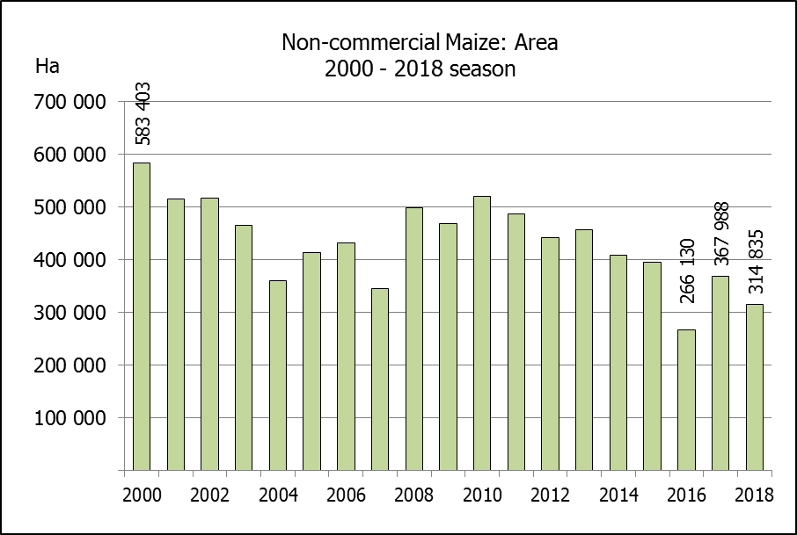  Change/  Verandering
CROP/GEWAS | Ha | Tons | Ha | Tons | %
CROP/GEWAS | (A) | (B) | (C) | (D) | (B) ÷ (D)
Non-commercial agriculture/Nie-kommersiële landbou:
White maize/Witmielies | 236 644 | 414 162 | 248 500 | 463 600 | -10,66
Yellow maize/Geelmielies | 78 191 | 179 813 | 118 150 | 267 400 | -32,76
Maize/Mielies | 314 835 | 593 975 | 366 650 | 731 000 | -18,74
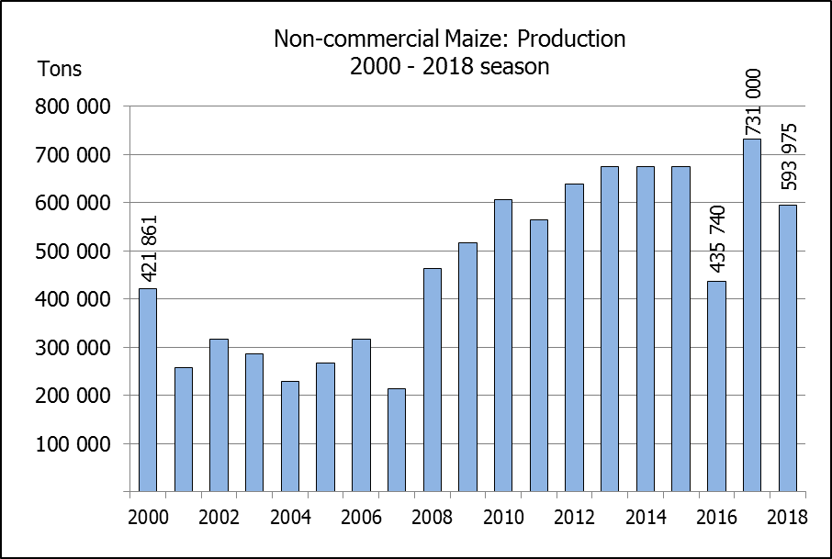
The preliminary area planted to maize in the non-commercial agricultural sector is estimated at 314 835 ha, which represents a decrease of 14,13%, compared to the 366 650 ha of the previous season. The expected maize crop for this sector is 593 975 tons, which is 18,74% less than the 731 000 tons of last season. It is important to note that about 40% of the maize produced in the non-commercial sector, is planted in the Eastern Cape.
Die voorlopige oppervlakte beplant met mielies in die nie-kommersiële landbou-sektor word geskat op 314 835 ha, wat ‘n afname van 14,13 % verteenwoordig in vergelyking met die 366 650 ha van die vorige seisoen. Die verwagte mielie-oes van dié sektor is 593 975 ton, wat 18,74% minder is as die 731 000 ton van die vorige seisoen. Dit is belangrik om daarop te let dat ongeveer 40% van die mielies wat geproduseer word in die nie-kommersiële sektor, in die Oos-Kaap geplant word.

The revised area estimate and second production forecast for winter cereals for the 2018 is hereby released. /
Hiermee word die hersiene oppervlakte- en tweede produksieskatting vir wintergewasse vir 2018 vrygestel.

WINTER CEREALS – REVISED AREA PLANTED AND SECOND PRODUCTION FORECAST: 2018 PRODUCTION SEASON
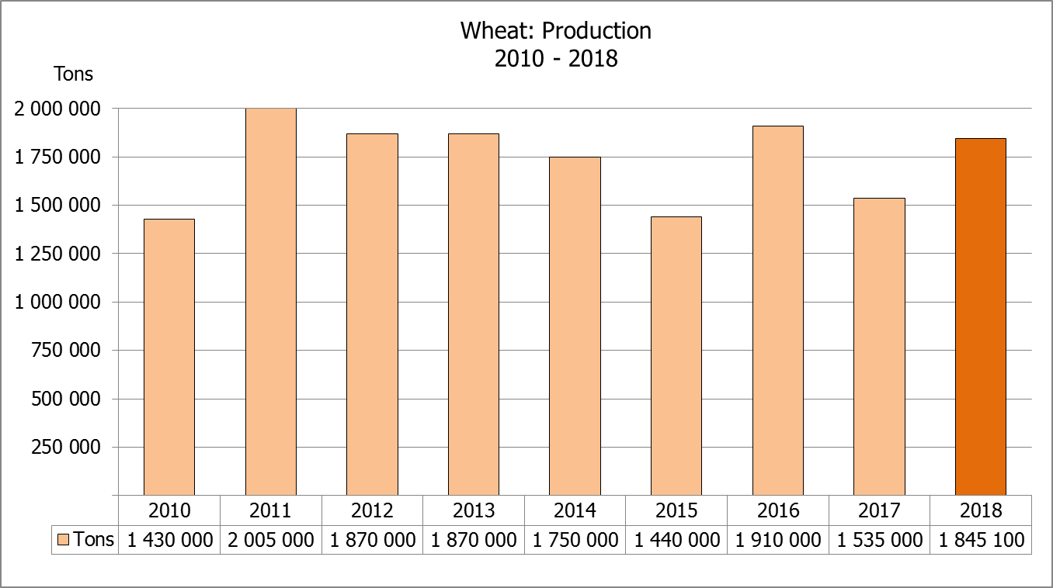
WINTERGEWASSE – HERSIENE OPPERVLAKTE- EN TWEEDE PRODUKSIESKATTING: 2018-PRODUKSIESEISOEN
CROP/GEWAS | Area planted/  Opp beplant  2018 | 2nd forecast/  2de skatting  2018 | 1st forecast/  1ste skatting  2018 | Area planted/  Opp beplant  2017 | Final crop/  Finale oes  2017 | Change/  Verandering
CROP/GEWAS | Ha | Tons | Tons | Ha | Tons | %
CROP/GEWAS | (A) | (B) | (C) | (D) | (E) | (B) ÷ (C)
Commercial/Kommersieel:
Wheat/Koring | 508 350 | 1 845 100 | 1 808 050 | 491 600 | 1 535 000 | +2,05
Malting barley/Moutgars | 119 000 | 390 840 | 390 840 | 91 380 | 307 000 | -
Canola/Kanola | 77 000 | 111 650 | 112 000 | 84 000 | 93 500 | 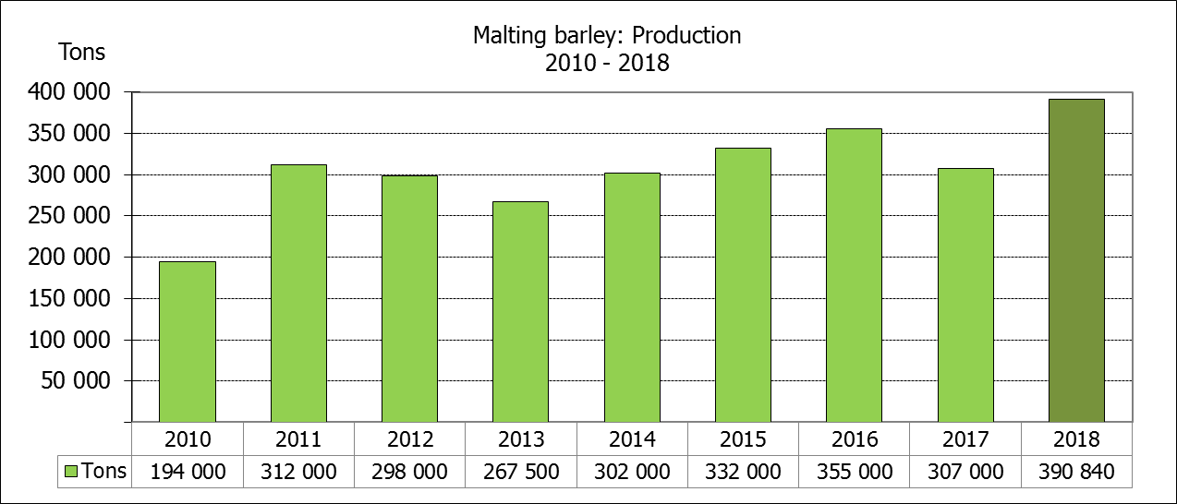  -0,31
* Note: Estimate is for calendar year, e.g. production season 2018/19 = 2018
* Nota: Skatting is vir kalenderjaar, bv. produksie-seisoen 2018/19 = 2018

WHEAT – REVISED AREA PLANTED AND SECOND PRODUCTION FORECAST: 2018
KORING – HERSIENE OPPERVLAKTE- EN TWEEDE PRODUKSIESKATTING: 2018
Province/  Provinsie | Area planted/  Opp beplant  Ha | 2nd forecast/  2de skatting  Tons | Area planted/  Opp beplant  Ha | Final crop/  Finale oes  Tons
Province/  Provinsie | 2018 | 2018 | 2017 | 2017
Western Cape/Wes-Kaap | 318 000 | 890 400 | 326 000 | 586 800
Northern Cape/Noord-Kaap | 38 000 | 292 600 | 38 000 | 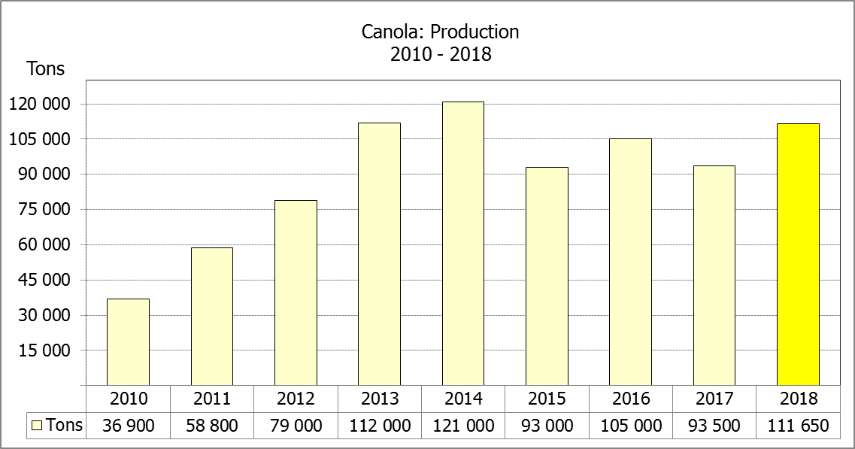  311 650
Free State/Vrystaat | 105 000 | 367 500 | 80 000 | 336 000
Eastern Cape/Oos-Kaap | 1 650 | 10 725 | 1 900 | 9 500
KwaZulu-Natal | 7 000 | 43 400 | 7 500 | 45 750
Mpumalanga | 3 500 | 21 875 | 4 000 | 25 400
Limpopo | 20 000 | 124 000 | 20 000 | 132 000
Gauteng | 1 200 | 7 800 | 700 | 4 200
North West/Noordwes | 14 000 | 86 800 | 13 500 | 83 700
Total/Totaal | 508 350 | 1 845 100 | 491 600 | 1 535 000

REVISED AREA ESTIMATE AND SECOND PRODUCTION FORECAST OF WINTER CROPS (2018) /
HERSIENE OPPERVLAKTEKSKATTING EN TWEEDE PRODUKSIESKATTING VAN WINTERGEWASSE (2018)
26 SEPTEMBER 2018
Winter cereal crops - 2018 production season  Wheat: The expected commercial production of wheat is 1,845 mill. tons, which is 2,05% or 37 050 tons more than the previous forecast of 1,808 mill. tons, whilst the expected yield is 3,63 t/ha.  The expected production in the Western Cape is 890 400 tons (48%), in the Free State 367 500 tons (20%) and in the Northern Cape 292 600 tons (16%).  The area estimate for wheat remained unchanged at 508 350 ha. An estimated 318 000 ha or 63% is planted in the Western Cape, 105 000 ha or 21% in the Free State and 38 000 ha or 7% in the Northern Cape.  Other crops: The production forecast for malting barley remained unchanged at 390 840 tons. The area planted is estimated at 119 000 ha, while the expected yield is 3,28 t/ha.  The expected canola crop is 111 650 tons, which is 0,31% or 350 tons less than the previous forecast of 112 000 tons. The area estimate for canola was revised downwards by 3 000 ha to 77 000 ha and the expected yield is 1,45 t/ha.  Please note that the third production forecast for winter cereals for 2018 will be released on 25 October 2018. |  | Wintergewasse - 2018 produksie-seisoen  Koring: Die verwagte kommersiële produksie vir koring is 1,845 milj. ton, wat 2,05% of 37 050 ton meer is as die vorige skatting van 1,808 milj. ton, terwyl die verwagte opbrengs 3,63 t/ha is.  Die verwagte produksie in die Wes-Kaap is 890 400 ton (48%), in die Vrystaat 367 500 ton (20%) en in die Noord-Kaap 292 600 ton (16%).  Die oppervlakteskatting vir koring is onveranderd gelaat op 508 350 ha. Die beraamde oppervlakte geplant in die Wes-Kaap is 318 000 ha of 63%, die Vrystaat is 105 000 ha of 21% en 38 000 ha of 7% is in die Noord-Kaap.  Ander gewasse: Die produksieskatting vir moutgars is onveranderd gelaat op 390 840 ton. Die oppervlakte beplant word beraam op 119 000 ha, terwyl die verwagte opbrengs 3,28 t/ha beloop.  Die verwagte kanola-oes is 111 650 ton, wat 0,31% of 350 ton minder is as die vorige skatting van 112 000 ton. Die oppervlakteskatting vir kanola is afwaarts aangepas met 3 000 ha na 77 000 ha en die verwagte opbrengs is 1,45 t/ha.  Neem asseblief kennis dat die derde produksieskatting vir wintergewasse vir 2018 op 25 Oktober 2018 vrygestel sal word.

Information is available on the internet at http://www.daff.gov.za/links/crop estimates or http://www.sagis.org.za, as from 15:30 on the date of the relevant meeting of the Crop Estimates Committee. |  | Inligting is beskikbaar op die internet by http://www.daff.gov.za/links/crop estimates of by http://www.sagis.org.za, vanaf 15:30 op die dag van die toepaslike vergadering van die Oesskattingskomitee.

