 | crop estimates committee | 
 | oesskattingskomitee
From/Van: M. Ellen Matsei
Tel: 012 319 8454  Fax/Faks: 012 319 8031  E-mail/E-pos: DAS@daff.gov.za
Web page/Webblad: www.daff.gov.za/statistics and economic reports or www.sagis.org.za/CEC: Crop Estimates
EMBARGO: 15:30

The area planted estimate and final production estimate for summer crops for 2017 is hereby released.
Hiermee word die oppervlakte- en finale produksieskatting vir somergewasse vir 2017 vrygestel.

SUMMER CROPS – AREA PLANTED AND FINAL PRODUCTION ESTIMATE: 2017
SOMERGEWASSE – OPPERVLAKTE- EN FINALE PRODUKSIESKATTING: 2017
CROP/GEWAS | Area planted/  Opp beplant  2017 | Final estimate/  Finale skatting  2017 | 7th forecast/  7de skatting  2017 | Area planted/  Opp beplant  2016 | Final crop/  Finale oes  2016 | Change/  Verandering
CROP/GEWAS | Ha | Tons | Tons | Ha | Tons | %
CROP/GEWAS | (A) | (B) | (C) | (D) | (E) | (B) ÷ (C)
Commercial/Kommersieël
White maize/Witmielies | 1 643 100 | 9 892 750 | 9 653 550 | 1 014 750 | 3 408 500 | +2,48
Yellow maize/Geelmielies | 985 500 | 6 851 250 | 6 759 925 | 932 000 | 4 370 000 | +1,35
Total Maize/Totaal Mielies | 2 628 600 | 16 744 000 | 16 413 475 | 1 946 750 | 7 778 500 | +2,01
Sunflower seed/Sonneblomsaad | 635 750 | 874 595 | 870 095 | 718 500 | 755 000 | +0,52
Soybeans/Sojabone | 573 950 | 1 316 370 | 1 316 370 | 502 800 | 742 000 | -
Groundnuts/Grondbone | 56 000 | 92 050 | 90 550 | 22 600 | 17 680 | +1.66
Sorghum | 42 350 | 151 335 | 151 335 | 48 500 | 70 500 | -
Dry beans/Droëbone | 45 050 | 68 525 | 68 525 | 34 400 | 35 445 | -
Non-Commercial Maize/Nie-Kommersiële Mielies
Total Maize/Totaal Mielies | 366 650 | 731 000 | 731 000 | 266 130 | 435 740 | -
Maize/Mielies: Commercial/Kommersieël + Non-Commercial/Nie-Kommersieël
Total Maize RSA/Totaal Mielies RSA | 2 995 250 | 17 475 000 | 17 144 475 | 2 212 880 | 8 214 240 | +1,93
Note: Estimate is for calendar year, e.g. production season 2016/17 = 2017
Nota: Skatting is vir kalenderjaar, bv. produksie-seisoen 2016/17 = 2017

The Crop Estimates Committee comprises officials of the following institutions:
Department of Agriculture, Forestry and Fisheries; Provincial Departments of Agriculture; various ARC-Institutes (Soil, Climate and Water; Small Grains Institute;
and Grain Crops Institute); BFAP and Statistics SA.
28 September 2017
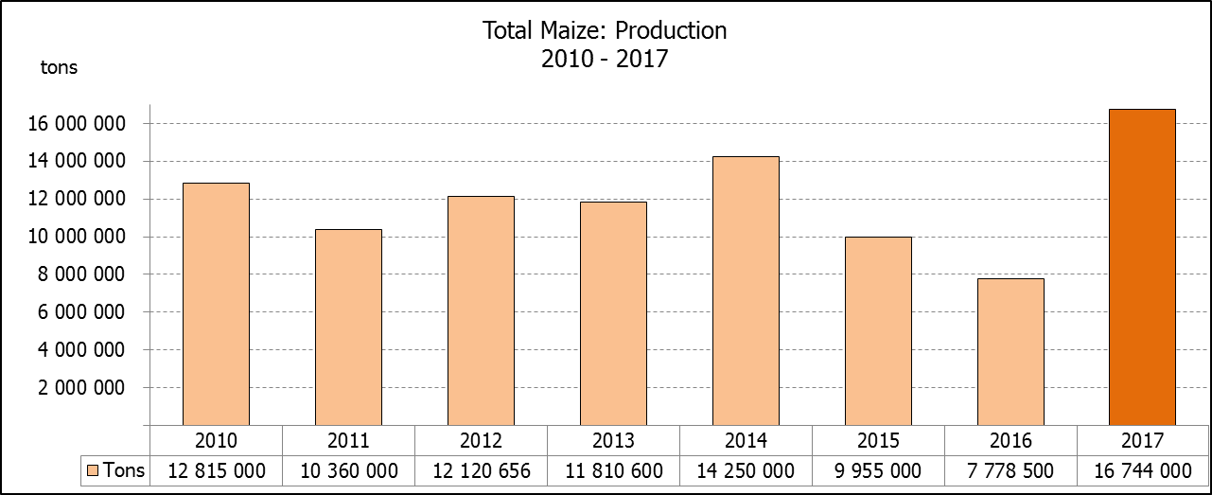

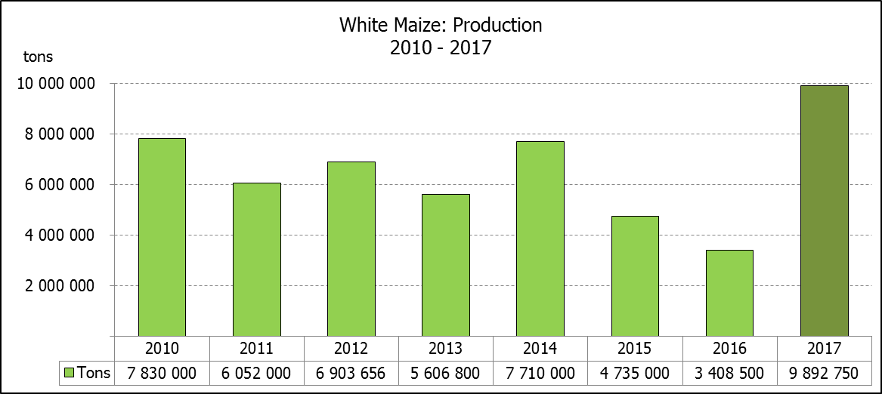

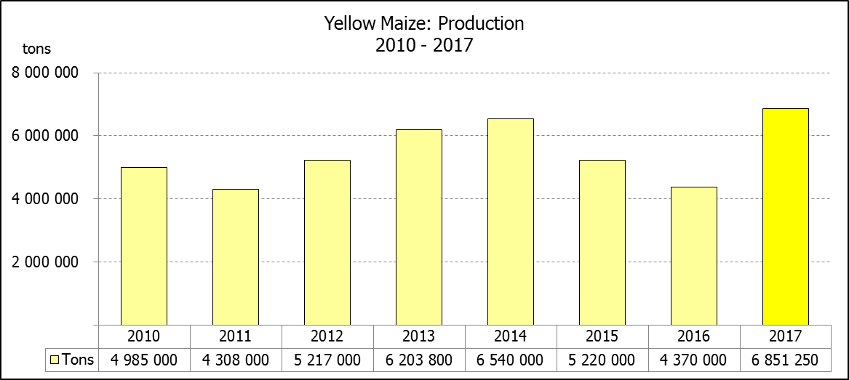

WHITE AND YELLOW MAIZE – AREA PLANTED AND FINAL PRODUCTION ESTIMATE: 2017
WIT- EN GEELMIELIES – OPPERVLAKTE EN FINALE PRODUKSIESKATTING: 2017

Provinsie/  Province | Area planted/  Oppervlakte beplant  2017 |  |  | Final estimate/  Finale skatting  2017 |  |  | Area planted/  Oppervlakte beplant  2016 |  |  | Final crop/  Finale oes  2016
Provinsie/  Province | White/  Wit  Ha | Yellow/  Geel  Ha | Total/  Totaal  Ha | White/  Wit  Tons | Yellow/  Geel  Tons | Total/  Totaal  Tons | White/  Wit  Ha | Yellow/  Geel  Ha | Total/  Totaal  Ha | White/  Wit  Tons | Yellow/  Geel  Tons | Total/  Totaal  Tons
Western Cape/Wes-Kaap | 200 | 2 000 | 2 200 | 2 000 | 20 000 | 22 000 | 500 | 4 000 | 4 500 | 5 000 | 40 000 | 45 000
Northern Cape/Noord-Kaap | 3 500 | 45 000 | 48 500 | 46 200 | 657 000 | 703 200 | 3 750 | 50 000 | 53 750 | 35 000 | 675 000 | 710 000
Free State/Vrystaat | 805 000 | 355 000 | 1 160 000 | 5 111 750 | 2 218 750 | 7 330 500 | 390 000 | 310 000 | 700 000 | 1 190 500 | 1 023 000 | 2 213 500
Eastern Cape/Oos-Kaap | 4 400 | 9 500 | 13 900 | 30 800 | 66 500 | 97 300 | 2 000 | 12 000 | 14 000 | 10 000 | 66 000 | 76 000
KwaZulu-Natal | 50 000 | 50 000 | 100 000 | 350 000 | 385 000 | 735 000 | 38 000 | 48 000 | 86 000 | 215 000 | 307 000 | 522 000
Mpumalanga | 160 000 | 330 000 | 490 000 | 1 088 000 | 2 343 000 | 3 431 000 | 160 000 | 330 000 | 490 000 | 752 000 | 1 567 000 | 2 319 000
Limpopo | 40 000 | 24 000 | 64 000 | 300 000 | 192 000 | 492 000 | 31 500 | 22 000 | 53 500 | 178 000 | 132 000 | 310 000
Gauteng | 60 000 | 60 000 | 120 000 | 390 000 | 408 000 | 798 000 | 49 000 | 56 000 | 105 000 | 207 000 | 235 000 | 442 000
North West/Noordwes | 520 000 | 110 000 | 630 000 | 2 574 000 | 561 000 | 3 135 000 | 340 000 | 100 000 | 440 000 | 816 000 | 325 000 | 1 141 000
Total/Totaal | 1 643 100 | 985 500 | 2 628 600 | 9 892 750 | 6 851 250 | 16 744 000 | 1 014 750 | 932 000 | 1 946 750 | 3 408 500 | 4 370 000 | 7 778 500

SUNFLOWER SEED – AREA PLANTED AND FINAL PRODUCTION ESTIMATE: 2017
SONNEBLOMSAAD – OPPERVLAKTE EN FINALE PRODUKSIESKATTING: 2017

Province/  Provinsie | Area planted/  Opp beplant  Ha | Final estimate/  Finale skatting  Tons | Area planted/  Opp beplant  Ha | Final crop/  Finale oes  Tons
Province/  Provinsie | 2017 | 2017 | 2016 | 2016
Western Cape/Wes-Kaap | - | - | - | -
Northern Cape/Noord-Kaap | 250 | 375 | 500 | 600
Free State/Vrystaat | 330 000 | 478 500 | 400 000 | 440 000
Eastern Cape/Oos-Kaap | - | - | - | -
KwaZulu-Natal | 300 | 300 | - | -
Mpumalanga | 2 200 | 2 420 | 4 000 | 4 400
Limpopo | 90 000 | 85 500 | 65 000 | 48 750
Gauteng | 3 000 | 3 000 | 4 000 | 4 000
North West/Noordwes | 210 000 | 304 500 | 245 000 | 257 250
Total/Totaal | 635 750 | 874 595 | 718 500 | 755 000

SOYBEANS – AREA PLANTED AND FINAL PRODUCTION ESTIMATE: 2017
SOJABONE – OPPERVLAKTE EN FINALE PRODUKSIESKATTING: 2017

Province/  Provinsie | Area planted/  Opp beplant  Ha | Final estimate/  Finale skatting  Tons | Area planted/  Opp beplant  Ha | Final crop/  Finale oes  Tons
Province/  Provinsie | 2017 | 2017 | 2016 | 2016
Western Cape/Wes-Kaap | 700 | 1 050 | 800 | 1 200
Northern Cape/Noord-Kaap | 3 000 | 10 500 | 4 000 | 13 600
Free State/Vrystaat | 240 000 | 504 000 | 174 000 | 148 000
Eastern Cape/Oos-Kaap | 1 850 | 2 775 | 1 500 | 2 100
KwaZulu-Natal | 30 500 | 89 975 | 28 000 | 66 000
Mpumalanga | 241 000 | 554 300 | 240 000 | 408 000
Limpopo | 8 500 | 29 750 | 16 000 | 38 400
Gauteng | 25 400 | 71 120 | 23 000 | 50 600
North West/Noordwes | 23 000 | 52 900 | 15 500 | 14 100
Total/Totaal | 573 950 | 1 316 370 | 502 800 | 742 000
GROUNDNUTS – AREA PLANTED AND FINAL PRODUCTION ESTIMATE: 2017
GRONDBONE – OPPERVLAKTE EN FINALE PRODUKSIESKATTING: 2017

Province/  Provinsie | Area planted/  Opp beplant  Ha | Final estimate/  Finale skatting  Tons | Area planted/  Opp beplant  Ha | Final crop/  Finale oes  Tons
Province/  Provinsie | 2017 | 2017 | 2016 | 2016
Western Cape/Wes-Kaap | - | - | - | -
Northern Cape/Noord-Kaap | 4 000 | 14 000 | 5 000 | 10 000
Free State/Vrystaat | 22 000 | 34 100 | 6 500 | 2 920
Eastern Cape/Oos-Kaap | - | - | - | -
KwaZulu-Natal | - | - | - | -
Mpumalanga | - | - | - | -
Limpopo | 3 000 | 4 800 | 1 600 | 1 440
Gauteng | - | - | - | -
North West/Noordwes | 27 000 | 39 150 | 9 500 | 3 320
Total/Totaal | 56 000 | 92 050 | 22 600 | 17 680

SORGHUM – AREA PLANTED AND FINAL PRODUCTION ESTIMATE: 2017
SORGHUM – OPPERVLAKTE EN FINALE PRODUKSIESKATTING: 2017

Province/  Provinsie | Area planted/  Opp beplant  Ha | Final estimate/  Finale skatting  Tons | Area planted/  Opp beplant  Ha | Final crop/  Finale oes  Tons
Province/  Provinsie | 2017 | 2017 | 2016 | 2016
Western Cape/Wes-Kaap | - | - | - | -
Northern Cape/Noord-Kaap | - | - | - | -
Free State/Vrystaat | 7 700 | 24 640 | 28 000 | 24 150
Eastern Cape/Oos-Kaap | - | - | - | -
KwaZulu-Natal | 400 | 1 520 | 500 | 1 650
Mpumalanga | 12 000 | 62 400 | 10 000 | 32 500
Limpopo | 18 000 | 50 400 | 7 000 | 9 800
Gauteng | 750 | 2 400 | - | -
North West/Noordwes | 3 500 | 9 975 | 3 000 | 2 400
Total/Totaal | 42 350 | 151 335 | 48 500 | 70 500

DRY BEANS – AREA PLANTED AND FINAL PRODUCTION ESTIMATE: 2017
DROëBONE – OPPERVLAKTE EN FINALE PRODUKSIESKATTING: 2017

Province/  Provinsie | Area planted/  Opp beplant  Ha | Final estimate/  Finale skatting  Tons | Area planted/  Opp beplant  Ha | Final crop/  Finale oes  Tons
Province/  Provinsie | 2017 | 2017 | 2016 | 2016
Western Cape/Wes-Kaap | 100 | 150 | 100 | 150
Northern Cape/Noord-Kaap | 650 | 1 300 | 350 | 630
Free State/Vrystaat | 20 000 | 32 000 | 17 000 | 17 000
Eastern Cape/Oos-Kaap | 300 | 450 | 250 | 375
KwaZulu-Natal | 4 500 | 5 400 | 2 200 | 2 640
Mpumalanga | 5 500 | 8 525 | 6 000 | 6 000
Limpopo | 7 000 | 12 950 | 3 000 | 3 750
Gauteng | 1 500 | 2 250 | 2 500 | 2 500
North West/Noordwes | 5 500 | 5 500 | 3 000 | 2 400
Total/Totaal | 45 050 | 68 525 | 34 400 | 35 445

CONFIDENTIALITY ISSUES that CEC members are committed to adhere to on the day of the meeting
- Personal items such as laptops, handbags, cell phones, etc. are not allowed in the venue during the meeting
- No member is allowed to leave the meeting before 12:00 in order to prevent disclosure of the information
- The embargo time for the release of crop estimates information is 15:30
- No member is allowed to discuss crop estimates information with anyone other than a member of the Committee before the embargo time
- Only the Chairperson, or a member appointed by the Chairperson, may release the figures to the media
- Members must regard the detail of any information that was collected for and/or discussed during the meeting, as confidential
- Individual information received for crop estimate purposes is treated strictly confidential, and is not divulged for any other purposes

AREA ESTIMATE AND FINAL PRODUCTION ESTIMATE OF SUMMER CROPS (2017 PRODUCTION SEASON)/
OPPERVLAKTE- EN FINALE PRODUKSIESKATTING VIR SOMERGEWASSE (2017 PRODUKSIE-SEISOEN)
28 SEPTEMBER 2017

Summer field crops – 2017  Commercial maize: The size of the expected commercial maize crop has been set at 16,744 mill. tons, which is 2,01 % or 330 525 tons more than the previous forecast of 16,413 mill. tons. The area estimate for maize is 2,629 mill. ha, while the expected yield is 6,37 t/ha.  The three main maize producing areas, namely the Free State, Mpumalanga and North West provinces produce 83% of the 2017 crop.  The area estimate for white maize is 1,643 mill. ha and for yellow maize the area estimate is 985 500 ha.  The production forecast of white maize is 9,893 mill. tons, which is 2,48 % or 239 200 tons more than the 9,654 mill. tons of the previous forecast. The yield for white maize is 6,02 t/ha. In the case of yellow maize the production forecast is 6,851 mill. tons, which is 1,35% or 91 325 tons more than the 6,760 mill. tons of the previous forecast. The yield for yellow maize is 6,95 t/ha.  Sunflower seed: The production forecast for sunflower seed increased slightly by 0,52% or 4 500 tons and amounts to 874 595 tons. The area estimate for sunflower seed is 635 750 ha, while the expected yield is 1,38 t/ha.  Other crops: The production forecast for soybeans remained unchanged at 1,316 mill. tons. The estimated area planted to soybeans is 573 950 ha and the expected yield is 2,29 t/ha.  The expected groundnut crop increased by 1,66% or 1 500 tons and is 92 050 tons. The area estimate is 56 000 ha and the expected yield is 1,64 t/ha.  The production forecast for sorghum also remained unchanged at 151 335 tons, whilst the area estimate for sorghum is 42 350 ha. The expected yield is 3,57 t/ha.  In the case of dry beans, the production forecast is 68 525 tons, the same as the previous forecast. The area estimate of dry beans is 45 050 ha, with an expected yield of 1,52 t/ha.  Please note that the ‘intentions of farmers’ to plant summer grain crops for 2018 will be released on 26 October 2017. |  | Somergewasse – 2017  Kommersiële mielies: Die grootte van die verwagte kommersiële mielie-oes is op 16,744 milj. ton gestel, wat 2,01% of 330 525 ton meer is as die vorige skatting van 16,413 milj. ton. Die skatting van die oppervlakte onder mielies is 2,629 milj. ha, terwyl die verwagte opbrengs 6,37 t/ha is.  Die drie belangrikste mielieproduserende gebiede, nl. die Vrystaat, Mpumalanga en Noordwes provinsies produseer 83% van die 2017-oes.  Die oppervlak onder witmielies is 1,643 milj. ha en vir geelmielies is die oppervlak 985 500 ha.  Die produksieskatting van witmielies is 9,893 milj. ton, wat 2,48% of 239 200 ton meer is as die 9,654 milj. ton van die vorige skatting. Die opbrengs van witmielies is 6,02 t/ha. In die geval van geelmielies is die produksieskatting 6,851 milj. ton, wat 1,35% of 91 325 ton meer is as die 6,760 milj. ton van die vorige skatting. Die opbrengs van geelmielies is 6,95 t/ha.  Sonneblomsaad: Die produksieskatting vir sonneblomsaad het effens gestyg met 0,52 % of 4 500 ton en beloop 874 595 ton. Die oppervlakteskatting vir sonneblomsaad is 635 750 ha, terwyl die verwagte opbrengs 1,38 t/ha is.  Ander gewasse: Die produksieskatting van sojabone is onveranderd gelaat op 1,316 milj. ton. Die geskatte oppervlakte beplant met sojabone is 573 950 ha en die verwagte opbrengs is 2,29 t/ha.  Die verwagte grondbone-oes is met 1,66% of 1 500 ton verhoog en beloop 92 050 ton. Die oppervlakteskatting is 56 000 ha, terwyl die verwagte opbrengs 1,64 t/ha is.  Die produksieskatting van sorghum is ook onveranderd gelaat op 151 335 ton, terwyl die oppervlakteskatting vir sorghum 42 350 ha is. Die verwagte opbrengs is 3,57 t/ha.  In die geval van droëbone is die produksieskatting 68 525 ton, dieselfde as die vorige skatting. Die oppervlakte beplant met droëbone is 45 050 ha, en die verwagte opbrengs is 1,52 t/ha.  Neem asseblief kennis dat die ‘voorneme van produsente om somergraangewasse te plant’ vir 2018, op 26 Oktober 2017 vrygestel sal word.

The non-commercial agricultural sectors’ production estimate for maize for 2017 is hereby released. /
Hiermee word die nie-kommersiële landbou-sektor se produksieskatting vir mielies vir 2017 vrygestel.

NON-COMMERCIAL MAIZE – AREA PLANTED AND PRODUCTION ESTIMATE: 2017
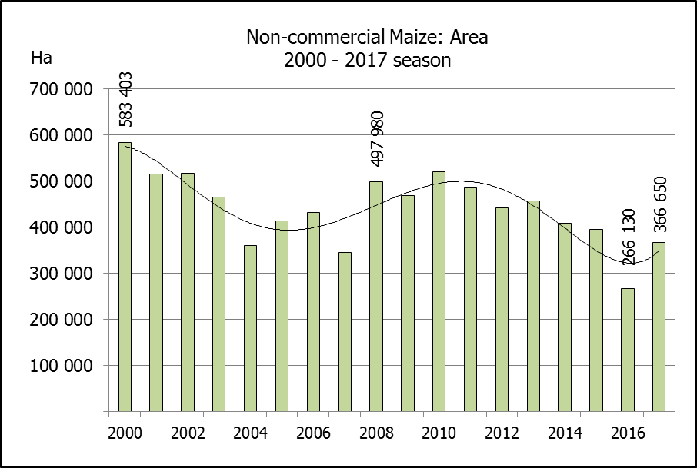
NIE-KOMMERSIëLE MIELIES – OPPERVLAKTE- EN PRODUKSIESKATTING: 2017
CROP/GEWAS | Area planted/  Opp beplant  2017 | Production/  Produksie  2017 | Area planted/  Opp beplant  2016 | Final crop/  Finale oes  2016 | Change/  Verandering
CROP/GEWAS | Ha | Tons | Ha | Tons | %
CROP/GEWAS | (A) | (B) | (C) | (D) | (B) ÷ (D)
Non-commercial agriculture/Nie-kommersiële landbou:
White maize/Witmielies | 248 500 | 463 600 | 191 225 | 286 175 | +62,00
Yellow maize/Geelmielies | 118 150 | 267 400 | 74 905 | 149 565 | +78,79
Maize/Mielies | 366 650 | 731 000 | 266 130 | 435 740 | +67,76
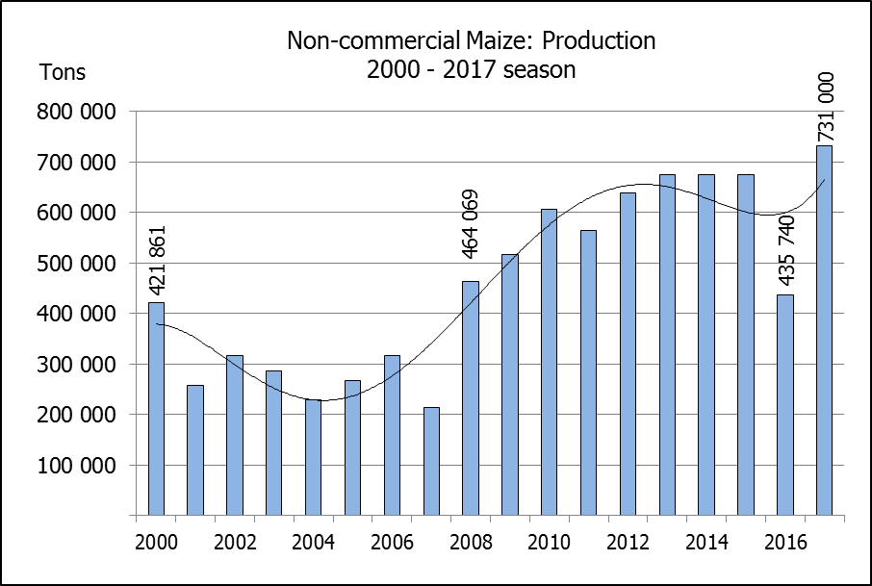
The area planted to maize in the non-commercial agricultural sector is estimated at 366 650 ha, which represents an increase of 37,77%, compared to the 266 130 ha of the previous season. The expected maize crop for this sector is 731 000 tons, which is 67,76% more than the 435 740 tons of last season. It is important to note that about 64% of the maize produced in the non-commercial sector, is planted in the Eastern Cape.
Die oppervlakte beplant met mielies in die nie-kommersiële landbou-sektor word geskat op 366 650 ha, wat ‘n toename van 37,77 % verteenwoordig in vergelyking met die 266 130 ha van die vorige seisoen. Die verwagte mielie-oes van dié sektor is 731 000 ton, wat 67,76% meer is as die 435 740 ton van die vorige seisoen. Dit is belangrik om daarop te let dat ongeveer 64% van die mielies wat geproduseer word in die nie-kommersiële sektor, in die Oos-Kaap geplant word.

The revised area estimate and second production forecast for winter cereals for the 2017 is hereby released. /
Hiermee word die hersiene oppervlakte- en tweede produksieskatting vir wintergewasse vir 2017 vrygestel.

WINTER CEREALS – REVISED AREA PLANTED AND SECOND PRODUCTION FORECAST: 2017 PRODUCTION SEASON
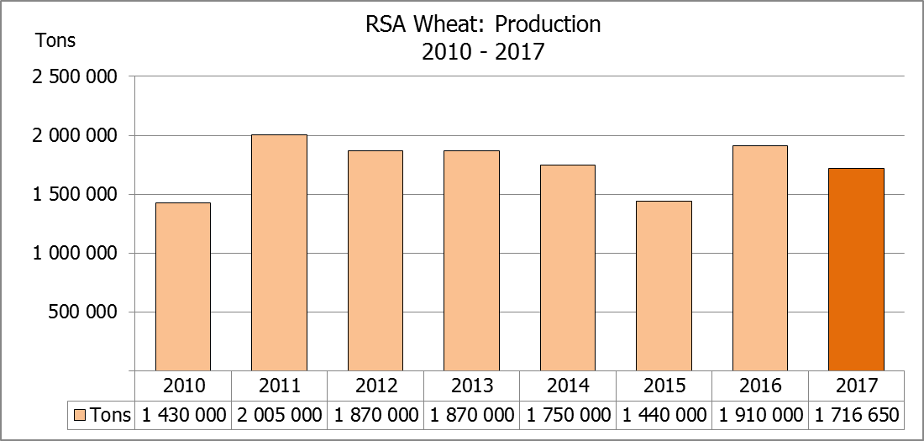
WINTERGEWASSE – HERSIENE OPPERVLAKTE- EN TWEEDE PRODUKSIESKATTING: 2017-PRODUKSIESEISOEN
CROP/GEWAS | Area planted/  Opp beplant  2017 | 2nd forecast/  2de skatting  2017 | 1st forecast/  1ste skatting  2017 | Area planted/  Opp beplant  2016 | Final crop/  Finale oes  2016 | Change/  Verandering
CROP/GEWAS | Ha | Tons | Tons | Ha | Tons | %
CROP/GEWAS | (A) | (B) | (C) | (D) | (E) | (B) ÷ (C)
Commercial/Kommersieel:
Wheat/Koring | 491 600 | 1 716 650 | 1 603 700 | 508 365 | 1 910 000 | +7,04
Malting barley/Moutgars | 91 380 | 268 309 | 265 990 | 88 695 | 355 000 | +0,87
Canola/Kanola | 84 000 | 100 800 | 109 200 | 68 075 | 105 000 | -7,69
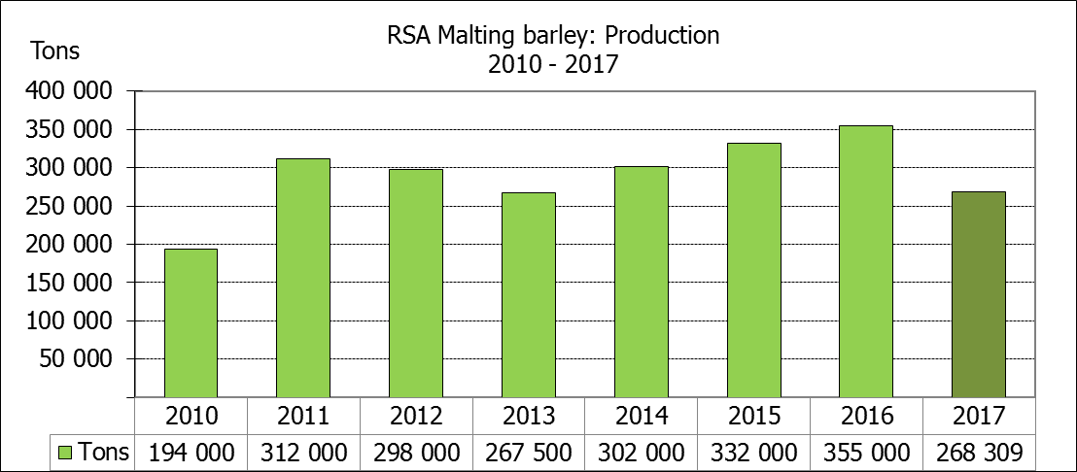
* Note: Estimate is for calendar year, e.g. production season 2017/18 = 2017
* Nota: Skatting is vir kalenderjaar, bv. produksie-seisoen 2017/18 = 2017

WHEAT – REVISED AREA PLANTED AND SECOND PRODUCTION FORECAST: 2017
KORING – HERSIENE OPPERVLAKTE- EN TWEEDE PRODUKSIESKATTING: 2017
Province/  Provinsie | Area planted/  Opp beplant  Ha | 2nd forecast/  2de skatting  Tons | 1st forecast/  1ste skatting  Tons | Area planted/  Opp beplant  Ha | Final crop/  Finale oes  Tons
Province/  Provinsie | 2017 | 2017 | 2017 | 2016 | 2016
Western Cape/Wes-Kaap | 326 000 | 815 000 | 861 250 | 323 000 | 1 098 200
Northern Cape/Noord-Kaap | 38 000 | 300 200 | 285 000 | 35 000 | 266 000
Free State/Vrystaat | 80 000 | 320 000 | 182 000 | 110 000 | 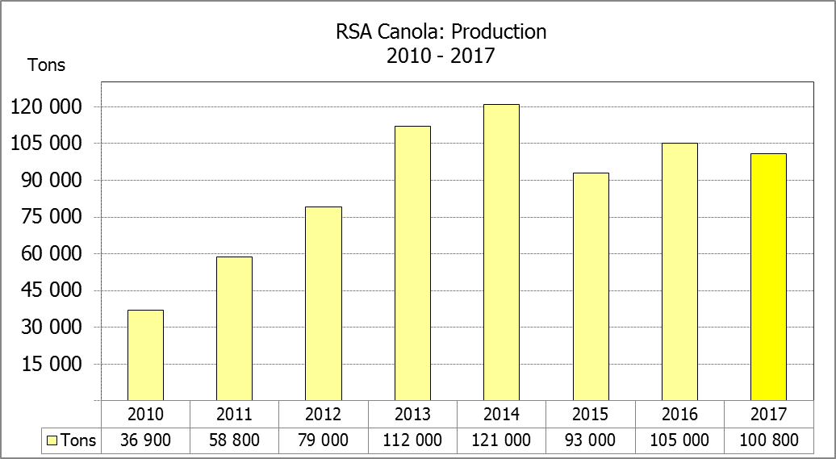  308 460
Eastern Cape/Oos-Kaap | 1 900 | 9 500 | 9 500 | 2 200 | 11 000
KwaZulu-Natal | 7 500 | 42 750 | 42 750 | 6 500 | 37 050
Mpumalanga | 4 000 | 24 000 | 19 800 | 2 300 | 13 800
Limpopo | 20 000 | 120 000 | 120 000 | 17 000 | 103 700
Gauteng | 700 | 4 200 | 2 400 | 365 | 2 190
North West/Noordwes | 13 500 | 81 000 | 81 000 | 12 000 | 69 600
Total/Totaal | 491 600 | 1 716 650 | 1 603 700 | 508 365 | 1 910 000

REVISED AREA ESTIMATE AND SECOND PRODUCTION FORECAST OF WINTER CROPS (2017) /
HERSIENE OPPERVLAKTEKSKATTING EN TWEEDE PRODUKSIESKATTING VAN WINTERGEWASSE (2017)
28 SEPTEMBER 2017
Winter cereal crops - 2017 production season  Wheat: The expected commercial production of wheat is 1,717 mill. tons, which is 7,04% or 112 950 tons more than the previous forecast of 1,604 mill. tons, whilst the expected yield is 3,49 t/ha.  The expected production in the Western Cape is 815 000 tons (47%), in the Free State 320 000 tons (19%) and in the Northern Cape 300 200 tons (17%).  The area estimate for wheat was revised to 491 600 ha, which is 12 000 ha more than the 479 600 ha of the previous estimate. The reason for the increase in the area planted was because of an upward revision in the area of the Free State, from 70 000 ha to 80 000 ha, followed by the Western Cape, from 325 000 ha to 326 000 ha, Mpumalanga, from 3 300 ha to 4 000 ha and Gauteng, from 400 ha to 700 ha.  Other crops: The production forecast for malting barley is 268 309 tons, which is 0,87% or 2 319 tons more than the previous forecast of 265 990 tons. The area planted estimate was increased by 0,14% or 130 ha to 91 380 ha, while the expected yield is 2,94 t/ha.  The expected canola crop was adjusted downwards by 7,69% or 8 400 tons, from 109 200 tons to 100 800 tons. The area estimate for canola is 84 000 ha, with an expected yield of 1,20 t/ha.  Please note that the third production forecast for winter cereals for 2017 will be released on 26 October 2017. |  | Wintergewasse - 2017 produksie-seisoen  Koring: Die verwagte kommersiële produksie vir koring is 1,717 milj. ton, wat 7,04% of 112 950 ton meer is as die vorige skatting van 1,604 milj. ton, terwyl die verwagte opbrengs 3,49 t/ha is.  Die verwagte produksie in die Wes-Kaap is 815 000 ton (47%), in die Vrystaat 320 000 ton (19%) en in die Noord-Kaap 300 200 ton (17%).  Die oppervlakteskatting vir koring is hersien na 491 600 ha, wat 12 000 ha meer is as die 479 600 ha van die vorige skatting. Die rede vir die toename in die oppervlakte beplant was as gevolg van ’n opwaartse aanpassing in die oppervlakte van die Vrystaat, vanaf 70 000 ha tot 80 000 ha, gevolg deur die Wes-Kaap, vanaf 325 000 ha tot 326 000 ha, Mpumalanga, vanaf 3 300 ha tot 4 000 ha en Gauteng, vanaf 400 ha tot 700 ha.  Ander gewasse: Die produksieskatting vir moutgars is 268 309 ton, wat 0,87% of 2 319 ton meer is as die vorige skatting van 265 990 ton. Die oppervlakte beplant skatting is opwaarts aangepas met 0,14% of 130 ha, na 91 380 ha, terwyl die verwagte opbrengs 2,94 t/ha beloop.  Die verwagte kanola-oes is afwaarts aangepas met 7,69% of 8 400 ton, vanaf 109 200 ton tot 100 800 ton. Die oppervlakteskatting vir kanola is 84 000 ha, met ŉ verwagte opbrengs van 1,20 t/ha.  Neem asseblief kennis dat die derde produksieskatting vir wintergewasse vir 2017 op 26 Oktober 2017 vrygestel sal word.

Information is available on the internet at http://www.daff.gov.za/links/crop estimates or http://www.sagis.org.za, as from 15:30 on the date of the relevant meeting of the Crop Estimates Committee. |  | Inligting is beskikbaar op die internet by http://www.daff.gov.za/links/crop estimates of by http://www.sagis.org.za, vanaf 15:30 op die dag van die toepaslike vergadering van die Oesskattingskomitee.

