 | crop estimates committee
 | oesskattingskomitee
From/Van: Mr Baldwin Netshifhefhe  Tel: 012 319 8043/32 E-mail/E-pos: BaldwinN@dalrrd.gov.za  Web page/Webblad: www.dalrrd.gov.za/old website/statistics and economic reports or  www.sagis.org.za/CEC: Crop Estimates EMBARGO: 14:30 |  |  | 

The area planted estimate and eighth production forecast for summer crops for 2023 is hereby released.
Hiermee word die oppervlakte- en agtste produksieskatting vir somergewasse vir 2023 vrygestel.

SUMMER CROPS – AREA PLANTED AND EIGHTH PRODUCTION FORECAST: 2023
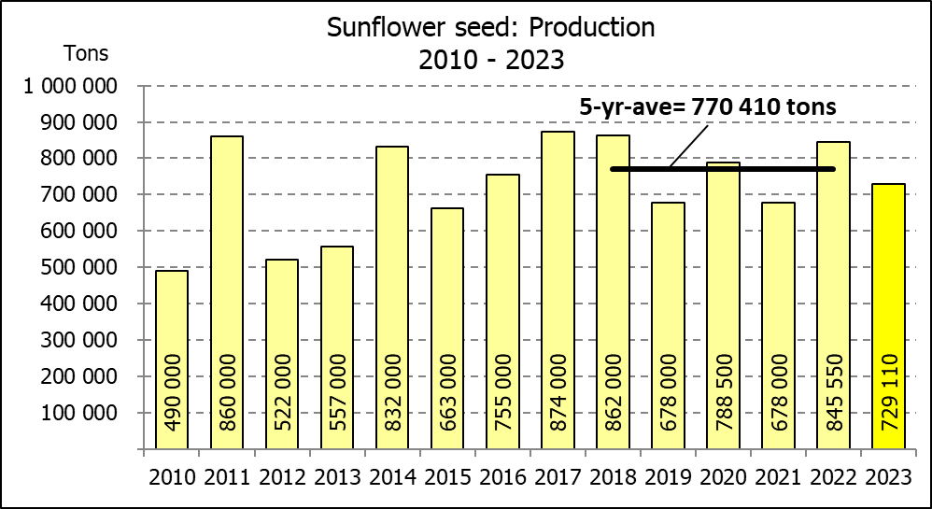
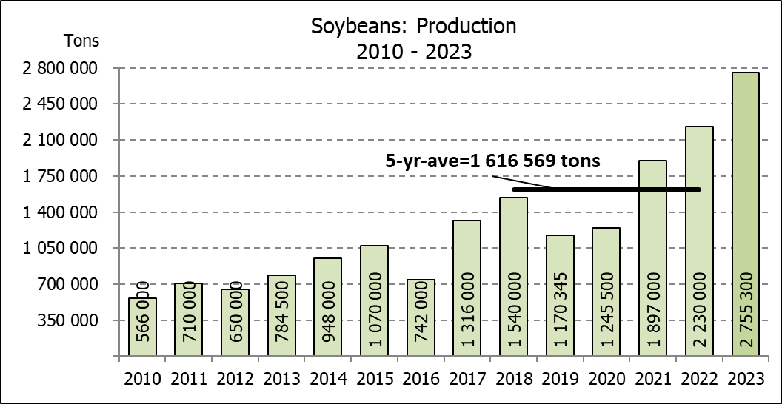
SOMERGEWASSE – OPPERVLAKTE- EN AGTSTE PRODUKSIESKATTING: 2023
CROP/GEWAS | Area planted/  Opp beplant  2023 | 8th forecast/  8ste skatting  2023 | 7th forecast/  7de skatting  2023 | Area planted/  Opp beplant  2022 | Final crop/  Finale oes  2022 | Change/  Verandering/
CROP/GEWAS | Ha | Tons | Tons | Ha | Tons | %
CROP/GEWAS | (A) | (B) | (C) | (D) | (E) | (B) ÷ (C)
Commercial/Kommersieël:
White maize/Witmielies | 1 521 300 | 8 499 965 | 8 637 950 | 1 575 000 | 7 850 000 | -1,60
Yellow maize/Geelmielies | 1 064 800 | 7 895 260 | 7 771 550 | 1 048 000 | 7 620 000 | +1,59
Total Maize/Totale Mielies | 2 586 100 | 16 395 225 | 16 409 500 | 2 623 000 | 15 470 000 | -0,09
Sunflower seed/Sonneblomsaad | 555 700 | 729 110 | 743 610 | 670 700 | 845 550 | -1,95
Soybeans/Sojabone | 1 148 300 | 2 755 300 | 2 755 300 | 925 300 | 2 230 000 | -
Groundnuts/Grondbone | 31 300 | 51 910 | 51 910 | 43 400 | 48 500 | -
Sorghum | 34 000 | 94 360 | 97 740 | 37 200 | 103 140 | -3,46
Dry beans/Droëbone | 36 650 | 50 260 | 50 260 | 42 900 | 52 590 | -
Non-Commercial Maize/Nie-Kommersiële Mielies
Total Maize/Totale Mielies | 358 620 | 664 040 | 664 040 | 378 800 | 667 000 | -
Maize/Mielies: Commercial/Kommersieël + Non-Commercial/Nie-Kommersieël
Total Maize RSA/Totaal Mielies RSA | 2 944 720 | 17 059 265 | 17 073 540 | 3 001 800 | 16 137 000 | -0,08
Note: Estimate is for calendar year, e.g. production season 2022/23 = 2023
Nota: Skatting is vir kalenderjaar, bv. produksie-seisoen 2022/23 = 2023

The Crop Estimates Committee comprises officials of the following institutions:
Department of Agriculture, Land Reform and Rural Development; Provincial Departments of Agriculture; various ARC-Institutes (Soil, Climate and Water; Small Grains Institute; and
Grain Crops Institute); BFAP and Statistics SA.
27 September 2023
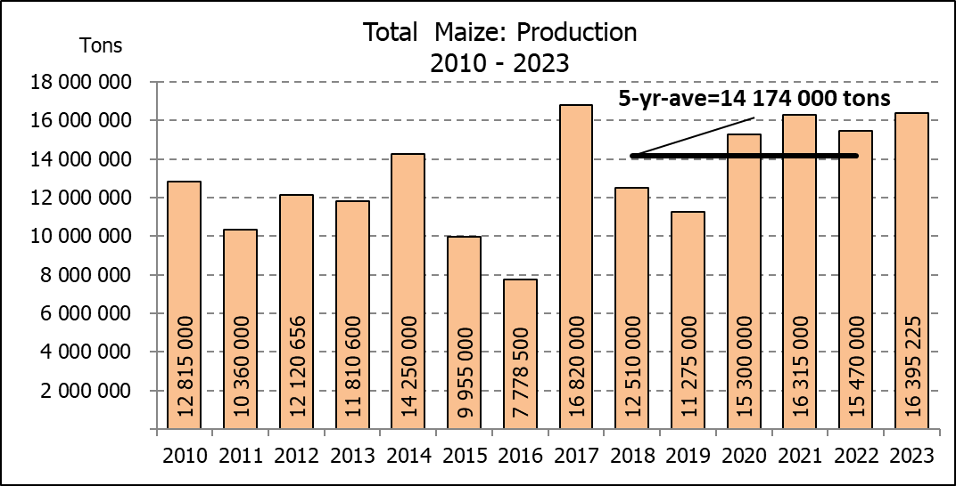

WHITE AND YELLOW MAIZE – AREA PLANTED AND EIGHTH PRODUCTION FORECAST: 2023
WIT- EN GEELMIELIES – OPPERVLAKTE EN AGTSTE PRODUKSIESKATTING: 2023

Provinsie/  Province | Area planted/  Oppervlakte beplant  2023 |  |  | 8th forecast/  8ste skatting  2023 |  |  | Area planted/  Oppervlakte beplant  2022 |  |  | Final crop/  Finale oes  2022
Provinsie/  Province | White/  Wit  Ha | Yellow/  Geel  Ha | Total/  Totaal  Ha | White/  Wit  Tons | Yellow/  Geel  Tons | Total/  Totaal  Tons | White/  Wit  Ha | Yellow/  Geel  Ha | Total/  Totaal  Ha | White/  Wit  Tons | Yellow/  Geel  Tons | Total/  Totaal  Tons
Western Cape/Wes-Kaap | 250 | 3 500 | 3 750 | 2 375 | 32 900 | 35 275 | 500 | 3 500 | 4 000 | 4 750 | 32 900 | 37 650
Northern Cape/Noord-Kaap | 1 000 | 43 500 | 44 500 | 12 500 | 696 000 | 708 500 | 3 000 | 42 000 | 45 000 | 36 000 | 672 000 | 708 000
Free State/Vrystaat | 780 000 | 401 000 | 1 181 000 | 4 446 000 | 2 686 700 | 7 132 700 | 826 500 | 398 000 | 1 224 500 | 3 801 900 | 2 547 800 | 6 349 700
Eastern Cape/Oos-Kaap | 5 750 | 25 000 | 30 750 | 40 250 | 192 500 | 232 750 | 6 000 | 20 500 | 26 500 | 40 800 | 157 900 | 198 700
KwaZulu-Natal | 49 000 | 65 000 | 114 000 | 298 900 | 533 000 | 831 900 | 52 000 | 59 000 | 111 000 | 322 400 | 489 700 | 812 100
Mpumalanga | 156 500 | 352 000 | 508 500 | 1 032 900 | 2 587 200 | 3 620 100 | 165 000 | 350 000 | 515 000 | 1 072 500 | 2 554 000 | 3 626 500
Limpopo | 16 800 | 22 800 | 39 600 | 114 240 | 186 960 | 301 200 | 15 500 | 25 000 | 40 500 | 102 300 | 202 500 | 304 800
Gauteng | 56 000 | 52 000 | 108 000 | 364 000 | 390 000 | 754 000 | 56 500 | 56 000 | 112 500 | 361 600 | 403 200 | 764 800
North West/Noordwes | 456 000 | 100 000 | 556 000 | 2 188 800 | 590 000 | 2 778 800 | 450 000 | 94 000 | 544 000 | 2 107 750 | 560 000 | 2 667 750
Total/Totaal | 1 521 300 | 1 064 800 | 2 586 100 | 8 499 965 | 7 895 260 | 16 395 225 | 1 575 000 | 1 048 000 | 2 623 000 | 7 850 000 | 7 620 000 | 15 470 000

SUNFLOWER SEED – AREA PLANTED AND EIGHTH PRODUCTION FORECAST: 2023
SONNEBLOMSAAD – OPPERVLAKTE EN AGTSTE PRODUKSIESKATTING: 2023

Province/  Provinsie | Area planted/  Opp beplant  Ha | 8th forecast/  8ste skatting  Tons | Area planted/  Opp beplant  Ha | Final crop/  Finale oes  Tons
Province/  Provinsie | 2023 | 2023 | 2022 | 2022
Western Cape/Wes-Kaap | - | - | - | -
Northern Cape/Noord-Kaap | 2 500 | 6 250 | 2 500 | 6 250
Free State/Vrystaat | 290 000 | 406 000 | 357 000 | 499 800
Eastern Cape/Oos-Kaap | 700 | 1 400 | 300 | 750
KwaZulu-Natal | 300 | 600 | - | -
Mpumalanga | 5 000 | 7 250 | 3 500 | 5 250
Limpopo | 100 000 | 80 000 | 110 000 | 77 000
Gauteng | 2 200 | 2 860 | 2 400 | 3 000
North West/Noordwes | 155 000 | 224 750 | 195 000 | 253 500
Total/Totaal | 555 700 | 729 110 | 670 700 | 845 550
SOYBEANS – AREA PLANTED AND EIGHTH PRODUCTION FORECAST: 2023
SOJABONE – OPPERVLAKTE EN AGTSTE PRODUKSIESKATTING: 2023

Province/  Provinsie | Area planted/  Opp beplant  Ha | 8th forecast/  8ste skatting  Tons | Area planted/  Opp beplant  Ha | Final crop/  Finale oes  Tons
Province/  Provinsie | 2023 | 2023 | 2022 | 2022
Western Cape/Wes-Kaap | - | - | - | -
Northern Cape/Noord-Kaap | 1 000 | 3 750 | 800 | 3 000
Free State/Vrystaat | 565 000 | 1 327 750 | 415 000 | 912 500
Eastern Cape/Oos-Kaap | 4 300 | 12 900 | 3 000 | 9 000
KwaZulu-Natal | 44 000 | 158 400 | 39 000 | 150 000
Mpumalanga | 305 000 | 671 000 | 300 000 | 710 000
Limpopo | 26 000 | 88 400 | 22 500 | 76 500
Gauteng | 48 000 | 105 600 | 45 000 | 99 000
North West/Noordwes | 155 000 | 387 500 | 100 000 | 270 000
Total/Totaal | 1 148 300 | 2 755 300 | 925 300 | 2 230 000

GROUNDNUTS – AREA PLANTED AND EIGHTH PRODUCTION FORECAST: 2023
GRONDBONE – OPPERVLAKTE EN AGTSTE PRODUKSIESKATTING: 2023

Province/  Provinsie | Area planted/  Opp beplant  Ha | 8th forecast/  8ste skatting  Tons | Area planted/  Opp beplant  Ha | Final crop/  Finale oes  Tons
Province/  Provinsie | 2023 | 2023 | 2022 | 2022
Western Cape/Wes-Kaap | - | - | - | -
Northern Cape/Noord-Kaap | 2 000 | 5 300 | 2 400 | 6 000
Free State/Vrystaat | 12 300 | 20 910 | 19 000 | 20 900
Eastern Cape/Oos-Kaap | - | - | - | -
KwaZulu-Natal | - | - | - | -
Mpumalanga | - | - | - | -
Limpopo | 2 000 | 4 700 | 2 000 | 4 600
Gauteng | - | - | - | -
North West/Noordwes | 15 000 | 21 000 | 20 000 | 17 000
Total/Totaal | 31 300 | 51 910 | 43 400 | 48 500

SORGHUM – AREA PLANTED AND EIGHTH PRODUCTION FORECAST: 2023
SORGHUM – OPPERVLAKTE EN AGTSTE PRODUKSIESKATTING: 2023

Province/  Provinsie | Area planted/  Opp beplant  Ha | 8th forecast/  8ste skatting/  Tons | Area planted/  Opp beplant  Ha | Final crop/  Finale oes  Tons
Province/  Provinsie | 2023 | 2023 | 2022 | 2022
Western Cape/Wes-Kaap | - | - | - | -
Northern Cape/Noord-Kaap | - | - | - | -
Free State/Vrystaat | 5 200 | 14 820 | 7 800 | 20 700
Eastern Cape/Oos-Kaap | - | - | - | -
KwaZulu-Natal | 100 | 400 | 200 | 740
Mpumalanga | 8 500 | 35 275 | 9 000 | 43 650
Limpopo | 15 500 | 33 325 | 15 000 | 26 250
Gauteng | 100 | 420 | 200 | 800
North West/Noordwes | 4 600 | 10 120 | 5 000 | 11 000
Total/Totaal | 34 000 | 94 360 | 37 200 | 103 140

DRY BEANS – AREA PLANTED AND EIGHTH PRODUCTION FORECAST: 2023
DROëBONE – OPPERVLAKTE EN AGTSTE PRODUKSIESKATTING: 2023

Province/  Provinsie | Area planted/  Opp beplant  Ha | 8th forecast/  8ste skatting  Tons | Area planted/  Opp beplant  Ha | Final crop/  Finale oes  Tons
Province/  Provinsie | 2023 | 2023 | 2022 | 2022
Western Cape/Wes-Kaap | 100 | 180 | 100 | 150
Northern Cape/Noord-Kaap | 450 | 990 | 600 | 1 080
Free State/Vrystaat | 14 000 | 13 300 | 15 500 | 13 950
Eastern Cape/Oos-Kaap | 200 | 360 | 200 | 300
KwaZulu-Natal | 2 100 | 3 150 | 2 300 | 2 760
Mpumalanga | 5 000 | 7 000 | 6 000 | 6 600
Limpopo | 8 000 | 16 000 | 10 400 | 18 200
Gauteng | 800 | 880 | 800 | 800
North West/Noordwes | 6 000 | 8 400 | 7 000 | 8 750
Total/Totaal | 36 650 | 50 260 | 42 900 | 52 590

CONFIDENTIALITY ISSUES that CEC members are committed to adhere to on the day of the meeting
- Personal items such as laptops, handbags, cell phones, etc. are not allowed in the venue during the meeting
- No member is allowed to leave the meeting before 12:00 in order to prevent disclosure of the information
- The embargo time for the release of crop estimates information is 14:30
- No member is allowed to discuss crop estimates information with anyone other than a member of the Committee before the embargo time
- Only the Chairperson, or a member appointed by the Chairperson, may release the figures to the media
- Members must regard the detail of any information that was collected for and/or discussed during the meeting, as confidential
- Individual information received for crop estimate purposes is treated strictly confidential, and is not divulged for any other purposes

AREA ESTIMATE AND EIGHTH PRODUCTION FORECAST OF SUMMER CROPS (2023 PRODUCTION SEASON)/
OPPERVLAKTE- EN AGTSTE PRODUKSIESKATTING VIR SOMERGEWASSE (2023 PRODUKSIE-SEISOEN)
27 SEPTEMBER 2023

Summer field crops – 2023  Commercial maize: The size of the expected commercial maize crop is 16,395 mill. tons, which is 0,09% or 14 275 tons less than the 16,410 mill. tons of the previous forecast . The area estimate for maize is 2,586 mill. ha and the expected yield is 6,34 t/ha.  The estimated maize crop is 5,98% or 925 225 tons larger than the 2022 crop. The three main maize producing areas, namely the Free State, Mpumalanga and North West provinces are expected to produce 83% of the 2023 crop.  The production forecast of white maize is set at 8,500 mill. tons, which is 1,60% or 137 985 tons less than the previous forecast of 8,638 mill. tons. The area estimate for white maize is 1,521 mill. ha and the expected yield is 5,59 t/ha.  In the case of yellow maize, the production forecast is 7,895 mill. tons, which is 1,59% or 123 710 tons more than the 7,772 mill. tons of the previous forecast. The area estimate for yellow maize is 1,065 mill. ha and the yield is 7,41 t/ha.  Other summer crops:  Sunflower seed: The production forecast for sunflower seed is set at 729 110 tons, which is 1,95% or 14 500 tons less than the 743 610 tons of the previous forecast. The area estimate for sunflower seed is 555 700 ha, while the expected yield is 1,31 t/ha.  Other crops: The production forecast for soybeans remained unchanged at 2,755 mill. tons. The estimated area planted to soybeans is 1,148 mill. ha and the expected yield is 2,40 t/ha.  The expected groundnut crop also remained unchanged at 51 910 tons. For groundnuts, the area estimate is 31 300 ha, with an expected yield of 1,66 t/ha.  The production forecast for sorghum is now 94 360 tons, which is 3,46% or 3 380 tons less than the 97 740 tons of the previous forecast. The area estimate for sorghum is 34 000 ha and the expected yield is 2,78 t/ha.  In the case of dry beans, the production forecast remained unchanged at 50 260 tons. The area estimate of dry beans is 36 650 ha, with an expected yield of 1,37 t/ha.  Please note that the ninth production forecast for summer field crops for 2023, as well as the ‘intentions of farmers’ to plant summer grain crops for 2024, will be released on 26 October 2023. |  | Somergewasse – 2023  Kommersiële mielies: Die grootte van die verwagte kommersiële mielie-oes is 16,395 milj. ton, wat 0,09% of 14 275 ton minder is as die 16,410 milj. ton van die vorige skatting. Die oppervlakteskatting vir mielies is 2,586 milj. ha en die verwagte opbrengs is 6,34 t/ha.  Die geskatte mielie-oes is 5,98% of 925 225 ton groter as die 2022-oes. Die drie belangrikste mielieproduserende gebiede, nl. die Vrystaat, Mpumalanga en Noordwes provinsies, gaan na verwagting 83% van die 2023-oes produseer.  Die produksieskatting van witmielies is op 8,500 milj. ton gestel, wat 1,60% of 137 985 ton minder is as die vorige skatting van 8,638 milj. ton. Die oppervlakteskatting vir witmielies is 1,521 milj. ha en die verwagte opbrengs is 5,59 t/ha.  In die geval van geelmielies is die produksieskatting 7,895 milj. ton, wat 1,59% of 123 710 ton meer is as die 7,772 milj. ton van die vorige skatting. Die oppervlakteskatting vir geelmielies is 1,065 milj. ha en die opbrengs is 7,41 t/ha.  Ander somergewasse:  Sonneblomsaad: Die produksieskatting vir sonneblomsaad is op 729 110 ton gestel, wat 1,95% of 14 500 ton minder is as die 743 610 ton van die vorige skatting. Die oppervlakteskatting vir sonneblomsaad is 555 700 ha, terwyl die verwagte opbrengs 1,31 t/ha is.  Ander gewasse: Die produksieskatting van sojabone is onveranderd gelaat op 2,755 milj. ton. Die geskatte oppervlakte beplant met sojabone is 1,148 milj. ha en die verwagte opbrengs is 2,40 t/ha.  Die verwagte grondbone-oes is ook onveranderd gelaat op 51 910 ton. Vir grondbone is die oppervlakteskatting 31 300 ha, terwyl the verwagte opbrengs 1,66 t/ha is.  Die produksieskatting van sorghum is nou 94 360 ton, wat 3,46% of 3 380 ton minder is as die 97 740 ton van die vorige skatting. Die oppervlakteskatting vir sorghum is 34 000 ha, en die verwagte opbrengs is 2,78 t/ha.  In die geval van droëbone is die oes onveranderd gelaat op 50 260 ton. Die oppervlakte beplant met droëbone is 36 650 ha, en die verwagte opbrengs is 1,37 t/ha.  Neem asseblief kennis dat die negende produksieskatting vir somergewasse vir 2023, sowel as die ‘voorneme van produsente om somergraangewasse te plant’ vir 2024, op 26 Oktober 2023 vrygestel sal word.

The non-commercial agricultural sectors’ production estimate for maize for 2023 is hereby released. /
Hiermee word die nie-kommersiële landbou-sektor se produksieskatting vir mielies vir 2023 vrygestel.

NON-COMMERCIAL MAIZE – AREA PLANTED AND PRODUCTION ESTIMATE: 2023
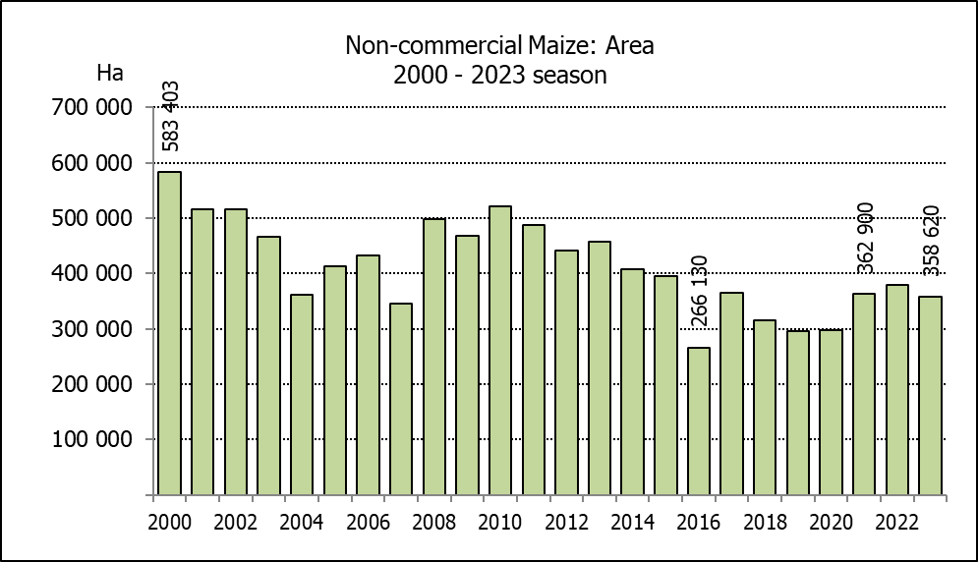
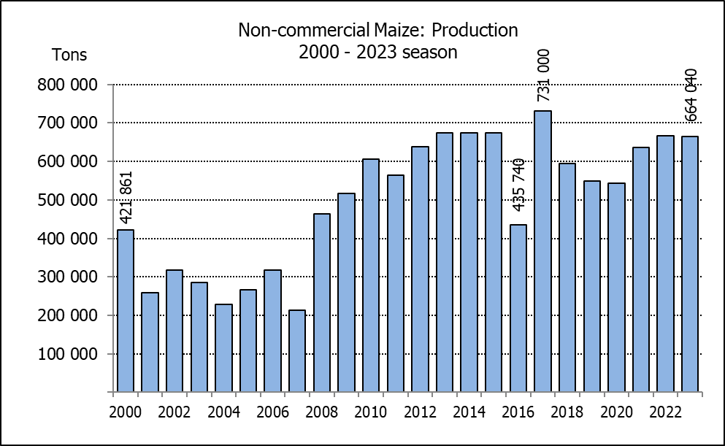
NIE-KOMMERSIëLE MIELIES – OPPERVLAKTE- EN PRODUKSIESKATTING: 2023
CROP/GEWAS | Area planted/  Opp beplant  2023 | Production/  Produksie  2023 | Area planted/  Opp beplant  2022 | Final crop/  Finale oes  2022 | Change/  Verandering
CROP/GEWAS | Ha | Tons | Ha | Tons | %
CROP/GEWAS | (A) | (B) | (C) | (D) | (B) ÷ (D)
Non-commercial agriculture/Nie-kommersiële landbou:
White maize/Witmielies | 278 655 | 472 765 | 296 950 | 482 000 | -1,92
Yellow maize/Geelmielies | 79 965 | 191 275 | 81 850 | 185 000 | +3,39
Maize/Mielies | 358 620 | 664 040 | 378 800 | 667 000 | -0,44
The preliminary area planted to maize in the non-commercial agricultural sector is estimated at 358 620 ha, which represents a decrease of 5,33%, compared to the 378 800 ha of the previous season. The expected maize crop for this sector is 664 040 tons, which is 0,44% less than the 667 000 tons of last season. It is important to note that about 48% of the maize produced in the non-commercial sector, is planted in the Eastern Cape, followed by KwaZulu-Natal with 21%.
Die voorlopige oppervlakte beplant met mielies in die nie-kommersiële landbou-sektor word geskat op 358 620 ha, wat ’n afname van 5,33% verteenwoordig in vergelyking met die 378 800 ha van die vorige seisoen. Die verwagte mielie-oes van dié sektor is 664 040 ton, wat 0,44% minder is as die 667 000 ton van die vorige seisoen. Dit is belangrik om daarop te let dat ongeveer 48% van die mielies wat geproduseer word in die nie-kommersiële sektor, in die Oos-Kaap geplant word, gevolg deur KwaZulu-Natal met 21%.

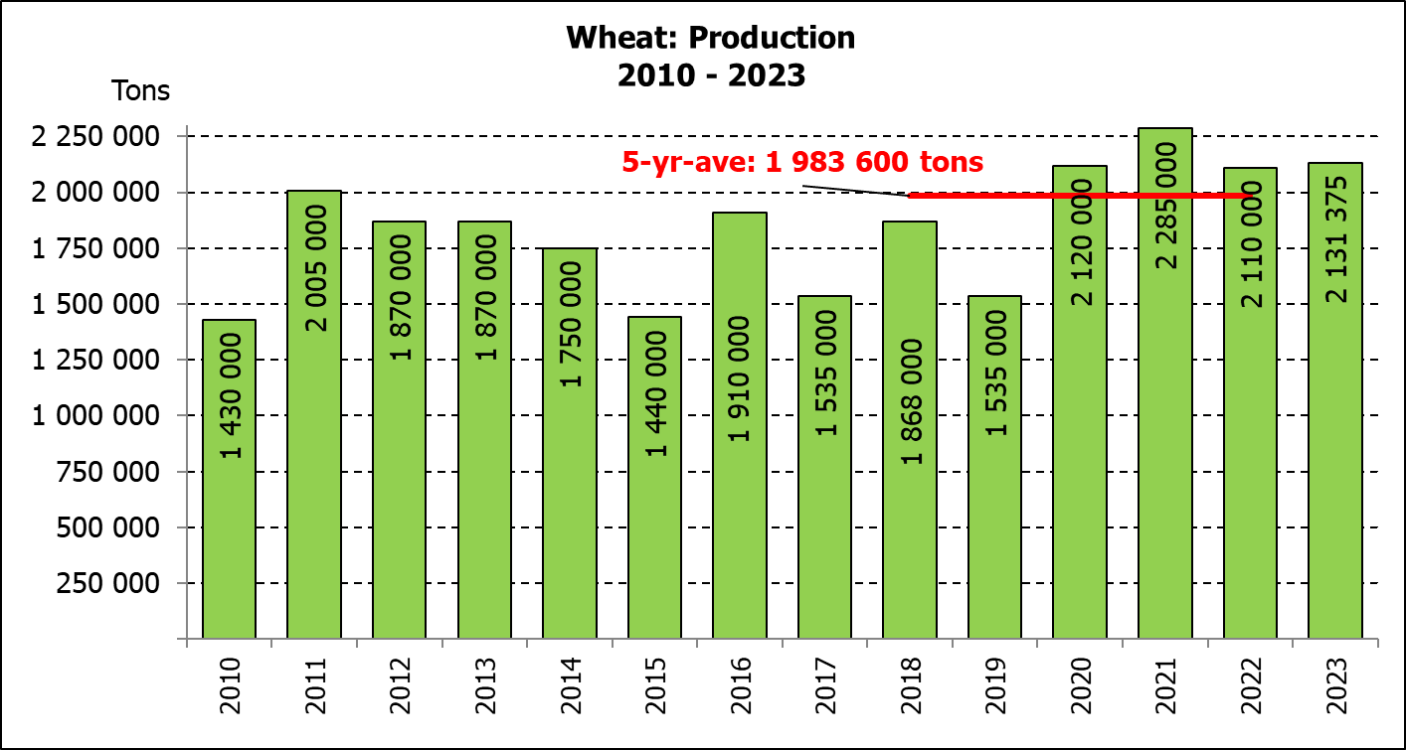
The revised area estimate and second production forecast for winter cereals for the 2023 is hereby released. /
Hiermee word die hersiene oppervlakteskatting en tweede produksieskatting vir wintergewasse vir 2023 vrygestel.

WINTER CEREALS – REVISED AREA PLANTED ESTIMATE AND SECOND PRODUCTION FORECAST: 2023 PRODUCTION SEASON
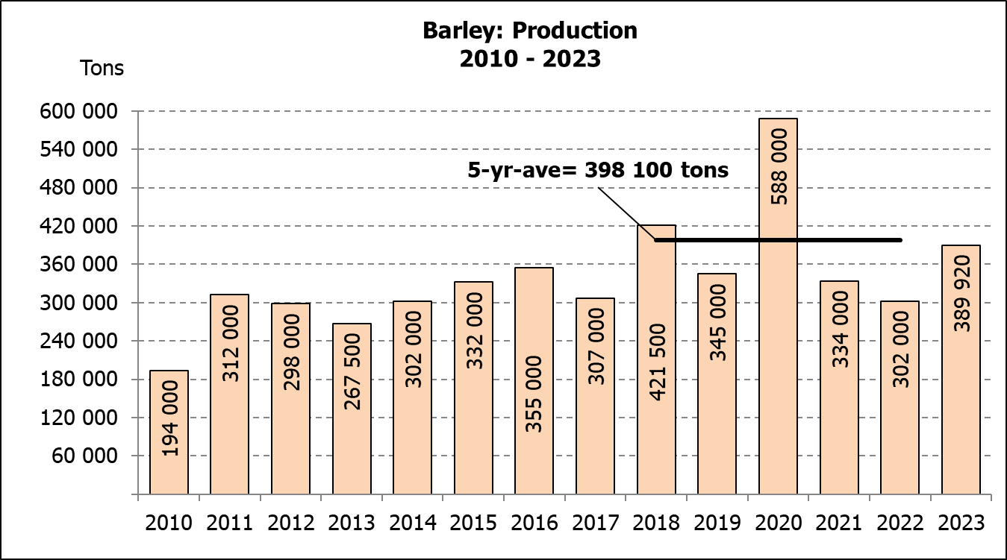
WINTERGEWASSE – HERSIENE OPPERVLAKTESKATTING EN TWEEDE PRODUKSIESKATTING: 2023-PRODUKSIESEISOEN
CROP/GEWAS | Area planted/  Opp beplant  2023 | 2nd forecast/  2de skatting  2023 | 1st forecast/  1ste skatting  2023 | Area planted/  Opp beplant  2022 | Final crop/  Finale oes  2022 | Change/  Verandering
CROP/GEWAS | Ha | Tons | Tons | Ha | Tons | %
CROP/GEWAS | (A) | (B) | (C) | (D) | (E) | (B) ÷ (C)
Commercial/Kommersieel:
Wheat/Koring | 537 950 | 2 131 375 | 2 141 625 | 566 800 | 2 110 000 | -0,48
Barley/Gars¹⁾ | 107 600 | 389 920 | 380 020 | 101 000 | 302 000 | +2,61
Canola/Kanola | 131 200 | 230 950 | 243 950 | 123 510 | 210 000 | -5,33
Oats/Hawer¹⁾ | 27 500 | 51 050 | 60 200 | 27 000 | 27 550 | -15,20
Sweet lupines/Soetlupine | 16 000 | 19 200 | 19 200 | 21 000 | 15 750 | -
1) Commercial only. Excluding barley or oats used as pasture, silage, hay and/or on the farm as fodder for livestock /
Slegs kommersieël. Uitgesluit gars of hawer wat gebruik word as weiding, kuilvoer, hooi en/of op die plaas as voer vir vee.

WHEAT – REVISED AREA PLANTED ESTIMATE AND SECOND PRODUCTION FORECAST: 2023
KORING – HERSIENE OPPERVLAKTESKATTING EN TWEEDE PRODUKSIESKATTING: 2023
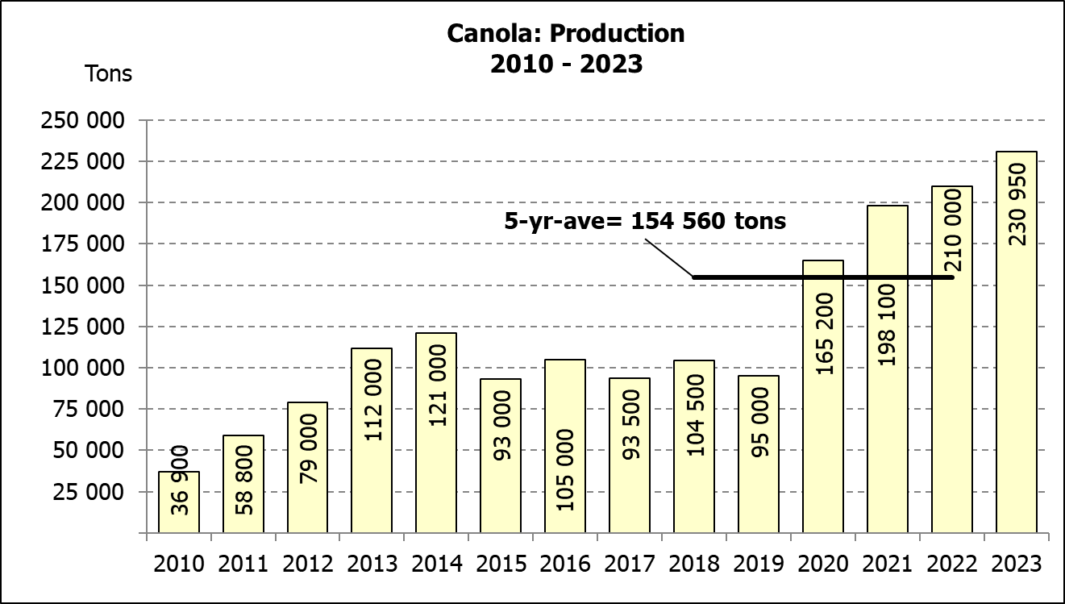
Province/  Provinsie | Area planted/  Opp beplant  Ha | 2nd forecast/  2de skatting  Tons | Area planted/  Opp beplant  Ha | Final crop/  Finale oes  Tons
Province/  Provinsie | 2023 | 2023 | 2022 | 2022
Western Cape/Wes-Kaap | 365 000 | 1 095 000 | 360 000 | 918 000
Northern Cape/Noord-Kaap | 40 000 | 310 000 | 47 000 | 338 500
Free State/Vrystaat | 72 000 | 331 200 | 96 000 | 436 800
Eastern Cape/Oos-Kaap | 6 300 | 40 950 | 6 000 | 40 200
KwaZulu-Natal | 8 500 | 56 100 | 9 200 | 60 730
Mpumalanga | 4 200 | 28 560 | 4 000 | 27 600
Limpopo | 30 000 | 195 000 | 29 000 | 187 000
Gauteng | 950 | 6 365 | 1 100 | 7 370
North West/Noordwes | 11 000 | 68 200 | 14 500 | 93 800
Total/Totaal | 537 950 | 2 131 375 | 566 800 | 2 110 000
REVISED AREA ESTIMATE AND SECOND PRODUCTION FORECAST OF WINTER CROPS (2023) /
HERSIENE OPPERVLAKTESKATTING EN TWEEDE PRODUKSIESKATTING VAN WINTERGEWASSE (2023)
27 SEPTEMBER 2023

Winter cereal crops - 2023 production season  Wheat: The expected production of wheat is 2,131 mill. tons, which is 0,48% or 10 250 tons less than the previous forecast of 2,142 mill. tons, whilst the expected yield is 3,96 t/ha.  The expected production in the Western Cape is 1,095 mill. tons (51%), which is unchanged from the previous forecast. In the Free State, the expected production is 331 200 tons (16%), compared to the 340 800 tons of the previous month. In the Northern Cape, 310 000 tons (14%) is expected to be produced – unchanged from the previous month.  The area estimate for wheat was revised to 537 950 ha, which is 900 ha more than the 537 050 ha of the previous forecast. An estimated 365 000 ha or 68 % is planted in the Western Cape, 72 000 ha or 13 % in the Free State and 40 000 ha or 7 % in the Northern Cape.  Other crops: The production forecast for barley is 389 920 tons, which is 2,61% or 9 900 tons more than the previous month’s forecast of 380 020 tons. The area planted is estimated at 107 600 ha, while the expected yield is 3,62 t/ha.  The expected canola crop is 230 950 tons, which is 5,33% or 13 000 tons less than the previous month’s forecast of 243 950 tons. The area estimate for canola is 131 200 ha, with an expected yield of 1,76 t/ha.  The expected crop for oats for the 2023 season is 51 050 tons and the revised area planted is 27 500 ha. The expected yield is 1,86 t/ha.  In the case of sweet lupines, the production forecast is 19 200 tons. The area estimate of sweet lupines is 16 000 ha, with an expected yield of 1,20 t/ha.  Please note that the third production forecast for winter cereals for 2023 will be released on 26 October 2023. |  | Wintergewasse - 2023 produksie-seisoen  Koring: Die verwagte produksie vir koring is 2,131 milj. ton, wat 0,48% of 10 250 ton minder is as die vorige skatting van 2,142 milj. ton, terwyl die verwagte opbrengs 3,96 t/ha is.  Die verwagte produksie in die Wes-Kaap is 1,095 mij. ton (51%), wat onveranderd is in vergelyking met die vorige skatting. In die Vrystaat is die verwagte produksie 331 200 ton (16%), in vergelyking met die vorige maand se 340 800 ton. In die Noord-Kaap is die beraamde produksie 310 000 ton (14%) – onveranderd in vergelyking met die vorige maand.  Die oppervlakteskatting vir koring is hersien na 537 950 ha, wat 900 ha meer is as die 537 050 ha teenoor die vorige skatting. Die beraamde oppervlakte geplant in die Wes-Kaap is 365 000 ha of 68 %, die Vrystaat is 72 000 ha of 13 % en 40 000 ha of 7 % is in die Noord-Kaap.  Ander gewasse: Die produksieskatting vir gars is 389 920 ton, wat 2,61% of 9 900 ton meer is as die vorige maand se skatting van 380 020 ton. Die oppervlakte beplant word beraam op 107 600 ha, terwyl die verwagte opbrengs 3,62 t/ha beloop.  Die verwagte kanola-oes is 230 950 ton, wat 5,33% of 13 000 ton minder is as die vorige maand se skatting van 243 950 ton. Die oppervlakteskatting vir kanola is 131 200 ha, met ŉ verwagte opbrengs van 1,76 t/ha.  Die verwagte oes vir hawer vir die 2023-seisoen is 51 050 ton en die hersiene oppervlakteskatting is 27 500 ha. Die verwagte opbrengs is 1,86 t/ha.  In die geval van soetlupine is die produksieskatting 19 200 ton. Die oppervlakte beplant met soetlupine is 16 000 ha, en die verwagte opbrengs is 1,20 t/ha.  Neem asseblief kennis dat die derde produksieskatting vir wintergewasse vir 2023 op 26 Oktober 2023 vrygestel sal word.

Information is available on the internet at http:// www.dalrrd.gov.za/old website/statistics or http://www.sagis.org.za, as from 14:30 on the date of the relevant meeting of the Crop Estimates Committee. |  | Inligting is beskikbaar op die internet by http://www.dalrrd.gov.za/old website/statistics of by http://www.sagis.org.za, vanaf 14:30 op die dag van die toepaslike vergadering van die Oesskattingskomitee.

