 | crop estimates committee | 
 | oesskattingskomitee
From/Van: M. Ellen Matsei
Tel: 012 319 8454  Fax/Faks: 012 319 8031  E-mail/E-pos: DAS@daff.gov.za
Web page/Webblad: www.daff.gov.za/statistics and economic reports or www.sagis.org.za/CEC: Crop Estimates
EMBARGO: 15:30

The intentions’ of producers to plant summer crops for 2019 is hereby released. /
Hiermee word produsente se voorneme om somergewasse te plant vir 2019 vrygestel.

SUMMER CROPS – INTENTIONS TO PLANT: 2019
The Crop Estimates Committee comprises officials of the following institutions:
Department of Agriculture, Forestry and Fisheries; Provincial Departments of Agriculture; various ARC-Institutes (Soil, Climate and Water; Small Grains Institute;
and Grain Crops Institute); BFAP, Statistics SA and CSIR.
SOMERGEWASSE – VOORNEME OM TE PLANT: 2019
CROP/GEWAS | Intentions/  Voorneme  2019 | Area planted/  Opp beplant  2018 | Final estimate/  Finale skatting  2018 | Change/  Verandering/
CROP/GEWAS | Ha | Ha | Tons | %
CROP/GEWAS | soos middel Oktober 2018/  as mid October 2018 |  | as on 26 Sep 2018/  soos op 26 Sept 2018
CROP/GEWAS | (A) | (B) | (C) | (A) ÷ (B)
Commercial/Kommersieël:
White maize/Witmielies | 1 373 400 | 1 268 100 | 6 801 560 | +8,30
Yellow maize/Geelmielies | 1 075 000 | 1 050 750 | 6 129 650 | +2,31
Maize/Mielies | 2 448 400 | 2 318 850 | 12 931 210 | +5,59
Sunflower seed/Sonneblomsaad | 575 000 | 601 500 | 858 605 | -4,41
Soybeans/Sojabone | 851 800 | 787 200 | 1 550 800 | +8,21
Groundnuts/Grondbone | 50 000 | 56 300 | 53 750 | -11,19
Sorghum | 43 000 | 28 800 | 109 855 | +49,31
Dry beans/Droëbone | 60 000 | 53 360 | 69 360 | +12,44
TOTAL/TOTAAL | 4 028 200 | 3 846 010 | 15 573 580 | +4,74
Note: Estimate is for calendar year, e.g. production season 2018/19 = 2019
Nota: Skatting is vir kalenderjaar, bv. produksie-seisoen 2018/19 = 2019

25 October/Oktober 2018
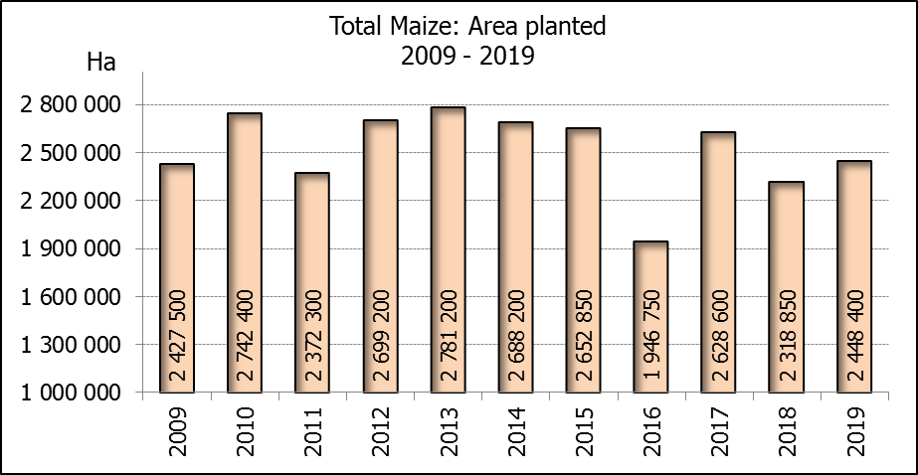

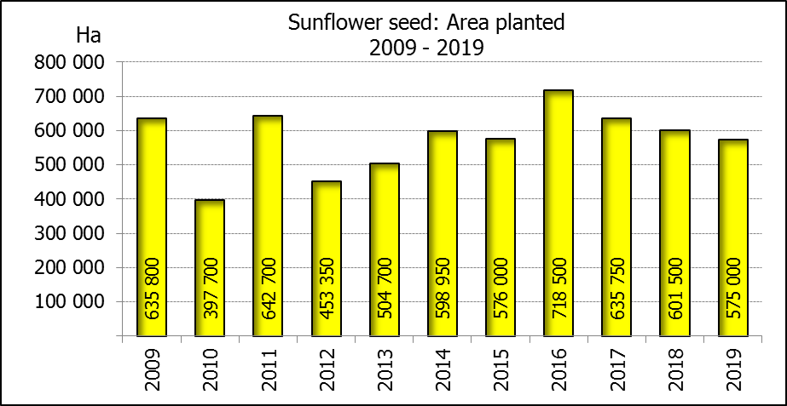

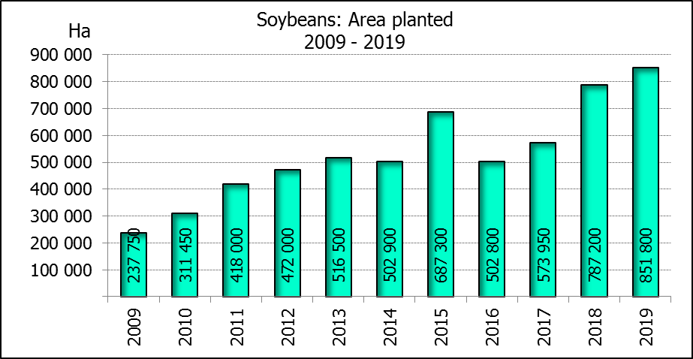
2019: Intentions’ of farmers/Produsente se voornemens

WHITE AND YELLOW MAIZE – INTENTIONS TO PLANT: 2019
WIT- EN GEELMIELIES – VOORNEME OM TE PLANT: 2019

Provinsie/  Province | Intentions (Area planted)/  Voorneme (Oppervlakte beplant)  2019 |  |  | Area planted/  Oppervlakte beplant  2018 |  |  | Final estimate¹⁾/  Finale skatting¹⁾  2018
Provinsie/  Province | White/  Wit  Ha | Yellow/  Geel  Ha | Total/  Totaal  Ha | White/  Wit  Ha | Yellow/  Geel  Ha | Total/  Totaal  Ha | White/  Wit  Tons | Yellow/  Geel  Tons | Total/  Totaal  Tons
Western Cape/Wes-Kaap | 400 | 3 000 | 3 400 | 0 | 3 750 | 3 750 | 0 | 33 750 | 33 750
Northern Cape/Noord-Kaap | 3 500 | 44 000 | 47 500 | 3 600 | 43 000 | 46 600 | 41 760 | 636 400 | 678 160
Free State/Vrystaat | 715 000 | 430 000 | 1 145 000 | 644 000 | 410 000 | 1 054 000 | 3 477 600 | 2 009 000 | 5 486 600
Eastern Cape/Oos-Kaap | 3 500 | 10 000 | 13 500 | 3 500 | 11 000 | 14 500 | 21 700 | 71 500 | 93 200
KwaZulu-Natal | 45 000 | 53 000 | 98 000 | 45 000 | 50 000 | 95 000 | 301 500 | 380 000 | 681 500
Mpumalanga | 140 000 | 346 000 | 486 000 | 140 000 | 340 000 | 480 000 | 840 000 | 2 040 000 | 2 880 000
Limpopo | 9 000 | 16 000 | 25 000 | 12 000 | 21 000 | 33 000 | 90 000 | 147 000 | 237 000
Gauteng | 47 000 | 58 000 | 105 000 | 50 000 | 62 000 | 112 000 | 290 000 | 372 000 | 662 000
North West/Noordwes | 410 000 | 115 000 | 525 000 | 370 000 | 110 000 | 480 000 | 1 739 000 | 440 000 | 2 179 000
Total/Totaal | 1 373 400 | 1 075 000 | 2 448 400 | 1 268 100 | 1 050 750 | 2 318 850 | 6 801 560 | 6 129 650 | 12 931 210

- 26 September 2018
SUNFLOWER SEED – INTENTIONS TO PLANT: 2019
SONNEBLOMSAAD – VOORNEME OM TE PLANT: 2019

Province/  Provinsie | Area planted/  Opp beplant  Ha | Area planted/  Opp beplant  Ha | Final estimate¹⁾/  Finale skatting¹⁾  Tons
Province/  Provinsie | 2019 | 2018 | 2018
Western Cape/Wes-Kaap | - | 100 | 100
Northern Cape/Noord-Kaap | 500 | 1 600 | 1 920
Free State/Vrystaat | 290 000 | 314 000 | 486 700
Eastern Cape/Oos-Kaap | - | - | -
KwaZulu-Natal | - | - | -
Mpumalanga | 1 000 | 2 300 | 2 185
Limpopo | 80 000 | 45 000 | 36 000
Gauteng | 3 500 | 5 500 | 5 500
North West/Noordwes | 200 000 | 233 000 | 326 200
Total/Totaal | 575 000 | 601 500 | 858 605
- 26 September 2018

SOYBEANS – INTENTIONS TO PLANT: 2019
SOJABONE – VOORNEME OM TE PLANT: 2019

Province/  Provinsie | Area planted/  Opp beplant  Ha | Area planted/  Opp beplant  Ha | Final estimate¹⁾/  Finale skatting¹⁾  Tons
Province/  Provinsie | 2019 | 2018 | 2018
Western Cape/Wes-Kaap | 400 | 800 | 1 200
Northern Cape/Noord-Kaap | 3 000 | 3 000 | 10 500
Free State/Vrystaat | 400 000 | 345 000 | 552 000
Eastern Cape/Oos-Kaap | 2 400 | 2 400 | 2 400
KwaZulu-Natal | 38 000 | 40 000 | 124 000
Mpumalanga | 320 000 | 310 000 | 682 000
Limpopo | 20 000 | 20 000 | 56 000
Gauteng | 28 000 | 30 000 | 61 500
North West/Noordwes | 40 000 | 36 000 | 61 200
Total/Totaal | 851 800 | 787 200 | 1 550 800
- 26 September 2018

INTENTIONS TO PLANT SUMMER CROPS (2019) / VOORNEME OM SOMERGEWASSE TE PLANT (2019)
25 OCTOBER /OKTOBER 2018

Producers intentions to plant summer crops are based on the results of a non-probability survey conducted by the Directorate: Statistics and Economic Analysis of the Department of Agriculture, Forestry and Fisheries and reflects the position as at the middle of October 2018.  According to the results of the survey, commercial producers intend to plant 2,448 mill. ha of maize for 2019, which is 5,6% or 129 550 ha more than the 2,319 mill. ha planted last season.  The figures show that producers intend to plant 1,373 mill. ha to white maize, which is 105 300 ha (8,3%) more than in the previous season. In the case of yellow maize, the expected plantings are 1,075 mill. ha, which is 24 250 ha (2,3%) more than in the previous season.  Producers indicated that more maize, especially white maize, will be planted for the 2019 season, mainly because of crop rotation practices.  In the case of sunflower seed, the expected area planted is estimated at 575 000 ha, which is 4,4% or 26 500 ha less than the 601 500 ha planted last season.  The intended plantings of soybeans shows an increase of 8,2% or 64 600 ha compared to the previous season – from 787 200 ha to 851 800 ha.  The expected plantings of groundnuts will decrease by 11,2% or 6 300 ha, from 56 300 ha to 50 000 ha.  The intended plantings of sorghum is expected to increase by 49,3% or 14 200 ha to 43 000 ha, compared to the previous season.  The expected plantings of dry beans is estimated at 60 000 ha, which is 12,4% or 6 640 ha more than in the previous season.  Please note that the preliminary area planted estimate for summer grains for 2019 will be released on 29 January 2019. |  | Produsente se voorneme om somergewasse te plant is gebaseer op die resultate van ’n nie-ewekansige opname onderneem deur die Direktoraat: Statistiek en Ekonomiese Analise van die Departement van Landbou, Bosbou en Visserye en weerspieël die situasie teen die middel van Oktober 2018.  Volgens die resultate van die opname, is kommersiele produsente van voorneme om 2,448 milj. ha mielies vir 2019 te plant, wat 5,6% of 129 550 ha meer is as die 2,319 milj. ha aangeplant verlede seisoen.  Die syfers toon dat produsente van voorneme is om 1,373 milj. ha witmielies aan te plant, wat 105 300 ha (8,3%) meer is as in die vorige seisoen. In die geval met geelmielies is die verwagte aanplantings 1,075 milj. ha, wat 24 250 ha (2,3%) meer is as in die vorige seisoen.  Produsente het aangedui dat meer mielies, veral witmielies, aangeplant sal word vir die 2019-seisoen, hoofsaaklik as gevolg van wisselboupraktyke.  In die geval van sonneblomsaad word die verwagte aanplantings beraam op 575 000 ha, wat 4,4% of 26 500 ha minder is as die 601 500 ha aangeplant verlede seisoen.  Die voorgenome sojaboon-aanplantings toon ’n toename van 8,2% of 64 600 ha, in vergelyking met die vorige seisoen - vanaf 787 200 ha tot 851 800 ha.  Die verwagte aanplantings van grondbone gaan afneem met 11,2% of 6 300 ha, van 56 300 ha tot 50 000 ha.  Die voorgenome aanplantings van sorghum sal na verwagting toeneem met 49,3% of 14 200 ha na 43 000 ha, in vergelyking met die vorige seisoen.  Die verwagte aanplantings van droëbone word beraam op 60 000 ha, wat 12,4% of 6 640 ha meer is as in die vorige seisoen.  Neem asseblief kennis dat die voorlopige oppervlakteskatting vir somergewasse vir 2019 op 29 Januarie 2019 vrygestel sal word.

The revised area estimate and third production forecast for winter cereals for the 2018 is hereby released. /
Hiermee word die hersiene oppervlakte- en derde produksieskatting vir wintergewasse vir 2018 vrygestel.

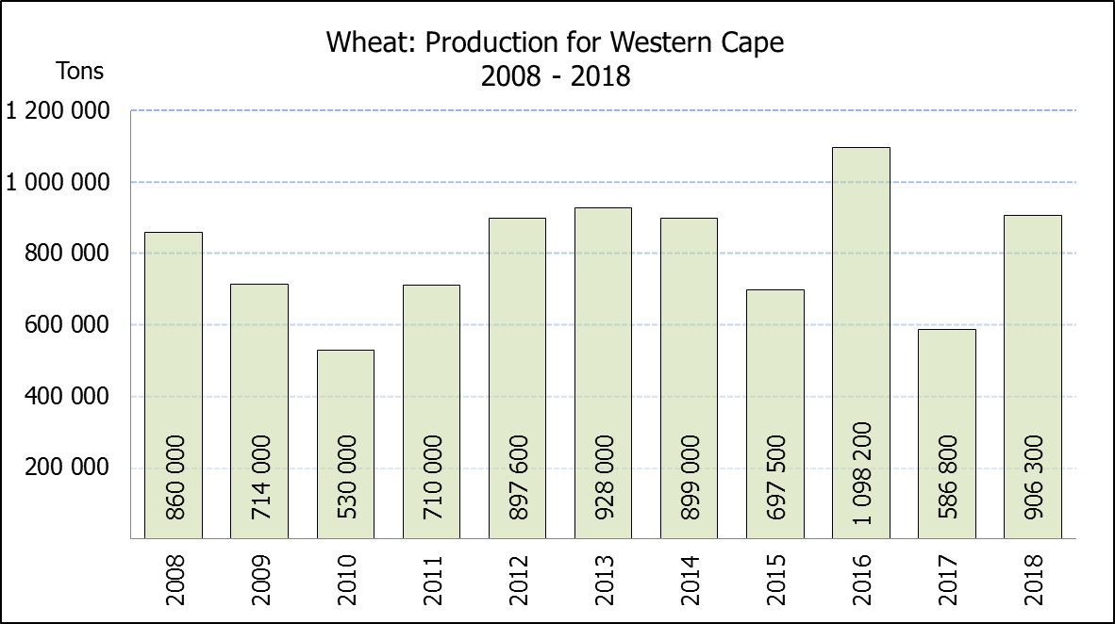
WINTER CEREALS – REVISED AREA PLANTED AND THIRD PRODUCTION FORECAST: 2018 PRODUCTION SEASON
WINTERGEWASSE – HERSIENE OPPERVLAKTE- EN DERDE PRODUKSIESKATTING: 2018-PRODUKSIESEISOEN
CROP/GEWAS | Area planted/  Opp beplant  2018 | 3rd forecast/  3de skatting  2018 | 2nd forecast/  2de skatting  2018 | Area planted/  Opp beplant  2017 | Final crop/  Finale oes  2017 | Change/  Verandering
CROP/GEWAS | Ha | Tons | Tons | Ha | Tons | %
CROP/GEWAS | (A) | (B) | (C) | (D) | (E) | (B) ÷ (C)
Commercial/Kommersieel:
Wheat/Koring | 503 350 | 1 862 400 | 1 845 100 | 491 600 | 1 535 000 | +0,94
Malting barley/Moutgars | 119 000 | 396 340 | 390 840 | 91 380 | 307 000 | +1,41
Canola/Kanola | 77 000 | 115 500 | 111 650 | 84 000 | 93 500 | 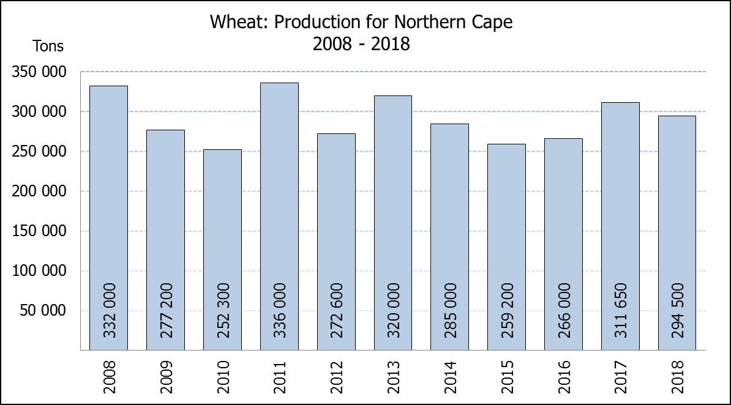  +3,45
* Note: Estimate is for calendar year, e.g. production season 2018/19 = 2018
* Nota: Skatting is vir kalenderjaar, bv. produksie-seisoen 2018/19 = 2018

WHEAT – REVISED AREA PLANTED AND THIRD PRODUCTION FORECAST: 2018
KORING – HERSIENE OPPERVLAKTE- EN DERDE PRODUKSIESKATTING: 2018
Province/  Provinsie | Area planted/  Opp beplant  Ha | 3rd forecast/  3de skatting  Tons | Area planted/  Opp beplant  Ha | Final crop/  Finale oes  Tons
Province/  Provinsie | 2018 | 2018 | 2017 | 2017
Western Cape/Wes-Kaap | 318 000 | 906 300 | 326 000 | 586 800
Northern Cape/Noord-Kaap | 38 000 | 294 500 | 38 000 | 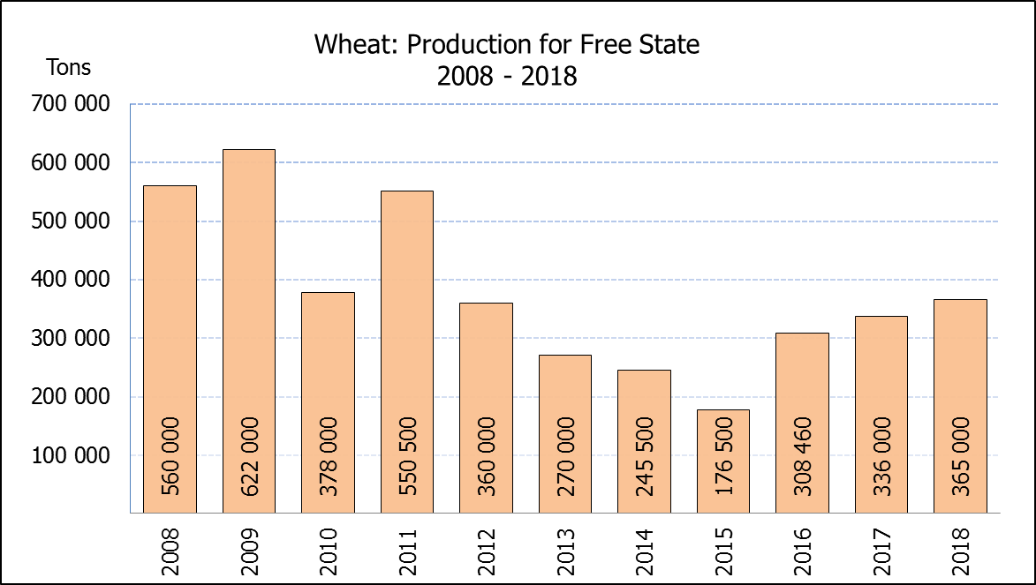  311 650
Free State/Vrystaat | 100 000 | 365 000 | 80 000 | 336 000
Eastern Cape/Oos-Kaap | 1 650 | 10 725 | 1 900 | 9 500
KwaZulu-Natal | 7 000 | 43 400 | 7 500 | 45 750
Mpumalanga | 3 500 | 21 875 | 4 000 | 25 400
Limpopo | 20 000 | 126 000 | 20 000 | 132 000
Gauteng | 1 200 | 7 800 | 700 | 4 200
North West/Noordwes | 14 000 | 86 800 | 13 500 | 83 700
Total/Totaal | 503 350 | 1 862 400 | 491 600 | 1 535 000

REVISED AREA ESTIMATE AND THIRD PRODUCTION FORECAST OF WINTER CROPS (2018) /
HERSIENE OPPERVLAKTEKSKATTING EN DERDE PRODUKSIESKATTING VAN WINTERGEWASSE (2018)
25 OCTOBER/OKTOBER 2018
Winter cereal crops - 2018 production season  Wheat: The expected commercial production of wheat is 1,862 mill. tons, which is 0,94% or 17 300 tons more than the previous forecast of 1,845 mill. tons, whilst the expected yield is 3,70 t/ha.  The expected production in the Western Cape is 906 300 tons (49%), in the Free State 365 000 tons (20%) and in the Northern Cape 294 500 tons (16%).  The area estimate for wheat was revised to 503 350 ha, which is 5 000 ha lower than the 508 350 ha of the previous forecast. An estimated 318 000 ha or 63% is planted in the Western Cape, 100 000 ha or 20% in the Free State and 38 000 ha or 8% in the Northern Cape.  Other crops: The production forecast for malting barley is 396 340 tons, which is 1,41% or 5 500 tons more than the previous forecast of 390 840 tons. The area planted is estimated at 119 000 ha, while the expected yield is 3,33 t/ha.  The expected canola crop is 115 500 tons, which is 3,45% or 3 850 tons more than the previous forecast of 111 650 tons. The area estimate for canola is 77 000 ha and the expected yield is 1,50 t/ha.  Please note that the fourth production forecast for winter cereals for 2018 will be released on 27 November 2018. |  | Wintergewasse - 2018 produksie-seisoen  Koring: Die verwagte kommersiële produksie vir koring is 1,862 milj. ton, wat 0,94% of 17 300 ton meer is as die vorige skatting van 1,845 milj. ton, terwyl die verwagte opbrengs 3,70 t/ha is.  Die verwagte produksie in die Wes-Kaap is 906 300 ton (49%), in die Vrystaat 365 000 ton (20%) en in die Noord-Kaap 294 500 ton (16%).  Die oppervlakteskatting vir koring is hersien na 503 350 ha, wat 5 000 ha minder is as die 508 350 ha teenoor die vorige skatting. Die beraamde oppervlakte geplant in die Wes-Kaap is 318 000 ha of 63%, die Vrystaat is 100 000 ha of 20% en 38 000 ha of 8% is in die Noord-Kaap.  Ander gewasse: Die produksieskatting vir moutgars is 396 340 ton, wat 1,41% of 5 500 ton meer is as die vorige skatting van 390 840 ton. Die oppervlakte beplant word beraam op 119 000 ha, terwyl die verwagte opbrengs 3,33 t/ha beloop.  Die verwagte kanola-oes is 115 500 ton, wat 3,45% of 3 850 ton meer is as die vorige skatting van 111 650 ton. Die oppervlakteskatting vir kanola is 77 000 ha en die verwagte opbrengs is 1,50 t/ha.  Neem asseblief kennis dat die vierde produksieskatting vir wintergewasse vir 2018 op 27 November 2018 vrygestel sal word.

Information is available on the internet at http://www.daff.gov.za/links/crop estimates or http://www.sagis.org.za, as from 15:30 on the date of the relevant meeting of the Crop Estimates Committee. |  | Inligting is beskikbaar op die internet by http://www.daff.gov.za/links/crop estimates of by http://www.sagis.org.za, vanaf 15:30 op die dag van die toepaslike vergadering van die Oesskattingskomitee.

