 | crop estimates committee | 
 | oesskattingskomitee
From/Van: Mr Baldwin Netshifhefhe
Tel: 012 319 8043  Fax/Faks: 012 319 8031  E-mail/E-pos: BaldwinN@dalrrd.gov.za
Web page/Webblad: www.dalrrd.gov.za/statistics and economic reports or www.sagis.org.za/CEC: Crop Estimates
EMBARGO: 14:30

The intentions’ of producers to plant summer crops for 2021 is hereby released. /
Hiermee word produsente se voorneme om somergewasse te plant vir 2021 vrygestel.

SUMMER CROPS – INTENTIONS TO PLANT: 2021
The Crop Estimates Committee comprises officials of the following institutions:
Department of Agriculture, Land Reform and Rural Development, Provincial Departments of Agriculture; various ARC-Institutes (Soil, Climate and Water; Small Grains Institute;
Grain Crops Institute); BFAP and Statistics SA.
SOMERGEWASSE – VOORNEME OM TE PLANT: 2021
CROP/GEWAS | Intentions/  Voorneme  2021 | Area planted/  Opp beplant  2020 | Ninth estimate/  Negende skatting  2020 | Change/  Verandering/
CROP/GEWAS | Ha | Ha | Tons | %
CROP/GEWAS | soos middel Okt 2020/  as mid Oct 2020 |  | as on 28 Oct 2020/  soos op 28 Okt 2020
CROP/GEWAS | (A) | (B) | (C) | (A) ÷ (B)
Commercial/Kommersieël:
White maize/Witmielies | 1 686 100 | 1 616 300 | 8 746 310 | +4,32
Yellow maize/Geelmielies | 1 059 900 | 994 500 | 6 673 910 | +6,58
Maize/Mielies | 2 746 000 | 2 610 800 | 15 420 220 | +5,18
Sunflower seed/Sonneblomsaad | 480 500 | 500 300 | 785 910 | -3,96
Soybeans/Sojabone | 785 800 | 705 000 | 1 261 250 | +11,46
Groundnuts/Grondbone | 38 000 | 37 500 | 50 080 | +1,33
Sorghum | 44 300 | 42 500 | 153 935 | +4,24
Dry beans/Droëbone | 54 650 | 50 150 | 64 800 | +8,97
TOTAL/TOTAAL | 4 149 250 | 3 946 250 | 17 736 195 | +5,14
Note: Estimate is for calendar year, e.g. production season 2020/21 = 2021
Nota: Skatting is vir kalenderjaar, bv. produksie-seisoen 2020/21 = 2021

28 October/Oktober 2020
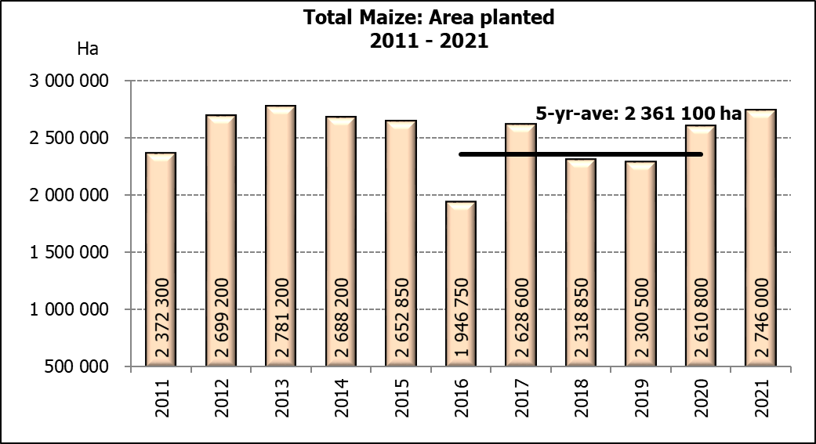

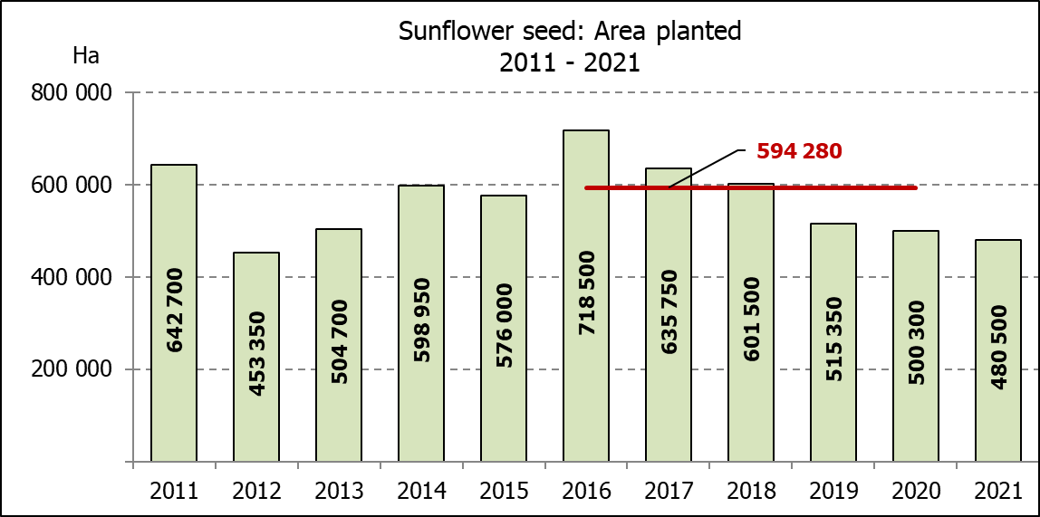

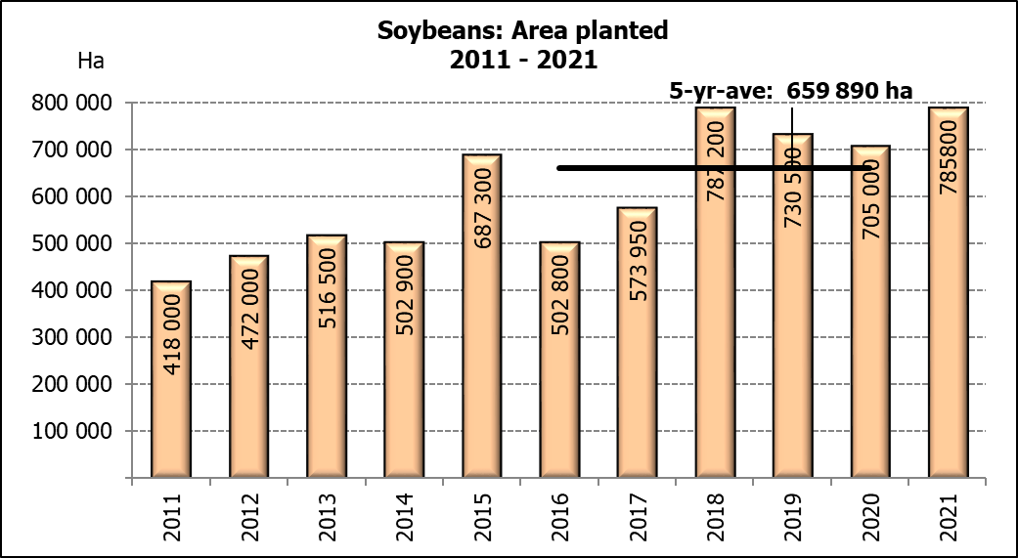
2020: Intentions’ of farmers/Produsente se voornemens

WHITE AND YELLOW MAIZE – INTENTIONS TO PLANT: 2021
WIT- EN GEELMIELIES – VOORNEME OM TE PLANT: 2021
Provinsie/  Province | Intentions (Area planted)/  Voorneme (Oppervlakte beplant)  2021 |  |  | Area planted/  Oppervlakte beplant  2020 |  |  | Ninth estimate¹⁾/  Negende skatting¹⁾  2020
Provinsie/  Province | White/  Wit  Ha | Yellow/  Geel  Ha | Total/  Totaal  Ha | White/  Wit  Ha | Yellow/  Geel  Ha | Total/  Totaal  Ha | White/  Wit  Tons | Yellow/  Geel  Tons | Total/  Totaal  Tons
Western Cape/Wes-Kaap | 500 | 3 400 | 3 900 | 400 | 3 400 | 3 800 | 3 600 | 30 600 | 34 200
Northern Cape/Noord-Kaap | 3 500 | 42 000 | 45 500 | 3 400 | 43 100 | 46 500 | 40 460 | 629 260 | 669 720
Free State/Vrystaat | 905 000 | 412 000 | 1 317 000 | 855 000 | 365 000 | 1 220 000 | 4 788 000 | 2 171 750 | 6 959 750
Eastern Cape/Oos-Kaap | 4 600 | 20 000 | 24 600 | 5 500 | 17 000 | 22 500 | 35 750 | 119 000 | 154 750
KwaZulu-Natal | 48 000 | 52 500 | 100 500 | 47 000 | 55 000 | 102 000 | 305 500 | 434 500 | 740 000
Mpumalanga | 170 000 | 360 000 | 530 000 | 160 000 | 353 000 | 513 000 | 880 000 | 2 329 800 | 3 209 800
Limpopo | 16 500 | 20 000 | 36 500 | 15 000 | 18 000 | 33 000 | 105 000 | 126 000 | 231 000
Gauteng | 56 000 | 50 000 | 106 000 | 55 000 | 50 000 | 105 000 | 308 000 | 320 000 | 628 000
North West/Noordwes | 482 000 | 100 000 | 582 000 | 475 000 | 90 000 | 565 000 | 2 280 000 | 513 000 | 2 793 000
Total/Totaal | 1 686 100 | 1 059 900 | 2 746 000 | 1 616 300 | 994 500 | 2 610 800 | 8 746 310 | 6 673 910 | 15 420 220

- 28 October 2020
SUNFLOWER SEED –INTENTIONS TO PLANT: 2021
SONNEBLOMSAAD – VOORNEME OM TE PLANT: 2021
Province/  Provinsie | Area planted/  Opp beplant  Ha | Area planted/  Opp beplant  Ha | Ninth estimate¹⁾/  Negende skatting¹⁾  Tons
Province/  Provinsie | 2021 | 2020 | 2020
Western Cape/Wes-Kaap | - | - | -
Northern Cape/Noord-Kaap | 1 100 | 1 200 | 1 440
Free State/Vrystaat | 230 000 | 260 000 | 442 000
Eastern Cape/Oos-Kaap | - | 300 | 750
KwaZulu-Natal | - | - | -
Mpumalanga | 2 500 | 2 800 | 3 920
Limpopo | 75 000 | 65 000 | 65 000
Gauteng | 3 900 | 4 000 | 5 600
North West/Noordwes | 168 000 | 167 000 | 267 200
Total/Totaal | 480 500 | 500 300 | 785 910
- 28 October 2020

SOYBEANS – INTENTIONS TO PLANT: 2021
SOJABONE – VOORNEME OM TE PLANT: 2021
Province/  Provinsie | Area planted/  Opp beplant  Ha | Area planted/  Opp beplant  Ha | Ninth estimate¹⁾/  Negende skatting¹⁾  Tons
Province/  Provinsie | 2021 | 2020 | 2020
Western Cape/Wes-Kaap | - | - | -
Northern Cape/Noord-Kaap | 1 800 | 2 000 | 7 000
Free State/Vrystaat | 375 000 | 315 000 | 535 500
Eastern Cape/Oos-Kaap | 1 500 | 1 500 | 3 000
KwaZulu-Natal | 35 500 | 35 000 | 101 500
Mpumalanga | 267 000 | 260 000 | 416 000
Limpopo | 20 000 | 15 500 | 48 050
Gauteng | 40 000 | 36 000 | 70 200
North West/Noordwes | 45 000 | 40 000 | 80 000
Total/Totaal | 785 800 | 705 000 | 1 261 250
- 28 October 2020

INTENTIONS TO PLANT SUMMER CROPS (2021) / VOORNEME OM SOMERGEWASSE TE PLANT (2021)
Producers intentions to plant summer crops are based on the results of a non-probability survey conducted by the Directorate: Statistics and Economic Analysis of the Department of Agriculture, Land Reform and Rural Development and reflects the position as at the middle of October 2020.  According to the results of the survey, commercial producers intend to plant 2,746 mill. ha of maize for 2021, which is 5,18% or 135 200 ha more than the 2,611 mill. ha planted last season.  The figures show that producers intend to plant 1,686 mill. ha to white maize, which is 69 800 ha (4,32%) more than in the previous season. In the case of yellow maize, the expected plantings are 1,060 mill. ha, which is 65 400 ha (6,58%) more than in the previous season.  In the case of sunflower seed, the expected area planted is estimated at 480 500 ha, which is 3,96% or 19 800 ha less than the 500 300 ha planted last season.  The intended plantings of soybeans shows an increase of 11,46% or 80 800 ha compared to the previous season – from 705 000 ha to 785 800 ha.  The expected plantings of groundnuts will increase by 1,33% or 500 ha, from 37 500 ha to 38 000 ha.  The intended plantings of sorghum is expected to increase by 4,24% or 1 800 ha to 44 300 ha, compared to the previous season.  The expected plantings of dry beans is estimated at 54 650 ha, which is 8,97% or 4 500 ha more than in the previous season.  Please note that the preliminary area planted estimate for summer grains for 2021 will be released on 28 January 2021. |  | Produsente se voorneme om somergewasse te plant is gebaseer op die resultate van ’n nie-ewekansige opname onderneem deur die Direktoraat: Statistiek en Ekonomiese Analise van die Departement van Landbou, Grondhervorming en Landelike Ontwikkeling en weerspieël die situasie teen die middel van Oktober 2020.  Volgens die resultate van die opname, is kommersiele produsente van voorneme om 2,746 milj. ha mielies vir 2021 te plant, wat 5,18% of 135 200 ha meer is as die 2,611 milj. ha aangeplant verlede seisoen.  Die syfers toon dat produsente van voorneme is om 1,686 milj. ha witmielies aan te plant, wat 69 800 ha (4,32%) meer is as in die vorige seisoen. In die geval met geelmielies is die verwagte aanplantings 1,060 milj. ha, wat 65 400 ha (6,58%) meer is as in die vorige seisoen.  In die geval van sonneblomsaad word die verwagte aanplantings beraam op 480 500 ha, wat 3,96% of 19 800 ha minder is as die 500 300 ha aangeplant verlede seisoen.  Die voorgenome sojaboon-aanplantings toon ’n toename van 11,46% of 80 800 ha, in vergelyking met die vorige seisoen - vanaf 705 000 ha tot 785 800 ha.  Die verwagte aanplantings van grondbone gaan toeneem met 1,33% of 500 ha, van 37 500 ha tot 38 000 ha.  Die voorgenome aanplantings van sorghum sal na verwagting toeneem met 4,24% of 1 800 ha na 44 300 ha, in vergelyking met die vorige seisoen.  Die verwagte aanplantings van droëbone word beraam op 54 650 ha, wat 8,97% of 4 500 ha meer is as in die vorige seisoen.  Neem asseblief kennis dat die voorlopige oppervlakteskatting vir somergewasse vir 2021 op 28 Januarie 2021 vrygestel sal word.

The area planted estimate and ninth production forecast for summer crops for 2020 is hereby released.
Hiermee word die oppervlakte- en negende produksieskatting vir somergewasse vir 2020 vrygestel.

SUMMER CROPS – AREA PLANTED AND NINTH PRODUCTION FORECAST: 2020
SOMERGEWASSE – OPPERVLAKTE- EN NEGENDE PRODUKSIESKATTING: 2020
CROP/GEWAS | Area planted/  Opp beplant  2020 | 9th forecast/  9de skatting  2020 | 8th forecast/  8ste skatting  2020 | Area planted/  Opp beplant  2019 | Final crop/  Finale oes  2019 | Change/  Verandering/
CROP/GEWAS | Ha | Tons | Tons | Ha | Tons | %
CROP/GEWAS | (A) | (B) | (C) | (D) | (E) | (B) ÷ (C)
Commercial/Kommersieël:
White maize/Witmielies | 1 616 300 | 8 746 310 | 8 801 760 | 1 298 400 | 5 545 000 | -0,63
Yellow maize/Geelmielies | 994 500 | 6 673 910 | 6 620 360 | 1 002 100 | 5 730 000 | +0,81
Total Maize/Totale Mielies | 2 610 800 | 15 420 220 | 15 422 120 | 2 300 500 | 11 275 000 | -0,01
Sunflower seed/Sonneblomsaad | 500 300 | 785 910 | 785 910 | 515 350 | 678 000 | -
Soybeans/Sojabone | 705 000 | 1 261 250 | 1 261 250 | 730 500 | 1 170 345 | -
Groundnuts/Grondbone | 37 500 | 50 080 | 50 080 | 20 050 | 19 400 | -
Sorghum | 42 500 | 153 935 | 150 885 | 50 500 | 127 000 | +2,02
Dry beans/Droëbone | 50 150 | 64 800 | 64 800 | 59 300 | 66 355 | -
Non-Commercial Maize/Nie-Kommersiële Mielies
Total Maize/Totaal Mielies | 297 460 | 543 545 | 543 545 | 296 000 | 549 180 | -
Maize/Mielies: Commercial/Kommersieël + Non-Commercial/Nie-Kommersieël
Total Maize RSA/Totaal Mielies RSA | 2 908 260 | 15 963 765 | 15 965 665 | 2 596 500 | 11 824 180 | -0,01
Note: Estimate is for calendar year, e.g. production season 2019/20 = 2020
Nota: Skatting is vir kalenderjaar, bv. produksie-seisoen 2019/20 = 2020

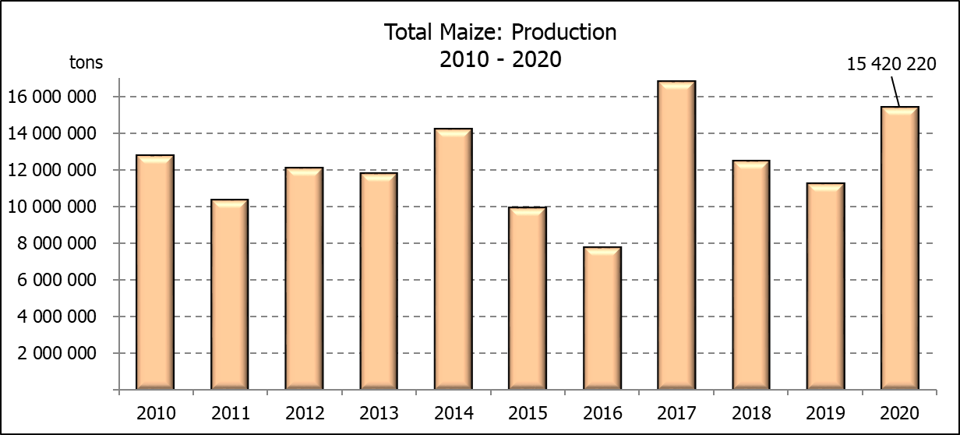

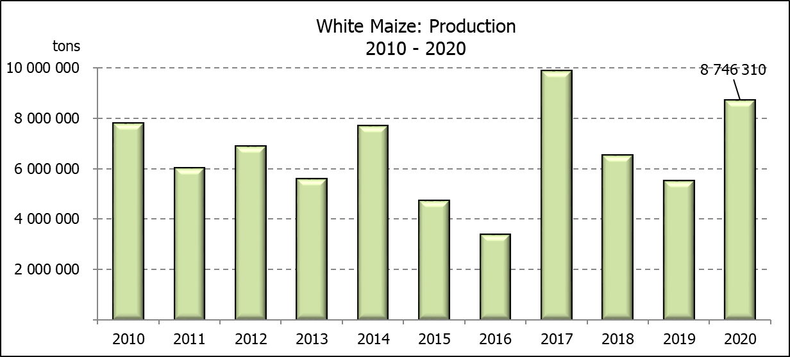
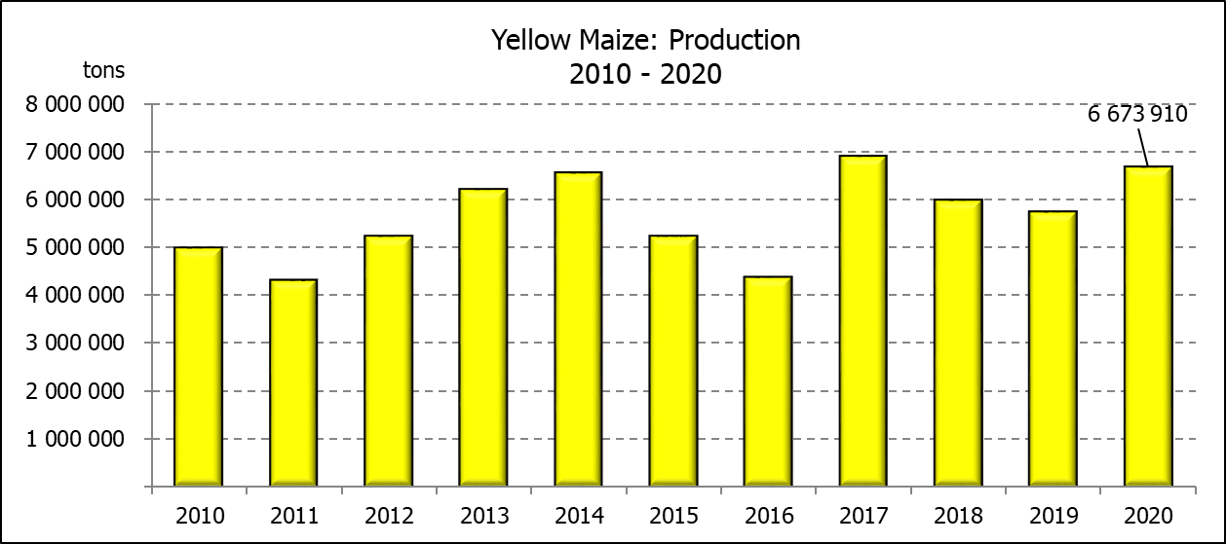

WHITE AND YELLOW MAIZE – AREA PLANTED AND NINTH PRODUCTION FORECAST: 2020
WIT- EN GEELMIELIES – OPPERVLAKTE EN NEGENDE PRODUKSIESKATTING: 2020

Provinsie/  Province | Area planted/  Oppervlakte beplant  2020 |  |  | 9th forecast/  9de skatting  2020 |  |  | Area planted/  Oppervlakte beplant  2019 |  |  | Final crop/  Finale oes  2019
Provinsie/  Province | White/  Wit  Ha | Yellow/  Geel  Ha | Total/  Totaal  Ha | White/  Wit  Tons | Yellow/  Geel  Tons | Total/  Totaal  Tons | White/  Wit  Ha | Yellow/  Geel  Ha | Total/  Totaal  Ha | White/  Wit  Tons | Yellow/  Geel  Tons | Total/  Totaal  Tons
Western Cape/Wes-Kaap | 400 | 3 400 | 3 800 | 3 600 | 30 600 | 34 200 | 400 | 3 400 | 3 800 | 3 600 | 30 600 | 34 200
Northern Cape/Noord-Kaap | 3 400 | 43 100 | 46 500 | 40 460 | 629 260 | 669 720 | 3 400 | 43 500 | 46 900 | 39 500 | 630 750 | 670 250
Free State/Vrystaat | 855 000 | 365 000 | 1 220 000 | 4 788 000 | 2 171 750 | 6 959 750 | 650 000 | 380 000 | 1 030 000 | 2 795 000 | 1 758 000 | 4 553 000
Eastern Cape/Oos-Kaap | 5 500 | 17 000 | 22 500 | 35 750 | 119 000 | 154 750 | 3 800 | 10 200 | 14 000 | 23 000 | 69 750 | 92 750
KwaZulu-Natal | 47 000 | 55 000 | 102 000 | 305 500 | 434 500 | 740 000 | 45 000 | 54 000 | 99 000 | 270 000 | 399 600 | 669 600
Mpumalanga | 160 000 | 353 000 | 513 000 | 880 000 | 2 329 800 | 3 209 800 | 145 000 | 338 000 | 483 000 | 797 500 | 1 977 300 | 2 774 800
Limpopo | 15 000 | 18 000 | 33 000 | 105 000 | 126 000 | 231 000 | 12 800 | 18 000 | 30 800 | 83 200 | 117 000 | 200 200
Gauteng | 55 000 | 50 000 | 105 000 | 308 000 | 320 000 | 628 000 | 48 000 | 60 000 | 108 000 | 259 200 | 348 000 | 607 200
North West/Noordwes | 475 000 | 90 000 | 565 000 | 2 280 000 | 513 000 | 2 793 000 | 390 000 | 95 000 | 485 000 | 1 274 000 | 399 000 | 1 673 000
Total/Totaal | 1 616 300 | 994 500 | 2 610 800 | 8 746 310 | 6 673 910 | 15 420 220 | 1 298 400 | 1 002 100 | 2 300 500 | 5 545 000 | 5 730 000 | 11 275 000

SUNFLOWER SEED – AREA PLANTED AND NINTH PRODUCTION FORECAST: 2020
SONNEBLOMSAAD – OPPERVLAKTE EN NEGENDE PRODUKSIESKATTING: 2020

Province/  Provinsie | Area planted/  Opp beplant  Ha | 9th forecast/  9de skatting  Tons | Area planted/  Opp beplant  Ha | Final crop/  Finale oes  Tons
Province/  Provinsie | 2020 | 2020 | 2019 | 2019
Western Cape/Wes-Kaap | - | - | - | -
Northern Cape/Noord-Kaap | 1 200 | 1 440 | 950 | 1 140
Free State/Vrystaat | 260 000 | 442 000 | 270 000 | 391 500
Eastern Cape/Oos-Kaap | 300 | 750 | 100 | 260
KwaZulu-Natal | - | - | - | -
Mpumalanga | 2 800 | 3 920 | 4 500 | 4 500
Limpopo | 65 000 | 65 000 | 61 000 | 61 000
Gauteng | 4 000 | 5 600 | 3 800 | 3 800
North West/Noordwes | 167 000 | 267 200 | 175 000 | 215 800
Total/Totaal | 500 300 | 785 910 | 515 350 | 678 000
SOYBEANS – AREA PLANTED AND NINTH PRODUCTION FORECAST: 2020
SOJABONE – OPPERVLAKTE EN NEGENDE PRODUKSIESKATTING: 2020

Province/  Provinsie | Area planted/  Opp beplant  Ha | 9th forecast/  9de skatting  Tons | Area planted/  Opp beplant  Ha | Final crop/  Finale oes  Tons
Province/  Provinsie | 2020 | 2020 | 2019 | 2019
Western Cape/Wes-Kaap | - | - | 100 | 10
Northern Cape/Noord-Kaap | 2 000 | 7 000 | 1 550 | 5 425
Free State/Vrystaat | 315 000 | 535 500 | 301 000 | 391 300
Eastern Cape/Oos-Kaap | 1 500 | 3 000 | 1 150 | 1 380
KwaZulu-Natal | 35 000 | 101 500 | 33 000 | 99 000
Mpumalanga | 260 000 | 416 000 | 310 000 | 511 500
Limpopo | 15 500 | 48 050 | 16 200 | 46 980
Gauteng | 36 000 | 70 200 | 31 500 | 66 150
North West/Noordwes | 40 000 | 80 000 | 36 000 | 48 600
Total/Totaal | 705 000 | 1 261 250 | 730 500 | 1 170 345

GROUNDNUTS – AREA PLANTED AND NINTH PRODUCTION FORECAST: 2020
GRONDBONE – OPPERVLAKTE EN NEGENDE PRODUKSIESKATTING: 2020

Province/  Provinsie | Area planted/  Opp beplant  Ha | 9th forecast/  9de skatting  Tons | Area planted/  Opp beplant  Ha | Final crop/  Finale oes  Tons
Province/  Provinsie | 2020 | 2020 | 2019 | 2019
Western Cape/Wes-Kaap | - | - | - | -
Northern Cape/Noord-Kaap | 1 200 | 2 580 | 1 200 | 2 520
Free State/Vrystaat | 11 000 | 15 400 | 8 000 | 9 775
Eastern Cape/Oos-Kaap | - | - | - | -
KwaZulu-Natal | - | - | - | -
Mpumalanga | - | - | - | -
Limpopo | 2 900 | 5 220 | 1 850 | 3 530
Gauteng | - | - | - | -
North West/Noordwes | 22 400 | 26 880 | 9 000 | 3 575
Total/Totaal | 37 500 | 50 080 | 20 050 | 19 400

SORGHUM – AREA PLANTED AND NINTH PRODUCTION FORECAST: 2020
SORGHUM – OPPERVLAKTE EN NEGENDE PRODUKSIESKATTING: 2020

Province/  Provinsie | Area planted/  Opp beplant  Ha | 9th forecast/  9de skatting  Tons | Area planted/  Opp beplant  Ha | Final crop/  Finale oes  Tons
Province/  Provinsie | 2020 | 2020 | 2019 | 2019
Western Cape/Wes-Kaap | - | - | - | -
Northern Cape/Noord-Kaap | - | - | - | -
Free State/Vrystaat | 8 000 | 34 400 | 8 000 | 23 600
Eastern Cape/Oos-Kaap | - | - | - | -
KwaZulu-Natal | 1 200 | 4 200 | 500 | 1 500
Mpumalanga | 8 500 | 45 900 | 7 500 | 36 000
Limpopo | 16 000 | 40 000 | 25 000 | 46 125
Gauteng | 300 | 960 | 1 000 | 3 200
North West/Noordwes | 8 500 | 28 475 | 8 500 | 16 575
Total/Totaal | 42 500 | 153 935 | 50 500 | 127 000

DRY BEANS – AREA PLANTED AND NINTH PRODUCTION FORECAST: 2020
DROëBONE – OPPERVLAKTE EN NEGENDE PRODUKSIESKATTING: 2020

Province/  Provinsie | Area planted/  Opp beplant  Ha | 9th forecast/  9de skatting  Tons | Area planted/  Opp beplant  Ha | Final crop/  Finale oes  Tons
Province/  Provinsie | 2020 | 2020 | 2019 | 2019
Western Cape/Wes-Kaap | 100 | 150 | 100 | 180
Northern Cape/Noord-Kaap | 350 | 700 | 1 000 | 1 400
Free State/Vrystaat | 24 000 | 30 000 | 27 000 | 28 350
Eastern Cape/Oos-Kaap | 200 | 300 | 400 | 720
KwaZulu-Natal | 2 900 | 3 480 | 3 500 | 4 025
Mpumalanga | 6 600 | 8 250 | 7 500 | 6 750
Limpopo | 8 400 | 13 440 | 7 800 | 12 480
Gauteng | 600 | 780 | 1 500 | 1 950
North West/Noordwes | 7 000 | 7 700 | 10 500 | 10 500
Total/Totaal | 50 150 | 64 800 | 59 300 | 66 355

CONFIDENTIALITY ISSUES that CEC members are committed to adhere to on the day of the meeting
- Personal items such as laptops, handbags, cell phones, etc. are not allowed in the venue during the meeting
- No member is allowed to leave the meeting before 12:00 in order to prevent disclosure of the information
- The embargo time for the release of crop estimates information is 14:30
- No member is allowed to discuss crop estimates information with anyone other than a member of the Committee before the embargo time
- Only the Chairperson, or a member appointed by the Chairperson, may release the figures to the media
- Members must regard the detail of any information that was collected for and/or discussed during the meeting, as confidential
- Individual information received for crop estimate purposes is treated strictly confidential, and is not divulged for any other purposes

AREA ESTIMATE AND NINTH PRODUCTION FORECAST OF SUMMER CROPS (2020 PRODUCTION SEASON)/
OPPERVLAKTE- EN NEGENDE PRODUKSIESKATTING VIR SOMERGEWASSE (2020 PRODUKSIE-SEISOEN)
28 OCTOBER/OKTOBER 2020

Summer field crops – 2020  Commercial maize: The size of the expected commercial maize crop has been set at 15,420 mill. tons, which is 0,01% or 1 900 tons less than the previous forecast of 15,422 mill. tons. The area estimate for maize is 2,611 mill. ha, while the expected yield is 5,91 t/ha.  The estimated maize crop is 37% bigger than the 2019 crop. The three main maize producing areas, namely the Free State, Mpumalanga and North West provinces are expected to produce 84% of the 2020 crop.  The area estimate for white maize is 1,616 mill. ha & for yellow maize the area estimate is 994 500 ha.  The production forecast of white maize is 8,746 mill. tons, which is 0,63% or 55 450 tons less than the 8,802 mill. tons of the previous forecast. The yield for white maize is 5,41 t/ha. The production forecast of yellow maize is 6,674 mill. tons, which is 0,81% or 53 550 tons more than the 6,620 mill. tons of the previous forecast. The yield for yellow maize is 6,71 t/ha.  Sunflower seed: The production forecast for sunflower seed remained unchanged at 785 910 tons. The area estimate for sunflower seed is 500 300 ha, while the expected yield is 1,57 t/ha.  Other crops: The production forecast for soybeans also remained unchanged at 1,261 mill. tons. The estimated area planted to soybeans is 705 000 ha and the expected yield is 1,79 t/ha.  The expected groundnut crop remained unchanged at 50 080 tons. The area estimate is 37 500 ha, with an expected yield of 1,34 t/ha.  The production forecast for sorghum is 153 935 tons, which is 2,02% or 3 050 tons more than the 150 885 tons of the previous forecast. The area estimate for sorghum is 42 500 ha and the expected yield is 3,62 t/ha.  In the case of dry beans, the production forecast remained unchanged at 64 800. The area estimate of dry beans is 50 150 ha, with an expected yield of 1,29 t/ha.  Please note that the final production estimate for summer field crops for 2020 will be released on 26 November 2020. |  | Somergewasse – 2020  Kommersiële mielies: Die grootte van die verwagte kommersiële mielie-oes is op 15,420 milj. ton gestel, wat 0,01% of 1 900 ton minder is as die vorige skatting van 15,422 milj. ton. Die skatting van die oppervlakte onder mielies is 2,611 milj. ha, terwyl die verwagte opbrengs 5,91 t/ha is.  Die geskatte mielie-oes is 37% groter as die 2019-oes. Die drie belangrikste mielieproduserende gebiede, nl. die Vrystaat, Mpumalanga en Noordwes provinsies, gaan na verwagting 84% van die 2020-oes produseer.  Die oppervlak onder witmielies is 1,616 milj. ha en vir geelmielies is die oppervlak 994 500 ha.  Die produksieskatting van witmielies is 8,746 milj. ton, wat 0,63% of 55 450 ton minder is as die 8,802 milj. ton van die vorige skatting. Die opbrengs van witmielies is 5,41 t/ha. Die produksieskatting van geelmielies is 6,674 milj. ton, wat 0,81% of 53 550 ton meer as die 6,620 milj. ton van die vorige skatting. Die opbrengs van geelmielies is 6,71 t/ha.  Sonneblomsaad: Die produksieskatting vir sonneblomsaad is onveranderd gelaat op 785 910 ton. Die oppervlakteskatting vir sonneblomsaad is 500 300 ha, terwyl die verwagte opbrengs 1,57 t/ha is.  Ander gewasse: Die produksieskatting van sojabone is ook onveranderd gelaat op 1,261 milj. ton Die geskatte oppervlakte beplant van sojabone is 705 000 ha en die verwagte opbrengs is 1,79 t/ha.  Die verwagte grondbone-oes is onverander gelaat op 50 080 ton. Die oppervlakteskatting is 37 500 ha, terwyl the verwagte opbrengs 1,34 t/ha is.  Die produksieskatting van sorghum is 153 935 ton, wat 2,02% of 3 050 ton meer is as die 150 885 ton van die vorige skatting. Die oppervlakteskatting vir sorghum is 42 500 ha, en die verwagte opbrengs is 3,62 t/ha.  In die geval van droëbone is die produksieskatting onveranderd gelaat op 64 800 ton. Die oppervlakte beplant met droëbone is 50 150 ha, en die verwagte opbrengs is 1,29 t/ha.  Neem asseblief kennis dat die finale produksieskatting vir somergewasse vir 2020, op 26 November 2020 vrygestel sal word.
Information is available on the internet at http://www.dalrrd.gov.za/statistics and economic reports or http://www.sagis.org.za, as from 14:30 on the date of the relevant meeting of the Crop Estimates Committee. |  | Inligting is beskikbaar op die internet by http://www.dalrrd.gov.za/statistics and economic reports of by http://www.sagis.org.za, vanaf 14:30 op die dag van die toepaslike vergadering van die Oesskattingskomitee.

The non-commercial agricultural sectors’ production estimate for maize for 2020 is hereby released. /
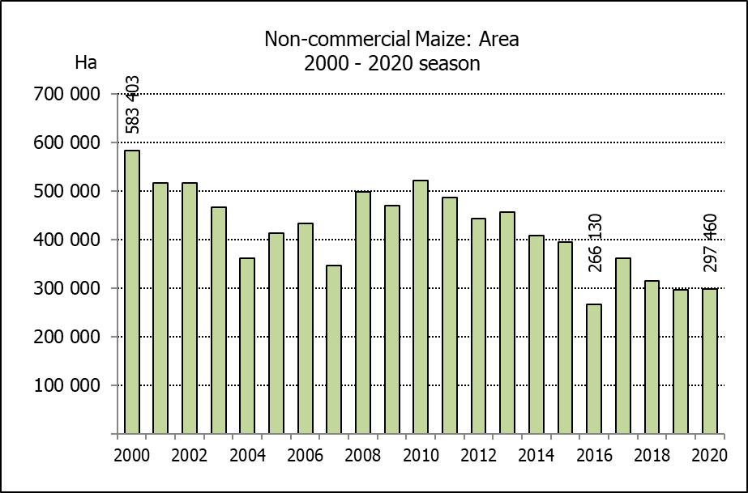
Hiermee word die nie-kommersiële landbou-sektor se produksieskatting vir mielies vir 2020 vrygestel.

NON-COMMERCIAL MAIZE – AREA PLANTED AND PRODUCTION ESTIMATE: 2020
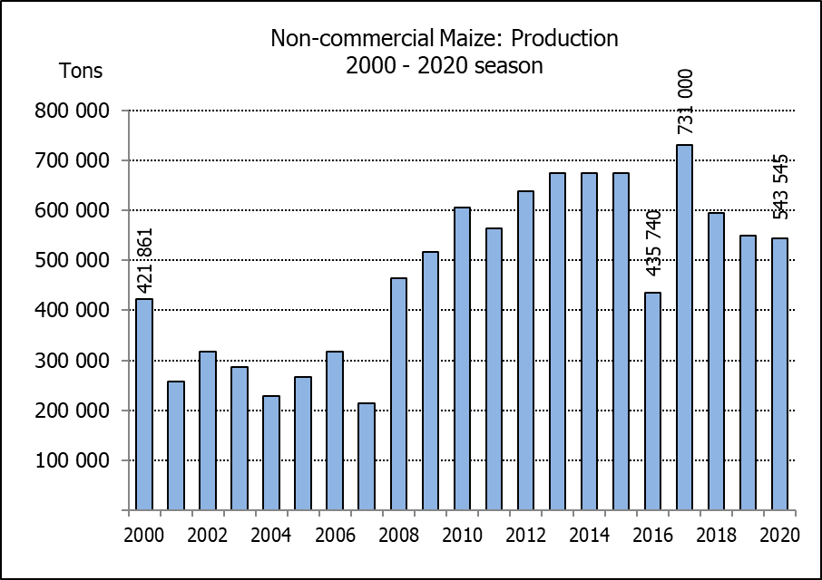
NIE-KOMMERSIëLE MIELIES – OPPERVLAKTE- EN PRODUKSIESKATTING: 2020
CROP/GEWAS | Area planted/  Opp beplant  2020 | Production/  Produksie  2020 | Area planted/  Opp beplant  2019 | Final crop/  Finale oes  2019 | Change/  Verandering
CROP/GEWAS | Ha | Tons | Ha | Tons | %
CROP/GEWAS | (A) | (B) | (C) | (D) | (B) ÷ (D)
Non-commercial agriculture/Nie-kommersiële landbou:
White maize/Witmielies | 221 945 | 375 295 | 221 300 | 379 460 | -1,10
Yellow maize/Geelmielies | 75 515 | 168 250 | 74 700 | 169 720 | -0,87
Maize/Mielies | 297 460 | 543 545 | 296 000 | 549 180 | -1,03
The area planted to maize in the non-commercial agricultural sector is estimated at 297 460 ha, which represents a slight increase of 0,49%, compared to the 296 000 ha of the previous season. The expected maize crop for this sector is 543 545 tons, which is 1,03% less than the 549 180 tons of last season. It is important to note that about 40% of the maize produced in the non-commercial sector, is planted in the Eastern Cape, followed by KwaZulu-Natal with 27%.
Die oppervlakte beplant met mielies in die nie-kommersiële landbou-sektor word geskat op 297 460 ha, wat ’n effense toename van 0,49 % verteenwoordig in vergelyking met die 296 000 ha van die vorige seisoen. Die verwagte mielie-oes van dié sektor is 543 545 ton, wat 1,03% minder is as die 549 180 ton van die vorige seisoen. Dit is belangrik om daarop te let dat ongeveer 40% van die mielies wat geproduseer word in die nie-kommersiële sektor, in die Oos-Kaap geplant word, gevolg deur KwaZulu-Natal met 27%.

The area estimate and third production forecast for winter cereals for the 2020 is hereby released. /
Hiermee word die oppervlakte- en derde produksieskatting vir wintergewasse vir 2020 vrygestel.

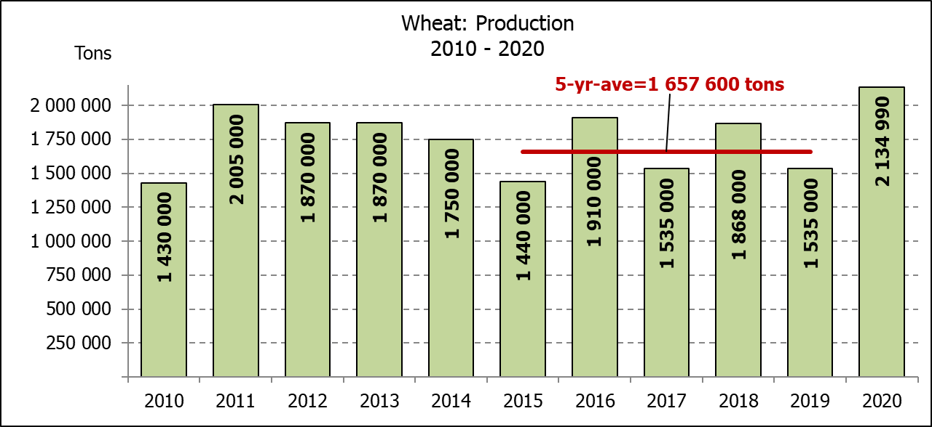
WINTER CEREALS – AREA PLANTED AND THIRD PRODUCTION FORECAST: 2020 PRODUCTION SEASON
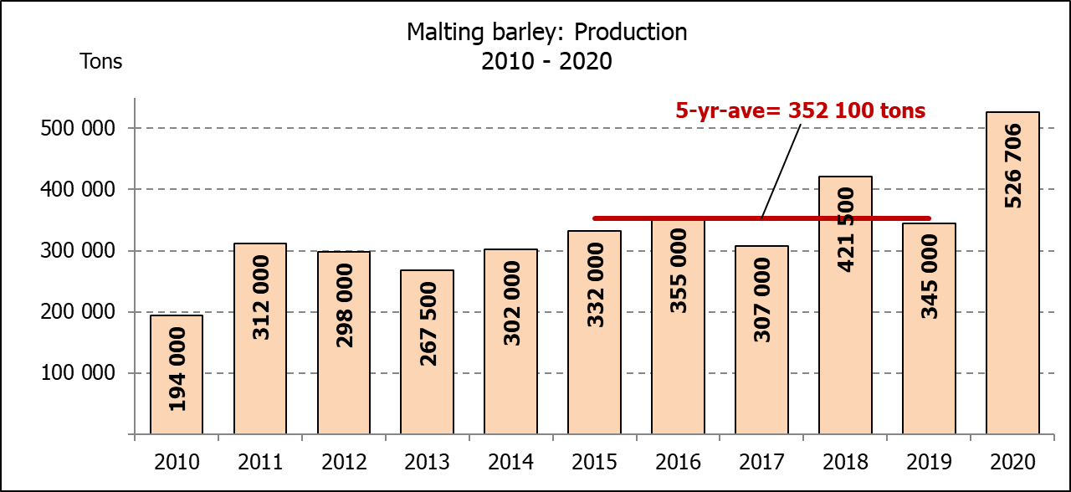
WINTERGEWASSE - OPPERVLAKTE- EN DERDE PRODUKSIESKATTING: 2020 PRODUKSIE-SEISOEN
CROP/GEWAS | Area planted/  Opp beplant  2020 | 3rd forecast/  3de skatting  2020 | 2nd forecast/  2de skatting  2020 | Area planted/  Opp beplant  2019 | Final crop/  Finale oes  2019 | Change/  Verandering
CROP/GEWAS | Ha | Tons | Tons | Ha | Tons | %
CROP/GEWAS | (A) | (B) | (C) | (D) | (E) | (B) ÷ (C)
Commercial/Kommersieel:
Wheat/Koring | 509 800 | 2 134 990 | 2 024 030 | 540 000 | 1 535 000 | +5,48
Malting barley/Moutgars | 141 690 | 526 706 | 520 106 | 131 960 | 345 000 | +1,27
Canola/Kanola | 74 120 | 137 356 | 126 520 | 74 000 | 95 000 | +8,56
Cereal oats/Hawermout | 26 200 | 47 400 | 44 900 | 21 000 | 16 500 | +5,57
* Note: Estimate is for calendar year, e.g. production season 2020/21 = 2020
* Nota: Skatting is vir kalenderjaar, bv. produksie-seisoen 2020/21 = 2020

WHEAT – AREA PLANTED AND THIRD PRODUCTION FORECAST: 2020
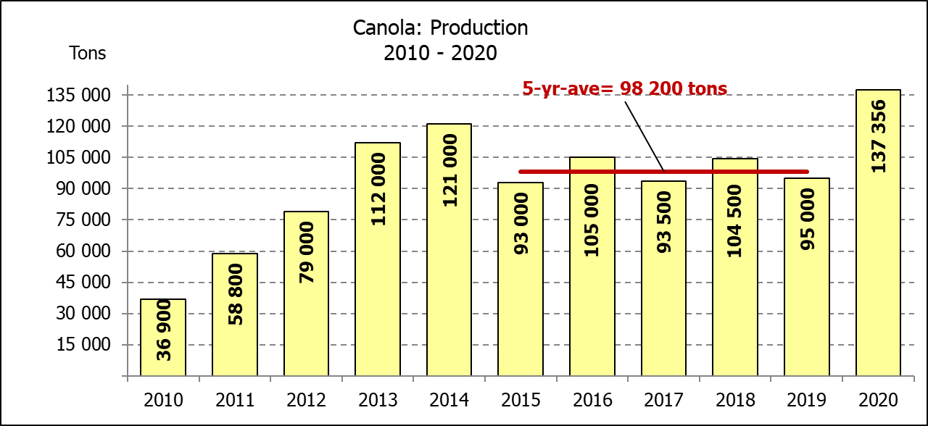
KORING – OPPERVLAKTE- EN DERDE PRODUKSIESKATTING: 2020
Province/  Provinsie | Area planted/  Opp beplant  Ha | 3rd forecast/  3de skatting  Tons | Area planted/  Opp beplant  Ha | Final crop/  Finale oes  Tons
Province/  Provinsie | 2020 | 2020 | 2019 | 2019
Western Cape/Wes-Kaap | 326 000 | 1 092 100 | 325 000 | 650 000
Northern Cape/Noord-Kaap | 37 000 | 277 500 | 37 500 | 262 500
Free State/Vrystaat | 94 000 | 432 400 | 128 000 | 326 000
Eastern Cape/Oos-Kaap | 4 000 | 24 800 | 3 100 | 18 150
KwaZulu-Natal | 7 800 | 48 360 | 7 500 | 45 750
Mpumalanga | 3 000 | 19 500 | 4 000 | 25 200
Limpopo | 23 000 | 147 200 | 20 000 | 120 000
Gauteng | 1 300 | 8 190 | 1 400 | 8 400
North West/Noordwes | 13 700 | 84 940 | 13 500 | 79 000
Total/Totaal | 509 800 | 2 134 990 | 540 000 | 1 535 000

AREA ESTIMATE AND THIRD PRODUCTION FORECAST OF WINTER CROPS (2020) /
OPPERVLAKTESKATTING EN DERDE PRODUKSIESKATTING VAN WINTERGEWASSE (2020)
28 OCTOBER / OKTOBER 2020
Winter cereal crops - 2020 production season  Wheat: The expected production of wheat is 2,135 mill. tons, which is 5,48% or 110 960 tons more than the previous forecast of 2,024 mill. tons, whilst the expected yield is 4,19 t/ha. This is the largest expected wheat crop since the 2,427 mill. tons of the 2002 season.  The expected production in the Western Cape is 1,092 mill. tons (51%), in the Free State 432 400 tons (20%) and in the Northern Cape 277 500 tons (13%).  Other crops: The production forecast for malting barley is 526 706 tons, which is 1,27% or 6 600 tons more than the previous forecast of 520 106 tons. The area planted is estimated at 141 690 ha, while the expected yield is 3,72 t/ha.  The expected canola crop is 137 356 tons, which is 8,56% or 10 836 tons more than the previous forecast of 126 520 tons. The area estimate for canola is 74 120 ha, with an expected yield of 1,85 t/ha.  The expected oats (cereals) crop for 2020 is 47 400 tons. The area estimate is 26 200 ha and the expected yield is 1,81 t/ha.  Please note that the fourth production forecast for winter cereals for 2020 will be released on 26 November 2020. |  | Wintergewasse - 2020 produksie-seisoen  Koring: Die verwagte produksie vir koring is 2,134 milj. ton, wat 5,48% of 110 960 ton meer is as die vorige skatting van 2,024 milj. ton, terwyl die verwagte opbrengs 4,19 t/ha is. Hierdie is die grootste verwagte koring-oes sedert die 2,427 milj. ton van die 2002 seisoen.  Die verwagte produksie in die Wes-Kaap is 1,092 milj. ton (51%), in die Vrystaat 432 400 ton (20%) en in die Noord-Kaap 277 500 ton (13%).  Ander gewasse: Die produksieskatting vir moutgars is 526 706 ton, wat 1,27% of 6 600 ton meer is as die vorige skatting van 520 106 ton. Die oppervlakte beplant word beraam op 141 690 ha, terwyl die verwagte opbrengs 3,72 t/ha beloop.  Die verwagte kanola-oes is 137 356 ton, wat 8,56% of 10 836 ton meer is as die vorige skatting van 126 520 ton. Die oppervlakteskatting vir kanola is 74 120 ha, met ŉ verwagte opbrengs van 1,85 t/ha.  Die verwagte hawer-oes (ontbytgraan) vir die 2020-seisoen is 47 400 ton. Die oppervlakteskatting is 26 200 ha en die verwagte opbrengs is 1,81 t/ha.  Neem asseblief kennis dat die vierde produksieskatting vir wintergewasse vir 2020 op 26 November 2020 vrygestel sal word.

Information is available on the internet at http://www.daff.gov.za/links/crop estimates or http://www.sagis.org.za, as from 14:30 on the date of the relevant meeting of the Crop Estimates Committee. |  | Inligting is beskikbaar op die internet by http://www.daff.gov.za/links/crop estimates of by http://www.sagis.org.za, vanaf 14:30 op die dag van die toepaslike vergadering van die Oesskattingskomitee.

