 | crop estimates committee | 
 | oesskattingskomitee
From/Van: Rodney D. Dredge
Tel: 012 319 6507  Fax/Faks: 012 319 6211  E-mail/E-pos: RodneyD@daff.gov.za
Web page/Webblad: www.daff.gov.za/statistics and economic reports or www.sagis.org.za/CEC: Crop Estimates
EMBARGO: 15:30

The intentions’ of producers to plant summer crops for 2016 is hereby released. /
Hiermee word produsente se voorneme om somergewasse te plant vir 2016 vrygestel.

SUMMER CROPS – INTENTIONS TO PLANT: 2016
SOMERGEWASSE – VOORNEME OM TE PLANT: 2016
CROP/GEWAS | Intentions/  Voorneme  2016 | Area planted/  Opp beplant  2015 | Final estimate/  Finale skatting  2015 | Change/  Verandering/
CROP/GEWAS | Ha | Ha | Tons | %
CROP/GEWAS | soos middel Oktober 2015/  as mid October 2015 |  | as on 29 Sep 2015/  soos op 29 Sept 2015
CROP/GEWAS | (A) | (B) | (C) | (A) ÷ (B)
Commercial/Kommersieël:
White maize/Witmielies | 1 421 800 | 1 448 050 | 4 702 700 | -1,81
Yellow maize/Geelmielies | 1 129 000 | 1 204 800 | 5 238 950 | -6,29
Maize/Mielies | 2 550 800 | 2 652 850 | 9 941 650 | -3,85
Sunflower seed/Sonneblomsaad | 614 000 | 576 000 | 660 900 | +6,60
Soybeans/Sojabone | 696 400 | 687 300 | 1 059 850 | +1,32
Groundnuts/Grondbone | 44 700 | 58 000 | 56 675 | -22,93
Sorghum | 74 750 | 70 500 | 116 500 | +6,03
Dry beans/Droëbone | 51 500 | 64 000 | 73 390 | -19,53
TOTAL/TOTAAL | 4 032 150 | 4 108 650 | 11 908 965 | -1,86
Note: Estimate is for calendar year, e.g. production season 2015/16 = 2016 / Nota: Skatting is vir kalenderjaar, bv. produksie-seisoen
2015/16 = 2016
27 October/ Oktober 2015

The Crop Estimates Committee comprises of the following officials:
Department of Agriculture, Forestry and Fisheries; Provincial Departments of Agriculture; various ARC-Institutes (Soil, Climate and Water; Small Grains Institute; and Grain Crops Institute),
Statistics SA

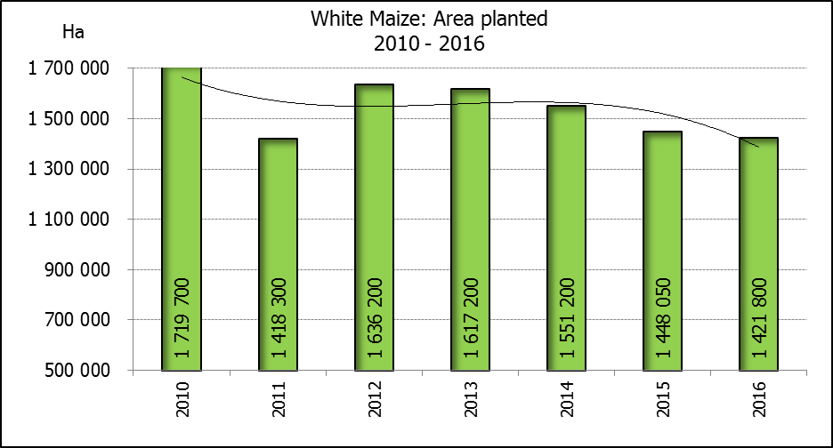

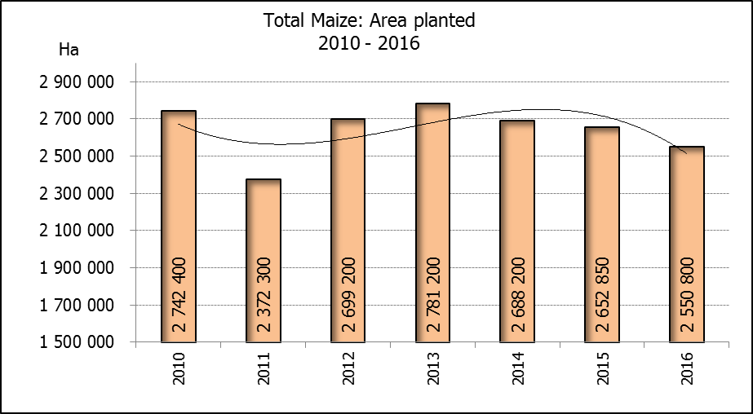
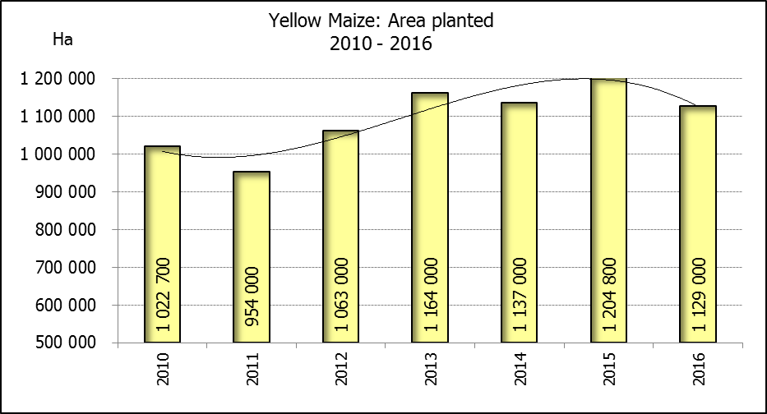

WHITE AND YELLOW MAIZE – INTENTIONS TO PLANT: 2016
WIT- EN GEELMIELIES – VOORNEME OM TE PLANT: 2016
Province/  Provinsie | Intentions (Area planted)/  Voorneme (Oppervlakte beplant)  2016 |  |  | Area planted/  Oppervlakte beplant  2015 |  |  | Final estimate¹⁾/  Finale skatting¹⁾  2015
Province/  Provinsie | White/  Wit  Ha | Yellow/  Geel  Ha | Totaal/  Total  Ha | White/  Wit  Ha | Yellow/  Geel  Ha | Totaal/  Total  Ha | White/  Wit  Tons | Geel/  Yellow  Tons | Totaal/  Total  Tons
Western Cape/Wes-Kaap | 400 | 3 500 | 3 900 | 450 | 3 800 | 4 250 | 4 050 | 34 200 | 38 250
Northern Cape/Noord-Kaap | 3 500 | 48 500 | 52 000 | 3 500 | 46 000 | 49 500 | 35 000 | 644 000 | 679 000
Free State/Vrystaat | 700 000 | 450 000 | 1 150 000 | 710 000 | 510 000 | 1 220 000 | 2 236 500 | 1 708 500 | 3 945 000
Eastern Cape/Oos-Kaap | 2 400 | 14 000 | 16 400 | 2 600 | 14 000 | 16 600 | 15 600 | 84 000 | 99 600
KwaZulu-Natal | 37 000 | 42 000 | 79 000 | 40 000 | 45 000 | 85 000 | 222 000 | 283 500 | 505 500
Mpumalanga | 160 000 | 320 000 | 480 000 | 154 000 | 315 000 | 469 000 | 816 200 | 1 622 250 | 2 438 450
Limpopo | 28 500 | 22 000 | 50 500 | 28 500 | 21 000 | 49 500 | 156 750 | 126 000 | 282 750
Gauteng | 45 000 | 64 000 | 109 000 | 44 000 | 65 000 | 109 000 | 193 600 | 292 500 | 486 100
North West/Noordwes | 445 000 | 165 000 | 610 000 | 465 000 | 185 000 | 650 000 | 1 023 000 | 444 000 | 1 467 000
Total/Totaal | 1 421 800 | 1 129 000 | 2 550 800 | 1 448 050 | 1 204 800 | 2 652 850 | 4 702 700 | 5 238 950 | 9 941 650
- 29 September 2015

CONFIDENTIALITY ISSUES that CEC members are committed to adhere to on the day of the meeting
- Personal items such as laptops, handbags, cell phones, etc. are not allowed in the venue during the meeting
- No member is allowed to leave the meeting before 12:00 in order to prevent disclosure of the information
- The embargo time for the release of crop estimates information is 15:30
- No member is allowed to discuss crop estimates information with anyone other than a member of the Committee before the embargo time
- Only the Chairperson, or a member appointed by the Chairperson, may release the figures to the media
- Members must regard the detail of any information that was collected for and/or discussed during the meeting, as confidential
- Individual information received for crop estimate purposes is treated strictly confidential, and is not divulged for any other purposes

INTENTIONS TO PLANT SUMMER CROPS / VOORNEME OM SOMERGEWASSE TE PLANT (2016)
27 October / Oktober 2015

Producers intentions to plant summer crops are based on the results of a non-probability survey conducted by the Directorate: Statistics and Economic Analysis of the Department of Agriculture, Forestry and Fisheries and reflects the position as at the middle of October 2015.  According to the results of the survey, commercial producers intend to plant 2,551 mill. ha of maize for 2016, which is 3,8% or 102 050 ha less than the 2,653 mill. ha planted last season.  The figures show that producers intend to plant 1,422 mill. ha to white maize, which is 26 250 ha (1,8%) less than in the previous season. In the case of yellow maize, the expected plantings are 1,129 mill. ha, which is 75 800 ha (6,3%) less than in the previous season.  Producers indicated that less maize will be planted for the 2016 season because they are under pressure due to the current dry weather conditions. However, the rainfall can still influence farmers’ decisions.  In the case of sunflower seed, the expected area planted is estimated at 614 000 ha, which is 6,6% or 38 000 ha more than the 576 000 ha planted last season.  The intended plantings of soybeans shows an increase of 1,3% compared to the previous season – from 687 300 ha to 696 400 ha.  The expected plantings of groundnuts will decrease by 22,9%, from 58 000 ha to 44 700 ha.  The intended plantings of sorghum is expected to increase by 6,0% or 4 250 ha to 74 750 ha, compared to the previous season.  The expected plantings of dry beans is estimated at 51 500 ha, which is 19,5% or 12 500 ha less than in the previous season.  Please note that the preliminary area planted estimate for summer grains for 2016 will be released on 27 January 2016. |  | Produsente se voorneme om somergewasse te plant is gebaseer op die resultate van ’n nie-ewekansige opname onderneem deur die Direktoraat: Statistiek en Ekonomiese Analise van die Departement van Landbou, Bosbou en Visserye en weerspieël die situasie teen die middel van Oktober 2015.  Volgens die resultate van die opname, is kommersiele produsente van voorneme om 2,551 milj. ha mielies vir 2016 te plant, wat 3,8% of 102 050 ha minder is as die 2,653 milj. ha aangeplant verlede seisoen.  Die syfers toon dat produsente van voorneme is om 1,422 milj. ha witmielies aan te plant, wat 26 250 ha (1,8%) minder is as in die vorige seisoen. In die geval met geelmielies is die verwagte aanplantings 1,129 milj. ha, wat 75 800 ha (6,3%) minder is as in die vorige seisoen.  Produsente het aangedui dat minder mielies aangeplant sal word vir die 2016-seisoen aangesien hulle onder druk is as gevolg van die huidige droë weerstoestande. Maar reënval kan steeds boere se besluite beïnvloed.  In die geval van sonneblomsaad word die verwagte aanplantings beraam op 614 000 ha, wat 6,6% of 38 000 ha meer is as die 576 000 ha aangeplant verlede seisoen.  Die voorgenome sojaboon-aanplantings toon ’n toename van 1,3% in vergelyking met die vorige seisoen - vanaf 687 300 ha tot 696 400 ha.  Die verwagte aanplantings van grondbone gaan afneem met 22,9%, van 58 000 ha tot 44 700 ha.  Die voorgenome aanplantings van sorghum sal na verwagting toeneem met 6,0% of 4 250 ha na 74 750 ha, in vergelyking met die vorige seisoen.  Die verwagte aanplantings van droëbone word beraam op 51 500 ha, wat 19,5% of 12 500 ha minder is as in die vorige seisoen.  Neem asseblief kennis dat die voorlopige oppervlakteskatting vir somergewasse vir 2016 op 27 Januarie 2016 vrygestel sal word.

Information is available on the internet at http://www.daff.gov.za/statistics and economic reports or www.sagis.org.za/CEC: Crop Estimates, as from 15:30 on the date of the relevant meeting of the Crop Estimates Committee. |  | Inligting is beskikbaar op die internet by http://www.daff.gov.za/statistics and economic reports of by http://www.sagis.org.za/CEC: Crop Estimates, vanaf 15:30 op die dag van die toepaslike vergadering van die Oesskattingskomitee.

The area estimate and third production forecast for winter cereals for the 2015 is hereby released. /
Hiermee word die oppervlakte- en derde produksieskatting vir wintergewasse vir 2015 vrygestel.
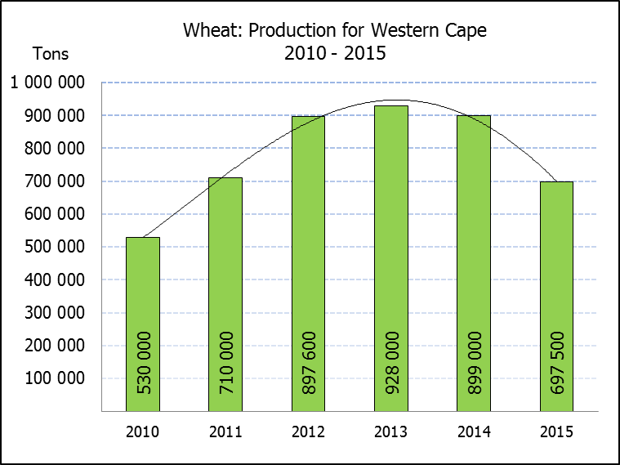
WINTER CEREALS – AREA PLANTED AND THIRD PRODUCTION FORECAST: 2015 PRODUCTION SEASON
WINTERGEWASSE – OPPERVLAKTE- EN DERDE PRODUKSIESKATTING: 2015-PRODUKSIESEISOEN
CROP/GEWAS | Area planted/  Opp beplant  2015 | 3rd forecast/  3de skatting  2015 | 2nd forecast/  2de skatting  2015 | Area planted/  Opp beplant  2014 | Final crop/  Finale oes  2014 | Change/  Verandering
CROP/GEWAS | Ha | Tons | Tons | Ha | Tons | %
CROP/GEWAS | (A) | (B) | (C) | (D) | (E) | (B) ÷ (C)
Commercial/Kommersieel:
Wheat/Koring | 482 150 | 1 542 350 | 1 635 400 | 476 570 | 1 750 000 |  | -5,69
Malting barley/Moutgars | 93 730 | 347 017 | 347 083 | 85 125 | 302 000 |  | -0,02
Canola/Kanola | 78 050 | 105 400 | 105 400 | 95 000 | 121 000 |  | 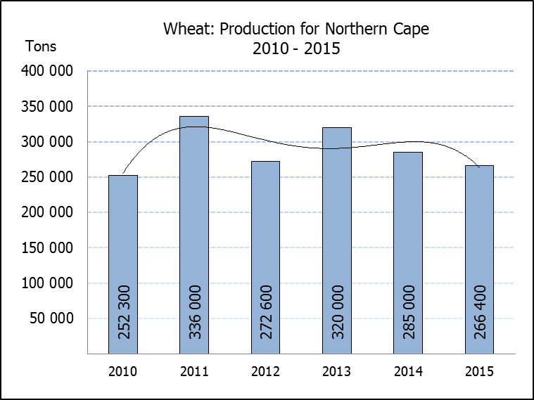  -
Total/Totaal | 653 930 | 1 994 767 | 2 087 883 | 656 695 | 2 173 000 |  | -4,46
Note: Estimate is for calendar year, e.g. production season 2015/16 = 2015
Nota: Skatting is vir kalenderjaar, bv. produksie-seisoen 2015/16 = 2015

WHEAT – AREA PLANTED AND THIRD PRODUCTION FORECAST: 2016
KORING – OPPERVLAKTE- EN DERDE PRODUKSIESKATTING: 2016

Province/  Provinsie | Area planted/  Opp beplant  Ha | 3rd forecast/  3de skatting  2015 | Area planted/  Opp beplant  Ha | Final crop/  Finale oes  Tons
Province/  Provinsie | 2015 | 2015 | 2014 | 2014
Western Cape/Wes-Kaap | 310 000 | 697 500 | 310 000 | 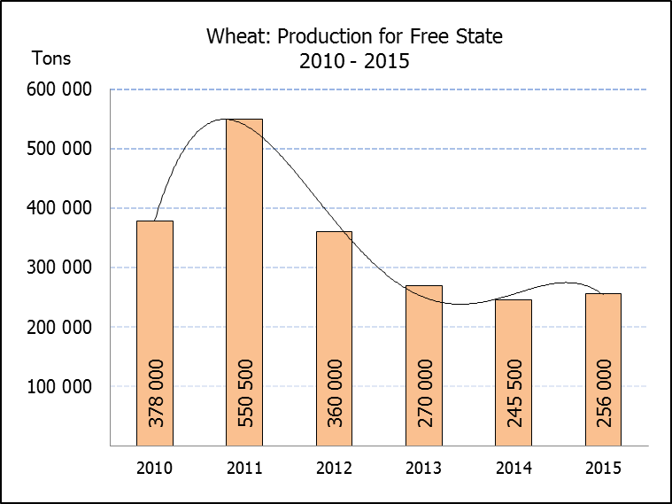  899 000
Northern Cape/Noord-Kaap | 36 000 | 266 400 | 38 000 | 285 000
Free State/Vrystaat | 80 000 | 256 000 | 69 500 | 245 500
Eastern Cape/Oos-Kaap | 3 100 | 14 880 | 3 000 | 12 000
KwaZulu-Natal | 7 300 | 43 070 | 6 500 | 39 000
Mpumalanga | 3 500 | 20 300 | 3 500 | 21 350
Limpopo | 27 000 | 151 200 | 27 500 | 137 500
Gauteng | 250 | 1 500 | 570 | 3 550
North West/Noordwes | 15 000 | 91 500 | 18 000 | 107 100
Total/Totaal | 482 150 | 1 542 350 | 476 570 | 1 750 000

AREA ESTIMATE AND THIRD PRODUCTION FORECAST OF WINTER CROPS (2015) /
OPPERVLAKTESKATTING EN DERDE PRODUKSIESKATTING VAN WINTERGEWASSE (2015)
27 OCTOBER / OKTOBER 2015

Winter cereal crops - 2015 production season  Please note that the yield for the Western Cape is mainly based on information as collected objectively by the National Crop Statistics Consortium (NCSC), which is led by the ARC. Information on the objective yield for the Free State will be available on 15 December 2015.  Wheat: The expected commercial production of wheat is 1,542 mill. tons, which is 5,69% or 93 050 tons less than the previous forecast of 1,635 mill. tons, whilst the expected yield is 3,20 t/ha.  The main reason for the decrease is because of the western parts (Swartland) of the Western Cape province that hasn’t received enough rain. Accordingly, the wheat in this province decreased by 10 % or 77 500 tons against the previous forecast.  The expected production in the Western Cape is thus now 697 500 tons (45%), in the Northern Cape 266 400 tons (17%) and in the Free State 256 000 tons (17%).  The area estimate for wheat is 482 150 ha.  Other crops: The production forecast for malting barley is 347 017 tons, which is 66 tons less than the previous forecast of 347 083 tons. The area planted is estimated at 93 730 ha, while the expected yield is 3,70 t/ha.  The expected canola crop remained unchanged at 105 400 tons. The area estimate for canola is 78 050 ha, with an expected yield of 1,35 t/ha.  Please note that the fourth production forecast for winter cereals for 2015 will be released on 25 November 2015. |  | Wintergewasse - 2015 produksie-seisoen  Let wel, die opbrengs vir die Wes-Kaap is hoofsaaklik gebaseer op inligting soos objektief versamel deur die LNR-begeleide Nasionale Oesskattingskonsortium. Inligting oor die objektiewe opbrengs vir die Vrystaat sal op 15 Desember 2015 beskikbaar wees.  Koring: Die verwagte kommersiële produksie vir koring is 1,542 milj. ton, wat 5,69% of 93 050 ton minder is as die vorige skatting van 1,635 milj. ton, terwyl die verwagte opbrengs 3,20 t/ha is.  Die hoofrede vir die afname is as gevolg van die westelike dele (Swartland) van die Wes-Kaap provinsie wat nie genoeg reën ontvang het nie. Gevolglik het die koring in hierdie provinsie afgeneem met 10% of 77 500 ton teenoor die vorige skatting.  Die verwagte produksie in die Wes-Kaap is dus nou 697 500 ton (45%), in die Noord-Kaap 266 400 ton (17%) en in die Vrystaat 256 000 ton (17%).  Die oppervlakteskatting vir koring is 482 150 ha.  Ander gewasse: Die produksieskatting vir moutgars is 347 017 ton, wat 66 ton minder is as die vorige skatting van 347 083 ton. Die oppervlakte beplant is beraam op 93 730 ha, terwyl die verwagte opbrengs 3,70 t/ha beloop.  Die verwagte kanola-oes is onveranderd gelaat op 105 400 ton. Die oppervlakteskatting vir kanola is 78 050 ha, met ŉ verwagte opbrengs van 1,35 t/ha.  Neem asseblief kennis dat die vierde produksieskatting vir wintergewasse vir 2015 op 25 November 2015 vrygestel sal word.

Information is available on the internet at http://www.daff.gov.za/crop estimates or http://www.sagis.org.za, as from 15:30 on the date of the relevant meeting of the Crop Estimates Committee. |  | Inligting is beskikbaar op die internet by http://www.daff.gov.za/crop estimates of by http://www.sagis.org.za, vanaf 15:30 op die dag van die toepaslike vergadering van die Oesskattingskomitee.

