 | crop estimates committee | 
 | oesskattingskomitee
From/Van: M. Ellen Matsei
Tel: 012 319 8454  Fax/Faks: 012 319 8031  E-mail/E-pos: DAS@daff.gov.za
Web page/Webblad: www.daff.gov.za/statistics and economic reports or www.sagis.org.za/CEC: Crop Estimates
EMBARGO: 15:30

The intentions’ of producers to plant summer crops for 2018 is hereby released. /
Hiermee word produsente se voorneme om somergewasse te plant vir 2018 vrygestel.

SUMMER CROPS – INTENTIONS TO PLANT: 2018
SOMERGEWASSE – VOORNEME OM TE PLANT: 2018
CROP/GEWAS | Intentions/  Voorneme  2018 | Area planted/  Opp beplant  2017 | Final estimate/  Finale skatting  2017 | Change/  Verandering/
CROP/GEWAS | Ha | Ha | Tons | %
CROP/GEWAS | soos middel Oktober 2017/  as mid October 2017 |  | as on 28 Sep 2017/  soos op 28 Sept 2017
CROP/GEWAS | (A) | (B) | (C) | (A) ÷ (B)
Commercial/Kommersieël:
White maize/Witmielies | 1 404 100 | 1 643 100 | 9 892 750 | -14,5
Yellow maize/Geelmielies | 1 066 300 | 985 500 | 6 851 250 | +8,2
Maize/Mielies | 2 470 400 | 2 628 600 | 16 744 000 | -6,0
Sunflower seed/Sonneblomsaad | 665 500 | 635 750 | 874 595 | +4,7
Soybeans/Sojabone | 720 000 | 573 950 | 1 316 370 | +25,4
Groundnuts/Grondbone | 65 500 | 56 000 | 92 050 | +17,0
Sorghum | 43 700 | 42 350 | 151 335 | +3,2
Dry beans/Droëbone | 60 000 | 45 050 | 68 525 | +33,2
TOTAL/TOTAAL | 4 025 100 | 3 981 700 | 19 246 875 | +1,1
Note: Estimate is for calendar year, e.g. production season 2017/18 = 2018
Nota: Skatting is vir kalenderjaar, bv. produksie-seisoen 2017/18 = 2018

The Crop Estimates Committee comprises officials of the following institutions:
Department of Agriculture, Forestry and Fisheries; Provincial Departments of Agriculture; various ARC-Institutes (Soil, Climate and Water; Small Grains Institute; and
Grain Crops Institute); BFAP and Statistics SA.
26 October/Oktober 2017
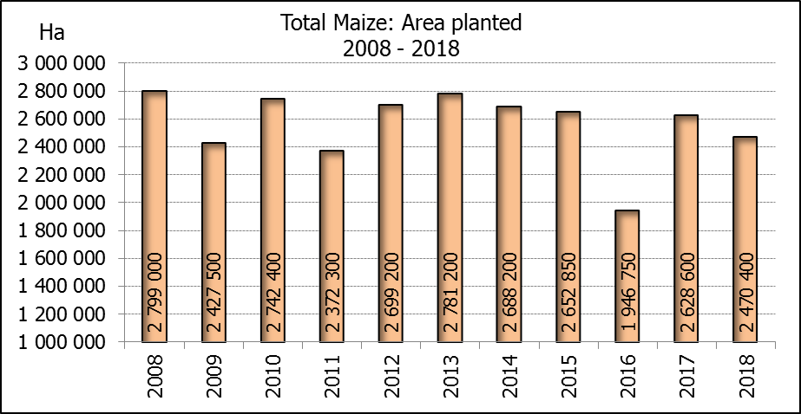

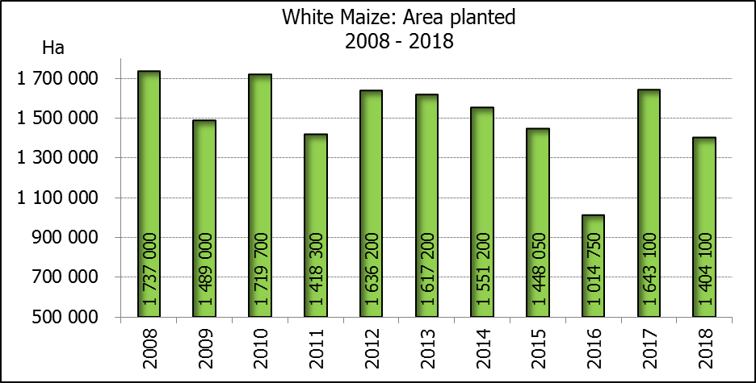

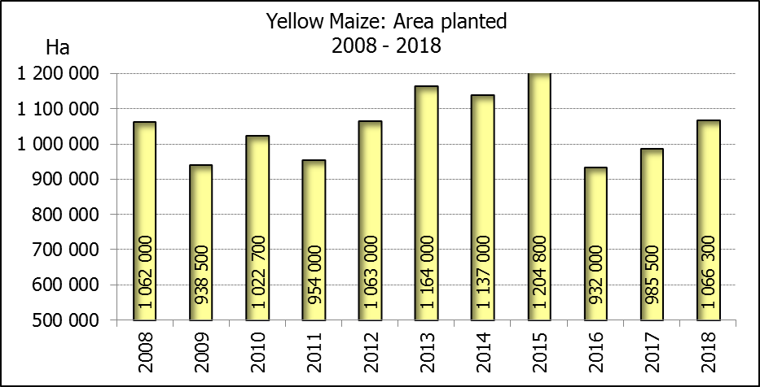
2018: Intentions’ of farmers/Produsente se voornemens

WHITE AND YELLOW MAIZE – INTENTIONS TO PLANT: 2018
WIT- EN GEELMIELIES – VOORNEME OM TE PLANT: 2018

Provinsie/  Province | Intentions (Area planted)/  Voorneme (Oppervlakte beplant)  2018 |  |  | Area planted/  Oppervlakte beplant  2017 |  |  | Final estimate¹⁾/  Finale skatting¹⁾  2017
Provinsie/  Province | White/  Wit  Ha | Yellow/  Geel  Ha | Total/  Totaal  Ha | White/  Wit  Ha | Yellow/  Geel  Ha | Total/  Totaal  Ha | White/  Wit  Tons | Yellow/  Geel  Tons | Total/  Totaal  Tons
Western Cape/Wes-Kaap | 0 | 1 500 | 1 500 | 200 | 2 000 | 2 200 | 2 000 | 20 000 | 22 000
Northern Cape/Noord-Kaap | 2 700 | 42 500 | 45 200 | 3 500 | 45 000 | 48 500 | 46 200 | 657 000 | 703 200
Free State/Vrystaat | 685 000 | 410 000 | 1 095 000 | 805 000 | 355 000 | 1 160 000 | 5 111 750 | 2 218 750 | 7 330 500
Eastern Cape/Oos-Kaap | 4 400 | 9 300 | 13 700 | 4 400 | 9 500 | 13 900 | 30 800 | 66 500 | 97 300
KwaZulu-Natal | 37 000 | 45 000 | 82 000 | 50 000 | 50 000 | 100 000 | 350 000 | 385 000 | 735 000
Mpumalanga | 137 000 | 348 000 | 485 000 | 160 000 | 330 000 | 490 000 | 1 088 000 | 2 343 000 | 3 431 000
Limpopo | 30 000 | 26 000 | 56 000 | 40 000 | 24 000 | 64 000 | 300 000 | 192 000 | 492 000
Gauteng | 48 000 | 64 000 | 112 000 | 60 000 | 60 000 | 120 000 | 390 000 | 408 000 | 798 000
North West/Noordwes | 460 000 | 120 000 | 580 000 | 520 000 | 110 000 | 630 000 | 2 574 000 | 561 000 | 3 135 000
Total/Totaal | 1 404 100 | 1 066 300 | 2 470 400 | 1 643 100 | 985 500 | 2 628 600 | 9 892 750 | 6 851 250 | 16 744 000

- 28 September 2017
SUNFLOWER SEED – INTENTIONS TO PLANT: 2018
SONNEBLOMSAAD – VOORNEME OM TE PLANT: 2018

Province/  Provinsie | Area planted/  Opp beplant  Ha | Area planted/  Opp beplant  Ha | Final estimate¹⁾/  Finale skatting¹⁾  Tons
Province/  Provinsie | 2018 | 2017 | 2017
Western Cape/Wes-Kaap | - | - | -
Northern Cape/Noord-Kaap | 100 | 250 | 375
Free State/Vrystaat | 350 000 | 330 000 | 478 500
Eastern Cape/Oos-Kaap | - | - | -
KwaZulu-Natal | - | 300 | 300
Mpumalanga | 2 200 | 2 200 | 2 420
Limpopo | 88 000 | 90 000 | 85 500
Gauteng | 3 200 | 3 000 | 3 000
North West/Noordwes | 222 000 | 210 000 | 304 500
Total/Totaal | 665 500 | 635 750 | 874 595
- 28 September 2017

SOYBEANS – INTENTIONS TO PLANT: 2018
SOJABONE – VOORNEME OM TE PLANT: 2018

Province/  Provinsie | Area planted/  Opp beplant  Ha | Area planted/  Opp beplant  Ha | Final estimate¹⁾/  Finale skatting¹⁾  Tons
Province/  Provinsie | 2018 | 2017 | 2017
Western Cape/Wes-Kaap | 500 | 700 | 1 050
Northern Cape/Noord-Kaap | 3 500 | 3 000 | 10 500
Free State/Vrystaat | 320 000 | 240 000 | 504 000
Eastern Cape/Oos-Kaap | 2 000 | 1 850 | 2 775
KwaZulu-Natal | 34 500 | 30 500 | 89 975
Mpumalanga | 276 500 | 241 000 | 554 300
Limpopo | 15 000 | 8 500 | 29 750
Gauteng | 33 000 | 25 400 | 71 120
North West/Noordwes | 35 000 | 23 000 | 52 900
Total/Totaal | 720 000 | 573 950 | 1 316 370
- 28 September 2017

INTENTIONS TO PLANT SUMMER CROPS (2018) / VOORNEME OM SOMERGEWASSE TE PLANT (2018)
26 OCTOBER /OKTOBER 2017

Producers intentions to plant summer crops are based on the results of a non-probability survey conducted by the Directorate: Statistics and Economic Analysis of the Department of Agriculture, Forestry and Fisheries and reflects the position as at the middle of October 2017.  According to the results of the survey, commercial producers intend to plant 2,470 mill. ha of maize for 2018, which is 6,0% or 158 200 ha less than the 2,629 mill. ha planted last season.  The figures show that producers intend to plant 1,404 mill. ha to white maize, which is 239 000 ha (14,5%) less than in the previous season. In the case of yellow maize, the expected plantings are 1,066 mill. ha, which is 80 800 ha (8,2%) more than in the previous season.  Producers indicated that less maize, especially white maize, will be planted for the 2018 season, mainly because of farmers switching to other crops such as oilseeds and yellow maize, due to price competitiveness.  In the case of sunflower seed, the expected area planted is estimated at 665 500 ha, which is 4,7% or 29 750 ha more than the 635 750 ha planted last season. The increase in the expected area planted to sunflower seed is mainly because of increases in the Free State and North West provinces, due to indications that the expected area planted with white maize will decrease more in the afore-mentioned provinces than in the other provinces.  The intended plantings of soybeans shows an increase of 25,4% or 146 050 ha compared to the previous season – from 573 950 ha to 720 000 ha.  The expected plantings of groundnuts will also increase by 17,0% or 9 500 ha, from 56 000 ha to 65 500 ha.  The intended plantings of sorghum is expected to increase slightly by 3,2% or 1 350 ha to 43 700 ha, compared to the previous season.  The expected plantings of dry beans is estimated at 60 000 ha, which is 33,2% or 14 950 ha more than in the previous season.  Please note that the preliminary area planted estimate for summer grains for 2018 will be released on 30 January 2018. |  | Produsente se voorneme om somergewasse te plant is gebaseer op die resultate van ’n nie-ewekansige opname onderneem deur die Direktoraat: Statistiek en Ekonomiese Analise van die Departement van Landbou, Bosbou en Visserye en weerspieël die situasie teen die middel van Oktober 2017.  Volgens die resultate van die opname, is kommersiele produsente van voorneme om 2,470 milj. ha mielies vir 2018 te plant, wat 6,0% of 158 200 ha minder is as die 2,629 milj. ha aangeplant verlede seisoen.  Die syfers toon dat produsente van voorneme is om 1,404 milj. ha witmielies aan te plant, wat 239 000 ha (14,5%) minder is as in die vorige seisoen. In die geval met geelmielies is die verwagte aanplantings 1,066 milj. ha, wat 80 800 ha (8,2%) meer is as in die vorige seisoen.  Produsente het aangedui dat minder mielies, veral witmielies, aangeplant sal word vir die 2018-seisoen, hoofsaaklik as gevolg van die feit dat boere oorskakel na ander gewasse soos oliesade en geelmielies, weens prysmededingendheid.  In die geval van sonneblomsaad word die verwagte aanplantings beraam op 665 500 ha, wat 4,7% of 29 750 ha meer is as die 635 750 ha aangeplant verlede seisoen. Die toename in die verwagte oppervlakte beplant met sonneblomsaad, is hoofsaaklik as gevolg van toenames in die Vrystaat en Noordwes provinsies, weens aanduidings dat die verwagte oppervlakte beplant met witmieliles in die genoemde provinsies meer gaan afneem as in die ander provinsies.  Die voorgenome sojaboon-aanplantings toon ’n toename van 25,4% of 146 050 ha, in vergelyking met die vorige seisoen - vanaf 573 950 ha tot 720 000 ha.  Die verwagte aanplantings van grondbone gaan ook toeneem met 17,0% of 9 500 ha, van 56 000 ha tot 65 500 ha.  Die voorgenome aanplantings van sorghum sal na verwagting effens toeneem met 3,2% of 1 350 ha na 43 700 ha, in vergelyking met die vorige seisoen.  Die verwagte aanplantings van droëbone word beraam op 60 000 ha, wat 33,2% of 14 950 ha meer is as in die vorige seisoen.  Neem asseblief kennis dat die voorlopige oppervlakteskatting vir somergewasse vir 2018 op 30 Januarie 2018 vrygestel sal word.

The area estimate and third production forecast for winter cereals for the 2017 is hereby released. /
Hiermee word die oppervlakte- en derde produksieskatting vir wintergewasse vir 2017 vrygestel.

WINTER CEREALS – AREA PLANTED AND THIRD PRODUCTION FORECAST: 2017 PRODUCTION SEASON
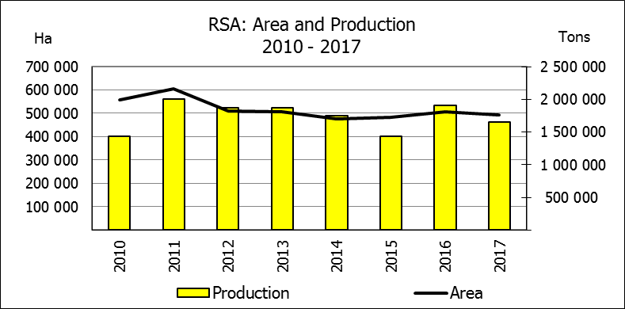
WINTERGEWASSE – OPPERVLAKTE- EN DERDE PRODUKSIESKATTING: 2017-PRODUKSIESEISOEN
CROP/GEWAS | Area planted/  Opp beplant  2017 | 3rd forecast/  3de skatting  2017 | 2nd forecast/  2de skatting  2017 | Area planted/  Opp beplant  2016 | Final crop/  Finale oes  2016 | Change/  Verandering
CROP/GEWAS | Ha | Tons | Tons | Ha | Tons | %
CROP/GEWAS | (A) | (B) | (C) | (D) | (E) | (B) ÷ (C)
Commercial/Kommersieel:
Wheat/Koring | 491 600 | 1 655 250 | 1 716 650 | 508 365 | 1 910 000 | -3,58
Malting barley/Moutgars | 91 380 | 281 059 | 268 309 | 88 695 | 355 000 | +4,75
Canola/Kanola | 84 000 | 100 800 | 100 800 | 68 075 | 105 000 | -
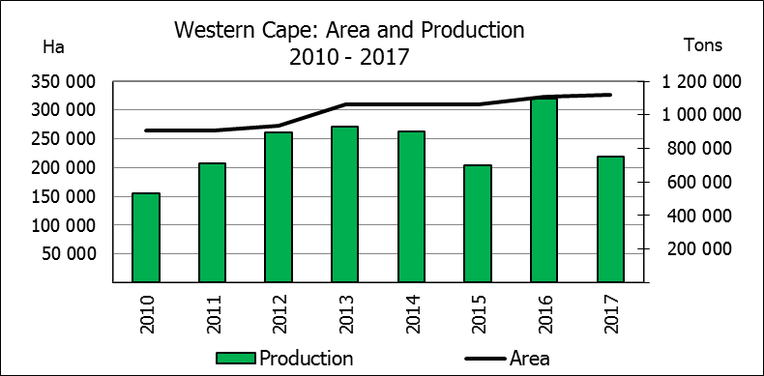
* Note: Estimate is for calendar year, e.g. production season 2017/18 = 2017
* Nota: Skatting is vir kalenderjaar, bv. produksie-seisoen 2017/18 = 2017

WHEAT – AREA PLANTED AND THIRD PRODUCTION FORECAST: 2017
KORING – OPPERVLAKTE- EN DERDE PRODUKSIESKATTING: 2017
Province/  Provinsie | Area planted/  Opp beplant  Ha | 3rd forecast/  3de skatting  Tons | 2nd forecast/  2de skatting  Tons | Area planted/  Opp beplant  Ha | Final crop/  Finale oes  Tons
Province/  Provinsie | 2017 | 2017 | 2017 | 2016 | 2016
Western Cape/Wes-Kaap | 326 000 | 749 800 | 815 000 | 323 000 | 1 098 200
Northern Cape/Noord-Kaap | 38 000 | 304 000 | 300 200 | 35 000 | 266 000
Free State/Vrystaat | 80 000 | 320 000 | 320 000 | 110 000 | 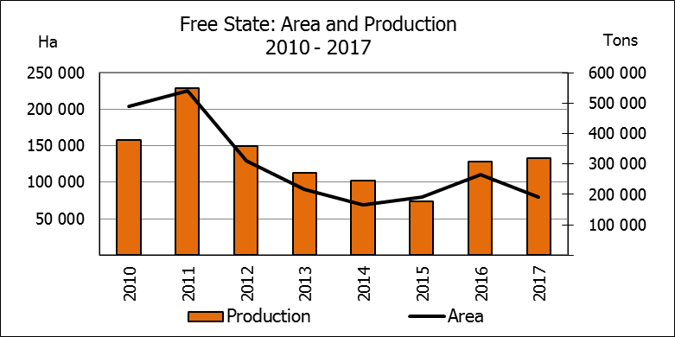  308 460
Eastern Cape/Oos-Kaap | 1 900 | 9 500 | 9 500 | 2 200 | 11 000
KwaZulu-Natal | 7 500 | 42 750 | 42 750 | 6 500 | 37 050
Mpumalanga | 4 000 | 24 000 | 24 000 | 2 300 | 13 800
Limpopo | 20 000 | 120 000 | 120 000 | 17 000 | 103 700
Gauteng | 700 | 4 200 | 4 200 | 365 | 2 190
North West/Noordwes | 13 500 | 81 000 | 81 000 | 12 000 | 69 600
Total/Totaal | 491 600 | 1 655 250 | 1 716 650 | 508 365 | 1 910 000

REVISED AREA ESTIMATE AND THIRD PRODUCTION FORECAST OF WINTER CROPS (2017) /
HERSIENE OPPERVLAKTEKSKATTING EN DERDE PRODUKSIESKATTING VAN WINTERGEWASSE (2017)
26 OCTOBER/OKTOBER 2017
Winter cereal crops - 2017 production season  Wheat: The expected commercial production of wheat is 1,655 mill. tons, which is 3,58% or 61 400 tons less than the previous forecast of 1,717 mill. tons, mainly because the main wheat producing province, namely the Western Cape, experiences dryness. The area estimate for wheat is 491 600 ha, whilst the expected yield is 3,37 t/ha.  The largest decline in production occurred in the Western Cape, namely 8,0% or 65 200 tons, followed by the Northern Cape by 1,3% or 3 800 tons. Thus, the expected production in the Western Cape is 749 800 tons (45%), in the Free State 320 000 tons (19%) and in the Northern Cape 304 000 tons (18%).  Other crops: The production forecast for malting barley is 281 059 tons, which is 4,75% or 12 750 tons more than the previous forecast of 268 309 tons. The area planted with malting barley is 91 380 ha and the expected yield is 3,08 t/ha.  The expected canola crop remained unchanged at 100 800 tons. The area estimate for canola is 84 000 ha, with an expected yield of 1,20 t/ha.  Please note that the fourth production forecast for winter cereals for 2017 will be released on 28 November 2017. |  | Wintergewasse - 2017 produksie-seisoen  Koring: Die verwagte kommersiële produksie vir koring is 1,655 milj. ton, wat 3,58% of 61 400 ton minder is as die vorige skatting van 1,717 milj. ton, hoofsaaklik omdat die grootste koringproduserende provinsie, naamlik die Wes-Kaap, droogte ervaar. Die oppervlakteskatting vir koring is 491 600 ha, terwyl die verwagte opbrengs 3,37 t/ha is.  Die grootste afname in produksie het in die Wes-Kaap plaasgevind, naamlik 8,0% of 65 200 ton, gevolg deur die Noord-Kaap met 1,3% of 3 800 ton. Dus is die verwagte produksie in die Wes-Kaap 749 800 ton (45%), in die Vrystaat 320 000 ton (19%) en in die Noord-Kaap 304 000 ton (18%).  Ander gewasse: Die produksieskatting vir moutgars is 281 059 ton, wat 4,75% of 12 750 ton meer is as die vorige skatting van 268 309 ton. Die oppervlakte beplant met moutgars is 91 380 ha, terwyl die verwagte opbrengs 3,08 t/ha beloop.  Die verwagte kanola-oes is onveranderd gelaat op 100 800 ton. Die oppervlakteskatting vir kanola is 84 000 ha, met ŉ verwagte opbrengs van 1,20 t/ha.  Neem asseblief kennis dat die vierde produksieskatting vir wintergewasse vir 2017 op 28 November 2017 vrygestel sal word.

Information is available on the internet at http://www.daff.gov.za/links/crop estimates or http://www.sagis.org.za, as from 15:30 on the date of the relevant meeting of the Crop Estimates Committee. |  | Inligting is beskikbaar op die internet by http://www.daff.gov.za/links/crop estimates of by http://www.sagis.org.za, vanaf 15:30 op die dag van die toepaslike vergadering van die Oesskattingskomitee.
CONFIDENTIALITY ISSUES that CEC members are committed to adhere to on the day of the meeting
- Personal items such as laptops, handbags, cell phones, etc. are not allowed in the venue during the meeting
- No member is allowed to leave the meeting before 12:00 in order to prevent disclosure of the information
- The embargo time for the release of crop estimates information is 15:30
- No member is allowed to discuss crop estimates information with anyone other than a member of the Committee before the embargo time

CONFIDENTIALITY ISSUES that CEC members are committed to adhere to on the day of the meeting (.. continued)
- Only the Chairperson, or a member appointed by the Chairperson, may release the figures to the media
- Members must regard the detail of any information that was collected for and/or discussed during the meeting, as confidential
- Individual information received for crop estimate purposes is treated strictly confidential, and is not divulged for any other purposes

