 | crop estimates committee
 | oesskattingskomitee
From/Van: Mr Baldwin Netshifhefhe  Tel: 012 319 8043/32 E-mail/E-pos: BaldwinN@dalrrd.gov.za  Web page/Webblad: www.dalrrd.gov.za/old website/statistics and economic reports or  www.sagis.org.za/CEC: Crop Estimates EMBARGO: 14:30 |  |  | 

The intentions’ of producers to plant summer crops for 2024 is hereby released. /
Hiermee word produsente se voorneme om somergewasse te plant vir 2024 vrygestel.

SUMMER CROPS – INTENTIONS TO PLANT: 2024
SOMERGEWASSE – VOORNEME OM TE PLANT: 2024
CROP/GEWAS | Intentions/  Voorneme  2024 | Area planted/  Opp beplant  2023 | Ninth estimate/  Negende skatting  2023 | Change/  Verandering/
CROP/GEWAS | Ha | Ha | Tons | %
CROP/GEWAS | soos middel Okt 2023/  as mid Oct 2023 |  | as on 26 Oct 2023/  soos op 26 Okt 2023
CROP/GEWAS | (A) | (B) | (C) | (A) ÷ (B)
Commercial/Kommersieël:
White maize/Witmielies | 1 584 250 | 1 521 300 | 8 499 965 | +4,1
Yellow maize/Geelmielies | 1 052 500 | 1 064 800 | 7 895 260 | -1,2
Maize/Mielies | 2 636 750 | 2 586 100 | 16 395 225 | +2,0
Sunflower seed/Sonneblomsaad | 640 000 | 555 700 | 729 110 | +15,2
Soybeans/Sojabone | 1 068 200 | 1 148 300 | 2 755 300 | -7,0
Groundnuts/Grondbone | 42 550 | 31 300 | 51 910 | +35,9
Sorghum | 38 000 | 34 000 | 94 360 | +11,8
Dry beans/Droëbone | 42 300 | 36 650 | 50 260 | +15,4
TOTAL/TOTAAL | 4 467 800 | 4 392 050 | 20 076 165 | +1,72
Note: Estimate is for calendar year, e.g. production season 2023/24 = 2024
Nota: Skatting is vir kalenderjaar, bv. produksie-seisoen 2023/24 = 2024

The Crop Estimates Committee comprises officials of the following institutions:
Department of Agriculture, Land Reform and Rural Development; Provincial Departments of Agriculture; various ARC-Institutes (Soil, Climate and Water; Small Grains Institute; and
Grain Crops Institute); BFAP and Statistics SA.

26 October/Oktober 2023

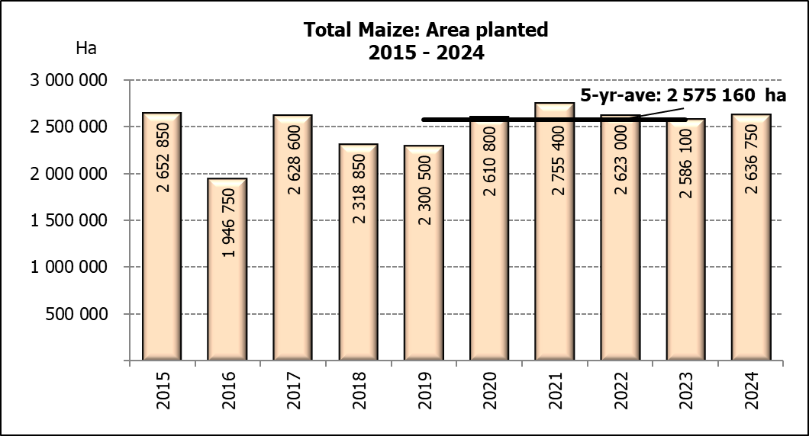

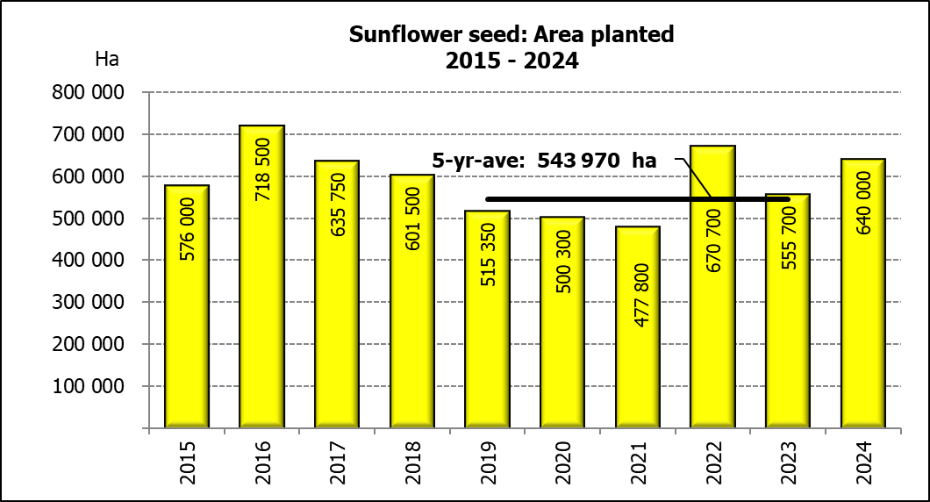

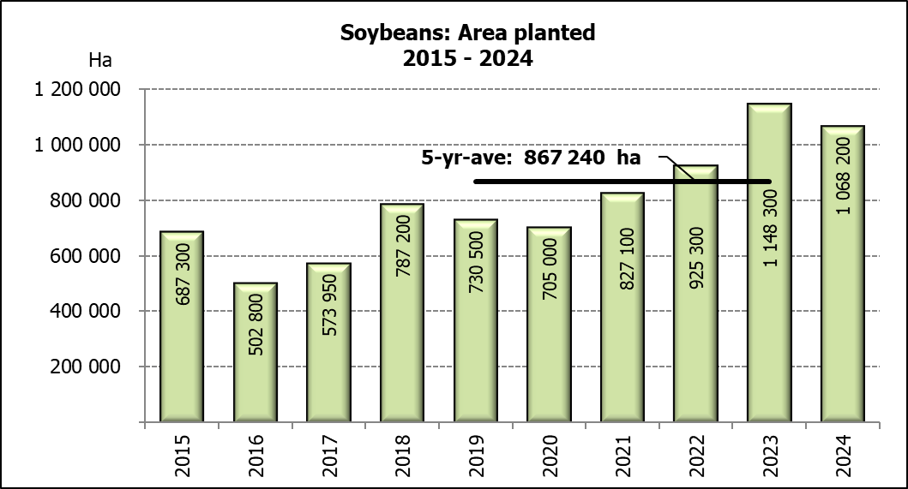

WHITE AND YELLOW MAIZE – INTENTIONS TO PLANT: 2024
WIT- EN GEELMIELIES – VOORNEME OM TE PLANT: 2024
Provinsie/  Province | Intentions (Area planted)/  Voorneme (Oppervlakte beplant)  2024 |  |  | Area planted/  Oppervlakte beplant  2023 |  |  | Ninth estimate¹⁾/  Negende skatting¹⁾  2023
Provinsie/  Province | White/  Wit  Ha | Yellow/  Geel  Ha | Total/  Totaal  Ha | White/  Wit  Ha | Yellow/  Geel  Ha | Total/  Totaal  Ha | White/  Wit  Tons | Yellow/  Geel  Tons | Total/  Totaal  Tons
Western Cape/Wes-Kaap | 250 | 3 500 | 3 750 | 250 | 3 500 | 3 750 | 2 375 | 32 900 | 35 275
Northern Cape/Noord-Kaap | 1 000 | 40 000 | 41 000 | 1 000 | 43 500 | 44 500 | 12 500 | 696 000 | 708 500
Free State/Vrystaat | 850 000 | 390 000 | 1 240 000 | 780 000 | 401 000 | 1 181 000 | 4 446 000 | 2 686 700 | 7 132 700
Eastern Cape/Oos-Kaap | 6 000 | 27 000 | 33 000 | 5 750 | 25 000 | 30 750 | 40 250 | 192 500 | 232 750
KwaZulu-Natal | 48 000 | 68 000 | 116 000 | 49 000 | 65 000 | 114 000 | 298 900 | 533 000 | 831 900
Mpumalanga | 162 000 | 358 000 | 520 000 | 156 500 | 352 000 | 508 500 | 1 032 900 | 2 587 200 | 3 620 100
Limpopo | 14 000 | 20 000 | 34 000 | 16 800 | 22 800 | 39 600 | 114 240 | 186 960 | 301 200
Gauteng | 53 000 | 56 000 | 109 000 | 56 000 | 52 000 | 108 000 | 364 000 | 390 000 | 754 000
North West/Noordwes | 450 000 | 90 000 | 540 000 | 456 000 | 100 000 | 556 000 | 2 188 800 | 590 000 | 2 778 800
Total/Totaal | 1 584 200 | 1 052 500 | 2 636 750 | 1 521 300 | 1 064 800 | 2 586 100 | 8 499 965 | 7 895 260 | 16 395 225

- 26 October 2023
SUNFLOWER SEED –INTENTIONS TO PLANT: 2024
SONNEBLOMSAAD – VOORNEME OM TE PLANT: 2024
Province/  Provinsie | Area planted/  Opp beplant  Ha | Area planted/  Opp beplant  Ha | Ninth estimate¹⁾/  Negende skatting¹⁾  Tons
Province/  Provinsie | 2024 | 2023 | 2023
Western Cape/Wes-Kaap | - | - | -
Northern Cape/Noord-Kaap | 2 100 | 2 500 | 6 250
Free State/Vrystaat | 340 000 | 290 000 | 406 000
Eastern Cape/Oos-Kaap | 700 | 700 | 1 400
KwaZulu-Natal | - | 300 | 600
Mpumalanga | 5 000 | 5 000 | 7 250
Limpopo | 105 000 | 100 000 | 80 000
Gauteng | 2 200 | 2 200 | 2 860
North West/Noordwes | 185 000 | 155 000 | 224 750
Total/Totaal | 640 000 | 555 700 | 729 110
- 26 October 2023

SOYBEANS – INTENTIONS TO PLANT: 2024
SOJABONE – VOORNEME OM TE PLANT: 2024
Province/  Provinsie | Area planted/  Opp beplant  Ha | Area planted/  Opp beplant  Ha | Ninth estimate¹⁾/  Negende skatting¹⁾  Tons
Province/  Provinsie | 2024 | 2023 | 2023
Western Cape/Wes-Kaap | - | - | -
Northern Cape/Noord-Kaap | 1 000 | 1 000 | 3 750
Free State/Vrystaat | 500 000 | 565 000 | 1 327 750
Eastern Cape/Oos-Kaap | 4 700 | 4 300 | 12 900
KwaZulu-Natal | 42 500 | 44 000 | 158 400
Mpumalanga | 320 000 | 305 000 | 671 000
Limpopo | 20 000 | 26 000 | 88 400
Gauteng | 40 000 | 48 000 | 105 600
North West/Noordwes | 140 000 | 155 000 | 387 500
Total/Totaal | 1 068 200 | 1 148 300 | 2 755 300
- 26 October 2023

INTENTIONS TO PLANT SUMMER CROPS (2024) / VOORNEME OM SOMERGEWASSE TE PLANT (2024)
Producers intentions to plant summer crops are based on the results of a non-probability survey conducted by the Directorate: Statistics and Economic Analysis of the Department of Agriculture, Land Reform and Rural Development and reflects the position as at the middle of October 2023.  According to the results of the survey, commercial producers intend to plant 2,637 mill. ha of maize for 2024, which is 2,0% or 50 650 ha more than the 2,586 mill. ha planted last season.  The figures show that producers intend to plant 1,584 mill. ha to white maize, which is 62 950 ha (4,1%) more than in the previous season. In the case of yellow maize, the expected plantings are 1,052 mill. ha, which is 12 300 ha (1,2%) less than in the previous season.  In the case of sunflower seed, the expected area planted is estimated at 640 000 ha, which is 15,2% or 84 300 ha more than the 555 700 ha planted last season.  The intended plantings of soybeans shows a decrease of 7,0% or 80 100 ha compared to the previous season – from 1,148 mill. ha to 1,068 mill. ha.  The expected plantings of groundnuts will increase by 35,9% or 11 250 ha, from 31 300 ha to 42 550 ha.  The intended plantings of sorghum is expected to increase by 11,8% or 4 000 ha to 38 000 ha, compared to the previous season.  The expected plantings of dry beans is estimated at 42 300 ha, which is 15,4% or 5 650 ha more than in the previous season.  Please note that the preliminary area planted estimate for summer grains for 2024 will be released on 30 January 2024. |  | Produsente se voorneme om somergewasse te plant is gebaseer op die resultate van ’n nie-ewekansige opname onderneem deur die Direktoraat: Statistiek en Ekonomiese Analise van die Departement van Landbou, Grondhervorming en Landelike Ontwikkeling en weerspieël die situasie teen die middel van Oktober 2023.  Volgens die resultate van die opname, is kommersiele produsente van voorneme om 2,637 milj. ha mielies vir 2024 te plant, wat 2,0% of 50 650 ha meer is as die 2,586 milj. ha aangeplant verlede seisoen.  Die syfers toon dat produsente van voorneme is om 1,584 milj. ha witmielies aan te plant, wat 62 950 ha (4,1%) meer is as in die vorige seisoen. In die geval met geelmielies is die verwagte aanplantings 1,052 milj. ha, wat 12 300 ha (1,2%) minder is as in die vorige seisoen.  In die geval van sonneblomsaad word die verwagte aanplantings beraam op 640 000 ha, wat 15,2% of 84 300 ha meer is as die 555 700 ha aangeplant verlede seisoen.  Die voorgenome sojaboon-aanplantings toon ’n afname van 7,0% of 80 100 ha, in vergelyking met die vorige seisoen - vanaf 1,148 milj. ha tot 1,068 milj. ha.  Die verwagte aanplantings van grondbone gaan toeneem met 35,9% of 11 250 ha, van 31 300 ha tot 42 550 ha.  Die voorgenome aanplantings van sorghum sal na verwagting toeneem met 11,8% of 4 000 ha na 38 000 ha, in vergelyking met die vorige seisoen.  Die verwagte aanplantings van droëbone word beraam op 42 300 ha, wat 15,4% of 5 650 ha meer is as in die vorige seisoen.  Neem asseblief kennis dat die voorlopige oppervlakteskatting vir somergewasse vir 2024 op 30 Januarie 2024 vrygestel sal word.

The area planted estimate and ninth production forecast for summer crops for 2023 is hereby released.
Hiermee word die oppervlakte- en negende produksieskatting vir somergewasse vir 2023 vrygestel.

SUMMER CROPS – AREA PLANTED AND NINTH PRODUCTION FORECAST: 2023
SOMERGEWASSE – OPPERVLAKTE- EN NEGENDE PRODUKSIESKATTING: 2023
CROP/GEWAS | Area planted/  Opp beplant  2023 | 9th forecast/  9de skatting  2023 | 8th forecast/  8ste skatting  2023 | Area planted/  Opp beplant  2022 | Final crop/  Finale oes  2022 | Change/  Verandering/
CROP/GEWAS | Ha | Tons | Tons | Ha | Tons | %
CROP/GEWAS | (A) | (B) | (C) | (D) | (E) | (B) ÷ (C)
Commercial/Kommersieël:
White maize/Witmielies | 1 521 300 | 8 499 965 | 8 499 965 | 1 575 000 | 7 850 000 | -
Yellow maize/Geelmielies | 1 064 800 | 7 895 260 | 7 895 260 | 1 048 000 | 7 620 000 | -
Total Maize/Totale Mielies | 2 586 100 | 16 395 225 | 16 395 225 | 2 623 000 | 15 470 000 | -
Sunflower seed/Sonneblomsaad | 555 700 | 729 110 | 729 110 | 670 700 | 845 550 | -
Soybeans/Sojabone | 1 148 300 | 2 755 300 | 2 755 300 | 925 300 | 2 230 000 | -
Groundnuts/Grondbone | 31 300 | 51 910 | 51 910 | 43 400 | 48 500 | -
Sorghum | 34 000 | 94 360 | 94 360 | 37 200 | 103 140 | -
Dry beans/Droëbone | 36 650 | 50 260 | 50 260 | 42 900 | 52 590 | -
Non-Commercial Maize/Nie-Kommersiële Mielies
Total Maize/Totale Mielies | 358 620 | 664 040 | 664 040 | 378 800 | 667 000 | -
Maize/Mielies: Commercial/Kommersieël + Non-Commercial/Nie-Kommersieël
Total Maize RSA/Totaal Mielies RSA | 2 944 720 | 17 059 265 | 17 059 265 | 3 001 800 | 16 137 000 | -
Note: Estimate is for calendar year, e.g. production season 2022/23 = 2023
Nota: Skatting is vir kalenderjaar, bv. produksie-seisoen 2022/23 = 2023

The Crop Estimates Committee comprises officials of the following institutions:
Department of Agriculture, Land Reform and Rural Development; Provincial Departments of Agriculture; various ARC-Institutes (Soil, Climate and Water; Small Grains Institute; and
Grain Crops Institute); BFAP and Statistics SA.

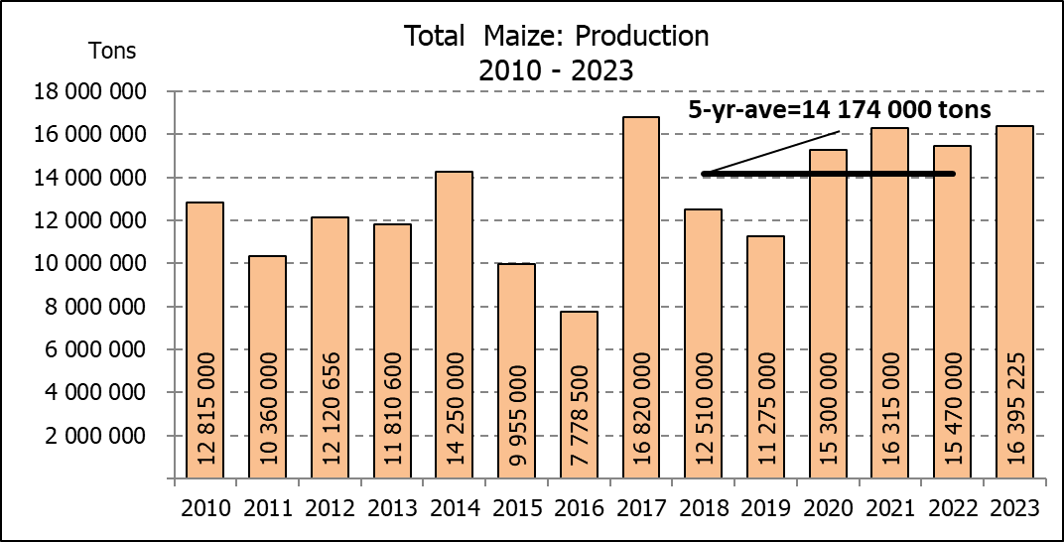

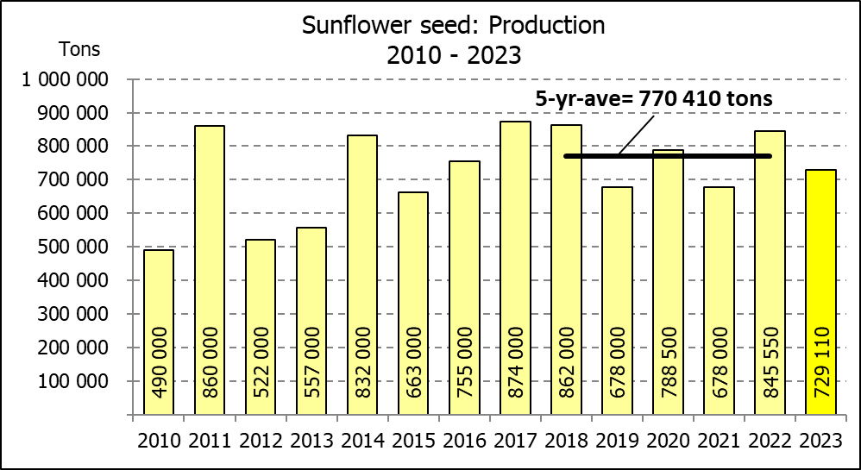
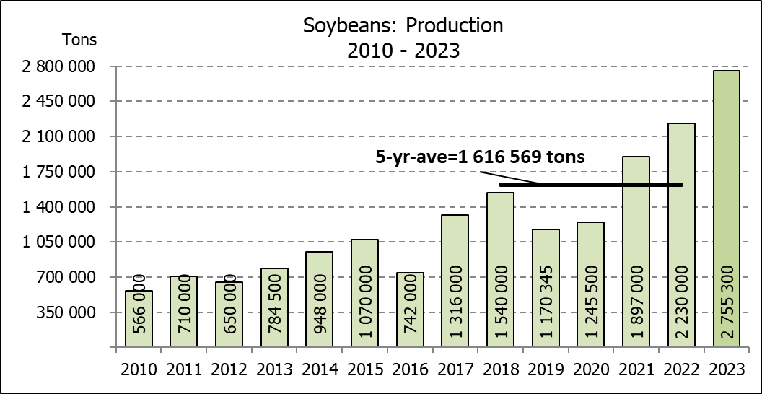

WHITE AND YELLOW MAIZE – AREA PLANTED AND NINTH PRODUCTION FORECAST: 2023
WIT- EN GEELMIELIES – OPPERVLAKTE EN NEGENDE PRODUKSIESKATTING: 2023

Provinsie/  Province | Area planted/  Oppervlakte beplant  2023 |  |  | 9th forecast/  9de skatting  2023 |  |  | Area planted/  Oppervlakte beplant  2022 |  |  | Final crop/  Finale oes  2022
Provinsie/  Province | White/  Wit  Ha | Yellow/  Geel  Ha | Total/  Totaal  Ha | White/  Wit  Tons | Yellow/  Geel  Tons | Total/  Totaal  Tons | White/  Wit  Ha | Yellow/  Geel  Ha | Total/  Totaal  Ha | White/  Wit  Tons | Yellow/  Geel  Tons | Total/  Totaal  Tons
Western Cape/Wes-Kaap | 250 | 3 500 | 3 750 | 2 375 | 32 900 | 35 275 | 500 | 3 500 | 4 000 | 4 750 | 32 900 | 37 650
Northern Cape/Noord-Kaap | 1 000 | 43 500 | 44 500 | 12 500 | 696 000 | 708 500 | 3 000 | 42 000 | 45 000 | 36 000 | 672 000 | 708 000
Free State/Vrystaat | 780 000 | 401 000 | 1 181 000 | 4 446 000 | 2 686 700 | 7 132 700 | 826 500 | 398 000 | 1 224 500 | 3 801 900 | 2 547 800 | 6 349 700
Eastern Cape/Oos-Kaap | 5 750 | 25 000 | 30 750 | 40 250 | 192 500 | 232 750 | 6 000 | 20 500 | 26 500 | 40 800 | 157 900 | 198 700
KwaZulu-Natal | 49 000 | 65 000 | 114 000 | 298 900 | 533 000 | 831 900 | 52 000 | 59 000 | 111 000 | 322 400 | 489 700 | 812 100
Mpumalanga | 156 500 | 352 000 | 508 500 | 1 032 900 | 2 587 200 | 3 620 100 | 165 000 | 350 000 | 515 000 | 1 072 500 | 2 554 000 | 3 626 500
Limpopo | 16 800 | 22 800 | 39 600 | 114 240 | 186 960 | 301 200 | 15 500 | 25 000 | 40 500 | 102 300 | 202 500 | 304 800
Gauteng | 56 000 | 52 000 | 108 000 | 364 000 | 390 000 | 754 000 | 56 500 | 56 000 | 112 500 | 361 600 | 403 200 | 764 800
North West/Noordwes | 456 000 | 100 000 | 556 000 | 2 188 800 | 590 000 | 2 778 800 | 450 000 | 94 000 | 544 000 | 2 107 750 | 560 000 | 2 667 750
Total/Totaal | 1 521 300 | 1 064 800 | 2 586 100 | 8 499 965 | 7 895 260 | 16 395 225 | 1 575 000 | 1 048 000 | 2 623 000 | 7 850 000 | 7 620 000 | 15 470 000

SUNFLOWER SEED – AREA PLANTED AND NINTH PRODUCTION FORECAST: 2023
SONNEBLOMSAAD – OPPERVLAKTE EN NEGENDE PRODUKSIESKATTING: 2023

Province/  Provinsie | Area planted/  Opp beplant  Ha | 9th forecast/  9de skatting  Tons | Area planted/  Opp beplant  Ha | Final crop/  Finale oes  Tons
Province/  Provinsie | 2023 | 2023 | 2022 | 2022
Western Cape/Wes-Kaap | - | - | - | -
Northern Cape/Noord-Kaap | 2 500 | 6 250 | 2 500 | 6 250
Free State/Vrystaat | 290 000 | 406 000 | 357 000 | 499 800
Eastern Cape/Oos-Kaap | 700 | 1 400 | 300 | 750
KwaZulu-Natal | 300 | 600 | - | -
Mpumalanga | 5 000 | 7 250 | 3 500 | 5 250
Limpopo | 100 000 | 80 000 | 110 000 | 77 000
Gauteng | 2 200 | 2 860 | 2 400 | 3 000
North West/Noordwes | 155 000 | 224 750 | 195 000 | 253 500
Total/Totaal | 555 700 | 729 110 | 670 700 | 845 550
SOYBEANS – AREA PLANTED AND NINTH PRODUCTION FORECAST: 2023
SOJABONE – OPPERVLAKTE EN NEGENDE PRODUKSIESKATTING: 2023

Province/  Provinsie | Area planted/  Opp beplant  Ha | 9th forecast/  9de skatting  Tons | Area planted/  Opp beplant  Ha | Final crop/  Finale oes  Tons
Province/  Provinsie | 2023 | 2023 | 2022 | 2022
Western Cape/Wes-Kaap | - | - | - | -
Northern Cape/Noord-Kaap | 1 000 | 3 750 | 800 | 3 000
Free State/Vrystaat | 565 000 | 1 327 750 | 415 000 | 912 500
Eastern Cape/Oos-Kaap | 4 300 | 12 900 | 3 000 | 9 000
KwaZulu-Natal | 44 000 | 158 400 | 39 000 | 150 000
Mpumalanga | 305 000 | 671 000 | 300 000 | 710 000
Limpopo | 26 000 | 88 400 | 22 500 | 76 500
Gauteng | 48 000 | 105 600 | 45 000 | 99 000
North West/Noordwes | 155 000 | 387 500 | 100 000 | 270 000
Total/Totaal | 1 148 300 | 2 755 300 | 925 300 | 2 230 000

GROUNDNUTS – AREA PLANTED AND NINTH PRODUCTION FORECAST: 2023
GRONDBONE – OPPERVLAKTE EN NEGENDE PRODUKSIESKATTING: 2023

Province/  Provinsie | Area planted/  Opp beplant  Ha | 9th forecast/  9de skatting  Tons | Area planted/  Opp beplant  Ha | Final crop/  Finale oes  Tons
Province/  Provinsie | 2023 | 2023 | 2022 | 2022
Western Cape/Wes-Kaap | - | - | - | -
Northern Cape/Noord-Kaap | 2 000 | 5 300 | 2 400 | 6 000
Free State/Vrystaat | 12 300 | 20 910 | 19 000 | 20 900
Eastern Cape/Oos-Kaap | - | - | - | -
KwaZulu-Natal | - | - | - | -
Mpumalanga | - | - | - | -
Limpopo | 2 000 | 4 700 | 2 000 | 4 600
Gauteng | - | - | - | -
North West/Noordwes | 15 000 | 21 000 | 20 000 | 17 000
Total/Totaal | 31 300 | 51 910 | 43 400 | 48 500

SORGHUM – AREA PLANTED AND NINTH PRODUCTION FORECAST: 2023
SORGHUM – OPPERVLAKTE EN NEGENDE PRODUKSIESKATTING: 2023

Province/  Provinsie | Area planted/  Opp beplant  Ha | 9th forecast/  9de skatting  Tons | Area planted/  Opp beplant  Ha | Final crop/  Finale oes  Tons
Province/  Provinsie | 2023 | 2023 | 2022 | 2022
Western Cape/Wes-Kaap | - | - | - | -
Northern Cape/Noord-Kaap | - | - | - | -
Free State/Vrystaat | 5 200 | 14 820 | 7 800 | 20 700
Eastern Cape/Oos-Kaap | - | - | - | -
KwaZulu-Natal | 100 | 400 | 200 | 740
Mpumalanga | 8 500 | 35 275 | 9 000 | 43 650
Limpopo | 15 500 | 33 325 | 15 000 | 26 250
Gauteng | 100 | 420 | 200 | 800
North West/Noordwes | 4 600 | 10 120 | 5 000 | 11 000
Total/Totaal | 34 000 | 94 360 | 37 200 | 103 140

DRY BEANS – AREA PLANTED AND NINTH PRODUCTION FORECAST: 2023
DROëBONE – OPPERVLAKTE EN NEGENDE PRODUKSIESKATTING: 2023

Province/  Provinsie | Area planted/  Opp beplant  Ha | 9th forecast/  9de skatting  Tons | Area planted/  Opp beplant  Ha | Final crop/  Finale oes  Tons
Province/  Provinsie | 2023 | 2023 | 2022 | 2022
Western Cape/Wes-Kaap | 100 | 180 | 100 | 150
Northern Cape/Noord-Kaap | 450 | 990 | 600 | 1 080
Free State/Vrystaat | 14 000 | 13 300 | 15 500 | 13 950
Eastern Cape/Oos-Kaap | 200 | 360 | 200 | 300
KwaZulu-Natal | 2 100 | 3 150 | 2 300 | 2 760
Mpumalanga | 5 000 | 7 000 | 6 000 | 6 600
Limpopo | 8 000 | 16 000 | 10 400 | 18 200
Gauteng | 800 | 880 | 800 | 800
North West/Noordwes | 6 000 | 8 400 | 7 000 | 8 750
Total/Totaal | 36 650 | 50 260 | 42 900 | 52 590

CONFIDENTIALITY ISSUES that CEC members are committed to adhere to on the day of the meeting
- Personal items such as laptops, handbags, cell phones, etc. are not allowed in the venue during the meeting
- No member is allowed to leave the meeting before 12:00 in order to prevent disclosure of the information
- The embargo time for the release of crop estimates information is 14:30
- No member is allowed to discuss crop estimates information with anyone other than a member of the Committee before the embargo time
- Only the Chairperson, or a member appointed by the Chairperson, may release the figures to the media
- Members must regard the detail of any information that was collected for and/or discussed during the meeting, as confidential
- Individual information received for crop estimate purposes is treated strictly confidential, and is not divulged for any other purposes

AREA ESTIMATE AND NINTH PRODUCTION FORECAST OF SUMMER CROPS (2023 PRODUCTION SEASON)/
OPPERVLAKTE- EN NEGENDE PRODUKSIESKATTING VIR SOMERGEWASSE (2023 PRODUKSIE-SEISOEN)
26 OCTOBER/OKTOBER 2023

Summer field crops – 2023  Commercial maize: The size of the expected commercial maize crop remained unchanged at 16,395 mill. tons. The area estimate for maize is 2,586 mill. ha and the expected yield is 6,34 t/ha.  The estimated maize crop is 5,98% or 925 225 tons larger than the 2022 crop. The three main maize producing areas, namely the Free State, Mpumalanga and North West provinces are expected to produce 83% of the 2023 crop.  The production forecast of white maize remained unchanged at 8,500 mill. tons. The area estimate for white maize is 1,521 mill. ha and the expected yield is 5,59 t/ha.  In the case of yellow maize, the production forecast remained unchanged at 7,895 mill. tons. The area estimate for yellow maize is 1,065 mill. ha and the yield is 7,41 t/ha.  Other summer crops:  Sunflower seed: The production forecast for sunflower seed remained unchanged at 729 110 tons. The area estimate for sunflower seed is 555 700 ha, while the expected yield is 1,31 t/ha.  Other crops: The production forecast for soybeans also remained unchanged at 2,755 mill. tons. The estimated area planted to soybeans is 1,148 mill. ha and the expected yield is 2,40 t/ha.  The expected groundnut crop remained unchanged at 51 910 tons. For groundnuts, the area estimate is 31 300 ha, with an expected yield of 1,66 t/ha.  The production forecast for sorghum remained unchanged at 94 360 tons. The area estimate for sorghum is 34 000 ha and the expected yield is 2,78 t/ha.  In the case of dry beans, the production forecast remained unchanged at 50 260 tons. The area estimate of dry beans is 36 650 ha, with an expected yield of 1,37 t/ha.  Please note that the final production estimate for summer field crops for 2023, will be released on 28 November 2023. |  | Somergewasse – 2023  Kommersiële mielies: Die grootte van die verwagte kommersiële mielie-oes is onveranderd gelaat op 16,395 milj. ton. Die oppervlakteskatting vir mielies is 2,586 milj. ha en die verwagte opbrengs is 6,34 t/ha.  Die geskatte mielie-oes is 5,98% of 925 225 ton groter as die 2022-oes. Die drie belangrikste mielieproduserende gebiede, nl. die Vrystaat, Mpumalanga en Noordwes provinsies, gaan na verwagting 83% van die 2023-oes produseer.  Die produksieskatting van witmielies is onveranderd gelaat op 8,500 milj. ton. Die oppervlakteskatting vir witmielies is 1,521 milj. ha en die verwagte opbrengs is 5,59 t/ha.  In die geval van geelmielies is die produksieskatting onveranderd gelaat op 7,895 milj. ton. Die oppervlakteskatting vir geelmielies is 1,065 milj. ha en die opbrengs is 7,41 t/ha.  Ander somergewasse:  Sonneblomsaad: Die produksieskatting vir sonneblomsaad is onveranderd gelaat op 729 110 ton. Die oppervlakteskatting vir sonneblomsaad is 555 700 ha, terwyl die verwagte opbrengs 1,31 t/ha is.  Ander gewasse: Die produksieskatting van sojabone is ook onveranderd gelaat op 2,755 milj. ton. Die geskatte oppervlakte beplant met sojabone is 1,148 milj. ha en die verwagte opbrengs is 2,40 t/ha.  Die verwagte grondbone-oes is onveranderd gelaat op 51 910 ton. Vir grondbone is die oppervlakteskatting 31 300 ha, terwyl die verwagte opbrengs 1,66 t/ha is.  Die produksieskatting van sorghum is onveranderd gelaat op 94 360 ton. Die oppervlakteskatting vir sorghum is 34 000 ha, en die verwagte opbrengs is 2,78 t/ha.  In die geval van droëbone is die oes onveranderd gelaat op 50 260 ton. Die oppervlakte beplant met droëbone is 36 650 ha, en die verwagte opbrengs is 1,37 t/ha.  Neem asseblief kennis dat die finale produksieskatting vir somergewasse vir 2023, op 28 November 2023 vrygestel sal word.

The non-commercial agricultural sectors’ production estimate for maize for 2023 is hereby released. /
Hiermee word die nie-kommersiële landbou-sektor se produksieskatting vir mielies vir 2023 vrygestel.

NON-COMMERCIAL MAIZE – AREA PLANTED AND PRODUCTION ESTIMATE: 2023
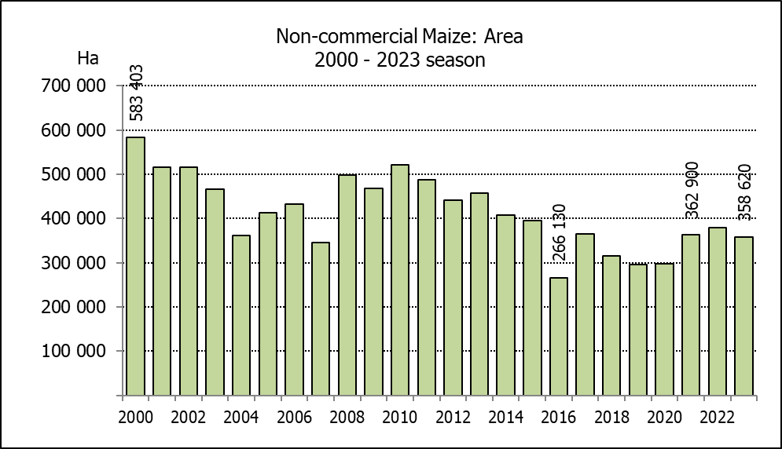
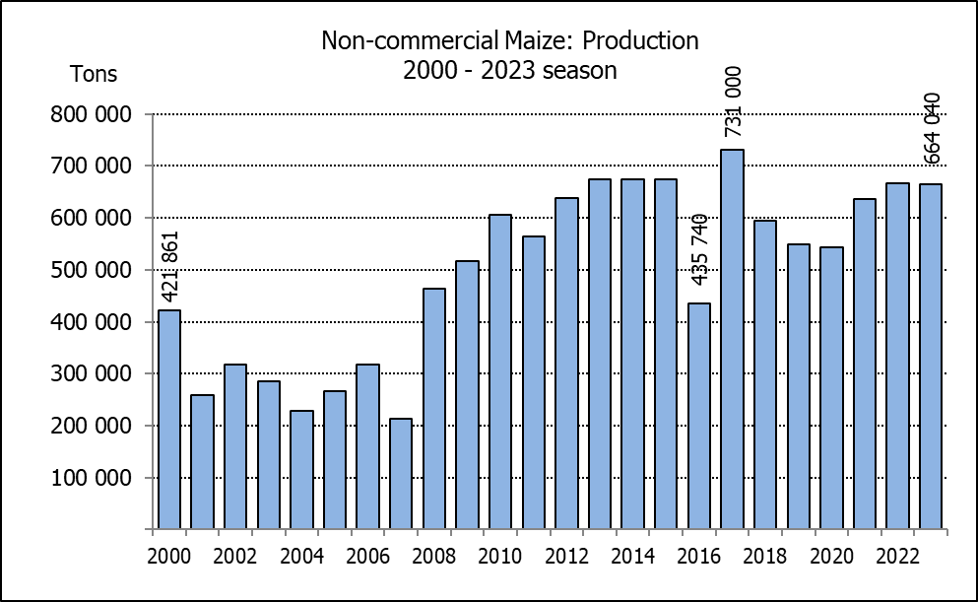
NIE-KOMMERSIëLE MIELIES – OPPERVLAKTE- EN PRODUKSIESKATTING: 2023
CROP/GEWAS | Area planted/  Opp beplant  2023 | Production/  Produksie  2023 | Area planted/  Opp beplant  2022 | Final crop/  Finale oes  2022 | Change/  Verandering
CROP/GEWAS | Ha | Tons | Ha | Tons | %
CROP/GEWAS | (A) | (B) | (C) | (D) | (B) ÷ (D)
Non-commercial agriculture/Nie-kommersiële landbou:
White maize/Witmielies | 278 655 | 472 765 | 296 950 | 482 000 | -1,92
Yellow maize/Geelmielies | 79 965 | 191 275 | 81 850 | 185 000 | +3,39
Maize/Mielies | 358 620 | 664 040 | 378 800 | 667 000 | -0,44
The preliminary area planted to maize in the non-commercial agricultural sector is estimated at 358 620 ha, which represents a decrease of 5,33%, compared to the 378 800 ha of the previous season. The expected maize crop for this sector is 664 040 tons, which is 0,44% less than the 667 000 tons of last season. It is important to note that about 48% of the maize produced in the non-commercial sector, is planted in the Eastern Cape, followed by KwaZulu-Natal with 21%.
Die voorlopige oppervlakte beplant met mielies in die nie-kommersiële landbou-sektor word geskat op 358 620 ha, wat ’n afname van 5,33% verteenwoordig in vergelyking met die 378 800 ha van die vorige seisoen. Die verwagte mielie-oes van dié sektor is 664 040 ton, wat 0,44% minder is as die 667 000 ton van die vorige seisoen. Dit is belangrik om daarop te let dat ongeveer 48% van die mielies wat geproduseer word in die nie-kommersiële sektor, in die Oos-Kaap geplant word, gevolg deur KwaZulu-Natal met 21%.

The area estimate and third production forecast for winter cereals for the 2023 is hereby released. /
Hiermee word die oppervlakteskatting en derde produksieskatting vir wintergewasse vir 2023 vrygestel.
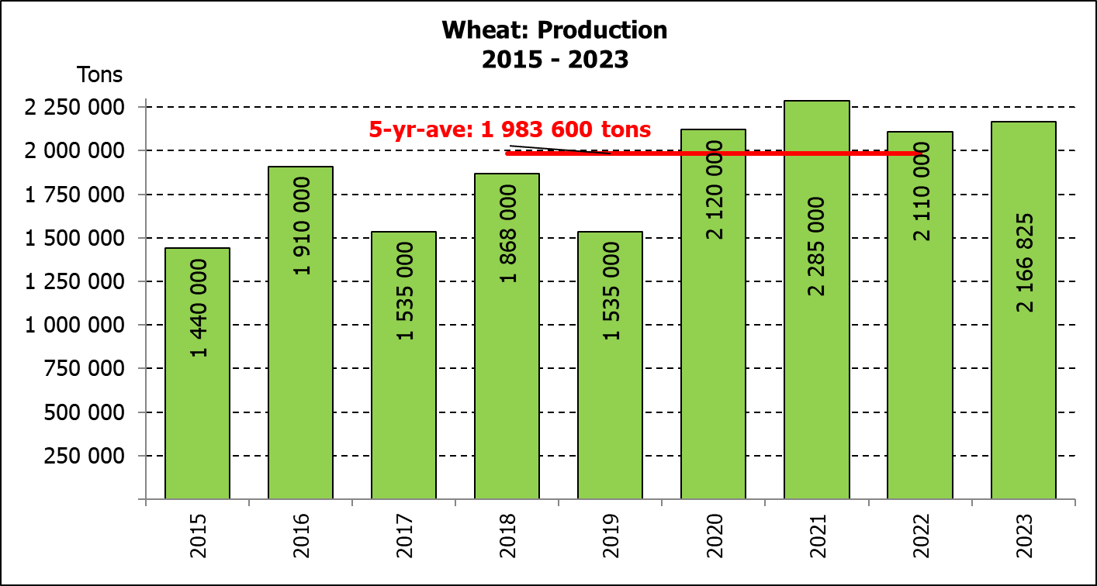
WINTER CEREALS – AREA PLANTED ESTIMATE AND THIRD PRODUCTION FORECAST: 2023 PRODUCTION SEASON
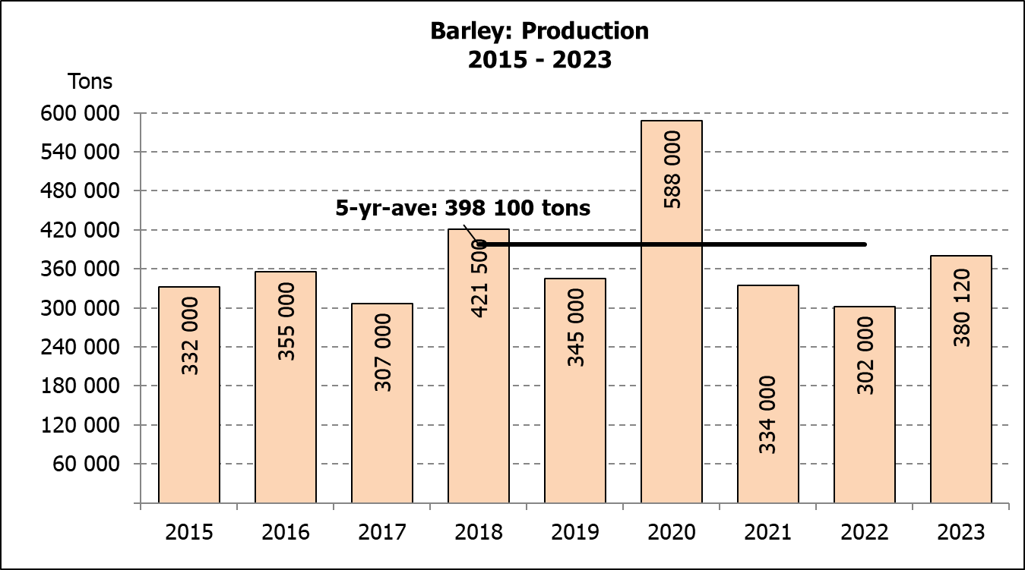
WINTERGEWASSE – OPPERVLAKTESKATTING EN DERDE PRODUKSIESKATTING: 2023-PRODUKSIESEISOEN
CROP/GEWAS | Area planted/  Opp beplant  2023 | 3rd forecast/  3de skatting  2023 | 2nd forecast/  2de skatting  2023 | Area planted/  Opp beplant  2022 | Final crop/  Finale oes  2022 | Change/  Verandering
CROP/GEWAS | Ha | Tons | Tons | Ha | Tons | %
CROP/GEWAS | (A) | (B) | (C) | (D) | (E) | (B) ÷ (C)
Commercial/Kommersieel:
Wheat/Koring | 537 950 | 2 166 825 | 2 131 375 | 566 800 | 2 110 000 | +1,66
Barley/Gars¹⁾ | 107 600 | 380 120 | 389 920 | 101 000 | 302 000 | -2,51
Canola/Kanola | 131 200 | 237 450 | 230 950 | 123 510 | 210 000 | +2,81
Oats/Hawer¹⁾ | 27 500 | 41 600 | 51 050 | 27 000 | 27 550 | -18,51
Sweet lupines/Soetlupine | 16 000 | 19 200 | 19 200 | 21 000 | 15 750 | -
1) Commercial only. Excluding barley or oats used as pasture, silage, hay and/or on the farm as fodder for livestock /
Slegs kommersieël. Uitgesluit gars of hawer wat gebruik word as weiding, kuilvoer, hooi en/of op die plaas as voer vir vee.

WHEAT – AREA PLANTED ESTIMATE AND THIRD PRODUCTION FORECAST: 2023
KORING – OPPERVLAKTESKATTING EN DERDE PRODUKSIESKATTING: 2023
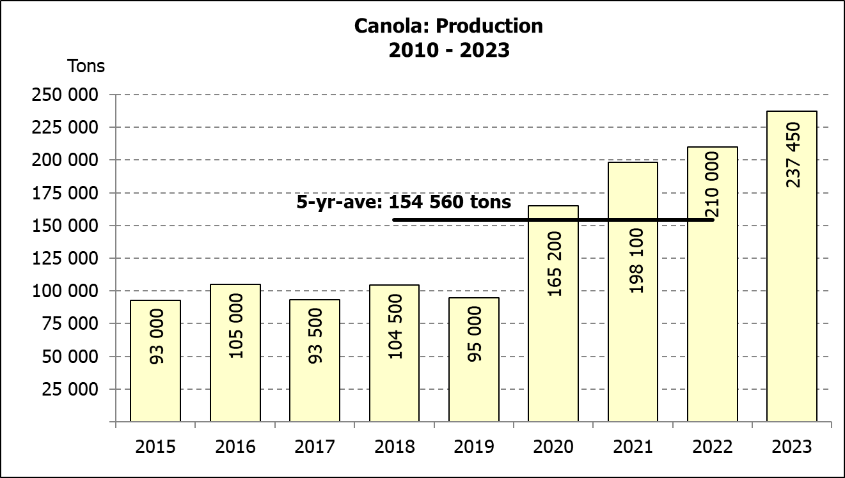
Province/  Provinsie | Area planted/  Opp beplant  Ha | 3rd forecast/  3de skatting  Tons | Area planted/  Opp beplant  Ha | Final crop/  Finale oes  Tons
Province/  Provinsie | 2023 | 2023 | 2022 | 2022
Western Cape/Wes-Kaap | 365 000 | 1 149 750 | 360 000 | 918 000
Northern Cape/Noord-Kaap | 40 000 | 310 000 | 47 000 | 338 500
Free State/Vrystaat | 72 000 | 309 600 | 96 000 | 436 800
Eastern Cape/Oos-Kaap | 6 300 | 40 950 | 6 000 | 40 200
KwaZulu-Natal | 8 500 | 56 100 | 9 200 | 60 730
Mpumalanga | 4 200 | 28 560 | 4 000 | 27 600
Limpopo | 30 000 | 199 500 | 29 000 | 187 000
Gauteng | 950 | 6 365 | 1 100 | 7 370
North West/Noordwes | 11 000 | 66 000 | 14 500 | 93 800
Total/Totaal | 537 950 | 2 166 825 | 566 800 | 2 110 000
AREA ESTIMATE AND THIRD PRODUCTION FORECAST OF WINTER CROPS (2023) /
OPPERVLAKTESKATTING EN DERDE PRODUKSIESKATTING VAN WINTERGEWASSE (2023)
26 OCTOBER/OKTOBER 2023

Winter cereal crops - 2023 production season  Wheat: The expected production of wheat is 2,167 mill. tons, which is 1,66% or 35 450 tons more than the previous forecast of 2,131 mill. tons, whilst the expected yield is 4,03 t/ha.  The expected production in the Western Cape is 1,150 mill. tons (53%), which is 5,0% or 54 750 tons more than the previous forecast. In the Free State, the expected production is 309 600 tons (14%), compared to the 331 200 tons of the previous month. In the Northern Cape, 310 000 tons (14%) is expected to be produced – unchanged from the previous month.  The area estimate for wheat is 537 950 ha, of which an estimated 365 000 ha or 68 % is planted in the Western Cape, 72 000 ha or 13 % in the Free State and 40 000 ha or 7 % in the Northern Cape.  Other crops: The production forecast for barley is 380 120 tons, which is 2,51% or 9 800 tons less than the previous month’s forecast of 389 920 tons. The area planted is estimated at 107 600 ha, while the expected yield is 3,53 t/ha.  The expected canola crop is 237 450 tons, which is 2,81% or 6 500 tons more than the previous month’s forecast of 230 950 tons. The area estimate for canola is 131 200 ha, with an expected yield of 1,81 t/ha.  The expected crop for oats for the 2023 season is 41 600 tons and the area planted is 27 500 ha. The expected yield is 1,51 t/ha.  In the case of sweet lupines, the production forecast is 19 200 tons. The area estimate of sweet lupines is 16 000 ha, with an expected yield of 1,20 t/ha.  Please note that the fourth production forecast for winter cereals for 2023 will be released on 28 November 2023. |  | Wintergewasse - 2023 produksie-seisoen  Koring: Die verwagte produksie vir koring is 2,167 milj. ton, wat 1,66% of 35 450 ton meer is as die vorige skatting van 2,131 milj. ton, terwyl die verwagte opbrengs 4,03 t/ha is.  Die verwagte produksie in die Wes-Kaap is 1,150 milj. ton (53%), wat 5,0 of 54 750 meer is as die vorige skatting. In die Vrystaat is die verwagte produksie 309 600 ton (14%), in vergelyking met die vorige maand se 331 200 ton. In die Noord-Kaap is die beraamde produksie 310 000 ton (14%) – onveranderd in vergelyking met die vorige maand.  Die oppervlakteskatting vir koring is 537 950 ha, waarvan ‘n geraamde 365 000 ha of 68% in die Wes-Kaap geplant is, 72 000 ha of 13% in die Vrystaat en 40 000 ha of 7 % in die Noord-Kaap.  Ander gewasse: Die produksieskatting vir gars is 380 120 ton, wat 2,51% of 9 800 ton minder is as die vorige maand se skatting van 389 920 ton. Die oppervlakte beplant word beraam op 107 600 ha, terwyl die verwagte opbrengs 3,53 t/ha beloop.  Die verwagte kanola-oes is 237 450 ton, wat 2,81% of 6 500 ton meer is as die vorige maand se skatting van 230 950 ton. Die oppervlakteskatting vir kanola is 131 200 ha, met ŉ verwagte opbrengs van 1,81 t/ha.  Die verwagte oes vir hawer vir die 2023-seisoen is 41 600 ton en die oppervlakteskatting is 27 500 ha. Die verwagte opbrengs is 1,51 t/ha.  In die geval van soetlupine is die produksieskatting 19 200 ton. Die oppervlakte beplant met soetlupine is 16 000 ha, en die verwagte opbrengs is 1,20 t/ha.  Neem asseblief kennis dat die vierde produksieskatting vir wintergewasse vir 2023 op 28 November 2023 vrygestel sal word.

Information is available on the internet at http:// www.dalrrd.gov.za/old website/statistics or http://www.sagis.org.za, as from 14:30 on the date of the relevant meeting of the Crop Estimates Committee. |  | Inligting is beskikbaar op die internet by http://www.dalrrd.gov.za/old website/statistics of by http://www.sagis.org.za, vanaf 14:30 op die dag van die toepaslike vergadering van die Oesskattingskomitee.

