 | crop estimates committee | 
 | oesskattingskomitee
From/Van: Mr Baldwin Netshifhefhe
Tel: 012 319 8043/32  Fax/Faks: 012 319 8031  E-mail/E-pos: BaldwinN@dalrrd.gov.za
Web page/Webblad: www.dalrrd.gov.za/statistics and economic reports or www.sagis.org.za/CEC: Crop Estimates
EMBARGO: 14:30

The area planted and final production estimate for summer crops for 2021 is hereby released.
Hiermee word die oppervlakte- en finale produksieskatting vir somergewasse vir 2021 vrygestel.

SUMMER CROPS – AREA PLANTED AN0 FINAL PRODUCTION ESTIMATE: 2021
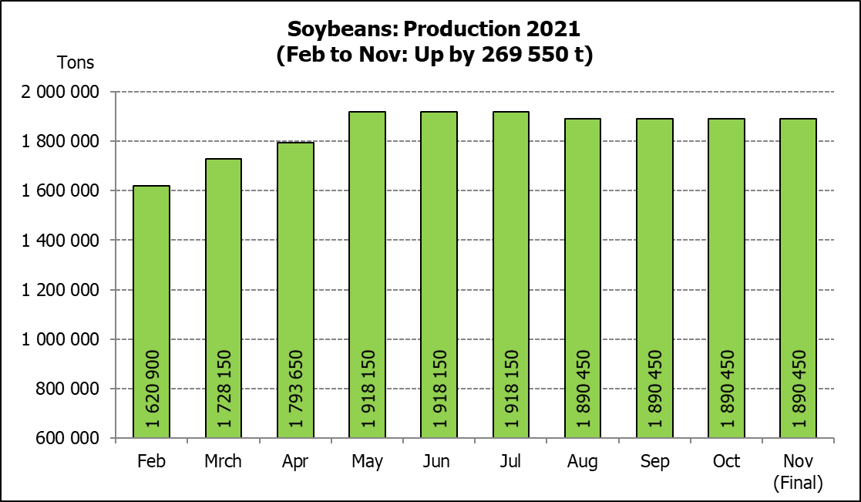
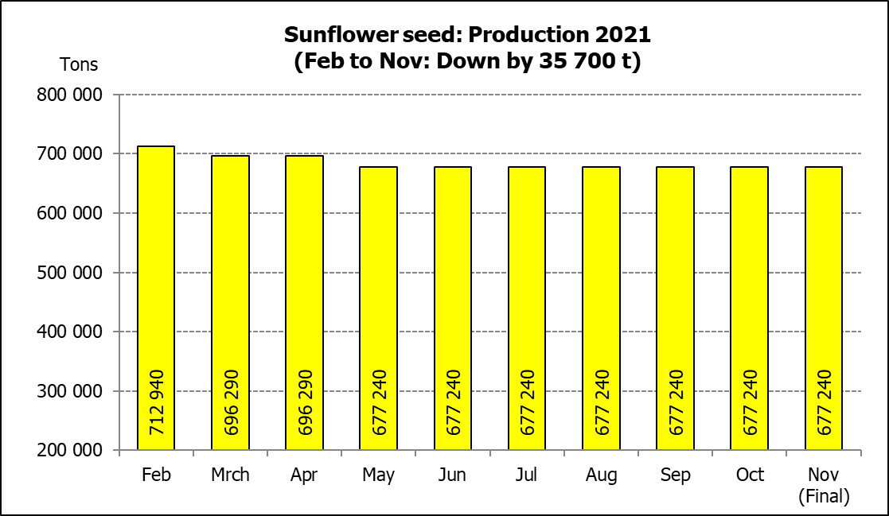
SOMERGEWASSE – OPPERVLAKTE- EN FINALE PRODUKSIESKATTING: 2021
CROP/GEWAS | Area planted/  Opp beplant  2021 | Final estimate/  Finale skatting  2021 | 9th forecast/  9de skatting  2021 | Area planted/  Opp beplant  2020 | Final crop/  Finale oes  2020 | Change/  Verandering/
CROP/GEWAS | Ha | Tons | Tons | Ha | Tons | %
CROP/GEWAS | (A) | (B) | (C) | (D) | (E) | (B) ÷ (C)
Commercial/Kommersieël:
White maize/Witmielies | 1 691 900 | 8 608 815 | 8 608 815 | 1 616 300 | 8 547 500 | -
Yellow maize/Geelmielies | 1 063 500 | 7 625 450 | 7 602 450 | 994 500 | 6 752 500 | +0,30
Total Maize/Totale Mielies | 2 755 400 | 16 234 265 | 16 211 265 | 2 610 800 | 15 300 000 | +0,14
Sunflower seed/Sonneblomsaad | 477 800 | 677 240 | 677 240 | 500 300 | 788 500 | -
Soybeans/Sojabone | 827 100 | 1 890 450 | 1 890 450 | 705 000 | 1 245 500 | -
Groundnuts/Grondbone | 38 550 | 59 950 | 58 900 | 37 500 | 50 080 | +1,78
Sorghum | 49 200 | 213 645 | 209 980 | 42 500 | 158 000 | +1,75
Dry beans/Droëbone | 47 390 | 57 672 | 57 672 | 50 150 | 64 800 | -
Non-Commercial Maize/Nie-Kommersiële Mielies
Total Maize/Totaal Mielies | 362 900 | 636 440 | 636 440 | 297 460 | 543 545 | -
Maize/Mielies: Commercial/Kommersieël + Non-Commercial/Nie-Kommersieël
Total Maize RSA/Totaal Mielies RSA | 3 118 300 | 16 870 705 | 16 847 705 | 2 908 260 | 15 843 545 | +0,14
Note: Estimate is for calendar year, e.g. production season 2020/21 = 2021
Nota: Skatting is vir kalenderjaar, bv. produksie-seisoen 2020/21 = 2021
The Crop Estimates Committee comprises officials of the following institutions:
Department of Agriculture, Land Reform and Rural Development, Provincial Departments of Agriculture; various ARC-Institutes (Soil, Climate and Water; Small Grains Institute;
Grain Crops Institute); BFAP and Statistics SA.
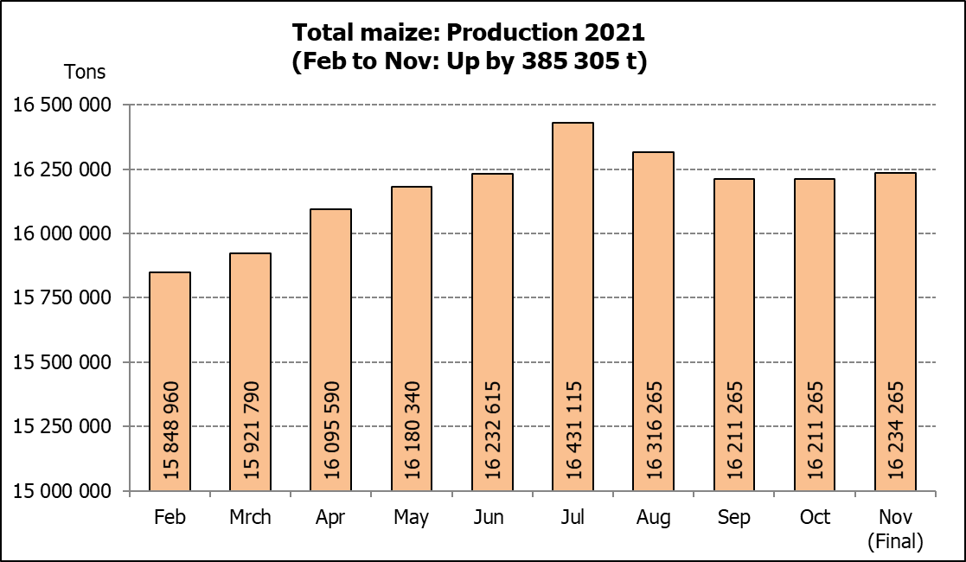
25 November 2021

WHITE AND YELLOW MAIZE – AREA PLANTED AND FINAL PRODUCTION ESTIMATE: 2021
WIT- EN GEELMIELIES – OPPERVLAKTE EN FINALE PRODUKSIESKATTING: 2021

Provinsie/  Province | Area planted/  Oppervlakte beplant  2021 |  |  | Final estimate/  Finale skatting  2021 |  |  | Area planted/  Oppervlakte beplant  2020 |  |  | Final crop/  Finale oes  2020
Provinsie/  Province | White/  Wit  Ha | Yellow/  Geel  Ha | Total/  Totaal  Ha | White/  Wit  Tons | Yellow/  Geel  Tons | Total/  Totaal  Tons | White/  Wit  Ha | Yellow/  Geel  Ha | Total/  Totaal  Ha | White/  Wit  Tons | Yellow/  Geel  Tons | Total/  Totaal  Tons
Western Cape/Wes-Kaap | 500 | 3 500 | 4 000 | 4 500 | 31 500 | 36 000 | 400 | 3 400 | 3 800 | 3 600 | 30 600 | 34 200
Northern Cape/Noord-Kaap | 3 400 | 41 000 | 44 400 | 40 290 | 627 300 | 667 590 | 3 400 | 43 100 | 46 500 | 40 300 | 633 900 | 674 200
Free State/Vrystaat | 907 500 | 420 000 | 1 327 500 | 4 492 125 | 2 499 000 | 6 991 125 | 855 000 | 365 000 | 1 220 000 | 4 700 000 | 2 209 000 | 6 909 000
Eastern Cape/Oos-Kaap | 6 000 | 18 000 | 24 000 | 39 000 | 133 200 | 172 200 | 5 500 | 17 000 | 22 500 | 35 200 | 119 000 | 154 200
KwaZulu-Natal | 50 000 | 55 000 | 105 000 | 310 000 | 451 000 | 761 000 | 47 000 | 55 000 | 102 000 | 298 400 | 434 500 | 732 900
Mpumalanga | 165 000 | 360 000 | 525 000 | 1 105 500 | 2 790 000 | 3 895 500 | 160 000 | 353 000 | 513 000 | 872 000 | 2 347 500 | 3 219 500
Limpopo | 16 500 | 21 000 | 37 500 | 112 200 | 172 200 | 284 400 | 15 000 | 18 000 | 33 000 | 105 000 | 126 000 | 231 000
Gauteng | 58 000 | 50 000 | 108 000 | 371 200 | 375 000 | 746 200 | 55 000 | 50 000 | 105 000 | 297 000 | 330 000 | 627 000
North West/Noordwes | 485 000 | 95 000 | 580 000 | 2 134 000 | 546 250 | 2 680 250 | 475 000 | 90 000 | 565 000 | 2 196 000 | 522 000 | 2 718 000
Total/Totaal | 1 691 900 | 1 063 500 | 2 755 400 | 8 608 815 | 7 625 450 | 16 234 265 | 1 616 300 | 994 500 | 2 610 800 | 8 547 500 | 6 752 500 | 15 300 000

SUNFLOWER SEED – AREA PLANTED AND FINAL PRODUCTION ESTIMATE: 2021
SONNEBLOMSAAD – OPPERVLAKTE EN FINALE PRODUKSIESKATTING: 2021

Province/  Provinsie | Area planted/  Opp beplant  Ha | Final estimate/  Finale skatting Tons | Area planted/  Opp beplant  Ha | Final crop/  Finale oes  Tons
Province/  Provinsie | 2021 | 2021 | 2020 | 2020
Western Cape/Wes-Kaap | - | - | - | -
Northern Cape/Noord-Kaap | 1 100 | 1 320 | 1 200 | 1 430
Free State/Vrystaat | 235 000 | 352 500 | 260 000 | 444 600
Eastern Cape/Oos-Kaap | 300 | 450 | 300 | 750
KwaZulu-Natal | - | - | - | -
Mpumalanga | 3 500 | 5 250 | 2 800 | 3 920
Limpopo | 76 500 | 76 500 | 65 000 | 65 000
Gauteng | 4 400 | 5 720 | 4 000 | 5 600
North West/Noordwes | 157 000 | 235 500 | 167 000 | 267 200
Total/Totaal | 477 800 | 677 240 | 500 300 | 788 500
SOYBEANS – AREA PLANTED AND FINAL PRODUCTION ESTIMATE: 2021
SOJABONE – OPPERVLAKTE EN FINALE PRODUKSIESKATTING: 2021

Province/  Provinsie | Area planted/  Opp beplant  Ha | Final estimate/  Finale skatting Tons | Area planted/  Opp beplant  Ha | Final crop/  Finale oes  Tons
Province/  Provinsie | 2021 | 2021 | 2020 | 2020
Western Cape/Wes-Kaap | - | - | - | -
Northern Cape/Noord-Kaap | 1 000 | 3 500 | 2 000 | 7 000
Free State/Vrystaat | 365 000 | 766 500 | 315 000 | 519 750
Eastern Cape/Oos-Kaap | 3 100 | 9 300 | 1 500 | 3 000
KwaZulu-Natal | 36 000 | 129 600 | 35 000 | 101 500
Mpumalanga | 290 000 | 638 000 | 260 000 | 416 000
Limpopo | 20 500 | 71 750 | 15 500 | 48 050
Gauteng | 42 000 | 105 000 | 36 000 | 70 200
North West/Noordwes | 69 500 | 166 800 | 40 000 | 80 000
Total/Totaal | 827 100 | 1 890 450 | 705 000 | 1 245 500

GROUNDNUTS – AREA PLANTED AND FINAL PRODUCTION ESTIMATE: 2021
GRONDBONE – OPPERVLAKTE EN FINALE PRODUKSIESKATTING: 2021

Province/  Provinsie | Area planted/  Opp beplant  Ha | Final estimate/  Finale skatting Tons | Area planted/  Opp beplant  Ha | Final crop/  Finale oes  Tons
Province/  Provinsie | 2021 | 2021 | 2020 | 2020
Western Cape/Wes-Kaap | - | - | - | -
Northern Cape/Noord-Kaap | 1 500 | 3 900 | 1 200 | 2 580
Free State/Vrystaat | 16 000 | 24 800 | 11 000 | 15 400
Eastern Cape/Oos-Kaap | - | - | - | -
KwaZulu-Natal | 50 | 50 | - | -
Mpumalanga | - | - | - | -
Limpopo | 3 000 | 6 900 | 2 900 | 5 220
Gauteng | - | - | - | -
North West/Noordwes | 18 000 | 24 300 | 22 400 | 26 880
Total/Totaal | 38 550 | 59 950 | 37 500 | 50 080

SORGHUM – AREA PLANTED AND FINAL PRODUCTION ESTIMATE: 2021
SORGHUM – OPPERVLAKTE EN FINALE PRODUKSIESKATTING: 2021

Province/  Provinsie | Area planted/  Opp beplant  Ha | Final estimate/  Finale skatting Tons | Area planted/  Opp beplant  Ha | Final crop/  Finale oes  Tons
Province/  Provinsie | 2021 | 2021 | 2020 | 2020
Western Cape/Wes-Kaap | - | - | - | -
Northern Cape/Noord-Kaap | - | - | - | -
Free State/Vrystaat | 10 500 | 44 625 | 8 000 | 35 200
Eastern Cape/Oos-Kaap |  | - | - | -
KwaZulu-Natal | 500 | 2 250 | 1 200 | 4 200
Mpumalanga | 9 400 | 57 340 | 8 500 | 46 340
Limpopo | 17 000 | 61 200 | 16 000 | 41 950
Gauteng | 300 | 1 080 | 300 | 960
North West/Noordwes | 11 500 | 47 150 | 8 500 | 29 350
Total/Totaal | 49 200 | 213 645 | 42 500 | 158 000

DRY BEANS – AREA PLANTED AND FINAL PRODUCTION ESTIMATE: 2021
DROëBONE – OPPERVLAKTE EN FINALE PRODUKSIESKATTING: 2021

Province/  Provinsie | Area planted/  Opp beplant  Ha | Final estimate/  Finale skatting Tons | Area planted/  Opp beplant  Ha | Final crop/  Finale oes  Tons
Province/  Provinsie | 2021 | 2021 | 2020 | 2020
Western Cape/Wes-Kaap | 100 | 150 | 100 | 150
Northern Cape/Noord-Kaap | 350 | 700 | 350 | 700
Free State/Vrystaat | 22 000 | 16 500 | 24 000 | 30 000
Eastern Cape/Oos-Kaap | 200 | 300 | 200 | 300
KwaZulu-Natal | 3 000 | 3 900 | 2 900 | 3 480
Mpumalanga | 6 500 | 9 750 | 6 600 | 8 250
Limpopo | 8 000 | 16 000 | 8 400 | 13 440
Gauteng | 840 | 1 092 | 600 | 780
North West/Noordwes | 6 400 | 9 280 | 7 000 | 7 700
Total/Totaal | 47 390 | 57 672 | 50 150 | 64 800

CONFIDENTIALITY ISSUES that CEC members are committed to adhere to on the day of the meeting
- Personal items such as laptops, handbags, cell phones, etc. are not allowed in the venue during the meeting
- No member is allowed to leave the meeting before 12:00 in order to prevent disclosure of the information
- The embargo time for the release of crop estimates information is 14:30
- No member is allowed to discuss crop estimates information with anyone other than a member of the Committee before the embargo time
- Only the Chairperson, or a member appointed by the Chairperson, may release the figures to the media
- Members must regard the detail of any information that was collected for and/or discussed during the meeting, as confidential
- Individual information received for crop estimate purposes is treated strictly confidential, and is not divulged for any other purposes

AREA ESTIMATE AND FINAL PRODUCTION ESTIMATE OF SUMMER CROPS (2021 PRODUCTION SEASON)/
OPPERVLAKTE- EN FINALE PRODUKSIESKATTING VIR SOMERGEWASSE (2021 PRODUKSIE-SEISOEN)
25 NOVEMBER 2021

Summer field crops – 2021  Commercial maize: The size of the expected commercial maize crop has been set at 16,234 mill. tons, which is 0,14% or 23 000 tons more than the previous forecast of 16,211 mill. tons. The area estimate for maize is 2,755 mill. ha, while the expected yield is 5,89 t/ha.  The estimated maize crop is 6% bigger than the 2020 crop. The three main maize producing areas, namely the Free State, Mpumalanga and North West provinces is expected to produce 84% of the 2021 crop.  The area estimate for white maize is 1,692 mill. ha and for yellow maize the area estimate is 1,064 mill. ha.  The production forecast of white maize remained unchanged at 8,609 mill. tons. The yield for white maize is 5,09 t/ha. In the case of yellow maize the production forecast increased by 0,30% or 23 000 tons from 7,602 mill. tons to 7,625 mill. tons. The yield for yellow maize is 7,17 t/ha.  Sunflower seed: The production forecast for sunflower seed remained unchanged at 677 240 tons. The area estimate for sunflower seed is 477 800 ha, while the expected yield is 1,42 t/ha.  Other crops: The production forecast for soybeans also remained unchanged at 1,890 mill. tons. The estimated area planted to soybeans is 827 100 ha and the expected yield is 2,29 t/ha.  The expected groundnut crop is 59 950 tons, which is 1,78% or 1 050 tons more than the previous forecast of 58 900 tons. For groundnuts, the area estimate is 38 550 ha, with an expected yield of 1,56 t/ha.  The production forecast for sorghum increased by 1,75% or 3 665 tons, from 209 980 tons to 213 645 tons. The area estimate for sorghum is 49 200 ha and the expected yield is 4,34 t/ha.  In the case of dry beans, the production forecast is 57 672 tons, also unchanged from the previous forecast. The area estimate of dry beans is 47 390 ha, with an expected yield of 1,22 t/ha.  Please note that the preliminary area estimate for summer field crops for 2022 will be released on 27 January 2022. |  | Somergewasse – 2021  Kommersiële mielies: Die grootte van die verwagte kommersiële mielie-oes is op 16,234 milj. ton gestel, wat 0,14% of 23 000 ton meer is as die vorige skatting van 16,211 milj. ton. Die skatting van die oppervlakte onder mielies is 2,755 milj. ha, terwyl die verwagte opbrengs 5,89 t/ha is.  Die geskatte mielie-oes is 6% groter as die 2020-oes. Die drie belangrikste mielieproduserende gebiede, nl. die Vrystaat, Mpumalanga en Noordwes provinsies, gaan na verwagting 84% van die 2021-oes produseer.  Die oppervlakte onder witmielies is 1,692 milj. ha en vir geelmielies is die oppervlakte 1,064 milj. ha.  Die produksieskatting van witmielies is onveranderd gelaat op 8,609 milj. ton. Die opbrengs van witmielies is 5,09 t/ha. In die geval van geelmielies is die produksieskatting met 0,30% of 23 000 ton verhoog vanaf 7,602 milj. ton na 7,625 milj. ton. Die opbrengs van geelmielies is 7,17 t/ha.  Sonneblomsaad: Die produksieskatting vir sonneblomsaad is onveranderd gelaat op 677 240 ton. Die oppervlakteskatting vir sonneblomsaad is 477 800 ha, terwyl die verwagte opbrengs 1,42 t/ha is.  Ander gewasse: Die produksieskatting van sojabone is ook onveranderd gelaat op 1,890 milj. ton. Die geskatte oppervlakte beplant van sojabone is 827 100 ha en die verwagte opbrengs is 2,29 t/ha.  Die verwagte grondbone-oes is 59 950 ton, wat 1,78% of 1 050 ton meer is as die vorige skatting van 58 900 ton. Vir grondbone is die oppervlakteskatting 38 550 ha, terwyl die verwagte opbrengs 1,56 t/ha is.  Die produksieskatting van sorghum is verhoog met 1,75% of 3 665 ton vanaf 209 980 ton na 213 645 ton. Die oppervlakteskatting vir sorghum is 49 200 ha, en die verwagte opbrengs is 4,34 t/ha.  In die geval van droëbone is die produksieskatting 57 672 ton, ook onveranderd teenoor die vorige skatting. Die oppervlakte beplant met droëbone is 47 390 ha, en die verwagte opbrengs is 1,22 t/ha.  Neem asseblief kennis dat die voorlopige oppervlakteskatting vir somergewasse vir 2022, op 27 Januarie 2022 vrygestel sal word.
Information is available on the internet at http://www.dalrrd.gov.za/statistics and economic reports or http://www.sagis.org.za, as from 14:30 on the date of the relevant meeting of the Crop Estimates Committee. |  | Inligting is beskikbaar op die internet by http://www.dalrrd.gov.za/statistics and economic reports of by http://www.sagis.org.za, vanaf 14:30 op die dag van die toepaslike vergadering van die Oesskattingskomitee.

The non-commercial agricultural sectors’ production estimate for maize for 2021 is hereby released. /
Hiermee word die nie-kommersiële landbou-sektor se produksieskatting vir mielies vir 2021 vrygestel.
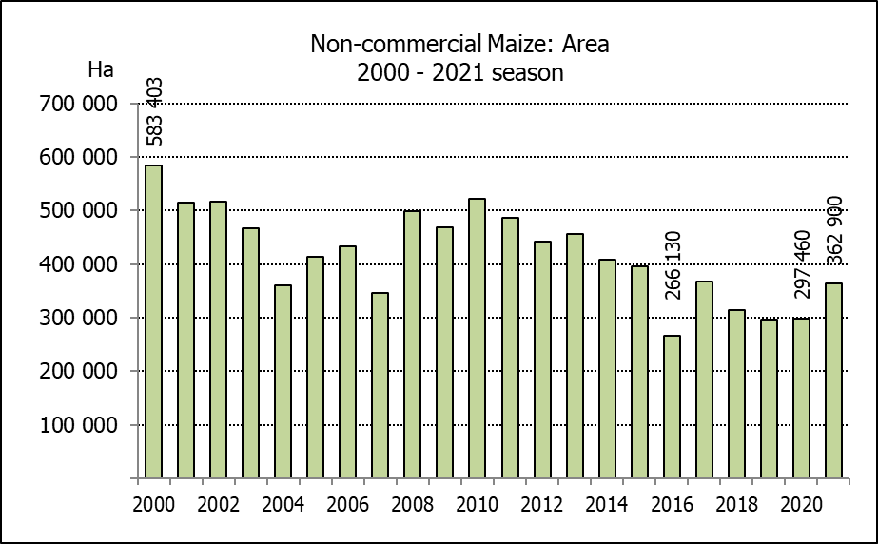
NON-COMMERCIAL MAIZE – AREA PLANTED AND PRODUCTION ESTIMATE: 2021
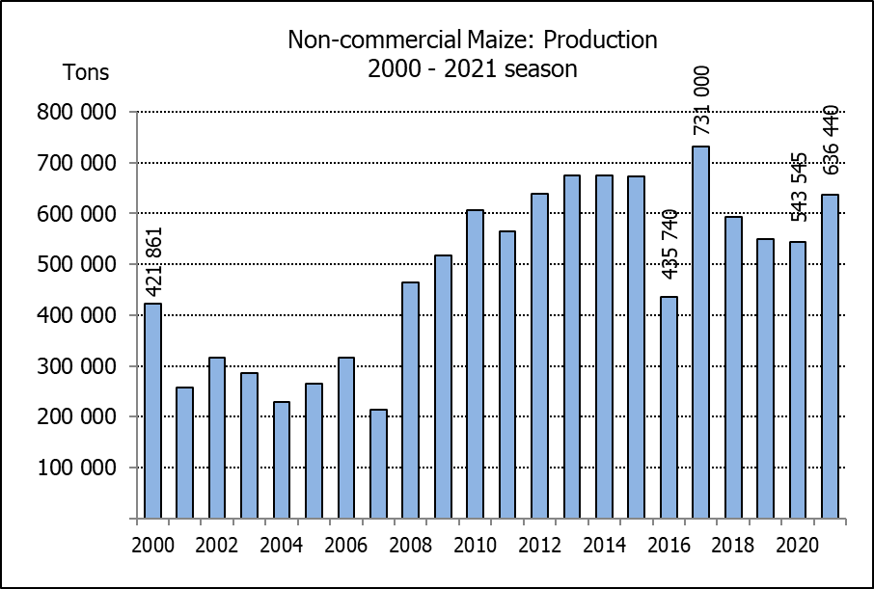
NIE-KOMMERSIëLE MIELIES – OPPERVLAKTE- EN PRODUKSIESKATTING: 2021
 | CROP/GEWAS | Area planted/  Opp beplant  2021 | Production/  Produksie  2021 | Area planted/  Opp beplant  2020 | Final crop/  Finale oes  2020 | Change/  Verandering
 | CROP/GEWAS | Ha | Tons | Ha | Tons | %
 | CROP/GEWAS | (A) | (B) | (C) | (D) | (B) ÷ (D)
 | Non-commercial agriculture/Nie-kommersiële landbou:
 | White maize/Witmielies | 276 100 | 445 335 | 221 945 | 375 295 | +18,66
 | Yellow maize/Geelmielies | 86 800 | 191 105 | 75 515 | 168 250 | +13,58
 | Maize/Mielies | 362 900 | 636 440 | 297 460 | 543 545 | +17,09
The preliminary area planted to maize in the non-commercial agricultural sector is estimated at 362 900 ha, which represents an increase of 22,00%, compared to the 297 460 ha of the previous season. The expected maize crop for this sector is 636 440 tons, which is 17,09% more than the 543 545 tons of last season. It is important to note that about 53% of the maize produced in the non-commercial sector, is planted in the Eastern Cape, followed by KwaZulu-Natal with 23%.
Die voorlopige oppervlakte beplant met mielies in die nie-kommersiële landbou-sektor word geskat op 362 900 ha, wat ’n toename van 22,00% verteenwoordig in vergelyking met die 297 460 ha van die vorige seisoen. Die verwagte mielie-oes van dié sektor is 636 440 ton, wat 17,09% meer is as die 543 545 ton van die vorige seisoen. Dit is belangrik om daarop te let dat ongeveer 53% van die mielies wat geproduseer word in die nie-kommersiële sektor, in die Oos-Kaap geplant word, gevolg deur KwaZulu-Natal met 23%.

The area estimate and fourth production forecast for winter cereals for the 2021 is hereby released. /
Hiermee word die oppervlakte- en vierde produksieskatting vir wintergewasse vir 2021 vrygestel.

WINTER CEREALS – AREA PLANTED AND FOURTH PRODUCTION FORECAST: 2021 PRODUCTION SEASON
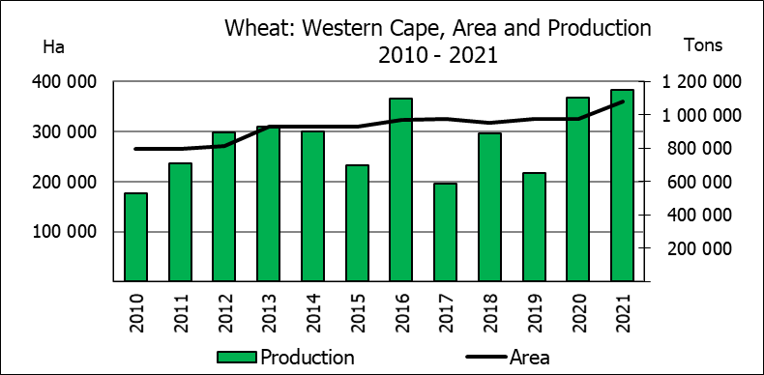
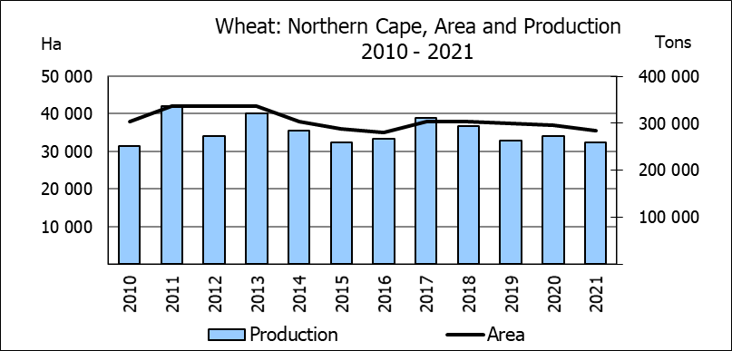
WINTERGEWASSE - OPPERVLAKTE- EN VIERDE PRODUKSIESKATTING: 2021 PRODUKSIE-SEISOEN
CROP/GEWAS | Area planted/  Opp beplant  2021 | 4th forecast/  4de skatting  2021 | 3rd forecast/  3de skatting  2021 | Area planted/  Opp beplant  2020 | Final crop/  Finale oes  2020 | Change/  Verandering
CROP/GEWAS | Ha | Tons | Tons | Ha | Tons | %
CROP/GEWAS | (A) | (B) | (C) | (D) | (E) | (B) ÷ (C)
Commercial/Kommersieël:
Wheat/Koring | 523 500 | 2 117 435 | 2 099 435 | 509 800 | 2 120 000 | +0,86
Malting barley/Moutgars | 94 730 | 339 800 | 348 200 | 141 690 | 588 000 | -2,41
Canola/Kanola | 100 000 | 190 000 | 190 000 | 74 120 | 165 200 | -
Cereal oats/Hawermout | 36 250 | 80 450 | 80 473 | 26 200 | 57 000 | -0,03
Sweet lupines/Soetlupine | 22 000 | 30 800 | 30 800 | N/a | N/a | -
* Note: Estimate is for calendar year, e.g. production season 2021/22 = 2021
* Nota: Skatting is vir kalenderjaar, bv. produksie-seisoen 2021/22 = 2021

WHEAT AREA PLANTED AND FOURTH PRODUCTION FORECAST: 2021 PRODUCTION SEASON
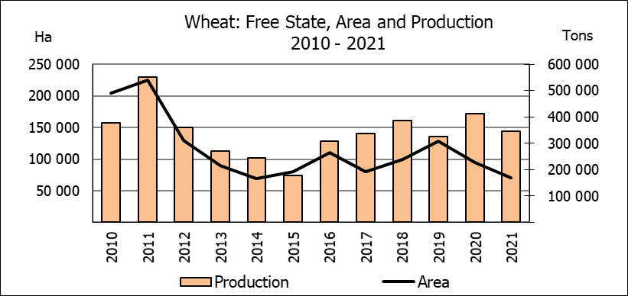
KORING – OPPERVLAKTE- EN VIERDE PRODUKSIESKATTING: 2021 PRODUKSIE-SEISOEN
Province/  Provinsie | Area planted/  Opp beplant  Ha | 4th forecast/  4de skatting  Tons | Area planted/  Opp beplant  Ha | Final crop/  Finale oes  Tons
Province/  Provinsie | 2021 | 2021 | 2019 | 2019
Western Cape/Wes-Kaap | 360 000 | 1 152 000 | 326 000 | 1 103 000
Northern Cape/Noord-Kaap | 35 500 | 259 150 | 37 000 | 271 950
Free State/Vrystaat | 70 000 | 346 500 | 94 000 | 413 600
Eastern Cape/Oos-Kaap | 3 800 | 24 700 | 4 000 | 26 000
KwaZulu-Natal | 8 500 | 53 125 | 7 800 | 48 360
Mpumalanga | 4 100 | 27 060 | 3 000 | 19 500
Limpopo | 26 500 | 164 300 | 23 000 | 147 200
Gauteng | 1 100 | 6 600 | 1 300 | 8 190
North West/Noordwes | 14 000 | 84 000 | 13 700 | 82 200
Total/Totaal | 523 500 | 2 117 435 | 509 800 | 2 120 000

AREA ESTIMATE AND FOURTH PRODUCTION FORECAST OF WINTER CROPS (2021) /
OPPERVLAKTESKATTING EN VIERDE PRODUKSIESKATTING VAN WINTERGEWASSE (2021)
25 NOVEMBER 2021
Winter cereal crops - 2021 production season  Wheat: The expected production of wheat is 2,117 mill. tons, which is 0,86% or 18 000 tons more than the previous forecast of 2,099 mill. tons, whilst the expected yield is 4,04 t/ha.  The expected production in the Western Cape is 1,152 mill. tons (54%), in the Free State 346 500 tons (16%) and in the Northern Cape 259 150 tons (12%).  Other crops: The production forecast for malting barley is 339 800 tons, which is 2,41% or 8 400 tons less than the previous forecast of 348 200 tons. The area planted is estimated at 94 730 ha, while the expected yield is 3,59 t/ha.  The expected canola crop remained unchanged at 190 000 tons. This is the largest expected canola crop produced in the history of SA. The area estimate for canola is 100 000 ha, with an expected yield of 1,90 t/ha.  The expected crop for oats (cereals) for the 2021 season is 80 450 tons and the area planted is 36 250 ha. The expected yield is 2,22 t/ha.  In the case of sweet lupines, the production forecast remained unchanged at 30 800 tons. The area estimate of sweet lupines is 22 000 ha, with an expected yield of 1,40 t/ha.  Please note that the fifth production forecast for winter cereals for 2021 will be released on 15 December 2021. |  | Wintergewasse - 2021 produksie-seisoen  Koring: Die verwagte produksie vir koring is 2,117 milj. ton, wat 0,86% of 18 000 ton meer is as die vorige skatting van 2,099 milj. ton, terwyl die verwagte opbrengs 4,04 t/ha is.  Die verwagte produksie in die Wes-Kaap is 1,152 milj. ton (54%), in die Vrystaat 346 500 ton (16%) en in die Noord-Kaap 259 150 ton (12%).  Ander gewasse: Die produksieskatting vir moutgars is 339 800 ton, wat 2,41% of 8 400 ton minder is as die vorige skatting van 348 200 ton. Die oppervlakte beplant word beraam op 94 730 ha, terwyl die verwagte opbrengs 3,59 t/ha beloop.  Die verwagte kanola-oes is onveranderd gelaat op 190 000 ton. Dit is die grootste kanola-oes wat nόg geproduseer is in die geskiedenis van SA. Die oppervlakteskatting vir kanola is 100 000 ha, met ŉ verwagte opbrengs van 1,90 t/ha.  Die verwagte oes vir hawer (ontbytgraan) vir die 2021-seisoen is 80 450 ton en die oppervlakteskatting is 36 250 ton. Die verwagte opbrengs is 2,22 t/ha.  In die geval van soetlupine is die produksieskatting onveranderd gelaat op 30 800 ton. Die oppervlakte beplant met soetlupine is 22 000 ha, en die verwagte opbrengs is 1,40 t/ha.  Neem asseblief kennis dat die vyfde produksieskatting vir wintergewasse vir 2021 op 15 Desember 2021 vrygestel sal word.

Information is available on the internet at http://www.dalrrd.gov.za/links/crop estimates or http://www.sagis.org.za, as from 14:30 on the date of the relevant meeting of the Crop Estimates Committee. |  | Inligting is beskikbaar op die internet by http://www.dalrrd.gov.za/links/crop estimates of by http://www.sagis.org.za, vanaf 14:30 op die dag van die toepaslike vergadering van die Oesskattingskomitee.

