 | crop estimates committee | 
 | oesskattingskomitee
From/Van: Mr Baldwin Netshifhefhe
Tel: 012 319 8043  Fax/Faks: 012 319 8031  E-mail/E-pos: BaldwinN@dalrrd.gov.za
Web page/Webblad: www.dalrrd.gov.za/statistics and economic reports or www.sagis.org.za/CEC: Crop Estimates
EMBARGO: 14:30

The area planted estimate and final production estimate for summer crops for 2020 is hereby released.
Hiermee word die oppervlakte- en finale produksieskatting vir somergewasse vir 2020 vrygestel.

SUMMER CROPS – AREA PLANTED AND FINAL PRODUCTION ESTIMATE: 2020
SOMERGEWASSE – OPPERVLAKTE- EN FINALE PRODUKSIESKATTING: 2020
CROP/GEWAS | Area planted/  Opp beplant  2020 | Final estimate/  Finale skatting  2020 | 9th forecast/  9de skatting  2020 | Area planted/  Opp beplant  2019 | Final crop/  Finale oes  2019 | Change/  Verandering/
CROP/GEWAS | Ha | Tons | Tons | Ha | Tons | %
CROP/GEWAS | (A) | (B) | (C) | (D) | (E) | (B) ÷ (C)
Commercial/Kommersieël:
White maize/Witmielies | 1 616 300 | 8 666 310 | 8 746 310 | 1 298 400 | 5 545 000 | -0,91
Yellow maize/Geelmielies | 994 500 | 6 741 870 | 6 673 910 | 1 002 100 | 5 730 000 | +1,02
Total Maize/Totale Mielies | 2 610 800 | 15 408 180 | 15 420 220 | 2 300 500 | 11 275 000 | -0,08
Sunflower seed/Sonneblomsaad | 500 300 | 785 910 | 785 910 | 515 350 | 678 000 | -
Soybeans/Sojabone | 705 000 | 1 245 500 | 1 261 250 | 730 500 | 1 170 345 | -1,25
Groundnuts/Grondbone | 37 500 | 50 080 | 50 080 | 20 050 | 19 400 | -
Sorghum | 42 500 | 155 560 | 153 935 | 50 500 | 127 000 | +1,06
Dry beans/Droëbone | 50 150 | 64 800 | 64 800 | 59 300 | 66 355 | -
Non-Commercial Maize/Nie-Kommersiële Mielies
Total Maize/Totaal Mielies | 297 460 | 543 545 | 543 545 | 296 000 | 549 180 | -
Maize/Mielies: Commercial/Kommersieël + Non-Commercial/Nie-Kommersieël
Total Maize RSA/Totaal Mielies RSA | 2 908 260 | 15 951 725 | 15 963 765 | 2 596 500 | 11 824 180 | -0,08
Note: Estimate is for calendar year, e.g. production season 2019/20 = 2020
Nota: Skatting is vir kalenderjaar, bv. produksie-seisoen 2019/20 = 2020
26 November 2020

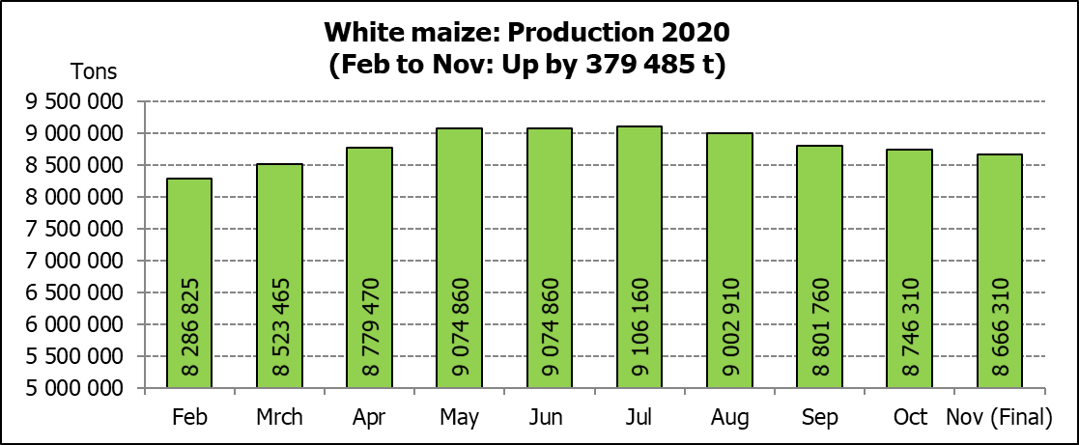

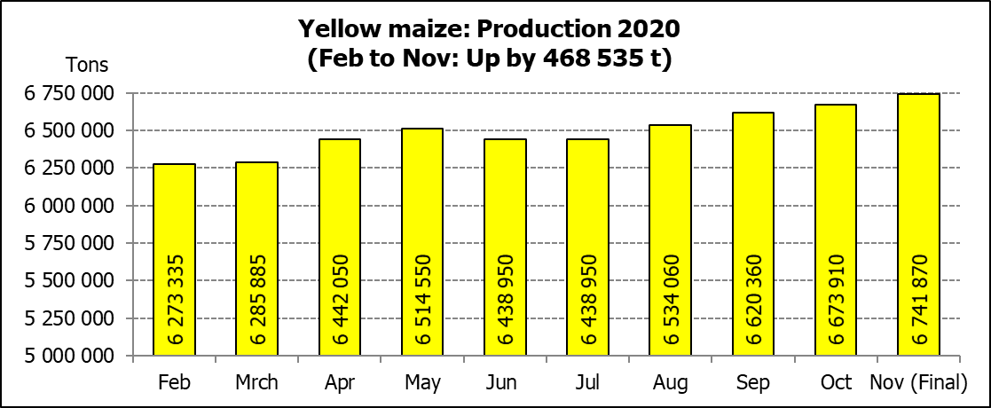
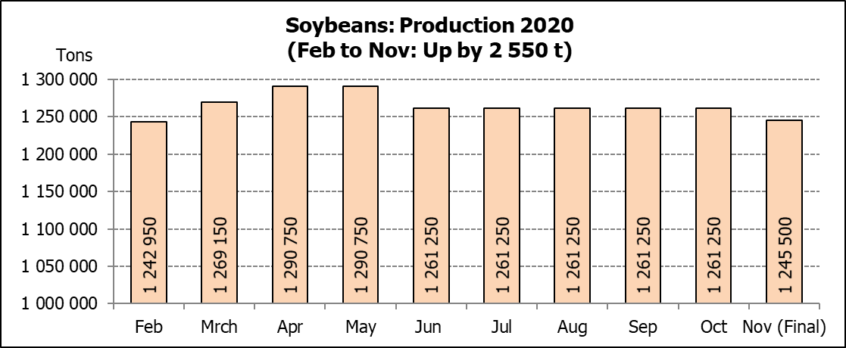

WHITE AND YELLOW MAIZE – AREA PLANTED AND FINAL PRODUCTION ESTIMATE: 2020
WIT- EN GEELMIELIES – OPPERVLAKTE EN FINALE PRODUKSIESKATTING: 2020

Provinsie/  Province | Area planted/  Oppervlakte beplant  2020 |  |  | Final estimate/  Finale skatting  2020 |  |  | Area planted/  Oppervlakte beplant  2019 |  |  | Final crop/  Finale oes  2019
Provinsie/  Province | White/  Wit  Ha | Yellow/  Geel  Ha | Total/  Totaal  Ha | White/  Wit  Tons | Yellow/  Geel  Tons | Total/  Totaal  Tons | White/  Wit  Ha | Yellow/  Geel  Ha | Total/  Totaal  Ha | White/  Wit  Tons | Yellow/  Geel  Tons | Total/  Totaal  Tons
Western Cape/Wes-Kaap | 400 | 3 400 | 3 800 | 3 600 | 30 600 | 34 200 | 400 | 3 400 | 3 800 | 3 600 | 30 600 | 34 200
Northern Cape/Noord-Kaap | 3 400 | 43 100 | 46 500 | 40 460 | 633 570 | 674 030 | 3 400 | 43 500 | 46 900 | 39 500 | 630 750 | 670 250
Free State/Vrystaat | 855 000 | 365 000 | 1 220 000 | 4 745 250 | 2 208 250 | 6 953 500 | 650 000 | 380 000 | 1 030 000 | 2 795 000 | 1 758 000 | 4 553 000
Eastern Cape/Oos-Kaap | 5 500 | 17 000 | 22 500 | 35 750 | 119 000 | 154 750 | 3 800 | 10 200 | 14 000 | 23 000 | 69 750 | 92 750
KwaZulu-Natal | 47 000 | 55 000 | 102 000 | 305 500 | 434 500 | 740 000 | 45 000 | 54 000 | 99 000 | 270 000 | 399 600 | 669 600
Mpumalanga | 160 000 | 353 000 | 513 000 | 872 000 | 2 347 450 | 3 219 450 | 145 000 | 338 000 | 483 000 | 797 500 | 1 977 300 | 2 774 800
Limpopo | 15 000 | 18 000 | 33 000 | 105 000 | 126 000 | 231 000 | 12 800 | 18 000 | 30 800 | 83 200 | 117 000 | 200 200
Gauteng | 55 000 | 50 000 | 105 000 | 302 500 | 325 000 | 627 500 | 48 000 | 60 000 | 108 000 | 259 200 | 348 000 | 607 200
North West/Noordwes | 475 000 | 90 000 | 565 000 | 2 256 250 | 517 500 | 2 773 750 | 390 000 | 95 000 | 485 000 | 1 274 000 | 399 000 | 1 673 000
Total/Totaal | 1 616 300 | 994 500 | 2 610 800 | 8 666 310 | 6 741 870 | 15 408 180 | 1 298 400 | 1 002 100 | 2 300 500 | 5 545 000 | 5 730 000 | 11 275 000

SUNFLOWER SEED – AREA PLANTED AND FINAL PRODUCTION ESTIMATE: 2020
SONNEBLOMSAAD – OPPERVLAKTE EN FINALE PRODUKSIESKATTING: 2020

Province/  Provinsie | Area planted/  Opp beplant  Ha | Final estimate/  Finale skatting  Tons | Area planted/  Opp beplant  Ha | Final crop/  Finale oes  Tons
Province/  Provinsie | 2020 | 2020 | 2019 | 2019
Western Cape/Wes-Kaap | - | - | - | -
Northern Cape/Noord-Kaap | 1 200 | 1 440 | 950 | 1 140
Free State/Vrystaat | 260 000 | 442 000 | 270 000 | 391 500
Eastern Cape/Oos-Kaap | 300 | 750 | 100 | 260
KwaZulu-Natal | - | - | - | -
Mpumalanga | 2 800 | 3 920 | 4 500 | 4 500
Limpopo | 65 000 | 65 000 | 61 000 | 61 000
Gauteng | 4 000 | 5 600 | 3 800 | 3 800
North West/Noordwes | 167 000 | 267 200 | 175 000 | 215 800
Total/Totaal | 500 300 | 785 910 | 515 350 | 678 000
SOYBEANS – AREA PLANTED AND FINAL PRODUCTION ESTIMATE: 2020
SOJABONE – OPPERVLAKTE EN FINALE PRODUKSIESKATTING: 2020

Province/  Provinsie | Area planted/  Opp beplant  Ha | Final estimate/  Finale skatting Tons | Area planted/  Opp beplant  Ha | Final crop/  Finale oes  Tons
Province/  Provinsie | 2020 | 2020 | 2019 | 2019
Western Cape/Wes-Kaap | - | - | 100 | 10
Northern Cape/Noord-Kaap | 2 000 | 7 000 | 1 550 | 5 425
Free State/Vrystaat | 315 000 | 519 750 | 301 000 | 391 300
Eastern Cape/Oos-Kaap | 1 500 | 3 000 | 1 150 | 1 380
KwaZulu-Natal | 35 000 | 101 500 | 33 000 | 99 000
Mpumalanga | 260 000 | 416 000 | 310 000 | 511 500
Limpopo | 15 500 | 48 050 | 16 200 | 46 980
Gauteng | 36 000 | 70 200 | 31 500 | 66 150
North West/Noordwes | 40 000 | 80 000 | 36 000 | 48 600
Total/Totaal | 705 000 | 1 245 500 | 730 500 | 1 170 345

GROUNDNUTS – AREA PLANTED AND FINAL PRODUCTION ESTIMATE: 2020
GRONDBONE – OPPERVLAKTE EN FINALE PRODUKSIESKATTING: 2020

Province/  Provinsie | Area planted/  Opp beplant  Ha | Final estimate/  Finale skatting  Tons | Area planted/  Opp beplant  Ha | Final crop/  Finale oes  Tons
Province/  Provinsie | 2020 | 2020 | 2019 | 2019
Western Cape/Wes-Kaap | - | - | - | -
Northern Cape/Noord-Kaap | 1 200 | 2 580 | 1 200 | 2 520
Free State/Vrystaat | 11 000 | 15 400 | 8 000 | 9 775
Eastern Cape/Oos-Kaap | - | - | - | -
KwaZulu-Natal | - | - | - | -
Mpumalanga | - | - | - | -
Limpopo | 2 900 | 5 220 | 1 850 | 3 530
Gauteng | - | - | - | -
North West/Noordwes | 22 400 | 26 880 | 9 000 | 3 575
Total/Totaal | 37 500 | 50 080 | 20 050 | 19 400

SORGHUM – AREA PLANTED AND FINAL PRODUCTION ESTIMATE: 2020
SORGHUM – OPPERVLAKTE EN FINALE PRODUKSIESKATTING: 2020

Province/  Provinsie | Area planted/  Opp beplant  Ha | Final estimate/  Finale skatting  Tons | Area planted/  Opp beplant  Ha | Final crop/  Finale oes  Tons
Province/  Provinsie | 2020 | 2020 | 2019 | 2019
Western Cape/Wes-Kaap | - | - | - | -
Northern Cape/Noord-Kaap | - | - | - | -
Free State/Vrystaat | 8 000 | 34 800 | 8 000 | 23 600
Eastern Cape/Oos-Kaap | - | - | - | -
KwaZulu-Natal | 1 200 | 4 200 | 500 | 1 500
Mpumalanga | 8 500 | 45 900 | 7 500 | 36 000
Limpopo | 16 000 | 40 800 | 25 000 | 46 125
Gauteng | 300 | 960 | 1 000 | 3 200
North West/Noordwes | 8 500 | 28 900 | 8 500 | 16 575
Total/Totaal | 42 500 | 155 560 | 50 500 | 127 000

DRY BEANS – AREA PLANTED AND FINAL PRODUCTION ESTIMATE: 2020
DROëBONE – OPPERVLAKTE EN FINALE PRODUKSIESKATTING: 2020

Province/  Provinsie | Area planted/  Opp beplant  Ha | Final estimate/  Finale skatting  Tons | Area planted/  Opp beplant  Ha | Final crop/  Finale oes  Tons
Province/  Provinsie | 2020 | 2020 | 2019 | 2019
Western Cape/Wes-Kaap | 100 | 150 | 100 | 180
Northern Cape/Noord-Kaap | 350 | 700 | 1 000 | 1 400
Free State/Vrystaat | 24 000 | 30 000 | 27 000 | 28 350
Eastern Cape/Oos-Kaap | 200 | 300 | 400 | 720
KwaZulu-Natal | 2 900 | 3 480 | 3 500 | 4 025
Mpumalanga | 6 600 | 8 250 | 7 500 | 6 750
Limpopo | 8 400 | 13 440 | 7 800 | 12 480
Gauteng | 600 | 780 | 1 500 | 1 950
North West/Noordwes | 7 000 | 7 700 | 10 500 | 10 500
Total/Totaal | 50 150 | 64 800 | 59 300 | 66 355

CONFIDENTIALITY ISSUES that CEC members are committed to adhere to on the day of the meeting
- Personal items such as laptops, handbags, cell phones, etc. are not allowed in the venue during the meeting
- No member is allowed to leave the meeting before 12:00 in order to prevent disclosure of the information
- The embargo time for the release of crop estimates information is 14:30
- No member is allowed to discuss crop estimates information with anyone other than a member of the Committee before the embargo time
- Only the Chairperson, or a member appointed by the Chairperson, may release the figures to the media
- Members must regard the detail of any information that was collected for and/or discussed during the meeting, as confidential
- Individual information received for crop estimate purposes is treated strictly confidential, and is not divulged for any other purposes

AREA ESTIMATE AND FINAL PRODUCTION ESTIMATE OF SUMMER CROPS (2020 PRODUCTION SEASON)/
OPPERVLAKTE- EN FINALE PRODUKSIESKATTING VIR SOMERGEWASSE (2020 PRODUKSIE-SEISOEN)
26 NOVEMBER 2020

Summer field crops – 2020  Commercial maize: The size of the expected commercial maize crop has been set at 15,408 mill. tons, which is 0,08% or 12 040 tons less than the previous forecast of 15,420 mill. tons. The area estimate for maize is 2,611 mill. ha, while the expected yield is 5,90 t/ha.  The estimated maize crop is 37% bigger than the 2019 crop. The three main maize producing areas, namely the Free State, Mpumalanga and North West provinces are expected to produce 84% of the 2020 crop.  The area estimate for white maize is 1,616 mill. ha & for yellow maize the area estimate is 994 500 ha.  The production forecast of white maize is 8,666 mill. tons, which is 0,91% or 80 000 tons less than the 8,746 mill. tons of the previous forecast. The yield for white maize is 5,36 t/ha. The production forecast of yellow maize is 6,742 mill. tons, which is 1,02% or 67 960 tons more than the 6,674 mill. tons of the previous forecast. The yield for yellow maize is 6,78 t/ha.  Sunflower seed: The production forecast for sunflower seed remained unchanged at 785 910 tons. The area estimate for sunflower seed is 500 300 ha, while the expected yield is 1,57 t/ha.  Other crops: The production forecast for soybeans is 1,246 mill. tons, which is 1,25% or 15 750 tons less than the 1,261 mill. tons of the previous forecast. The estimated area planted to soybeans is 705 000 ha and the expected yield is 1,77 t/ha.  The expected groundnut crop remained unchanged at 50 080 tons. The area estimate is 37 500 ha, with an expected yield of 1,34 t/ha.  The production forecast for sorghum is 155 560 tons, which is 1,06% or 1 625 tons more than the 153 935 tons of the previous forecast. The area estimate for sorghum is 42 500 ha and the expected yield is 3,66 t/ha.  In the case of dry beans, the production forecast remained unchanged at 64 800 tons. The area estimate of dry beans is 50 150 ha, with an expected yield of 1,29 t/ha.  Please note that the preliminary area estimate for summer field crops for 2021 will be released on 28 January 2021. |  | Somergewasse – 2020  Kommersiële mielies: Die grootte van die verwagte kommersiële mielie-oes is op 15,408 milj. ton gestel, wat 0,08% of 12 040 ton minder is as die vorige skatting van 15,420 milj. ton. Die skatting van die oppervlakte onder mielies is 2,611 milj. ha, terwyl die verwagte opbrengs 5,90 t/ha is.  Die geskatte mielie-oes is 37% groter as die 2019-oes. Die drie belangrikste mielieproduserende gebiede, nl. die Vrystaat, Mpumalanga en Noordwes provinsies, gaan na verwagting 84% van die 2020-oes produseer.  Die oppervlak onder witmielies is 1,616 milj. ha en vir geelmielies is die oppervlak 994 500 ha.  Die produksieskatting van witmielies is 8,666 milj. ton, wat 0,91% of 80 000 ton minder is as die 8,746 milj. ton van die vorige skatting. Die opbrengs van witmielies is 5,36 t/ha. Die produksieskatting van geelmielies is 6,742 milj. ton, wat 1,02% of 67 960 ton meer as die 6,674 milj. ton van die vorige skatting. Die opbrengs van geelmielies is 6,78 t/ha.  Sonneblomsaad: Die produksieskatting vir sonneblomsaad is onveranderd gelaat op 785 910 ton. Die oppervlakteskatting vir sonneblomsaad is 500 300 ha, terwyl die verwagte opbrengs 1,57 t/ha is.  Ander gewasse: Die produksieskatting van sojabone is 1,246 milj. ton, wat 1,25% of 15 750 ton minder is as die 1,261 milj. ton van die vorige skatting. Die geskatte oppervlakte beplant van sojabone is 705 000 ha en die verwagte opbrengs is 1,77 t/ha.  Die verwagte grondbone-oes is onveranderd gelaat op 50 080 ton. Die oppervlakteskatting is 37 500 ha, terwyl the verwagte opbrengs 1,34 t/ha is.  Die produksieskatting van sorghum is 155 560 ton, wat 1,06% of 1 625 ton meer is as die 153 935 ton van die vorige skatting. Die oppervlakteskatting vir sorghum is 42 500 ha, en die verwagte opbrengs is 3,66 t/ha.  In die geval van droëbone is die produksieskatting onveranderd gelaat op 64 800 ton. Die oppervlakte beplant met droëbone is 50 150 ha, en die verwagte opbrengs is 1,29 t/ha.  Neem asseblief kennis dat die voorlopige oppervlakteskatting vir somergewasse vir 2021, op 28 Januarie 2021 vrygestel sal word.
Information is available on the internet at http://www.dalrrd.gov.za/statistics and economic reports or http://www.sagis.org.za, as from 14:30 on the date of the relevant meeting of the Crop Estimates Committee. |  | Inligting is beskikbaar op die internet by http://www.dalrrd.gov.za/statistics and economic reports of by http://www.sagis.org.za, vanaf 14:30 op die dag van die toepaslike vergadering van die Oesskattingskomitee.

The non-commercial agricultural sectors’ production estimate for maize for 2020 is hereby released. /
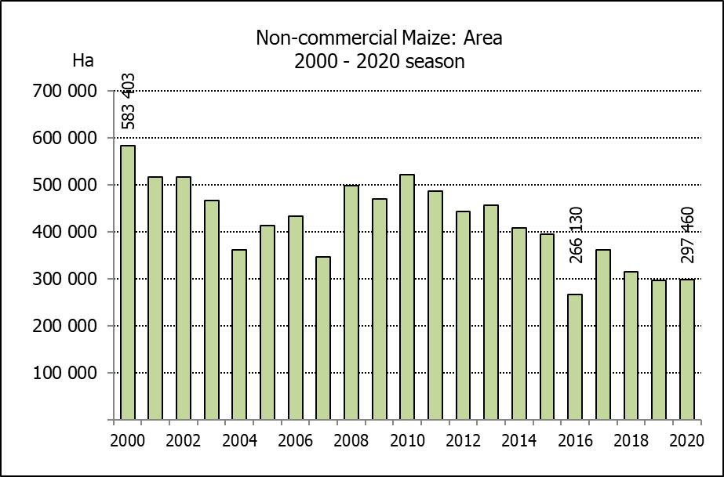
Hiermee word die nie-kommersiële landbou-sektor se produksieskatting vir mielies vir 2020 vrygestel.

NON-COMMERCIAL MAIZE – AREA PLANTED AND PRODUCTION ESTIMATE: 2020
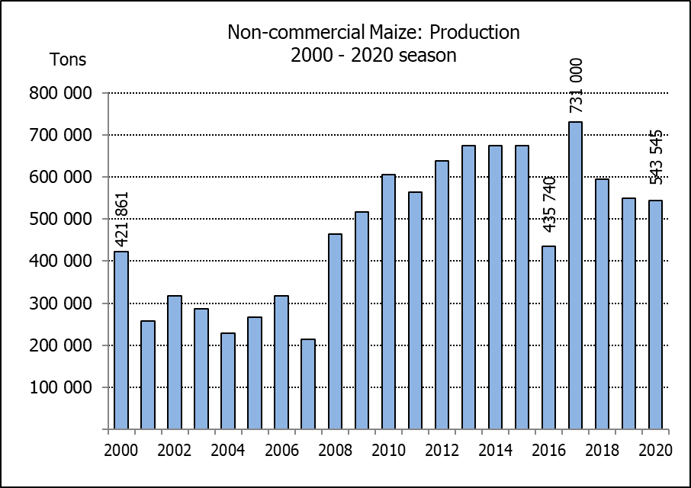
NIE-KOMMERSIëLE MIELIES – OPPERVLAKTE- EN PRODUKSIESKATTING: 2020
CROP/GEWAS | Area planted/  Opp beplant  2020 | Production/  Produksie  2020 | Area planted/  Opp beplant  2019 | Final crop/  Finale oes  2019 | Change/  Verandering
CROP/GEWAS | Ha | Tons | Ha | Tons | %
CROP/GEWAS | (A) | (B) | (C) | (D) | (B) ÷ (D)
Non-commercial agriculture/Nie-kommersiële landbou:
White maize/Witmielies | 221 945 | 375 295 | 221 300 | 379 460 | -1,10
Yellow maize/Geelmielies | 75 515 | 168 250 | 74 700 | 169 720 | -0,87
Maize/Mielies | 297 460 | 543 545 | 296 000 | 549 180 | -1,03
The area planted to maize in the non-commercial agricultural sector is estimated at 297 460 ha, which represents a slight increase of 0,49%, compared to the 296 000 ha of the previous season. The expected maize crop for this sector is 543 545 tons, which is 1,03% less than the 549 180 tons of last season. It is important to note that about 40% of the maize produced in the non-commercial sector, is planted in the Eastern Cape, followed by KwaZulu-Natal with 27%.
Die oppervlakte beplant met mielies in die nie-kommersiële landbou-sektor word geskat op 297 460 ha, wat ’n effense toename van 0,49 % verteenwoordig in vergelyking met die 296 000 ha van die vorige seisoen. Die verwagte mielie-oes van dié sektor is 543 545 ton, wat 1,03% minder is as die 549 180 ton van die vorige seisoen. Dit is belangrik om daarop te let dat ongeveer 40% van die mielies wat geproduseer word in die nie-kommersiële sektor, in die Oos-Kaap geplant word, gevolg deur KwaZulu-Natal met 27%.

The area estimate and fourth production forecast for winter cereals for the 2020 is hereby released. /
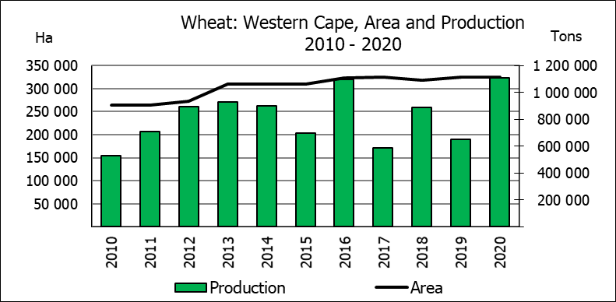
Hiermee word die oppervlakte- en vierde produksieskatting vir wintergewasse vir 2020 vrygestel.

WINTER CEREALS – AREA PLANTED AND FOURTH PRODUCTION FORECAST: 2020 PRODUCTION SEASON
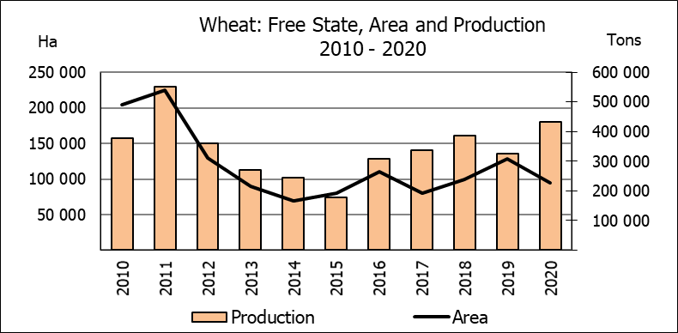
WINTERGEWASSE - OPPERVLAKTE- EN VIERDE PRODUKSIESKATTING: 2020 PRODUKSIE-SEISOEN
CROP/GEWAS | Area planted/  Opp beplant  2020 | 4th forecast/  4de skatting  2020 | 3rd forecast/  3de skatting  2020 | Area planted/  Opp beplant  2019 | Final crop/  Finale oes  2019 | Change/  Verandering
CROP/GEWAS | Ha | Tons | Tons | Ha | Tons | %
CROP/GEWAS | (A) | (B) | (C) | (D) | (E) | (B) ÷ (C)
Commercial/Kommersieel:
Wheat/Koring | 509 800 | 2 149 270 | 2 134 990 | 540 000 | 1 535 000 | +0,67
Malting barley/Moutgars | 141 690 | 552 766 | 526 706 | 131 960 | 345 000 | +4,95
Canola/Kanola | 74 120 | 148 456 | 137 356 | 74 000 | 95 000 | +8,08
Cereal oats/Hawermout | 26 200 | 47 400 | 47 400 | 21 000 | 16 500 | -
* Note: Estimate is for calendar year, e.g. production season 2020/21 = 2020
* Nota: Skatting is vir kalenderjaar, bv. produksie-seisoen 2020/21 = 2020

WHEAT – AREA PLANTED AND FOURTH PRODUCTION FORECAST: 2020
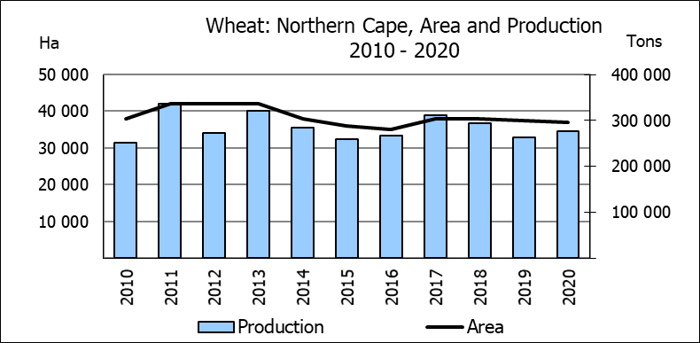
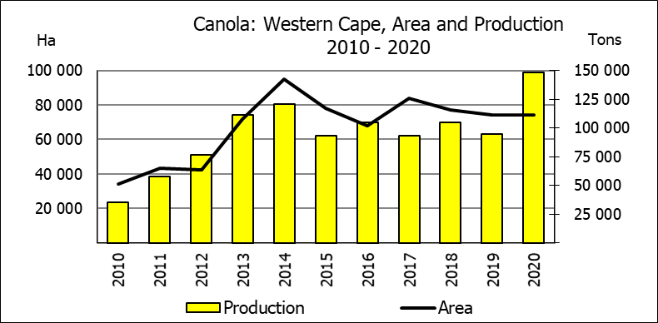
KORING – OPPERVLAKTE- EN VIERDE PRODUKSIESKATTING: 2020
Province/  Provinsie | Area planted/  Opp beplant  Ha | 4th forecast/  4de skatting  2020 | Area planted/  Opp beplant  Ha | Final crop/  Finale oes  Tons
Province/  Provinsie | 2020 | 2020 | 2019 | 2019
Western Cape/Wes-Kaap | 326 000 | 1 108 400 | 325 000 | 650 000
Northern Cape/Noord-Kaap | 37 000 | 275 650 | 37 500 | 262 500
Free State/Vrystaat | 94 000 | 432 400 | 128 000 | 326 000
Eastern Cape/Oos-Kaap | 4 000 | 26 000 | 3 100 | 18 150
KwaZulu-Natal | 7 800 | 48 360 | 7 500 | 45 750
Mpumalanga | 3 000 | 19 500 | 4 000 | 25 200
Limpopo | 23 000 | 147 200 | 20 000 | 120 000
Gauteng | 1 300 | 8 190 | 1 400 | 8 400
North West/Noordwes | 13 700 | 83 570 | 13 500 | 79 000
Total/Totaal | 509 800 | 2 149 270 | 540 000 | 1 535 000

AREA ESTIMATE AND FOURTH PRODUCTION FORECAST OF WINTER CROPS (2020) /
OPPERVLAKTE- EN VIERDE PRODUKSIESKATTING VAN WINTERGEWASSE (2020)
26 NOVEMBER 2020
Winter cereal crops - 2020 production season  Wheat: The expected production of wheat is 2,149 mill. tons, which is 0,67% or 14 280 tons more than the previous forecast of 2,135 mill. tons, whilst the expected yield is 4,22 t/ha. This is the largest expected wheat crop since the 2,427 mill. tons of the 2002 season.  The expected production in the Western Cape is 1,108 mill. tons (52%), in the Free State 432 400 tons (20%) and in the Northern Cape 275 650 tons (13%).  Other crops: The production forecast for malting barley is 552 766 tons, which is 4,95% or 26 060 tons more than the previous forecast of 526 706 tons. The area planted is estimated at 141 690 ha, while the expected yield is 3,90 t/ha. This is the largest expected malting barley crop recorded for SA.  The expected canola crop is 148 456 tons, which is 8,08% or 11 100 tons more than the previous forecast of 137 356 tons. The area estimate for canola is 74 120 ha, with an expected yield of 2,00 t/ha. It is also the largest expected canola crop ever recorded for SA.  The expected oats (cereals) crop for 2020 remained unchanged at 47 400 tons. The area estimate is 26 200 ha and the expected yield is 1,81 t/ha.  Please note that the fifth production forecast for winter cereals for 2020 will be released on 18 December 2020. |  | Wintergewasse - 2020 produksie-seisoen  Koring: Die verwagte produksie vir koring is 2,149 milj. ton, wat 0,67% of 14 280 ton meer is as die vorige skatting van 2,135 milj. ton, terwyl die verwagte opbrengs 4,22 t/ha is. Hierdie is die grootste verwagte koring-oes sedert die 2,427 milj. ton van die 2002 seisoen.  Die verwagte produksie in die Wes-Kaap is 1,108 milj. ton (52%), in die Vrystaat 432 400 ton (20%) en in die Noord-Kaap 275 650 ton (13%).  Ander gewasse: Die produksieskatting vir moutgars is 552 766 ton, wat 4,95% of 26 060 ton meer is as die vorige skatting van 526 706 ton. Die oppervlakte beplant word beraam op 141 690 ha, terwyl die verwagte opbrengs 3,90 t/ha beloop. Dit is die grootste verwagte moutgars-oes wat nog vir SA aangeteken is.  Die verwagte kanola-oes is 148 456 ton, wat 8,08% of 11 100 ton meer is as die vorige skatting van 137 356 ton. Die oppervlakteskatting vir kanola is 74 120 ha, met ŉ verwagte opbrengs van 2,00 t/ha. Dit is ook die grootste verwagte kanola-oes wat nog aangeteken is vir SA.  Die verwagte hawer-oes (ontbytgraan) vir die 2020-seisoen is onveranderd gelaat op 47 400 ton. Die oppervlakteskatting is 26 200 ha en die verwagte opbrengs is 1,81 t/ha.  Neem asseblief kennis dat die vyfde produksieskatting vir wintergewasse vir 2020 op 18 Desember 2020 vrygestel sal word.

Information is available on the internet at http://www.daff.gov.za/links/crop estimates or http://www.sagis.org.za, as from 14:30 on the date of the relevant meeting of the Crop Estimates Committee. |  | Inligting is beskikbaar op die internet by http://www.daff.gov.za/links/crop estimates of by http://www.sagis.org.za, vanaf 14:30 op die dag van die toepaslike vergadering van die Oesskattingskomitee.

