 | crop estimates committee | 
 | oesskattingskomitee
From/Van: Baldwin Netshifhefhe
Tel: 012 319 8043  Fax/Faks: 012 319 8031/5  E-mail/E-pos: BaldwinN@daff.gov.za
Web page/Webblad: www.daff.gov.za/statistics and economic reports or www.sagis.org.za/CEC: Crop Estimates
EMBARGO: 15:30
27 November 2018
The area estimate and fourth production forecast for winter cereals for the 2018 is hereby released. /
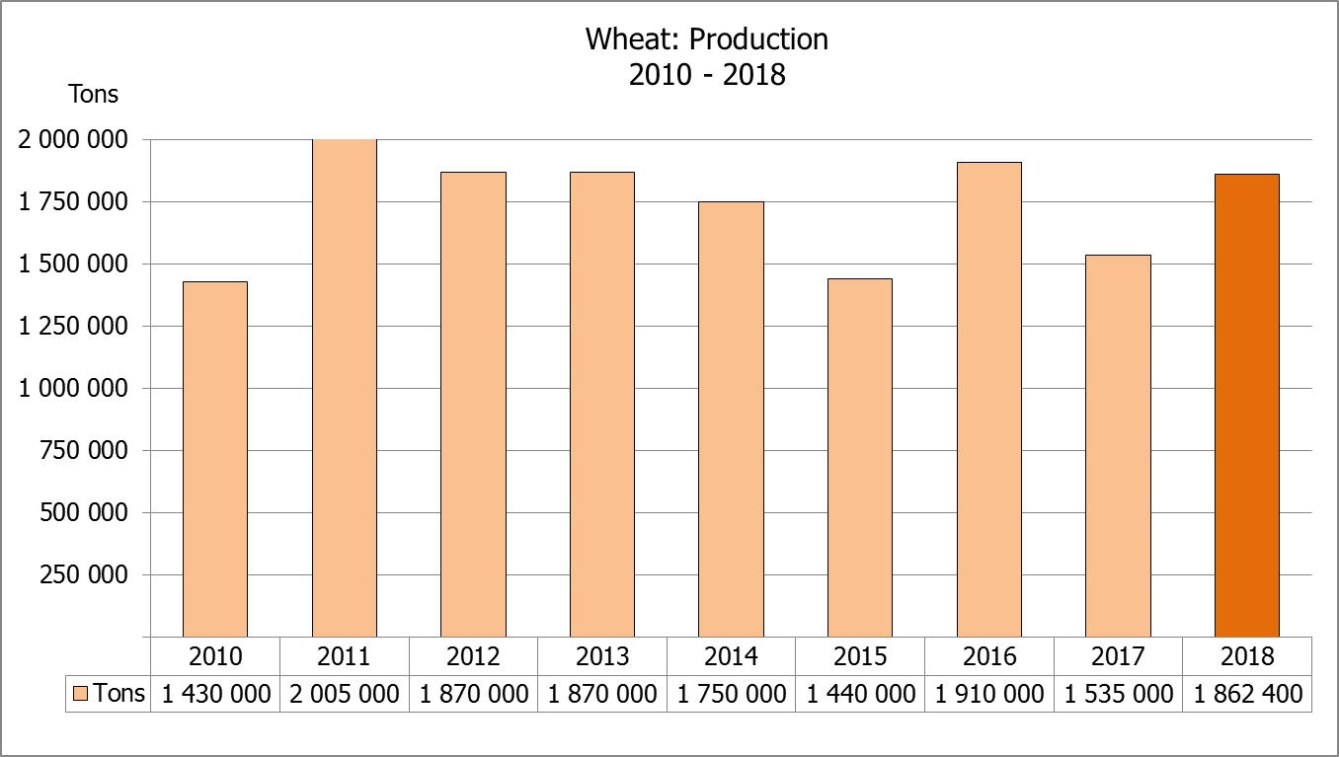
Hiermee word die oppervlakteskatting en vierde produksieskatting vir wintergewasse vir 2018 vrygestel.
WINTER CEREALS – AREA PLANTED ESTIMATE AND FOURTH PRODUCTION FORECAST: 2018
WINTERGEWASSE – OPPERVLAKTE- EN VIERDE PRODUKSIESKATTING: 2018
CROP/GEWAS | Area planted/  Opp beplant  2018 | 4th forecast/  4de skatting  2018 | 3rd forecast/  3de skatting  2018 | Area planted/  Opp beplant  2017 | Final crop/  Finale oes  2017 | Change/  Verandering
CROP/GEWAS | Ha | Tons | Tons | Ha | Tons | %
CROP/GEWAS | (A) | (B) | (C) | (D) | (E) | (B) ÷ (C)
Commercial/Kommersieel:
Wheat/Koring | 503 350 | 1 862 400 | 1 862 400 | 491 600 | 1 535 000 | -
Malting barley/Moutgars | 119 000 | 401 840 | 396 340 | 91 380 | 307 000 | +1,39
Canola/Kanola | 77 000 | 115 500 | 115 500 | 84 000 | 93 500 | 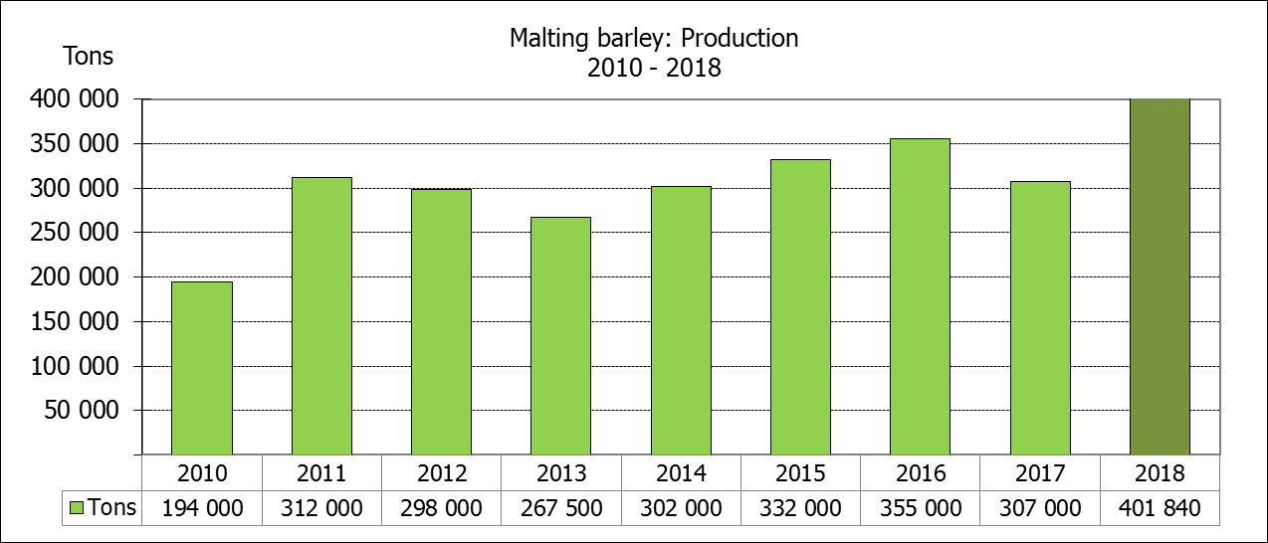  -
Total/Totaal | 699 350 | 2 379 740 | 2 374 240 | 666 980 | 1 935 500 | +0,23
* Note: Estimate is for calendar year, e.g. production season 2018 = 2018
* Nota: Skatting is vir kalenderjaar, bv. produksie-seisoen 2018 = 2018
WHEAT – AREA PLANTED ESTIMATE AND FOURTH PRODUCTION FORECAST: 2018
KORING – OPPERVLAKTE- EN VIERDE PRODUKSIESKATTING: 2018
Province/  Provinsie | Area planted/  Opp beplant  Ha | 4th forecast/  4de skatting  Tons | Area planted/  Opp beplant  Ha | Final crop/  Finale oes  Tons
Province/  Provinsie | 2018 | 2018 | 2017 | 2017
Western Cape/Wes-Kaap | 318 000 | 906 300 | 326 000 | 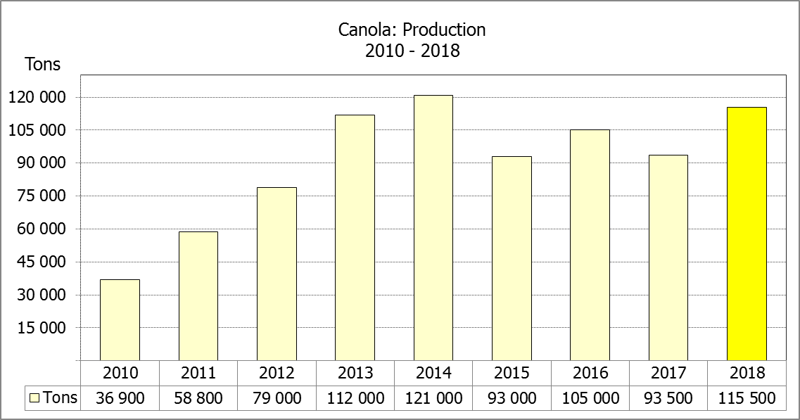  586 800
Northern Cape/Noord-Kaap | 38 000 | 294 500 | 38 000 | 311 650
Free State/Vrystaat | 100 000 | 365 000 | 80 000 | 336 000
Eastern Cape/Oos-Kaap | 1 650 | 10 725 | 1 900 | 9 500
KwaZulu-Natal | 7 000 | 43 400 | 7 500 | 45 750
Mpumalanga | 3 500 | 21 875 | 4 000 | 25 400
Limpopo | 20 000 | 126 000 | 20 000 | 132 000
Gauteng | 1 200 | 7 800 | 700 | 4 200
North West/Noordwes | 14 000 | 86 800 | 13 500 | 83 700
Total/Totaal | 503 350 | 1 862 400 | 491 600 | 1 535 000

AREA ESTIMATE AND FOURTH PRODUCTION FORECAST OF WINTER CROPS (2018) /
OPPERVLAKTESKATTING EN VIERDE PRODUKSIESKATTING VAN WINTERGEWASSE (2018)
27 NOVEMBER 2018

Winter cereal crops - 2018 production season  Wheat: The expected commercial production of wheat is 1,862 mill. tons, which is the same than the previous forecast, with an expected yield of 3,70 t/ha.  The expected production in the Western Cape is 906 300 tons (49%), in the Free State 365 000 tons (20%) and in the Northern Cape 294 500 tons (16%).  The area estimate for wheat is 503 350 ha. An estimated 318 000 ha or 63% is planted in the Western Cape, 100 000 ha or 20% in the Free State and 38 000 ha or 8% in the Northern Cape.  Other crops: The production forecast for malting barley is 401 840 tons, which is 1,39% or 5 500 tons more than the previous forecast of 396 340 tons. The area planted is estimated at 119 000 ha, while the expected yield is 3,38 t/ha.  The expected canola crop also remained unchanged at 115 500 tons. The area estimate for canola is 77 000 ha and the expected yield is 1,50 t/ha.  Please note that the fifth production forecast for winter cereals for 2018 will be released on 20 December 2018. |  | Wintergewasse - 2018 produksie-seisoen  Koring: Die verwagte kommersiële produksie vir koring is 1,862 milj. ton, wat dieselfde is as die vorige skatting, met ‘n verwagte opbrengs van 3,70 t/ha.  Die verwagte produksie in die Wes-Kaap is 906 300 ton (49%), in die Vrystaat 365 000 ton (20%) en in die Noord-Kaap 294 500 ton (16%).  Die oppervlakteskatting vir koring is 503 350 ha. Die beraamde oppervlakte geplant in die Wes-Kaap is 318 000 ha of 63%, die Vrystaat is 100 000 ha of 20% en 38 000 ha of 8% is in die Noord-Kaap.  Ander gewasse: Die produksieskatting vir moutgars is 401 840 ton, wat 1,39% of 5 500 ton meer is as die vorige skatting van 396 340 ton. Die oppervlakte beplant word beraam op 119 000 ha, terwyl die verwagte opbrengs 3,38 t/ha beloop.  Die verwagte kanola-oes is ook onveranderd gelaat op 115 500 ton. Die oppervlakteskatting vir kanola is 77 000 ha en die verwagte opbrengs is 1,50 t/ha.  Neem asseblief kennis dat die vyfde produksieskatting vir wintergewasse vir 2018 op 20 Desember 2018 vrygestel sal word.

Information is available on the internet at http://www.daff.gov.za/statistics and economic reports or http://www.sagis.org.za, as from 15:30 on the date of the relevant meeting of the Crop Estimates Committee. |  | Inligting is beskikbaar op die internet by http://www.daff.gov.za/statistics and economic reports of by http://www.sagis.org.za, vanaf 15:30 op die dag van die toepaslike vergadering van die Oesskattingskomitee.
CONFIDENTIALITY ISSUES that CEC members are committed to adhere to on the day of the meeting
- Personal items such as laptops, handbags, cell phones, etc. are not allowed in the venue during the meeting
- No member is allowed to leave the meeting before 12:00 in order to prevent disclosure of the information
- The embargo time for the release of crop estimates information is 15:30
- No member is allowed to discuss crop estimates information with anyone other than a member of the Committee before the embargo time
- Only the Chairperson, or a member appointed by the Chairperson, may release the figures to the media
- Members must regard the detail of any information that was collected for and/or discussed during the meeting, as confidential
- Individual information received for crop estimate purposes is treated strictly confidential, and is not divulged for any other purposes

