 | crop estimates committee | 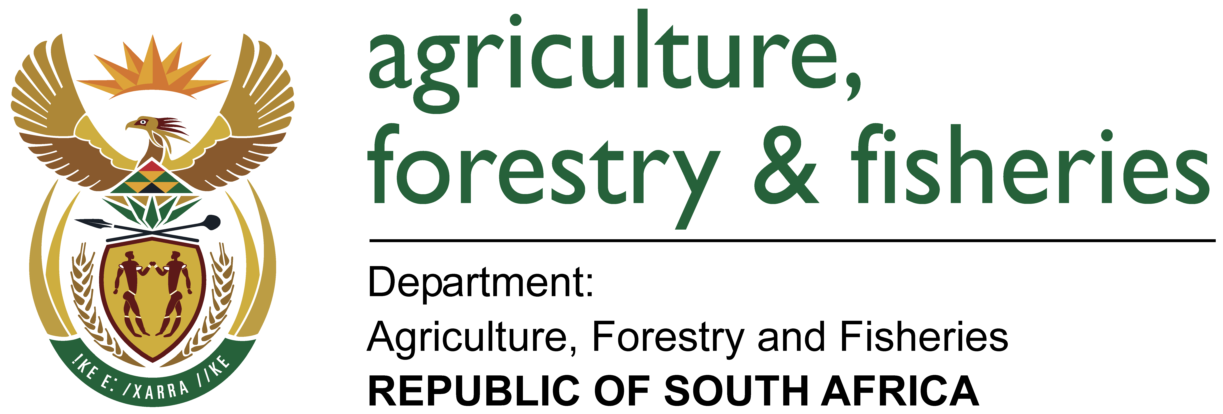
 | oesskattingskomitee
From/Van: Baldwin Netshifhefhe
Tel: 012 319 8043  Fax/Faks: 012 319 8031/5  E-mail/E-pos: BaldwinN@daff.gov.za
Web page/Webblad: www.daff.gov.za/statistics and economic reports or www.sagis.org.za/CEC: Crop Estimates
EMBARGO: 15:30
28 November 2017
The area estimate and fourth production forecast for winter cereals for the 2017 is hereby released. /
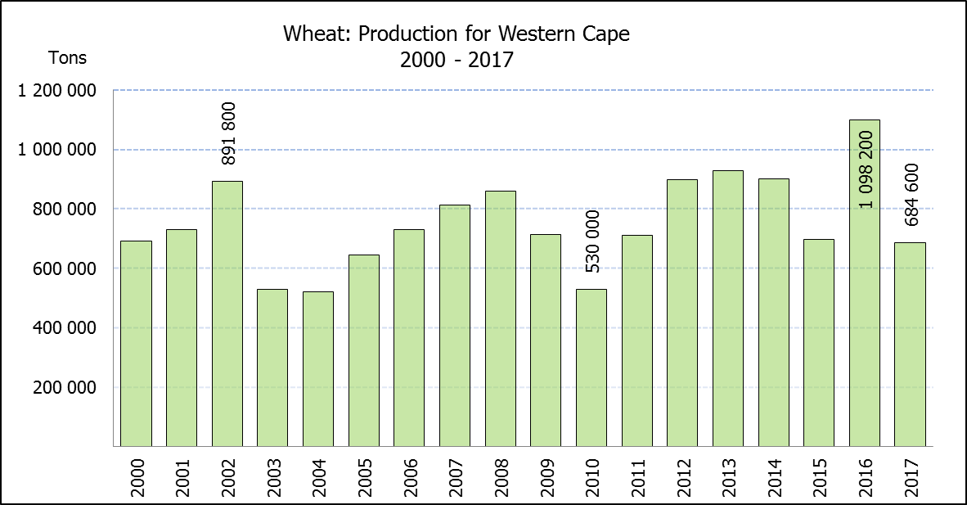
Hiermee word die oppervlakteskatting en vierde produksieskatting vir wintergewasse vir 2017 vrygestel.
WINTER CEREALS – AREA PLANTED ESTIMATE AND FOURTH PRODUCTION FORECAST: 2017
WINTERGEWASSE – OPPERVLAKTE- EN VIERDE PRODUKSIESKATTING: 2017
CROP/GEWAS | Area planted/  Opp beplant  2017 | 4th forecast/  4de skatting  2017 | 3rd forecast/  3de skatting  2017 | Area planted/  Opp beplant  2016 | Final crop/  Finale oes  2016 | Change/  Verandering
CROP/GEWAS | Ha | Tons | Tons | Ha | Tons | %
CROP/GEWAS | (A) | (B) | (C) | (D) | (E) | (B) ÷ (C)
Commercial/Kommersieel:
Wheat/Koring | 491 600 | 1 581 250 | 1 655 250 | 508 365 | 1 910 000 | -4,47
Malting barley/Moutgars | 91 380 | 281 059 | 281 059 | 88 695 | 355 000 | -
Canola/Kanola | 84 000 | 96 600 | 100 800 | 68 075 | 105 000 | 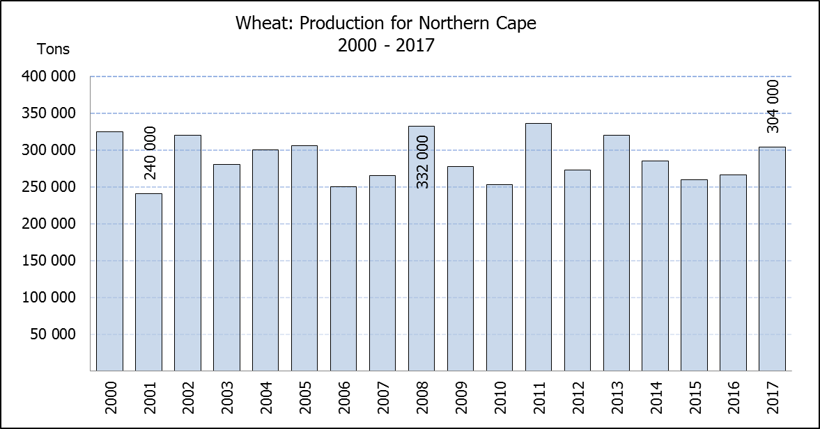  -4,17
Total/Totaal | 666 980 | 1 958 909 | 2 037 109 | 665 135 | 2 370 000 | -3,84
* Note: Estimate is for calendar year, e.g. production season 2017 = 2017
* Nota: Skatting is vir kalenderjaar, bv. produksie-seisoen 2017 = 2017
WHEAT – AREA PLANTED ESTIMATE AND FOURTH PRODUCTION FORECAST: 2017
KORING – OPPERVLAKTE- EN VIERDE PRODUKSIESKATTING: 2017
Province/  Provinsie | Area planted/  Opp beplant  Ha | 4th forecast/  4de skatting  Tons | Area planted/  Opp beplant  Ha | Final crop/  Finale oes  Tons
Province/  Provinsie | 2017 | 2017 | 2016 | 2016
Western Cape/Wes-Kaap | 326 000 | 684 600 | 323 000 | 1 098 200
Northern Cape/Noord-Kaap | 38 000 | 304 000 | 35 000 | 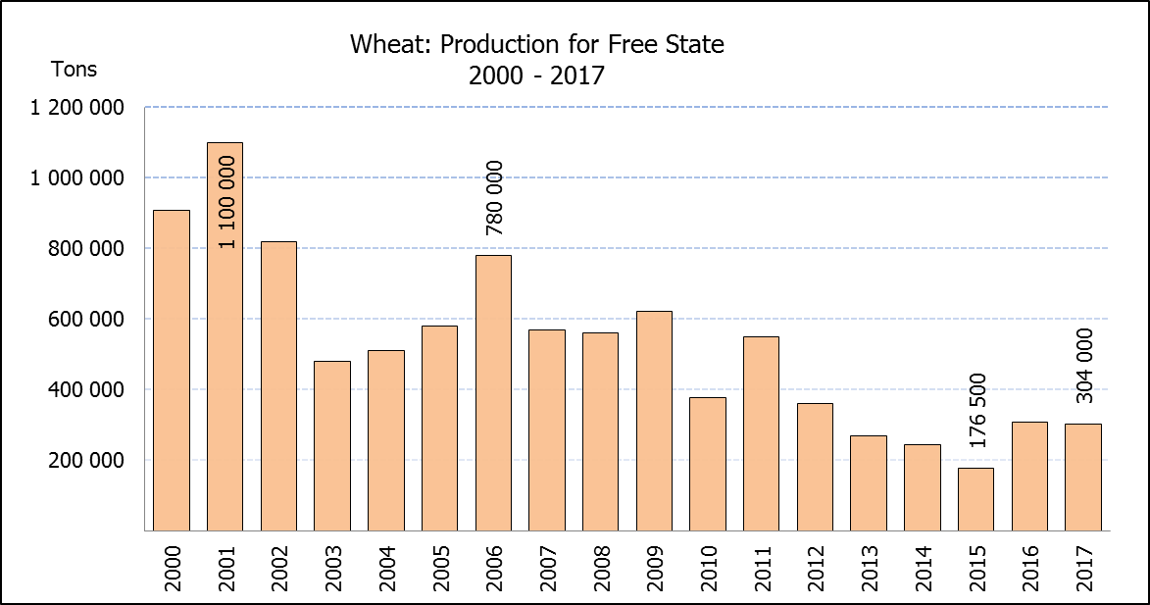  266 000
Free State/Vrystaat | 80 000 | 304 000 | 110 000 | 308 460
Eastern Cape/Oos-Kaap | 1 900 | 9 500 | 2 200 | 11 000
KwaZulu-Natal | 7 500 | 42 750 | 6 500 | 37 050
Mpumalanga | 4 000 | 25 200 | 2 300 | 13 800
Limpopo | 20 000 | 126 000 | 17 000 | 103 700
Gauteng | 700 | 4 200 | 365 | 2 190
North West/Noordwes | 13 500 | 81 000 | 12 000 | 69 600
Total/Totaal | 491 600 | 1 581 250 | 508 365 | 1 910 000

AREA ESTIMATE AND FOURTH PRODUCTION FORECAST OF WINTER CROPS (2017) /
OPPERVLAKTESKATTING EN VIERDE PRODUKSIESKATTING VAN WINTERGEWASSE (2017)
28 NOVEMBER 2017

Winter cereal crops - 2017 production season  Wheat: The expected commercial production of wheat is 1,581 mill. tons, which is 4,5% or 74 000 tons less than the previous forecast of 1,655 mill. tons, mainly because the main wheat producing province, namely the Western Cape, experiences dryness. The area estimate for wheat is 491 600 ha, whilst the expected yield is 3,22 t/ha.  The largest decline in production occurred in the Western Cape, namely 8,7% or 65 200 tons, followed by the Free State by 5,0% or 16 000 tons. Thus, the expected production in the Western Cape is 684 600 tons (43%), whereas the Free State and Northern Cape provinces are both expected to produce 304 000 tons (19%).  Other crops: The production forecast for malting barley remained unchanged at 281 059 tons. The area planted with malting barley is 91 380 ha and the expected yield is 3,08 t/ha.  The expected canola crop is 96 600 tons, which is 4,2% or 4 200 tons less than the previous forecast of 100 800 tons. The area estimate for canola is 84 000 ha, with an expected yield of 1,15 t/ha.  Please note that the fifth production forecast for winter cereals for 2017 will be released on 19 December 2017. |  | Wintergewasse - 2017 produksie-seisoen  Koring: Die verwagte kommersiële produksie vir koring is 1,581 milj. ton, wat 4,5% of 74 000 ton minder is as die vorige skatting van 1,655 milj. ton, hoofsaaklik omdat die grootste koringproduserende provinsie, naamlik die Wes-Kaap, droogte ervaar. Die oppervlakteskatting vir koring is 491 600 ha, terwyl die verwagte opbrengs 3,22 t/ha is.  Die grootste afname in produksie het in die Wes-Kaap plaasgevind, naamlik 8,7% of 65 200 ton, gevolg deur die Vrystaat met 5,0% of 16 000 ton. Dus is die verwagte produksie in die Wes-Kaap 684 600 ton (43%), terwyl die Vrystaat en Noord-Kaap provinsies albei verwag om 304 000 ton (19%) te produseer.  Ander gewasse: Die produksieskatting vir moutgars is onveranderd gelaat op 281 059 ton. Die oppervlakte beplant met moutgars is 91 380 ha, terwyl die verwagte opbrengs 3,08 t/ha beloop.  Die verwagte kanola-oes is 96 600 ton, wat 4,2% of 4 200 ton minder is as die vorige skatting van 100 800 ton. Die oppervlakteskatting vir kanola is 84 000 ha, met ŉ verwagte opbrengs van 1,15 t/ha.  Neem asseblief kennis dat die vyfde produksieskatting vir wintergewasse vir 2017 op 19 Desember 2017 vrygestel sal word.

Information is available on the internet at http://www.daff.gov.za/statistics and economic reports or http://www.sagis.org.za, as from 15:30 on the date of the relevant meeting of the Crop Estimates Committee. |  | Inligting is beskikbaar op die internet by http://www.daff.gov.za/statistics and economic reports of by http://www.sagis.org.za, vanaf 15:30 op die dag van die toepaslike vergadering van die Oesskattingskomitee.
CONFIDENTIALITY ISSUES that CEC members are committed to adhere to on the day of the meeting
- Personal items such as laptops, handbags, cell phones, etc. are not allowed in the venue during the meeting
- No member is allowed to leave the meeting before 12:00 in order to prevent disclosure of the information
- The embargo time for the release of crop estimates information is 15:30
- No member is allowed to discuss crop estimates information with anyone other than a member of the Committee before the embargo time
- Only the Chairperson, or a member appointed by the Chairperson, may release the figures to the media
- Members must regard the detail of any information that was collected for and/or discussed during the meeting, as confidential
- Individual information received for crop estimate purposes is treated strictly confidential, and is not divulged for any other purposes

