 | crop estimates committee | 
 | oesskattingskomitee
From/Van: Mr Baldwin Netshifhefhe
Tel: 012 319 8043  Fax/Faks: 012 319 8031  E-mail/E-pos: BaldwinN@daff.gov.za
Web page/Webblad: www.daff.gov.za/statistics and economic reports or www.sagis.org.za/CEC: Crop Estimates
EMBARGO: 14:30

The area planted estimate and second production forecast for summer crops for 2020 is hereby released.
Hiermee word die oppervlakte- en tweede produksieskatting vir somergewasse vir 2020 vrygestel.

SUMMER CROPS – AREA PLANTED AND SECOND PRODUCTION FORECAST: 2020
SOMERGEWASSE – OPPERVLAKTE- EN TWEEDE PRODUKSIESKATTING: 2020
CROP/GEWAS | Area planted/  Opp beplant  2020 | 2nd forecast/  2de skatting  2020 | 1stforecast/  1ste skatting  2020 | Area planted/  Opp beplant  2019 | Final crop/  Finale oes  2019 | Change/  Verandering/
CROP/GEWAS | Ha | Tons | Tons | Ha | Tons | %
CROP/GEWAS | (A) | (B) | (C) | (D) | (E) | (B) ÷ (C)
Commercial/Kommersieël:
White maize/Witmielies | 1 616 300 | 8 523 465 | 8 286 825 | 1 298 400 | 5 545 000 | +2,86
Yellow maize/Geelmielies | 994 500 | 6 285 885 | 6 273 335 | 1 002 100 | 5 730 000 | +0,20
Total Maize/Totale Mielies | 2 610 800 | 14 809 350 | 14 560 160 | 2 300 500 | 11 275 000 | +1,71
Sunflower seed/Sonneblomsaad | 500 300 | 731 210 | 699 130 | 515 350 | 678 000 | +4,59
Soybeans/Sojabone | 705 000 | 1 269 150 | 1 242 950 | 730 500 | 1 170 345 | +2,11
Groundnuts/Grondbone | 37 500 | 56 060 | 54 390 | 20 050 | 19 400 | +3,07
Sorghum | 42 500 | 132 810 | 135 090 | 50 500 | 127 000 | -1,69
Dry beans/Droëbone | 50 150 | 72 910 | 72 910 | 59 300 | 66 355 | -
TOTAL/TOTAAL | 3 946 250 | 17 071 490 | 16 764 630 | 3 676 200 | 13 336 100 | +1,83
Note: Estimate is for calendar year, e.g. production season 2019/20 = 2020
Nota: Skatting is vir kalenderjaar, bv. produksie-seisoen 2019/20 = 2020

25 March / Maart 2020
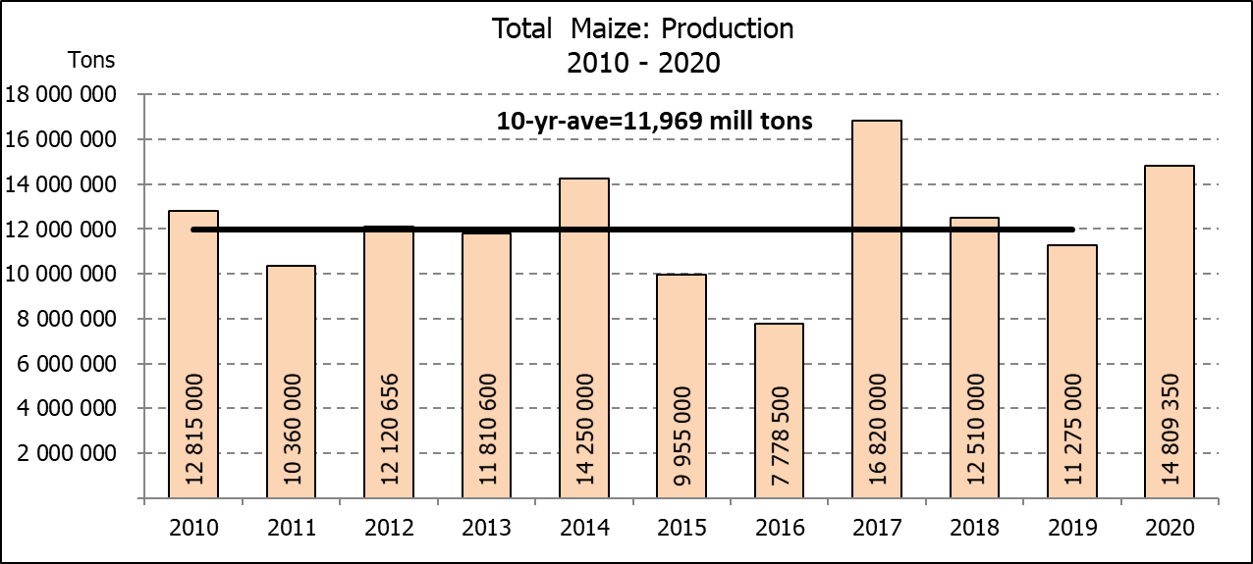

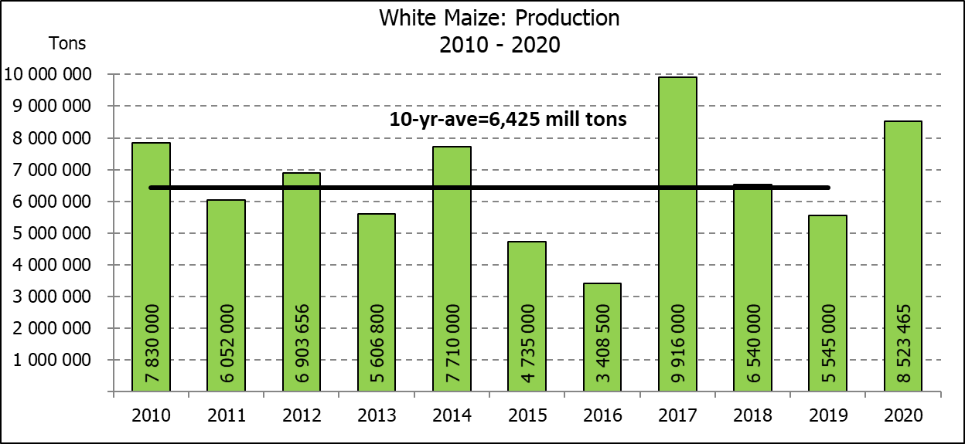
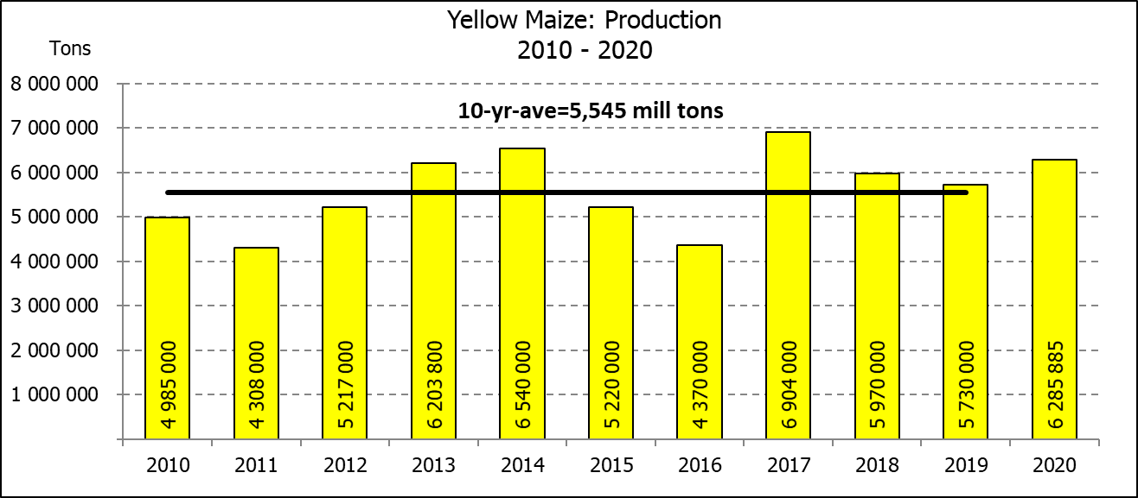

WHITE AND YELLOW MAIZE – AREA PLANTED AND SECOND PRODUCTION FORECAST: 2020
WIT- EN GEELMIELIES – OPPERVLAKTE EN TWEEDE PRODUKSIESKATTING: 2020

Provinsie/  Province | Area planted/  Oppervlakte beplant  2020 |  |  | 2nd forecast/  2de skatting  2020 |  |  | Area planted/  Oppervlakte beplant  2019 |  |  | Final crop/  Finale oes  2019
Provinsie/  Province | White/  Wit  Ha | Yellow/  Geel  Ha | Total/  Totaal  Ha | White/  Wit  Tons | Yellow/  Geel  Tons | Total/  Totaal  Tons | White/  Wit  Ha | Yellow/  Geel  Ha | Total/  Totaal  Ha | White/  Wit  Tons | Yellow/  Geel  Tons | Total/  Totaal  Tons
Western Cape/Wes-Kaap | 400 | 3 400 | 3 800 | 3 600 | 30 600 | 34 200 | 400 | 3 400 | 3 800 | 3 600 | 30 600 | 34 200
Northern Cape/Noord-Kaap | 3 400 | 43 100 | 46 500 | 39 440 | 618 485 | 657 925 | 3 400 | 43 500 | 46 900 | 39 500 | 630 750 | 670 250
Free State/Vrystaat | 855 000 | 365 000 | 1 220 000 | 4 617 000 | 1 989 250 | 6 606 250 | 650 000 | 380 000 | 1 030 000 | 2 795 000 | 1 758 000 | 4 553 000
Eastern Cape/Oos-Kaap | 5 500 | 17 000 | 22 500 | 36 025 | 118 150 | 154 175 | 3 800 | 10 200 | 14 000 | 23 000 | 69 750 | 92 750
KwaZulu-Natal | 47 000 | 55 000 | 102 000 | 303 150 | 423 500 | 726 650 | 45 000 | 54 000 | 99 000 | 270 000 | 399 600 | 669 600
Mpumalanga | 160 000 | 353 000 | 513 000 | 928 000 | 2 223 900 | 3 151 900 | 145 000 | 338 000 | 483 000 | 797 500 | 1 977 300 | 2 774 800
Limpopo | 15 000 | 18 000 | 33 000 | 105 000 | 126 000 | 231 000 | 12 800 | 18 000 | 30 800 | 83 200 | 117 000 | 200 200
Gauteng | 55 000 | 50 000 | 105 000 | 330 000 | 315 000 | 645 000 | 48 000 | 60 000 | 108 000 | 259 200 | 348 000 | 607 200
North West/Noordwes | 475 000 | 90 000 | 565 000 | 2 161 250 | 441 000 | 2 602 250 | 390 000 | 95 000 | 485 000 | 1 274 000 | 399 000 | 1 673 000
Total/Totaal | 1 616 300 | 994 500 | 2 610 800 | 8 523 465 | 6 285 885 | 14 809 350 | 1 298 400 | 1 002 100 | 2 300 500 | 5 545 000 | 5 730 000 | 11 275 000

SUNFLOWER SEED – AREA PLANTED AND SECOND PRODUCTION FORECAST: 2020
SONNEBLOMSAAD – OPPERVLAKTE EN TWEEDE PRODUKSIESKATTING: 2020

Province/  Provinsie | Area planted/  Opp beplant  Ha | 2nd forecast/  2de skatting  Tons | Area planted/  Opp beplant  Ha | Final crop/  Finale oes  Tons
Province/  Provinsie | 2020 | 2020 | 2019 | 2019
Western Cape/Wes-Kaap | - | - | - | -
Northern Cape/Noord-Kaap | 1 200 | 1 440 | 950 | 1 140
Free State/Vrystaat | 260 000 | 416 000 | 270 000 | 391 500
Eastern Cape/Oos-Kaap | 300 | 750 | 100 | 260
KwaZulu-Natal | - | - | - | -
Mpumalanga | 2 800 | 3 920 | 4 500 | 4 500
Limpopo | 65 000 | 61 750 | 61 000 | 61 000
Gauteng | 4 000 | 5 200 | 3 800 | 3 800
North West/Noordwes | 167 000 | 242 150 | 175 000 | 215 800
Total/Totaal | 500 300 | 731 210 | 515 350 | 678 000
SOYBEANS – AREA PLANTED AND SECOND PRODUCTION FORECAST: 2020
SOJABONE – OPPERVLAKTE EN TWEEDE PRODUKSIESKATTING: 2020

Province/  Provinsie | Area planted/  Opp beplant  Ha | 2nd forecast/  2de skatting Tons | Area planted/  Opp beplant  Ha | Final crop/  Finale oes  Tons
Province/  Provinsie | 2020 | 2020 | 2019 | 2019
Western Cape/Wes-Kaap |  |  | 100 | 10
Northern Cape/Noord-Kaap | 2 000 | 7 000 | 1 550 | 5 425
Free State/Vrystaat | 315 000 | 535 500 | 301 000 | 391 300
Eastern Cape/Oos-Kaap | 1 500 | 3 000 | 1 150 | 1 380
KwaZulu-Natal | 35 000 | 101 500 | 33 000 | 99 000
Mpumalanga | 260 000 | 429 000 | 310 000 | 511 500
Limpopo | 15 500 | 44 950 | 16 200 | 46 980
Gauteng | 36 000 | 70 200 | 31 500 | 66 150
North West/Noordwes | 40 000 | 78 000 | 36 000 | 48 600
Total/Totaal | 705 000 | 1 269 150 | 730 500 | 1 170 345

GROUNDNUTS – AREA PLANTED AND SECOND PRODUCTION FORECAST: 2020
GRONDBONE – OPPERVLAKTE EN TWEEDE PRODUKSIESKATTING: 2020

Province/  Provinsie | Area planted/  Opp beplant  Ha | 2nd forecast/  2de skatting  Tons | Area planted/  Opp beplant  Ha | Final crop/  Finale oes  Tons
Province/  Provinsie | 2020 | 2020 | 2019 | 2019
Western Cape/Wes-Kaap | - | - | - | -
Northern Cape/Noord-Kaap | 1 200 | 3 600 | 1 200 | 2 520
Free State/Vrystaat | 8 000 | 14 800 | 8 000 | 9 775
Eastern Cape/Oos-Kaap | - | - | - | -
KwaZulu-Natal | - | - | - | -
Mpumalanga | - | - | - | -
Limpopo | 2 900 | 4 640 | 1 850 | 3 530
Gauteng | - | - | - | -
North West/Noordwes | 25 400 | 33 020 | 9 000 | 3 575
Total/Totaal | 37 500 | 56 060 | 20 050 | 19 400

SORGHUM – AREA PLANTED AND SECOND PRODUCTION FORECAST: 2020
SORGHUM – HERSIENE OPPERVLAKTE EN TWEEDE PRODUKSIESKATTING: 2020

Province/  Provinsie | Area planted/  Opp beplant  Ha | 2nd forecast/  2de skatting Tons | Area planted/  Opp beplant  Ha | Final crop/  Finale oes  Tons
Province/  Provinsie | 2020 | 2020 | 2019 | 2019
Western Cape/Wes-Kaap | - | - | - | -
Northern Cape/Noord-Kaap | - | - | - | -
Free State/Vrystaat | 8 000 | 28 000 | 8 000 | 23 600
Eastern Cape/Oos-Kaap | - | - | - | -
KwaZulu-Natal | 1 200 | 3 000 | 500 | 1 500
Mpumalanga | 8 500 | 40 800 | 7 500 | 36 000
Limpopo | 16 000 | 32 000 | 25 000 | 46 125
Gauteng | 300 | 960 | 1 000 | 3 200
North West/Noordwes | 8 500 | 28 050 | 8 500 | 16 575
Total/Totaal | 42 500 | 132 810 | 50 500 | 127 000

DRY BEANS – AREA PLANTED AND SECOND PRODUCTION FORECAST: 2020
DROëBONE – OPPERVLAKTE EN TWEEDE PRODUKSIESKATTING: 2020

Province/  Provinsie | Area planted/  Opp beplant  Ha | 2nd forecast/  2de skatting  Tons | Area planted/  Opp beplant  Ha | Final crop/  Finale oes  Tons
Province/  Provinsie | 2020 | 2020 | 2019 | 2019
Western Cape/Wes-Kaap | 100 | 150 | 100 | 180
Northern Cape/Noord-Kaap | 350 | 700 | 1 000 | 1 400
Free State/Vrystaat | 24 000 | 32 400 | 27 000 | 28 350
Eastern Cape/Oos-Kaap | 200 | 300 | 400 | 720
KwaZulu-Natal | 2 900 | 3 770 | 3 500 | 4 025
Mpumalanga | 6 600 | 8 910 | 7 500 | 6 750
Limpopo | 8 400 | 16 800 | 7 800 | 12 480
Gauteng | 600 | 780 | 1 500 | 1 950
North West/Noordwes | 7 000 | 9 100 | 10 500 | 10 500
Total/Totaal | 50 150 | 72 910 | 59 300 | 66 355

CONFIDENTIALITY ISSUES that CEC members are committed to adhere to on the day of the meeting
- Personal items such as laptops, handbags, cell phones, etc. are not allowed in the venue during the meeting
- No member is allowed to leave the meeting before 12:00 in order to prevent disclosure of the information
- The embargo time for the release of crop estimates information is 14:30
- No member is allowed to discuss crop estimates information with anyone other than a member of the Committee before the embargo time
- Only the Chairperson, or a member appointed by the Chairperson, may release the figures to the media
- Members must regard the detail of any information that was collected for and/or discussed during the meeting, as confidential
- Individual information received for crop estimate purposes is treated strictly confidential, and is not divulged for any other purposes

AREA ESTIMATE AND SECOND PRODUCTION FORECAST OF SUMMER CROPS (2020 PRODUCTION SEASON)/
OPPERVLAKTE- EN TWEEDE PRODUKSIESKATTING VIR SOMERGEWASSE (2020 PRODUKSIE-SEISOEN)
25 MARCH 2020 / 25 MAART 2020

Summer field crops – 2020  Commercial maize: The size of the expected commercial maize crop has been set at 14,809 mill. tons, which is 1,71% or 249 190 tons more than the previous forecast of 14,560 mill. tons. The revised area estimate for maize is 2,611 mill. ha, while the expected yield is 5,67 t/ha.  The estimated maize crop is 31% bigger than the 2019 crop. The three main maize producing areas, namely the Free State, Mpumalanga and North West provinces are expected to produce 83% of the 2020 crop.  The revised area estimate for white maize is 1,616 mill. ha and for yellow maize the revised area estimate is 994 500 ha.  The production forecast of white maize is 8,523 mill. tons, which is 2,86% or 236 640 tons more than the 8,287 mill. tons of the previous forecast. The yield for white maize is 5,27 t/ha. In the case of yellow maize the production forecast is 6,286 mill. tons, which is 0,20% or 12 550 tons more than the 6,273 mill. tons of the previous forecast. The yield for yellow maize is 6,32 t/ha.  Please note that information from the objective yield survey by the ARC for the Mpumalanga province will be available in April 2020; and for the Free State and North West provinces in May 2020. The current yield figures are mainly obtained from producers in the different provinces.  Sunflower seed: The production forecast for sunflower seed is 731 210 tons, which is 4,59% or 32 080 tons more than the previous forecast of 699 130 tons. The area estimate for sunflower seed is 500 300 ha, while the expected yield is 1,46 t/ha.  Other crops: The production forecast for soybeans increased by 2,11% or 26 200 tons to 1,269 mill. tons. The estimated area planted to soybeans is 705 000 ha and the expected yield is 1,80 t/ha.  The expected groundnut crop has been set at 56 060 tons, which is 3,07% or 1 670 tons more than the previous forecast of 54 390 tons. For groundnuts, the area estimate is 37 500 ha, with an expected yield of 1,49 t/ha.  The production forecast for sorghum is 132 810 tons, which is 1,69% or 2 280 tons less than the 135 090 tons of the previous forecast. The revised area estimate for sorghum is 42 500 ha and the expected yield is 3,12 t/ha.  In the case of dry beans, the production forecast remained unchanged at 72 910 tons. The area estimate of dry beans is 50 150 ha, with an expected yield of 1,45 t/ha.  Please note that the third production forecast for summer field crops for 2020 will be released on 29 April 2020. |  | Somergewasse – 2020  Kommersiële mielies: Die grootte van die verwagte kommersiële mielie-oes is op 14,809 milj. ton gestel, wat 1,71% of 249 190 ton meer is as die vorige skatting van 14,560 milj. ton. Die hersiene skatting van die oppervlakte onder mielies is 2,611 milj. ha, terwyl die verwagte opbrengs 5,67 t/ha is.  Die geskatte mielie-oes is 31% groter as die 2019-oes. Die drie belangrikste mielieproduserende gebiede, nl. die Vrystaat, Mpumalanga en Noordwes provinsies, gaan na verwagting 83% van die 2020-oes produseer.  Die hersiene oppervlak onder witmielies is 1,616 milj. ha en vir geelmielies is die oppervlak 994 500 ha.  Die produksieskatting van witmielies is 8,523 milj. ton, 2,86% of 236 640 ton meer as die 8,287 milj. ton van die vorige skatting. Die opbrengs van witmielies is 5,27 t/ha. In die geval van geelmielies is die produksieskatting 6,286 milj. ton, wat 0,20% of 12 550 ton meer is as die 6,273 milj. ton van die vorige skatting. Die opbrengs van geelmielies is 6,32 t/ha.  Neem kennis dat inligting van die objektiewe opbrengs-opname van die LNR vir die Mpumalanga provinsie, in April 2020 gerapporteer word en vir die Vrystaat en Noordwes provinsies in Mei 2020. Die huidige opbrengs syfers is hoofsaaklik verkry vanaf produsente in die verskillende provinsies.  Sonneblomsaad: Die produksieskatting vir sonneblomsaad is 731 210 ton, wat 4,59% of 32 080 ton meer is as die vorige skatting van 699 130 ton. Die oppervlakteskatting vir sonneblomsaad is 500 300 ha, terwyl die verwagte opbrengs 1,46 t/ha is.  Ander gewasse: Die produksieskatting van sojabone is verhoog met 2,11% of 26 200 ton na 1,269 milj. ton. Die geskatte oppervlakte beplant van sojabone is 705 000 ha en die verwagte opbrengs is 1,80 t/ha.  Die verwagte grondbone-oes is op 56 060 ton gestel, wat 3,07% of 1 670 ton meer is as die vorige skatting van 54 390 ton. Vir grondbone is die oppervlakteskatting 37 500 ha, terwyl the verwagte opbrengs 1,49 t/ha is.  Die produksieskatting van sorghum is 132 810 ton, wat 1,69% of 2 280 ton minder is as die 135 090 ton van die vorige skatting. Die hersiene oppervlakteskatting vir sorghum is 42 500 ha, en die verwagte opbrengs is 3,12 t/ha.  In die geval van droëbone is die produksieskatting onveranderd gelaat op 72 910 ton. Die oppervlakte beplant met droëbone is 50 150 ha, en die verwagte opbrengs is 1,45 t/ha.  Neem asseblief kennis dat die derde produksieskatting vir somergewasse vir 2020, op 29 April 2020 vrygestel sal word.

