 | crop estimates committee | 
 | oesskattingskomitee
From/Van: Ms Ellen Matsei
The Crop Estimates Committee comprises officials of the following institutions:
Department of Agriculture, Forestry and Fisheries; Provincial Departments of Agriculture; various ARC-Institutes (Soil, Climate and Water; Small Grains Institute; and
Grain Crops Institute); BFAP and Statistics SA.
Tel: 012 319 8454  Fax/Faks: 012 319 8031  E-mail/E-pos: DAS@daff.gov.za
Web page/Webblad: www.daff.gov.za/statistics and economic reports or www.sagis.org.za/CEC: Crop Estimates
EMBARGO: 15:30

The revised area planted estimate and second production forecast for summer crops for 2018 is hereby released.
Hiermee word die hersiene oppervlakte- en tweede produksieskatting vir somergewasse vir 2018 vrygestel.

SUMMER CROPS – REVISED AREA PLANTED AND SECOND PRODUCTION FORECAST: 2018
SOMERGEWASSE – HERSIENE OPPERVLAKTE- EN TWEEDE PRODUKSIESKATTING: 2018
CROP/GEWAS | Area planted/  Opp beplant  2018 | 2nd forecast/  2de skatting  2018 | 1stforecast/  1ste skatting  2018 | Area planted/  Opp beplant  2017 | Final crop/  Finale oes  2017 | Change/  Verandering/
CROP/GEWAS | Ha | Tons | Tons | Ha | Tons | %
CROP/GEWAS | (A) | (B) | (C) | (D) | (E) | (B) ÷ (C)
Commercial/Kommersieël:
White maize/Witmielies | 1 268 100 | 6 363 100 | 6 108 000 | 1 643 100 | 9 916 000 | +4,2
Yellow maize/Geelmielies | 1 050 750 | 6 057 400 | 6 114 950 | 985 500 | 6 904 000 | -0,9
Total Maize/Totale Mielies | 2 318 850 | 12 420 500 | 12 222 950 | 2 628 600 | 16 820 000 | +1,6
Sunflower seed/Sonneblomsaad | 601 500 | 749 205 | 731 505 | 635 750 | 874 000 | +2,4
Soybeans/Sojabone | 787 200 | 1 394 800 | 1 374 700 | 573 950 | 1 316 000 | +1,5
Groundnuts/Grondbone | 56 300 | 80 600 | 88 850 | 56 000 | 92 050 | -9,3
Sorghum | 28 800 | 84 750 | 78 200 | 42 350 | 152 000 | +8,4
Dry beans/Droëbone | 53 360 | 68 210 | 70 770 | 45 050 | 68 525 | -3,6
TOTAL/TOTAAL | 3 846 010 | 14 798 065 | 14 566 975 | 3 981 700 | 19 322 575 | +1,6
Note: Estimate is for calendar year, e.g. production season 2017/18 = 2018
Nota: Skatting is vir kalenderjaar, bv. produksie-seisoen 2017/18 = 2018

28 March / Maart 2018

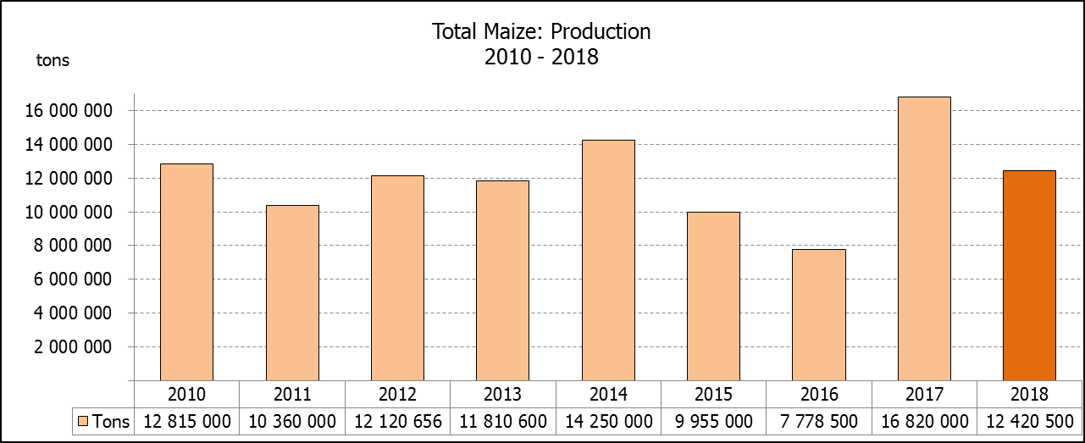

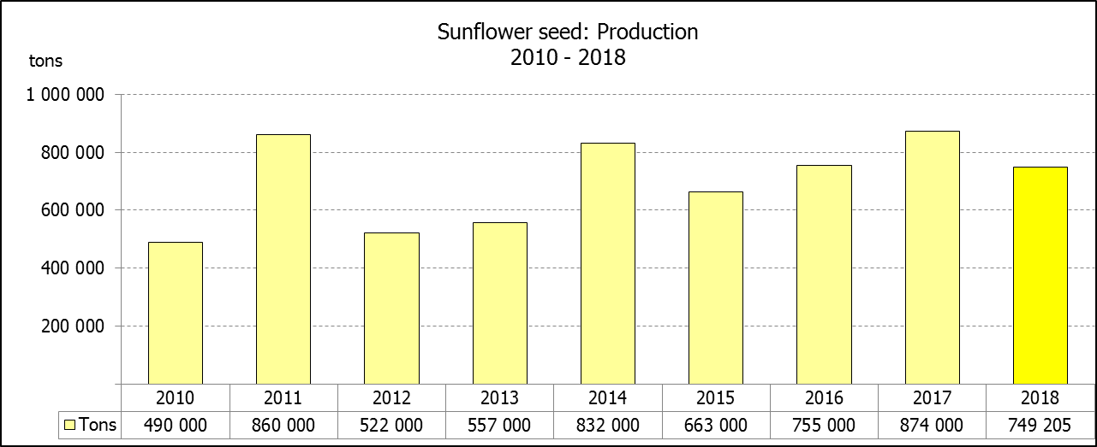
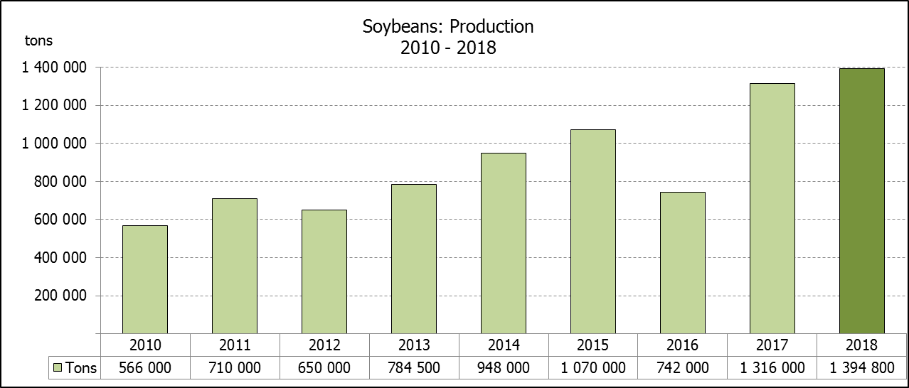

WHITE AND YELLOW MAIZE – REVISED AREA PLANTED AND SECOND PRODUCTION FORECAST: 2018
WIT- EN GEELMIELIES – HERSIENE OPPERVLAKTE EN TWEEDE PRODUKSIESKATTING: 2018

Provinsie/  Province | Area planted/  Oppervlakte beplant  2018 |  |  | 2nd forecast/  2de skatting  2018 |  |  | Area planted/  Oppervlakte beplant  2017 |  |  | Final crop/  Finale oes  2017
Provinsie/  Province | White/  Wit  Ha | Yellow/  Geel  Ha | Total/  Totaal  Ha | White/  Wit  Tons | Yellow/  Geel  Tons | Total/  Totaal  Tons | White/  Wit  Ha | Yellow/  Geel  Ha | Total/  Totaal  Ha | White/  Wit  Tons | Yellow/  Geel  Tons | Total/  Totaal  Tons
Western Cape/Wes-Kaap | 0 | 3 750 | 3 750 | 0 | 33 750 | 33 750 | 200 | 2 000 | 2 200 | 2 000 | 20 000 | 22 000
Northern Cape/Noord-Kaap | 3 600 | 43 000 | 46 600 | 43 200 | 629 950 | 673 150 | 3 500 | 45 000 | 48 500 | 46 200 | 666 000 | 712 200
Free State/Vrystaat | 644 000 | 410 000 | 1 054 000 | 3 316 600 | 2 070 500 | 5 387 100 | 805 000 | 355 000 | 1 160 000 | 5 110 000 | 2 252 000 | 7 362 000
Eastern Cape/Oos-Kaap | 3 500 | 11 000 | 14 500 | 21 700 | 71 500 | 93 200 | 4 400 | 9 500 | 13 900 | 30 800 | 66 500 | 97 300
KwaZulu-Natal | 45 000 | 50 000 | 95 000 | 288 000 | 375 000 | 663 000 | 50 000 | 50 000 | 100 000 | 350 000 | 390 000 | 740 000
Mpumalanga | 140 000 | 340 000 | 480 000 | 805 000 | 1 955 000 | 2 760 000 | 160 000 | 330 000 | 490 000 | 1 088 000 | 2 342 500 | 3 430 500
Limpopo | 12 000 | 21 000 | 33 000 | 81 600 | 136 500 | 218 100 | 40 000 | 24 000 | 64 000 | 300 000 | 192 000 | 492 000
Gauteng | 50 000 | 62 000 | 112 000 | 290 000 | 378 200 | 668 200 | 60 000 | 60 000 | 120 000 | 390 000 | 414 000 | 804 000
North West/Noordwes | 370 000 | 110 000 | 480 000 | 1 517 000 | 407 000 | 1 924 000 | 520 000 | 110 000 | 630 000 | 2 599 000 | 561 000 | 3 160 000
Total/Totaal | 1 268 100 | 1 050 750 | 2 318 850 | 6 363 100 | 6 057 400 | 12 420 500 | 1 643 100 | 985 500 | 2 628 600 | 9 916 000 | 6 904 000 | 16 820 000

SUNFLOWER SEED – REVISED AREA PLANTED AND SECOND PRODUCTION FORECAST: 2018
SONNEBLOMSAAD – HERSIENE OPPERVLAKTE EN TWEEDE PRODUKSIESKATTING: 2018

Province/  Provinsie | Area planted/  Opp beplant  Ha | 2nd forecast/  2de skatting  Tons | Area planted/  Opp beplant  Ha | Final crop/  Finale oes  Tons
Province/  Provinsie | 2018 | 2018 | 2017 | 2017
Western Cape/Wes-Kaap | 100 | 100 | - | -
Northern Cape/Noord-Kaap | 1 600 | 1 920 | 250 | 400
Free State/Vrystaat | 314 000 | 423 900 | 330 000 | 478 000
Eastern Cape/Oos-Kaap | - | - | - | -
KwaZulu-Natal | - | - | 300 | 300
Mpumalanga | 2 300 | 2 185 | 2 200 | 2 300
Limpopo | 45 000 | 36 000 | 90 000 | 85 500
Gauteng | 5 500 | 5 500 | 3 000 | 3 000
North West/Noordwes | 233 000 | 279 600 | 210 000 | 304 500
Total/Totaal | 601 500 | 749 205 | 635 750 | 874 000
SOYBEANS – REVISED AREA PLANTED AND SECOND PRODUCTION FORECAST: 2018
SOJABONE – HERSIENE OPPERVLAKTE EN TWEEDE PRODUKSIESKATTING: 2018

Province/  Provinsie | Area planted/  Opp beplant  Ha | 2nd forecast/  2de skatting  Tons | Area planted/  Opp beplant  Ha | Final crop/  Finale oes  Tons
Province/  Provinsie | 2018 | 2018 | 2017 | 2017
Western Cape/Wes-Kaap | 800 | 1 200 | 700 | 1 050
Northern Cape/Noord-Kaap | 3 000 | 9 000 | 3 000 | 10 500
Free State/Vrystaat | 345 000 | 517 500 | 240 000 | 504 000
Eastern Cape/Oos-Kaap | 2 400 | 2 400 | 1 850 | 2 775
KwaZulu-Natal | 40 000 | 124 000 | 30 500 | 89 605
Mpumalanga | 310 000 | 573 500 | 241 000 | 554 300
Limpopo | 20 000 | 55 000 | 8 500 | 29 750
Gauteng | 30 000 | 60 000 | 25 400 | 71 120
North West/Noordwes | 36 000 | 52 200 | 23 000 | 52 900
Total/Totaal | 787 200 | 1 394 800 | 573 950 | 1 316 000

GROUNDNUTS – REVISED AREA PLANTED AND SECOND PRODUCTION FORECAST: 2018
GRONDBONE – HERSIENE OPPERVLAKTE EN TWEEDE PRODUKSIESKATTING: 2018

Province/  Provinsie | Area planted/  Opp beplant  Ha | 2nd forecast/  2de skatting  Tons | Area planted/  Opp beplant  Ha | Final crop/  Finale oes  Tons
Province/  Provinsie | 2018 | 2018 | 2017 | 2017
Western Cape/Wes-Kaap | - | - | - | -
Northern Cape/Noord-Kaap | 2 800 | 8 400 | 4 000 | 14 000
Free State/Vrystaat | 22 000 | 33 000 | 22 000 | 34 100
Eastern Cape/Oos-Kaap | - | - | - | -
KwaZulu-Natal | - | - | - | -
Mpumalanga | - | - | - | -
Limpopo | 3 500 | 7 000 | 3 000 | 4 800
Gauteng | - | - | - | -
North West/Noordwes | 28 000 | 32 200 | 27 000 | 39 150
Total/Totaal | 56 300 | 80 600 | 56 000 | 92 050

SORGHUM – REVISED AREA PLANTED AND SECOND PRODUCTION FORECAST: 2018
SORGHUM – HERSIENE OPPERVLAKTE EN TWEEDE PRODUKSIESKATTING: 2018

Province/  Provinsie | Area planted/  Opp beplant  Ha | 2nd forecast/  2de skatting  Tons | Area planted/  Opp beplant  Ha | Final crop/  Finale oes  Tons
Province/  Provinsie | 2018 | 2018 | 2017 | 2017
Western Cape/Wes-Kaap | - | - | - | -
Northern Cape/Noord-Kaap | - | - | - | -
Free State/Vrystaat | 6 300 | 18 900 | 7 700 | 24 640
Eastern Cape/Oos-Kaap | - | - | - | -
KwaZulu-Natal | 500 | 1 750 | 400 | 1 520
Mpumalanga | 7 500 | 36 000 | 12 000 | 62 400
Limpopo | 5 000 | 6 000 | 18 000 | 50 400
Gauteng | 1 500 | 4 500 | 750 | 2 400
North West/Noordwes | 8 000 | 17 600 | 3 500 | 10 640
Total/Totaal | 28 800 | 84 750 | 42 350 | 152 000

DRY BEANS – REVISED AREA PLANTED AND SECOND PRODUCTION FORECAST: 2018
DROëBONE – HERSIENE OPPERVLAKTE EN TWEEDE PRODUKSIESKATTING: 2018

Province/  Provinsie | Area planted/  Opp beplant  Ha | 2nd forecast/  2de skatting  Tons | Area planted/  Opp beplant  Ha | Final crop/  Finale oes  Tons
Province/  Provinsie | 2018 | 2018 | 2017 | 2017
Western Cape/Wes-Kaap | 20 | 30 | 100 | 150
Northern Cape/Noord-Kaap | 540 | 1 080 | 650 | 1 300
Free State/Vrystaat | 26 000 | 31 200 | 20 000 | 32 000
Eastern Cape/Oos-Kaap | 300 | 450 | 300 | 450
KwaZulu-Natal | 3 000 | 3 600 | 4 500 | 5 400
Mpumalanga | 7 000 | 9 800 | 5 500 | 8 525
Limpopo | 7 500 | 11 250 | 7 000 | 12 950
Gauteng | 1 000 | 1 200 | 1 500 | 2 250
North West/Noordwes | 8 000 | 9 600 | 5 500 | 5 500
Total/Totaal | 53 360 | 68 210 | 45 050 | 68 525

CONFIDENTIALITY ISSUES that CEC members are committed to adhere to on the day of the meeting
- Personal items such as laptops, handbags, cell phones, etc. are not allowed in the venue during the meeting
- No member is allowed to leave the meeting before 12:00 in order to prevent disclosure of the information
- The embargo time for the release of crop estimates information is 15:30
- No member is allowed to discuss crop estimates information with anyone other than a member of the Committee before the embargo time
- Only the Chairperson, or a member appointed by the Chairperson, may release the figures to the media
- Members must regard the detail of any information that was collected for and/or discussed during the meeting, as confidential
- Individual information received for crop estimate purposes is treated strictly confidential, and is not divulged for any other purposes

REVISED AREA ESTIMATE AND SECOND PRODUCTION FORECAST OF SUMMER CROPS (2018 PRODUCTION SEASON)/
HERSIENE OPPERVLAKTE- EN TWEEDE PRODUKSIESKATTING VIR SOMERGEWASSE (2018 PRODUKSIE-SEISOEN)
28 MARCH 2018 / 27 MAART 2018

Summer field crops – 2018  Commercial maize: The size of the expected commercial maize crop has been set at 12,420 mill. tons, which is 1,62% or 197 550 tons more than the previous forecast of 12,223 mill. tons. The area estimate for maize was increased by 16 150 ha to 2,319 mill. ha, while the expected yield is 5,36 t/ha.  The estimated maize crop is 26% smaller than the 2017 crop, which was the highest crop ever produced in the RSA. The three main maize producing areas, namely the Free State, Mpumalanga and North West provinces are expected to produce 81% of the 2018 crop.  The area estimate for white maize is 1,268 mill. ha and for yellow maize the area estimate is 1,051 mill. ha.  The production forecast of white maize is 6,363 mill. tons, which is 4,18% or 255 100 tons more than the 6,108 mill. tons of the previous forecast. The yield for white maize is 5,02 t/ha. In the case of yellow maize the production forecast is 6,057 mill. tons, which is 0,94% or 57 550 tons less than the 6,115 mill. tons of the previous forecast. The yield for yellow maize is 5,76 t/ha.  Please note that information from the objective yield survey by the ARC for the Mpumalanga province will be available in April 2018; and for the Free State and North West provinces in May 2018. The current yield figures are mainly obtained from producers in the different provinces.  Sunflower seed: The production forecast for sunflower seed is 749 205 tons, which is 2,42% or 17 700 tons more than the 731 505 tons of the previous forecast. The area estimate for sunflower seed was increased by 16 600 ha to 601 500 ha, while the expected yield is 1,25 t/ha.  Other crops: The production forecast for soybeans is 1,395 mill. tons, which is 1,46% or 20 100 tons more than the 1,375 mill. tons of the previous forecast. The estimated area planted to soybeans was increased by 11 900 ha to 787 200 ha and the expected yield is 1,77 t/ha.  The expected groundnut crop is 80 600 tons, which is 9,29% or 8 250 tons less than the 88 850 tons of the last forecast. For groundnuts, the area estimate remained unchanged at 56 300 ha, with an expected yield of 1,43 t/ha.  The production forecast for sorghum is 84 750 tons, which is 8,38% or 6 550 tons more than the 78 200 tons of the previous forecast. The area estimate for sorghum was increased by 4 000 ha to 28 800 ha and the expected yield is 2,94 t/ha.  In the case of dry beans, the production forecast is 68 210 tons, which is 3,62% or 2 560 tons less than the 70 770 tons of the previous forecast. The area estimate of dry beans was decreased by 3 240 ha to 53 360 ha, with an expected yield of 1,28 t/ha.  Please note that the third production forecast for summer field crops for 2018 will be released on 25 April 2018. |  | Somergewasse – 2018  Kommersiële mielies: Die grootte van die verwagte kommersiële mielie-oes is op 12,420 milj. ton gestel, wat 1,62% of 197 550 ton meer is as die vorige skatting van 12,223 milj. ton. Die skatting van die oppervlakte onder mielies het met 16 150 ha toegeneem na 2,319 milj. ha, terwyl die verwagte opbrengs 5,36 t/ha is.  Die geskatte mielie-oes is 26% kleiner as die 2017-oes, wat die grootste oes was wat die RSA nog ooit geproduseer het. Die drie belangrikste mielieproduserende gebiede, nl. die Vrystaat, Mpumalanga en Noordwes provinsies, gaan na verwagting 81% van die 2018-oes produseer.  Die oppervlak onder witmielies is 1,268 milj. ha en vir geelmielies is die oppervlak 1,051 milj. ha.  Die produksieskatting van witmielies is 6,363 milj. ton, 4,18% of 255 100 ton meer is as die 6,108 milj. ton van die vorige skatting. Die opbrengs van witmielies is 5,02 t/ha. In die geval van geelmielies is die produksieskatting 6,057 milj. ton, wat 0,94% of 57 550 ton minder is as die 6,115 milj. ton van die vorige skatting. Die opbrengs van geelmielies is  5,76 t/ha.  Neem kennis dat inligting van die objektiewe opbrengs-opname van die LNR vir die Mpumalanga provinsie, in April 2018 gerapporteer word en vir die Vrystaat en Noordwes provinsies in Mei 2018. Die huidige opbrengs syfers is hoofsaaklik verkry vanaf produsente in die verskillende provinsies.  Sonneblomsaad: Die produksieskatting vir sonneblomsaad is 749 205 ton, wat 2,42% of 17 700 ton meer is as die 731 505 ton van die vorige skatting. Die oppervlakteskatting vir sonneblomsaad is opwaarts aangepas met 16 600 ha na 601 500 ha, terwyl die verwagte opbrengs 1,25 t/ha is.  Ander gewasse: Die produksieskatting van sojabone is 1,395 milj. ton, wat 1,46% of 20 100 ton meer is as die 1,375 milj. ton van die vorige skatting. Die geskatte oppervlakte beplant van sojabone is opwaart aangepas met 11 900 ha na 787 200 ha en die verwagte opbrengs is 1,77 t/ha.  Die verwagte grondbone-oes is 80 6000 ton, wat 9,29% of 8 250 ton minder is as die 88 850 ton van die vorige skatting. Vir grondbone is die oppervlakteskatting onveranderd gelaat op 56 300 ha, terwyl the verwagte opbrengs 1,43 t/ha is.  Die produksieskatting van sorghum is 84 750 ton, wat 8,38% of 6 550 ton meer is as die 78 200 ton van die vorige skatting. Die oppervlakteskatting vir sorghum is opwaarts aangepas met 4 000 ha na 28 800 ha, en die verwagte opbrengs is 2,94 t/ha.  In die geval van droëbone is die produksieskatting 68 210 ton, wat 3,62% of 2 560 ton minder is as die 70 770 ton van die vorige skatting. Die oppervlakte beplant met droëbone is verminder met 3 240 ha na 53 360 ha, en die verwagte opbrengs is 1,28 t/ha.  Neem asseblief kennis dat die derde produksieskatting vir somergewasse vir 2017, op 25 April 2018 vrygestel sal word.

