 | crop estimates committee
 | oesskattingskomitee
From/Van: Mr Baldwin Netshifhefhe  Tel: 012 319 8043/32 E-mail/E-pos: BaldwinN@dalrrd.gov.za  Web page/Webblad: www.dalrrd.gov.za/old website/statistics and economic reports or  www.sagis.org.za/CEC: Crop Estimates EMBARGO: 14:30 |  |  | 

The area planted estimate and fourth production forecast for summer crops for 2023 is hereby released.
Hiermee word die oppervlakte- en vierde produksieskatting vir somergewasse vir 2023 vrygestel.

SUMMER CROPS – AREA PLANTED AND FOURTH PRODUCTION FORECAST: 2023
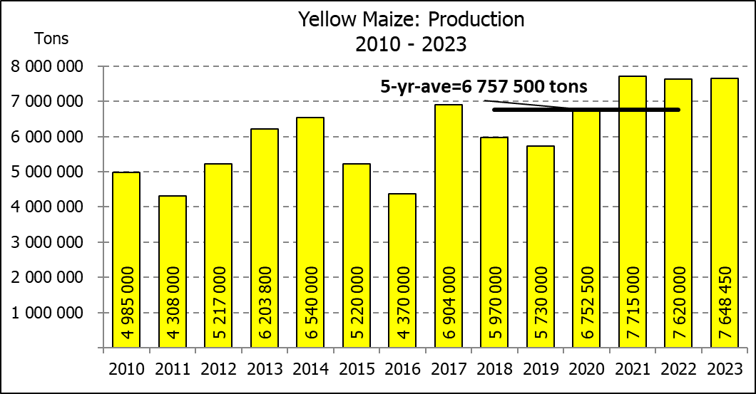
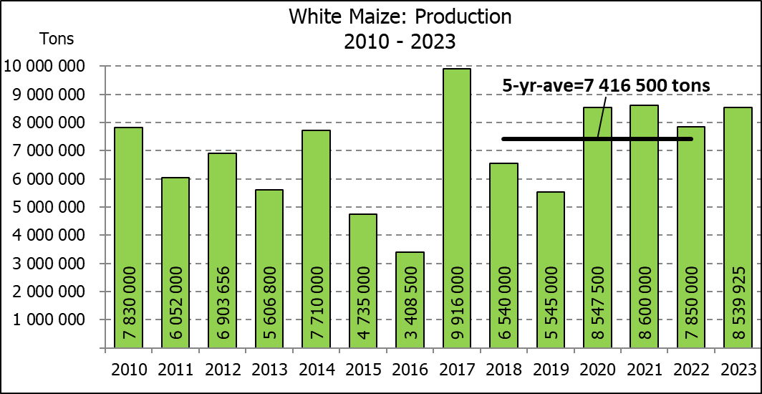
SOMERGEWASSE – OPPERVLAKTE- EN VIERDE PRODUKSIESKATTING: 2023
CROP/GEWAS | Area planted/  Opp beplant  2023 | 4th forecast/  4de skatting  2023 | 3rd forecast/  3de skatting  2023 | Area planted/  Opp beplant  2022 | Final crop/  Finale oes  2022 | Change/  Verandering/
CROP/GEWAS | Ha | Tons | Tons | Ha | Tons | %
CROP/GEWAS | (A) | (B) | (C) | (D) | (E) | (B) ÷ (C)
Commercial/Kommersieël:
White maize/Witmielies | 1 521 300 | 8 539 925 | 8 361 175 | 1 575 000 | 7 850 000 | +2,14
Yellow maize/Geelmielies | 1 064 800 | 7 648 450 | 7 528 600 | 1 048 000 | 7 620 000 | +1,59
Total Maize/Totale Mielies | 2 586 100 | 16 188 375 | 15 889 775 | 2 623 000 | 15 470 000 | +1,88
Sunflower seed/Sonneblomsaad | 555 700 | 797 610 | 797 610 | 670 700 | 845 550 | -
Soybeans/Sojabone | 1 148 300 | 2 755 300 | 2 755 300 | 925 300 | 2 230 000 | -
Groundnuts/Grondbone | 31 300 | 51 510 | 49 080 | 43 400 | 48 500 | +4,95
Sorghum | 34 000 | 104 700 | 107 180 | 37 200 | 103 140 | -2,31
Dry beans/Droëbone | 36 650 | 48 560 | 46 710 | 42 900 | 52 590 | +3,96
Non-Commercial Maize/Nie-Kommersiële Mielies
Total Maize/Totale Mielies | 358 620 | 664 040 | 664 040 | 378 800 | 667 000 | -
Maize/Mielies: Commercial/Kommersieël + Non-Commercial/Nie-Kommersieël
Total Maize RSA/Totaal Mielies RSA | 2 944 720 | 16 852 415 | 16 553 815 | 3 001 800 | 16 137 000 | +1,80
Note: Estimate is for calendar year, e.g. production season 2022/23 = 2023
Nota: Skatting is vir kalenderjaar, bv. produksie-seisoen 2022/23 = 2023

The Crop Estimates Committee comprises officials of the following institutions:
Department of Agriculture, Land Reform and Rural Development; Provincial Departments of Agriculture; various ARC-Institutes (Soil, Climate and Water; Small Grains Institute; and
Grain Crops Institute); BFAP and Statistics SA.
25 May/Mei 2023
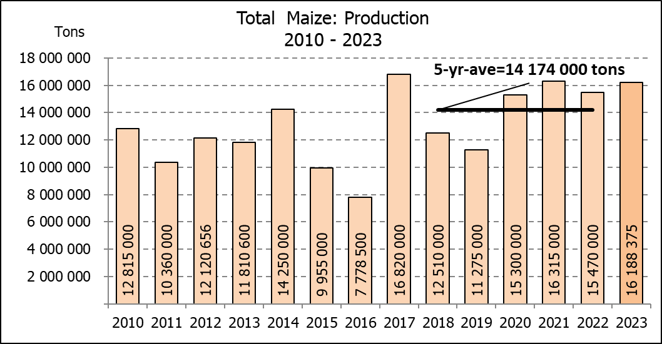

WHITE AND YELLOW MAIZE – AREA PLANTED AND FOURTH PRODUCTION FORECAST: 2023
WIT- EN GEELMIELIES – OPPERVLAKTE EN VIERDE PRODUKSIESKATTING: 2023

Provinsie/  Province | Area planted/  Oppervlakte beplant  2023 |  |  | 4th forecast/  4de skatting  2023 |  |  | Area planted/  Oppervlakte beplant  2022 |  |  | Final crop/  Finale oes  2022
Provinsie/  Province | White/  Wit  Ha | Yellow/  Geel  Ha | Total/  Totaal  Ha | White/  Wit  Tons | Yellow/  Geel  Tons | Total/  Totaal  Tons | White/  Wit  Ha | Yellow/  Geel  Ha | Total/  Totaal  Ha | White/  Wit  Tons | Yellow/  Geel  Tons | Total/  Totaal  Tons
Western Cape/Wes-Kaap | 250 | 3 500 | 3 750 | 2 375 | 32 900 | 35 275 | 500 | 3 500 | 4 000 | 4 750 | 32 900 | 37 650
Northern Cape/Noord-Kaap | 1 000 | 43 500 | 44 500 | 12 500 | 652 500 | 665 000 | 3 000 | 42 000 | 45 000 | 36 000 | 672 000 | 708 000
Free State/Vrystaat | 780 000 | 401 000 | 1 181 000 | 4 524 000 | 2 626 550 | 7 150 550 | 826 500 | 398 000 | 1 224 500 | 3 801 900 | 2 547 800 | 6 349 700
Eastern Cape/Oos-Kaap | 5 750 | 25 000 | 30 750 | 40 250 | 187 500 | 227 750 | 6 000 | 20 500 | 26 500 | 40 800 | 157 900 | 198 700
KwaZulu-Natal | 49 000 | 65 000 | 114 000 | 308 700 | 533 000 | 841 700 | 52 000 | 59 000 | 111 000 | 322 400 | 489 700 | 812 100
Mpumalanga | 156 500 | 352 000 | 508 500 | 1 032 900 | 2 499 200 | 3 532 100 | 165 000 | 350 000 | 515 000 | 1 072 500 | 2 554 000 | 3 626 500
Limpopo | 16 800 | 22 800 | 39 600 | 117 600 | 182 400 | 300 000 | 15 500 | 25 000 | 40 500 | 102 300 | 202 500 | 304 800
Gauteng | 56 000 | 52 000 | 108 000 | 358 400 | 374 400 | 732 800 | 56 500 | 56 000 | 112 500 | 361 600 | 403 200 | 764 800
North West/Noordwes | 456 000 | 100 000 | 556 000 | 2 143 200 | 560 000 | 2 703 200 | 450 000 | 94 000 | 544 000 | 2 107 750 | 560 000 | 2 667 750
Total/Totaal | 1 521 300 | 1 064 800 | 2 586 100 | 8 539 925 | 7 648 450 | 16 188 375 | 1 575 000 | 1 048 000 | 2 623 000 | 7 850 000 | 7 620 000 | 15 470 000

SUNFLOWER SEED – AREA PLANTED AND FOURTH PRODUCTION FORECAST: 2023
SONNEBLOMSAAD – OPPERVLAKTE EN VIERDE PRODUKSIESKATTING: 2023

Province/  Provinsie | Area planted/  Opp beplant  Ha | 4th forecast/  4de skatting  Tons | Area planted/  Opp beplant  Ha | Final crop/  Finale oes  Tons
Province/  Provinsie | 2023 | 2023 | 2022 | 2022
Western Cape/Wes-Kaap | - | - | - | -
Northern Cape/Noord-Kaap | 2 500 | 6 250 | 2 500 | 6 250
Free State/Vrystaat | 290 000 | 449 500 | 357 000 | 499 800
Eastern Cape/Oos-Kaap | 700 | 1 400 | 300 | 750
KwaZulu-Natal | 300 | 600 | - | -
Mpumalanga | 5 000 | 7 250 | 3 500 | 5 250
Limpopo | 100 000 | 105 000 | 110 000 | 77 000
Gauteng | 2 200 | 2 860 | 2 400 | 3 000
North West/Noordwes | 155 000 | 224 750 | 195 000 | 253 500
Total/Totaal | 555 700 | 797 610 | 670 700 | 845 550
SOYBEANS – AREA PLANTED AND FOURTH PRODUCTION FORECAST: 2023
SOJABONE – OPPERVLAKTE EN VIERDE PRODUKSIESKATTING: 2023

Province/  Provinsie | Area planted/  Opp beplant  Ha | 4th forecast/  4de skatting  Tons | Area planted/  Opp beplant  Ha | Final crop/  Finale oes  Tons
Province/  Provinsie | 2023 | 2023 | 2022 | 2022
Western Cape/Wes-Kaap | - | - | - | -
Northern Cape/Noord-Kaap | 1 000 | 3 750 | 800 | 3 000
Free State/Vrystaat | 565 000 | 1 327 750 | 415 000 | 912 500
Eastern Cape/Oos-Kaap | 4 300 | 12 900 | 3 000 | 9 000
KwaZulu-Natal | 44 000 | 158 400 | 39 000 | 150 000
Mpumalanga | 305 000 | 671 000 | 300 000 | 710 000
Limpopo | 26 000 | 88 400 | 22 500 | 76 500
Gauteng | 48 000 | 105 600 | 45 000 | 99 000
North West/Noordwes | 155 000 | 387 500 | 100 000 | 270 000
Total/Totaal | 1 148 300 | 2 755 300 | 925 300 | 2 230 000

GROUNDNUTS – AREA PLANTED AND FOURTH PRODUCTION FORECAST: 2023
GRONDBONE – OPPERVLAKTE EN VIERDE PRODUKSIESKATTING: 2023

Province/  Provinsie | Area planted/  Opp beplant  Ha | 4th forecast/  4de skatting  Tons | Area planted/  Opp beplant  Ha | Final crop/  Finale oes  Tons
Province/  Provinsie | 2023 | 2023 | 2022 | 2022
Western Cape/Wes-Kaap | - | - | - | -
Northern Cape/Noord-Kaap | 2 000 | 5 300 | 2 400 | 6 000
Free State/Vrystaat | 12 300 | 20 910 | 19 000 | 20 900
Eastern Cape/Oos-Kaap | - | - | - | -
KwaZulu-Natal | - | - | - | -
Mpumalanga | - | - | - | -
Limpopo | 2 000 | 5 800 | 2 000 | 4 600
Gauteng | - | - | - | -
North West/Noordwes | 15 000 | 19 500 | 20 000 | 17 000
Total/Totaal | 31 300 | 51 510 | 43 400 | 48 500

SORGHUM – AREA PLANTED AND FOURTH PRODUCTION FORECAST: 2023
SORGHUM – OPPERVLAKTE EN VIERDE PRODUKSIESKATTING: 2023

Province/  Provinsie | Area planted/  Opp beplant  Ha | 4th forecast/  4de skatting  Tons | Area planted/  Opp beplant  Ha | Final crop/  Finale oes  Tons
Province/  Provinsie | 2023 | 2023 | 2022 | 2022
Western Cape/Wes-Kaap | - | - | - | -
Northern Cape/Noord-Kaap | - | - | - | -
Free State/Vrystaat | 5 200 | 16 900 | 7 800 | 20 700
Eastern Cape/Oos-Kaap | - | - | - | -
KwaZulu-Natal | 100 | 400 | 200 | 740
Mpumalanga | 8 500 | 38 250 | 9 000 | 43 650
Limpopo | 15 500 | 37 200 | 15 000 | 26 250
Gauteng | 100 | 450 | 200 | 800
North West/Noordwes | 4 600 | 11 500 | 5 000 | 11 000
Total/Totaal | 34 000 | 104 700 | 37 200 | 103 140

DRY BEANS – AREA PLANTED AND FOURTH PRODUCTION FORECAST: 2023
DROëBONE – OPPERVLAKTE EN VIERDE PRODUKSIESKATTING: 2023

Province/  Provinsie | Area planted/  Opp beplant  Ha | 4th forecast/  4de skatting  Tons | Area planted/  Opp beplant  Ha | Final crop/  Finale oes  Tons
Province/  Provinsie | 2023 | 2023 | 2022 | 2022
Western Cape/Wes-Kaap | 100 | 180 | 100 | 150
Northern Cape/Noord-Kaap | 450 | 990 | 600 | 1 080
Free State/Vrystaat | 14 000 | 11 900 | 15 500 | 13 950
Eastern Cape/Oos-Kaap | 200 | 360 | 200 | 300
KwaZulu-Natal | 2 100 | 3 150 | 2 300 | 2 760
Mpumalanga | 5 000 | 7 000 | 6 000 | 6 600
Limpopo | 8 000 | 16 000 | 10 400 | 18 200
Gauteng | 800 | 880 | 800 | 800
North West/Noordwes | 6 000 | 8 100 | 7 000 | 8 750
Total/Totaal | 36 650 | 48 560 | 42 900 | 52 590

CONFIDENTIALITY ISSUES that CEC members are committed to adhere to on the day of the meeting
- Personal items such as laptops, handbags, cell phones, etc. are not allowed in the venue during the meeting
- No member is allowed to leave the meeting before 12:00 in order to prevent disclosure of the information
- The embargo time for the release of crop estimates information is 14:30
- No member is allowed to discuss crop estimates information with anyone other than a member of the Committee before the embargo time
- Only the Chairperson, or a member appointed by the Chairperson, may release the figures to the media
- Members must regard the detail of any information that was collected for and/or discussed during the meeting, as confidential
- Individual information received for crop estimate purposes is treated strictly confidential, and is not divulged for any other purposes

AREA ESTIMATE AND FOURTH PRODUCTION FORECAST OF SUMMER CROPS (2023 PRODUCTION SEASON)/
OPPERVLAKTE- EN VIERDE PRODUKSIESKATTING VIR SOMERGEWASSE (2023 PRODUKSIE-SEISOEN)
25 MAY/MEI 2023

Summer field crops – 2023  Commercial maize: The size of the expected commercial maize crop has been set at 16,188 mill. tons, which is 1,88% or 298 600 tons more than the previous forecast of 15,890 mill. tons. The area estimate for maize is 2,586 mill. ha and the expected yield is 6,26 t/ha.  The estimated maize crop is 4,64% or 718 375 tons larger than the 2022 crop. The three main maize producing areas, namely the Free State, Mpumalanga and North West provinces are expected to produce 83% of the 2023 crop.  The production forecast of white maize is 8,540 mill. tons, which is 2,14% or 178 750 tons more than the 8,361 mill. tons of the previous forecast. The area estimate for white maize is 1,521 mill. ha and the expected yield is 5,61 t/ha.  In the case of yellow maize, the production forecast is 7,648 mill. tons, which is 1,59% or 119 850 tons more than the 7,529 mill. tons of the previous forecast. The area estimate for yellow maize is 1,065 mill. ha and the yield is 7,18 t/ha.  The yield per ha for the Free State and North West provinces were based on scientific and objective results provided by the ARC.  Other summer crops:  Sunflower seed: The production forecast for sunflower seed remained unchanged at 797 610 tons. The area estimate for sunflower seed is 555 700 ha, while the expected yield is 1,44 t/ha.  Other crops: The production forecast for soybeans also remained unchanged at 2,755 mill. tons. The estimated area planted to soybeans is 1,148 mill. ha and the expected yield is 2,40 t/ha.  The expected groundnut crop is 51 510 tons, which is 4,95% or 2 430 tons more than the 49 080 tons of the previous forecast. For groundnuts, the area estimate is 31 300 ha, with an expected yield of 1,65 t/ha.  The production forecast for sorghum is 104 700 tons, which is 2,31% or 2 480 tons less than the 107 180 tons of the previous forecast. The area estimate for sorghum is 34 000 ha and the expected yield is 3,08 t/ha.  In the case of dry beans, the production forecast increased by 3,96% or 1 850 tons, from 46 710 tons to 48 560 tons. The area estimate of dry beans is 36 650 ha, with an expected yield of 1,32 t/ha.  Please note that the fifth production forecast for summer field crops for 2023 will be released on 27 June 2023. |  | Somergewasse – 2023  Kommersiële mielies: Die grootte van die verwagte kommersiële mielie-oes is op 16,188 milj. ton gestel, wat 1,88% of 298 600 ton meer is as die vorige skatting van 15,890 milj. ton. Die oppervlakteskatting vir mielies is 2,586 milj. ha en die verwagte opbrengs is  6,26 t/ha.  Die geskatte mielie-oes is 4,64% of 718 375 ton groter as die 2022-oes. Die drie belangrikste mielieproduserende gebiede, nl. die Vrystaat, Mpumalanga en Noordwes provinsies, gaan na verwagting 83% van die 2023-oes produseer.  Die produksieskatting van witmielies is 8,540 milj. ton, wat 2,14% of 178 750 ton meer is as die 8,361 milj. ton van die vorige skatting. Die oppervlakteskatting vir witmielies is 1,521 milj. ha en die verwagte opbrengs is 5,61 t/ha.  In die geval van geelmielies is die produksieskatting 7,648 milj. ton, wat 1,59% of 119 850 ton meer is as die 7,529 milj. ton van die vorige skatting. Die oppervlakteskatting vir geelmielies is 1,065 milj. ha en die opbrengs is 7,18 t/ha.  Die opbrengs-bepaling per ha vir die Vrystaat en Noordwes provinsies is gebaseer op wetenskaplike en objektiewe resultate verstrek deur die LNR.  Ander somergewasse:  Sonneblomsaad: Die produksieskatting vir sonneblomsaad is onveranderd gelaat op 797 610 ton. Die oppervlakteskatting vir sonneblomsaad is 555 700 ha, terwyl die verwagte opbrengs 1,44 t/ha is.  Ander gewasse: Die produksieskatting van sojabone is ook onveranderd gelaat op 2,755 milj. ton. Die geskatte oppervlakte beplant met sojabone is 1,148 milj. ha en die verwagte opbrengs is 2,40 t/ha.  Die verwagte grondbone-oes is 51 510 ton, wat 4,95% of 2 430 ton meer is as die 49 080 ton van die vorige skatting. Vir grondbone is die oppervlakteskatting 31 300 ha, terwyl the verwagte opbrengs 1,65 t/ha is.  Die produksieskatting van sorghum is 104 700 ton, wat 2,31% of 2 480 ton minder is as die 107 180 ton van die vorige skatting. Die oppervlakteskatting vir sorghum is 34 000 ha, en die verwagte opbrengs is 3,08 t/ha.  In die geval van droëbone is die produksieskatting opwaarts aangepas met 3,96% of 1 850 ton, vanaf 46 710 ton na 48 560 ton. Die oppervlakte beplant met droëbone is 36 650 ha, en die verwagte opbrengs is 1,32 t/ha.  Neem asseblief kennis dat die vyfde produksieskatting vir somergewasse vir 2023, op 27 Junie 2023 vrygestel sal word.

The non-commercial agricultural sectors’ production estimate for maize for 2023 is hereby released. /
Hiermee word die nie-kommersiële landbou-sektor se produksieskatting vir mielies vir 2023 vrygestel.

NON-COMMERCIAL MAIZE – AREA PLANTED AND PRODUCTION ESTIMATE: 2023
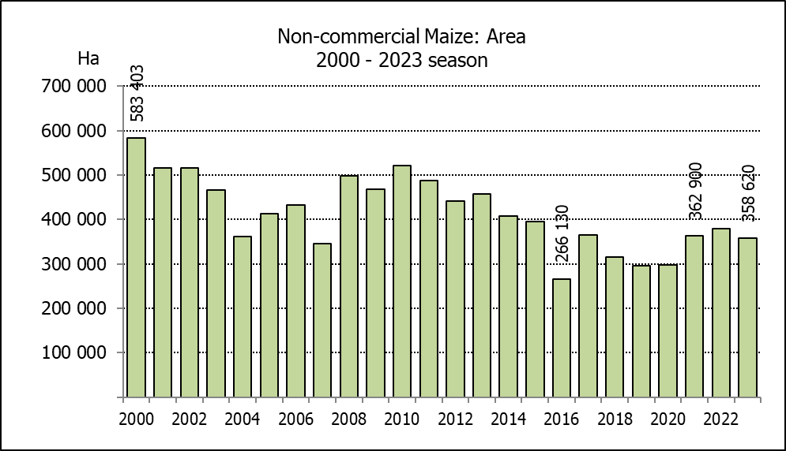
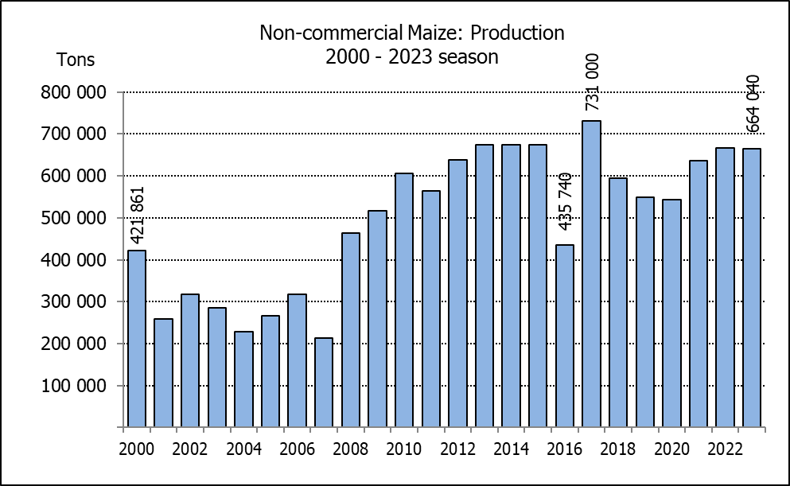
NIE-KOMMERSIëLE MIELIES – OPPERVLAKTE- EN PRODUKSIESKATTING: 2023
CROP/GEWAS | Area planted/  Opp beplant  2023 | Production/  Produksie  2023 | Area planted/  Opp beplant  2022 | Final crop/  Finale oes  2022 | Change/  Verandering
CROP/GEWAS | Ha | Tons | Ha | Tons | %
CROP/GEWAS | (A) | (B) | (C) | (D) | (B) ÷ (D)
Non-commercial agriculture/Nie-kommersiële landbou:
White maize/Witmielies | 278 655 | 472 765 | 296 950 | 482 000 | -1,92
Yellow maize/Geelmielies | 79 965 | 191 275 | 81 850 | 185 000 | +3,39
Maize/Mielies | 358 620 | 664 040 | 378 800 | 667 000 | -0,44
The preliminary area planted to maize in the non-commercial agricultural sector is estimated at 358 620 ha, which represents a decrease of 5,33%, compared to the 378 800 ha of the previous season. The expected maize crop for this sector is 664 040 tons, which is 0,44% less than the 667 000 tons of last season. It is important to note that about 48% of the maize produced in the non-commercial sector, is planted in the Eastern Cape, followed by KwaZulu-Natal with 21%.
Die voorlopige oppervlakte beplant met mielies in die nie-kommersiële landbou-sektor word geskat op 358 620 ha, wat ’n afname van 5,33% verteenwoordig in vergelyking met die 378 800 ha van die vorige seisoen. Die verwagte mielie-oes van dié sektor is 664 040 ton, wat 0,44% minder is as die 667 000 ton van die vorige seisoen. Dit is belangrik om daarop te let dat ongeveer 48% van die mielies wat geproduseer word in die nie-kommersiële sektor, in die Oos-Kaap geplant word, gevolg deur KwaZulu-Natal met 21%.

