 | crop estimates committee | 
 | oesskattingskomitee
From/Van: Mr Baldwin Netshifhefhe
Tel: 012 319 8043  Fax/Faks: 012 319 8031  E-mail/E-pos: BaldwinN@daff.gov.za
Web page/Webblad: www.daff.gov.za/statistics and economic reports or www.sagis.org.za/CEC: Crop Estimates
EMBARGO: 14:30

The area planted estimate and fourth production forecast for summer crops for 2019 is hereby released.
Hiermee word die oppervlakte- en vierde produksieskatting vir somergewasse vir 2019 vrygestel.

SUMMER CROPS – AREA PLANTED AND FOURTH PRODUCTION FORECAST: 2019
SOMERGEWASSE – OPPERVLAKTE- EN VIERDE PRODUKSIESKATTING: 2019
CROP/GEWAS | Area planted/  Opp beplant  2019 |  |  | 4th forecast/  4de skatting  2019 | 3rd forecast/  3de skatting  2019 |  | Area planted/  Opp beplant  2018 |  |  | Final crop/  Finale oes  2018 |  |  | Change/  Verandering/
CROP/GEWAS | Ha |  |  | Tons | Tons |  | Ha |  |  | Tons |  |  | %
CROP/GEWAS | (A) |  |  | (B) | (C) |  | (D) |  |  | (E) |  |  | (B) ÷ (C)
Commercial/Kommersieël:
White maize/Witmielies |  | 1 298 400 |  | 5 488 040 | 5 286 540 |  | 1 268 100 |  |  | 6 540 000 |  |  | +3,81
Yellow maize/Geelmielies |  | 1 002 100 |  | 5 412 220 | 5 368 820 |  | 1 050 750 |  |  | 5 970 000 |  |  | +0,81
Total Maize/Totale Mielies |  | 2 300 500 |  | 10 900 260 | 10 655 360 |  | 2 318 850 |  |  | 12 510 000 |  |  | +2,30
Sunflower seed/Sonneblomsaad |  | 515 350 |  | 611 140 | 611 140 |  | 601 500 |  |  | 862 000 |  |  | -
Soybeans/Sojabone |  | 730 500 |  | 1 295 845 | 1 295 845 |  | 787 200 |  |  | 1 540 000 |  |  | -
Groundnuts/Grondbone |  | 20 050 |  | 22 705 | 22 705 |  | 56 300 |  |  | 57 000 |  |  | -
Sorghum |  | 50 500 |  | 165 850 | 165 850 |  | 28 800 |  |  | 115 000 |  |  | -
Dry beans/Droëbone |  | 59 300 |  | 72 450 | 72 450 |  | 53 360 |  |  | 69 360 |  |  | -
Non-Commercial Maize/Nie-Kommersiële Mielies
Total Maize/Totaal Mielies |  | 296 000 |  | 549 180 | N/A |  | 314 835 |  | 593 975 |  |  | N/A
Maize/Mielies: Commercial/Kommersieël + Non-Commercial/Nie-Kommersieël
Total Maize RSA/Totaal Mielies RSA |  |  | 2 596 500 | 11 449 440 |  | N/A |  | 2 633 685 |  |  | 13 103 975 |  |  | N/A
Note: Estimate is for calendar year, e.g. production season 2018/19 = 2019
Nota: Skatting is vir kalenderjaar, bv. produksie-seisoen 2018/19 = 2019

28 May 2019

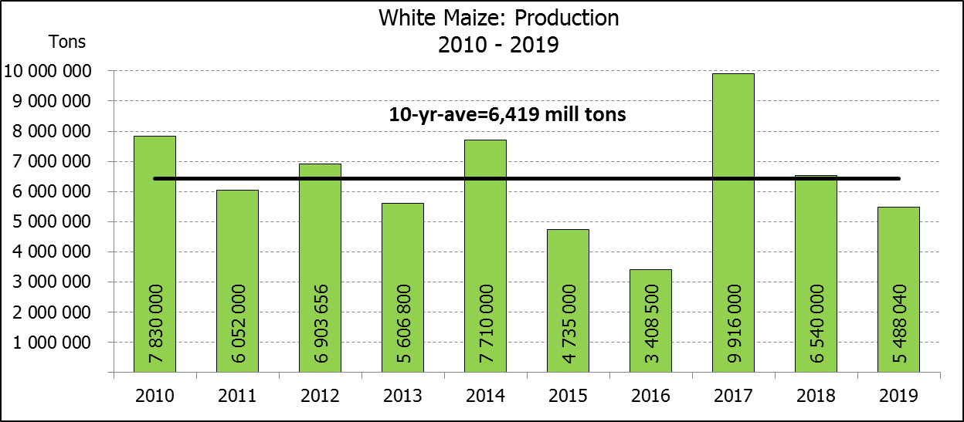

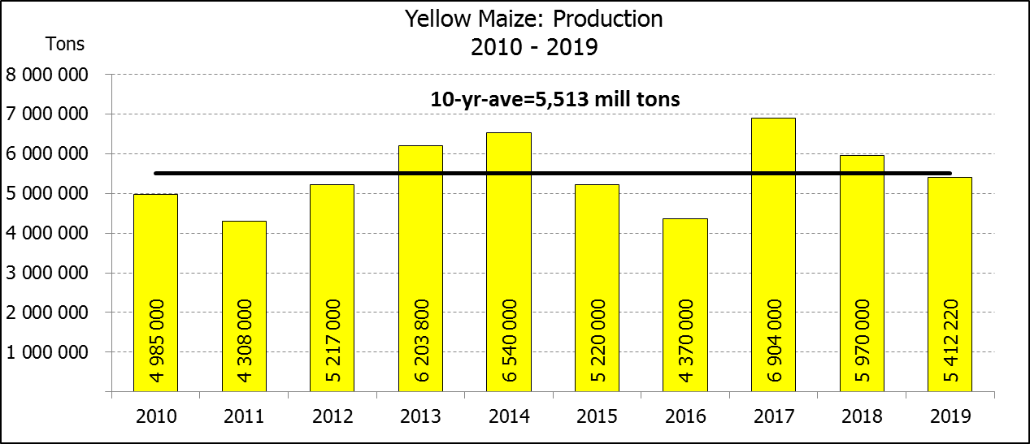
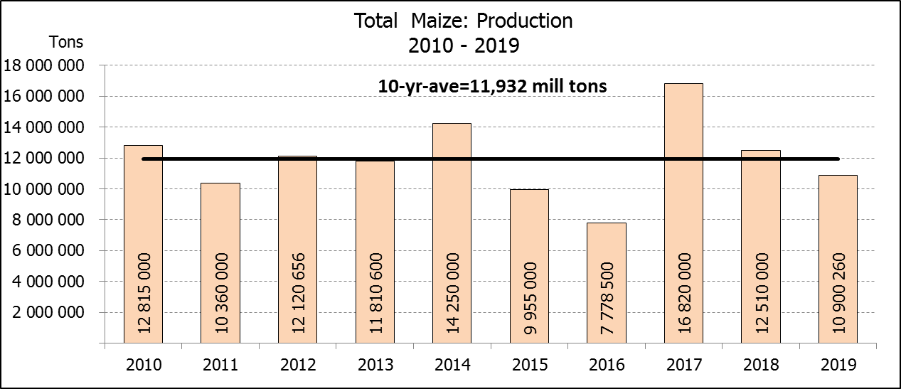

WHITE AND YELLOW MAIZE – AREA PLANTED AND FOURTH PRODUCTION FORECAST: 2019
WIT- EN GEELMIELIES – OPPERVLAKTE EN VIERDE PRODUKSIESKATTING: 2019

Provinsie/  Province | Area planted/  Oppervlakte beplant  2019 |  |  | 4th forecast/  4de skatting  2019 |  |  | Area planted/  Oppervlakte beplant  2018 |  |  | Final crop/  Finale oes  2018
Provinsie/  Province | White/  Wit  Ha | Yellow/  Geel  Ha | Total/  Totaal  Ha | White/  Wit  Tons | Yellow/  Geel  Tons | Total/  Totaal  Tons | White/  Wit  Ha | Yellow/  Geel  Ha | Total/  Totaal  Ha | White/  Wit  Tons | Yellow/  Geel  Tons | Total/  Totaal  Tons
Western Cape/Wes-Kaap | 400 | 3 400 | 3 800 | 3 600 | 30 600 | 34 200 | 0 | 3 750 | 3 750 | 0 | 33 750 | 33 750
Northern Cape/Noord-Kaap | 3 400 | 43 500 | 46 900 | 39 440 | 626 400 | 665 840 | 3 600 | 43 000 | 46 600 | 41 300 | 628 000 | 669 300
Free State/Vrystaat | 650 000 | 380 000 | 1 030 000 | 2 730 000 | 1 634 000 | 4 364 000 | 644 000 | 410 000 | 1 054 000 | 3 350 000 | 1 925 000 | 5 275 000
Eastern Cape/Oos-Kaap | 3 800 | 10 200 | 14 000 | 22 800 | 67 320 | 90 120 | 3 500 | 11 000 | 14 500 | 21 700 | 71 500 | 93 200
KwaZulu-Natal | 45 000 | 54 000 | 99 000 | 270 000 | 383 400 | 653 400 | 45 000 | 50 000 | 95 000 | 280 000 | 380 000 | 660 000
Mpumalanga | 145 000 | 338 000 | 483 000 | 812 000 | 1 859 000 | 2 671 000 | 140 000 | 340 000 | 480 000 | 812 000 | 2 005 000 | 2 817 000
Limpopo | 12 800 | 18 000 | 30 800 | 83 200 | 117 000 | 200 200 | 12 000 | 21 000 | 33 000 | 90 000 | 141 700 | 231 700
Gauteng | 48 000 | 60 000 | 108 000 | 240 000 | 324 000 | 564 000 | 50 000 | 62 000 | 112 000 | 275 000 | 356 500 | 631 500
North West/Noordwes | 390 000 | 95 000 | 485 000 | 1 287 000 | 370 500 | 1 657 500 | 370 000 | 110 000 | 480 000 | 1 670 000 | 428 550 | 2 098 550
Total/Totaal | 1 298 400 | 1 002 100 | 2 300 500 | 5 488 040 | 5 412 220 | 10 900 260 | 1 268 100 | 1 050 750 | 2 318 850 | 6 540 000 | 5 970 000 | 12 510 000

SUNFLOWER SEED – AREA PLANTED AND FOURTH PRODUCTION FORECAST: 2019
SONNEBLOMSAAD – OPPERVLAKTE EN VIERDE PRODUKSIESKATTING: 2019

Province/  Provinsie | Area planted/  Opp beplant  Ha | 4th forecast/  4de skatting  Tons | Area planted/  Opp beplant  Ha | Final crop/  Finale oes  Tons
Province/  Provinsie | 2019 | 2019 | 2018 | 2018
Western Cape/Wes-Kaap | - | - | 100 | 100
Northern Cape/Noord-Kaap | 950 | 1 140 | 1 600 | 1 920
Free State/Vrystaat | 270 000 | 351 000 | 314 000 | 490 000
Eastern Cape/Oos-Kaap | 100 | 250 | - | -
KwaZulu-Natal | - | - | - | -
Mpumalanga | 4 500 | 4 500 | 2 300 | 2 180
Limpopo | 61 000 | 57 950 | 45 000 | 36 000
Gauteng | 3 800 | 3 800 | 5 500 | 5 600
North West/Noordwes | 175 000 | 192 500 | 233 000 | 326 200
Total/Totaal | 515 350 | 611 140 | 601 500 | 862 000
SOYBEANS – AREA PLANTED AND FOURTH PRODUCTION FORECAST: 2019
SOJABONE – OPPERVLAKTE EN VIERDE PRODUKSIESKATTING: 2019

Province/  Provinsie | Area planted/  Opp beplant  Ha | 4th forecast/  4de skatting  Tons | Area planted/  Opp beplant  Ha | Final crop/  Finale oes  Tons
Province/  Provinsie | 2019 | 2019 | 2018 | 2018
Western Cape/Wes-Kaap | 100 | 10 | 800 | 1 200
Northern Cape/Noord-Kaap | 1 550 | 5 425 | 3 000 | 10 500
Free State/Vrystaat | 301 000 | 451 500 | 345 000 | 552 000
Eastern Cape/Oos-Kaap | 1 150 | 1 380 | 2 400 | 2 900
KwaZulu-Natal | 33 000 | 102 300 | 40 000 | 124 000
Mpumalanga | 310 000 | 573 500 | 310 000 | 672 700
Limpopo | 16 200 | 46 980 | 20 000 | 54 000
Gauteng | 31 500 | 66 150 | 30 000 | 61 500
North West/Noordwes | 36 000 | 48 600 | 36 000 | 61 200
Total/Totaal | 730 500 | 1 295 845 | 787 200 | 1 540 000

GROUNDNUTS – AREA PLANTED AND FOURTH PRODUCTION FORECAST: 2019
GRONDBONE – OPPERVLAKTE EN VIERDE PRODUKSIESKATTING: 2019

Province/  Provinsie | Area planted/  Opp beplant  Ha | 4th forecast/  4de skatting  Tons | Area planted/  Opp beplant  Ha | Final crop/  Finale oes  Tons
Province/  Provinsie | 2019 | 2019 | 2018 | 2018
Western Cape/Wes-Kaap | - | - | - | -
Northern Cape/Noord-Kaap | 1 200 | 2 760 | 2 800 | 7 000
Free State/Vrystaat | 11 500 | 10 925 | 22 000 | 21 150
Eastern Cape/Oos-Kaap | - | - | - | -
KwaZulu-Natal | - | - | - | -
Mpumalanga | - | - | - | -
Limpopo | 1 850 | 4 070 | 3 500 | 7 350
Gauteng | - | - | - | -
North West/Noordwes | 5 500 | 4 950 | 28 000 | 21 500
Total/Totaal | 20 050 | 22 705 | 56 300 | 57 000

SORGHUM – AREA PLANTED AND FOURTH PRODUCTION FORECAST: 2019
SORGHUM – OPPERVLAKTE EN VIERDE PRODUKSIESKATTING: 2019

Province/  Provinsie | Area planted/  Opp beplant  Ha | 4th forecast/  4de skatting  Tons | Area planted/  Opp beplant  Ha | Final crop/  Finale oes  Tons
Province/  Provinsie | 2019 | 2019 | 2018 | 2018
Western Cape/Wes-Kaap | - | - | - | -
Northern Cape/Noord-Kaap | - | - | - | -
Free State/Vrystaat | 8 000 | 30 400 | 6 300 | 25 200
Eastern Cape/Oos-Kaap | - | - | - | -
KwaZulu-Natal | 500 | 1 750 | 500 | 2 200
Mpumalanga | 7 500 | 37 500 | 7 500 | 40 500
Limpopo | 25 000 | 67 500 | 5 000 | 15 500
Gauteng | 1 000 | 3 200 | 1 500 | 4 950
North West/Noordwes | 8 500 | 25 500 | 8 000 | 26 650
Total/Totaal | 50 500 | 165 850 | 28 800 | 115 000

DRY BEANS – AREA PLANTED AND FOURTH PRODUCTION FORECAST: 2019
DROëBONE – OPPERVLAKTE EN VIERDE PRODUKSIESKATTING: 2019

Province/  Provinsie | Area planted/  Opp beplant  Ha | 4th forecast/  4de skatting  Tons | Area planted/  Opp beplant  Ha | Final crop/  Finale oes  Tons
Province/  Provinsie | 2019 | 2019 | 2018 | 2018
Western Cape/Wes-Kaap | 100 | 200 | 20 | 30
Northern Cape/Noord-Kaap | 1 000 | 2 000 | 540 | 1 080
Free State/Vrystaat | 27 000 | 28 350 | 26 000 | 28 600
Eastern Cape/Oos-Kaap | 400 | 800 | 300 | 450
KwaZulu-Natal | 3 500 | 4 200 | 3 000 | 3 600
Mpumalanga | 7 500 | 7 500 | 7 000 | 9 800
Limpopo | 7 800 | 15 600 | 7 500 | 15 000
Gauteng | 1 500 | 2 250 | 1 000 | 1 200
North West/Noordwes | 10 500 | 11 550 | 8 000 | 9 600
Total/Totaal | 59 300 | 72 450 | 53 360 | 69 360

CONFIDENTIALITY ISSUES that CEC members are committed to adhere to on the day of the meeting
- Personal items such as laptops, handbags, cell phones, etc. are not allowed in the venue during the meeting
- No member is allowed to leave the meeting before 12:00 in order to prevent disclosure of the information
- The embargo time for the release of crop estimates information is 14:30
- No member is allowed to discuss crop estimates information with anyone other than a member of the Committee before the embargo time
- Only the Chairperson, or a member appointed by the Chairperson, may release the figures to the media
- Members must regard the detail of any information that was collected for and/or discussed during the meeting, as confidential
- Individual information received for crop estimate purposes is treated strictly confidential, and is not divulged for any other purposes

AREA ESTIMATE AND FOURTH PRODUCTION FORECAST OF SUMMER CROPS (2019 PRODUCTION SEASON)/
OPPERVLAKTE- EN VIERDE PRODUKSIESKATTING VIR SOMERGEWASSE (2019 PRODUKSIE-SEISOEN)
28 MAY/MEI 2019

Summer field crops – 2019  Commercial maize: The size of the expected commercial maize crop has been set at 10,900 mill. tons, which is 2,30% or 244 900 tons more than the previous forecast of 10,655 mill. tons. The area estimate for maize is 2,301 mill. ha, while the expected yield is 4,74 t/ha.  The estimated maize crop is 13% smaller than the 2018 crop. The three main maize producing areas, namely the Free State, Mpumalanga and North West provinces are expected to produce 80% of the 2019 crop.  The area estimate for white maize is1,298 mill. ha & for yellow maize the area estimate is1,002 mill. ha.  The production forecast of white maize is 5,488 mill. tons, which is 3,81% or 201 500 tons more than the 5,287 mill. tons of the previous forecast. The yield for white maize is 4,23 t/ha. In the case of yellow maize the production forecast is 5,412 mill. tons, which is 0,81% or 43 400 tons more than the 5,369 mill. tons of the previous forecast. The yield for yellow maize is 5,40 t/ha.  The yield per ha for the Free State and North West provinces was based on scientific and objective results provided by the Agricultural Research Council (ARC).  Sunflower seed: The production forecast for sunflower seed remained unchanged at 611 140 tons. The area estimate for sunflower seed is 515 350 ha, while the expected yield is 1,19 t/ha.  Other crops: The production forecast for soybeans also remained unchanged at 1,296 mill. tons. The estimated area planted to soybeans is 730 500 ha and the expected yield is 1,77 t/ha.  The expected groundnut crop remained unchanged at 22 705 tons and the expected yield is 1,13 t/ha. The area estimate for groundnuts is 20 050 ha.  The production forecast for sorghum remained unchanged at 165 850 tons. The area estimate for sorghum is 50 500 ha and the expected yield is 3,28 t/ha.  In the case of dry beans, the production forecast remained unchanged at 72 450 tons. The area estimate of dry beans is 59 300 ha, with an expected yield of 1,22 t/ha.  Please note that the fifth production forecast for summer field crops for 2019 will be released on 26 June 2019. |  | Somergewasse – 2019  Kommersiële mielies: Die grootte van die verwagte kommersiële mielie-oes is op 10,900 milj. ton gestel, wat 2,30% of 244 900 ton meer is as die vorige skatting van 10,655 milj. ton. Die skatting van die oppervlakte onder mielies is 2,301 milj. ha, terwyl die verwagte opbrengs 4,74 t/ha is.  Die geskatte mielie-oes is 13% kleiner as die 2018-oes. Die drie belangrikste mielieproduserende gebiede, nl. die Vrystaat, Mpumalanga en Noordwes provinsies, gaan na verwagting 80% van die 2019-oes produseer.  Die oppervlak onder witmielies is 1,298 milj. ha en vir geelmielies is die oppervlak 1,002 milj. ha.  Die produksieskatting van witmielies is 5,488 milj. ton, 3,81% of 201 500 ton meer as die 5,287 milj. ton van die vorige skatting. Die opbrengs van witmielies is 4,23 t/ha. In die geval van geelmielies is die produksieskatting 5,412 milj. ton, wat 0,81% of 43 400 ton meer is as die 5,369 milj. ton van die vorige skatting. Die opbrengs van geelmielies is 5,40 t/ha.  Die opbrengs-bepaling per ha vir die Vrystaat en Noordwes provinsies is gebaseer op wetenskaplike en objektiewe resultate verstrek deur die LNR.  Sonneblomsaad: Die produksieskatting vir sonneblomsaad is onveranderd gelaat op 611 140 ton. Die oppervlakteskatting vir sonneblomsaad is 515 350 ha, terwyl die verwagte opbrengs 1,19 t/ha is.  Ander gewasse: Die produksieskatting van sojabone is ook onveranderd gelaat op 1,296 milj. ton. Die geskatte oppervlakte beplant van sojabone is 730 500 ha en die verwagte opbrengs is 1,77 t/ha.  Die verwagte grondbone-oes is onveranderd gelaat op 22 705 ton en die verwagte opbrengs is 1,13 t/ha. Die oppervlakteskatting vir grondbone is 20 050 ha.  Die produksieskatting van sorghum is onveranderd gelaat op 165 850 ton. Die oppervlakteskatting vir sorghum is 50 500 ha, en die verwagte opbrengs is 3,28 t/ha.  In die geval van droëbone is die produksieskatting onveranderd gelaat op 72 450 ton. Die oppervlakte beplant met droëbone is 59 300 ha, en die verwagte opbrengs is 1,22 t/ha.  Neem asseblief kennis dat die vyfde produksieskatting vir somergewasse vir 2019, op 26 Junie 2019 vrygestel sal word.
Information is available on the internet at http://www.daff.gov.za/statistics and economic reports or http://www.sagis.org.za, as from 14:30 on the date of the relevant meeting of the Crop Estimates Committee. |  | Inligting is beskikbaar op die internet by http://www.daff.gov.za/statistics and economic reports of by http://www.sagis.org.za, vanaf 14:30 op die dag van die toepaslike vergadering van die Oesskattingskomitee.

The preliminary non-commercial agricultural sectors’ production estimate for maize for 2019 is hereby released. /
Hiermee word die voorlopige nie-kommersiële landbou-sektor se produksieskatting vir mielies vir 2019 vrygestel.

NON-COMMERCIAL MAIZE – PRELIMINARY AREA PLANTED AND PRODUCTION ESTIMATE: 2019
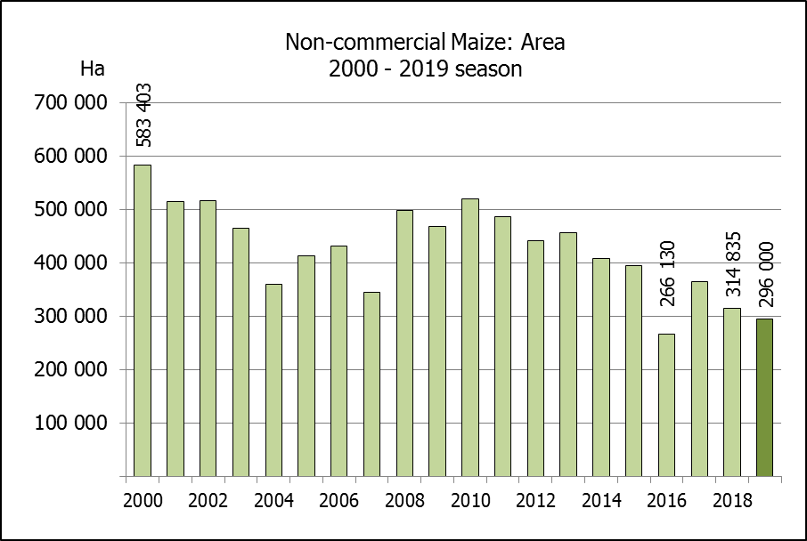
NIE-KOMMERSIëLE MIELIES – VOORLOPIGE OPPERVLAKTE- EN PRODUKSIESKATTING: 2019
CROP/GEWAS | Area planted/  Opp beplant  2019 | Production/  Produksie  2019 | Area planted/  Opp beplant  2018 | Final crop/  Finale oes  2018 | Change/  Verandering
CROP/GEWAS | Ha | Tons | Ha | Tons | %
CROP/GEWAS | (A) | (B) | (C) | (D) | (B) ÷ (D)
Non-commercial agriculture/Nie-kommersiële landbou:
White maize/Witmielies | 221 300 | 379 460 | 236 644 | 414 162 | -8,38
Yellow maize/Geelmielies | 74 700 | 169 720 | 78 191 | 179 813 | -5,61
Maize/Mielies | 296 000 | 549 180 | 314 835 | 593 975 | -7,54
The preliminary area planted to maize in the non-commercial agricultural sector is estimated at 296 000 ha, which represents a decrease of 5,98%, compared to the 314 835 ha of the previous season. The expected maize crop for this sector is 549 180 tons, which is 7,54% less than the 593 975 tons of last season. It is important to note that about 43% of the maize produced in the non-commercial sector, is planted in the Eastern Cape, followed by KwaZulu-Natal with 27%.
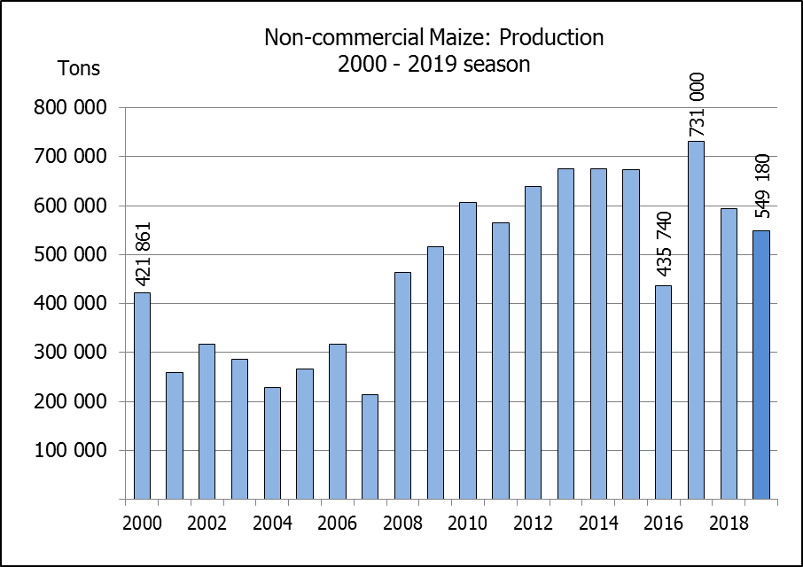
Die voorlopige oppervlakte beplant met mielies in die nie-kommersiële landbou-sektor word geskat op 296 000 ha, wat ‘n afname van 5,98 % verteenwoordig in vergelyking met die 314 835 ha van die vorige seisoen. Die verwagte mielie-oes van dié sektor is 549 180 ton, wat 7,54% minder is as die 593 975 ton van die vorige seisoen. Dit is belangrik om daarop te let dat ongeveer 43% van die mielies wat geproduseer word in die nie-kommersiële sektor, in die Oos-Kaap geplant word, gevolg deur KwaZulu-Natal met 27%.

