 | crop estimates committee | 
 | oesskattingskomitee
From/Van: M. Ellen Matsei
Tel: 012 319 8454  Fax/Faks: 012 319 8031  E-mail/E-pos: DAS@daff.gov.za
Web page/Webblad: www.daff.gov.za/statistics and economic reports or www.sagis.org.za/CEC: Crop Estimates
EMBARGO: 15:30

The area planted estimate and fourth production forecast for summer crops for 2017 is hereby released.
Hiermee word die oppervlakte- en vierde produksieskatting vir somergewasse vir 2017 vrygestel.

SUMMER CROPS – AREA PLANTED AND FOURTH PRODUCTION FORECAST: 2017
SOMERGEWASSE – OPPERVLAKTE- EN VIERDE PRODUKSIESKATTING: 2017
CROP/GEWAS  The Crop Estimates Committee comprises officials of the following institutions:  Department of Agriculture, Forestry and Fisheries; Provincial Departments of Agriculture; various ARC-Institutes (Soil, Climate and Water; Small Grains Institute;  and Grain Crops Institute); and Statistics SA. | Area planted/  Opp beplant  2017 | 4th forecast/  4de skatting  2017 | 3rd forecast/  3de skatting  2017 | Area planted/  Opp beplant  2016 | Final crop/  Finale oes  2016 | Change/  Verandering
 | Ha | Tons | Tons | Ha | Tons | %
 | (A) | (B) | (C) | (D) | (E) | (B) ÷ (C)
Commercial/Kommersieel:
White maize/Witmielies | 1 643 100 | 9 466 800 | 8 618 400 | 1 014 750 | 3 408 500 | +9,84
Yellow maize/Geelmielies | 985 500 | 6 164 250 | 5 917 300 | 932 000 | 4 370 000 | +4,17
Total Maize/Totale Mielies | 2 628 600 | 15 631 050 | 14 535 700 | 1 946 750 | 7 778 500 | +7,54
Sunflower seed/Sonneblomsaad | 635 750 | 853 470 | 853 470 | 718 500 | 755 000 | -
Soybeans/Sojabone | 573 950 | 1 233 130 | 1 233 130 | 502 800 | 742 000 | -
Groundnuts/Grondbone | 56 000 | 86 600 | 86 600 | 22 600 | 17 680 | -
Sorghum | 42 350 | 153 480 | 153 480 | 48 500 | 70 500 | -
Dry beans/Droëbone | 45 050 | 68 450 | 67 150 | 34 400 | 35 445 | +1,94
TOTAL/TOTAAL | 3 981 700 | 18 026 180 | 16 929 530 | 3 273 550 | 9 399 125 | +6,48
Note: Estimate is for calendar year, e.g. production season 2016/17 = 2017
Nota: Skatting is vir kalenderjaar, bv. produksie-seisoen 2016/17 = 2017

26 May/Mei 2017

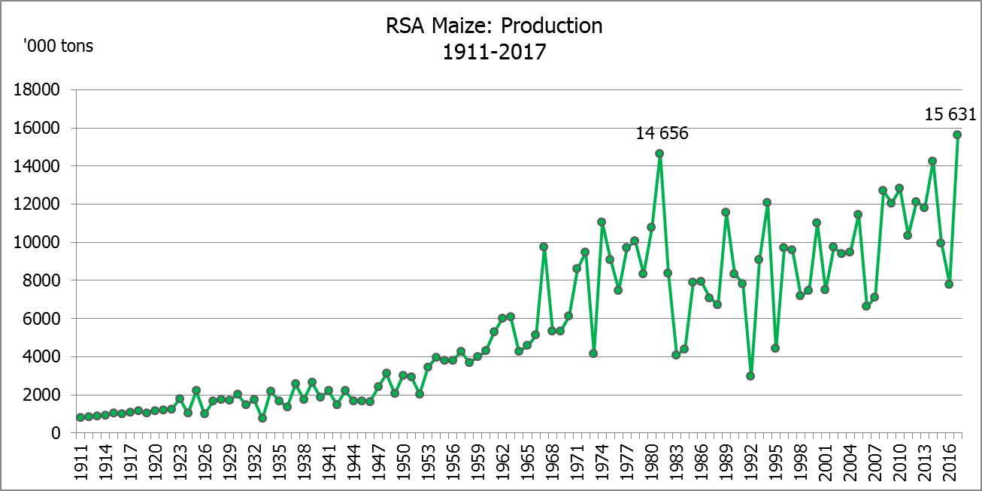

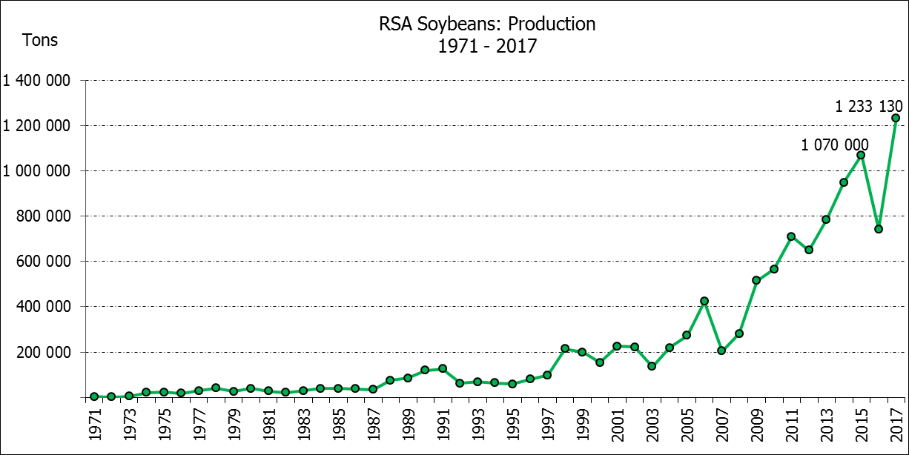

WHITE AND YELLOW MAIZE – AREA PLANTED AND FOURTH PRODUCTION FORECAST: 2017
WIT- EN GEELMIELIES – OPPERVLAKTE EN VIERDE PRODUKSIESKATTING: 2017

Provinsie/  Province | Area planted/  Oppervlakte beplant  2017 |  |  | 4th forecast/  4de skatting  2017 |  |  | Area planted/  Oppervlakte beplant  2016 |  |  | Final crop/  Finale oes  2016
Provinsie/  Province | White/  Wit  Ha | Yellow/  Geel  Ha | Total/  Totaal  Ha | White/  Wit  Tons | Yellow/  Geel  Tons | Total/  Totaal  Tons | White/  Wit  Ha | Yellow/  Geel  Ha | Total/  Totaal  Ha | White/  Wit  Tons | Yellow/  Geel  Tons | Total/  Totaal  Tons
Western Cape/Wes-Kaap | 200 | 2 000 | 2 200 | 2 000 | 20 000 | 22 000 | 500 | 4 000 | 4 500 | 5 000 | 40 000 | 45 000
Northern Cape/Noord-Kaap | 3 500 | 45 000 | 48 500 | 45 500 | 652 500 | 698 000 | 3 750 | 50 000 | 53 750 | 35 000 | 675 000 | 710 000
Free State/Vrystaat | 805 000 | 355 000 | 1 160 000 | 4 910 500 | 1 917 000 | 6 827 500 | 390 000 | 310 000 | 700 000 | 1 190 500 | 1 023 000 | 2 213 500
Eastern Cape/Oos-Kaap | 4 400 | 9 500 | 13 900 | 30 800 | 61 750 | 92 550 | 2 000 | 12 000 | 14 000 | 10 000 | 66 000 | 76 000
KwaZulu-Natal | 50 000 | 50 000 | 100 000 | 330 000 | 355 000 | 685 000 | 38 000 | 48 000 | 86 000 | 215 000 | 307 000 | 522 000
Mpumalanga | 160 000 | 330 000 | 490 000 | 1 040 000 | 2 112 000 | 3 152 000 | 160 000 | 330 000 | 490 000 | 752 000 | 1 567 000 | 2 319 000
Limpopo | 40 000 | 24 000 | 64 000 | 292 000 | 192 000 | 484 000 | 31 500 | 22 000 | 53 500 | 178 000 | 132 000 | 310 000
Gauteng | 60 000 | 60 000 | 120 000 | 372 000 | 348 000 | 720 000 | 49 000 | 56 000 | 105 000 | 207 000 | 235 000 | 442 000
North West/Noordwes | 520 000 | 110 000 | 630 000 | 2 444 000 | 506 000 | 2 950 000 | 340 000 | 100 000 | 440 000 | 816 000 | 325 000 | 1 141 000
Total/Totaal | 1 643 100 | 985 500 | 2 628 600 | 9 466 800 | 6 164 250 | 15 631 050 | 1 014 750 | 932 000 | 1 946 750 | 3 408 500 | 4 370 000 | 7 778 500

SUNFLOWER SEED – AREA PLANTED AND FOURTH PRODUCTION FORECAST: 2017
SONNEBLOMSAAD – OPPERVLAKTE EN VIERDE PRODUKSIESKATTING: 2017

Province/  Provinsie | Area planted/  Opp beplant  Ha | 4th forecast/  4de skatting  Tons | Area planted/  Opp beplant  Ha | Final crop/  Finale oes  Tons
Province/  Provinsie | 2017 | 2017 | 2016 | 2016
Western Cape/Wes-Kaap | - | - | - | -
Northern Cape/Noord-Kaap | 250 | 250 | 500 | 600
Free State/Vrystaat | 330 000 | 462 000 | 400 000 | 440 000
Eastern Cape/Oos-Kaap | - | - | - | -
KwaZulu-Natal | 300 | 300 | - | -
Mpumalanga | 2 200 | 2 420 | 4 000 | 4 400
Limpopo | 90 000 | 81 000 | 65 000 | 48 750
Gauteng | 3 000 | 3 000 | 4 000 | 4 000
North West/Noordwes | 210 000 | 304 500 | 245 000 | 257 250
Total/Totaal | 635 750 | 853 470 | 718 500 | 755 000

SOYBEANS – AREA PLANTED AND FOURTH PRODUCTION FORECAST: 2017
SOJABONE – OPPERVLAKTE EN VIERDE PRODUKSIESKATTING: 2017

Province/  Provinsie | Area planted/  Opp beplant  Ha | 4th forecast/  4de skatting  Tons | Area planted/  Opp beplant  Ha | Final crop/  Finale oes  Tons
Province/  Provinsie | 2017 | 2017 | 2016 | 2016
Western Cape/Wes-Kaap | 700 | 1 050 | 800 | 1 200
Northern Cape/Noord-Kaap | 3 000 | 10 500 | 4 000 | 13 600
Free State/Vrystaat | 240 000 | 480 000 | 174 000 | 148 000
Eastern Cape/Oos-Kaap | 1 850 | 2 775 | 1 500 | 2 100
KwaZulu-Natal | 30 500 | 86 925 | 28 000 | 66 000
Mpumalanga | 241 000 | 506 100 | 240 000 | 408 000
Limpopo | 8 500 | 28 900 | 16 000 | 38 400
Gauteng | 25 400 | 68 580 | 23 000 | 50 600
North West/Noordwes | 23 000 | 48 300 | 15 500 | 14 100
Total/Totaal | 573 950 | 1 233 130 | 502 800 | 742 000
GROUNDNUTS – AREA PLANTED AND FOURTH PRODUCTION FORECAST: 2017
GRONDBONE – OPPERVLAKTE EN VIERDE PRODUKSIESKATTING: 2017

Province/  Provinsie | Area planted/  Opp beplant  Ha | 4th forecast/  4de skatting  Tons | Area planted/  Opp beplant  Ha | Final crop/  Finale oes  Tons
Province/  Provinsie | 2017 | 2017 | 2016 | 2016
Western Cape/Wes-Kaap | - | - | - | -
Northern Cape/Noord-Kaap | 4 000 | 14 000 | 5 000 | 10 000
Free State/Vrystaat | 22 000 | 33 000 | 6 500 | 2 920
Eastern Cape/Oos-Kaap | - | - | - | -
KwaZulu-Natal | - | - | - | -
Mpumalanga | - | - | - | -
Limpopo | 3 000 | 4 500 | 1 600 | 1 440
Gauteng | - | - | - | -
North West/Noordwes | 27 000 | 35 100 | 9 500 | 3 320
Total/Totaal | 56 000 | 86 600 | 22 600 | 17 680

SORGHUM – AREA PLANTED AND FOURTH PRODUCTION FORECAST: 2017
SORGHUM – OPPERVLAKTE EN VIERDE PRODUKSIESKATTING: 2017

Province/  Provinsie | Area planted/  Opp beplant  Ha | 4th forecast/  4de skatting  Tons | Area planted/  Opp beplant  Ha | Final crop/  Finale oes  Tons
Province/  Provinsie | 2017 | 2017 | 2016 | 2016
Western Cape/Wes-Kaap | - | - | - | -
Northern Cape/Noord-Kaap | - | - | - | -
Free State/Vrystaat | 7 700 | 26 180 | 28 000 | 24 150
Eastern Cape/Oos-Kaap | - | - | - | -
KwaZulu-Natal | 400 | 1 600 | 500 | 1 650
Mpumalanga | 12 000 | 62 400 | 10 000 | 32 500
Limpopo | 18 000 | 50 400 | 7 000 | 9 800
Gauteng | 750 | 2 400 | - | -
North West/Noordwes | 3 500 | 10 500 | 3 000 | 2 400
Total/Totaal | 42 350 | 153 480 | 48 500 | 70 500

DRY BEANS – AREA PLANTED AND FOURTH PRODUCTION FORECAST: 2017
DROëBONE – OPPERVLAKTE EN VIERDE PRODUKSIESKATTING: 2017

Province/  Provinsie | Area planted/  Opp beplant  Ha | 4th forecast/  4de skatting  Tons | Area planted/  Opp beplant  Ha | Final crop/  Finale oes  Tons
Province/  Provinsie | 2017 | 2017 | 2016 | 2016
Western Cape/Wes-Kaap | 100 | 150 | 100 | 150
Northern Cape/Noord-Kaap | 650 | 1 300 | 350 | 630
Free State/Vrystaat | 20 000 | 32 000 | 17 000 | 17 000
Eastern Cape/Oos-Kaap | 300 | 450 | 250 | 375
KwaZulu-Natal | 4 500 | 5 400 | 2 200 | 2 640
Mpumalanga | 5 500 | 8 250 | 6 000 | 6 000
Limpopo | 7 000 | 13 300 | 3 000 | 3 750
Gauteng | 1 500 | 2 100 | 2 500 | 2 500
North West/Noordwes | 5 500 | 5 500 | 3 000 | 2 400
Total/Totaal | 45 050 | 68 450 | 34 400 | 35 445

CONFIDENTIALITY ISSUES that CEC members are committed to adhere to on the day of the meeting
- Personal items such as laptops, handbags, cell phones, etc. are not allowed in the venue during the meeting
- No member is allowed to leave the meeting before 12:00 in order to prevent disclosure of the information
- The embargo time for the release of crop estimates information is 15:30
- No member is allowed to discuss crop estimates information with anyone other than a member of the Committee before the embargo time
- Only the Chairperson, or a member appointed by the Chairperson, may release the figures to the media
- Members must regard the detail of any information that was collected for and/or discussed during the meeting, as confidential
- Individual information received for crop estimate purposes is treated strictly confidential, and is not divulged for any other purposes

AREA ESTIMATE AND FOURTH PRODUCTION FORECAST OF SUMMER CROPS (2017 PRODUCTION SEASON)/
OPPERVLAKTE- EN VIERDE PRODUKSIESKATTING VIR SOMERGEWASSE (2017 PRODUKSIE-SEISOEN)
26 MAY 2017

Summer field crops – 2017  Commercial maize: The size of the expected commercial maize crop has been set at 15,631 mill. tons, which is 7,54% or 1,095 mill. tons more than the previous forecast of 14,536 mill. tons. It is the largest maize crop produced in the history of SA. The area estimate for maize is 2,629 mill. ha, while the expected yield is 5,95 t/ha – also the highest yield ever.  The estimated maize crop is 101% bigger than the 2016 crop, which was the smallest crop since 2007. The three main maize producing areas, namely the Free State, Mpumalanga and North West provinces are expected to produce 83% of the 2017 crop.  The area estimate for white maize is 1,643 mill. ha and for yellow maize the area estimate is 985 500 ha.  The production forecast of white maize is 9,467 mill. tons, which is 9,84% or 848 400 tons more than the 8,618 mill. tons of the previous forecast. The yield for white maize is 5,76 t/ha. In the case of yellow maize the production forecast is 6,164 mill. tons, which is 4,17% or 246 950 tons more than the 5,917 mill. tons of the previous forecast. The yield for yellow maize is 6,25 t/ha.  The yield per ha for the Free State and North West provinces was based on scientific and objective results provided by the National Crop Statistics Consortium (NCSC), which is led by the ARC.  Sunflower seed: The production forecast for sunflower seed remained unchanged at 853 470 tons. The area estimate for sunflower seed is 635 750 ha, while the expected yield is 1,34 t/ha.  Other crops: The production forecast for soybeans also remained unchanged at 1,233 mill. tons. The estimated area planted to soybeans is 573 950 ha and the expected yield is 2,15 t/ha.  The expected groundnut crop remained unchanged at 86 600 tons. The area estimate is 56 000 ha and the expected yield is 1,55 t/ha.  The production forecast for sorghum also remained unchanged at 153 480 tons, whilst the area estimate for sorghum is 42 350 ha. The expected yield is 3,62 t/ha.  In the case of dry beans, the production forecast is 68 450 tons, which is 1,94% or 1 300 tons more than the 67 150 tons of the previous forecast. The area estimate of dry beans is 45 050 ha, with an expected yield of 1,52 t/ha.  Please note that the fifth production forecast for summer field crops for 2017 will be released on 28 June 2017. |  | Somergewasse – 2017  Kommersiële mielies: Die grootte van die verwagte kommersiële mielie-oes is op 15,631 milj. ton gestel, wat 7,54% of 1,095 milj. ton meer is as die vorige skatting van 14,536 milj. ton. Dit is die grootste mielie-oes nog geproduseer in die geskiedenis van SA. Die skatting van die oppervlakte onder mielies is 2,629 milj. ha, terwyl die verwagte opbrengs 5,95 t/ha is – ook die hoogste opbrengs ooit.  Die geskatte mielie-oes is 101% groter as die 2016-oes, wat die kleinste oes was sedert 2007. Die drie belangrikste mielieproduserende gebiede, nl. die Vrystaat, Mpumalanga en Noordwes provinsies, gaan na verwagting 83% van die 2017-oes produseer.  Die oppervlak onder witmielies is 1,643 milj. ha en vir geelmielies is die oppervlak 985 500 ha.  Die produksieskatting van witmielies is 9,467 miljoen ton, wat 9,84% of 848 400 ton meer is as die 8,618 milj. ton van die vorige skatting. Die opbrengs van witmielies is 5,76 t/ha. In die geval van geelmielies is die produksieskatting 6,164 milj. ton, wat 4,17% of 246 950 ton meer is as die 5,917 milj. ton van die vorige skatting. Die opbrengs van geelmielies is 6,25 t/ha.  Die opbrengs-bepaling per ha vir die Vrystaat en Noordwes provinsies is gebaseer op wetenskaplike en objektiewe resultate verstrek deur die Nasionale Oesskattingskonsortium, gelei deur die LNR.  Sonneblomsaad: Die produksieskatting vir sonneblomsaad is onveranderd gelaat op 853 470 ton. Die oppervlakteskatting vir sonneblomsaad is 635 750 ha, terwyl die verwagte opbrengs 1,34 t/ha is.  Ander gewasse: Die produksieskatting van sojabone is ook onveranderd gelaat op 1,233 milj. ton. Die geskatte oppervlakte beplant met sojabone is 573 950 ha en die verwagte opbrengs is 2,15 t/ha.  Die verwagte grondbone-oes is onveranderd gelaat op 86 600 ton. Die oppervlakteskatting is 56 000 ha, terwyl die verwagte opbrengs 1,55 t/ha is.  Die produksieskatting van sorghum is ook onveranderd gelaat op 153 480 ton, terwyl die oppervlakteskatting vir sorghum 42 350 ha is. Die verwagte opbrengs is 3,62 t/ha.  In die geval van droëbone is die produksieskatting 68 450 ton, wat 1,94% of 1 300 ton meer is as die 67 150 ton van die vorige skatting. Die oppervlakte beplant met droëbone is 45 050 ha, en die verwagte opbrengs is 1,52 t/ha.  Neem asseblief kennis dat die vyfde produksieskatting vir somergewasse vir 2017, op 28 Junie 2017 vrygestel sal word.

The non-commercial agricultural sectors’ production estimate for maize for 2017 is hereby released. /
Hiermee word die nie-kommersiële landbou-sektor se produksieskatting vir mielies vir 2017 vrygestel.

NON-COMMERCIAL MAIZE – AREA PLANTED AND PRODUCTION ESTIMATE: 2017
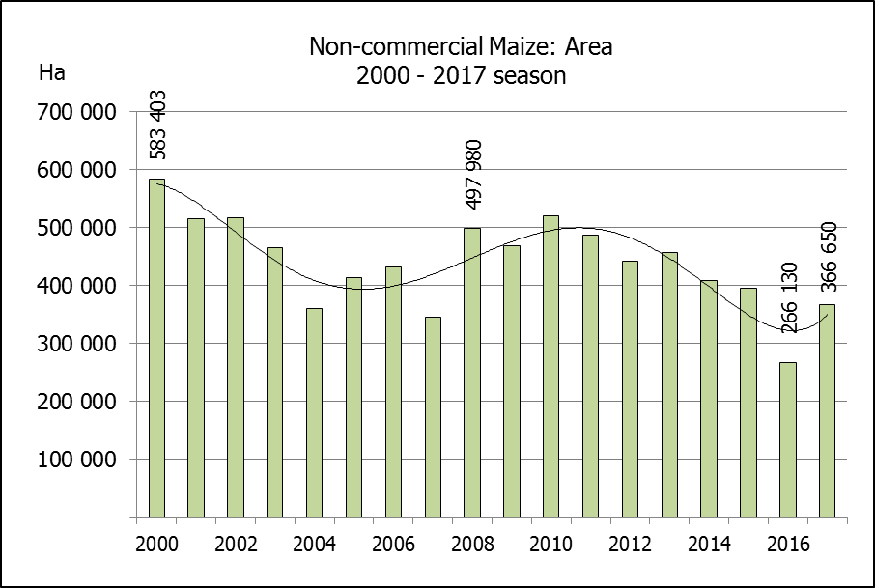
NIE-KOMMERSIëLE MIELIES – OPPERVLAKTE- EN PRODUKSIESKATTING: 2017
CROP/GEWAS | Area planted/  Opp beplant  2017 | Production/  Produksie  2017 | Area planted/  Opp beplant  2016 | Final crop/  Finale oes  2016 | Change/  Verandering
CROP/GEWAS | Ha | Tons | Ha | Tons | %
CROP/GEWAS | (A) | (B) | (C) | (D) | (B) ÷ (D)
Non-commercial agriculture/Nie-kommersiële landbou:
White maize/Witmielies | 248 500 | 463 600 | 191 225 | 286 175 | +62,00
Yellow maize/Geelmielies | 118 150 | 267 400 | 74 905 | 149 565 | +78,79
Maize/Mielies | 366 650 | 731 000 | 266 130 | 435 740 | +67,76
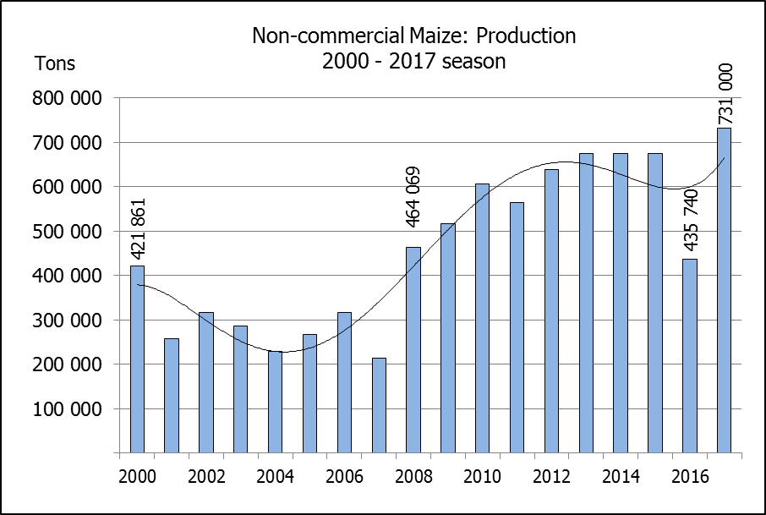
The area planted to maize in the non-commercial agricultural sector is estimated at 366 650 ha, which represents an increase of 37,77%, compared to the 266 130 ha of the previous season. The expected maize crop for this sector is 731 000 tons, which is 67,76% more than the 435 740 tons of last season. It is important to note that about 64% of the maize produced in the non-commercial sector, is planted in the Eastern Cape.
Die oppervlakte beplant met mielies in die nie-kommersiële landbou-sektor word geskat op 366 650 ha, wat ‘n toename van 37,77 % verteenwoordig in vergelyking met die 266 130 ha van die vorige seisoen. Die verwagte mielie-oes van dié sektor is 731 000 ton, wat 67,76% meer is as die 435 740 ton van die vorige seisoen. Dit is belangrik om daarop te let dat ongeveer 64% van die mielies wat geproduseer word in die nie-kommersiële sektor, in die Oos-Kaap geplant word.

