 | crop estimates committee | 
 | oesskattingskomitee
From/Van: M. Ellen Matsei
Tel: 012 319 8454  Fax/Faks: 012 319 8031  E-mail/E-pos: DAS@daff.gov.za
Web page/Webblad: www.daff.gov.za/statistics and economic reports or www.sagis.org.za/CEC: Crop Estimates
EMBARGO: 15:30

The area planted estimate and second production forecast for summer crops for 2017 is hereby released.
Hiermee word die oppervlakte- en tweede produksieskatting vir somergewasse vir 2017 vrygestel.

SUMMER CROPS – AREA PLANTED AND SECOND PRODUCTION FORECAST: 2017
SOMERGEWASSE – OPPERVLAKTE- EN TWEEDE PRODUKSIESKATTING: 2017
CROP/GEWAS  The Crop Estimates Committee comprises officials of the following institutions:  Department of Agriculture, Forestry and Fisheries; Provincial Departments of Agriculture; various ARC-Institutes (Soil, Climate and Water; Small Grains Institute;  and Grain Crops Institute); and Statistics SA. | Area planted/  Opp beplant  2017 | 2nd forecast/  2de skatting  2017 | 1st forecast/  1ste skatting  2017 | Area planted/  Opp beplant  2016 | Final crop/  Finale oes  2016 | Change/  Verandering
 | Ha | Tons | Tons | Ha | Tons | %
 | (A) | (B) | (C) | (D) | (E) | (B) ÷ (C)
Commercial/Kommersieel:
White maize/Witmielies | 1 643 100 | 8 513 200 | 8 312 950 | 1 014 750 | 3 408 500 | +2,41
Yellow maize/Geelmielies | 985 500 | 5 810 300 | 5 605 500 | 932 000 | 4 370 000 | +3,65
Total Maize/Totale Mielies | 2 628 600 | 14 323 500 | 13 918 450 | 1 946 750 | 7 778 500 | +2,91
Sunflower seed/Sonneblomsaad | 635 750 | 896 060 | 928 620 | 718 500 | 755 000 | -3,51
Soybeans/Sojabone | 573 950 | 1 162 425 | 1 070 495 | 502 800 | 742 000 | +8,59
Groundnuts/Grondbone | 56 000 | 86 600 | 88 175 | 22 600 | 17 680 | -1,79
Sorghum | 42 350 | 153 480 | 140 950 | 48 500 | 70 500 | +8,89
Dry beans/Droëbone | 45 050 | 65 275 | 64 345 | 34 400 | 35 445 | +1,45
TOTAL/TOTAAL | 3 981 700 | 16 687 340 | 16 211 035 | 3 273 550 | 9 399 125 | +2,94
Note: Estimate is for calendar year, e.g. production season 2016/17 = 2017
Nota: Skatting is vir kalenderjaar, bv. produksie-seisoen 2016/17 = 2017

28 March 2017 / 28 Maart 2017
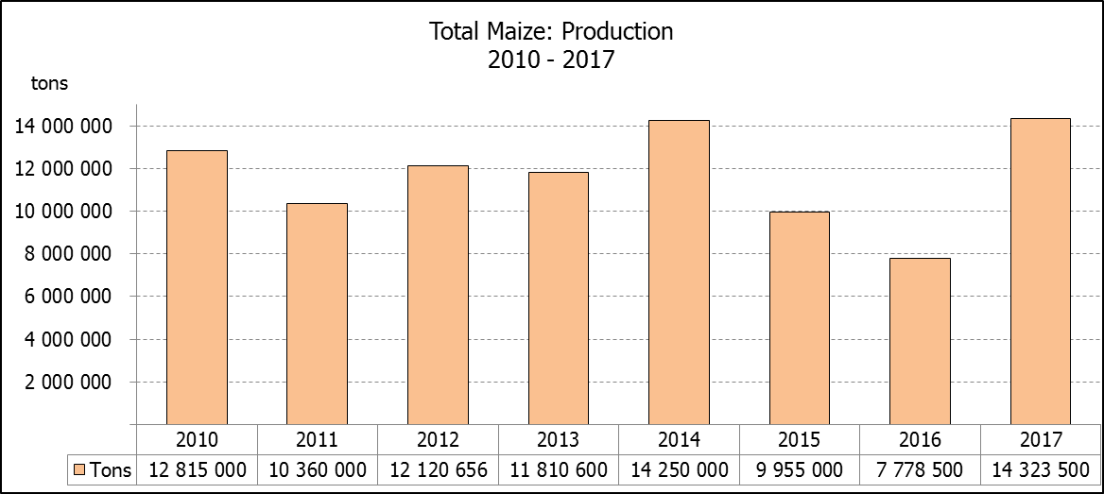

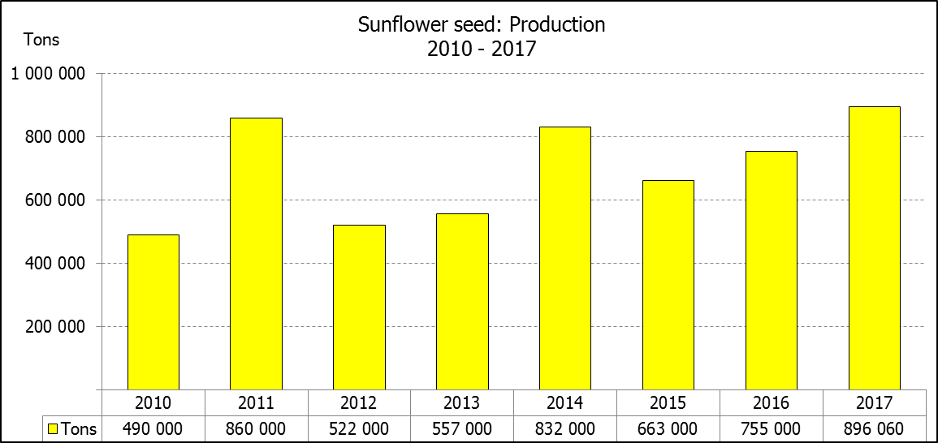

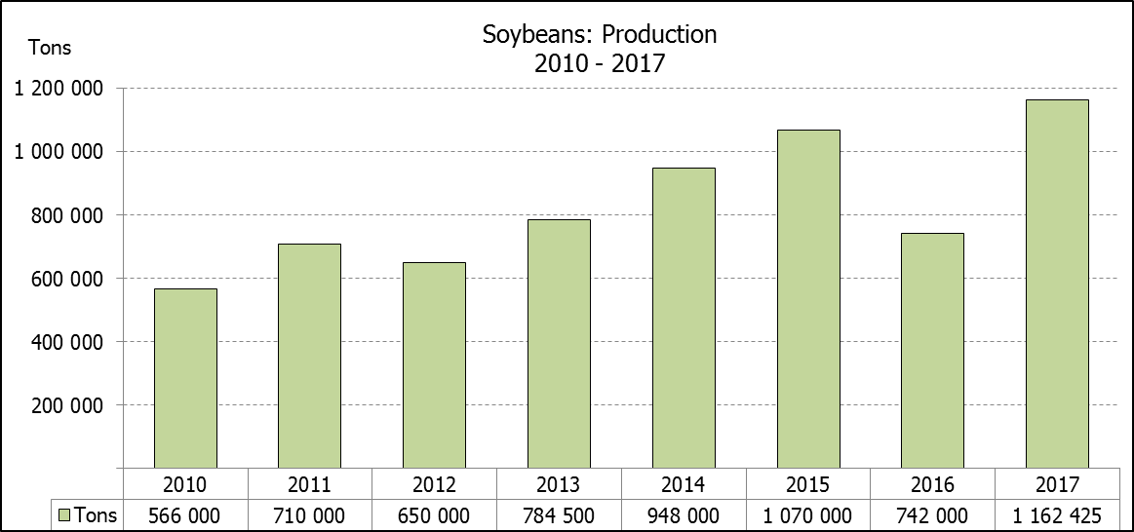

WHITE AND YELLOW MAIZE – AREA PLANTED AND SECOND PRODUCTION FORECAST: 2017
WIT- EN GEELMIELIES – OPPERVLAKTE EN TWEEDE PRODUKSIESKATTING: 2017

Provinsie/  Province | Area planted/  Oppervlakte beplant  2017 |  |  | 2nd forecast/  2de skatting  2017 |  |  | Area planted/  Oppervlakte beplant  2016 |  |  | Final crop/  Finale oes  2016
Provinsie/  Province | White/  Wit  Ha | Yellow/  Geel  Ha | Total/  Totaal  Ha | White/  Wit  Tons | Yellow/  Geel  Tons | Total/  Totaal  Tons | White/  Wit  Ha | Yellow/  Geel  Ha | Total/  Totaal  Ha | White/  Wit  Tons | Yellow/  Geel  Tons | Total/  Totaal  Tons
Western Cape/Wes-Kaap | 200 | 2 000 | 2 200 | 1 800 | 18 000 | 19 800 | 500 | 4 000 | 4 500 | 5 000 | 40 000 | 45 000
Northern Cape/Noord-Kaap | 3 500 | 45 000 | 48 500 | 43 750 | 643 500 | 687 250 | 3 750 | 50 000 | 53 750 | 35 000 | 675 000 | 710 000
Free State/Vrystaat | 805 000 | 355 000 | 1 160 000 | 4 226 250 | 1 775 000 | 6 001 250 | 390 000 | 310 000 | 700 000 | 1 190 500 | 1 023 000 | 2 213 500
Eastern Cape/Oos-Kaap | 4 400 | 9 500 | 13 900 | 26 400 | 57 000 | 83 400 | 2 000 | 12 000 | 14 000 | 10 000 | 66 000 | 76 000
KwaZulu-Natal | 50 000 | 50 000 | 100 000 | 315 000 | 330 000 | 645 000 | 38 000 | 48 000 | 86 000 | 215 000 | 307 000 | 522 000
Mpumalanga | 160 000 | 330 000 | 490 000 | 960 000 | 2 046 000 | 3 006 000 | 160 000 | 330 000 | 490 000 | 752 000 | 1 567 000 | 2 319 000
Limpopo | 40 000 | 24 000 | 64 000 | 240 000 | 148 800 | 388 800 | 31 500 | 22 000 | 53 500 | 178 000 | 132 000 | 310 000
Gauteng | 60 000 | 60 000 | 120 000 | 360 000 | 330 000 | 690 000 | 49 000 | 56 000 | 105 000 | 207 000 | 235 000 | 442 000
North West/Noordwes | 520 000 | 110 000 | 630 000 | 2 340 000 | 462 000 | 2 802 000 | 340 000 | 100 000 | 440 000 | 816 000 | 325 000 | 1 141 000
Total/Totaal | 1 643 100 | 985 500 | 2 628 600 | 8 513 200 | 5 810 300 | 14 323 500 | 1 014 750 | 932 000 | 1 946 750 | 3 408 500 | 4 370 000 | 7 778 500

SUNFLOWER SEED – AREA PLANTED AND SECOND PRODUCTION FORECAST: 2017
SONNEBLOMSAAD – OPPERVLAKTE EN TWEEDE PRODUKSIESKATTING: 2017

Province/  Provinsie | Area planted/  Opp beplant  Ha | 2nd forecast/  2de skatting  Tons | Area planted/  Opp beplant  Ha | Final crop/  Finale oes  Tons
Province/  Provinsie | 2017 | 2017 | 2016 | 2016
Western Cape/Wes-Kaap | - | - | - | -
Northern Cape/Noord-Kaap | 250 | 250 | 500 | 600
Free State/Vrystaat | 330 000 | 495 000 | 400 000 | 440 000
Eastern Cape/Oos-Kaap | - | - | - | -
KwaZulu-Natal | 300 | 300 | - | -
Mpumalanga | 2 200 | 2 860 | 4 000 | 4 400
Limpopo | 90 000 | 90 000 | 65 000 | 48 750
Gauteng | 3 000 | 3 150 | 4 000 | 4 000
North West/Noordwes | 210 000 | 304 500 | 245 000 | 257 250
Total/Totaal | 635 750 | 896 060 | 718 500 | 755 000

SOYBEANS – AREA PLANTED AND SECOND PRODUCTION FORECAST: 2017
SOJABONE – OPPERVLAKTE EN TWEEDE PRODUKSIESKATTING: 2017

Province/  Provinsie | Area planted/  Opp beplant  Ha | 2nd forecast/  2de skatting  Tons | Area planted/  Opp beplant  Ha | Final crop/  Finale oes  Tons
Province/  Provinsie | 2017 | 2017 | 2016 | 2016
Western Cape/Wes-Kaap | 700 | 1 050 | 800 | 1 200
Northern Cape/Noord-Kaap | 3 000 | 10 500 | 4 000 | 13 600
Free State/Vrystaat | 240 000 | 444 000 | 174 000 | 148 000
Eastern Cape/Oos-Kaap | 1 850 | 2 775 | 1 500 | 2 100
KwaZulu-Natal | 30 500 | 85 400 | 28 000 | 66 000
Mpumalanga | 241 000 | 482 000 | 240 000 | 408 000
Limpopo | 8 500 | 27 200 | 16 000 | 38 400
Gauteng | 25 400 | 63 500 | 23 000 | 50 600
North West/Noordwes | 23 000 | 46 000 | 15 500 | 14 100
Total/Totaal | 573 950 | 1 162 425 | 502 800 | 742 000
GROUNDNUTS – AREA PLANTED AND SECOND PRODUCTION FORECAST: 2017
GRONDBONE – OPPERVLAKTE EN TWEEDE PRODUKSIESKATTING: 2017

Province/  Provinsie | Area planted/  Opp beplant  Ha | 2nd forecast/  2de skatting  Tons | Area planted/  Opp beplant  Ha | Final crop/  Finale oes  Tons
Province/  Provinsie | 2017 | 2017 | 2016 | 2016
Western Cape/Wes-Kaap | - | - | - | -
Northern Cape/Noord-Kaap | 4 000 | 14 000 | 5 000 | 10 000
Free State/Vrystaat | 22 000 | 33 000 | 6 500 | 2 920
Eastern Cape/Oos-Kaap | - | - | - | -
KwaZulu-Natal | - | - | - | -
Mpumalanga | - | - | - | -
Limpopo | 3 000 | 4 500 | 1 600 | 1 440
Gauteng | - | - | - | -
North West/Noordwes | 27 000 | 35 100 | 9 500 | 3 320
Total/Totaal | 56 000 | 86 600 | 22 600 | 17 680

SORGHUM – AREA PLANTED AND SECOND PRODUCTION FORECAST: 2017
SORGHUM – OPPERVLAKTE EN TWEEDE PRODUKSIESKATTING: 2017

Province/  Provinsie | Area planted/  Opp beplant  Ha | 2nd forecast/  2de skatting  Tons | Area planted/  Opp beplant  Ha | Final crop/  Finale oes  Tons
Province/  Provinsie | 2017 | 2017 | 2016 | 2016
Western Cape/Wes-Kaap | - | - | - | -
Northern Cape/Noord-Kaap | - | - | - | -
Free State/Vrystaat | 7 700 | 26 180 | 28 000 | 24 150
Eastern Cape/Oos-Kaap | - | - | - | -
KwaZulu-Natal | 400 | 1 600 | 500 | 1 650
Mpumalanga | 12 000 | 62 400 | 10 000 | 32 500
Limpopo | 18 000 | 50 400 | 7 000 | 9 800
Gauteng | 750 | 2 400 | - | -
North West/Noordwes | 3 500 | 10 500 | 3 000 | 2 400
Total/Totaal | 42 350 | 153 480 | 48 500 | 70 500

DRY BEANS – AREA PLANTED AND SECOND PRODUCTION FORECAST: 2017
DROëBONE – OPPERVLAKTE EN TWEEDE PRODUKSIESKATTING: 2017

Province/  Provinsie | Area planted/  Opp beplant  Ha | 2nd forecast/  2de skatting  Tons | Area planted/  Opp beplant  Ha | Final crop/  Finale oes  Tons
Province/  Provinsie | 2017 | 2017 | 2016 | 2016
Western Cape/Wes-Kaap | 100 | 150 | 100 | 150
Northern Cape/Noord-Kaap | 650 | 1 300 | 350 | 630
Free State/Vrystaat | 20 000 | 28 000 | 17 000 | 17 000
Eastern Cape/Oos-Kaap | 300 | 450 | 250 | 375
KwaZulu-Natal | 4 500 | 5 400 | 2 200 | 2 640
Mpumalanga | 5 500 | 7 425 | 6 000 | 6 000
Limpopo | 7 000 | 14 000 | 3 000 | 3 750
Gauteng | 1 500 | 1 950 | 2 500 | 2 500
North West/Noordwes | 5 500 | 6 600 | 3 000 | 2 400
Total/Totaal | 45 050 | 65 275 | 34 400 | 35 445

CONFIDENTIALITY ISSUES that CEC members are committed to adhere to on the day of the meeting
- Personal items such as laptops, handbags, cell phones, etc. are not allowed in the venue during the meeting
- No member is allowed to leave the meeting before 12:00 in order to prevent disclosure of the information
- The embargo time for the release of crop estimates information is 15:30
- No member is allowed to discuss crop estimates information with anyone other than a member of the Committee before the embargo time
- Only the Chairperson, or a member appointed by the Chairperson, may release the figures to the media
- Members must regard the detail of any information that was collected for and/or discussed during the meeting, as confidential
- Individual information received for crop estimate purposes is treated strictly confidential, and is not divulged for any other purposes

AREA ESTIMATE AND SECOND PRODUCTION FORECAST OF SUMMER CROPS (2017 PRODUCTION SEASON)/
OPPERVLAKTE- EN TWEEDE PRODUKSIESKATTING VIR SOMERGEWASSE (2017 PRODUKSIE-SEISOEN)
28 MARCH 2017 / 28 MARCH 2017

Summer field crops – 2017  Commercial maize: The size of the expected commercial maize crop has been set at 14,324 mill. tons, which is 2,91% or 405 050 tons more than the previous forecast of 13,918 mill. tons. The area estimate for maize remained unchanged at 2,629 mill. ha, while the expected yield is 5,45 t/ha.  The estimated maize crop is 84% bigger than the 2016 crop, which was the smallest crop since 2007. The three main maize producing areas, namely the Free State, Mpumalanga and North West provinces are expected to produce 82% of the 2017 crop.  The area estimate for white maize is 1,643 mill. ha and for yellow maize the area estimate is 985 500 ha.  The production forecast of white maize is 8,513 mill. tons, which is 2,41% or 200 250 tons more than the 8,313 mill. tons of the previous forecast. The yield for white maize is 5,18 t/ha. In the case of yellow maize the production forecast is 5,810 mill. tons, which is 3,65% or 204 800 tons more than the 5,605 mill. tons of the previous forecast. The yield for yellow maize is 5,90 t/ha.  Please note that information from the objective yield survey by the NCSC for the Mpumalanga province will be available in April 2017; and for the Free State and North West provinces in May 2017. The current yield figures are mainly obtained from producers in the different provinces, as well as from the IDSS-model (Inter Decision Support System), maintained by the ARC-Institute for Grain Crops Institute.  Sunflower seed: The production forecast for sunflower seed is 896 060 tons, which is 3,51% or 32 560 tons less than the 928 620 tons of the previous forecast. The area estimate for sunflower seed is 635 750 ha, while the expected yield is 1,41 t/ha.  Other crops: The production forecast for soybeans is 1,162 mill. tons, which is 8,59% or 91 930 tons more than the 1,070 mill. tons of the previous forecast. The estimated area planted to soybeans was increased by 8 100 ha to 573 950 ha and the expected yield is 2,03 t/ha.  The expected groundnut crop is 86 600 tons, which is 1,79% or 1 575 tons less than the 88 175 tons of the last forecast. For groundnuts, the area estimate was increased by 3 500 ha to 56 000 ha, with an expected yield of 1,55 t/ha.  The production forecast for sorghum is 153 480 tons, which is 8,89% or 12 530 tons more than the 140 950 tons of the previous forecast. The area estimate for sorghum is 42 350 ha and the expected yield is 3,62 t/ha.  In the case of dry beans, the production forecast is 65 275 tons, which is 1,45% or 930 tons more than the 64 345 tons of the previous forecast. The area estimate of dry beans was decreased by 500 ha to 45 050 ha, with an expected yield of 1,45 t/ha.  Please note that the third production forecast for summer field crops for 2017 will be released on 25 April 2017. |  | Somergewasse – 2017  Kommersiële mielies: Die grootte van die verwagte kommersiële mielie-oes is op 14,324 milj. ton gestel, wat 2,91% of 405 050 ton meer is as die vorige skatting van 13,918 milj. ton. Die skatting van die oppervlakte onder mielies is onveranderd gelaat op 2,629 milj. ha, terwyl die verwagte opbrengs 5,45 t/ha is.  Die geskatte mielie-oes is 84% groter as die 2016-oes, wat die kleinste oes was sedert 2007. Die drie belangrikste mielieproduserende gebiede, nl. die Vrystaat, Mpumalanga en Noordwes provinsies, gaan na verwagting 82% van die 2017-oes produseer.  Die oppervlak onder witmielies is 1,643 milj. ha en vir geelmielies is die oppervlak 985 500 ha.  Die produksieskatting van witmielies is 8,513 miljoen ton, 2,41% of 200 250 ton meer is as die 8,313 milj. ton van die vorige skatting. Die opbrengs van witmielies is 5,18 t/ha. In die geval van geelmielies is die produksieskatting 5,810 miljoen ton, wat 3,65% of 204 800 ton meer is as die 5,605 milj. ton van die vorige skatting. Die opbrengs van geelmielies is 5,90 t/ha.  Neem kennis dat inligting van die objektiewe opbrengs-opname van die Konsortium vir die Mpumalanga provinsie, in April 2017 gerapporteer word en vir die Vrystaat en Noordwes provinsies in Mei 2017. Die huidige opbrengs syfers is hoofsaaklik verkry vanaf produsente in die verskillende provinsies, asook vanaf die IDSS-model (“Inter Decision Support System”), soos saamgestel deur die LNR-Instituut vir Graangewasse.  Sonneblomsaad: Die produksieskatting vir sonneblomsaad is 896 060 ton, wat 3,51% of 32 560 ton minder is as die 928 620 ton van die vorige skatting. Die oppervlakteskatting vir sonneblomsaad is 635 750 ha, terwyl die verwagte opbrengs 1,41 t/ha is.  Ander gewasse: Die produksieskatting van sojabone is 1,162 milj. ton, wat 8,59% of 91 930 ton meer is as die 1,070 milj. ton van die vorige skatting. Die geskatte oppervlakte beplant met sojabone is verhoog met 8 100 ha na 573 950 ha en die verwagte opbrengs is 2,03 t/ha.  Die verwagte grondbone-oes is 86 600 ton, wat 1,79% of 1 575 ton minder is as die 88 175 ton van die vorige skatting. Vir grondbone is die oppervlakteskatting verhoog met 3 500 ha na 56 000 ha, terwyl the verwagte opbrengs 1,55 t/ha is.  Die produksieskatting van sorghum is 153 480 ton, wat 8,89% of 12 530 ton meer is as die 140 950 ton van die vorige skatting. Die oppervlakteskatting vir sorghum is 42 350 ha, en die verwagte opbrengs is 3,62 t/ha.  In die geval van droëbone is die produksieskatting 65 275 ton, wat 1,45% of 930 ton meer is as die 64 345 ton van die vorige skatting. Die oppervlakte beplant met droëbone is verminder met 500 ha na 45 050 ha, en die verwagte opbrengs is 1,45 t/ha.  Neem asseblief kennis dat die derde produksieskatting vir somergewasse vir 2017, op 25 April 2017 vrygestel sal word.

