 | crop estimates committee
 | oesskattingskomitee
From/Van: Mr Baldwin Netshifhefhe  Tel: 012 319 8043/32  Fax/Faks: 012 319 8031  E-mail/E-pos: BaldwinN@dalrrd.gov.za  Web page/Webblad: www.dalrrd.gov.za/statistics and economic reports or  www.sagis.org.za/CEC: Crop Estimates EMBARGO: 14:30 |  |  | 

The area planted estimate and second production forecast for summer crops for 2023 is hereby released.
Hiermee word die oppervlakte- en tweede produksieskatting vir somergewasse vir 2023 vrygestel.

SUMMER CROPS – AREA PLANTED AND SECOND PRODUCTION FORECAST: 2023
SOMERGEWASSE – OPPERVLAKTE- EN TWEEDE PRODUKSIESKATTING: 2023
CROP/GEWAS | Area planted/  Opp beplant  2023 | 2nd forecast/  2de skatting  2023 | 1st forecast/  1ste skatting  2023 | Area planted/  Opp beplant  2022 | Final crop/  Finale oes  2022 | Change/  Verandering/
CROP/GEWAS | Ha | Tons | Tons | Ha | Tons | %
CROP/GEWAS | (A) | (B) | (C) | (D) | (E) | (B) ÷ (C)
Commercial/Kommersieël:
White maize/Witmielies | 1 521 300 | 8 344 375 | 8 187 150 | 1 575 000 | 7 850 000 | +1,92
Yellow maize/Geelmielies | 1 064 800 | 7 535 150 | 7 427 900 | 1 048 000 | 7 620 000 | +1,44
Total Maize/Totale Mielies | 2 586 100 | 15 879 525 | 15 615 050 | 2 623 000 | 15 470 000 | +1,69
Sunflower seed/Sonneblomsaad | 555 700 | 797 610 | 775 260 | 670 700 | 845 550 | +2,88
Soybeans/Sojabone | 1 148 300 | 2 710 150 | 2 651 680 | 925 300 | 2 230 000 | +2,21
Groundnuts/Grondbone | 31 300 | 49 080 | 51 155 | 43 400 | 48 500 | -4,06
Sorghum | 34 000 | 109 400 | 112 330 | 37 200 | 103 140 | -2,61
Dry beans/Droëbone | 36 650 | 47 930 | 49 755 | 42 900 | 52 590 | -3,67
TOTAL/TOTAAL | 4 392 050 | 19 593 695 | 19 255 230 | 4 342 500 | 18 749 780 | +1,76
Note: Estimate is for calendar year, e.g. production season 2022/23 = 2023
Nota: Skatting is vir kalenderjaar, bv. produksie-seisoen 2022/23 = 2023
The Crop Estimates Committee comprises officials of the following institutions:
Department of Agriculture, Land Reform and Rural Development; Provincial Departments of Agriculture; various ARC-Institutes (Soil, Climate and Water; Small Grains Institute; and
Grain Crops Institute); BFAP and Statistics SA.

28 March / Maart 2023
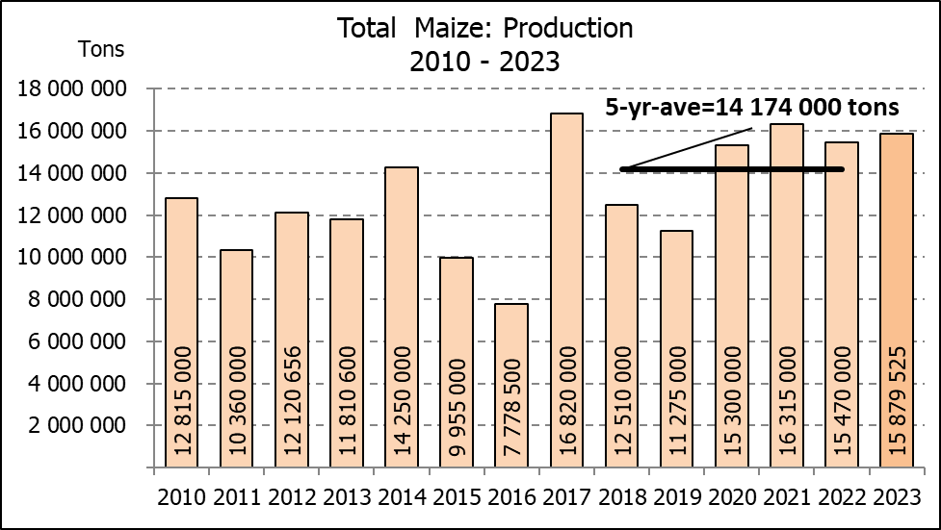
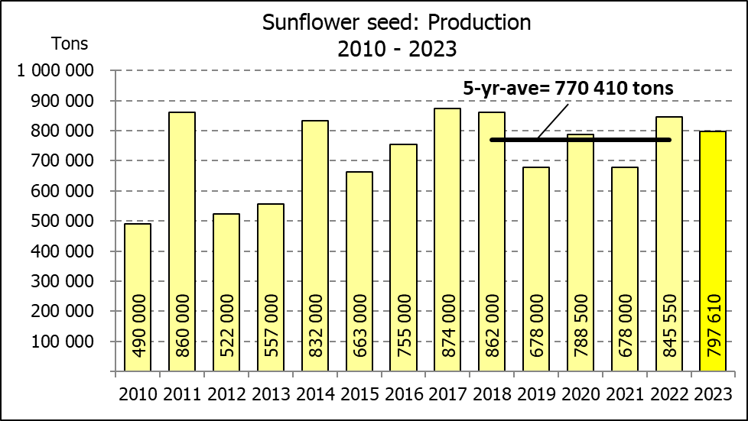

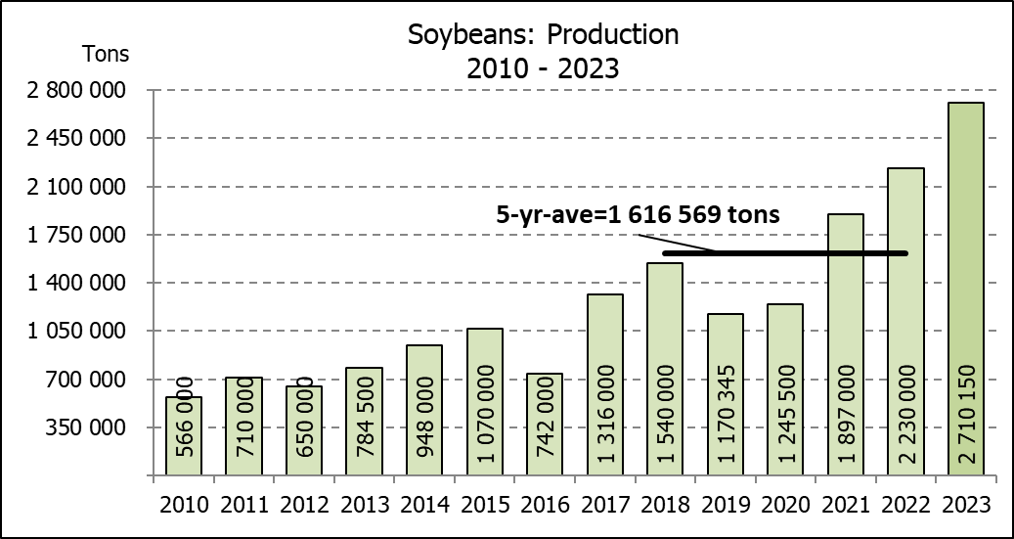

WHITE AND YELLOW MAIZE – AREA PLANTED AND SECOND PRODUCTION FORECAST: 2023
WIT- EN GEELMIELIES – OPPERVLAKTE EN TWEEDE PRODUKSIESKATTING: 2023

Provinsie/  Province | Area planted/  Oppervlakte beplant  2023 |  |  | 2nd forecast/  2de skatting  2023 |  |  | Area planted/  Oppervlakte beplant  2022 |  |  | Final crop/  Finale oes  2022
Provinsie/  Province | White/  Wit  Ha | Yellow/  Geel  Ha | Total/  Totaal  Ha | White/  Wit  Tons | Yellow/  Geel  Tons | Total/  Totaal  Tons | White/  Wit  Ha | Yellow/  Geel  Ha | Total/  Totaal  Ha | White/  Wit  Tons | Yellow/  Geel  Tons | Total/  Totaal  Tons
Western Cape/Wes-Kaap | 250 | 3 500 | 3 750 | 2 375 | 32 900 | 35 275 | 500 | 3 500 | 4 000 | 4 750 | 32 900 | 37 650
Northern Cape/Noord-Kaap | 1 000 | 43 500 | 44 500 | 12 000 | 652 500 | 664 500 | 3 000 | 42 000 | 45 000 | 36 000 | 672 000 | 708 000
Free State/Vrystaat | 780 000 | 401 000 | 1 181 000 | 4 407 000 | 2 586 450 | 6 993 450 | 826 500 | 398 000 | 1 224 500 | 3 801 900 | 2 547 800 | 6 349 700
Eastern Cape/Oos-Kaap | 5 750 | 25 000 | 30 750 | 39 100 | 187 500 | 226 600 | 6 000 | 20 500 | 26 500 | 40 800 | 157 900 | 198 700
KwaZulu-Natal | 49 000 | 65 000 | 114 000 | 308 700 | 520 000 | 828 700 | 52 000 | 59 000 | 111 000 | 322 400 | 489 700 | 812 100
Mpumalanga | 156 500 | 352 000 | 508 500 | 1 001 600 | 2 464 000 | 3 465 600 | 165 000 | 350 000 | 515 000 | 1 072 500 | 2 554 000 | 3 626 500
Limpopo | 16 800 | 22 800 | 39 600 | 117 600 | 182 400 | 300 000 | 15 500 | 25 000 | 40 500 | 102 300 | 202 500 | 304 800
Gauteng | 56 000 | 52 000 | 108 000 | 358 400 | 374 400 | 732 800 | 56 500 | 56 000 | 112 500 | 361 600 | 403 200 | 764 800
North West/Noordwes | 456 000 | 100 000 | 556 000 | 2 097 600 | 535 000 | 2 632 600 | 450 000 | 94 000 | 544 000 | 2 107 750 | 560 000 | 2 667 750
Total/Totaal | 1 521 300 | 1 064 800 | 2 586 100 | 8 344 375 | 7 535 150 | 15 879 525 | 1 575 000 | 1 048 000 | 2 623 000 | 7 850 000 | 7 620 000 | 15 470 000

SUNFLOWER SEED – AREA PLANTED AND SECOND PRODUCTION FORECAST: 2023
SONNEBLOMSAAD – OPPERVLAKTE EN TWEEDE PRODUKSIESKATTING: 2023

Province/  Provinsie | Area planted/  Opp beplant  Ha | 2nd forecast/  2de skatting  Tons | Area planted/  Opp beplant  Ha | Final crop/  Finale oes  Tons
Province/  Provinsie | 2023 | 2023 | 2022 | 2022
Western Cape/Wes-Kaap | - | - | - | -
Northern Cape/Noord-Kaap | 2 500 | 6 250 | 2 500 | 6 250
Free State/Vrystaat | 290 000 | 449 500 | 357 000 | 499 800
Eastern Cape/Oos-Kaap | 700 | 1 400 | 300 | 750
KwaZulu-Natal | 300 | 600 | - | -
Mpumalanga | 5 000 | 7 250 | 3 500 | 5 250
Limpopo | 100 000 | 105 000 | 110 000 | 77 000
Gauteng | 2 200 | 2 860 | 2 400 | 3 000
North West/Noordwes | 155 000 | 224 750 | 195 000 | 253 500
Total/Totaal | 555 700 | 797 610 | 670 700 | 845 550
SOYBEANS – AREA PLANTED AND SECOND PRODUCTION FORECAST: 2023
SOJABONE – OPPERVLAKTE EN TWEEDE PRODUKSIESKATTING: 2023

Province/  Provinsie | Area planted/  Opp beplant  Ha | 2nd forecast/  2de skatting  Tons | Area planted/  Opp beplant  Ha | Final crop/  Finale oes  Tons
Province/  Provinsie | 2023 | 2023 | 2022 | 2022
Western Cape/Wes-Kaap | - | - | - | -
Northern Cape/Noord-Kaap | 1 000 | 3 750 | 800 | 3 000
Free State/Vrystaat | 565 000 | 1 299 500 | 415 000 | 912 500
Eastern Cape/Oos-Kaap | 4 300 | 10 750 | 3 000 | 9 000
KwaZulu-Natal | 44 000 | 154 000 | 39 000 | 150 000
Mpumalanga | 305 000 | 671 000 | 300 000 | 710 000
Limpopo | 26 000 | 85 800 | 22 500 | 76 500
Gauteng | 48 000 | 105 600 | 45 000 | 99 000
North West/Noordwes | 155 000 | 379 750 | 100 000 | 270 000
Total/Totaal | 1 148 300 | 2 710 150 | 925 300 | 2 230 000

GROUNDNUTS – AREA PLANTED AND SECOND PRODUCTION FORECAST: 2023
GRONDBONE – OPPERVLAKTE EN TWEEDE PRODUKSIESKATTING: 2023

Province/  Provinsie | Area planted/  Opp beplant  Ha | 2nd forecast/  2de skatting Tons | Area planted/  Opp beplant  Ha | Final crop/  Finale oes  Tons
Province/  Provinsie | 2023 | 2023 | 2022 | 2022
Western Cape/Wes-Kaap | - | - | - | -
Northern Cape/Noord-Kaap | 2 000 | 4 800 | 2 400 | 6 000
Free State/Vrystaat | 12 300 | 19 680 | 19 000 | 20 900
Eastern Cape/Oos-Kaap | - | - | - | -
KwaZulu-Natal | - | - | - | -
Mpumalanga | - | - | - | -
Limpopo | 2 000 | 5 100 | 2 000 | 4 600
Gauteng | - | - | - | -
North West/Noordwes | 15 000 | 19 500 | 20 000 | 17 000
Total/Totaal | 31 300 | 49 080 | 43 400 | 48 500

SORGHUM – AREA PLANTED AND SECOND PRODUCTION FORECAST: 2023
SORGHUM – OPPERVLAKTE EN TWEEDE PRODUKSIESKATTING: 2023

Province/  Provinsie | Area planted/  Opp beplant  Ha | 2nd forecast/  2de skatting  Tons | Area planted/  Opp beplant  Ha | Final crop/  Finale oes  Tons
Province/  Provinsie | 2023 | 2023 | 2022 | 2022
Western Cape/Wes-Kaap | - | - | - | -
Northern Cape/Noord-Kaap | - | - | - | -
Free State/Vrystaat | 5 200 | 18 200 | 7 800 | 20 700
Eastern Cape/Oos-Kaap | - | - | - | -
KwaZulu-Natal | 100 | 400 | 200 | 740
Mpumalanga | 8 500 | 41 650 | 9 000 | 43 650
Limpopo | 15 500 | 37 200 | 15 000 | 26 250
Gauteng | 100 | 450 | 200 | 800
North West/Noordwes | 4 600 | 11 500 | 5 000 | 11 000
Total/Totaal | 34 000 | 109 400 | 37 200 | 103 140

DRY BEANS – AREA PLANTED AND SECOND PRODUCTION FORECAST: 2023
DROëBONE – OPPERVLAKTE EN TWEEDE PRODUKSIESKATTING: 2023

Province/  Provinsie | Area planted/  Opp beplant  Ha | 2nd forecast/  2de skatting Tons | Area planted/  Opp beplant  Ha | Final crop/  Finale oes  Tons
Province/  Provinsie | 2023 | 2023 | 2022 | 2022
Western Cape/Wes-Kaap | 100 | 180 | 100 | 150
Northern Cape/Noord-Kaap | 450 | 810 | 600 | 1 080
Free State/Vrystaat | 14 000 | 13 300 | 15 500 | 13 950
Eastern Cape/Oos-Kaap | 200 | 360 | 200 | 300
KwaZulu-Natal | 2 100 | 3 150 | 2 300 | 2 760
Mpumalanga | 5 000 | 6 750 | 6 000 | 6 600
Limpopo | 8 000 | 14 400 | 10 400 | 18 200
Gauteng | 800 | 880 | 800 | 800
North West/Noordwes | 6 000 | 8 100 | 7 000 | 8 750
Total/Totaal | 36 650 | 47 930 | 42 900 | 52 590

CONFIDENTIALITY ISSUES that CEC members are committed to adhere to on the day of the meeting
- Personal items such as laptops, handbags, cell phones, etc. are not allowed in the venue during the meeting
- No member is allowed to leave the meeting before 12:00 in order to prevent disclosure of the information
- The embargo time for the release of crop estimates information is 14:30
- No member is allowed to discuss crop estimates information with anyone other than a member of the Committee before the embargo time
- Only the Chairperson, or a member appointed by the Chairperson, may release the figures to the media
- Members must regard the detail of any information that was collected for and/or discussed during the meeting, as confidential
- Individual information received for crop estimate purposes is treated strictly confidential, and is not divulged for any other purposes

AREA ESTIMATE AND SECOND PRODUCTION FORECAST OF SUMMER CROPS (2023 PRODUCTION SEASON)/
OPPERVLAKTE- EN TWEEDE PRODUKSIESKATTING VIR SOMERGEWASSE (2023 PRODUKSIE-SEISOEN)
28 MARCH / MAART 2023

Summer field crops – 2023  Commercial maize: The size of the expected commercial maize crop has been set at 15,880 mill. tons, which is 1,69% or 264 475 tons more than the previous forecast of 15,615 mill. tons. The expected yield for maize is 6,14 t/ha.  The estimated maize crop is 2,65% or 409 525 tons larger than the 2022 crop. The three main maize producing areas, namely the Free State, Mpumalanga and North West provinces are expected to produce 82% of the 2023 crop.  The production forecast of white maize is 8,344 mill. tons, which is 1,92% or 157 225 tons more than the 8,187 mill. tons of the previous forecast. The revised area estimate for white maize is 1,521 mill. ha and the expected yield is 5,49 t/ha.  In the case of yellow maize, the production forecast is 7,535 mill. tons, which is 1,44% or 107 250 tons more than the 7,428 mill. tons of the previous forecast. The revised area estimate for yellow maize is 1,065 mill. ha and the yield is 7,08 t/ha.  Please note that information from the objective yield survey by the NCSC for the Mpumalanga province will be available in April 2023; and for the Free State and North West provinces in May 2023. The current yield figures are mainly obtained from producers in the different provinces.  Other summer crops:  Sunflower seed: The production forecast for sunflower seed is 797 610 tons, which is 2,88% or 22 350 tons more than the previous forecast of 775 260 tons. The area estimate for sunflower seed is 555 700 ha, while the expected yield is 1,44 t/ha.  Other crops: The production forecast for soybeans increased by 2,21% or 58 470 tons to 2,710 mill. tons. The estimated area planted to soybeans is 1,148 mill. ha and the expected yield is 2,36 t/ha.  The expected groundnut crop has been set at 49 080 tons, which is 4,06% or 2 075 tons less than the previous forecast of 51 155 tons. For groundnuts, the revised area estimate is 31 300 ha, with an expected yield of 1,57 t/ha.  The production forecast for sorghum is 109 400 tons, which is 2,61% or 2 930 tons less than the 112 330 tons of the previous forecast. The area estimate for sorghum is 34 000 ha and the expected yield is 3,22 t/ha.  In the case of dry beans, the production forecast is 47 930 tons. The revised area estimate of dry beans is 36 650 ha, with an expected yield of 1,31 t/ha.  Please note that the third production forecast for summer field crops for 2023 will be released on 26 April 2023. |  | Somergewasse – 2023  Kommersiële mielies: Die grootte van die verwagte kommersiële mielie-oes is op 15,880 milj. ton gestel, wat 1,69% of 264 475 ton meer is as die vorige skatting van 15,615 milj. ton. Die verwagte opbrengs van mielies is 6,14 t/ha.  Die geskatte mielie-oes is 2,65% of 409 525 ton groter as die 2022-oes. Die drie belangrikste mielieproduserende gebiede, nl. die Vrystaat, Mpumalanga en Noordwes provinsies, gaan na verwagting 82% van die 2023-oes produseer.  Die produksieskatting van witmielies is 8,344 milj. ton, wat 1,92% of 157 225 ton meer is as die 8,187 milj. ton van die vorige skatting. Die hersiene oppervlakteskatting vir witmielies is 1,521 milj. ha en die verwagte opbrengs is 5,49 t/ha.  In die geval van geelmielies is die produksieskatting 7,535 milj. ton, wat 1,44% of 107 250 ton meer is as die 7,428 milj. ton van die vorige skatting. Die hersiene oppervlakteskatting vir geelmielies is 1,065 milj. ha en die opbrengs is 7,08 t/ha.  Neem kennis dat inligting van die objektiewe opbrengs-opname van die Konsortium vir die Mpumalanga provinsie, in April 2023 gerapporteer word en vir die Vrystaat en Noordwes provinsies in Mei 2023. Die huidige opbrengs syfers is hoofsaaklik verkry vanaf produsente in die verskillende provinsies.  Ander somergewasse:  Sonneblomsaad: Die produksieskatting vir sonneblomsaad is 797 610 ton, wat 2,88% of 22 350 ton meer is as die vorige skatting van 775 260 ton. Die oppervlakteskatting vir sonneblomsaad is 555 700 ha, terwyl die verwagte opbrengs 1,44 t/ha is.  Ander gewasse: Die produksieskatting van sojabone is verhoog met 2,21% of 58 470 ton na 2,710 milj. ton. Die geskatte oppervlakte beplant van sojabone is 1,148 milj. ha en die verwagte opbrengs is 2,36 t/ha.  Die verwagte grondbone-oes is op 49 080 ton gestel, wat 4,06% of 2 075 ton minder is as die vorige skatting van 51 155 ton. Vir grondbone is die hersiene oppervlakteskatting 31 300 ha, terwyl the verwagte opbrengs 1,57 t/ha is.  Die produksieskatting van sorghum is 109 400 ton, wat 2,61% of 2 930 ton minder is as die 112 330 ton van die vorige skatting. Die oppervlakteskatting vir sorghum is 34 000 ha, en die verwagte opbrengs is 3,22 t/ha.  In die geval van droëbone is die produksieskatting 47 930 ton. Die hersiene oppervlakte beplant met droëbone is 36 650 ha, en die verwagte opbrengs is 1,31 t/ha.  Neem asseblief kennis dat die derde produksieskatting vir somergewasse vir 2023, op 26 April 2023 vrygestel sal word.

