 | crop estimates committee
 | oesskattingskomitee
From/Van: Mr Baldwin Netshifhefhe  Tel: 012 319 8043  Fax/Faks: 012 319 8031  E-mail/E-pos: BaldwinN@dalrrd.gov.za  Web page/Webblad: www.dalrrd.gov.za/statistics and economic reports or  www.sagis.org.za/CEC: Crop Estimates EMBARGO: 14:30 |  |  | 

The area planted estimate and second production forecast for summer crops for 2021 is hereby released.
Hiermee word die oppervlakte- en tweede produksieskatting vir somergewasse vir 2021 vrygestel.

SUMMER CROPS – AREA PLANTED AND SECOND PRODUCTION FORECAST: 2021
SOMERGEWASSE – OPPERVLAKTE- EN TWEEDE PRODUKSIESKATTING: 2021
CROP/GEWAS | Area planted/  Opp beplant  2021 | 2nd forecast/  2de skatting  2021 | 1stforecast/  1ste skatting  2021 | Area planted/  Opp beplant  2020 | Final crop/  Finale oes  2020 | Change/  Verandering/
CROP/GEWAS | Ha | Tons | Tons | Ha | Tons | %
CROP/GEWAS | (A) | (B) | (C) | (D) | (E) | (B) ÷ (C)
Commercial/Kommersieël:
White maize/Witmielies | 1 691 900 | 8 795 890 | 8 799 360 | 1 616 300 | 8 547 500 | -0,04
Yellow maize/Geelmielies | 1 063 500 | 7 125 900 | 7 049 600 | 994 500 | 6 752 500 | +1,08
Total Maize/Totale Mielies | 2 755 400 | 15 921 790 | 15 848 960 | 2 610 800 | 15 300 000 | +0,46
Sunflower seed/Sonneblomsaad | 477 800 | 696 290 | 712 940 | 500 300 | 788 500 | -2,34
Soybeans/Sojabone | 827 100 | 1 728 150 | 1 620 900 | 705 000 | 1 245 500 | +6,62
Groundnuts/Grondbone | 38 550 | 57 900 | 58 425 | 37 500 | 50 080 | -0,90
Sorghum | 49 200 | 187 670 | 170 590 | 42 500 | 158 000 | +10,01
Dry beans/Droëbone | 48 890 | 62 117 | 65 467 | 50 150 | 64 800 | -5,12
TOTAL/TOTAAL | 4 196 940 | 18 653 917 | 18 477 282 | 3 946 250 | 17 606 880 | +0,96
Note: Estimate is for calendar year, e.g. production season 2020/21 = 2021
Nota: Skatting is vir kalenderjaar, bv. produksie-seisoen 2020/210 = 2021
The Crop Estimates Committee comprises officials of the following institutions:
Department of Agriculture, Land Reform and Rural Development; Provincial Departments of Agriculture; various ARC-Institutes (Soil, Climate and Water; Small Grains Institute; and Grain Crops Institute); BFAP and Statistics SA.
25 March / Maart 2021
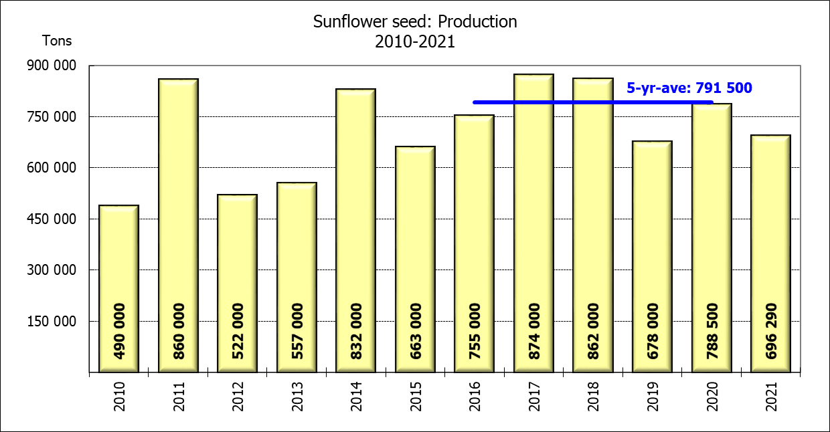

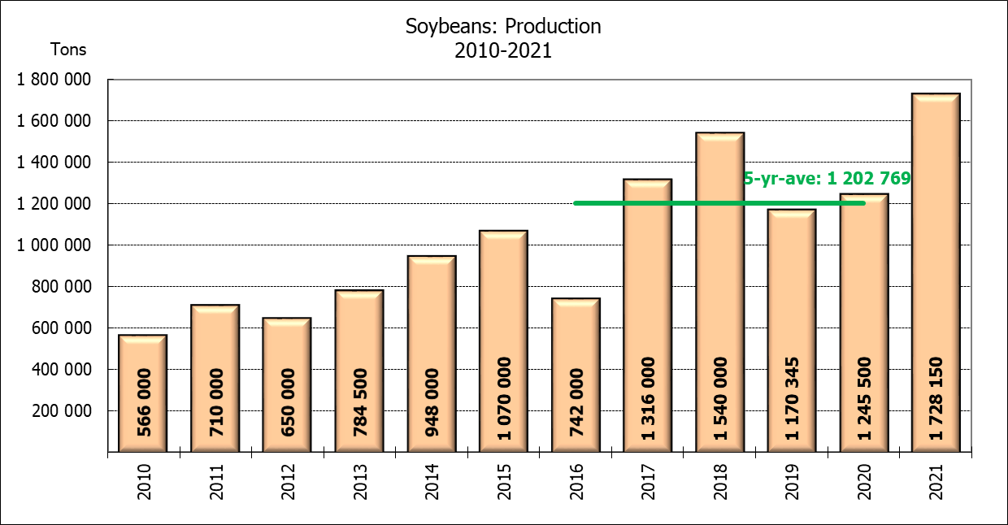
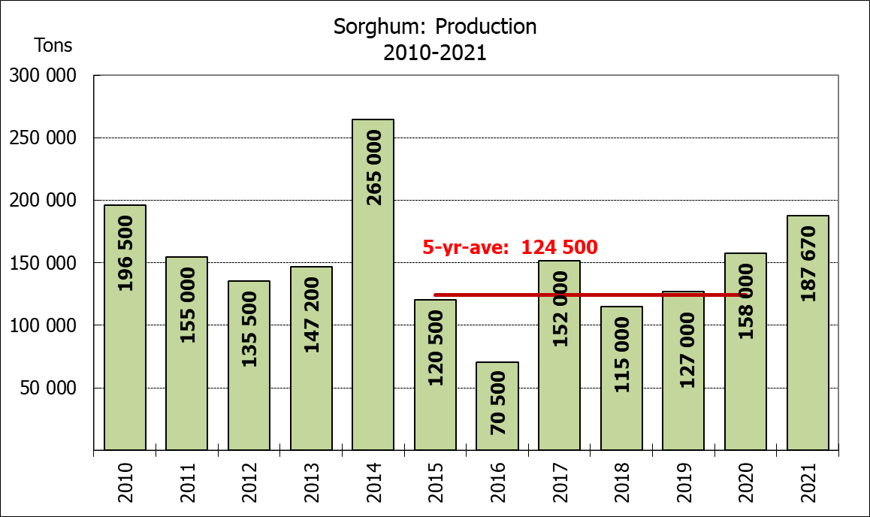

WHITE AND YELLOW MAIZE – AREA PLANTED AND SECOND PRODUCTION FORECAST: 2021
WIT- EN GEELMIELIES – OPPERVLAKTE EN TWEEDE PRODUKSIESKATTING: 2021

Provinsie/  Province | Area planted/  Oppervlakte beplant  2021 |  |  | 2nd forecast/  2de skatting  2021 |  |  | Area planted/  Oppervlakte beplant  2020 |  |  | Final crop/  Finale oes  2020
Provinsie/  Province | White/  Wit  Ha | Yellow/  Geel  Ha | Total/  Totaal  Ha | White/  Wit  Tons | Yellow/  Geel  Tons | Total/  Totaal  Tons | White/  Wit  Ha | Yellow/  Geel  Ha | Total/  Totaal  Ha | White/  Wit  Tons | Yellow/  Geel  Tons | Total/  Totaal  Tons
Western Cape/Wes-Kaap | 500 | 3 500 | 4 000 | 4 500 | 31 500 | 36 000 | 400 | 3 400 | 3 800 | 3 600 | 30 600 | 34 200
Northern Cape/Noord-Kaap | 3 400 | 41 000 | 44 400 | 40 290 | 615 000 | 655 290 | 3 400 | 43 100 | 46 500 | 40 300 | 633 900 | 674 200
Free State/Vrystaat | 907 500 | 420 000 | 1 327 500 | 4 719 000 | 2 394 000 | 7 113 000 | 855 000 | 365 000 | 1 220 000 | 4 700 000 | 2 209 000 | 6 909 000
Eastern Cape/Oos-Kaap | 6 000 | 18 000 | 24 000 | 39 000 | 131 400 | 170 400 | 5 500 | 17 000 | 22 500 | 35 200 | 119 000 | 154 200
KwaZulu-Natal | 50 000 | 55 000 | 105 000 | 310 000 | 418 000 | 728 000 | 47 000 | 55 000 | 102 000 | 298 400 | 434 500 | 732 900
Mpumalanga | 165 000 | 360 000 | 525 000 | 1 023 000 | 2 520 000 | 3 543 000 | 160 000 | 353 000 | 513 000 | 872 000 | 2 347 500 | 3 219 500
Limpopo | 16 500 | 21 000 | 37 500 | 112 200 | 168 000 | 280 200 | 15 000 | 18 000 | 33 000 | 105 000 | 126 000 | 231 000
Gauteng | 58 000 | 50 000 | 108 000 | 365 400 | 335 000 | 700 400 | 55 000 | 50 000 | 105 000 | 297 000 | 330 000 | 627 000
North West/Noordwes | 485 000 | 95 000 | 580 000 | 2 182 500 | 513 000 | 2 695 500 | 475 000 | 90 000 | 565 000 | 2 196 000 | 522 000 | 2 718 000
Total/Totaal | 1 691 900 | 1 063 500 | 2 755 400 | 8 795 890 | 7 125 900 | 15 921 790 | 1 616 300 | 994 500 | 2 610 800 | 8 547 500 | 6 752 500 | 15 300 000

SUNFLOWER SEED – AREA PLANTED AND SECOND PRODUCTION FORECAST: 2021
SONNEBLOMSAAD – OPPERVLAKTE EN TWEEDE PRODUKSIESKATTING: 2021

Province/  Provinsie | Area planted/  Opp beplant  Ha | 2nd forecast/  2de skatting  Tons | Area planted/  Opp beplant  Ha | Final crop/  Finale oes  Tons
Province/  Provinsie | 2021 | 2021 | 2020 | 2020
Western Cape/Wes-Kaap | - | - | - | -
Northern Cape/Noord-Kaap | 1 100 | 1 320 | 1 200 | 1 430
Free State/Vrystaat | 235 000 | 364 250 | 260 000 | 444 600
Eastern Cape/Oos-Kaap | 300 | 450 | 300 | 750
KwaZulu-Natal | - | - | - | -
Mpumalanga | 3 500 | 4 900 | 2 800 | 3 920
Limpopo | 76 500 | 84 150 | 65 000 | 65 000
Gauteng | 4 400 | 5 720 | 4 000 | 5 600
North West/Noordwes | 157 000 | 235 500 | 167 000 | 267 200
Total/Totaal | 477 800 | 696 290 | 500 300 | 788 500
SOYBEANS – AREA PLANTED AND SECOND PRODUCTION FORECAST: 2021
SOJABONE – OPPERVLAKTE EN TWEEDE PRODUKSIESKATTING: 2021

Province/  Provinsie | Area planted/  Opp beplant  Ha | 2nd forecast/  2de skatting  Tons | Area planted/  Opp beplant  Ha | Final crop/  Finale oes  Tons
Province/  Provinsie | 2021 | 2021 | 2020 | 2020
Western Cape/Wes-Kaap | - | - | - | -
Northern Cape/Noord-Kaap | 1 000 | 3 500 | 2 000 | 7 000
Free State/Vrystaat | 365 000 | 693 500 | 315 000 | 519 750
Eastern Cape/Oos-Kaap | 3 100 | 7 750 | 1 500 | 3 000
KwaZulu-Natal | 36 000 | 118 800 | 35 000 | 101 500
Mpumalanga | 290 000 | 594 500 | 260 000 | 416 000
Limpopo | 20 500 | 71 750 | 15 500 | 48 050
Gauteng | 42 000 | 92 400 | 36 000 | 70 200
North West/Noordwes | 69 500 | 145 950 | 40 000 | 80 000
Total/Totaal | 827 100 | 1 728 150 | 705 000 | 1 245 500

GROUNDNUTS – AREA PLANTED AND SECOND PRODUCTION FORECAST: 2021
GRONDBONE – OPPERVLAKTE EN TWEEDE PRODUKSIESKATTING: 2021

Province/  Provinsie | Area planted/  Opp beplant  Ha | 2nd forecast/  2de skatting  Tons | Area planted/  Opp beplant  Ha | Final crop/  Finale oes  Tons
Province/  Provinsie | 2021 | 2021 | 2020 | 2020
Western Cape/Wes-Kaap | - | - | - | -
Northern Cape/Noord-Kaap | 1 500 | 3 750 | 1 200 | 2 580
Free State/Vrystaat | 16 000 | 23 200 | 11 000 | 15 400
Eastern Cape/Oos-Kaap | - | - | - | -
KwaZulu-Natal | 50 | 50 | - | -
Mpumalanga | - | - | - | -
Limpopo | 3 000 | 6 600 | 2 900 | 5 220
Gauteng | - | - | - | -
North West/Noordwes | 18 000 | 24 300 | 22 400 | 26 880
Total/Totaal | 38 550 | 57 900 | 37 500 | 50 080

SORGHUM – AREA PLANTED AND SECOND PRODUCTION FORECAST: 2021
SORGHUM – OPPERVLAKTE EN TWEEDE PRODUKSIESKATTING: 2021

Province/  Provinsie | Area planted/  Opp beplant  Ha | 2nd forecast/  2de skatting  Tons | Area planted/  Opp beplant  Ha | Final crop/  Finale oes  Tons
Province/  Provinsie | 2021 | 2021 | 2020 | 2020
Western Cape/Wes-Kaap | - | - | - | -
Northern Cape/Noord-Kaap | - | - | - | -
Free State/Vrystaat | 10 500 | 39 900 | 8 000 | 35 200
Eastern Cape/Oos-Kaap |  | - | - | -
KwaZulu-Natal | 500 | 2 250 | 1 200 | 4 200
Mpumalanga | 9 400 | 52 640 | 8 500 | 46 340
Limpopo | 17 000 | 52 700 | 16 000 | 41 950
Gauteng | 300 | 1 080 | 300 | 960
North West/Noordwes | 11 500 | 39 100 | 8 500 | 29 350
Total/Totaal | 49 200 | 187 670 | 42 500 | 158 000

DRY BEANS – AREA PLANTED AND SECOND PRODUCTION FORECAST: 2021
DROëBONE – OPPERVLAKTE EN TWEEDE PRODUKSIESKATTING: 2021

Province/  Provinsie | Area planted/  Opp beplant  Ha | 2nd forecast/  2de skatting  Tons | Area planted/  Opp beplant  Ha | Final crop/  Finale oes  Tons
Province/  Provinsie | 2021 | 2021 | 2020 | 2020
Western Cape/Wes-Kaap | 100 | 150 | 100 | 150
Northern Cape/Noord-Kaap | 350 | 700 | 350 | 700
Free State/Vrystaat | 22 000 | 17 600 | 24 000 | 30 000
Eastern Cape/Oos-Kaap | 200 | 300 | 200 | 300
KwaZulu-Natal | 3 000 | 3 600 | 2 900 | 3 480
Mpumalanga | 6 500 | 10 075 | 6 600 | 8 250
Limpopo | 9 500 | 19 000 | 8 400 | 13 440
Gauteng | 840 | 1 092 | 600 | 780
North West/Noordwes | 6 400 | 9 600 | 7 000 | 7 700
Total/Totaal | 48 890 | 62 117 | 50 150 | 64 800

CONFIDENTIALITY ISSUES that CEC members are committed to adhere to on the day of the meeting
- Personal items such as laptops, handbags, cell phones, etc. are not allowed in the venue during the meeting
- No member is allowed to leave the meeting before 12:00 in order to prevent disclosure of the information
- The embargo time for the release of crop estimates information is 14:30
- No member is allowed to discuss crop estimates information with anyone other than a member of the Committee before the embargo time
- Only the Chairperson, or a member appointed by the Chairperson, may release the figures to the media
- Members must regard the detail of any information that was collected for and/or discussed during the meeting, as confidential
- Individual information received for crop estimate purposes is treated strictly confidential, and is not divulged for any other purposes

AREA ESTIMATE AND SECOND PRODUCTION FORECAST OF SUMMER CROPS (2021 PRODUCTION SEASON)/
OPPERVLAKTE- EN TWEEDE PRODUKSIESKATTING VIR SOMERGEWASSE (2021 PRODUKSIE-SEISOEN)
25 MARCH / MAART 2021

Summer field crops – 2021  Commercial maize: The size of the expected commercial maize crop has been set at 15,922 mill. tons, which is 0,46% or 72 830 tons more than the previous forecast of 15,849 mill. tons. The revised area estimate for maize is 2,755 mill. ha, while the expected yield is 5,78 t/ha.  The estimated maize crop is 4% bigger than the 2020 crop. The three main maize producing areas, namely the Free State, Mpumalanga and North West provinces are expected to produce 84% of the 2021 crop.  The revised area estimate for white maize is 1,692 mill. ha and for yellow maize the area estimate is 1,063 mill. ha.  The production forecast of white maize is 8,796 mill. tons, which is 0,04% or 3 470 tons less than the 8,799 mill. tons of the previous forecast. The yield for white maize is 5,20 t/ha. In the case of yellow maize the production forecast is 7,126 mill. tons, which is 1,08% or 76 300 tons more than the 7,050 mill. tons of the previous forecast. The yield for yellow maize is 6,70 t/ha.  Please note that information from the objective yield survey by the ARC for the Mpumalanga province will be available in April 2021; and for the Free State and North West provinces in May 2021. The current yield figures are mainly obtained from producers in the different provinces.  Sunflower seed: The production forecast for sunflower seed is 696 290 tons, which is 2,34% or 16 650 tons less than the previous forecast of 712 940 tons. The revised area estimate for sunflower seed is 477 800 ha, while the expected yield is 1,46 t/ha.  Other crops: The production forecast for soybeans increased by 6,62% or 107 250 tons to 1,728 mill. tons. The revised estimated area planted to soybeans is 827 100 ha and the expected yield is 2,09 t/ha.  The expected groundnut crop has been set at 57 900 tons, which is 0,90% or 525 tons less than the previous forecast of 58 425 tons. For groundnuts, the area estimate is 38 550 ha, with an expected yield of 1,50 t/ha.  The production forecast for sorghum is 187 670 tons, which is 10,01% or 17 080 tons more than the 170 590 tons of the previous forecast. The revised area estimate for sorghum is 49 200 ha and the expected yield is 3,81 t/ha.  In the case of dry beans, the production forecast is 62 117 tons. The revised area estimate of dry beans is 48 890 ha, with an expected yield of 1,27 t/ha.  Please note that the third production forecast for summer field crops for 2021 will be released on 29 April 2021. |  | Somergewasse – 2021  Kommersiële mielies: Die grootte van die verwagte kommersiële mielie-oes is op 15,922 milj. ton gestel, wat 0,46% of 72 830 ton meer is as die vorige skatting van 15,849 milj. ton. Die hersiene skatting van die oppervlakte onder mielies is 2,755 milj. ha, terwyl die verwagte opbrengs 5,78 t/ha is.  Die geskatte mielie-oes is 4% groter as die 2020-oes. Die drie belangrikste mielieproduserende gebiede, nl. die Vrystaat, Mpumalanga en Noordwes provinsies, gaan na verwagting 84% van die 2021-oes produseer.  Die hersiene oppervlak onder witmielies is 1,692 milj. ha en vir geelmielies is die oppervlak 1,063 milj. ha.  Die produksieskatting van witmielies is 8,796 milj. ton, 0,04% of 3 470 ton minder is as die 8,799 milj. ton van die vorige skatting. Die opbrengs van witmielies is 5,20 t/ha. In die geval van geelmielies is die produksieskatting 7,126 milj. ton, wat 1,08% of 76 300 ton meer is as die 7,050 milj. ton van die vorige skatting. Die opbrengs van geelmielies is 6,70 t/ha.  Neem kennis dat inligting van die objektiewe opbrengs-opname van die LNR vir die Mpumalanga provinsie, in April 2021 gerapporteer word en vir die Vrystaat en Noordwes provinsies in Mei 2021. Die huidige opbrengs syfers is hoofsaaklik verkry vanaf produsente in die verskillende provinsies.  Sonneblomsaad: Die produksieskatting vir sonneblomsaad is 696 290 ton, wat 2,34% of 16 650 ton minder is as die vorige skatting van 712 940 ton. Die hersiene oppervlakteskatting vir sonneblomsaad is 477 800 ha, terwyl die verwagte opbrengs 1,46 t/ha is.  Ander gewasse: Die produksieskatting van sojabone is verhoog met 6,62% of 107 250 ton na 1,728 milj. ton. Die geskatte oppervlakte beplant van sojabone is 827 100 ha en die verwagte opbrengs is 2,09 t/ha.  Die verwagte grondbone-oes is op 57 900 ton gestel, wat 0,90% of 525 ton minder is as die vorige skatting van 58 425 ton. Vir grondbone is die oppervlakteskatting 38 550 ha, terwyl the verwagte opbrengs 1,50 t/ha is.  Die produksieskatting van sorghum is 187 670 ton, wat 10,01% of 17 080 ton meer is as die 170 590 ton van die vorige skatting. Die hersiene oppervlakteskatting vir sorghum is 49 200 ha, en die verwagte opbrengs is 3,81 t/ha.  In die geval van droëbone is die produksieskatting 62 117 ton. Die hersiene oppervlakte beplant met droëbone is 48 890 ha, en die verwagte opbrengs is 1,27 t/ha.  Neem asseblief kennis dat die derde produksieskatting vir somergewasse vir 2021, op 29 April 2021 vrygestel sal word.

