 | crop estimates committee
 | oesskattingskomitee
From/Van: Mr Baldwin Netshifhefhe  Tel: 012 319 8043  Fax/Faks: 012 319 8031  E-mail/E-pos: BaldwinN@dalrrd.gov.za  Web page/Webblad: www.dalrrd.gov.za/statistics and economic reports or  www.sagis.org.za/CEC: Crop Estimates EMBARGO: 14:30 |  |  | 

The area planted estimate and fifth production forecast for summer crops for 2021 is hereby released.
Hiermee word die oppervlakte- en vyfde produksieskatting vir somergewasse vir 2021 vrygestel.

SUMMER CROPS – AREA PLANTED AND FIFTH PRODUCTION FORECAST: 2021
SOMERGEWASSE – OPPERVLAKTE- EN VYFDE PRODUKSIESKATTING: 2021
CROP/GEWAS | Area planted/  Opp beplant  2021 |  | 5th forecast/  5de skatting  2021 | 4th forecast/  4de skatting  2021 | Area planted/  Opp beplant  2020 |  | Final crop/  Finale oes  2020 | Change/  Verandering/
CROP/GEWAS | Ha |  | Tons | Tons | Ha |  | Tons | %
CROP/GEWAS | (A) |  | (B) | (C) | (D) |  | (E) | (B) ÷ (C)
Commercial/Kommersieël:
White maize/Witmielies | 1 691 900 |  | 8 936 815 | 8 982 190 | 1 616 300 |  | 8 547 500 | -0,51
Yellow maize/Geelmielies | 1 063 500 |  | 7 295 800 | 7 198 150 | 994 500 |  | 6 752 500 | +1,36
Total Maize/Totale Mielies | 2 755 400 |  | 16 232 615 | 16 180 340 | 2 610 800 |  | 15 300 000 | +0,32
Sunflower seed/Sonneblomsaad | 477 800 |  | 677 240 | 716 240 | 500 300 |  | 788 500 | -5,45
Soybeans/Sojabone | 827 100 |  | 1 918 150 | 1 918 150 | 705 000 |  | 1 245 500 | -
Groundnuts/Grondbone | 38 550 |  | 58 900 | 57 900 | 37 500 |  | 50 080 | +1,73
Sorghum | 49 200 |  | 195 035 | 195 035 | 42 500 |  | 158 000 | -
Dry beans/Droëbone | 47 390 |  | 56 577 | 56 577 | 50 150 |  | 64 800 | -
Non-Commercial Maize/Nie-Kommersiële Mielies
Total Maize/Totaal Mielies | 319 460 | 586 650 |  | 586 650 | 297 460 | 543 545 |  |  | +8,49
Maize/Mielies: Commercial/Kommersieël + Non-Commercial/Nie-Kommersieël
Total Maize RSA/Totaal Mielies RSA | 3 074 860 | 16 819 265 |  | 16 766 990 | 2 908 260 | 15 843 545 |  |  | +0,31
Note: Estimate is for calendar year, e.g. production season 2020/21 = 2021
Nota: Skatting is vir kalenderjaar, bv. produksie-seisoen 2020/21 = 2021
The Crop Estimates Committee comprises officials of the following institutions:
Department of Agriculture, Land Reform and Rural Development; Provincial Departments of Agriculture; various ARC-Institutes (Soil, Climate and Water; Small Grains Institute; and Grain Crops Institute); BFAP and Statistics SA.
29 June 2021

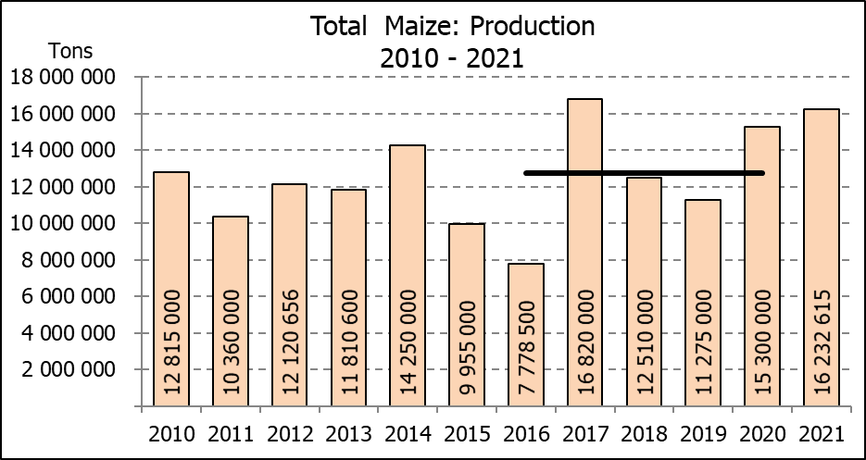

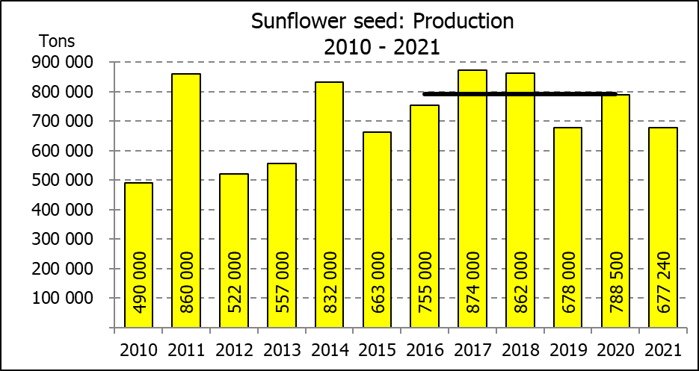
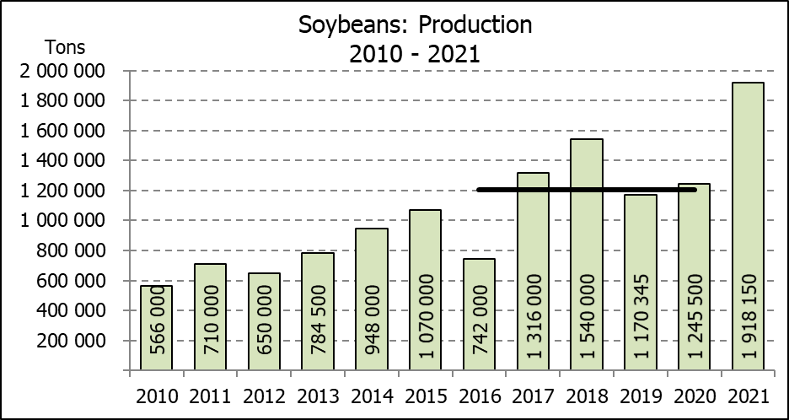

WHITE AND YELLOW MAIZE – AREA PLANTED AND FOURTH PRODUCTION FORECAST: 2021
WIT- EN GEELMIELIES – OPPERVLAKTE EN VIERDE PRODUKSIESKATTING: 2021

Provinsie/  Province | Area planted/  Oppervlakte beplant  2021 |  |  | 5th forecast/  5de skatting  2021 |  |  | Area planted/  Oppervlakte beplant  2020 |  |  | Final crop/  Finale oes  2020
Provinsie/  Province | White/  Wit  Ha | Yellow/  Geel  Ha | Total/  Totaal  Ha | White/  Wit  Tons | Yellow/  Geel  Tons | Total/  Totaal  Tons | White/  Wit  Ha | Yellow/  Geel  Ha | Total/  Totaal  Ha | White/  Wit  Tons | Yellow/  Geel  Tons | Total/  Totaal  Tons
Western Cape/Wes-Kaap | 500 | 3 500 | 4 000 | 4 500 | 31 500 | 36 000 | 400 | 3 400 | 3 800 | 3 600 | 30 600 | 34 200
Northern Cape/Noord-Kaap | 3 400 | 41 000 | 44 400 | 40 290 | 623 200 | 663 490 | 3 400 | 43 100 | 46 500 | 40 300 | 633 900 | 674 200
Free State/Vrystaat | 907 500 | 420 000 | 1 327 500 | 4 673 625 | 2 457 000 | 7 130 625 | 855 000 | 365 000 | 1 220 000 | 4 700 000 | 2 209 000 | 6 909 000
Eastern Cape/Oos-Kaap | 6 000 | 18 000 | 24 000 | 39 000 | 131 400 | 170 400 | 5 500 | 17 000 | 22 500 | 35 200 | 119 000 | 154 200
KwaZulu-Natal | 50 000 | 55 000 | 105 000 | 310 000 | 423 500 | 733 500 | 47 000 | 55 000 | 102 000 | 298 400 | 434 500 | 732 900
Mpumalanga | 165 000 | 360 000 | 525 000 | 1 155 000 | 2 592 000 | 3 747 000 | 160 000 | 353 000 | 513 000 | 872 000 | 2 347 500 | 3 219 500
Limpopo | 16 500 | 21 000 | 37 500 | 112 200 | 172 200 | 284 400 | 15 000 | 18 000 | 33 000 | 105 000 | 126 000 | 231 000
Gauteng | 58 000 | 50 000 | 108 000 | 371 200 | 342 500 | 713 700 | 55 000 | 50 000 | 105 000 | 297 000 | 330 000 | 627 000
North West/Noordwes | 485 000 | 95 000 | 580 000 | 2 231 000 | 522 500 | 2 753 500 | 475 000 | 90 000 | 565 000 | 2 196 000 | 522 000 | 2 718 000
Total/Totaal | 1 691 900 | 1 063 500 | 2 755 400 | 8 936 815 | 7 295 800 | 16 232 615 | 1 616 300 | 994 500 | 2 610 800 | 8 547 500 | 6 752 500 | 15 300 000

SUNFLOWER SEED – AREA PLANTED AND FOURTH PRODUCTION FORECAST: 2021
SONNEBLOMSAAD – OPPERVLAKTE EN VIERDE PRODUKSIESKATTING: 2021

Province/  Provinsie | Area planted/  Opp beplant  Ha | 5th forecast/  5de skatting  Tons | Area planted/  Opp beplant  Ha | Final crop/  Finale oes  Tons
Province/  Provinsie | 2021 | 2021 | 2020 | 2020
Western Cape/Wes-Kaap | - | - | - | -
Northern Cape/Noord-Kaap | 1 100 | 1 320 | 1 200 | 1 430
Free State/Vrystaat | 235 000 | 352 500 | 260 000 | 444 600
Eastern Cape/Oos-Kaap | 300 | 450 | 300 | 750
KwaZulu-Natal | - | - | - | -
Mpumalanga | 3 500 | 5 250 | 2 800 | 3 920
Limpopo | 76 500 | 76 500 | 65 000 | 65 000
Gauteng | 4 400 | 5 720 | 4 000 | 5 600
North West/Noordwes | 157 000 | 235 500 | 167 000 | 267 200
Total/Totaal | 477 800 | 677 240 | 500 300 | 788 500
SOYBEANS – AREA PLANTED AND FOURTH PRODUCTION FORECAST: 2021
SOJABONE – OPPERVLAKTE EN VIERDE PRODUKSIESKATTING: 2021

Province/  Provinsie | Area planted/  Opp beplant  Ha | 5th forecast/  5de skatting  Tons | Area planted/  Opp beplant  Ha | Final crop/  Finale oes  Tons
Province/  Provinsie | 2021 | 2021 | 2020 | 2020
Western Cape/Wes-Kaap | - | - | - | -
Northern Cape/Noord-Kaap | 1 000 | 3 500 | 2 000 | 7 000
Free State/Vrystaat | 365 000 | 766 500 | 315 000 | 519 750
Eastern Cape/Oos-Kaap | 3 100 | 9 300 | 1 500 | 3 000
KwaZulu-Natal | 36 000 | 129 600 | 35 000 | 101 500
Mpumalanga | 290 000 | 652 500 | 260 000 | 416 000
Limpopo | 20 500 | 73 800 | 15 500 | 48 050
Gauteng | 42 000 | 109 200 | 36 000 | 70 200
North West/Noordwes | 69 500 | 173 750 | 40 000 | 80 000
Total/Totaal | 827 100 | 1 918 150 | 705 000 | 1 245 500

GROUNDNUTS – AREA PLANTED AND FOURTH PRODUCTION FORECAST: 2021
GRONDBONE – OPPERVLAKTE EN VIERDE PRODUKSIESKATTING: 2021

Province/  Provinsie | Area planted/  Opp beplant  Ha | 5th forecast/  5de skatting  Tons | Area planted/  Opp beplant  Ha | Final crop/  Finale oes  Tons
Province/  Provinsie | 2021 | 2021 | 2020 | 2020
Western Cape/Wes-Kaap | - | - | - | -
Northern Cape/Noord-Kaap | 1 500 | 3 750 | 1 200 | 2 580
Free State/Vrystaat | 16 000 | 24 800 | 11 000 | 15 400
Eastern Cape/Oos-Kaap | - | - | - | -
KwaZulu-Natal | 50 | 50 | - | -
Mpumalanga | - | - | - | -
Limpopo | 3 000 | 6 900 | 2 900 | 5 220
Gauteng | - | - | - | -
North West/Noordwes | 18 000 | 23 400 | 22 400 | 26 880
Total/Totaal | 38 550 | 58 900 | 37 500 | 50 080

SORGHUM – AREA PLANTED AND FOURTH PRODUCTION FORECAST: 2021
SORGHUM – OPPERVLAKTE EN VIERDE PRODUKSIESKATTING: 2021

Province/  Provinsie | Area planted/  Opp beplant  Ha | 5th forecast/  5de skatting  Tons | Area planted/  Opp beplant  Ha | Final crop/  Finale oes  Tons
Province/  Provinsie | 2021 | 2021 | 2020 | 2020
Western Cape/Wes-Kaap | - | - | - | -
Northern Cape/Noord-Kaap | - | - | - | -
Free State/Vrystaat | 10 500 | 38 325 | 8 000 | 35 200
Eastern Cape/Oos-Kaap |  | - | - | -
KwaZulu-Natal | 500 | 2 250 | 1 200 | 4 200
Mpumalanga | 9 400 | 53 580 | 8 500 | 46 340
Limpopo | 17 000 | 56 100 | 16 000 | 41 950
Gauteng | 300 | 1 080 | 300 | 960
North West/Noordwes | 11 500 | 43 700 | 8 500 | 29 350
Total/Totaal | 49 200 | 195 035 | 42 500 | 158 000

DRY BEANS – AREA PLANTED AND FOURTH PRODUCTION FORECAST: 2021
DROëBONE – OPPERVLAKTE EN VIERDE PRODUKSIESKATTING: 2021

Province/  Provinsie | Area planted/  Opp beplant  Ha | 5th forecast/  5de skatting  Tons | Area planted/  Opp beplant  Ha | Final crop/  Finale oes  Tons
Province/  Provinsie | 2021 | 2021 | 2020 | 2020
Western Cape/Wes-Kaap | 100 | 150 | 100 | 150
Northern Cape/Noord-Kaap | 350 | 700 | 350 | 700
Free State/Vrystaat | 22 000 | 15 400 | 24 000 | 30 000
Eastern Cape/Oos-Kaap | 200 | 300 | 200 | 300
KwaZulu-Natal | 3 000 | 3 900 | 2 900 | 3 480
Mpumalanga | 6 500 | 10 075 | 6 600 | 8 250
Limpopo | 8 000 | 16 000 | 8 400 | 13 440
Gauteng | 840 | 1 092 | 600 | 780
North West/Noordwes | 6 400 | 8 960 | 7 000 | 7 700
Total/Totaal | 47 390 | 56 577 | 50 150 | 64 800

CONFIDENTIALITY ISSUES that CEC members are committed to adhere to on the day of the meeting
- No member is allowed to leave the meeting before 12:00 in order to prevent disclosure of the information
- The embargo time for the release of crop estimates information is 14:30
- No member is allowed to discuss crop estimates information with anyone other than a member of the Committee before the embargo time
- Only the Chairperson, or a member appointed by the Chairperson, may release the figures to the media
- Members must regard the detail of any information that was collected for and/or discussed during the meeting, as confidential
- Individual information received for crop estimate purposes is treated strictly confidential, and is not divulged for any other purposes

AREA ESTIMATE AND FIFTH PRODUCTION FORECAST OF SUMMER CROPS (2021 PRODUCTION SEASON)/
OPPERVLAKTE- EN VYFDE PRODUKSIESKATTING VIR SOMERGEWASSE (2021 PRODUKSIE-SEISOEN)
29 JUNE 2021

Summer field crops – 2021  Commercial maize: The size of the expected commercial maize crop has been set at 16,233 mill. tons, which is 0,32% or 52 275 tons more than the previous forecast of 16,180 mill. tons. The area estimate for maize is 2,755 mill. ha, while the expected yield is 5,89 t/ha.  The estimated maize crop is 6% bigger than the 2020 crop. The three main maize producing areas, namely the Free State, Mpumalanga and North West provinces is expected to produce 84% of the 2021 crop.  The area estimate for white maize is 1,692 mill. ha & for yellow maize the area estimate is 1,064 mill. ha.  The production forecast of white maize is 8,937 mill. tons, which is 0,51% or 45 375 tons less than the 8,982 mill. tons of the previous forecast. The yield for white maize is 5,28 t/ha. In the case of yellow maize the production forecast is 7,296 mill. tons, which is 1,36% or 97 650 tons more than the 7,198 mill. tons of the previous forecast. The yield for yellow maize is 6,86 t/ha.  Sunflower seed: The production forecast for sunflower seed is 677 240 tons, which is 5,45% or 39 000 tons less than the 716 240 tons of the previous forecast. The area estimate for sunflower seed is 477 800 ha, while the expected yield is 1,42 t/ha.  Other crops: The production forecast for soybeans remained unchanged at 1,918 mill. tons. The estimated area planted to soybeans is 827 100 ha and the expected yield is 2,32 t/ha.  The expected groundnut crop is 58 900 tons, which is 1,73% or 1 000 tons more than the 57 900 tons of the previous forecast. For groundnuts, the area estimate is 38 550 ha, with an expected yield of 1,53 t/ha.  The production forecast for sorghum remained unchanged at 195 035 tons. The area estimate for sorghum is 49 200 ha and the expected yield is 3,96 t/ha.  In the case of dry beans, the production forecast remained unchanged at 56 577 tons. The area estimate of dry beans is 47 390 ha, with an expected yield of 1,19 t/ha.  Please note that the sixth production forecast for summer field crops for 2021, as well as the preliminary area planted to winter grain for 2021 will be released on 28 July 2021. |  | Somergewasse – 2021  Kommersiële mielies: Die grootte van die verwagte kommersiële mielie-oes is op 16,233 milj. ton gestel, wat 0,32% of 52 275 ton meer is as die vorige skatting van 16,096 milj. ton. Die skatting van die oppervlakte onder mielies is 2,755 milj. ha, terwyl die verwagte opbrengs 5,89 t/ha is.  Die geskatte mielie-oes is 6% groter as die 2020-oes. Die drie belangrikste mielieproduserende gebiede, nl. die Vrystaat, Mpumalanga en Noordwes provinsies, gaan na verwagting 84% van die 2021-oes produseer.  Die oppervlak onder witmielies is 1,692 milj. ha en vir geelmielies is die oppervlak 1,064 milj. ha.  Die produksieskatting van witmielies is 8,937 milj. ton, 0,51% of 45 375 ton minder as die 8,982 milj. ton van die vorige skatting. Die opbrengs van witmielies is 5,28 t/ha. In die geval van geelmielies is die produksieskatting 7,296 milj. ton, wat 1,36% of 97 650 ton meer is as die 7,198 milj. ton van die vorige skatting. Die opbrengs van geelmielies is 6,86 t/ha.  Sonneblomsaad: Die produksieskatting vir sonneblomsaad is 677 240 ton, wat 5,45% of 39 000 ton minder is as die 716 240 ton van die vorige skatting. Die oppervlakteskatting vir sonneblomsaad is 477 800 ha, terwyl die verwagte opbrengs 1,42 t/ha is.  Ander gewasse: Die produksieskatting van sojabone is onveranderd gelaat op 1,918 milj. ton. Die geskatte oppervlakte beplant van sojabone is 827 100 ha en die verwagte opbrengs is 2,32 t/ha.  Die verwagte grondbone-oes is 58 900 ton, wat 1,73% or 1 000 ton meer is as die 57 900 ton van die vorige skatting. Vir grondbone is die oppervlakteskatting 38 550 ha, terwyl die verwagte opbrengs 1,53 t/ha is.  Die produksieskatting van sorghum is onveranderd gelaat op 195 035 ton. Die oppervlakteskatting vir sorghum is 49 200 ha, en die verwagte opbrengs is 3,96 t/ha.  In die geval van droëbone is die produksieskatting onveranderd gelaat op 56 577 ton. Die oppervlakte beplant met droëbone is 47 390 ha, en die verwagte opbrengs is 1,19 t/ha.  Neem asseblief kennis dat die sesde produksieskatting vir somergewasse vir 2021 sowel as die voorlopige oppervlakskatting vir wintergrane for 2021, op 28 Julie 2021 vrygestel sal word.

The preliminary non-commercial agricultural sectors’ production estimate for maize for 2021 is hereby released. /
Hiermee word die voorlopige nie-kommersiële landbou-sektor se produksieskatting vir mielies vir 2021 vrygestel.

NON-COMMERCIAL MAIZE – PRELIMINARY AREA PLANTED AND PRODUCTION ESTIMATE: 2021
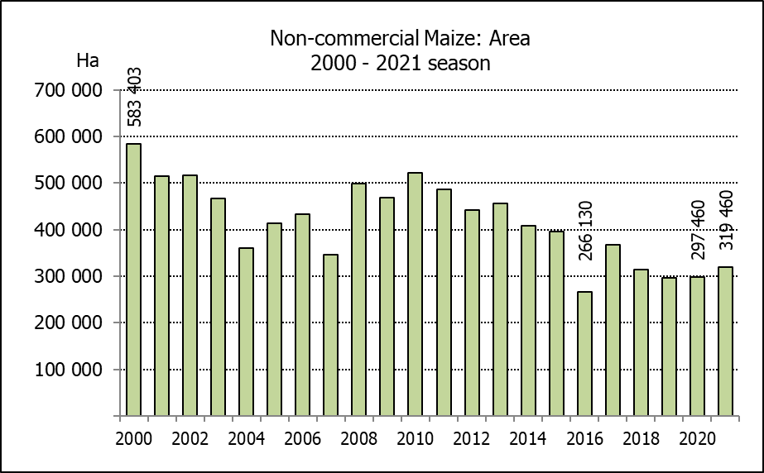
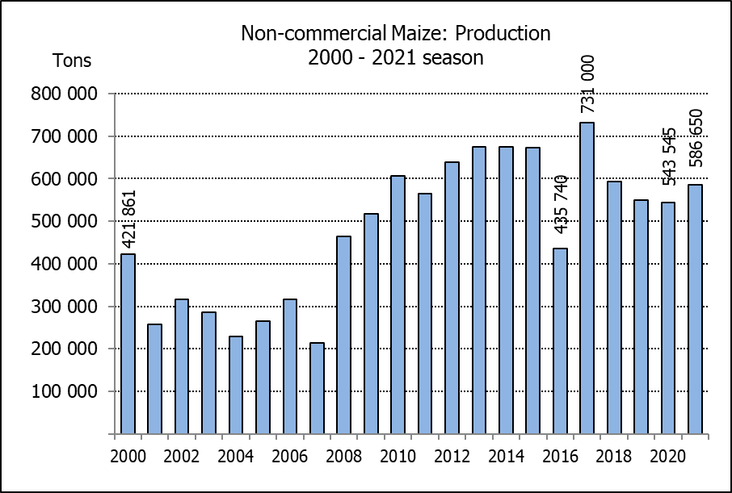
NIE-KOMMERSIëLE MIELIES – VOORLOPIGE OPPERVLAKTE- EN PRODUKSIESKATTING: 2021
CROP/GEWAS | Area planted/  Opp beplant  2021 | Production/  Produksie  2021 | Area planted/  Opp beplant  2020 | Final crop/  Finale oes  2020 | Change/  Verandering
CROP/GEWAS | Ha | Tons | Ha | Tons | %
CROP/GEWAS | (A) | (B) | (C) | (D) | (B) ÷ (D)
Non-commercial agriculture/Nie-kommersiële landbou:
White maize/Witmielies | 236 600 | 399 330 | 221 945 | 375 295 | +6,40
Yellow maize/Geelmielies | 82 860 | 187 320 | 75 515 | 168 250 | +11,33
Maize/Mielies | 319 460 | 586 650 | 297 460 | 543 545 | +7,93
The preliminary area planted to maize in the non-commercial agricultural sector is estimated at 319 460 ha, which represents an increase of 7,40%, compared to the 297 460 ha of the previous season. The expected maize crop for this sector is 586 650 tons, which is 7,93% more than the 543 545 tons of last season. It is important to note that about 45% of the maize produced in the non-commercial sector, is planted in the Eastern Cape, followed by KwaZulu-Natal with 28%.
Die voorlopige oppervlakte beplant met mielies in die nie-kommersiële landbou-sektor word geskat op 319 460 ha, wat ’n toename van 7,40% verteenwoordig in vergelyking met die 297 460 ha van die vorige seisoen. Die verwagte mielie-oes van dié sektor is 586 650 ton, wat 7,93% meer is as die 543 545 ton van die vorige seisoen. Dit is belangrik om daarop te let dat ongeveer 45% van die mielies wat geproduseer word in die nie-kommersiële sektor, in die Oos-Kaap geplant word, gevolg deur KwaZulu-Natal met 28%.

