 | crop estimates committee | 
 | oesskattingskomitee
From/Van: M. Ellen Matsei
Tel: 012 319 8454  Fax/Faks: 012 319 8031  E-mail/E-pos: DAS@daff.gov.za
Web page/Webblad: www.daff.gov.za/statistics and economic reports or www.sagis.org.za/CEC: Crop Estimates
EMBARGO: 15:30

The area planted estimate and fifth production forecast for summer crops for 2017 is hereby released.
Hiermee word die oppervlakte- en vyfde produksieskatting vir somergewasse vir 2017 vrygestel.

SUMMER CROPS – AREA PLANTED AND FIFTH PRODUCTION FORECAST: 2017
SOMERGEWASSE – OPPERVLAKTE- EN VYFDE PRODUKSIESKATTING: 2017
CROP/GEWAS  The Crop Estimates Committee comprises officials of the following institutions:  Department of Agriculture, Forestry and Fisheries; Provincial Departments of Agriculture; various ARC-Institutes (Soil, Climate and Water; Small Grains Institute;  and Grain Crops Institute); BFAP and Statistics SA. | Area planted/  Opp beplant  2017 | 5th forecast/  5de skatting  2017 | 4th forecast/  4de skatting  2017 | Area planted/  Opp beplant  2016 | Final crop/  Finale oes  2016 | Change/  Verandering
 | Ha | Tons | Tons | Ha | Tons | %
 | (A) | (B) | (C) | (D) | (E) | (B) ÷ (C)
Commercial/Kommersieel:
White maize/Witmielies | 1 643 100 | 9 466 800 | 9 466 800 | 1 014 750 | 3 408 500 | -
Yellow maize/Geelmielies | 985 500 | 6 164 250 | 6 164 250 | 932 000 | 4 370 000 | -
Total Maize/Totale Mielies | 2 628 600 | 15 631 050 | 15 631 050 | 1 946 750 | 7 778 500 | -
Sunflower seed/Sonneblomsaad | 635 750 | 821 970 | 853 470 | 718 500 | 755 000 | -3,69
Soybeans/Sojabone | 573 950 | 1 340 370 | 1 233 130 | 502 800 | 742 000 | +8,70
Groundnuts/Grondbone | 56 000 | 90 550 | 86 600 | 22 600 | 17 680 | +4,56
Sorghum | 42 350 | 151 335 | 153 480 | 48 500 | 70 500 | -1,40
Dry beans/Droëbone | 45 050 | 68 450 | 68 450 | 34 400 | 35 445 | -
TOTAL/TOTAAL | 3 981 700 | 18 103 725 | 18 026 180 | 3 273 550 | 9 399 125 | +0,43
Note: Estimate is for calendar year, e.g. production season 2016/17 = 2017
Nota: Skatting is vir kalenderjaar, bv. produksie-seisoen 2016/17 = 2017

28 June/Junie 2017
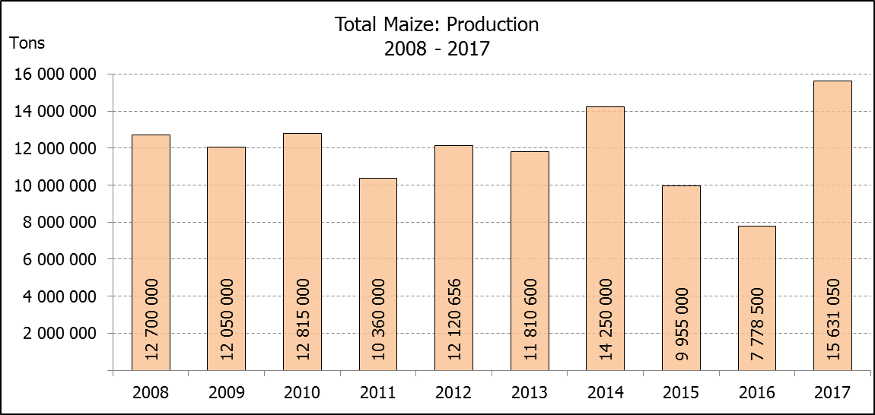
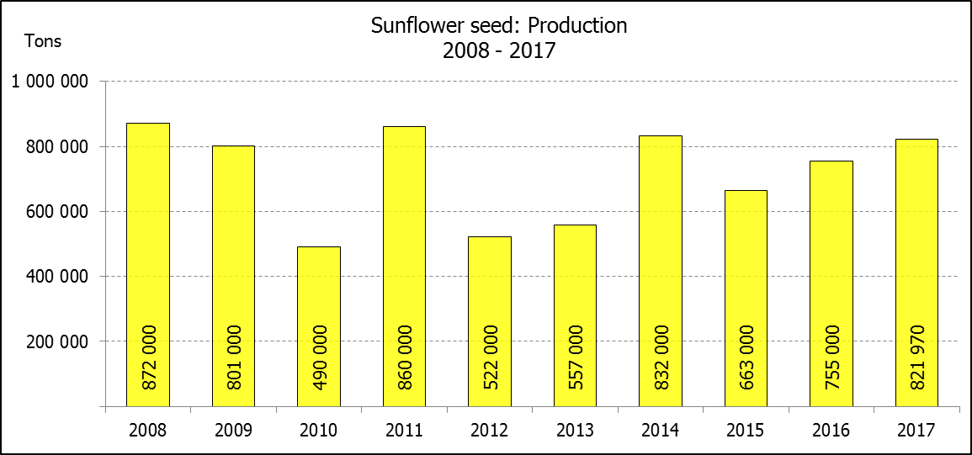

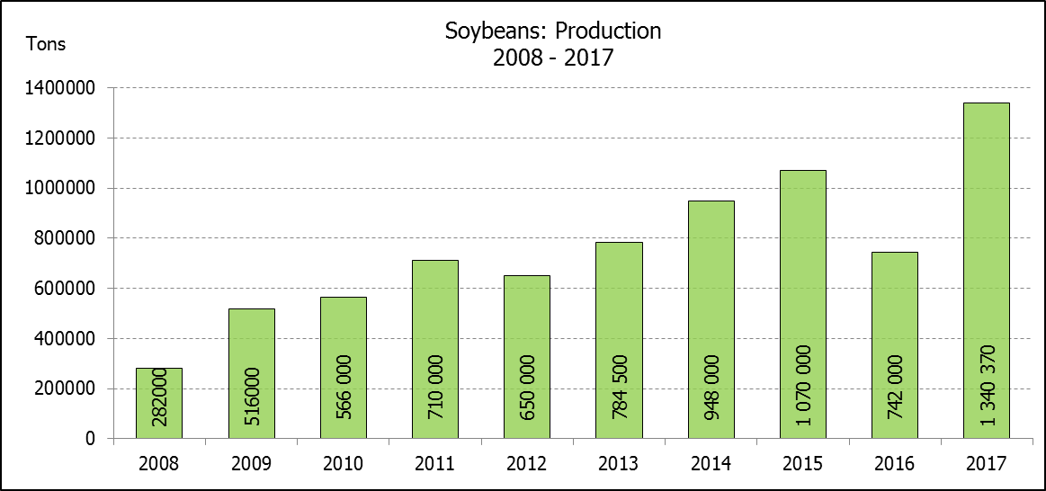

WHITE AND YELLOW MAIZE – AREA PLANTED AND FIFTH PRODUCTION FORECAST: 2017
WIT- EN GEELMIELIES – OPPERVLAKTE EN VYFDE PRODUKSIESKATTING: 2017

Provinsie/  Province | Area planted/  Oppervlakte beplant  2017 |  |  | 5th forecast/  5de skatting  2017 |  |  | Area planted/  Oppervlakte beplant  2016 |  |  | Final crop/  Finale oes  2016
Provinsie/  Province | White/  Wit  Ha | Yellow/  Geel  Ha | Total/  Totaal  Ha | White/  Wit  Tons | Yellow/  Geel  Tons | Total/  Totaal  Tons | White/  Wit  Ha | Yellow/  Geel  Ha | Total/  Totaal  Ha | White/  Wit  Tons | Yellow/  Geel  Tons | Total/  Totaal  Tons
Western Cape/Wes-Kaap | 200 | 2 000 | 2 200 | 2 000 | 20 000 | 22 000 | 500 | 4 000 | 4 500 | 5 000 | 40 000 | 45 000
Northern Cape/Noord-Kaap | 3 500 | 45 000 | 48 500 | 45 500 | 652 500 | 698 000 | 3 750 | 50 000 | 53 750 | 35 000 | 675 000 | 710 000
Free State/Vrystaat | 805 000 | 355 000 | 1 160 000 | 4 910 500 | 1 917 000 | 6 827 500 | 390 000 | 310 000 | 700 000 | 1 190 500 | 1 023 000 | 2 213 500
Eastern Cape/Oos-Kaap | 4 400 | 9 500 | 13 900 | 30 800 | 61 750 | 92 550 | 2 000 | 12 000 | 14 000 | 10 000 | 66 000 | 76 000
KwaZulu-Natal | 50 000 | 50 000 | 100 000 | 330 000 | 355 000 | 685 000 | 38 000 | 48 000 | 86 000 | 215 000 | 307 000 | 522 000
Mpumalanga | 160 000 | 330 000 | 490 000 | 1 040 000 | 2 112 000 | 3 152 000 | 160 000 | 330 000 | 490 000 | 752 000 | 1 567 000 | 2 319 000
Limpopo | 40 000 | 24 000 | 64 000 | 292 000 | 192 000 | 484 000 | 31 500 | 22 000 | 53 500 | 178 000 | 132 000 | 310 000
Gauteng | 60 000 | 60 000 | 120 000 | 372 000 | 348 000 | 720 000 | 49 000 | 56 000 | 105 000 | 207 000 | 235 000 | 442 000
North West/Noordwes | 520 000 | 110 000 | 630 000 | 2 444 000 | 506 000 | 2 950 000 | 340 000 | 100 000 | 440 000 | 816 000 | 325 000 | 1 141 000
Total/Totaal | 1 643 100 | 985 500 | 2 628 600 | 9 466 800 | 6 164 250 | 15 631 050 | 1 014 750 | 932 000 | 1 946 750 | 3 408 500 | 4 370 000 | 7 778 500

SUNFLOWER SEED – AREA PLANTED AND FIFTH PRODUCTION FORECAST: 2017
SONNEBLOMSAAD – OPPERVLAKTE EN VYFDE PRODUKSIESKATTING: 2017

Province/  Provinsie | Area planted/  Opp beplant  Ha | 5th forecast/  5de skatting  Tons | Area planted/  Opp beplant  Ha | Final crop/  Finale oes  Tons
Province/  Provinsie | 2017 | 2017 | 2016 | 2016
Western Cape/Wes-Kaap | - | - | - | -
Northern Cape/Noord-Kaap | 250 | 250 | 500 | 600
Free State/Vrystaat | 330 000 | 445 500 | 400 000 | 440 000
Eastern Cape/Oos-Kaap | - | - | - | -
KwaZulu-Natal | 300 | 300 | - | -
Mpumalanga | 2 200 | 2 420 | 4 000 | 4 400
Limpopo | 90 000 | 76 500 | 65 000 | 48 750
Gauteng | 3 000 | 3 000 | 4 000 | 4 000
North West/Noordwes | 210 000 | 294 000 | 245 000 | 257 250
Total/Totaal | 635 750 | 821 970 | 718 500 | 755 000

SOYBEANS – AREA PLANTED AND FIFTH PRODUCTION FORECAST: 2017
SOJABONE – OPPERVLAKTE EN VYFDE PRODUKSIESKATTING: 2017

Province/  Provinsie | Area planted/  Opp beplant  Ha | 5th forecast/  5de skatting  Tons | Area planted/  Opp beplant  Ha | Final crop/  Finale oes  Tons
Province/  Provinsie | 2017 | 2017 | 2016 | 2016
Western Cape/Wes-Kaap | 700 | 1 050 | 800 | 1 200
Northern Cape/Noord-Kaap | 3 000 | 10 500 | 4 000 | 13 600
Free State/Vrystaat | 240 000 | 528 000 | 174 000 | 148 000
Eastern Cape/Oos-Kaap | 1 850 | 2 775 | 1 500 | 2 100
KwaZulu-Natal | 30 500 | 89 975 | 28 000 | 66 000
Mpumalanga | 241 000 | 554 300 | 240 000 | 408 000
Limpopo | 8 500 | 29 750 | 16 000 | 38 400
Gauteng | 25 400 | 71 120 | 23 000 | 50 600
North West/Noordwes | 23 000 | 52 900 | 15 500 | 14 100
Total/Totaal | 573 950 | 1 340 370 | 502 800 | 742 000
GROUNDNUTS – AREA PLANTED AND FIFTH PRODUCTION FORECAST: 2017
GRONDBONE – OPPERVLAKTE EN VYFDE PRODUKSIESKATTING: 2017

Province/  Provinsie | Area planted/  Opp beplant  Ha | 5th forecast/  5de skatting  Tons | Area planted/  Opp beplant  Ha | Final crop/  Finale oes  Tons
Province/  Provinsie | 2017 | 2017 | 2016 | 2016
Western Cape/Wes-Kaap | - | - | - | -
Northern Cape/Noord-Kaap | 4 000 | 14 000 | 5 000 | 10 000
Free State/Vrystaat | 22 000 | 34 100 | 6 500 | 2 920
Eastern Cape/Oos-Kaap | - | - | - | -
KwaZulu-Natal | - | - | - | -
Mpumalanga | - | - | - | -
Limpopo | 3 000 | 4 650 | 1 600 | 1 440
Gauteng | - | - | - | -
North West/Noordwes | 27 000 | 37 800 | 9 500 | 3 320
Total/Totaal | 56 000 | 90 550 | 22 600 | 17 680

SORGHUM – AREA PLANTED AND FIFTH PRODUCTION FORECAST: 2017
SORGHUM – OPPERVLAKTE EN VYFDE PRODUKSIESKATTING: 2017

Province/  Provinsie | Area planted/  Opp beplant  Ha | 5th forecast/  5de skatting  Tons | Area planted/  Opp beplant  Ha | Final crop/  Finale oes  Tons
Province/  Provinsie | 2017 | 2017 | 2016 | 2016
Western Cape/Wes-Kaap | - | - | - | -
Northern Cape/Noord-Kaap | - | - | - | -
Free State/Vrystaat | 7 700 | 24 640 | 28 000 | 24 150
Eastern Cape/Oos-Kaap | - | - | - | -
KwaZulu-Natal | 400 | 1 520 | 500 | 1 650
Mpumalanga | 12 000 | 62 400 | 10 000 | 32 500
Limpopo | 18 000 | 50 400 | 7 000 | 9 800
Gauteng | 750 | 2 400 | - | -
North West/Noordwes | 3 500 | 9 975 | 3 000 | 2 400
Total/Totaal | 42 350 | 151 335 | 48 500 | 70 500

DRY BEANS – AREA PLANTED AND FIFTH PRODUCTION FORECAST: 2017
DROëBONE – OPPERVLAKTE EN VYFDE PRODUKSIESKATTING: 2017

Province/  Provinsie | Area planted/  Opp beplant  Ha | 5th forecast/  5de skatting  Tons | Area planted/  Opp beplant  Ha | Final crop/  Finale oes  Tons
Province/  Provinsie | 2017 | 2017 | 2016 | 2016
Western Cape/Wes-Kaap | 100 | 150 | 100 | 150
Northern Cape/Noord-Kaap | 650 | 1 300 | 350 | 630
Free State/Vrystaat | 20 000 | 32 000 | 17 000 | 17 000
Eastern Cape/Oos-Kaap | 300 | 450 | 250 | 375
KwaZulu-Natal | 4 500 | 5 400 | 2 200 | 2 640
Mpumalanga | 5 500 | 8 250 | 6 000 | 6 000
Limpopo | 7 000 | 13 300 | 3 000 | 3 750
Gauteng | 1 500 | 2 100 | 2 500 | 2 500
North West/Noordwes | 5 500 | 5 500 | 3 000 | 2 400
Total/Totaal | 45 050 | 68 450 | 34 400 | 35 445

CONFIDENTIALITY ISSUES that CEC members are committed to adhere to on the day of the meeting
- Personal items such as laptops, handbags, cell phones, etc. are not allowed in the venue during the meeting
- No member is allowed to leave the meeting before 12:00 in order to prevent disclosure of the information
- The embargo time for the release of crop estimates information is 15:30
- No member is allowed to discuss crop estimates information with anyone other than a member of the Committee before the embargo time
- Only the Chairperson, or a member appointed by the Chairperson, may release the figures to the media
- Members must regard the detail of any information that was collected for and/or discussed during the meeting, as confidential
- Individual information received for crop estimate purposes is treated strictly confidential, and is not divulged for any other purposes

AREA ESTIMATE AND FIFTH PRODUCTION FORECAST OF SUMMER CROPS (2017 PRODUCTION SEASON)/
OPPERVLAKTE- EN VYFDE PRODUKSIESKATTING VIR SOMERGEWASSE (2017 PRODUKSIE-SEISOEN)
28 JUNE 2017

Summer field crops – 2017  Commercial maize: The size of the expected commercial maize crop remained unchanged at 15,631 mill. tons. The area estimate for maize is 2,629 mill. ha, while the expected yield is 5,95 t/ha.  The three main maize producing areas, namely the Free State, Mpumalanga and North West provinces are expected to produce 83% of the 2017 crop.  The area estimate for white maize is 1,643 mill. ha and for yellow maize the area estimate is 985 500 ha.  The production forecast of white maize remained unchanged at 9,467 mill. tons. The yield for white maize is 5,76 t/ha. In the case of yellow maize the production forecast remained unchanged at 6,164 mill. tons. The yield for yellow maize is 6,25 t/ha.  Sunflower seed: The production forecast for sunflower seed was decreased by 3,69% or 31 500 tons to 821 970 tons. The area estimate for sunflower seed is 635 750 ha, while the expected yield is 1,29 t/ha.  Other crops: The production forecast for soybeans is 1,340 mill. tons, which is 8,70% or 107 240 tons more than the previous forecast of 1,233 mill. tons. The estimated area planted to soybeans is 573 950 ha and the expected yield is 2,34 t/ha.  The expected groundnut crop was increased by 4,56% or 3 950 tons to 90 550 tons. The area estimate is 56 000 ha and the expected yield is 1,62 t/ha.  The production forecast for sorghum showed a slight decrease of 1,40% or 2 145 tons to 151 335 tons, whilst the area estimate for sorghum is 42 350 ha. The expected yield is 3,57 t/ha.  In the case of dry beans, the production forecast remained unchanged at 68 450 tons. The area estimate of dry beans is 45 050 ha, with an expected yield of 1,52 t/ha.  Please note that the sixth production forecast for summer field crops for 2017 will be released on 26 July 2017. |  | Somergewasse – 2017  Kommersiële mielies: Die grootte van die verwagte kommersiële mielie-oes is onveranderd gelaat op 15,631 milj. ton. Die skatting van die oppervlakte onder mielies is 2,629 milj. ha, terwyl die verwagte opbrengs 5,95 t/ha is.  Die drie belangrikste mielieproduserende gebiede, nl. die Vrystaat, Mpumalanga en Noordwes provinsies, gaan na verwagting 83% van die 2017-oes produseer.  Die oppervlak onder witmielies is 1,643 milj. ha en vir geelmielies is die oppervlak 985 500 ha.  Die produksieskatting van witmielies is onveranderd gelaat op 9,467 milj. ton. Die opbrengs van witmielies is 5,76 t/ha. In die geval van geelmielies is die produksieskatting onveranderd gelaat op 6,164 milj. ton. Die opbrengs van geelmielies is 6,25 t/ha.  Sonneblomsaad: Die produksieskatting vir sonneblomsaad is met 3,69% of 31 500 ton verminder na 821 970 ton. Die oppervlakteskatting vir sonneblomsaad is 635 750 ha, terwyl die verwagte opbrengs 1,29 t/ha is.  Ander gewasse: Die produksieskatting van sojabone is 1,340 milj. ton, wat 8,70% of 107 240 ton meer is as die 1,233 milj. ton van die vorige skatting. Die geskatte oppervlakte beplant met sojabone is 573 950 ha en die verwagte opbrengs is 2,34 t/ha.  Die verwagte grondbone-oes is verhoog met 4,56% of 3 950 ton na 90 550 ton. Die oppervlakteskatting is 56 000 ha, terwyl die verwagte opbrengs 1,62 t/ha is.  Die produksieskatting van sorghum dui op ’n geringe daling van 1,40% of 2 145 ton na 151 335 ton, terwyl die oppervlakteskatting vir sorghum 42 350 ha is. Die verwagte opbrengs is 3,57 t/ha.  In die geval van droëbone is die produksieskatting onveranderd gelaat op 68 450 ton. Die oppervlakte beplant met droëbone is 45 050 ha, en die verwagte opbrengs is 1,52 t/ha.  Neem asseblief kennis dat die sesde produksieskatting vir somergewasse vir 2017, op 26 Julie 2017 vrygestel sal word.

The non-commercial agricultural sectors’ production estimate for maize for 2017 is hereby released. /
Hiermee word die nie-kommersiële landbou-sektor se produksieskatting vir mielies vir 2017 vrygestel.

NON-COMMERCIAL MAIZE – AREA PLANTED AND PRODUCTION ESTIMATE: 2017
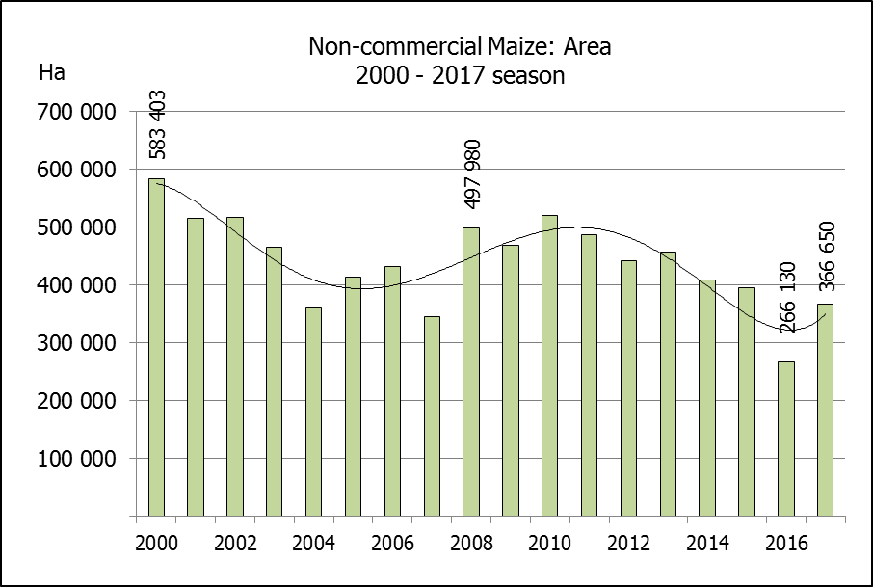
NIE-KOMMERSIëLE MIELIES – OPPERVLAKTE- EN PRODUKSIESKATTING: 2017
CROP/GEWAS | Area planted/  Opp beplant  2017 | Production/  Produksie  2017 | Area planted/  Opp beplant  2016 | Final crop/  Finale oes  2016 | Change/  Verandering
CROP/GEWAS | Ha | Tons | Ha | Tons | %
CROP/GEWAS | (A) | (B) | (C) | (D) | (B) ÷ (D)
Non-commercial agriculture/Nie-kommersiële landbou:
White maize/Witmielies | 248 500 | 463 600 | 191 225 | 286 175 | +62,00
Yellow maize/Geelmielies | 118 150 | 267 400 | 74 905 | 149 565 | +78,79
Maize/Mielies | 366 650 | 731 000 | 266 130 | 435 740 | +67,76
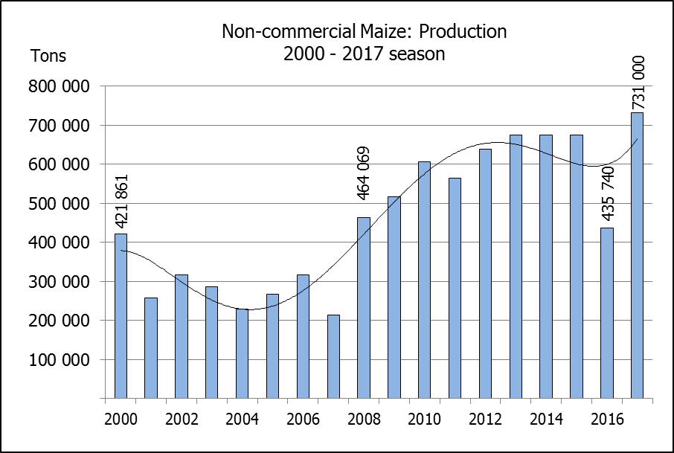
The area planted to maize in the non-commercial agricultural sector is estimated at 366 650 ha, which represents an increase of 37,77%, compared to the 266 130 ha of the previous season. The expected maize crop for this sector is 731 000 tons, which is 67,76% more than the 435 740 tons of last season. It is important to note that about 64% of the maize produced in the non-commercial sector, is planted in the Eastern Cape.
Die oppervlakte beplant met mielies in die nie-kommersiële landbou-sektor word geskat op 366 650 ha, wat ‘n toename van 37,77 % verteenwoordig in vergelyking met die 266 130 ha van die vorige seisoen. Die verwagte mielie-oes van dié sektor is 731 000 ton, wat 67,76% meer is as die 435 740 ton van die vorige seisoen. Dit is belangrik om daarop te let dat ongeveer 64% van die mielies wat geproduseer word in die nie-kommersiële sektor, in die Oos-Kaap geplant word.

