 | crop estimates committee | 
 | oesskattingskomitee
From/Van: Rodney D. Dredge
Tel: 012 319 6507  Fax/Faks: 012 319 6211  E-mail/E-pos: RodneyD@daff.gov.za
Web page/Webblad: www.daff.gov.za/statistics and economic reports or www.sagis.org.za/CEC: Crop Estimates
EMBARGO: 15:30

The area planted estimate and sixth production forecast for summer crops for 2016 is hereby released.
Hiermee word die oppervlakte- en sesde produksieskatting vir somergewasse vir 2016 vrygestel.

SUMMER CROPS – AREA PLANTED AND SIXTH PRODUCTION FORECAST: 2016
SOMERGEWASSE – OPPERVLAKTE- EN SESDE PRODUKSIESKATTING: 2016
CROP/GEWAS | Area planted/  Opp beplant  2016 | 6th forecast/  6de skatting  2016 | 5th forecast/  5de skatting  2016 | Area planted/  Opp beplant  2015 | Final crop/  Finale oes  2015 | Change/  Verandering/
CROP/GEWAS | Ha | Tons | Tons | Ha | Tons | %
CROP/GEWAS | (A) | (B) | (C) | (D) | (E) | (B) ÷ (C)
Commercial/Kommersieel:
White maize/Witmielies | 1 014 750 | 3 097 225 | 3 097 225 | 1 448 050 | 4 735 000 | -
Yellow maize/Geelmielies | 932 000 | 4 063 700 | 4 063 700 | 1 204 800 | 5 220 000 | -
Total Maize/Totale Mielies | 1 946 750 | 7 160 925 | 7 160 925 | 2 652 850 | 9 955 000 | -
Sunflower seed/Sonneblomsaad | 718 500 | 742 750 | 742 750 | 576 000 | 663 000 | -
Soybeans/Sojabone | 502 800 | 728 650 | 728 650 | 687 300 | 1 070 000 | -
Groundnuts/Grondbone | 22 600 | 31 600 | 31 600 | 58 000 | 62 300 | -
Sorghum | 48 500 | 88 500 | 88 500 | 70 500 | 120 500 | -
Dry beans/Droëbone | 34 400 | 38 095 | 38 095 | 64 000 | 73 390 | -
TOTAL/TOTAAL | 3 273 550 | 8 790 520 | 8 790 520 | 4 108 650 | 11 944 190 | -
Note: Estimate is for calendar year, e.g. production season 2015/16 = 2016
Nota: Skatting is vir kalenderjaar, bv. produksie-seisoen 2015/16 = 2016

The Crop Estimates Committee comprises officials of the following institutions:
Department of Agriculture, Forestry and Fisheries; Provincial Departments of Agriculture; various ARC-Institutes (Soil, Climate and Water; Small Grains Institute;
and Grain Crops Institute); and Statistics SA.
28 June/Junie 2016

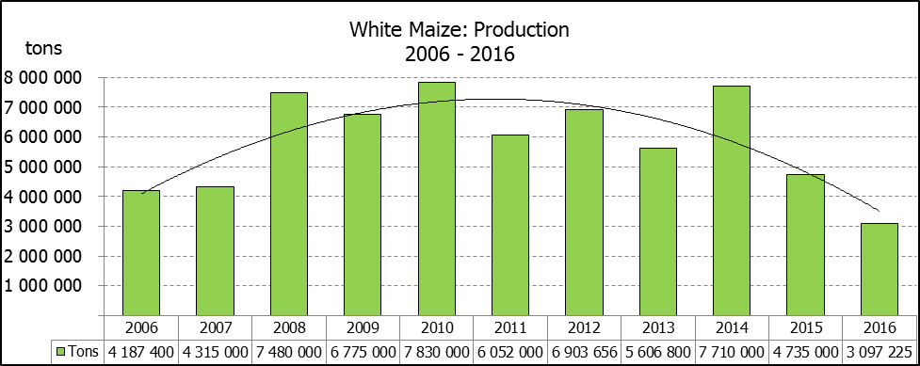

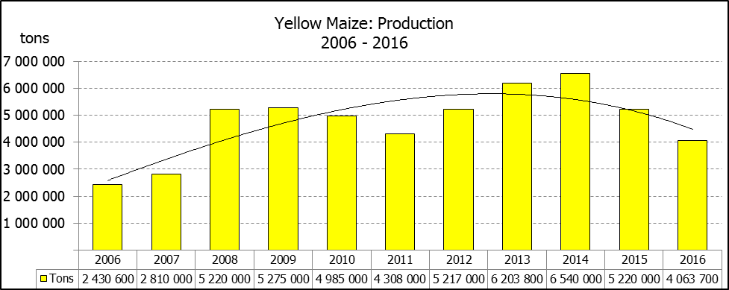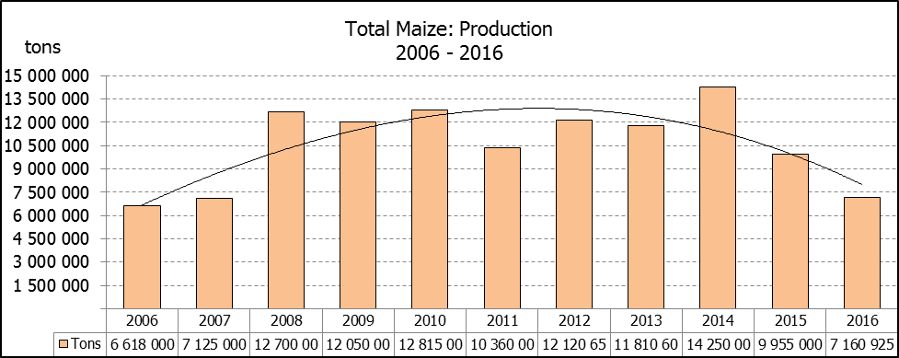

WHITE AND YELLOW MAIZE – AREA PLANTED AND SIXTH PRODUCTION FORECAST: 2016
WIT- EN GEELMIELIES – OPPERVLAKTE EN SESDE PRODUKSIESKATTING: 2016

Provinsie/  Province | Area planted/  Oppervlakte beplant  2016 |  |  | 6th forecast/  6de skatting  2016 |  |  | Area planted/  Oppervlakte beplant  2015 |  |  | Final crop/  Finale oes  2015
Provinsie/  Province | White/  Wit  Ha | Yellow/  Geel  Ha | Total/  Totaal  Ha | White/  Wit  Tons | Yellow/  Geel  Tons | Total/  Totaal  Tons | White/  Wit  Ha | Yellow/  Geel  Ha | Total/  Totaal  Ha | White/  Wit  Tons | Yellow/  Geel  Tons | Total/  Totaal  Tons
Western Cape/Wes-Kaap | 500 | 4 000 | 4 500 | 5 000 | 40 000 | 45 000 | 450 | 3 800 | 4 250 | 4 050 | 34 200 | 38 250
Northern Cape/Noord-Kaap | 3 750 | 50 000 | 53 750 | 34 875 | 665 000 | 699 875 | 3 500 | 46 000 | 49 500 | 35 000 | 644 000 | 679 000
Free State/Vrystaat | 390 000 | 310 000 | 700 000 | 1 072 500 | 976 500 | 2 049 000 | 710 000 | 510 000 | 1 220 000 | 2 236 000 | 1 708 500 | 3 944 500
Eastern Cape/Oos-Kaap | 2 000 | 12 000 | 14 000 | 9 000 | 58 800 | 67 800 | 2 600 | 14 000 | 16 600 | 15 600 | 84 000 | 99 600
KwaZulu-Natal | 38 000 | 48 000 | 86 000 | 193 800 | 283 200 | 477 000 | 40 000 | 45 000 | 85 000 | 224 000 | 283 500 | 507 500
Mpumalanga | 160 000 | 330 000 | 490 000 | 672 000 | 1 452 000 | 2 124 000 | 154 000 | 315 000 | 469 000 | 824 000 | 1 605 300 | 2 429 300
Limpopo | 31 500 | 22 000 | 53 500 | 173 250 | 129 800 | 303 050 | 28 500 | 21 000 | 49 500 | 156 750 | 124 000 | 280 750
Gauteng | 49 000 | 56 000 | 105 000 | 205 800 | 218 400 | 424 200 | 44 000 | 65 000 | 109 000 | 193 600 | 292 500 | 486 100
North West/Noordwes | 340 000 | 100 000 | 440 000 | 731 000 | 240 000 | 971 000 | 465 000 | 185 000 | 650 000 | 1 046 000 | 444 000 | 1 490 000
Total/Totaal | 1 014 750 | 932 000 | 1 946 750 | 3 097 225 | 4 063 700 | 7 160 925 | 1 448 050 | 1 204 800 | 2 652 850 | 4 735 000 | 5 220 000 | 9 955 000

SUNFLOWER SEED – AREA PLANTED AND SIXTH PRODUCTION FORECAST: 2016
SONNEBLOMSAAD – OPPERVLAKTE EN SESDE PRODUKSIESKATTING: 2016

Province/  Provinsie | Area planted/  Opp beplant  Ha | 6th forecast/  6de skatting  Tons | Area planted/  Opp beplant  Ha | Final crop/  Finale oes  Tons
Province/  Provinsie | 2016 | 2016 | 2015 | 2015
Western Cape/Wes-Kaap | - | - | - | -
Northern Cape/Noord-Kaap | 500 | 600 | 500 | 500
Free State/Vrystaat | 400 000 | 440 000 | 285 000 | 370 500
Eastern Cape/Oos-Kaap | - | - | - | -
KwaZulu-Natal | - | - | - | -
Mpumalanga | 4 000 | 4 400 | 2 500 | 3 300
Limpopo | 65 000 | 48 750 | 82 000 | 61 500
Gauteng | 4 000 | 4 000 | 6 000 | 7 200
North West/Noordwes | 245 000 | 245 000 | 200 000 | 220 000
Total/Totaal | 718 500 | 742 750 | 576 000 | 663 000

SOYBEANS – AREA PLANTED AND SIXTH PRODUCTION FORECAST: 2016
SOJABONE – OPPERVLAKTE EN SESDE PRODUKSIESKATTING: 2016

Province/  Provinsie | Area planted/  Opp beplant  Ha | 6th forecast/  6de skatting  Tons | Area planted/  Opp beplant  Ha | Final crop/  Finale oes  Tons
Province/  Provinsie | 2016 | 2016 | 2015 | 2015
Western Cape/Wes-Kaap | 800 | 1 200 | 800 | 1 600
Northern Cape/Noord-Kaap | 4 000 | 12 400 | 4 000 | 14 000
Free State/Vrystaat | 174 000 | 165 300 | 305 000 | 366 000
Eastern Cape/Oos-Kaap | 1 500 | 2 100 | 1 500 | 2 100
KwaZulu-Natal | 28 000 | 63 000 | 42 000 | 102 900
Mpumalanga | 240 000 | 384 000 | 245 000 | 389 900
Limpopo | 16 000 | 38 400 | 24 000 | 72 000
Gauteng | 23 000 | 48 300 | 30 000 | 69 000
North West/Noordwes | 15 500 | 13 950 | 35 000 | 52 500
Total/Totaal | 502 800 | 728 650 | 687 300 | 1 070 000

GROUNDNUTS – AREA PLANTED AND SIXTH PRODUCTION FORECAST: 2016
GRONDBONE – OPPERVLAKTE EN SESDE PRODUKSIESKATTING: 2016

Province/  Provinsie | Area planted/  Opp beplant  Ha | 6th forecast/  6de skatting Tons | Area planted/  Opp beplant  Ha | Final crop/  Finale oes  Tons
Province/  Provinsie | 2016 | 2016 | 2015 | 2015
Western Cape/Wes-Kaap | - | - | - | -
Northern Cape/Noord-Kaap | 5 000 | 15 500 | 7 100 | 22 700
Free State/Vrystaat | 6 500 | 6 500 | 22 500 | 21 800
Eastern Cape/Oos-Kaap | - | - | - | -
KwaZulu-Natal | - | - | 100 | 100
Mpumalanga | - | - | - | -
Limpopo | 1 600 | 2 000 | 2 500 | 3 250
Gauteng | - | - | - | -
North West/Noordwes | 9 500 | 7 600 | 25 800 | 14 450
Total/Totaal | 22 600 | 31 600 | 58 000 | 62 300

SORGHUM – AREA PLANTED AND SIXTH PRODUCTION FORECAST: 2016
SORGHUM – OPPERVLAKTE EN SESDE PRODUKSIESKATTING: 2016

Province/  Provinsie | Area planted/  Opp beplant  Ha | 6th forecast/  6de skatting  Tons | Area planted/  Opp beplant  Ha | Final crop/  Finale oes  Tons
Province/  Provinsie | 2016 | 2016 | 2015 | 2015
Western Cape/Wes-Kaap | - | - | - | -
Northern Cape/Noord-Kaap | - | - | - | -
Free State/Vrystaat | 28 000 | 37 800 | 36 000 | 45 000
Eastern Cape/Oos-Kaap | - | - | - | -
KwaZulu-Natal | 500 | 2 000 | 500 | 2 200
Mpumalanga | 10 000 | 35 000 | 11 000 | 48 000
Limpopo | 7 000 | 9 800 | 16 000 | 17 600
Gauteng | - | - | 1 000 | 2 600
North West/Noordwes | 3 000 | 3 900 | 6 000 | 5 100
Total/Totaal | 48 500 | 88 500 | 70 500 | 120 500

DRY BEANS – AREA PLANTED AND SIXTH PRODUCTION FORECAST: 2016
DROëBONE – OPPERVLAKTE EN SESDE PRODUKSIESKATTING: 2016

Province/  Provinsie | Area planted/  Opp beplant  Ha | 6th forecast/  6de skatting  Tons | Area planted/  Opp beplant  Ha | Final crop/  Finale oes  Tons
Province/  Provinsie | 2016 | 2016 | 2015 | 2015
Western Cape/Wes-Kaap | 100 | 150 | 300 | 390
Northern Cape/Noord-Kaap | 350 | 630 | 900 | 2 160
Free State/Vrystaat | 17 000 | 17 000 | 28 000 | 22 400
Eastern Cape/Oos-Kaap | 250 | 375 | 800 | 1 040
KwaZulu-Natal | 2 200 | 2 640 | 6 500 | 7 800
Mpumalanga | 6 000 | 6 000 | 9 000 | 11 250
Limpopo | 3 000 | 4 500 | 7 000 | 16 800
Gauteng | 2 500 | 3 500 | 4 000 | 4 800
North West/Noordwes | 3 000 | 3 300 | 7 500 | 6 750
Total/Totaal | 34 400 | 38 095 | 64 000 | 73 390

CONFIDENTIALITY ISSUES that CEC members are committed to adhere to on the day of the meeting
- Personal items such as laptops, handbags, cell phones, etc. are not allowed in the venue during the meeting
- No member is allowed to leave the meeting before 12:00 in order to prevent disclosure of the information
- The embargo time for the release of crop estimates information is 15:30
- No member is allowed to discuss crop estimates information with anyone other than a member of the Committee before the embargo time
- Only the Chairperson, or a member appointed by the Chairperson, may release the figures to the media
- Members must regard the detail of any information that was collected for and/or discussed during the meeting, as confidential
- Individual information received for crop estimate purposes is treated strictly confidential, and is not divulged for any other purposes

AREA ESTIMATE AND SIXTH PRODUCTION FORECAST OF SUMMER CROPS (2016 PRODUCTION SEASON)/
OPPERVLAKTE- EN SESDE PRODUKSIESKATTING VIR SOMERGEWASSE (2016 PRODUKSIE-SEISOEN)
28 JUNE/JUNIE 2016

Summer field crops – 2016  Commercial maize: The size of the expected commercial maize crop has been left unchanged at 7,161 million tons. The area estimate for maize remained unchanged at 1,947 million ha, while the expected yield is 3,68 t/ha.  The production forecast of white maize remained unchanged at 3,097 million tons. The yield for white maize is 3,05 t/ha. In the case of yellow maize the production forecast remained unchanged at 4,064 million tons. The yield for yellow maize is 4,36 t/ha.  Other summer crops:  Sunflower seed: The production forecast for sunflower seed also remained unchanged at 742 750 tons. The area estimate for sunflower seed is 718 500 ha, while the expected yield is 1,03 t/ha.  Other crops: The production forecast for soybeans remained unchanged at 728 650 tons. The estimated area planted to soybeans is 502 800 ha, with an expected yield of 1,45 t/ha.  The expected groundnut crop remained unchanged at 31 600 tons. For groundnuts, the area estimate is 22 600 ha, with an expected yield of 1,40 t/ha.  The production forecast for sorghum remained unchanged at 88 500 tons, whilst the area estimate for sorghum is 48 500 ha and the expected yield 1,82 t/ha.  In the case of dry beans, the production forecast also remained unchanged at 38 095 tons, with an area estimate of 34 400 ha, and an expected yield of 1,11 t/ha.  Please note that the seventh production forecast for summer field crops for 2016, as well as the preliminary area estimate of the winter cereal crops for 2016, will be released on 27 July 2016. |  | Somergewasse – 2016  Kommersiële mielies: Die grootte van die verwagte kommersiële mielie-oes is onveranderd gelaat op 7,161 miljoen ton. Die skatting van die oppervlakte onder mielies is onveranderd gelaat op 1,947 miljoen ha, terwyl die verwagte opbrengs 3,68 t/ha is.  Die produksieskatting van witmielies is onveranderd gelaat op 3,097 miljoen ton. Die opbrengs van witmielies is 3,05 t/ha. In die geval van geelmielies is die produksieskatting onveranderd gelaat op 4,064 miljoen ton. Die opbrengs van geelmielies is 4,36 t/ha.  Ander somergewasse:  Sonneblomsaad: Die produksieskatting vir sonneblomsaad is ook onveranderd gelaat op 742 750 ton. Die oppervlakteskatting vir sonneblomsaad is 718 500 ha, terwyl die verwagte opbrengs 1,03 t/ha is.  Ander gewasse: Die produksieskatting van sojabone is onveranderd gelaat op 728 650 ton. Die geskatte oppervlakte beplant met sojabone is 502 800 ha, met ‘n verwagte opbrengs van 1,45 t/ha.  Die verwagte grondbone-oes is onveranderd gelaat op 31 600 ton. Vir grondbone is die oppervlakteskatting 22 600 ha, terwyl die verwagte opbrengs 1,40 t/ha is.  Die produksieskatting van sorghum is onveranderd gelaat op 88 500 ton, terwyl die oppervlakteskatting vir sorghum 48 500 ha is en die verwagte opbrengs 1,82 t/ha.  In die geval van droëbone is die produksieskatting ook onveranderd gelaat op 38 095 ton, met ‘n oppervlakte skatting van 34 400 ha, en ‘n verwagte opbrengs van 1,11 t/ha.  Neem asseblief kennis dat die sewende produksieskatting vir somergewasse vir 2016, sowel as die voorlopige oppervlakteskatting van die wintergewasse vir 2016 op 27 Julie 2016 vrygestel sal word.

The non-commercial agricultural sectors’ production estimate for maize for 2016 is hereby released. /
Hiermee word die nie-kommersiële landbou-sektor se produksieskatting vir mielies vir 2016 vrygestel.

NON-COMMERCIAL MAIZE – AREA PLANTED AND PRODUCTION ESTIMATE: 2016
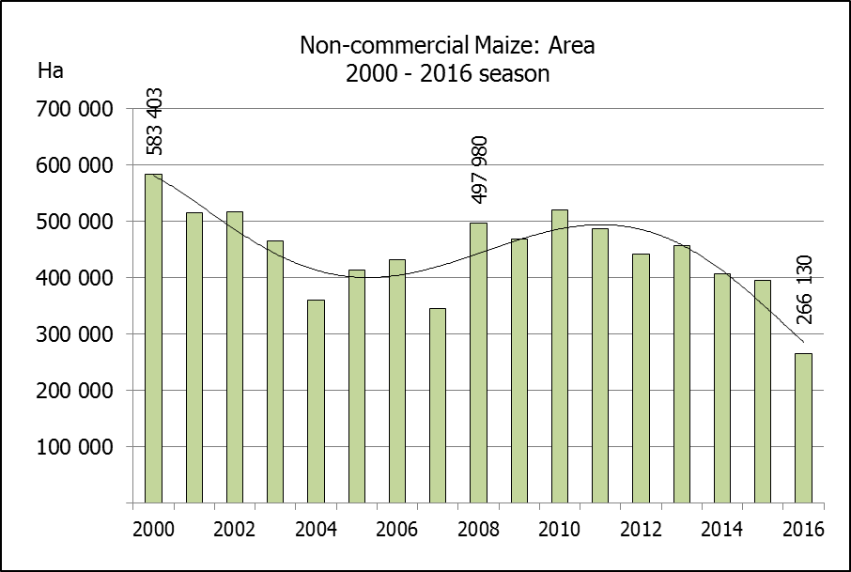
NIE-KOMMERSIëLE MIELIES – OPPERVLAKTE- EN PRODUKSIESKATTING: 2016
CROP/GEWAS | Area planted/  Opp beplant  2016 | Production/  Produksie  2016 | Area planted/  Opp beplant  2015 | Final crop/  Finale oes  2015 | Change/  Verandering
CROP/GEWAS | Ha | Tons | Ha | Tons | %
CROP/GEWAS | (A) | (B) | (C) | (D) | (B) ÷ (D)
Non-commercial agriculture/Nie-kommersiële landbou:
White maize/Witmielies | 191 225 | 286 175 | 278 000 | 442 200 | -35,28
Yellow maize/Geelmielies | 74 905 | 149 565 | 117 200 | 231 600 | -35,42
Maize/Mielies | 266 130 | 435 740 | 395 200 | 673 800 | -35,33
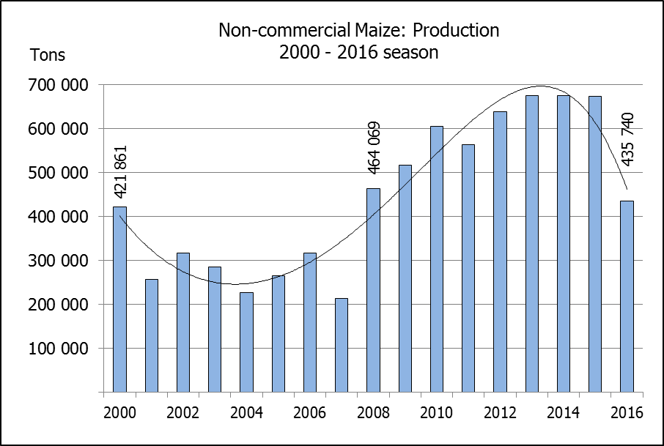
The area planted to maize in the non-commercial agricultural sector is estimated at 266 130 ha, which represents a decrease of 32,7% compared to the 395 200 ha of the previous season. The expected maize crop for this sector is 435 740 tons, which is 35,3% less than the 673 800 tons of last season. It is important to note that about 60% of the maize produced in the non-commercial sector, is planted in the Eastern Cape.
Die oppervlakte beplant met mielies in die nie-kommersiële landbou-sektor word geskat op 266 130 ha, wat ‘n afname van 32,7 % verteenwoordig in vergelyking met die 395 200 ha van die vorige seisoen. Die verwagte mielie-oes van dié sektor is 435 740 ton, wat 35,3% minder is as die 673 800 ton van die vorige seisoen. Dit is belangrik om daarop te let dat ongeveer 60% van die mielies wat geproduseer word in die nie-kommersiële sektor, in die Oos-Kaap geplant word.

