 | crop estimates committee
 | oesskattingskomitee
From/Van: Mr Baldwin Netshifhefhe  Tel: 012 319 8043/32 E-mail/E-pos: BaldwinN@dalrrd.gov.za  Web page/Webblad: www.dalrrd.gov.za/old website/statistics and economic reports or  www.sagis.org.za/CEC: Crop Estimates EMBARGO: 14:30 |  |  | 

The area planted estimate and sixth production forecast for summer crops for 2023 is hereby released.
Hiermee word die oppervlakte- en sesde produksieskatting vir somergewasse vir 2023 vrygestel.

SUMMER CROPS – AREA PLANTED AND SIXTH PRODUCTION FORECAST: 2023
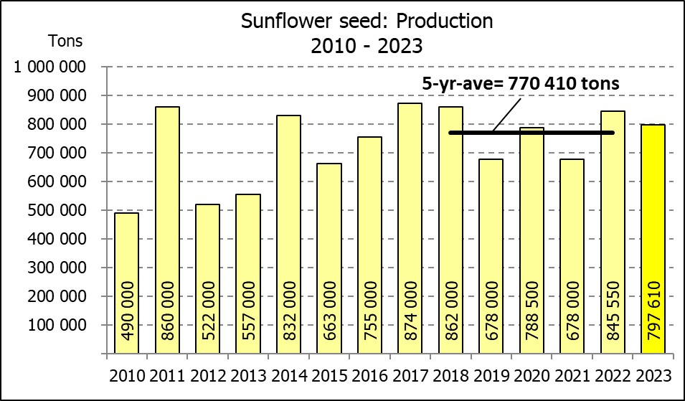
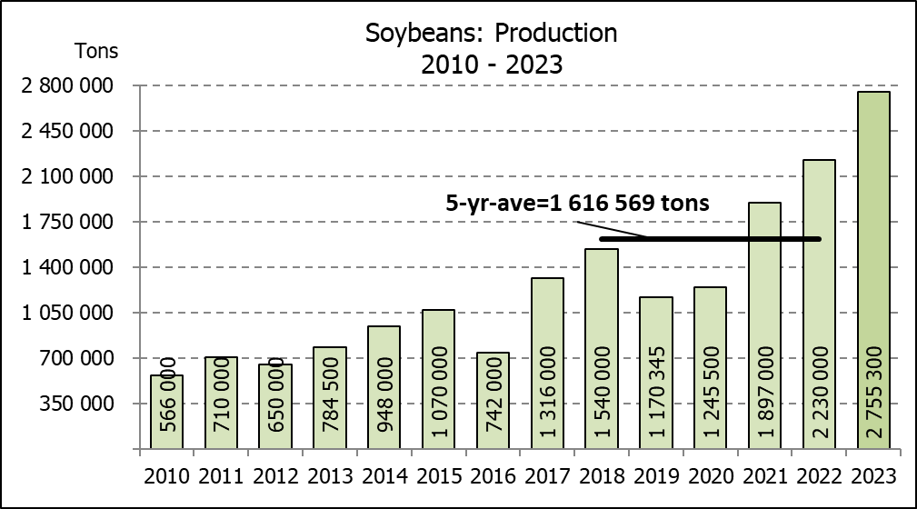
SOMERGEWASSE – OPPERVLAKTE- EN SESDE PRODUKSIESKATTING: 2023
CROP/GEWAS | Area planted/  Opp beplant  2023 | 6th forecast/  6de skatting  2023 | 5th forecast/  5de skatting  2023 | Area planted/  Opp beplant  2022 | Final crop/  Finale oes  2022 | Change/  Verandering/
CROP/GEWAS | Ha | Tons | Tons | Ha | Tons | %
CROP/GEWAS | (A) | (B) | (C) | (D) | (E) | (B) ÷ (C)
Commercial/Kommersieël:
White maize/Witmielies | 1 521 300 | 8 637 950 | 8 637 950 | 1 575 000 | 7 850 000 | -
Yellow maize/Geelmielies | 1 064 800 | 7 716 150 | 7 716 150 | 1 048 000 | 7 620 000 | -
Total Maize/Totale Mielies | 2 586 100 | 16 354 100 | 16 354 100 | 2 623 000 | 15 470 000 | -
Sunflower seed/Sonneblomsaad | 555 700 | 758 610 | 758 610 | 670 700 | 845 550 | -
Soybeans/Sojabone | 1 148 300 | 2 755 300 | 2 755 300 | 925 300 | 2 230 000 | -
Groundnuts/Grondbone | 31 300 | 51 910 | 51 510 | 43 400 | 48 500 | +0,78
Sorghum | 34 000 | 100 525 | 103 870 | 37 200 | 103 140 | -3,22
Dry beans/Droëbone | 36 650 | 48 560 | 48 560 | 42 900 | 52 590 | -
Non-Commercial Maize/Nie-Kommersiële Mielies
Total Maize/Totale Mielies | 358 620 | 664 040 | 664 040 | 378 800 | 667 000 | -
Maize/Mielies: Commercial/Kommersieël + Non-Commercial/Nie-Kommersieël
Total Maize RSA/Totaal Mielies RSA | 2 944 720 | 17 018 140 | 17 018 140 | 3 001 800 | 16 137 000 | -
Note: Estimate is for calendar year, e.g. production season 2022/23 = 2023
Nota: Skatting is vir kalenderjaar, bv. produksie-seisoen 2022/23 = 2023

The Crop Estimates Committee comprises officials of the following institutions:
Department of Agriculture, Land Reform and Rural Development; Provincial Departments of Agriculture; various ARC-Institutes (Soil, Climate and Water; Small Grains Institute; and
Grain Crops Institute); BFAP and Statistics SA.
26 July/Julie 2023
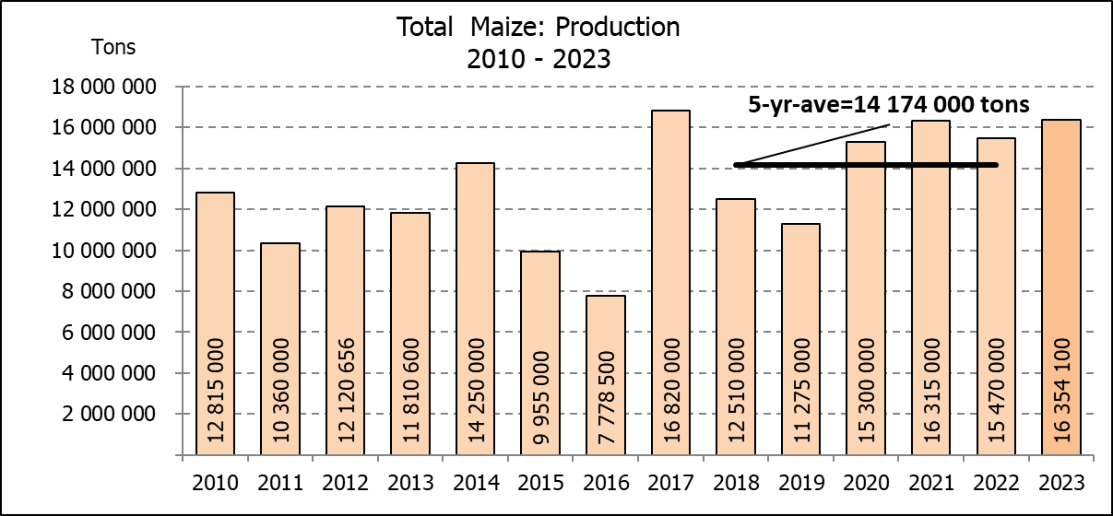

WHITE AND YELLOW MAIZE – AREA PLANTED AND SIXTH PRODUCTION FORECAST: 2023
WIT- EN GEELMIELIES – OPPERVLAKTE EN SESDE PRODUKSIESKATTING: 2023

Provinsie/  Province | Area planted/  Oppervlakte beplant  2023 |  |  | 6th forecast/  6de skatting  2023 |  |  | Area planted/  Oppervlakte beplant  2022 |  |  | Final crop/  Finale oes  2022
Provinsie/  Province | White/  Wit  Ha | Yellow/  Geel  Ha | Total/  Totaal  Ha | White/  Wit  Tons | Yellow/  Geel  Tons | Total/  Totaal  Tons | White/  Wit  Ha | Yellow/  Geel  Ha | Total/  Totaal  Ha | White/  Wit  Tons | Yellow/  Geel  Tons | Total/  Totaal  Tons
Western Cape/Wes-Kaap | 250 | 3 500 | 3 750 | 2 375 | 32 900 | 35 275 | 500 | 3 500 | 4 000 | 4 750 | 32 900 | 37 650
Northern Cape/Noord-Kaap | 1 000 | 43 500 | 44 500 | 12 500 | 652 500 | 665 000 | 3 000 | 42 000 | 45 000 | 36 000 | 672 000 | 708 000
Free State/Vrystaat | 780 000 | 401 000 | 1 181 000 | 4 563 000 | 2 666 650 | 7 229 650 | 826 500 | 398 000 | 1 224 500 | 3 801 900 | 2 547 800 | 6 349 700
Eastern Cape/Oos-Kaap | 5 750 | 25 000 | 30 750 | 40 250 | 187 500 | 227 750 | 6 000 | 20 500 | 26 500 | 40 800 | 157 900 | 198 700
KwaZulu-Natal | 49 000 | 65 000 | 114 000 | 308 700 | 533 000 | 841 700 | 52 000 | 59 000 | 111 000 | 322 400 | 489 700 | 812 100
Mpumalanga | 156 500 | 352 000 | 508 500 | 1 040 725 | 2 516 800 | 3 557 525 | 165 000 | 350 000 | 515 000 | 1 072 500 | 2 554 000 | 3 626 500
Limpopo | 16 800 | 22 800 | 39 600 | 117 600 | 182 400 | 300 000 | 15 500 | 25 000 | 40 500 | 102 300 | 202 500 | 304 800
Gauteng | 56 000 | 52 000 | 108 000 | 364 000 | 374 400 | 738 400 | 56 500 | 56 000 | 112 500 | 361 600 | 403 200 | 764 800
North West/Noordwes | 456 000 | 100 000 | 556 000 | 2 188 800 | 570 000 | 2 758 800 | 450 000 | 94 000 | 544 000 | 2 107 750 | 560 000 | 2 667 750
Total/Totaal | 1 521 300 | 1 064 800 | 2 586 100 | 8 637 950 | 7 716 150 | 16 354 100 | 1 575 000 | 1 048 000 | 2 623 000 | 7 850 000 | 7 620 000 | 15 470 000

SUNFLOWER SEED – AREA PLANTED AND SIXTH PRODUCTION FORECAST: 2023
SONNEBLOMSAAD – OPPERVLAKTE EN SESDE PRODUKSIESKATTING: 2023

Province/  Provinsie | Area planted/  Opp beplant  Ha | 6th forecast/  6de skatting  Tons | Area planted/  Opp beplant  Ha | Final crop/  Finale oes  Tons
Province/  Provinsie | 2023 | 2023 | 2022 | 2022
Western Cape/Wes-Kaap | - | - | - | -
Northern Cape/Noord-Kaap | 2 500 | 6 250 | 2 500 | 6 250
Free State/Vrystaat | 290 000 | 420 500 | 357 000 | 499 800
Eastern Cape/Oos-Kaap | 700 | 1 400 | 300 | 750
KwaZulu-Natal | 300 | 600 | - | -
Mpumalanga | 5 000 | 7 250 | 3 500 | 5 250
Limpopo | 100 000 | 95 000 | 110 000 | 77 000
Gauteng | 2 200 | 2 860 | 2 400 | 3 000
North West/Noordwes | 155 000 | 224 750 | 195 000 | 253 500
Total/Totaal | 555 700 | 758 610 | 670 700 | 845 550
SOYBEANS – AREA PLANTED AND SIXTH PRODUCTION FORECAST: 2023
SOJABONE – OPPERVLAKTE EN SESDE PRODUKSIESKATTING: 2023

Province/  Provinsie | Area planted/  Opp beplant  Ha | 6th forecast/  6de skatting Tons | Area planted/  Opp beplant  Ha | Final crop/  Finale oes  Tons
Province/  Provinsie | 2023 | 2023 | 2022 | 2022
Western Cape/Wes-Kaap | - | - | - | -
Northern Cape/Noord-Kaap | 1 000 | 3 750 | 800 | 3 000
Free State/Vrystaat | 565 000 | 1 327 750 | 415 000 | 912 500
Eastern Cape/Oos-Kaap | 4 300 | 12 900 | 3 000 | 9 000
KwaZulu-Natal | 44 000 | 158 400 | 39 000 | 150 000
Mpumalanga | 305 000 | 671 000 | 300 000 | 710 000
Limpopo | 26 000 | 88 400 | 22 500 | 76 500
Gauteng | 48 000 | 105 600 | 45 000 | 99 000
North West/Noordwes | 155 000 | 387 500 | 100 000 | 270 000
Total/Totaal | 1 148 300 | 2 755 300 | 925 300 | 2 230 000

GROUNDNUTS – AREA PLANTED AND SIXTH PRODUCTION FORECAST: 2023
GRONDBONE – OPPERVLAKTE EN SESDE PRODUKSIESKATTING: 2023

Province/  Provinsie | Area planted/  Opp beplant  Ha | 6th forecast/  6de skatting Tons | Area planted/  Opp beplant  Ha | Final crop/  Finale oes  Tons
Province/  Provinsie | 2023 | 2023 | 2022 | 2022
Western Cape/Wes-Kaap | - | - | - | -
Northern Cape/Noord-Kaap | 2 000 | 5 300 | 2 400 | 6 000
Free State/Vrystaat | 12 300 | 20 910 | 19 000 | 20 900
Eastern Cape/Oos-Kaap | - | - | - | -
KwaZulu-Natal | - | - | - | -
Mpumalanga | - | - | - | -
Limpopo | 2 000 | 4 700 | 2 000 | 4 600
Gauteng | - | - | - | -
North West/Noordwes | 15 000 | 21 000 | 20 000 | 17 000
Total/Totaal | 31 300 | 51 910 | 43 400 | 48 500

SORGHUM – AREA PLANTED AND SIXTH PRODUCTION FORECAST: 2023
SORGHUM – OPPERVLAKTE EN SESDE PRODUKSIESKATTING: 2023

Province/  Provinsie | Area planted/  Opp beplant  Ha | 6th forecast/  6de skatting  Tons | Area planted/  Opp beplant  Ha | Final crop/  Finale oes  Tons
Province/  Provinsie | 2023 | 2023 | 2022 | 2022
Western Cape/Wes-Kaap | - | - | - | -
Northern Cape/Noord-Kaap | - | - | - | -
Free State/Vrystaat | 5 200 | 16 640 | 7 800 | 20 700
Eastern Cape/Oos-Kaap | - | - | - | -
KwaZulu-Natal | 100 | 400 | 200 | 740
Mpumalanga | 8 500 | 36 975 | 9 000 | 43 650
Limpopo | 15 500 | 34 100 | 15 000 | 26 250
Gauteng | 100 | 450 | 200 | 800
North West/Noordwes | 4 600 | 11 960 | 5 000 | 11 000
Total/Totaal | 34 000 | 100 525 | 37 200 | 103 140

DRY BEANS – AREA PLANTED AND SIXTH PRODUCTION FORECAST: 2023
DROëBONE – OPPERVLAKTE EN SESDE PRODUKSIESKATTING: 2023

Province/  Provinsie | Area planted/  Opp beplant  Ha | 6th forecast/  6de skatting Tons | Area planted/  Opp beplant  Ha | Final crop/  Finale oes  Tons
Province/  Provinsie | 2023 | 2023 | 2022 | 2022
Western Cape/Wes-Kaap | 100 | 180 | 100 | 150
Northern Cape/Noord-Kaap | 450 | 990 | 600 | 1 080
Free State/Vrystaat | 14 000 | 11 900 | 15 500 | 13 950
Eastern Cape/Oos-Kaap | 200 | 360 | 200 | 300
KwaZulu-Natal | 2 100 | 3 150 | 2 300 | 2 760
Mpumalanga | 5 000 | 7 000 | 6 000 | 6 600
Limpopo | 8 000 | 16 000 | 10 400 | 18 200
Gauteng | 800 | 880 | 800 | 800
North West/Noordwes | 6 000 | 8 100 | 7 000 | 8 750
Total/Totaal | 36 650 | 48 560 | 42 900 | 52 590

CONFIDENTIALITY ISSUES that CEC members are committed to adhere to on the day of the meeting
- Personal items such as laptops, handbags, cell phones, etc. are not allowed in the venue during the meeting
- No member is allowed to leave the meeting before 12:00 in order to prevent disclosure of the information
- The embargo time for the release of crop estimates information is 14:30
- No member is allowed to discuss crop estimates information with anyone other than a member of the Committee before the embargo time
- Only the Chairperson, or a member appointed by the Chairperson, may release the figures to the media
- Members must regard the detail of any information that was collected for and/or discussed during the meeting, as confidential
- Individual information received for crop estimate purposes is treated strictly confidential, and is not divulged for any other purposes

AREA ESTIMATE AND SIXTH PRODUCTION FORECAST OF SUMMER CROPS (2023 PRODUCTION SEASON)/
OPPERVLAKTE- EN SESDE PRODUKSIESKATTING VIR SOMERGEWASSE (2023 PRODUKSIE-SEISOEN)
26 JULY/JULIE 2023

Summer field crops – 2023  Commercial maize: The size of the expected commercial maize crop remained unchanged at 16,354 mill. tons. The area estimate for maize is 2,586 mill. ha and the expected yield is 6,32 t/ha.  The estimated maize crop is 5,71% or 884 100 tons larger than the 2022 crop. The three main maize producing areas, namely the Free State, Mpumalanga and North West provinces are expected to produce 83% of the 2023 crop.  The production forecast of white maize remained unchanged at 8,638 mill. tons. The area estimate for white maize is 1,521 mill. ha and the expected yield is 5,68 t/ha.  In the case of yellow maize, the production forecast remained unchanged at 7,716 mill. tons. The area estimate for yellow maize is 1,065 mill. ha and the yield is 7,25 t/ha.  Other summer crops:  Sunflower seed: The production forecast for sunflower seed also remained unchanged at 758 610 tons. The area estimate for sunflower seed is 555 700 ha, while the expected yield is 1,37 t/ha.  Other crops: The production forecast for soybeans remained unchanged at 2,755 mill. tons. The estimated area planted to soybeans is 1,148 mill. ha and the expected yield is 2,40 t/ha.  The expected groundnut crop is 51 910 tons, which is 0,78% or 400 tons more than the 51 510 tons of the previous forecast. For groundnuts, the area estimate is 31 300 ha, with an expected yield of 1,66 t/ha.  The production forecast for sorghum is 100 525 tons, which is 3,22% or 3 345 tons less than the 103 870 tons of the previous forecast. The area estimate for sorghum is 34 000 ha and the expected yield is 2,96 t/ha.  In the case of dry beans, the production forecast remained unchanged at 48 560 tons. The area estimate of dry beans is 36 650 ha, with an expected yield of 1,32 t/ha.  Please note that the seventh production forecast for summer field crops for 2023 will be released on 29 August 2023. |  | Somergewasse – 2023  Kommersiële mielies: Die grootte van die verwagte kommersiële mielie-oes is onveranderd gelaat op 16,354 milj. ton gestel. Die oppervlakteskatting vir mielies is 2,586 milj. ha en die verwagte opbrengs is 6,32 t/ha.  Die geskatte mielie-oes is 5,71% of 884 100 ton groter as die 2022-oes. Die drie belangrikste mielieproduserende gebiede, nl. die Vrystaat, Mpumalanga en Noordwes provinsies, gaan na verwagting 83% van die 2023-oes produseer.  Die produksieskatting van witmielies is onveranderd gelaat op 8,638 milj. ton. Die oppervlakteskatting vir witmielies is 1,521 milj. ha en die verwagte opbrengs is 5,68 t/ha.  In die geval van geelmielies is die produksieskatting onveranderd gelaat op 7,716 milj. ton. Die oppervlakteskatting vir geelmielies is 1,065 milj. ha en die opbrengs is 7,25 t/ha.  Ander somergewasse:  Sonneblomsaad: Die produksieskatting vir sonneblomsaad is ook onveranderd gelaat op 758 610 ton. Die oppervlakteskatting vir sonneblomsaad is 555 700 ha, terwyl die verwagte opbrengs 1,37 t/ha is.  Ander gewasse: Die produksieskatting van sojabone is onveranderd gelaat op 2,755 milj. ton. Die geskatte oppervlakte beplant met sojabone is 1,148 milj. ha en die verwagte opbrengs is 2,40 t/ha.  Die verwagte grondbone-oes is 51 910 ton, wat 0,78% of 400 ton meer is as die 51 510 ton van die vorige skatting. Vir grondbone is die oppervlakteskatting 31 300 ha, terwyl the verwagte opbrengs 1,66 t/ha is.  Die produksieskatting van sorghum is 100 525 ton, wat 3,22% of 3 345 ton minder is as die 103 870 ton van die vorige skatting. Die oppervlakteskatting vir sorghum is 34 000 ha, en die verwagte opbrengs is 2,96 t/ha.  In die geval van droëbone is die produksieskatting onveranderd gelaat op 48 560 ton. Die oppervlakte beplant met droëbone is 36 650 ha, en die verwagte opbrengs is 1,32 t/ha.  Neem asseblief kennis dat die sewende produksieskatting vir somergewasse vir 2023, op 29 Augustus 2023 vrygestel sal word.

The non-commercial agricultural sectors’ production estimate for maize for 2023 is hereby released. /
Hiermee word die nie-kommersiële landbou-sektor se produksieskatting vir mielies vir 2023 vrygestel.

NON-COMMERCIAL MAIZE – AREA PLANTED AND PRODUCTION ESTIMATE: 2023
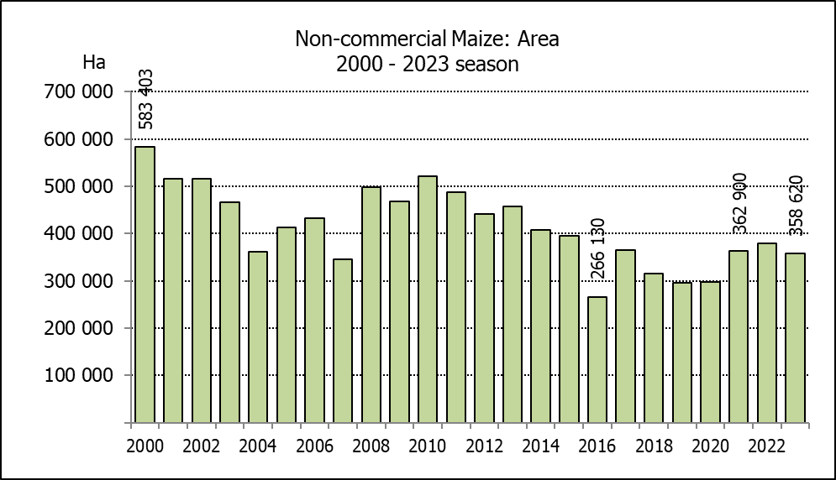
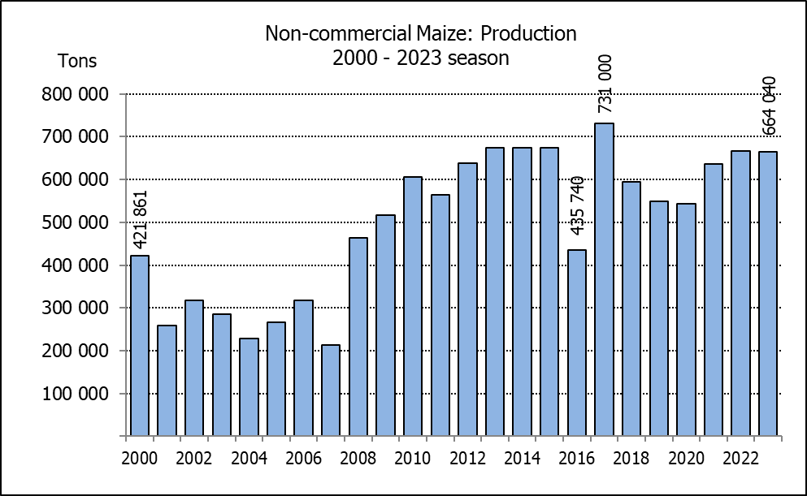
NIE-KOMMERSIëLE MIELIES – OPPERVLAKTE- EN PRODUKSIESKATTING: 2023
CROP/GEWAS | Area planted/  Opp beplant  2023 | Production/  Produksie  2023 | Area planted/  Opp beplant  2022 | Final crop/  Finale oes  2022 | Change/  Verandering
CROP/GEWAS | Ha | Tons | Ha | Tons | %
CROP/GEWAS | (A) | (B) | (C) | (D) | (B) ÷ (D)
Non-commercial agriculture/Nie-kommersiële landbou:
White maize/Witmielies | 278 655 | 472 765 | 296 950 | 482 000 | -1,92
Yellow maize/Geelmielies | 79 965 | 191 275 | 81 850 | 185 000 | +3,39
Maize/Mielies | 358 620 | 664 040 | 378 800 | 667 000 | -0,44
The preliminary area planted to maize in the non-commercial agricultural sector is estimated at 358 620 ha, which represents a decrease of 5,33%, compared to the 378 800 ha of the previous season. The expected maize crop for this sector is 664 040 tons, which is 0,44% less than the 667 000 tons of last season. It is important to note that about 48% of the maize produced in the non-commercial sector, is planted in the Eastern Cape, followed by KwaZulu-Natal with 21%.
Die voorlopige oppervlakte beplant met mielies in die nie-kommersiële landbou-sektor word geskat op 358 620 ha, wat ’n afname van 5,33% verteenwoordig in vergelyking met die 378 800 ha van die vorige seisoen. Die verwagte mielie-oes van dié sektor is 664 040 ton, wat 0,44% minder is as die 667 000 ton van die vorige seisoen. Dit is belangrik om daarop te let dat ongeveer 48% van die mielies wat geproduseer word in die nie-kommersiële sektor, in die Oos-Kaap geplant word, gevolg deur KwaZulu-Natal met 21%.

The preliminary area estimate for winter cereals for the 2023 is hereby released. /
Hiermee word die voorlopige oppervlakteskatting vir wintergewasse vir 2023 vrygestel.

WINTER CEREALS – PRELIMINARY AREA PLANTED ESTIMATE: 2023 PRODUCTION SEASON
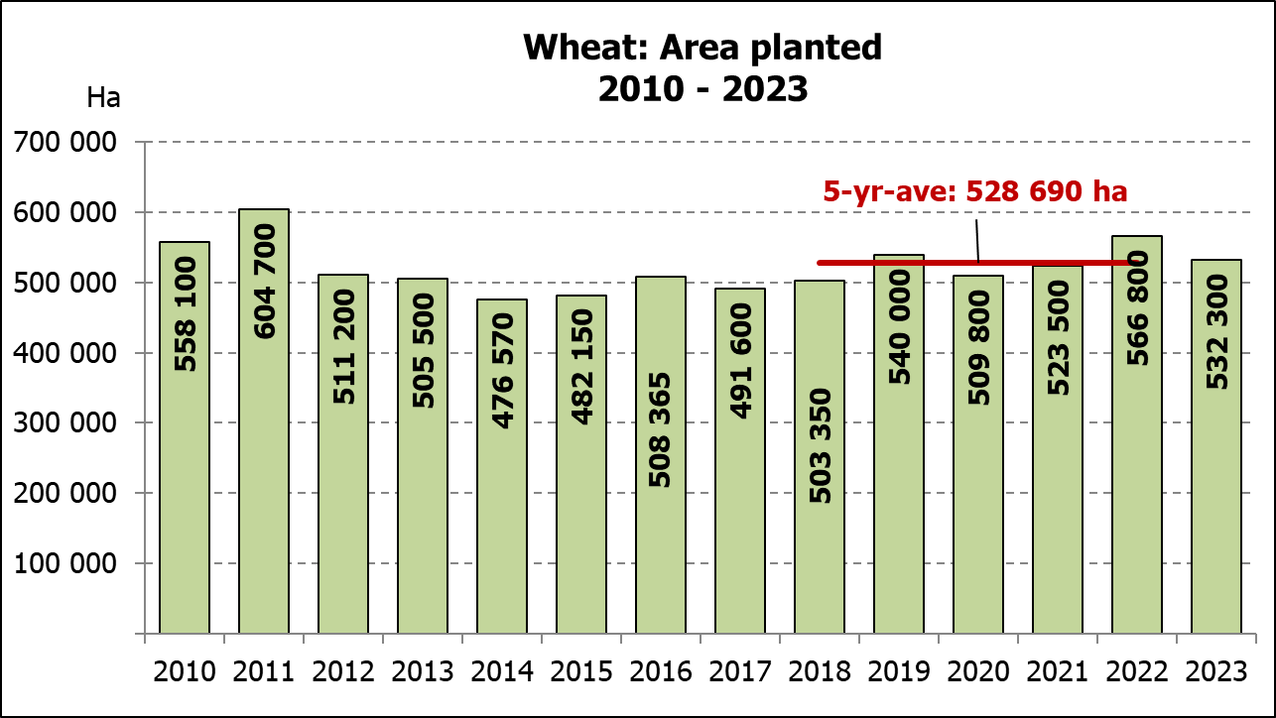
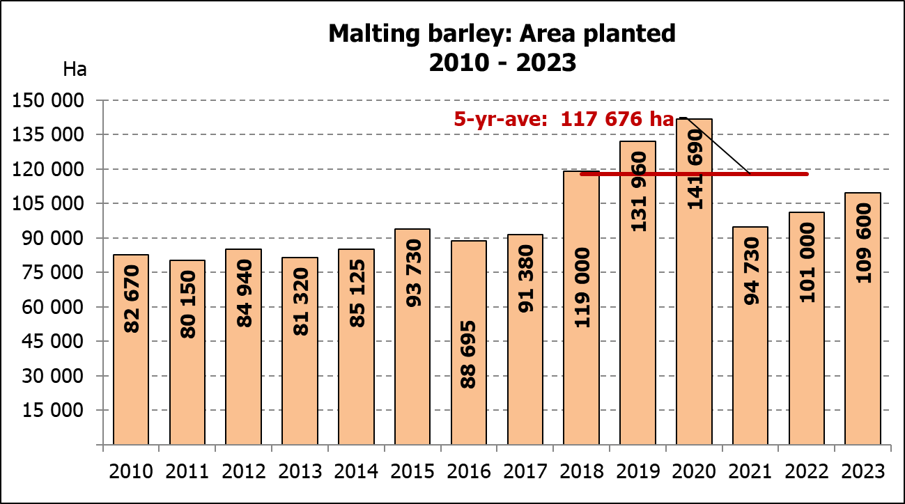
WINTERGEWASSE – VOORLOPIGE OPPERVLAKTESKATTING: 2023-PRODUKSIESEISOEN
CROP/GEWAS | Area planted/  Opp beplant  2023 | Intentions/  Voorneme*  Mid April 2023 | Area planted/  Opp beplant  2022 | Final crop/  Finale oes  2022 | Change/  Verandering
CROP/GEWAS | Ha | Ha | Ha | Tons | %
CROP/GEWAS | (A) | (B) | (C) | (D) | (A) ÷ (C)
Commercial/Kommersieel:
Wheat/Koring | 532 300 | 542 600 | 566 800 | 2 110 000 | -6,09
Barley/Gars¹⁾ | 109 600 | 109 100 | 101 000 | 302 000 | +8,51
Canola/Kanola | 128 100 | 127 500 | 123 510 | 210 000 | +3,72
Oats/Hawer¹⁾ | 26 000 | 29 600 | 27 000 | 27 550 | -3,70
Sweet lupines/Soetlupine | 18 000 | 11 500 | 21 000 | 15 750 | -14,29
* Intentions based on conditions at the middle of April 2023 / Voorneme gebaseer op toestande soos teen middel April 2023.
1) Commercial only. Excluding barley or oats used as pasture, silage, hay and/or on the farm as fodder for livestock /
Slegs kommersieël. Uitgesluit gars of hawer wat gebruik word as weiding, kuilvoer, hooi en/of op die plaas as voer vir vee.

WHEAT – PRELIMINARY AREA PLANTED ESTIMATE: 2023
KORING – VOORLOPIGE OPPERVLAKTESKATTING: 2023
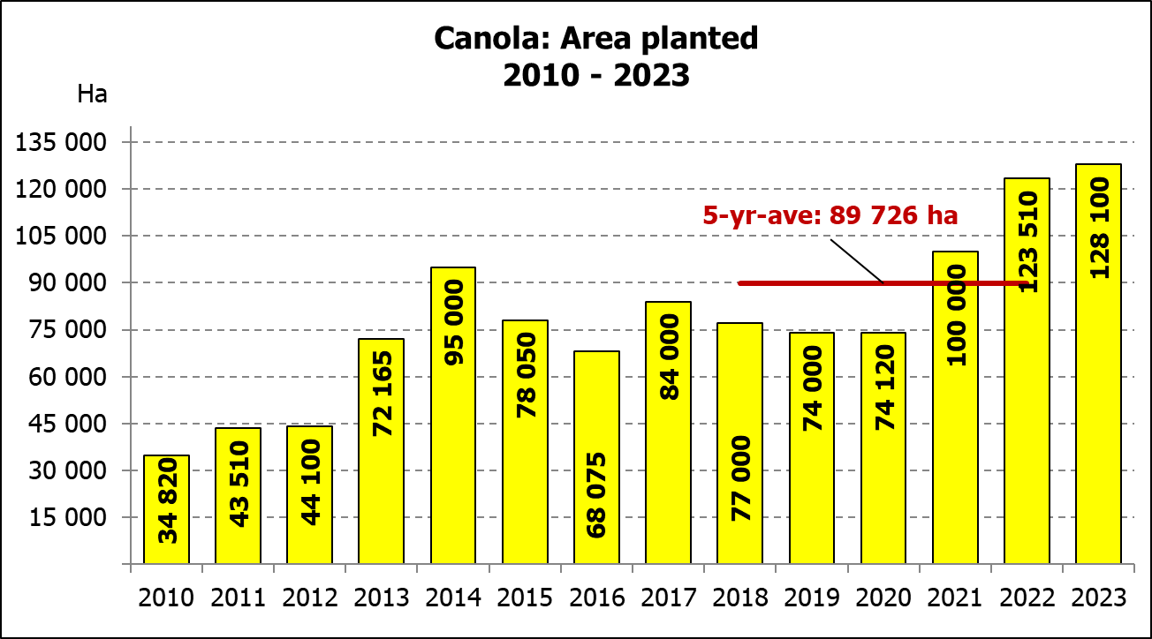
Province/  Provinsie | Area planted/  Opp beplant  Ha | Intentions/  Voorneme*  Ha | Area planted/  Opp beplant  Ha | Final crop/  Finale oes  Tons
Province/  Provinsie | 2023 | Mid April 2023 | 2022 | 2022
Western Cape/Wes-Kaap | 362 000 | 362 500 | 360 000 | 918 000
Northern Cape/Noord-Kaap | 39 000 | 40 000 | 47 000 | 338 500
Free State/Vrystaat | 71 000 | 77 000 | 96 000 | 436 800
Eastern Cape/Oos-Kaap | 6 400 | 6 300 | 6 000 | 40 200
KwaZulu-Natal | 8 500 | 8 500 | 9 200 | 60 730
Mpumalanga | 4 200 | 4 100 | 4 000 | 27 600
Limpopo | 30 000 | 31 000 | 29 000 | 187 000
Gauteng | 1 200 | 1 200 | 1 100 | 7 370
North West/Noordwes | 10 000 | 12 000 | 14 500 | 93 800
Total/Totaal | 532 300 | 542 600 | 566 800 | 2 110 000
* Intentions based on conditions at the middle of April 2023 / Voorneme gebaseer op toestande soos teen middel April 2023.
PRELIMINARY AREA ESTIMATE OF WINTER CROPS (2023) /
VOORLOPIGE OPPERVLAKTESKATTING VAN WINTERGEWASSE (2023)
26 JULY/ 26 JULIE 2023

Winter cereal crops - 2023 production season  The preliminary area estimate is based on the results of a non-probability survey conducted by the Directorate: Statistics and Economic Analysis from the Department of Agriculture, Land Reform and Rural Development, and reflects the position as at the middle of July 2023, as well as inputs from the PDA representatives. Please note that the information from the Producer Independent Crop Estimation System (PICES), as conducted by the National Crop Statistics Consortium (NCSC), for the Western Cape will be available in August 2023 and for the Free State in September 2023.  Wheat: The preliminary area estimate for wheat is 532 300 ha, which is 6,09% or 34 500 ha less than the 566 800 ha planted for the previous season.  The estimated area planted in the Western Cape is 362 000 ha, which is 2 000 ha more than the 360 000 ha of the previous season. In the Free State, 71 000 ha is planted, which is 25 000 ha less than the 96 000 ha planted for the previous season. The area planted in the Northern Cape is 39 000 ha, which is 8 000 ha less than the previous season.  Other crops: The preliminary area estimate for barley is 109 600 ha, which is 8,51% or 8 600 ha more than the 101 000 ha of last season. The area planted to canola is 128 100 ha, which is 3,72% or 4 590 ha more than the 123 510 ha planted for the previous season.  The preliminary area estimate for oats for the 2023 season is 26 000 ha and for sweet lupines 18 000 ha.  Please note that the revised area planted estimate and first production forecast for winter cereals for 2023 will be released on 29 August 2023. |  | Wintergewasse - 2023 produksie-seisoen  Die voorlopige oppervlakteskatting is gebaseer op die resultate van ’n nie-ewekansige opname onderneem deur die Direktoraat: Statistiek en Ekonomiese Analise van die Departement van Landbou, Grondhervorming en Landelike Ontwikkeling, en weerspieël die situasie teen die middel van Julie 2023, sowel as insette van die PDL verteenwoordigers. Let wel, inligting van die Produsente Onafhanklike Oesskattingstelsel (“PICES”), soos gedoen deur die Nasionale Oesskattingskonsortium, sal vir die Wes-Kaap in Augustus 2023 gerapporteer word en vir die Vrystaat in September 2023.  Koring: Die voorlopige skatting van die oppervlakte onder koring beloop 532 300 ha, wat 6,09% of 34 500 ha minder is as die 566 800 ha wat verlede seisoen aangeplant is.  Die beraamde oppervlakte beplant in die Wes-Kaap is 362 000 ha, wat 2 000 ha meer is as die 360 000 ha van die vorige seisoen. Vir die Vrystaat is die aanplantings 71 000 ha, wat 25 000 ha minder is as die 96 000 ha wat verlede seisoen aangeplant is. Die oppervlakte beplant in die Noord-Kaap is 39 000 ha, wat 8 000 ha minder is as die vorige seisoen.  Ander gewasse: Die voorlopige oppervlakskatting vir gars is 109 600 ha, wat 8,51% of 8 600 ha meer is as die 101 000 ha van verlede seisoen. Die oppervlakte onder kanola is 128 100 ha, wat 3,72% of 4 590 ha meer is as die 123 510 ha wat verlede seisoen aangeplant is.  Die voorlopige oppervlakteskatting vir hawer vir die 2023-seisoen is 26 000 ha en vir soetlupine 18 000 ha.  Neem asseblief kennis dat die hersiene oppervlakte beplant en eerste produksieskatting vir wintergewasse vir 2023 op 29 Augustus 2023 vrygestel sal word.

Information is available on the internet at http:// www.dalrrd.gov.za/old website/statistics or http://www.sagis.org.za, as from 14:30 on the date of the relevant meeting of the Crop Estimates Committee. |  | Inligting is beskikbaar op die internet by http://www.dalrrd.gov.za/old website/statistics of by http://www.sagis.org.za, vanaf 14:30 op die dag van die toepaslike vergadering van die Oesskattingskomitee.

