 | crop estimates committee
 | oesskattingskomitee
From/Van: Mr Baldwin Netshifhefhe  Tel: 012 319 8043  Fax/Faks: 012 319 8031  E-mail/E-pos: BaldwinN@dalrrd.gov.za  Web page/Webblad: www.dalrrd.gov.za/statistics and economic reports or  www.sagis.org.za/CEC: Crop Estimates EMBARGO: 14:30 |  |  | 

The area planted estimate and sixth production forecast for summer crops for 2021 is hereby released.
Hiermee word die oppervlakte- en sesde produksieskatting vir somergewasse vir 2021 vrygestel.

SUMMER CROPS – AREA PLANTED AND SIXTH PRODUCTION FORECAST: 2021
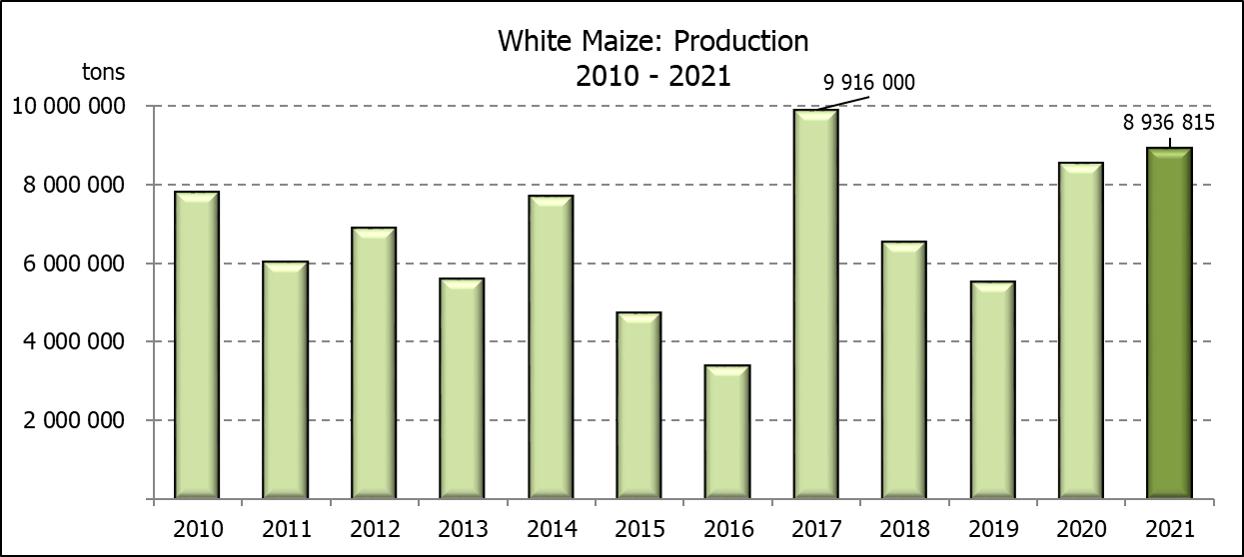
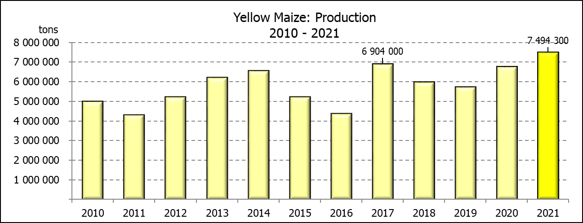
SOMERGEWASSE – OPPERVLAKTE- EN SESDE PRODUKSIESKATTING: 2021
CROP/GEWAS | Area planted/  Opp beplant  2021 |  | 6th forecast/  6de skatting  2021 | 5th forecast/  5de skatting  2021 | Area planted/  Opp beplant  2020 |  | Final crop/  Finale oes  2020 | Change/  Verandering/
CROP/GEWAS | Ha |  | Tons | Tons | Ha |  | Tons | %
CROP/GEWAS | (A) |  | (B) | (C) | (D) |  | (E) | (B) ÷ (C)
Commercial/Kommersieël:
White maize/Witmielies | 1 691 900 |  | 8 936 815 | 8 936 815 | 1 616 300 |  | 8 547 500 | -
Yellow maize/Geelmielies | 1 063 500 |  | 7 494 300 | 7 295 800 | 994 500 |  | 6 752 500 | +2,72
Total Maize/Totale Mielies | 2 755 400 |  | 16 431 115 | 16 232 615 | 2 610 800 |  | 15 300 000 | +1,22
Sunflower seed/Sonneblomsaad | 477 800 |  | 677 240 | 677 240 | 500 300 |  | 788 500 | -
Soybeans/Sojabone | 827 100 |  | 1 918 150 | 1 918 150 | 705 000 |  | 1 245 500 | -
Groundnuts/Grondbone | 38 550 |  | 58 900 | 58 900 | 37 500 |  | 50 080 | -
Sorghum | 49 200 |  | 203 980 | 195 035 | 42 500 |  | 158 000 | +4,59
Dry beans/Droëbone | 47 390 |  | 56 577 | 56 577 | 50 150 |  | 64 800 | -
Non-Commercial Maize/Nie-Kommersiële Mielies
Total Maize/Totaal Mielies | 362 900 | 636 440 |  | 586 650 | 297 460 | 543 545 |  |  | +8,49
Maize/Mielies: Commercial/Kommersieël + Non-Commercial/Nie-Kommersieël
Total Maize RSA/Totaal Mielies RSA | 3 118 300 | 17 067 555 |  | 16 819 265 | 2 908 260 | 15 843 545 |  |  | +1,48
Note: Estimate is for calendar year, e.g. production season 2020/21 = 2021
Nota: Skatting is vir kalenderjaar, bv. produksie-seisoen 2020/21 = 2021
The Crop Estimates Committee comprises officials of the following institutions:
Department of Agriculture, Land Reform and Rural Development; Provincial Departments of Agriculture; various ARC-Institutes (Soil, Climate and Water; Small Grains Institute; and Grain Crops Institute); BFAP and Statistics SA.
28 July / Julie 2021

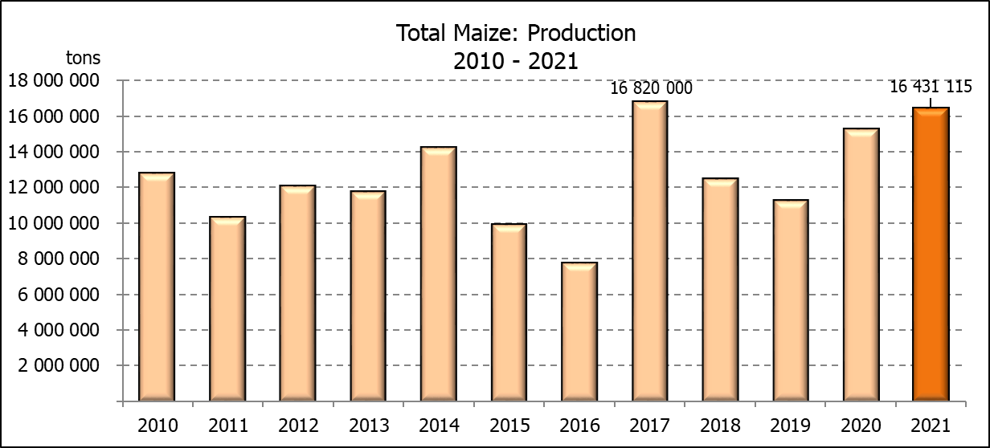

WHITE AND YELLOW MAIZE – AREA PLANTED AND SIXTH PRODUCTION FORECAST: 2021
WIT- EN GEELMIELIES – OPPERVLAKTE EN SESDE PRODUKSIESKATTING: 2021

Provinsie/  Province | Area planted/  Oppervlakte beplant  2021 |  |  | 6th forecast/  6de skatting  2021 |  |  | Area planted/  Oppervlakte beplant  2020 |  |  | Final crop/  Finale oes  2020
Provinsie/  Province | White/  Wit  Ha | Yellow/  Geel  Ha | Total/  Totaal  Ha | White/  Wit  Tons | Yellow/  Geel  Tons | Total/  Totaal  Tons | White/  Wit  Ha | Yellow/  Geel  Ha | Total/  Totaal  Ha | White/  Wit  Tons | Yellow/  Geel  Tons | Total/  Totaal  Tons
Western Cape/Wes-Kaap | 500 | 3 500 | 4 000 | 4 500 | 31 500 | 36 000 | 400 | 3 400 | 3 800 | 3 600 | 30 600 | 34 200
Northern Cape/Noord-Kaap | 3 400 | 41 000 | 44 400 | 40 290 | 623 200 | 663 490 | 3 400 | 43 100 | 46 500 | 40 300 | 633 900 | 674 200
Free State/Vrystaat | 907 500 | 420 000 | 1 327 500 | 4 673 625 | 2 478 000 | 7 151 625 | 855 000 | 365 000 | 1 220 000 | 4 700 000 | 2 209 000 | 6 909 000
Eastern Cape/Oos-Kaap | 6 000 | 18 000 | 24 000 | 39 000 | 131 400 | 170 400 | 5 500 | 17 000 | 22 500 | 35 200 | 119 000 | 154 200
KwaZulu-Natal | 50 000 | 55 000 | 105 000 | 310 000 | 440 000 | 750 000 | 47 000 | 55 000 | 102 000 | 298 400 | 434 500 | 732 900
Mpumalanga | 165 000 | 360 000 | 525 000 | 1 155 000 | 2 736 000 | 3 891 000 | 160 000 | 353 000 | 513 000 | 872 000 | 2 347 500 | 3 219 500
Limpopo | 16 500 | 21 000 | 37 500 | 112 200 | 172 200 | 284 400 | 15 000 | 18 000 | 33 000 | 105 000 | 126 000 | 231 000
Gauteng | 58 000 | 50 000 | 108 000 | 371 200 | 350 000 | 721 200 | 55 000 | 50 000 | 105 000 | 297 000 | 330 000 | 627 000
North West/Noordwes | 485 000 | 95 000 | 580 000 | 2 231 000 | 532 000 | 2 763 000 | 475 000 | 90 000 | 565 000 | 2 196 000 | 522 000 | 2 718 000
Total/Totaal | 1 691 900 | 1 063 500 | 2 755 400 | 8 936 815 | 7 494 300 | 16 431 115 | 1 616 300 | 994 500 | 2 610 800 | 8 547 500 | 6 752 500 | 15 300 000

SUNFLOWER SEED – AREA PLANTED AND SIXTH PRODUCTION FORECAST: 2021
SONNEBLOMSAAD – OPPERVLAKTE EN SESDE PRODUKSIESKATTING: 2021

Province/  Provinsie | Area planted/  Opp beplant  Ha | 6th forecast/  6de skatting  Tons | Area planted/  Opp beplant  Ha | Final crop/  Finale oes  Tons
Province/  Provinsie | 2021 | 2021 | 2020 | 2020
Western Cape/Wes-Kaap | - | - | - | -
Northern Cape/Noord-Kaap | 1 100 | 1 320 | 1 200 | 1 430
Free State/Vrystaat | 235 000 | 352 500 | 260 000 | 444 600
Eastern Cape/Oos-Kaap | 300 | 450 | 300 | 750
KwaZulu-Natal | - | - | - | -
Mpumalanga | 3 500 | 5 250 | 2 800 | 3 920
Limpopo | 76 500 | 76 500 | 65 000 | 65 000
Gauteng | 4 400 | 5 720 | 4 000 | 5 600
North West/Noordwes | 157 000 | 235 500 | 167 000 | 267 200
Total/Totaal | 477 800 | 677 240 | 500 300 | 788 500
SOYBEANS – AREA PLANTED AND SIXTH PRODUCTION FORECAST: 2021
SOJABONE – OPPERVLAKTE EN SESDE PRODUKSIESKATTING: 2021

Province/  Provinsie | Area planted/  Opp beplant  Ha | 6th forecast/  6de skatting  Tons | Area planted/  Opp beplant  Ha | Final crop/  Finale oes  Tons
Province/  Provinsie | 2021 | 2021 | 2020 | 2020
Western Cape/Wes-Kaap | - | - | - | -
Northern Cape/Noord-Kaap | 1 000 | 3 500 | 2 000 | 7 000
Free State/Vrystaat | 365 000 | 766 500 | 315 000 | 519 750
Eastern Cape/Oos-Kaap | 3 100 | 9 300 | 1 500 | 3 000
KwaZulu-Natal | 36 000 | 129 600 | 35 000 | 101 500
Mpumalanga | 290 000 | 652 500 | 260 000 | 416 000
Limpopo | 20 500 | 73 800 | 15 500 | 48 050
Gauteng | 42 000 | 109 200 | 36 000 | 70 200
North West/Noordwes | 69 500 | 173 750 | 40 000 | 80 000
Total/Totaal | 827 100 | 1 918 150 | 705 000 | 1 245 500

GROUNDNUTS – AREA PLANTED AND SIXTH PRODUCTION FORECAST: 2021
GRONDBONE – OPPERVLAKTE EN SESDE PRODUKSIESKATTING: 2021

Province/  Provinsie | Area planted/  Opp beplant  Ha | 6th forecast/  6de skatting  Tons | Area planted/  Opp beplant  Ha | Final crop/  Finale oes  Tons
Province/  Provinsie | 2021 | 2021 | 2020 | 2020
Western Cape/Wes-Kaap | - | - | - | -
Northern Cape/Noord-Kaap | 1 500 | 3 750 | 1 200 | 2 580
Free State/Vrystaat | 16 000 | 24 800 | 11 000 | 15 400
Eastern Cape/Oos-Kaap | - | - | - | -
KwaZulu-Natal | 50 | 50 | - | -
Mpumalanga | - | - | - | -
Limpopo | 3 000 | 6 900 | 2 900 | 5 220
Gauteng | - | - | - | -
North West/Noordwes | 18 000 | 23 400 | 22 400 | 26 880
Total/Totaal | 38 550 | 58 900 | 37 500 | 50 080

SORGHUM – AREA PLANTED AND SIXTH PRODUCTION FORECAST: 2021
SORGHUM – OPPERVLAKTE EN SESDE PRODUKSIESKATTING: 2021

Province/  Provinsie | Area planted/  Opp beplant  Ha | 6^{h} forecast/  6de skatting  Tons | Area planted/  Opp beplant  Ha | Final crop/  Finale oes  Tons
Province/  Provinsie | 2021 | 2021 | 2020 | 2020
Western Cape/Wes-Kaap | - | - | - | -
Northern Cape/Noord-Kaap | - | - | - | -
Free State/Vrystaat | 10 500 | 39 900 | 8 000 | 35 200
Eastern Cape/Oos-Kaap |  | - | - | -
KwaZulu-Natal | 500 | 2 250 | 1 200 | 4 200
Mpumalanga | 9 400 | 56 400 | 8 500 | 46 340
Limpopo | 17 000 | 59 500 | 16 000 | 41 950
Gauteng | 300 | 1 080 | 300 | 960
North West/Noordwes | 11 500 | 44 850 | 8 500 | 29 350
Total/Totaal | 49 200 | 203 980 | 42 500 | 158 000

DRY BEANS – AREA PLANTED AND SIXTH PRODUCTION FORECAST: 2021
DROëBONE – OPPERVLAKTE EN SESDE PRODUKSIESKATTING: 2021

Province/  Provinsie | Area planted/  Opp beplant  Ha | 6th forecast/  6de skatting  Tons | Area planted/  Opp beplant  Ha | Final crop/  Finale oes  Tons
Province/  Provinsie | 2021 | 2021 | 2020 | 2020
Western Cape/Wes-Kaap | 100 | 150 | 100 | 150
Northern Cape/Noord-Kaap | 350 | 700 | 350 | 700
Free State/Vrystaat | 22 000 | 15 400 | 24 000 | 30 000
Eastern Cape/Oos-Kaap | 200 | 300 | 200 | 300
KwaZulu-Natal | 3 000 | 3 900 | 2 900 | 3 480
Mpumalanga | 6 500 | 10 075 | 6 600 | 8 250
Limpopo | 8 000 | 16 000 | 8 400 | 13 440
Gauteng | 840 | 1 092 | 600 | 780
North West/Noordwes | 6 400 | 8 960 | 7 000 | 7 700
Total/Totaal | 47 390 | 56 577 | 50 150 | 64 800

CONFIDENTIALITY ISSUES that CEC members are committed to adhere to on the day of the meeting
- No member is allowed to leave the meeting before 12:00 in order to prevent disclosure of the information
- The embargo time for the release of crop estimates information is 14:30
- No member is allowed to discuss crop estimates information with anyone other than a member of the Committee before the embargo time
- Only the Chairperson, or a member appointed by the Chairperson, may release the figures to the media
- Members must regard the detail of any information that was collected for and/or discussed during the meeting, as confidential
- Individual information received for crop estimate purposes is treated strictly confidential, and is not divulged for any other purposes

AREA ESTIMATE AND SIXTH PRODUCTION FORECAST OF SUMMER CROPS (2021 PRODUCTION SEASON)/
OPPERVLAKTE- EN SESDE PRODUKSIESKATTING VIR SOMERGEWASSE (2021 PRODUKSIE-SEISOEN)
28 JULY/JULIE 2021

Summer field crops – 2021  Commercial maize: The size of the expected commercial maize crop has been set at 16,431 mill. tons, which is 1,22% or 198 500 tons more than the previous forecast of 16,233 mill. tons. The area estimate for maize is 2,755 mill. ha, while the expected yield is 5,96 t/ha.  The estimated maize crop is 7% bigger than the 2020 crop. The three main maize producing areas, namely the Free State, Mpumalanga and North West provinces is expected to produce 84% of the 2021 crop.  The area estimate for white maize is 1,692 mill. ha & for yellow maize the area estimate is 1,064 mill. ha.  The production forecast of white maize remained unchanged at 8,937 mill. tons against the previous estimate. The yield for white maize is 5,28 t/ha. In the case of yellow maize the production forecast is 7,494 mill. tons, which is 2,72% or 198 500 tons more than the 7,296 mill. tons of the previous forecast. The yield for yellow maize is 7,05 t/ha.  Sunflower seed: The production forecast for sunflower seed remained unchanged at 677 240 tons. The area estimate for sunflower seed is 477 800 ha, while the expected yield is 1,42 t/ha.  Other crops: The production forecast for soybeans also remained unchanged at 1,918 mill. tons. The estimated area planted to soybeans is 827 100 ha and the expected yield is 2,32 t/ha.  The expected groundnut crop is 58 900 tons, also unchanged from the previous forecast. For groundnuts, the area estimate is 38 550 ha, with an expected yield of 1,53 t/ha.  The production forecast for sorghum increased by 4,59% or 8 945 tons, from 195 035 tons to 203 980 tons. The area estimate for sorghum is 49 200 ha and the expected yield is 4,15 t/ha.  In the case of dry beans, the production forecast remained unchanged at 56 577 tons. The area estimate of dry beans is 47 390 ha, with an expected yield of 1,19 t/ha.  Please note that the seventh production forecast for summer field crops for 2021 will be released on 26 August 2021. |  | Somergewasse – 2021  Kommersiële mielies: Die grootte van die verwagte kommersiële mielie-oes is op 16,431 milj. ton gestel, wat 1,22% of 198 500 ton meer is as die vorige skatting van 16,233 milj. ton. Die skatting van die oppervlakte onder mielies is 2,755 milj. ha, terwyl die verwagte opbrengs 5,96 t/ha is.  Die geskatte mielie-oes is 7% groter as die 2020-oes. Die drie belangrikste mielieproduserende gebiede, nl. die Vrystaat, Mpumalanga en Noordwes provinsies, gaan na verwagting 84% van die 2021-oes produseer.  Die oppervlak onder witmielies is 1,692 milj. ha en vir geelmielies is die oppervlak 1,064 milj. ha.  Die produksieskatting van witmielies is onveranderd gelaat op 8,937 milj. ton teenoor die vorige skatting. Die opbrengs van witmielies is 5,28 t/ha. In die geval van geelmielies is die produksieskatting 7,494 milj. ton, wat 2,72% of 198 500 ton meer is as die 7,296 milj. ton van die vorige skatting. Die opbrengs van geelmielies is 7,05 t/ha.  Sonneblomsaad: Die produksieskatting vir sonneblomsaad is onveranderd gelaat op 677 240 ton. Die oppervlakteskatting vir sonneblomsaad is 477 800 ha, terwyl die verwagte opbrengs 1,42 t/ha is.  Ander gewasse: Die produksieskatting van sojabone is ook onveranderd gelaat op 1,918 milj. ton. Die geskatte oppervlakte beplant van sojabone is 827 100 ha en die verwagte opbrengs is 2,32 t/ha.  Die verwagte grondbone-oes is 58 900 ton, ook onveranderd teenoor die vorige skatting. Vir grondbone is die oppervlakteskatting 38 550 ha, terwyl die verwagte opbrengs 1,53 t/ha is.  Die produksieskatting van sorghum het met 4,59% of 8 945 ton toegeneem, van 195 035 ton tot 203 980 ton. Die oppervlakteskatting vir sorghum is 49 200 ha, en die verwagte opbrengs is 4,15 t/ha.  In die geval van droëbone is die produksieskatting onveranderd gelaat op 56 577 ton. Die oppervlakte beplant met droëbone is 47 390 ha, en die verwagte opbrengs is 1,19 t/ha.  Neem asseblief kennis dat die sewende produksieskatting vir somergewasse vir 2021 op 26 Augustus 2021 vrygestel sal word.

The non-commercial agricultural sectors’ production estimate for maize for 2021 is hereby released. /
Hiermee word die nie-kommersiële landbou-sektor se produksieskatting vir mielies vir 2021 vrygestel.

NON-COMMERCIAL MAIZE – AREA PLANTED AND PRODUCTION ESTIMATE: 2021
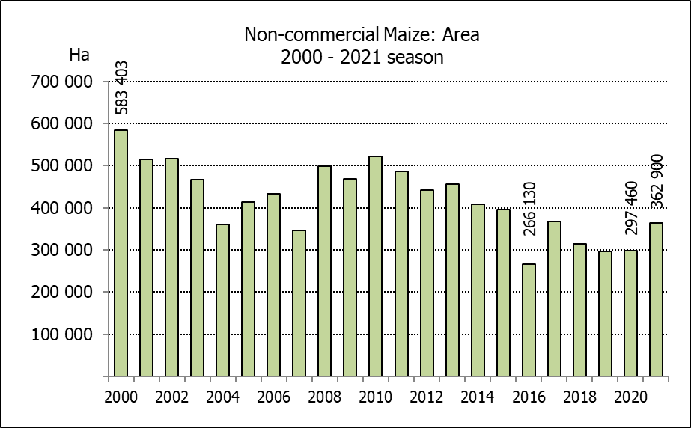
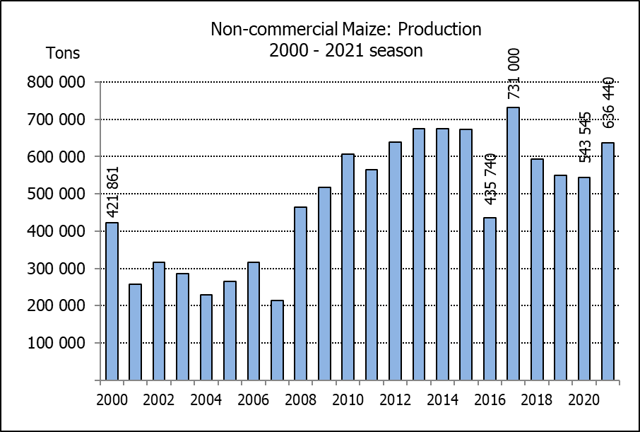
NIE-KOMMERSIëLE MIELIES – OPPERVLAKTE- EN PRODUKSIESKATTING: 2021
CROP/GEWAS | Area planted/  Opp beplant  2021 | Production/  Produksie  2021 | Area planted/  Opp beplant  2020 | Final crop/  Finale oes  2020 | Change/  Verandering
CROP/GEWAS | Ha | Tons | Ha | Tons | %
CROP/GEWAS | (A) | (B) | (C) | (D) | (B) ÷ (D)
Non-commercial agriculture/Nie-kommersiële landbou:
White maize/Witmielies | 276 100 | 445 335 | 221 945 | 375 295 | +18,66
Yellow maize/Geelmielies | 86 800 | 191 105 | 75 515 | 168 250 | +13,58
Maize/Mielies | 362 900 | 636 440 | 297 460 | 543 545 | +17,09
The preliminary area planted to maize in the non-commercial agricultural sector is estimated at 362 900 ha, which represents an increase of 22,00%, compared to the 297 460 ha of the previous season. The expected maize crop for this sector is 636 440 tons, which is 17,09% more than the 543 545 tons of last season. It is important to note that about 53% of the maize produced in the non-commercial sector, is planted in the Eastern Cape, followed by KwaZulu-Natal with 23%.
Die voorlopige oppervlakte beplant met mielies in die nie-kommersiële landbou-sektor word geskat op 362 900 ha, wat ’n toename van 22,00% verteenwoordig in vergelyking met die 297 460 ha van die vorige seisoen. Die verwagte mielie-oes van dié sektor is 636 440 ton, wat 17,09% meer is as die 543 545 ton van die vorige seisoen. Dit is belangrik om daarop te let dat ongeveer 53% van die mielies wat geproduseer word in die nie-kommersiële sektor, in die Oos-Kaap geplant word, gevolg deur KwaZulu-Natal met 23%.

The preliminary area estimate for winter cereals for the 2021 is hereby released. /
Hiermee word die voorlopige oppervlakteskatting vir wintergewasse vir 2021 vrygestel.

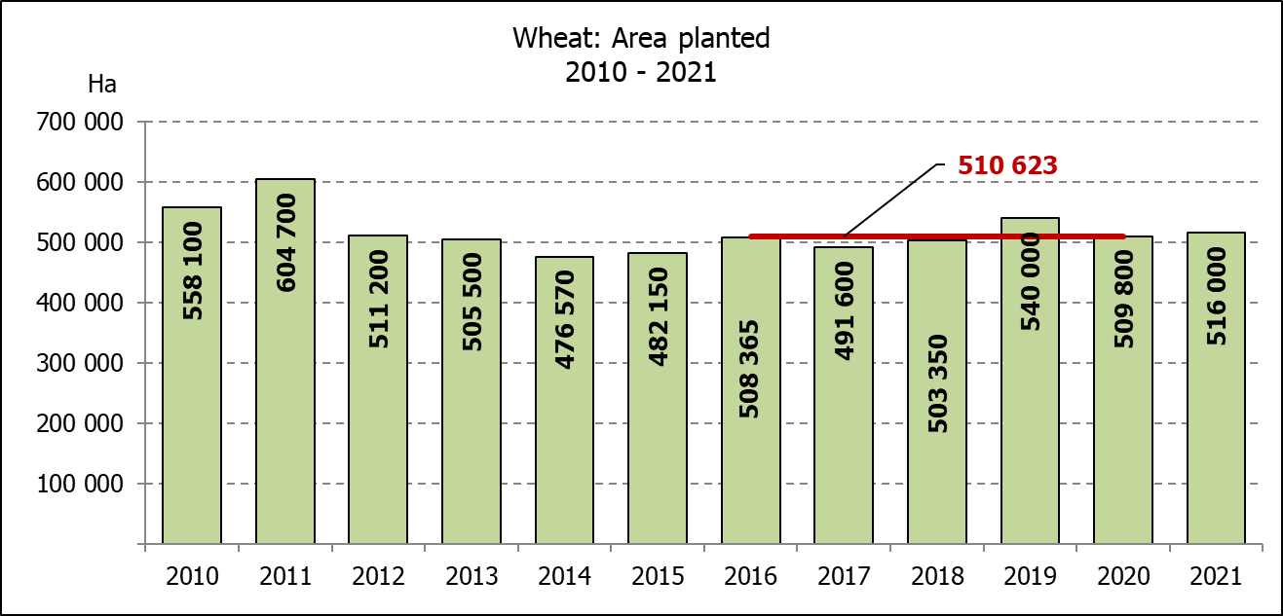
WINTER CEREALS – PRELIMINARY AREA PLANTED ESTIMATE: 2021 PRODUCTION SEASON
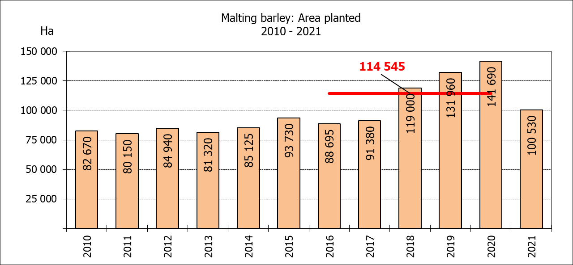
WINTERGEWASSE – VOORLOPIGE OPPERVLAKTESKATTING: 2021-PRODUKSIESEISOEN
CROP/GEWAS | Area planted/  Opp beplant  2021 | Intentions/  Voorneme*  Mid April 2021 | Area planted/  Opp beplant  2020 | Final crop/  Finale oes  2020 | Change/  Verandering
CROP/GEWAS | Ha | Ha | Ha | Tons | %
CROP/GEWAS | (A) | (B) | (C) | (D) | (A) ÷ (C)
Commercial/Kommersieel:
Wheat/Koring | 516 000 | 512 500 | 509 800 | 2 120 000 | +1,22
Malting barley/Moutgars | 100 530 | 95 000 | 141 690 | 588 000 | -29,05
Canola/Kanola | 96 000 | 95 000 | 74 120 | 165 200 | +29,52
Cereal oats/Hawermout | 30 350 | 34 500 | 26 200 | 57 000 | +15,84
Sweet lupines/Soetlupine | 22 300 | 20 000 | N/a | N/a | +23,20
* Intentions based on conditions at the middle of April 2021 / Voorneme gebaseer op toestande soos teen middel April 2021.

WHEAT – PRELIMINARY AREA PLANTED ESTIMATE: 2021
KORING – VOORLOPIGE OPPERVLAKTESKATTING: 2021
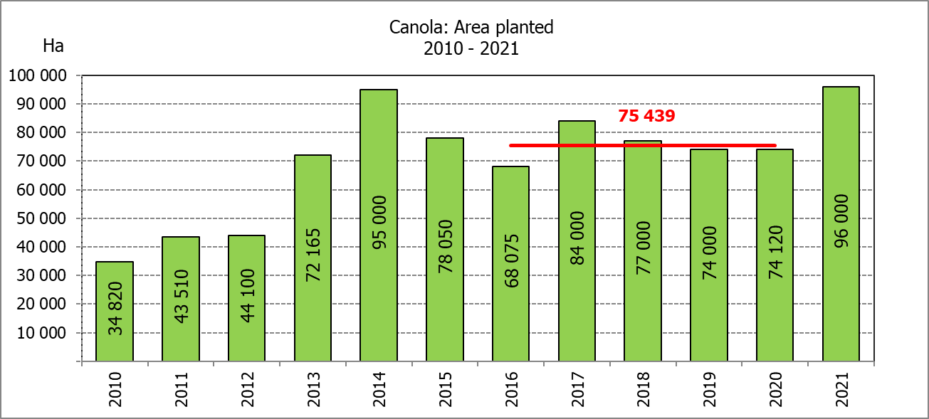
Province/  Provinsie | Area planted/  Opp beplant  Ha | Intentions/  Voorneme*  Ha | Area planted/  Opp beplant  Ha | Final crop/  Finale oes  Tons
Province/  Provinsie | 2021 | Mid April 2021 | 2020 | 2020
Western Cape/Wes-Kaap | 355 000 | 352 000 | 326 000 | 1 103 000
Northern Cape/Noord-Kaap | 35 500 | 35 000 | 37 000 | 271 950
Free State/Vrystaat | 71 500 | 77 000 | 94 000 | 413 600
Eastern Cape/Oos-Kaap | 3 800 | 3 200 | 4 000 | 26 000
KwaZulu-Natal | 8 500 | 7 800 | 7 800 | 48 360
Mpumalanga | 3 700 | 3 500 | 3 000 | 19 500
Limpopo | 24 000 | 21 000 | 23 000 | 147 200
Gauteng | 1 000 | 1 000 | 1 300 | 8 190
North West/Noordwes | 13 000 | 12 000 | 13 700 | 82 200
Total/Totaal | 516 000 | 512 500 | 509 800 | 2 120 000
* Intentions based on conditions at the middle of April 2021 / Voorneme gebaseer op toestande soos teen middel April 2021.
PRELIMINARY AREA ESTIMATE OF WINTER CROPS (2021) /
VOORLOPIGE OPPERVLAKTESKATTING VAN WINTERGEWASSE (2021)
28 JULY/ 28 JULIE 2021

Winter cereal crops - 2020 production season  The preliminary area estimate is based on the results of a non-probability survey conducted by the Directorate: Statistics and Economic Analysis from the Department of Agriculture, Land Reform and Rural Development, and reflects the position as at the middle of July 2021, as well as inputs from the PDA representatives. Please note that the information from the Producer Independent Crop Estimation System (PICES), as conducted by the National Crop Statistics Consortium (NCSC), for the Western Cape will be available in August 2021 and for the Free State in September 2021.  Wheat: The preliminary area estimate for wheat is 516 000 ha, which is 1,22% or 6 200 ha more than the 509 800 ha planted for the previous season.  An estimated 355 000 ha is planted in the Western Cape, which is 29 000 ha more than the 326 000 ha planted for the previous season. In the Free State, 71 500 ha is planted, which is 22 500 ha less than the 94 000 ha planted for the previous season. The area planted in the Northern Cape is 35 500 ha, which is 1 500 ha less than the previous season.  Other crops: The preliminary area estimate for malting barley is 100 530 ha, which is 29,05% or 41 160 ha less than the 141 690 ha of last season. The area planted to canola is 96 000 ha, which is 29,52% or 21 880 ha more than the 74 120 ha planted for the previous season.  The preliminary area estimate for oats for the 2021 season is 30 350 ha and for sweet lupines 22 300 ha.  Please note that the revised area planted estimate and first production forecast for winter cereals for 2021 will be released on 26 August 2021. |  | Wintergewasse - 2020 produksie-seisoen  Die voorlopige oppervlakteskatting is gebaseer op die resultate van ’n nie-ewekansige opname onderneem deur die Direktoraat: Statistiek en Ekonomiese Analise van die Departement van Landbou, Grondhervorming en Landelike Ontwikkeling, en weerspieël die situasie teen die middel van Julie 2021, sowel as insette van die PDL verteenwoordigers. Let wel, inligting van die Produsente Onafhanklike Oesskattingstelsel (“PICES”), soos gedoen deur die Nasionale Oesskattingskonsortium, sal vir die Wes-Kaap in Augustus 2021 gerapporteer word en vir die Vrystaat in September 2021.  Koring: Die voorlopige skatting van die oppervlakte onder koring beloop 516 000 ha, wat 1,22% of 6 200 ha meer is as die 509 800 ha wat verlede seisoen aangeplant is.  Die beraamde oppervlakte beplant in die Wes-Kaap is 355 000 ha, wat 29 000 ha meer is as die 326 000 ha wat verlede seisoen aangeplant is. Vir die Vrystaat is die aanplantings 71 500 ha, wat 22 500 ha minder is as die 94 000 ha wat verlede seisoen aangeplant is. Die oppervlakte beplant in die Noord-Kaap is 35 500 ha, wat 1 500 ha minder is as die vorige seisoen.  Ander gewasse: Die voorlopige oppervlakskatting vir moutgars is 100 530 ha, wat 29,05% of 41 160 ha minder is as die 141 690 ha van verlede seisoen. Die oppervlakte onder kanola is 96 000 ha, wat 29,52% of 21 880 ha meer is as die 74 120 ha wat verlede seisoen aangeplant is.  Die voorlopige oppervlakteskatting vir hawer vir die 2021-seisoen is 30 350 ha en vir soetlupine 22 300 ha.  Neem asseblief kennis dat die hersiene oppervlakte beplant en eerste produksieskatting vir wintergewasse vir 2021 op 26 Augustus 2021 vrygestel sal word.

Information is available on the internet at http://www.daff.gov.za/links/crop estimates or http://www.sagis.org.za, as from 14:30 on the date of the relevant meeting of the Crop Estimates Committee. |  | Inligting is beskikbaar op die internet by http://www.daff.gov.za/links/crop estimates of by http://www.sagis.org.za, vanaf 14:30 op die dag van die toepaslike vergadering van die Oesskattingskomitee.

