 | crop estimates committee | 
 | oesskattingskomitee
From/Van: Mr Baldwin Netshifhefhe
Tel: 012 319 8043  Fax/Faks: 012 319 8031  E-mail/E-pos: BaldwinN@daff.gov.za
Web page/Webblad: www.daff.gov.za/statistics and economic reports or www.sagis.org.za/CEC: Crop Estimates
EMBARGO: 14:30

The area planted estimate and sixth production forecast for summer crops for 2019 is hereby released.
Hiermee word die oppervlakte- en sesde produksieskatting vir somergewasse vir 2019 vrygestel.

SUMMER CROPS – AREA PLANTED AND SIXTH PRODUCTION FORECAST: 2019
SOMERGEWASSE – OPPERVLAKTE- EN SESDE PRODUKSIESKATTING: 2019
CROP/GEWAS | Area planted/  Opp beplant  2019 |  |  | 6th forecast/  6de skatting  2019 | 5th forecast/  5de skatting  2019 |  | Area planted/  Opp beplant  2018 |  |  | Final crop/  Finale oes  2018 |  |  | Change/  Verandering/
CROP/GEWAS | Ha |  |  | Tons | Tons |  | Ha |  |  | Tons |  |  | %
CROP/GEWAS | (A) |  |  | (B) | (C) |  | (D) |  |  | (E) |  |  | (B) ÷ (C)
Commercial/Kommersieël:
White maize/Witmielies |  | 1 298 400 |  | 5 572 240 | 5 488 040 |  | 1 268 100 |  |  | 6 540 000 |  |  | +1,53
Yellow maize/Geelmielies |  | 1 002 100 |  | 5 406 620 | 5 444 620 |  | 1 050 750 |  |  | 5 970 000 |  |  | -0,70
Total Maize/Totale Mielies |  | 2 300 500 |  | 10 978 860 | 10 932 660 |  | 2 318 850 |  |  | 12 510 000 |  |  | +0,42
Sunflower seed/Sonneblomsaad |  | 515 350 |  | 655 640 | 611 140 |  | 601 500 |  |  | 862 000 |  |  | +7,28
Soybeans/Sojabone |  | 730 500 |  | 1 170 345 | 1 216 395 |  | 787 200 |  |  | 1 540 000 |  |  | -3,79
Groundnuts/Grondbone |  | 20 050 |  | 18 880 | 20 580 |  | 56 300 |  |  | 57 000 |  |  | -8,26
Sorghum |  | 50 500 |  | 153 950 | 161 450 |  | 28 800 |  |  | 115 000 |  |  | -4,65
Dry beans/Droëbone |  | 59 300 |  | 66 355 | 66 530 |  | 53 360 |  |  | 69 360 |  |  | -0,26
Non-Commercial Maize/Nie-Kommersiële Mielies
Total Maize/Totaal Mielies |  | 296 000 |  | 549 180 | 549 180 |  | 314 835 |  | 593 975 |  |  | -
Maize/Mielies: Commercial/Kommersieël + Non-Commercial/Nie-Kommersieël
Total Maize RSA/Totaal Mielies RSA |  |  | 2 596 500 | 11 528 040 |  | 11 481 840 |  | 2 633 685 |  |  | 13 103 975 |  |  | +0,40
Note: Estimate is for calendar year, e.g. production season 2018/19 = 2019
Nota: Skatting is vir kalenderjaar, bv. produksie-seisoen 2018/19 = 2019

25 July/Julie 2019

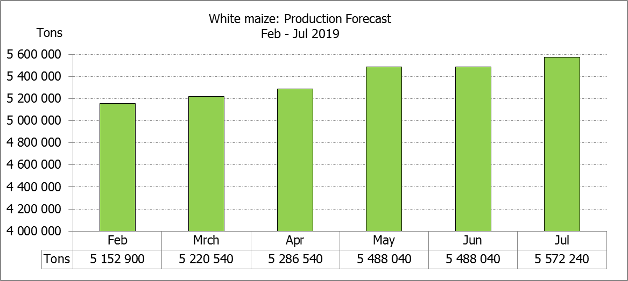

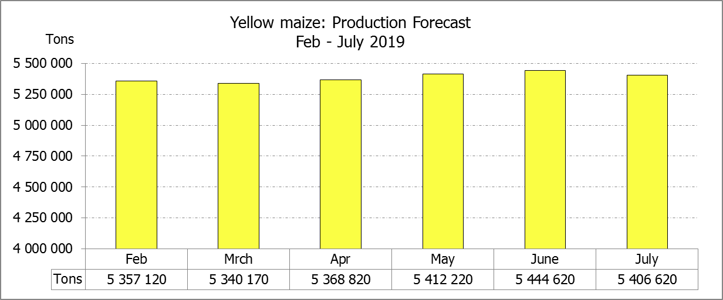
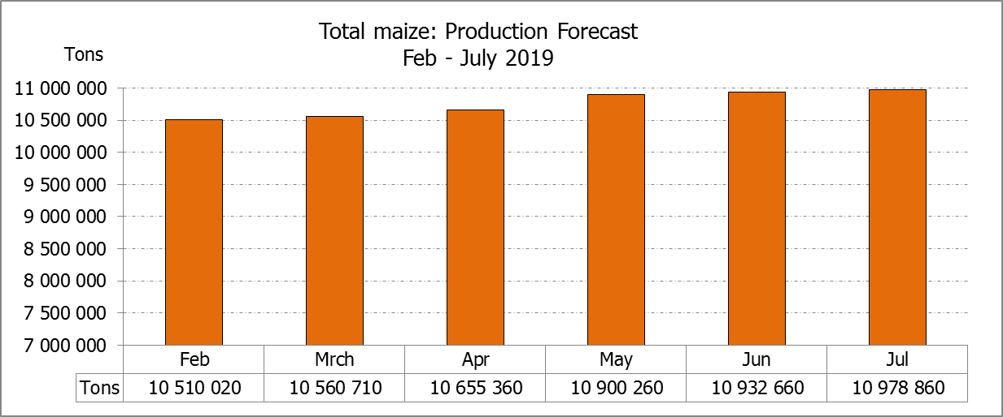

WHITE AND YELLOW MAIZE – AREA PLANTED AND SIXTH PRODUCTION FORECAST: 2019
WIT- EN GEELMIELIES – OPPERVLAKTE EN SESDE PRODUKSIESKATTING: 2019

Provinsie/  Province | Area planted/  Oppervlakte beplant  2019 |  |  | 6th forecast/  6de skatting  2019 |  |  | Area planted/  Oppervlakte beplant  2018 |  |  | Final crop/  Finale oes  2018
Provinsie/  Province | White/  Wit  Ha | Yellow/  Geel  Ha | Total/  Totaal  Ha | White/  Wit  Tons | Yellow/  Geel  Tons | Total/  Totaal  Tons | White/  Wit  Ha | Yellow/  Geel  Ha | Total/  Totaal  Ha | White/  Wit  Tons | Yellow/  Geel  Tons | Total/  Totaal  Tons
Western Cape/Wes-Kaap | 400 | 3 400 | 3 800 | 3 600 | 30 600 | 34 200 | 0 | 3 750 | 3 750 | 0 | 33 750 | 33 750
Northern Cape/Noord-Kaap | 3 400 | 43 500 | 46 900 | 39 440 | 626 400 | 665 840 | 3 600 | 43 000 | 46 600 | 41 300 | 628 000 | 669 300
Free State/Vrystaat | 650 000 | 380 000 | 1 030 000 | 2 795 000 | 1 596 000 | 4 391 000 | 644 000 | 410 000 | 1 054 000 | 3 350 000 | 1 925 000 | 5 275 000
Eastern Cape/Oos-Kaap | 3 800 | 10 200 | 14 000 | 22 800 | 67 320 | 90 120 | 3 500 | 11 000 | 14 500 | 21 700 | 71 500 | 93 200
KwaZulu-Natal | 45 000 | 54 000 | 99 000 | 270 000 | 383 400 | 653 400 | 45 000 | 50 000 | 95 000 | 280 000 | 380 000 | 660 000
Mpumalanga | 145 000 | 338 000 | 483 000 | 812 000 | 1 875 900 | 2 687 900 | 140 000 | 340 000 | 480 000 | 812 000 | 2 005 000 | 2 817 000
Limpopo | 12 800 | 18 000 | 30 800 | 83 200 | 117 000 | 200 200 | 12 000 | 21 000 | 33 000 | 90 000 | 141 700 | 231 700
Gauteng | 48 000 | 60 000 | 108 000 | 259 200 | 330 000 | 589 200 | 50 000 | 62 000 | 112 000 | 275 000 | 356 500 | 631 500
North West/Noordwes | 390 000 | 95 000 | 485 000 | 1 287 000 | 380 000 | 1 667 000 | 370 000 | 110 000 | 480 000 | 1 670 000 | 428 550 | 2 098 550
Total/Totaal | 1 298 400 | 1 002 100 | 2 300 500 | 5 572 240 | 5 406 620 | 10 978 860 | 1 268 100 | 1 050 750 | 2 318 850 | 6 540 000 | 5 970 000 | 12 510 000

SUNFLOWER SEED – AREA PLANTED AND SIXTH PRODUCTION FORECAST: 2019
SONNEBLOMSAAD – OPPERVLAKTE EN SESDE PRODUKSIESKATTING: 2019

Province/  Provinsie | Area planted/  Opp beplant  Ha | 6th forecast/  6de skatting  Tons | Area planted/  Opp beplant  Ha | Final crop/  Finale oes  Tons
Province/  Provinsie | 2019 | 2019 | 2018 | 2018
Western Cape/Wes-Kaap | - | - | 100 | 100
Northern Cape/Noord-Kaap | 950 | 1 140 | 1 600 | 1 920
Free State/Vrystaat | 270 000 | 378 000 | 314 000 | 490 000
Eastern Cape/Oos-Kaap | 100 | 250 | - | -
KwaZulu-Natal | - | - | - | -
Mpumalanga | 4 500 | 4 500 | 2 300 | 2 180
Limpopo | 61 000 | 57 950 | 45 000 | 36 000
Gauteng | 3 800 | 3 800 | 5 500 | 5 600
North West/Noordwes | 175 000 | 210 000 | 233 000 | 326 200
Total/Totaal | 515 350 | 655 640 | 601 500 | 862 000
SOYBEANS – AREA PLANTED AND SIXTH PRODUCTION FORECAST: 2019
SOJABONE – OPPERVLAKTE EN SESDE PRODUKSIESKATTING: 2019

Province/  Provinsie | Area planted/  Opp beplant  Ha | 6th forecast/  6de skatting Tons | Area planted/  Opp beplant  Ha | Final crop/  Finale oes  Tons
Province/  Provinsie | 2019 | 2019 | 2018 | 2018
Western Cape/Wes-Kaap | 100 | 10 | 800 | 1 200
Northern Cape/Noord-Kaap | 1 550 | 5 425 | 3 000 | 10 500
Free State/Vrystaat | 301 000 | 391 300 | 345 000 | 552 000
Eastern Cape/Oos-Kaap | 1 150 | 1 380 | 2 400 | 2 900
KwaZulu-Natal | 33 000 | 99 000 | 40 000 | 124 000
Mpumalanga | 310 000 | 511 500 | 310 000 | 672 700
Limpopo | 16 200 | 46 980 | 20 000 | 54 000
Gauteng | 31 500 | 66 150 | 30 000 | 61 500
North West/Noordwes | 36 000 | 48 600 | 36 000 | 61 200
Total/Totaal | 730 500 | 1 170 345 | 787 200 | 1 540 000

GROUNDNUTS – AREA PLANTED AND SIXTH PRODUCTION FORECAST: 2019
GRONDBONE – OPPERVLAKTE EN SESDE PRODUKSIESKATTING: 2019

Province/  Provinsie | Area planted/  Opp beplant  Ha | 6th forecast/  6de skatting  Tons | Area planted/  Opp beplant  Ha | Final crop/  Finale oes  Tons
Province/  Provinsie | 2019 | 2019 | 2018 | 2018
Western Cape/Wes-Kaap | - | - | - | -
Northern Cape/Noord-Kaap | 1 200 | 2 520 | 2 800 | 7 000
Free State/Vrystaat | 11 500 | 8 625 | 22 000 | 21 150
Eastern Cape/Oos-Kaap | - | - | - | -
KwaZulu-Natal | - | - | - | -
Mpumalanga | - | - | - | -
Limpopo | 1 850 | 3 885 | 3 500 | 7 350
Gauteng | - | - | - | -
North West/Noordwes | 5 500 | 3 850 | 28 000 | 21 500
Total/Totaal | 20 050 | 18 880 | 56 300 | 57 000

SORGHUM – AREA PLANTED AND SIXTH PRODUCTION FORECAST: 2019
SORGHUM – OPPERVLAKTE EN SESDE PRODUKSIESKATTING: 2019

Province/  Provinsie | Area planted/  Opp beplant  Ha | 6th forecast/  6de skatting  Tons | Area planted/  Opp beplant  Ha | Final crop/  Finale oes  Tons
Province/  Provinsie | 2019 | 2019 | 2018 | 2018
Western Cape/Wes-Kaap | - | - | - | -
Northern Cape/Noord-Kaap | - | - | - | -
Free State/Vrystaat | 8 000 | 28 000 | 6 300 | 25 200
Eastern Cape/Oos-Kaap | - | - | - | -
KwaZulu-Natal | 500 | 1 500 | 500 | 2 200
Mpumalanga | 7 500 | 37 500 | 7 500 | 40 500
Limpopo | 25 000 | 62 500 | 5 000 | 15 500
Gauteng | 1 000 | 3 200 | 1 500 | 4 950
North West/Noordwes | 8 500 | 21 250 | 8 000 | 26 650
Total/Totaal | 50 500 | 153 950 | 28 800 | 115 000

DRY BEANS – AREA PLANTED AND SIXTH PRODUCTION FORECAST: 2019
DROëBONE – OPPERVLAKTE EN SESDE PRODUKSIESKATTING: 2019

Province/  Provinsie | Area planted/  Opp beplant  Ha | 6th forecast/  6de skatting  Tons | Area planted/  Opp beplant  Ha | Final crop/  Finale oes  Tons
Province/  Provinsie | 2019 | 2019 | 2018 | 2018
Western Cape/Wes-Kaap | 100 | 180 | 20 | 30
Northern Cape/Noord-Kaap | 1 000 | 1 400 | 540 | 1 080
Free State/Vrystaat | 27 000 | 28 350 | 26 000 | 28 600
Eastern Cape/Oos-Kaap | 400 | 720 | 300 | 450
KwaZulu-Natal | 3 500 | 4 200 | 3 000 | 3 600
Mpumalanga | 7 500 | 6 750 | 7 000 | 9 800
Limpopo | 7 800 | 12 480 | 7 500 | 15 000
Gauteng | 1 500 | 1 950 | 1 000 | 1 200
North West/Noordwes | 10 500 | 10 500 | 8 000 | 9 600
Total/Totaal | 59 300 | 66 530 | 53 360 | 69 360

CONFIDENTIALITY ISSUES that CEC members are committed to adhere to on the day of the meeting
- Personal items such as laptops, handbags, cell phones, etc. are not allowed in the venue during the meeting
- No member is allowed to leave the meeting before 12:00 in order to prevent disclosure of the information
- The embargo time for the release of crop estimates information is 14:30
- No member is allowed to discuss crop estimates information with anyone other than a member of the Committee before the embargo time
- Only the Chairperson, or a member appointed by the Chairperson, may release the figures to the media
- Members must regard the detail of any information that was collected for and/or discussed during the meeting, as confidential
- Individual information received for crop estimate purposes is treated strictly confidential, and is not divulged for any other purposes

AREA ESTIMATE AND SIXTH PRODUCTION FORECAST OF SUMMER CROPS (2019 PRODUCTION SEASON)/
OPPERVLAKTE- EN SESDE PRODUKSIESKATTING VIR SOMERGEWASSE (2019 PRODUKSIE-SEISOEN)
25 JULY/JULIE 2019

Summer field crops – 2019  Commercial maize: The size of the expected commercial maize crop has been set at 10,979 mill. tons, which is 0,42% or 46 200 tons more than the previous forecast of 10,933 mill. tons. The area estimate for maize is 2,301 mill. ha, while the expected yield is 4,77 t/ha.  The estimated maize crop is 12% smaller than the 2018 crop. The three main maize producing areas, namely the Free State, Mpumalanga and North West provinces are expected to produce 80% of the 2019 crop.  The area estimate for white maize is 1,298 mill. ha & for yellow maize the area estimate is 1,002 mill. ha.  The production forecast of white maize is 5,572 mill. tons, which is 1,53% or 84 200 tons more than the 5,488 mill. tons of the previous forecast. The yield for white maize is 4,29 t/ha. In the case of yellow maize the production forecast is 5,407 mill. tons, which is 0,70% or 38 000 tons less than the 5,445 mill. tons of the previous forecast. The yield for yellow maize is 5,40 t/ha.  Sunflower seed: The production forecast for sunflower seed increased by 7,28% or 44 500 tons to 655 640 tons. The area estimate for sunflower seed is 515 350 ha, while the expected yield is 1,27 t/ha.  Other crops: The production forecast for soybeans is 1,170 mill. tons, which is 3,79% or 46 050 tons less than the previous forecast of 1,216 million tons. The estimated area planted to soybeans is 730 500 ha and the expected yield is 1,60 t/ha.  The expected groundnut crop decreased by 8,26% or 1 700 tons to 18 880 tons, with an expected yield of 0,94 t/ha. The area estimate for groundnuts is 20 050 ha.  The production forecast for sorghum also decreased by 4,65% or 7 500 tons, from 161 450 tons to 153 950 tons. The area estimate for sorghum is 50 500 ha and the expected yield is 3,05 t/ha.  In the case of dry beans, the production forecast has been adjusted slightly downwards by 0,26% or 175 tons – from 66 530 tons to 66 355 tons. The area estimate of dry beans is 59 300 ha, with an expected yield of 1,12 t/ha.  Please note that the seventh production forecast for summer field crops for 2019 will be released on 27 August 2019. |  | Somergewasse – 2019  Kommersiële mielies: Die grootte van die verwagte kommersiële mielie-oes is op 10,979 milj. ton gestel, wat 0,42% of 46 200 ton meer is as die vorige skatting van 10,933 milj. ton. Die skatting van die oppervlakte onder mielies is 2,301 milj. ha, terwyl die verwagte opbrengs 4,77 t/ha is.  Die geskatte mielie-oes is 12% kleiner as die 2018-oes. Die drie belangrikste mielieproduserende gebiede, nl. die Vrystaat, Mpumalanga en Noordwes provinsies, gaan na verwagting 80% van die 2019-oes produseer.  Die oppervlak onder witmielies is 1,298 milj. ha en vir geelmielies is die oppervlak 1,002 milj. ha.  Die produksieskatting van witmielies is onveranderd gelaat op 5,572 milj. ton, wat 1,53% of 84 200 ton meer is as die 5,488 milj. ton van die vorige skatting. Die opbrengs van witmielies is 4,29 t/ha. In die geval van geelmielies is die produksieskatting 5,407 milj. ton, wat 0,70% of 38 000 ton minder is as die 5,445 milj. ton van die vorige skatting. Die opbrengs van geelmielies is 5,40 t/ha.  Sonneblomsaad: Die produksieskatting vir sonneblomsaad het toegeneem met 7,28% of 44 500 ton na 655 640 ton. Die oppervlakteskatting vir sonneblomsaad is 515 350 ha, terwyl die verwagte opbrengs 1,27 t/ha is.  Ander gewasse: Die produksieskatting van sojabone is 1,170 milj. ton, wat 3,79% of 46 050 ton minder is as die vorige skatting van 1,216 milj. ton . Die geskatte oppervlakte beplant van sojabone is 730 500 ha en die verwagte opbrengs is 1,60 t/ha.  Die verwagte grondbone-oes het met 8,26% of 1 700 ton tot 18 880 ton afgeneem, met ’n verwagte opbrengs van 0,94 t/ha. Die oppervlakteskatting vir grondbone is 20 050 ha.  Die produksieskatting van sorghum het ook afgeneem met 4,65% of 7 500 ton, van 161 450 ton tot 153 950 ton. Die oppervlakteskatting vir sorghum is 50 500 ha, en die verwagte opbrengs is 3,05 t/ha.  In die geval van droëbone is die produksieskatting effens afwaarts aangepas met 0,26% of 175 ton – van 66 530 ton na 66 355 ton. Die oppervlakte beplant met droëbone is 59 300 ha, en die verwagte opbrengs is 1,12 t/ha.  Neem asseblief kennis dat die sewende produksieskatting vir somergewasse vir 2019, op 27 Augustus 2019 vrygestel sal word.
Information is available on the internet at http://www.daff.gov.za/statistics and economic reports or http://www.sagis.org.za, as from 14:30 on the date of the relevant meeting of the Crop Estimates Committee. |  | Inligting is beskikbaar op die internet by http://www.daff.gov.za/statistics and economic reports of by http://www.sagis.org.za, vanaf 14:30 op die dag van die toepaslike vergadering van die Oesskattingskomitee.

The non-commercial agricultural sectors’ production estimate for maize for 2019 is hereby released. /
Hiermee word die nie-kommersiële landbou-sektor se produksieskatting vir mielies vir 2019 vrygestel.

NON-COMMERCIAL MAIZE – AREA PLANTED AND PRODUCTION ESTIMATE: 2019
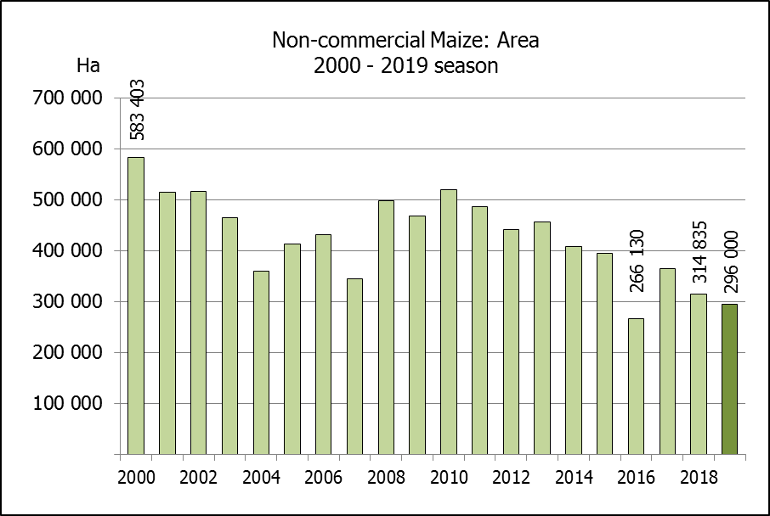
NIE-KOMMERSIëLE MIELIES – OPPERVLAKTE- EN PRODUKSIESKATTING: 2019
CROP/GEWAS | Area planted/  Opp beplant  2019 | Production/  Produksie  2019 | Area planted/  Opp beplant  2018 | Final crop/  Finale oes  2018 | Change/  Verandering
CROP/GEWAS | Ha | Tons | Ha | Tons | %
CROP/GEWAS | (A) | (B) | (C) | (D) | (B) ÷ (D)
Non-commercial agriculture/Nie-kommersiële landbou:
White maize/Witmielies | 221 300 | 379 460 | 236 644 | 414 162 | -8,38
Yellow maize/Geelmielies | 74 700 | 169 720 | 78 191 | 179 813 | -5,61
Maize/Mielies | 296 000 | 549 180 | 314 835 | 593 975 | -7,54
The area planted to maize in the non-commercial agricultural sector is estimated at 296 000 ha, which represents a decrease of 5,98%, compared to the 314 835 ha of the previous season. The expected maize crop for this sector is 549 180 tons, which is 7,54% less than the 593 975 tons of last season. It is important to note that about 43% of the maize produced in the non-commercial sector, is planted in the Eastern Cape, followed by KwaZulu-Natal with 27%.
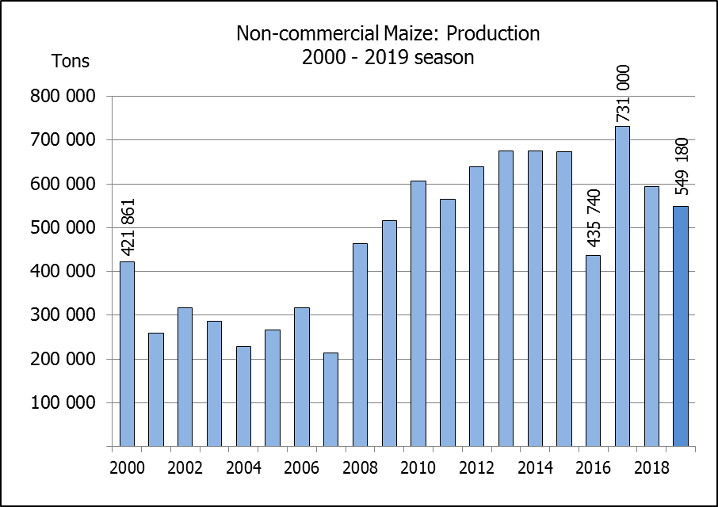
Die oppervlakte beplant met mielies in die nie-kommersiële landbou-sektor word geskat op 296 000 ha, wat ‘n afname van 5,98 % verteenwoordig in vergelyking met die 314 835 ha van die vorige seisoen. Die verwagte mielie-oes van dié sektor is 549 180 ton, wat 7,54% minder is as die 593 975 ton van die vorige seisoen. Dit is belangrik om daarop te let dat ongeveer 43% van die mielies wat geproduseer word in die nie-kommersiële sektor, in die Oos-Kaap geplant word, gevolg deur KwaZulu-Natal met 27%.

The preliminary area estimate for winter cereals for the 2019 is hereby released. /
Hiermee word die voorlopige oppervlakteskatting vir wintergewasse vir 2019 vrygestel.

WINTER CEREALS – PRELIMINARY AREA PLANTED ESTIMATE: 2019 PRODUCTION SEASON
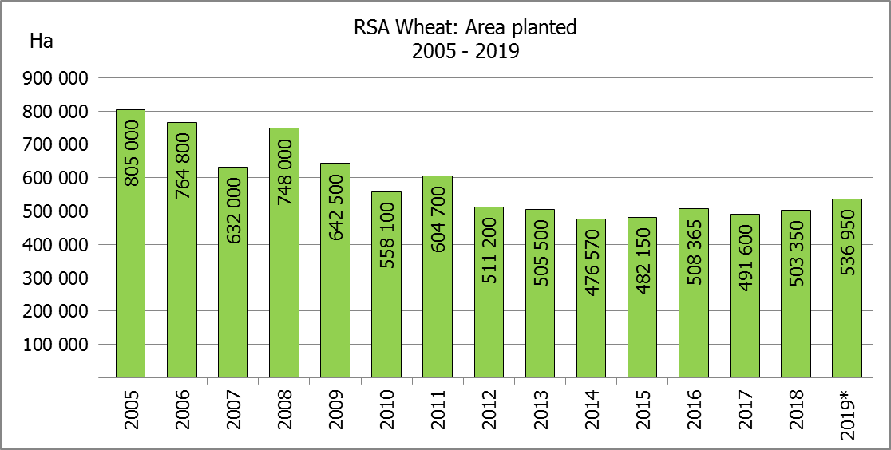
WINTERGEWASSE – VOORLOPIGE OPPERVLAKTESKATTING: 2019-PRODUKSIESEISOEN
CROP/GEWAS | Area planted/  Opp beplant  2019 | Intentions/  Voorneme*  Mid April 2019 | Area planted/  Opp beplant  2018 | Final crop/  Finale oes  2018 | Change/  Verandering
CROP/GEWAS | Ha | Ha | Ha | Tons | %
CROP/GEWAS | (A) | (B) | (C) | (D) | (A) ÷ (C)
Commercial/Kommersieel:
Wheat/Koring | 536 950 | 513 450 | 503 350 | 1 868 000 | +6,68
Malting barley/Moutgars | 120 500 | 118 500 | 119 000 | 421 500 | +1,26
Canola/Kanola | 74 000 | 80 000 | 77 000 | 104 500 | -3,90
Cereal oats/Hawermout | 22 000 | N/A | 19 235 | 32 700 | 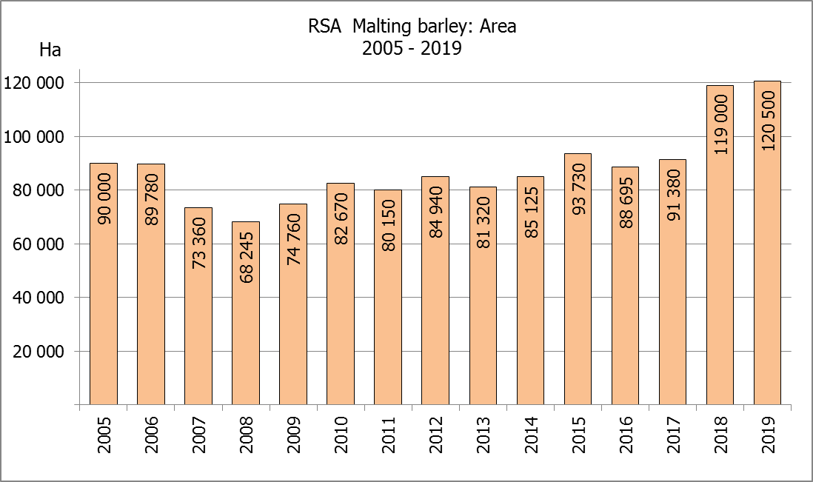  +14,37
* Intentions based on conditions at the middle of April 2019 / Voorneme gebaseer op toestande soos teen middel April 2019.

WHEAT – PRELIMINARY AREA PLANTED ESTIMATE: 2019
KORING – VOORLOPIGE OPPERVLAKTESKATTING: 2019

Province/  Provinsie | Area planted/  Opp beplant  Ha | Intentions/  Voorneme*  Ha | Area planted/  Opp beplant  Ha | Final crop/  Finale oes  Tons
Province/  Provinsie | 2019 | Mid April 2019 | 2018 | 2018
Western Cape/Wes-Kaap | 324 000 | 324 000 | 318 000 | 890 500
Northern Cape/Noord-Kaap | 36 000 | 34 000 | 38 000 | 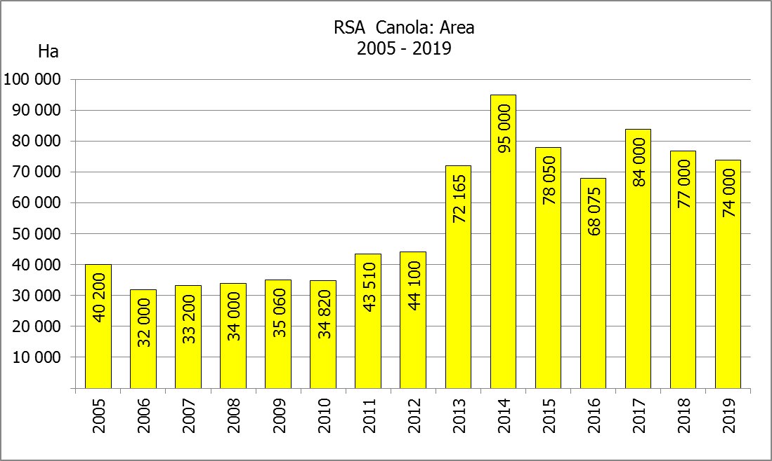  294 500
Free State/Vrystaat | 125 000 | 105 000 | 100 000 | 385 000
Eastern Cape/Oos-Kaap | 3 500 | 3 500 | 1 650 | 10 730
KwaZulu-Natal | 7 500 | 7 500 | 7 000 | 43 400
Mpumalanga | 3 450 | 3 450 | 3 500 | 22 740
Limpopo | 23 000 | 22 000 | 20 000 | 128 000
Gauteng | 1 000 | 1 000 | 1 200 | 7 800
North West/Noordwes | 13 500 | 13 000 | 14 000 | 85 330
Total/Totaal | 536 950 | 513 450 | 503 350 | 1 868 000
* Intentions based on conditions at the middle of April 2019 / Voorneme gebaseer op toestande soos teen middel April 2019.

PRELIMINARY AREA ESTIMATE OF WINTER CROPS (2019) /
VOORLOPIGE OPPERVLAKTEKSKATTING VAN WINTERGEWASSE (2019)
25 JULY/ 25 JULIE 2019

Winter cereal crops - 2019 production season  The preliminary area estimate is based on the results of a non-probability survey conducted by the Directorate: Statistics and Economic Analysis and reflects the position as at the middle of July 2019, as well as inputs from the PDA representatives. Please note that the information from the Producer Independent Crop Estimation System (PICES), as conducted by the National Crop Statistics Consortium (NCSC), for the Western Cape will be available in August 2019 and for the Free State in September 2019.  Wheat: The preliminary area estimate for wheat is 536 950 ha, which is 6,68% or 33 600 ha more than the 503 350 ha planted for the previous season.  An estimated 324 000 ha is planted in the Western Cape, which is 6 000 ha more than the 318 000 ha planted for the previous season. In the Free State, 125 000 ha is planted, which is 25 000 ha more than the 100 000 ha planted for the previous season. The area planted in the Northern Cape is 36 000 ha, which is 2 000 ha less than the previous season.  Other crops: The preliminary area estimate for malting barley is 120 500 ha, which is 1,26% or 1 500 ha more than the 119 000 ha of last season. The area planted to canola is 74 000 ha, which is 3,90% or 3 000 ha less than the 77 000 ha planted for the previous season.  Following a request from industry, it was decided to incorporate oats (for cereals) in future estimates. The preliminary area estimate for oats for the 2019 season is 22 000 ha.  Please note that the revised area planted estimate and first production forecast for winter cereals for 2019 will be released on 27 August 2019. |  | Wintergewasse - 2019 produksie-seisoen  Die voorlopige oppervlakteskatting is gebaseer op die resultate van ’n nie-ewekansige opname onderneem deur die Direktoraat: Statistiek en Ekonomiese Analise en weerspieël die situasie teen die middel van Julie 2019, sowel as insette van die PDL verteenwoordigers. Let wel, inligting van die Produsente Onafhanklike Oesskattingstelsel (“PICES”), soos gedoen deur die Nasionale Oesskattingskonsortium, sal vir die Wes-Kaap in Augustus 2019 gerapporteer word en vir die Vrystaat in September 2019.  Koring: Die voorlopige skatting van die oppervlakte onder koring beloop 536 950 ha, wat 6,68% of 33 600 ha meer is as die 503 350 ha wat verlede seisoen aangeplant is.  Die beraamde oppervlakte beplant in die Wes-Kaap is 324 000 ha, wat 6 000 ha meer is as die 318 000 ha wat verlede seisoen aangeplant is. Vir die Vrystaat is die aanplantings 125 000 ha, wat 25 000 ha meer is as die 100 000 ha wat verlede seisoen aangeplant is. Die oppervlakte beplant in die Noord-Kaap is 36 000 ha, wat 2 000 ha minder is as die vorige seisoen.  Ander gewasse: Die voorlopige oppervlakskatting vir moutgars is 120 500 ha, wat 1,26% of 1 500 ha meer is as die 119 000 ha van verlede seisoen. Die oppervlakte onder kanola is 74 000 ha, wat 3,90% of 3 000 ha minder is as die 77 000 ha wat verlede seisoen aangeplant is.  Na aanleiding van ’n versoek van die bedryf, is daar besluit om hawer (ontbytgraan) in toekomstige skattings te inkorporeer. Die voorlopige oppervlakteskatting vir hawer vir die 2019-seisoen is 22 000 ha.  Neem asseblief kennis dat die hersiene oppervlakte beplant en eerste produksieskatting vir wintergewasse vir 2019 op 27 Augustus 2019 vrygestel sal word.

Information is available on the internet at http://www.daff.gov.za/links/crop estimates or http://www.sagis.org.za, as from 14:30 on the date of the relevant meeting of the Crop Estimates Committee. |  | Inligting is beskikbaar op die internet by http://www.daff.gov.za/links/crop estimates of by http://www.sagis.org.za, vanaf 14:30 op die dag van die toepaslike vergadering van die Oesskattingskomitee.

