 | crop estimates committee | 
 | oesskattingskomitee
From/Van: M. Ellen Matsei
Tel: 012 319 8454  Fax/Faks: 012 319 8031  E-mail/E-pos: DAS@daff.gov.za
Web page/Webblad: www.daff.gov.za/statistics and economic reports or www.sagis.org.za/CEC: Crop Estimates
EMBARGO: 15:30

The area planted estimate and sixth production forecast for summer crops for 2018 is hereby released.
Hiermee word die oppervlakte- en sesde produksieskatting vir somergewasse vir 2018 vrygestel.

SUMMER CROPS – AREA PLANTED AND SIXTH PRODUCTION FORECAST: 2018
SOMERGEWASSE – OPPERVLAKTE- EN SESDE PRODUKSIESKATTING: 2018
CROP/GEWAS | Area planted/  Opp beplant  2018 | 6th forecast/  6de skatting  2018 | 5th forecast/  5de skatting  2018 | Area planted/  Opp beplant  2017 | Final crop/  Finale oes  2017 | Change/  Verandering
CROP/GEWAS | Ha | Tons | Tons | Ha | Tons | %
CROP/GEWAS | (A) | (B) | (C) | (D) | (E) | (B) ÷ (C)
Commercial/Kommersieel:
White maize/Witmielies | 1 268 100 | 6 879 960 | 6 879 960 | 1 643 100 | 9 916 000 | -
Yellow maize/Geelmielies | 1 050 750 | 6 327 350 | 6 327 350 | 985 500 | 6 904 000 | -
Total Maize/Totale Mielies | 2 318 850 | 13 207 310 | 13 207 310 | 2 628 600 | 16 820 000 | -
Sunflower seed/Sonneblomsaad | 601 500 | 792 255 | 792 255 | 635 750 | 874 000 | -
Soybeans/Sojabone | 787 200 | 1 550 800 | 1 550 800 | 573 950 | 1 316 000 | -
Groundnuts/Grondbone | 56 300 | 52 000 | 60 600 | 56 000 | 92 050 | -14,2
Sorghum | 28 800 | 83 070 | 83 070 | 42 350 | 152 000 | -
Dry beans/Droëbone | 53 360 | 65 610 | 65 610 | 45 050 | 68 525 | -
Non-Commercial Maize/Nie-Kommersiële Mielies
Total Maize/Totaal Mielies | 314 835 | 593 975 | 593 975 | 366 650 | 731 000 | -
Maize/Mielies: Commercial/Kommersieël + Non-Commercial/Nie-Kommersieël
Total Maize RSA/Totaal Mielies RSA | 2 633 685 | 13 801 285 | 13 801 285 | 2 995 250 | 17 551 000 | -
Note: Estimate is for calendar year, e.g. production season 2017/18 = 2018
Nota: Skatting is vir kalenderjaar, bv. produksie-seisoen 2017/18 = 2018
The Crop Estimates Committee comprises officials of the following institutions:
Department of Agriculture, Forestry and Fisheries; Provincial Departments of Agriculture; various ARC-Institutes (Soil, Climate and Water; Small Grains Institute;
and Grain Crops Institute); BFAP, Statistics SA and CSIR.

26 July/Julie 2018
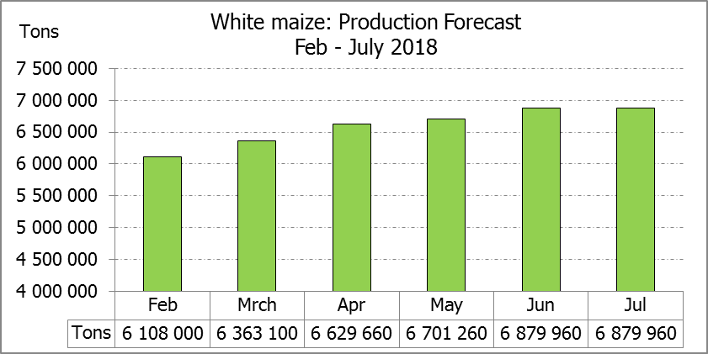

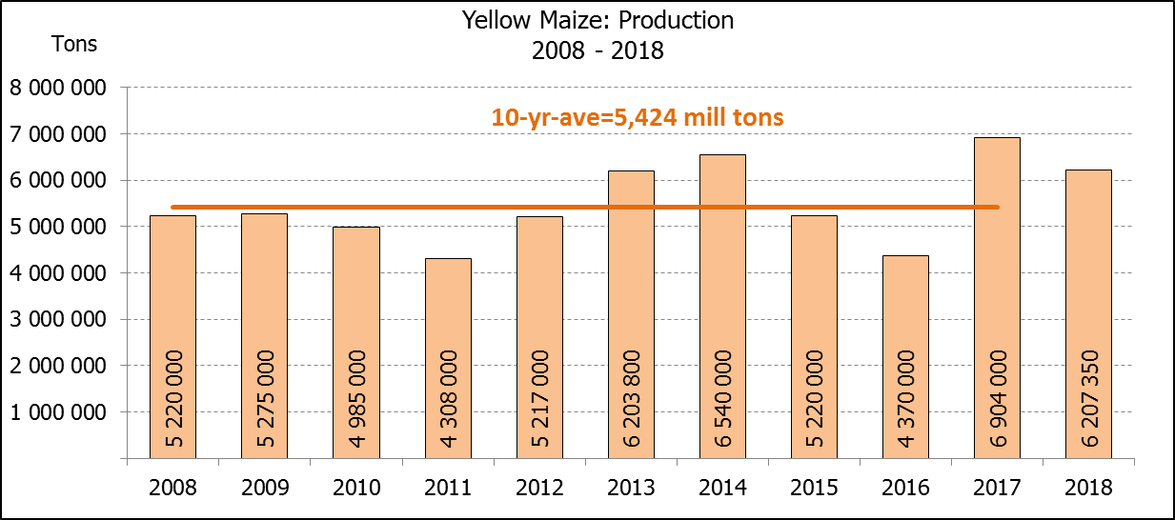

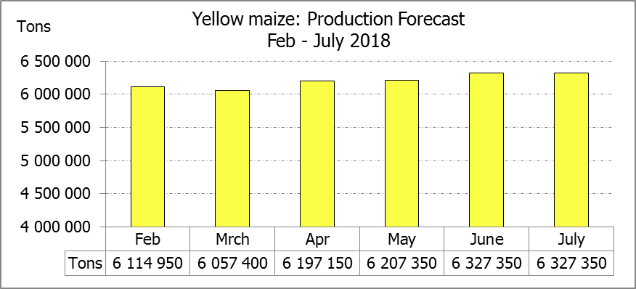

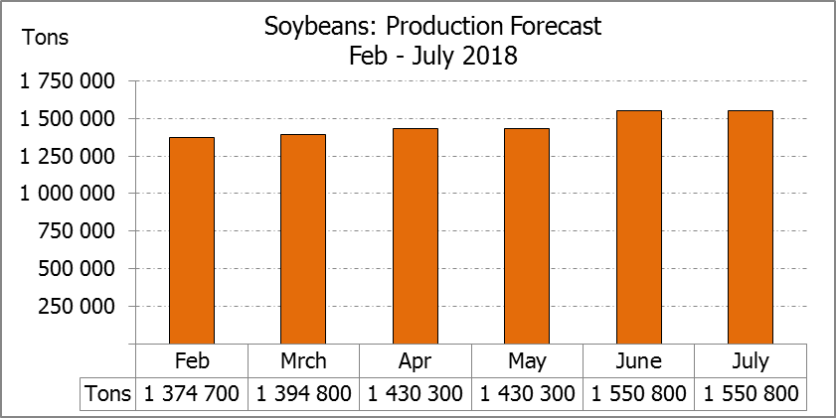

WHITE AND YELLOW MAIZE – AREA PLANTED AND SIXTH PRODUCTION FORECAST: 2018
WIT- EN GEELMIELIES – OPPERVLAKTE EN SESDE PRODUKSIESKATTING: 2018

Provinsie/  Province | Area planted/  Oppervlakte beplant  2018 |  |  | 6th forecast/  6de skatting  2018 |  |  | Area planted/  Oppervlakte beplant  2017 |  |  | Final crop/  Finale oes  2017
Provinsie/  Province | White/  Wit  Ha | Yellow/  Geel  Ha | Total/  Totaal  Ha | White/  Wit  Tons | Yellow/  Geel  Tons | Total/  Totaal  Tons | White/  Wit  Ha | Yellow/  Geel  Ha | Total/  Totaal  Ha | White/  Wit  Tons | Yellow/  Geel  Tons | Total/  Totaal  Tons
Western Cape/Wes-Kaap | 0 | 3 750 | 3 750 | 0 | 33 750 | 33 750 | 200 | 2 000 | 2 200 | 2 000 | 20 000 | 22 000
Northern Cape/Noord-Kaap | 3 600 | 43 000 | 46 600 | 41 760 | 636 400 | 678 160 | 3 500 | 45 000 | 48 500 | 46 200 | 666 000 | 712 200
Free State/Vrystaat | 644 000 | 410 000 | 1 054 000 | 3 542 000 | 2 111 500 | 5 653 500 | 805 000 | 355 000 | 1 160 000 | 5 110 000 | 2 252 000 | 7 362 000
Eastern Cape/Oos-Kaap | 3 500 | 11 000 | 14 500 | 21 700 | 71 500 | 93 200 | 4 400 | 9 500 | 13 900 | 30 800 | 66 500 | 97 300
KwaZulu-Natal | 45 000 | 50 000 | 95 000 | 301 500 | 390 000 | 691 500 | 50 000 | 50 000 | 100 000 | 350 000 | 390 000 | 740 000
Mpumalanga | 140 000 | 340 000 | 480 000 | 854 000 | 2 108 000 | 2 962 000 | 160 000 | 330 000 | 490 000 | 1 088 000 | 2 342 500 | 3 430 500
Limpopo | 12 000 | 21 000 | 33 000 | 90 000 | 147 000 | 237 000 | 40 000 | 24 000 | 64 000 | 300 000 | 192 000 | 492 000
Gauteng | 50 000 | 62 000 | 112 000 | 290 000 | 378 200 | 668 200 | 60 000 | 60 000 | 120 000 | 390 000 | 414 000 | 804 000
North West/Noordwes | 370 000 | 110 000 | 480 000 | 1 739 000 | 451 000 | 2 190 000 | 520 000 | 110 000 | 630 000 | 2 599 000 | 561 000 | 3 160 000
Total/Totaal | 1 268 100 | 1 050 750 | 2 318 850 | 6 879 960 | 6 327 350 | 13 207 310 | 1 643 100 | 985 500 | 2 628 600 | 9 916 000 | 6 904 000 | 16 820 000

SUNFLOWER SEED – AREA PLANTED AND SIXTH PRODUCTION FORECAST: 2018
SONNEBLOMSAAD – OPPERVLAKTE EN SESDE PRODUKSIESKATTING: 2018

Province/  Provinsie | Area planted/  Opp beplant  Ha | 6th forecast/  6de skatting  Tons | Area planted/  Opp beplant  Ha | Final crop/  Finale oes  Tons
Province/  Provinsie | 2018 | 2018 | 2017 | 2017
Western Cape/Wes-Kaap | 100 | 100 | - | -
Northern Cape/Noord-Kaap | 1 600 | 1 920 | 250 | 400
Free State/Vrystaat | 314 000 | 455 300 | 330 000 | 478 000
Eastern Cape/Oos-Kaap | - | - | - | -
KwaZulu-Natal | - | - | 300 | 300
Mpumalanga | 2 300 | 2 185 | 2 200 | 2 300
Limpopo | 45 000 | 36 000 | 90 000 | 85 500
Gauteng | 5 500 | 5 500 | 3 000 | 3 000
North West/Noordwes | 233 000 | 291 250 | 210 000 | 304 500
Total/Totaal | 601 500 | 792 255 | 635 750 | 874 000

SOYBEANS – AREA PLANTED AND SIXTH PRODUCTION FORECAST: 2018
SOJABONE – OPPERVLAKTE EN SESDE PRODUKSIESKATTING: 2018

Province/  Provinsie | Area planted/  Opp beplant  Ha | 6th forecast/  6de skatting  Tons | Area planted/  Opp beplant  Ha | Final crop/  Finale oes  Tons
Province/  Provinsie | 2018 | 2018 | 2017 | 2017
Western Cape/Wes-Kaap | 800 | 1 200 | 700 | 1 050
Northern Cape/Noord-Kaap | 3 000 | 10 500 | 3 000 | 10 500
Free State/Vrystaat | 345 000 | 552 000 | 240 000 | 504 000
Eastern Cape/Oos-Kaap | 2 400 | 2 400 | 1 850 | 2 775
KwaZulu-Natal | 40 000 | 124 000 | 30 500 | 89 605
Mpumalanga | 310 000 | 682 000 | 241 000 | 554 300
Limpopo | 20 000 | 56 000 | 8 500 | 29 750
Gauteng | 30 000 | 61 500 | 25 400 | 71 120
North West/Noordwes | 36 000 | 61 200 | 23 000 | 52 900
Total/Totaal | 787 200 | 1 550 800 | 573 950 | 1 316 000
GROUNDNUTS – AREA PLANTED AND SIXTH PRODUCTION FORECAST: 2018
GRONDBONE – OPPERVLAKTE EN SESDE PRODUKSIESKATTING: 2018

Province/  Provinsie | Area planted/  Opp beplant  Ha | 6th forecast/  6de skatting Tons | Area planted/  Opp beplant  Ha | Final crop/  Finale oes  Tons
Province/  Provinsie | 2018 | 2018 | 2017 | 2017
Western Cape/Wes-Kaap | - | - | - | -
Northern Cape/Noord-Kaap | 2 800 | 7 000 | 4 000 | 14 000
Free State/Vrystaat | 22 000 | 19 800 | 22 000 | 34 100
Eastern Cape/Oos-Kaap | - | - | - | -
KwaZulu-Natal | - | - | - | -
Mpumalanga | - | - | - | -
Limpopo | 3 500 | 7 000 | 3 000 | 4 800
Gauteng | - | - | - | -
North West/Noordwes | 28 000 | 18 200 | 27 000 | 39 150
Total/Totaal | 56 300 | 52 000 | 56 000 | 92 050

SORGHUM – AREA PLANTED AND SIXTH PRODUCTION FORECAST: 2018
SORGHUM – OPPERVLAKTE EN SESDE PRODUKSIESKATTING: 2018

Province/  Provinsie | Area planted/  Opp beplant  Ha | 6th forecast/  6de skatting Tons | Area planted/  Opp beplant  Ha | Final crop/  Finale oes  Tons
Province/  Provinsie | 2018 | 2018 | 2017 | 2017
Western Cape/Wes-Kaap | - | - | - | -
Northern Cape/Noord-Kaap | - | - | - | -
Free State/Vrystaat | 6 300 | 18 270 | 7 700 | 24 640
Eastern Cape/Oos-Kaap | - | - | - | -
KwaZulu-Natal | 500 | 1 500 | 400 | 1 520
Mpumalanga | 7 500 | 36 000 | 12 000 | 62 400
Limpopo | 5 000 | 6 000 | 18 000 | 50 400
Gauteng | 1 500 | 4 500 | 750 | 2 400
North West/Noordwes | 8 000 | 16 800 | 3 500 | 10 640
Total/Totaal | 28 800 | 83 070 | 42 350 | 152 000

DRY BEANS – AREA PLANTED AND SIXTH PRODUCTION FORECAST: 2018
DROëBONE – OPPERVLAKTE EN SESDE PRODUKSIESKATTING: 2018

Province/  Provinsie | Area planted/  Opp beplant  Ha | 6th forecast/  6de skatting Tons | Area planted/  Opp beplant  Ha | Final crop/  Finale oes  Tons
Province/  Provinsie | 2018 | 2018 | 2017 | 2017
Western Cape/Wes-Kaap | 20 | 30 | 100 | 150
Northern Cape/Noord-Kaap | 540 | 1 080 | 650 | 1 300
Free State/Vrystaat | 26 000 | 28 600 | 20 000 | 32 000
Eastern Cape/Oos-Kaap | 300 | 450 | 300 | 450
KwaZulu-Natal | 3 000 | 3 600 | 4 500 | 5 400
Mpumalanga | 7 000 | 9 800 | 5 500 | 8 525
Limpopo | 7 500 | 11 250 | 7 000 | 12 950
Gauteng | 1 000 | 1 200 | 1 500 | 2 250
North West/Noordwes | 8 000 | 9 600 | 5 500 | 5 500
Total/Totaal | 53 360 | 65 610 | 45 050 | 68 525

CONFIDENTIALITY ISSUES that CEC members are committed to adhere to on the day of the meeting
- Personal items such as laptops, handbags, cell phones, etc. are not allowed in the venue during the meeting
- No member is allowed to leave the meeting before 12:00 in order to prevent disclosure of the information
- The embargo time for the release of crop estimates information is 15:30
- No member is allowed to discuss crop estimates information with anyone other than a member of the Committee before the embargo time
- Only the Chairperson, or a member appointed by the Chairperson, may release the figures to the media
- Members must regard the detail of any information that was collected for and/or discussed during the meeting, as confidential
- Individual information received for crop estimate purposes is treated strictly confidential, and is not divulged for any other purposes

AREA ESTIMATE AND SIXTH PRODUCTION FORECAST OF SUMMER CROPS (2018 PRODUCTION SEASON)/
OPPERVLAKTE- EN SESDE PRODUKSIESKATTING VIR SOMERGEWASSE (2018 PRODUKSIE-SEISOEN)
26 JULY/JULIE 2018

Summer field crops – 2018  Commercial maize: The size of the expected commercial maize crop remained unchanged at 13,207 mill. tons. The area estimate for maize is 2,319 mill. ha, while the expected yield is 5,70 t/ha.  The area estimate for white maize is 1,268 mill. ha and for yellow maize the area estimate is 1,051 mill. ha.  The production forecast of white maize is 6,880 mill. tons, whilst the yield is 5,43 t/ha. In the case of yellow maize the production forecast is 6,327 mill. tons and the yield is 6,02 t/ha.  Sunflower seed: The production forecast for sunflower seed also remained unchanged at 792 255 tons. The area estimate for sunflower seed is 601 500 ha and the expected yield is 1,32 t/ha.  Other crops: The production forecast for soybeans is 1,551 mill. tons, with an estimated planted area of 787 200 ha and an expected yield of 1,97 t/ha.  The expected groundnut crop was decreased by 14,19% or 8 600 tons to 52 000 tons. For groundnuts, the area estimate is 56 300 ha and the expected yield is 0,92 t/ha.  The production forecast for sorghum remained unchanged at 83 070 tons. The area estimate for sorghum is 28 800 ha. The expected yield is 2,88 t/ha.  In the case of dry beans, the production forecast also remained unchanged at 65 610 tons. The area estimate of dry beans is 53 360 ha, with an expected yield of 1,23 t/ha.  Please note that the seventh production forecast for summer field crops for 2018, will be released on 28 August 2018. |  | Somergewasse – 2018  Kommersiële mielies: Die grootte van die verwagte kommersiële mielie-oes is onveranderd gelaat op 13,207 milj. ton. Die skatting van die oppervlakte onder mielies is 2,319 milj. ha, terwyl die verwagte opbrengs 5,70 t/ha is.  Die oppervlak onder witmielies is 1,268 milj. ha en vir geelmielies is die oppervlak 1,051 milj. ha.  Die produksieskatting van witmielies is 6,880 milj. ton, terwyl die opbrengs 5,43 t/ha is. In die geval van geelmielies is die produksieskatting 6,327 milj. ton, en die opbrengs is 6,02 t/ha.  Sonneblomsaad: Die produksieskatting vir sonneblomsaad is onveranderd gelaat op 792 255 ton. Die oppervlakteskatting vir sonneblomsaad is 601 500 ha, terwyl die verwagte opbrengs 1,32 t/ha is.  Ander gewasse: Die produksieskatting van sojabone is 1,551 milj. ton met ’n geskatte oppervlakte van 787 200 ha en die verwagte opbrengs is 1,97 t/ha.  Die verwagte grondbone-oes is afwaarts aangepas met 14,19% of 8 600 ton na 52 000 ton. Vir grondbone is die oppervlakteskatting 56 300 ha, terwyl die verwagte opbrengs 0,92 t/ha is.  Die produksieskatting van sorghum is onveranderd gelaat op 83 070 ton. Die oppervlakte beplant met sorghum is 28 800 ha. Die verwagte opbrengs is 2,88 t/ha.  In die geval van droëbone is die produksieskatting ook onveranderd gelaat op 65 610 ton. Die oppervlakte beplant met droëbone is 53 360 ha, en die verwagte opbrengs is 1,23 t/ha.  Neem asseblief kennis dat die sewende produksieskatting vir somergewasse vir 2018, op 28 Augustus 2018 vrygestel sal word.

The non-commercial agricultural sectors’ production estimate for maize for 2018 is hereby released. /
Hiermee word die nie-kommersiële landbou-sektor se produksieskatting vir mielies vir 2018 vrygestel.

NON-COMMERCIAL MAIZE – PRELIMINARY AREA PLANTED AND PRODUCTION ESTIMATE: 2018
NIE-KOMMERSIëLE MIELIES – VOORLOPIGE OPPERVLAKTE- EN PRODUKSIESKATTING: 2018
CROP/GEWAS | Area planted/  Opp beplant  2018 | Production/  Produksie  2018 | Area planted/  Opp beplant  2017 | Final crop/  Finale oes  2017 | 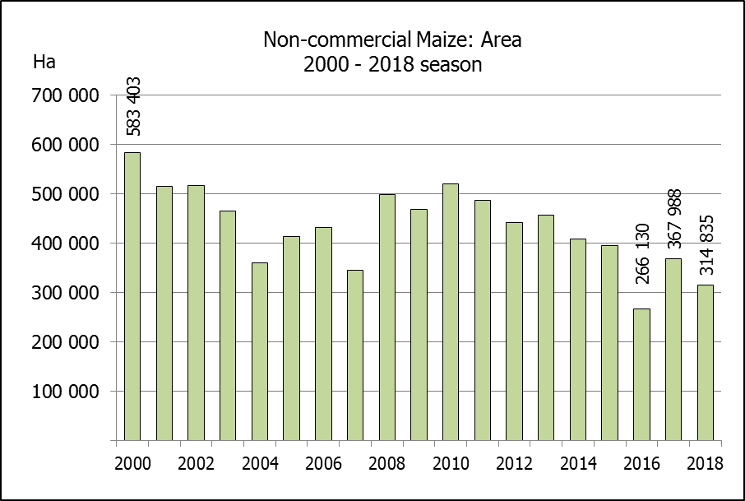  Change/  Verandering
CROP/GEWAS | Ha | Tons | Ha | Tons | %
CROP/GEWAS | (A) | (B) | (C) | (D) | (B) ÷ (D)
Non-commercial agriculture/Nie-kommersiële landbou:
White maize/Witmielies | 236 644 | 414 162 | 248 500 | 463 600 | -10,66
Yellow maize/Geelmielies | 78 191 | 179 813 | 118 150 | 267 400 | -32,76
Maize/Mielies | 314 835 | 593 975 | 366 650 | 731 000 | -18,74
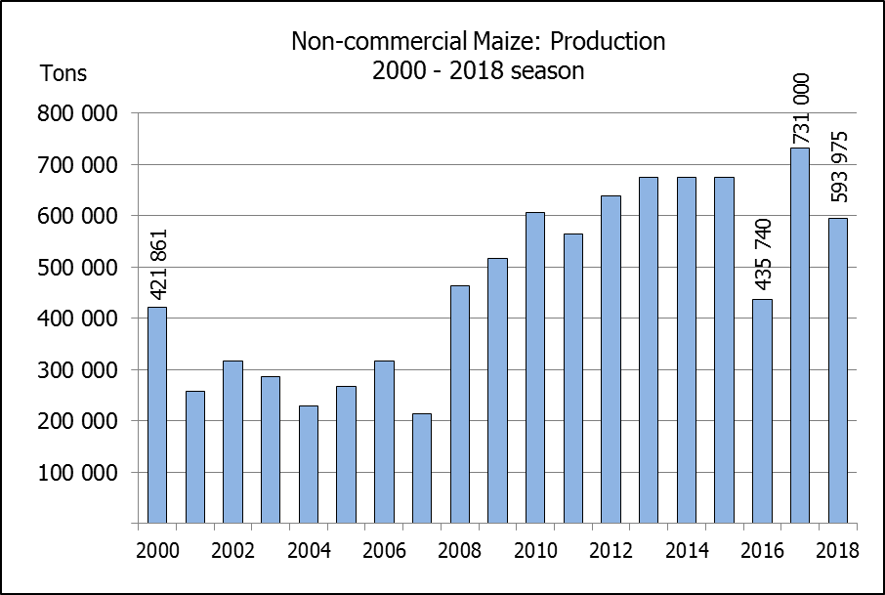
The preliminary area planted to maize in the non-commercial agricultural sector is estimated at 314 835 ha, which represents a decrease of 14,13%, compared to the 366 650 ha of the previous season. The expected maize crop for this sector is 593 975 tons, which is 18,74% less than the 731 000 tons of last season. It is important to note that about 40% of the maize produced in the non-commercial sector, is planted in the Eastern Cape.
Die voorlopige oppervlakte beplant met mielies in die nie-kommersiële landbou-sektor word geskat op 314 835 ha, wat ‘n afname van 14,13 % verteenwoordig in vergelyking met die 366 650 ha van die vorige seisoen. Die verwagte mielie-oes van dié sektor is 593 975 ton, wat 18,74% minder is as die 731 000 ton van die vorige seisoen. Dit is belangrik om daarop te let dat ongeveer 40% van die mielies wat geproduseer word in die nie-kommersiële sektor, in die Oos-Kaap geplant word.

The preliminary area estimate for winter cereals for the 2018 is hereby released. /
Hiermee word die voorlopige oppervlakteskatting vir wintergewasse vir 2018 vrygestel.

WINTER CEREALS – PRELIMINARY AREA PLANTED ESTIMATE: 2018 PRODUCTION SEASON
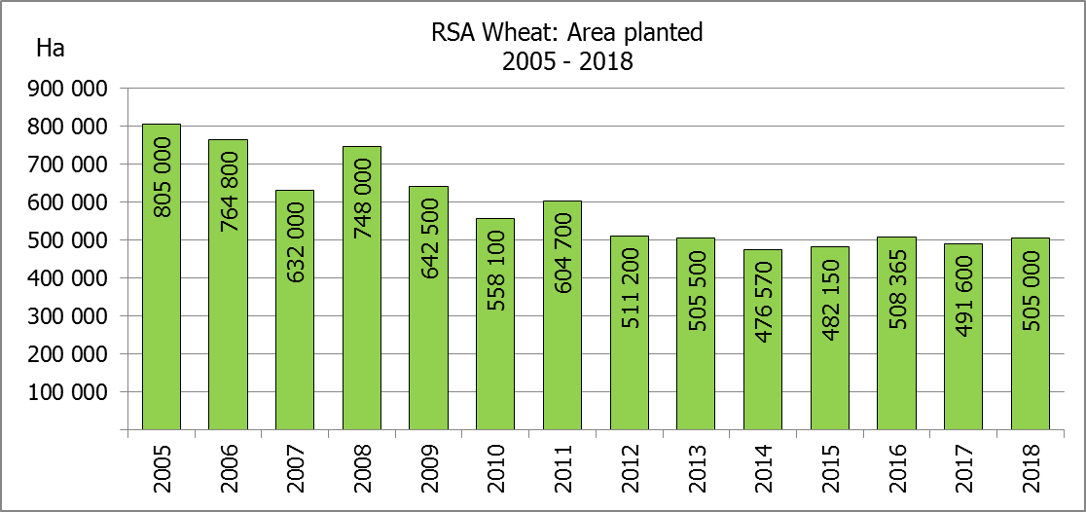
WINTERGEWASSE – VOORLOPIGE OPPERVLAKTESKATTING: 2018-PRODUKSIESEISOEN
CROP/GEWAS | Area planted/  Opp beplant  2018 | Intentions/  Voorneme*  Mid April 2018 | Area planted/  Opp beplant  2017 | Final crop/  Finale oes  2017 | Change/  Verandering
CROP/GEWAS | Ha | Ha | Ha | Tons | %
CROP/GEWAS | (A) | (B) | (C) | (D) | (A) ÷ (C)
Commercial/Kommersieel:
Wheat/Koring | 505 000 | 500 500 | 491 600 | 1 535 000 | +2,73
Malting barley/Moutgars | 106 150 | 95 700 | 91 380 | 307 000 | +16,16
Canola/Kanola | 80 000 | 78 500 | 84 000 | 93 500 | -4,76
Total/Totaal | 691 150 | 674 700 | 666 980 | 1 935 500 | 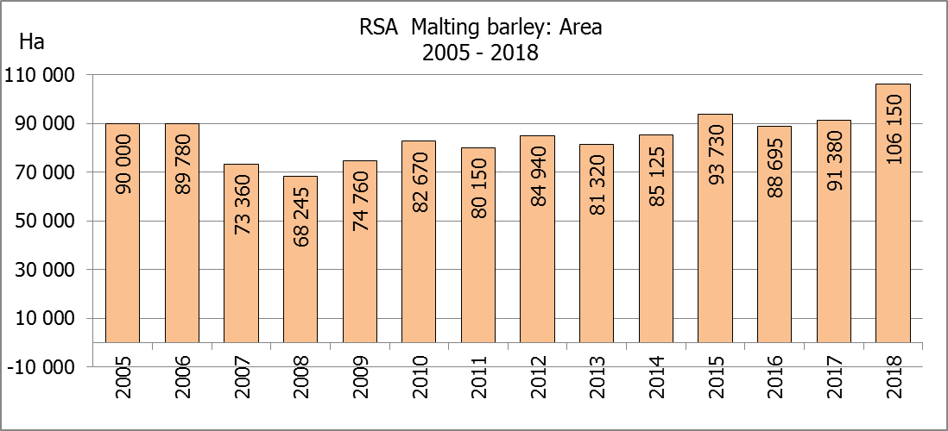  +3,62
* Intentions based on conditions at the middle of April 2018 / Voorneme gebaseer op toestande soos teen middel April 2018.

WHEAT – PRELIMINARY AREA PLANTED ESTIMATE: 2018
KORING – VOORLOPIGE OPPERVLAKTESKATTING: 2018

Province/  Provinsie | Area planted/  Opp beplant  Ha | Intentions/  Voorneme*  Ha | Area planted/  Opp beplant  Ha | Final crop/  Finale oes  Tons
Province/  Provinsie | 2018 | Mid April 2018 | 2017 | 2017
Western Cape/Wes-Kaap | 318 000 | 320 000 | 326 000 | 586 800
Northern Cape/Noord-Kaap | 38 000 | 37 000 | 38 000 | 311 650
Free State/Vrystaat | 100 000 | 95 000 | 80 000 | 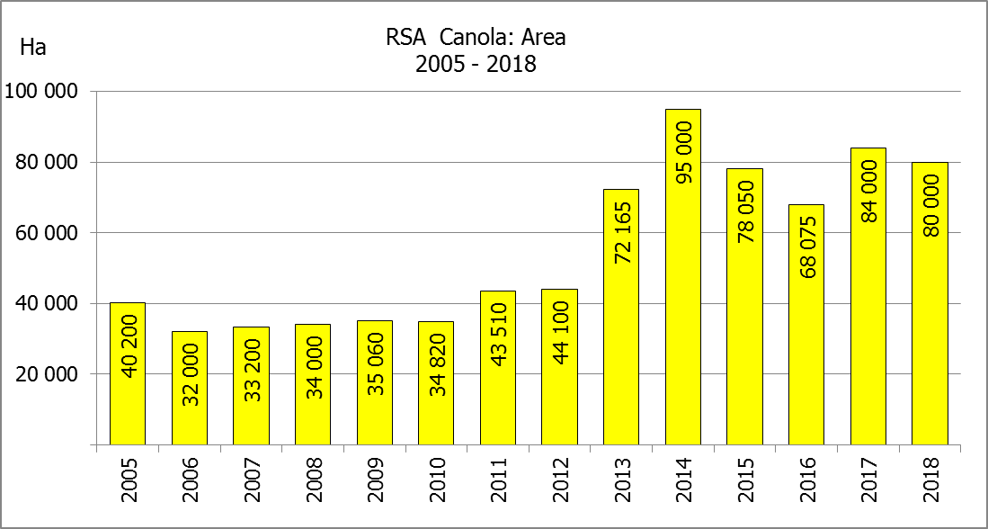  336 000
Eastern Cape/Oos-Kaap | 1 750 | 2 000 | 1 900 | 9 500
KwaZulu-Natal | 7 000 | 6 500 | 7 500 | 45 750
Mpumalanga | 3 500 | 3 500 | 4 000 | 25 400
Limpopo | 22 000 | 22 000 | 20 000 | 132 000
Gauteng | 750 | 500 | 700 | 4 200
North West/Noordwes | 14 000 | 14 000 | 13 500 | 83 700
Total/Totaal | 505 000 | 500 500 | 491 600 | 1 535 000
* Intentions based on conditions at the middle of April 2018 / Voorneme gebaseer op toestande soos teen middel April 2018.

PRELIMINARY AREA ESTIMATE OF WINTER CROPS (2018) /
VOORLOPIGE OPPERVLAKTEKSKATTING VAN WINTERGEWASSE (2018)
26 JULY/ 26 JULIE 2018

Winter cereal crops - 2018 production season  The preliminary area estimate is based on the results of a non-probability survey conducted by the Directorate: Statistics and Economic Analysis and reflects the position as at the middle of July 2018, as well as inputs from the PDA representatives. Please note that the information from the Producer Independent Crop Estimation System (PICES), as conducted by the National Crop Statistics Consortium (NCSC), for the Western Cape will be available in August 2018 and for the Free State in September 2018.  Wheat: The preliminary area estimate for wheat is 505 000 ha, which is 2,73% or 13 400 ha more than the 491 600 ha planted for the previous season.  An estimated 318 000 ha is planted in the Western Cape, which is 8 000 ha less than the 326 000 ha planted for the previous season. In the Free State, 100 000 ha is planted, which is 20 000 ha more than the 80 000 ha planted for the previous season. The area planted in the Northern Cape is 38 000 ha, which is the same area than the previous season.  Other crops: The preliminary area estimate for malting barley is 106 150 ha, which is 16,16% or 14 770 ha more than the 91 380 ha of last season. The area planted to canola is 80 000 ha, which is 4,76% or 4 000 ha less than the 84 000 ha planted for the previous season.  Please note that the revised area planted estimate and first production forecast for winter cereals for 2018 will be released on 28 August 2018. |  | Wintergewasse - 2018 produksie-seisoen  Die voorlopige oppervlakteskatting is gebaseer op die resultate van ’n nie-ewekansige opname onderneem deur die Direktoraat: Statistiek en Ekonomiese Analise en weerspieël die situasie teen die middel van Julie 2018, sowel as insette van die PDL verteenwoordigers. Let wel, inligting van die Produsente Onafhanklike Oesskattingstelsel (“PICES”), soos gedoen deur die Nasionale Oesskattingskonsortium, sal vir die Wes-Kaap in Augustus 2018 gerapporteer word en vir die Vrystaat in September 2018.  Koring: Die voorlopige skatting van die oppervlakte onder koring beloop 505 000 ha, wat 2,73% of 13 400 ha meer is as die 491 600 ha wat verlede seisoen aangeplant is.  Die beraamde oppervlakte beplant in die Wes-Kaap is 318 000 ha, wat 8 000 ha minder is as die 326 000 ha wat verlede seisoen aangeplant is. Vir die Vrystaat is die aanplantings 100 000 ha, wat 20 000 ha meer is as die 80 000 ha wat verlede seisoen aangeplant is. Die oppervlakte beplant in die Noord-Kaap is 38 000 ha, wat dieselfde oppervlakte is as die vorige seisoen.  Ander gewasse: Die voorlopige oppervlakskatting vir moutgars is 106 150 ha, wat 16,16% of 14 770 ha meer is as die 91 380 ha van verlede seisoen. Die oppervlakte onder kanola is 80 000 ha, wat 4,76% of 4 000 ha minder is as die 84 000 ha wat verlede seisoen aangeplant is.  Neem asseblief kennis dat die hersiene oppervlakte beplant en eerste produksieskatting vir wintergewasse vir 2018 op 28 Augustus 2018 vrygestel sal word.

Information is available on the internet at http://www.daff.gov.za/links/crop estimates or http://www.sagis.org.za, as from 15:30 on the date of the relevant meeting of the Crop Estimates Committee. |  | Inligting is beskikbaar op die internet by http://www.daff.gov.za/links/crop estimates of by http://www.sagis.org.za, vanaf 15:30 op die dag van die toepaslike vergadering van die Oesskattingskomitee.

