 | crop estimates committee | 
 | oesskattingskomitee
From/Van: M. Ellen Matsei
Tel: 012 319 8454  Fax/Faks: 012 319 8031  E-mail/E-pos: DAS@daff.gov.za
Web page/Webblad: www.daff.gov.za/statistics and economic reports or www.sagis.org.za/CEC: Crop Estimates
EMBARGO: 15:30

The area planted estimate and sixth production forecast for summer crops for 2017 is hereby released.
Hiermee word die oppervlakte- en sesde produksieskatting vir somergewasse vir 2017 vrygestel.

SUMMER CROPS – AREA PLANTED AND SIXTH PRODUCTION FORECAST: 2017
SOMERGEWASSE – OPPERVLAKTE- EN SESDE PRODUKSIESKATTING: 2017
CROP/GEWAS  The Crop Estimates Committee comprises officials of the following institutions:  Department of Agriculture, Forestry and Fisheries; Provincial Departments of Agriculture; various ARC-Institutes (Soil, Climate and Water; Small Grains Institute;  and Grain Crops Institute); BFAP and Statistics SA. | Area planted/  Opp beplant  2017 | 6th forecast/  6de skatting  2017 | 5th forecast/  5de skatting  2017 | Area planted/  Opp beplant  2016 | Final crop/  Finale oes  2016 | Change/  Verandering
 | Ha | Tons | Tons | Ha | Tons | %
 | (A) | (B) | (C) | (D) | (E) | (B) ÷ (C)
Commercial/Kommersieel:
White maize/Witmielies | 1 643 100 | 9 507 050 | 9 466 800 | 1 014 750 | 3 408 500 | +0,43
Yellow maize/Geelmielies | 985 500 | 6 462 250 | 6 164 250 | 932 000 | 4 370 000 | +4,83
Total Maize/Totale Mielies | 2 628 600 | 15 969 300 | 15 631 050 | 1 946 750 | 7 778 500 | +2,16
Sunflower seed/Sonneblomsaad | 635 750 | 821 970 | 821 970 | 718 500 | 755 000 | -
Soybeans/Sojabone | 573 950 | 1 340 370 | 1 340 370 | 502 800 | 742 000 | -
Groundnuts/Grondbone | 56 000 | 90 550 | 90 550 | 22 600 | 17 680 | -
Sorghum | 42 350 | 151 335 | 151 335 | 48 500 | 70 500 | -
Dry beans/Droëbone | 45 050 | 68 525 | 68 450 | 34 400 | 35 445 | +0,11
TOTAL/TOTAAL | 3 981 700 | 18 442 050 | 18 103 725 | 3 273 550 | 9 399 125 | +1,87
Note: Estimate is for calendar year, e.g. production season 2016/17 = 2017
Nota: Skatting is vir kalenderjaar, bv. produksie-seisoen 2016/17 = 2017

26 July/Julie 2017
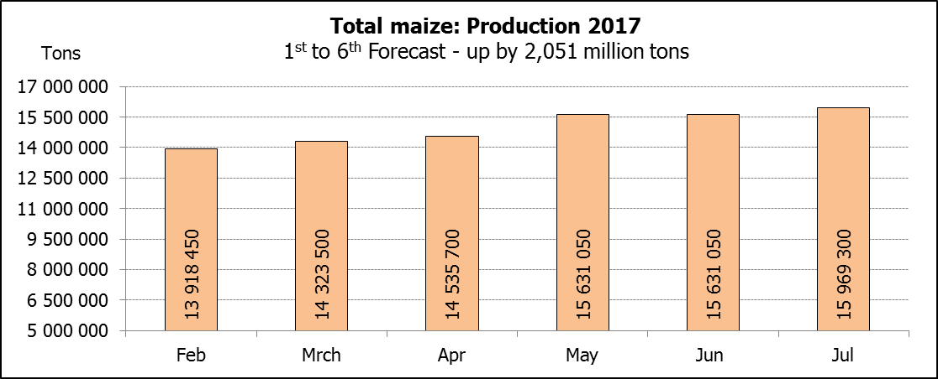
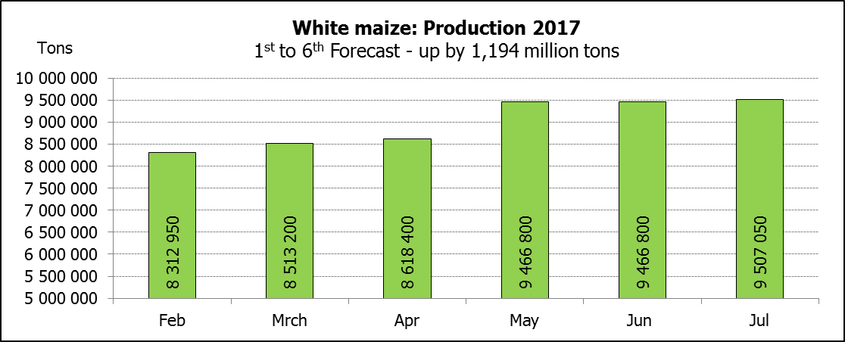

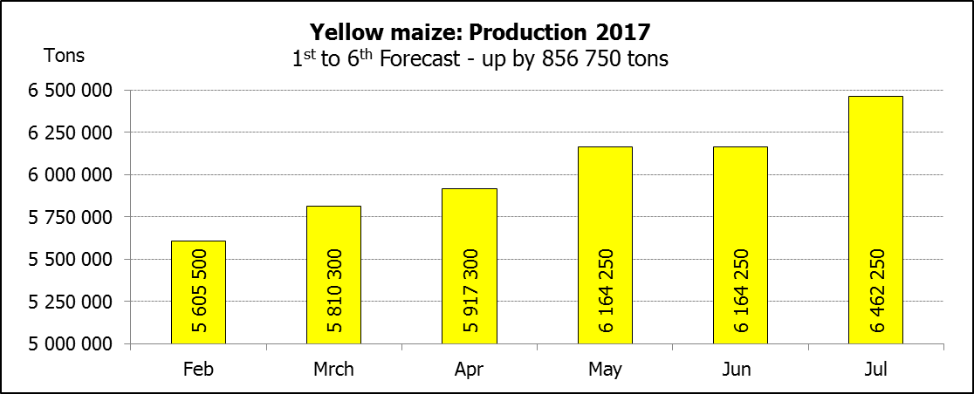

WHITE AND YELLOW MAIZE – AREA PLANTED AND SIXTH PRODUCTION FORECAST: 2017
WIT- EN GEELMIELIES – OPPERVLAKTE EN SESDE PRODUKSIESKATTING: 2017

Provinsie/  Province | Area planted/  Oppervlakte beplant  2017 |  |  | 6th forecast/  6de skatting  2017 |  |  | Area planted/  Oppervlakte beplant  2016 |  |  | Final crop/  Finale oes  2016
Provinsie/  Province | White/  Wit  Ha | Yellow/  Geel  Ha | Total/  Totaal  Ha | White/  Wit  Tons | Yellow/  Geel  Tons | Total/  Totaal  Tons | White/  Wit  Ha | Yellow/  Geel  Ha | Total/  Totaal  Ha | White/  Wit  Tons | Yellow/  Geel  Tons | Total/  Totaal  Tons
Western Cape/Wes-Kaap | 200 | 2 000 | 2 200 | 2 000 | 20 000 | 22 000 | 500 | 4 000 | 4 500 | 5 000 | 40 000 | 45 000
Northern Cape/Noord-Kaap | 3 500 | 45 000 | 48 500 | 45 500 | 652 500 | 698 000 | 3 750 | 50 000 | 53 750 | 35 000 | 675 000 | 710 000
Free State/Vrystaat | 805 000 | 355 000 | 1 160 000 | 4 950 750 | 2 023 500 | 6 974 250 | 390 000 | 310 000 | 700 000 | 1 190 500 | 1 023 000 | 2 213 500
Eastern Cape/Oos-Kaap | 4 400 | 9 500 | 13 900 | 30 800 | 61 750 | 92 550 | 2 000 | 12 000 | 14 000 | 10 000 | 66 000 | 76 000
KwaZulu-Natal | 50 000 | 50 000 | 100 000 | 330 000 | 375 000 | 705 000 | 38 000 | 48 000 | 86 000 | 215 000 | 307 000 | 522 000
Mpumalanga | 160 000 | 330 000 | 490 000 | 1 040 000 | 2 244 000 | 3 284 000 | 160 000 | 330 000 | 490 000 | 752 000 | 1 567 000 | 2 319 000
Limpopo | 40 000 | 24 000 | 64 000 | 292 000 | 192 000 | 484 000 | 31 500 | 22 000 | 53 500 | 178 000 | 132 000 | 310 000
Gauteng | 60 000 | 60 000 | 120 000 | 372 000 | 360 000 | 732 000 | 49 000 | 56 000 | 105 000 | 207 000 | 235 000 | 442 000
North West/Noordwes | 520 000 | 110 000 | 630 000 | 2 444 000 | 533 500 | 2 977 500 | 340 000 | 100 000 | 440 000 | 816 000 | 325 000 | 1 141 000
Total/Totaal | 1 643 100 | 985 500 | 2 628 600 | 9 507 050 | 6 462 250 | 15 969 300 | 1 014 750 | 932 000 | 1 946 750 | 3 408 500 | 4 370 000 | 7 778 500

SUNFLOWER SEED – AREA PLANTED AND SIXTH PRODUCTION FORECAST: 2017
SONNEBLOMSAAD – OPPERVLAKTE EN SESDE PRODUKSIESKATTING: 2017

Province/  Provinsie | Area planted/  Opp beplant  Ha | 6th forecast/  6de skatting  Tons | Area planted/  Opp beplant  Ha | Final crop/  Finale oes  Tons
Province/  Provinsie | 2017 | 2017 | 2016 | 2016
Western Cape/Wes-Kaap | - | - | - | -
Northern Cape/Noord-Kaap | 250 | 250 | 500 | 600
Free State/Vrystaat | 330 000 | 445 500 | 400 000 | 440 000
Eastern Cape/Oos-Kaap | - | - | - | -
KwaZulu-Natal | 300 | 300 | - | -
Mpumalanga | 2 200 | 2 420 | 4 000 | 4 400
Limpopo | 90 000 | 76 500 | 65 000 | 48 750
Gauteng | 3 000 | 3 000 | 4 000 | 4 000
North West/Noordwes | 210 000 | 294 000 | 245 000 | 257 250
Total/Totaal | 635 750 | 821 970 | 718 500 | 755 000

SOYBEANS – AREA PLANTED AND SIXTH PRODUCTION FORECAST: 2017
SOJABONE – OPPERVLAKTE EN SESDE PRODUKSIESKATTING: 2017

Province/  Provinsie | Area planted/  Opp beplant  Ha | 6th forecast/  6de skatting  Tons | Area planted/  Opp beplant  Ha | Final crop/  Finale oes  Tons
Province/  Provinsie | 2017 | 2017 | 2016 | 2016
Western Cape/Wes-Kaap | 700 | 1 050 | 800 | 1 200
Northern Cape/Noord-Kaap | 3 000 | 10 500 | 4 000 | 13 600
Free State/Vrystaat | 240 000 | 528 000 | 174 000 | 148 000
Eastern Cape/Oos-Kaap | 1 850 | 2 775 | 1 500 | 2 100
KwaZulu-Natal | 30 500 | 89 975 | 28 000 | 66 000
Mpumalanga | 241 000 | 554 300 | 240 000 | 408 000
Limpopo | 8 500 | 29 750 | 16 000 | 38 400
Gauteng | 25 400 | 71 120 | 23 000 | 50 600
North West/Noordwes | 23 000 | 52 900 | 15 500 | 14 100
Total/Totaal | 573 950 | 1 340 370 | 502 800 | 742 000
GROUNDNUTS – AREA PLANTED AND SIXTH PRODUCTION FORECAST: 2017
GRONDBONE – OPPERVLAKTE EN SESDE PRODUKSIESKATTING: 2017

Province/  Provinsie | Area planted/  Opp beplant  Ha | 6th forecast/  6de skatting  Tons | Area planted/  Opp beplant  Ha | Final crop/  Finale oes  Tons
Province/  Provinsie | 2017 | 2017 | 2016 | 2016
Western Cape/Wes-Kaap | - | - | - | -
Northern Cape/Noord-Kaap | 4 000 | 14 000 | 5 000 | 10 000
Free State/Vrystaat | 22 000 | 34 100 | 6 500 | 2 920
Eastern Cape/Oos-Kaap | - | - | - | -
KwaZulu-Natal | - | - | - | -
Mpumalanga | - | - | - | -
Limpopo | 3 000 | 4 650 | 1 600 | 1 440
Gauteng | - | - | - | -
North West/Noordwes | 27 000 | 37 800 | 9 500 | 3 320
Total/Totaal | 56 000 | 90 550 | 22 600 | 17 680

SORGHUM – AREA PLANTED AND SIXTH PRODUCTION FORECAST: 2017
SORGHUM – OPPERVLAKTE EN SESDE PRODUKSIESKATTING: 2017

Province/  Provinsie | Area planted/  Opp beplant  Ha | 6th forecast/  6de skatting  Tons | Area planted/  Opp beplant  Ha | Final crop/  Finale oes  Tons
Province/  Provinsie | 2017 | 2017 | 2016 | 2016
Western Cape/Wes-Kaap | - | - | - | -
Northern Cape/Noord-Kaap | - | - | - | -
Free State/Vrystaat | 7 700 | 24 640 | 28 000 | 24 150
Eastern Cape/Oos-Kaap | - | - | - | -
KwaZulu-Natal | 400 | 1 520 | 500 | 1 650
Mpumalanga | 12 000 | 62 400 | 10 000 | 32 500
Limpopo | 18 000 | 50 400 | 7 000 | 9 800
Gauteng | 750 | 2 400 | - | -
North West/Noordwes | 3 500 | 9 975 | 3 000 | 2 400
Total/Totaal | 42 350 | 151 335 | 48 500 | 70 500

DRY BEANS – AREA PLANTED AND SIXTH PRODUCTION FORECAST: 2017
DROëBONE – OPPERVLAKTE EN SESDE PRODUKSIESKATTING: 2017

Province/  Provinsie | Area planted/  Opp beplant  Ha | 6th forecast/  6de skatting  Tons | Area planted/  Opp beplant  Ha | Final crop/  Finale oes  Tons
Province/  Provinsie | 2017 | 2017 | 2016 | 2016
Western Cape/Wes-Kaap | 100 | 150 | 100 | 150
Northern Cape/Noord-Kaap | 650 | 1 300 | 350 | 630
Free State/Vrystaat | 20 000 | 32 000 | 17 000 | 17 000
Eastern Cape/Oos-Kaap | 300 | 450 | 250 | 375
KwaZulu-Natal | 4 500 | 5 400 | 2 200 | 2 640
Mpumalanga | 5 500 | 8 525 | 6 000 | 6 000
Limpopo | 7 000 | 12 950 | 3 000 | 3 750
Gauteng | 1 500 | 2 250 | 2 500 | 2 500
North West/Noordwes | 5 500 | 5 500 | 3 000 | 2 400
Total/Totaal | 45 050 | 68 525 | 34 400 | 35 445

CONFIDENTIALITY ISSUES that CEC members are committed to adhere to on the day of the meeting
- Personal items such as laptops, handbags, cell phones, etc. are not allowed in the venue during the meeting
- No member is allowed to leave the meeting before 12:00 in order to prevent disclosure of the information
- The embargo time for the release of crop estimates information is 15:30
- No member is allowed to discuss crop estimates information with anyone other than a member of the Committee before the embargo time
- Only the Chairperson, or a member appointed by the Chairperson, may release the figures to the media
- Members must regard the detail of any information that was collected for and/or discussed during the meeting, as confidential
- Individual information received for crop estimate purposes is treated strictly confidential, and is not divulged for any other purposes

AREA ESTIMATE AND SIXTH PRODUCTION FORECAST OF SUMMER CROPS (2017 PRODUCTION SEASON)/
OPPERVLAKTE- EN SESDE PRODUKSIESKATTING VIR SOMERGEWASSE (2017 PRODUKSIE-SEISOEN)
26 JULY 2017

Summer field crops – 2017  Commercial maize: The size of the expected commercial maize crop has been set at 15,969 mill. tons, which is 2,16% or 338 250 tons more than the previous forecast of 15,631 mill. tons. It is the largest maize crop produced in the history of SA. The area estimate for maize is 2,629 mill. ha, while the expected yield is 6,08 t/ha – also the highest yield ever.  The three main maize producing areas, namely the Free State, Mpumalanga and North West provinces are expected to produce 83% of the 2017 crop.  The area estimate for white maize is 1,643 mill. ha and for yellow maize the area estimate is 985 500 ha.  The production forecast of white maize is 9,507 mill. tons, which is 0,43% or 40 250 tons more than the 9,467 mill. tons of the previous forecast. The yield for white maize is 5,79 t/ha. In the case of yellow maize the production forecast is 6,462 mill. tons, which is 4,83% or 298 000 tons more than the 6,164 mill. tons of the previous forecast. The yield for yellow maize is 6,56 t/ha.  Sunflower seed: The production forecast for sunflower seed remained unchanged at 821 970 tons. The area estimate for sunflower seed is 635 750 ha, while the expected yield is 1,29 t/ha.  Other crops: The production forecast for soybeans also remained unchanged at 1,340 mill. tons. The estimated area planted to soybeans is 573 950 ha and the expected yield is 2,34 t/ha.  The expected groundnut crop remained unchanged at 90 550 tons. The area estimate is 56 000 ha and the expected yield is 1,62 t/ha.  The production forecast for sorghum remained unchanged at 151 335 tons, whilst the area estimate for sorghum is 42 350 ha. The expected yield is 3,57 t/ha.  In the case of dry beans, the production forecast showed a slight increase of 0,11% or 75 tons to 68 525 tons. The area estimate of dry beans is 45 050 ha, with an expected yield of 1,52 t/ha.  Please note that the seventh production forecast for summer field crops for 2017 will be released on 29 August 2017. |  | Somergewasse – 2017  Kommersiële mielies: Die grootte van die verwagte kommersiële mielie-oes is op 15,969 milj. ton gestel, wat 2,16% of 338 250 ton meer is as die vorige skatting van 15,631 milj. ton. Dit is die grootste mielie-oes nog geproduseer in die geskiedenis van SA. Die skatting van die oppervlakte onder mielies is 2,629 milj. ha, terwyl die verwagte opbrengs 6,08 t/ha is – ook die hoogste opbrengs ooit.  Die drie belangrikste mielieproduserende gebiede, nl. die Vrystaat, Mpumalanga en Noordwes provinsies, gaan na verwagting 83% van die 2017-oes produseer.  Die oppervlak onder witmielies is 1,643 milj. ha en vir geelmielies is die oppervlak 985 500 ha.  Die produksieskatting van witmielies is 9,507 milj. ton, wat 0,43% of 40 250 ton meer is as die 9,467 milj. ton van die vorige skatting. Die opbrengs van witmielies is 5,79 t/ha. In die geval van geelmielies is die produksieskatting 6,462 milj. ton, wat 4,83% of 298 000 ton meer is as die 6,164 milj. ton van die vorige skatting. Die opbrengs van geelmielies is 6,56 t/ha.  Sonneblomsaad: Die produksieskatting vir sonneblomsaad is onveranderd gelaat op 821 970 ton. Die oppervlakteskatting vir sonneblomsaad is 635 750 ha, terwyl die verwagte opbrengs 1,29 t/ha is.  Ander gewasse: Die produksieskatting van sojabone is ook onveranderd gelaat op 1,340 milj. ton. Die geskatte oppervlakte beplant met sojabone is 573 950 ha en die verwagte opbrengs is 2,34 t/ha.  Die verwagte grondbone-oes is onveranderd gelaat op 90 550 ton. Die oppervlakteskatting is 56 000 ha, terwyl die verwagte opbrengs 1,62 t/ha is.  Die produksieskatting van sorghum is onveranderd gelaat op 151 335 ton, terwyl die oppervlakteskatting vir sorghum 42 350 ha is. Die verwagte opbrengs is 3,57 t/ha.  In die geval van droëbone dui die produksieskatting op ’n geringe styging van 0,11% of 75 ton na 68 525 ton. Die oppervlakte beplant met droëbone is 45 050 ha, en die verwagte opbrengs is 1,52 t/ha.  Neem asseblief kennis dat die sewende produksieskatting vir somergewasse vir 2017, op 29 Augustus 2017 vrygestel sal word.

The non-commercial agricultural sectors’ production estimate for maize for 2017 is hereby released. /
Hiermee word die nie-kommersiële landbou-sektor se produksieskatting vir mielies vir 2017 vrygestel.

NON-COMMERCIAL MAIZE – AREA PLANTED AND PRODUCTION ESTIMATE: 2017
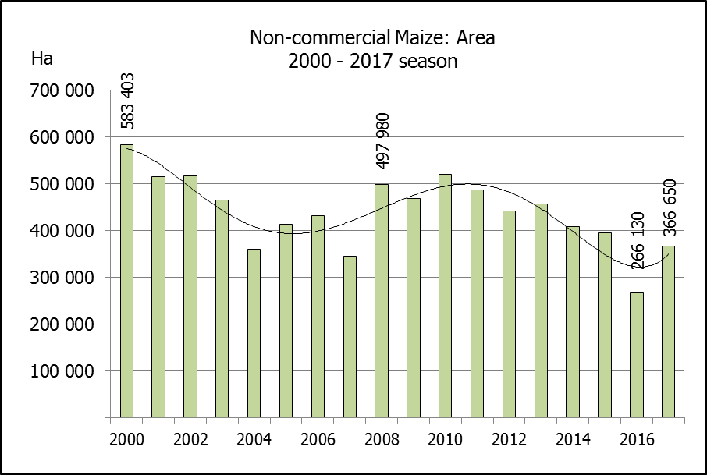
NIE-KOMMERSIëLE MIELIES – OPPERVLAKTE- EN PRODUKSIESKATTING: 2017
CROP/GEWAS | Area planted/  Opp beplant  2017 | Production/  Produksie  2017 | Area planted/  Opp beplant  2016 | Final crop/  Finale oes  2016 | Change/  Verandering
CROP/GEWAS | Ha | Tons | Ha | Tons | %
CROP/GEWAS | (A) | (B) | (C) | (D) | (B) ÷ (D)
Non-commercial agriculture/Nie-kommersiële landbou:
White maize/Witmielies | 248 500 | 463 600 | 191 225 | 286 175 | +62,00
Yellow maize/Geelmielies | 118 150 | 267 400 | 74 905 | 149 565 | +78,79
Maize/Mielies | 366 650 | 731 000 | 266 130 | 435 740 | +67,76
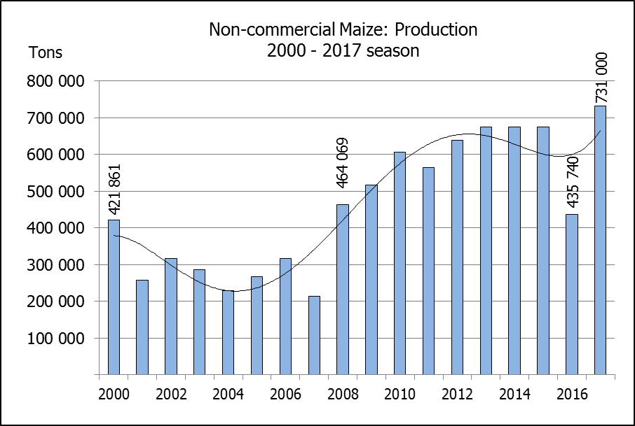
The area planted to maize in the non-commercial agricultural sector is estimated at 366 650 ha, which represents an increase of 37,77%, compared to the 266 130 ha of the previous season. The expected maize crop for this sector is 731 000 tons, which is 67,76% more than the 435 740 tons of last season. It is important to note that about 64% of the maize produced in the non-commercial sector, is planted in the Eastern Cape.
Die oppervlakte beplant met mielies in die nie-kommersiële landbou-sektor word geskat op 366 650 ha, wat ‘n toename van 37,77 % verteenwoordig in vergelyking met die 266 130 ha van die vorige seisoen. Die verwagte mielie-oes van dié sektor is 731 000 ton, wat 67,76% meer is as die 435 740 ton van die vorige seisoen. Dit is belangrik om daarop te let dat ongeveer 64% van die mielies wat geproduseer word in die nie-kommersiële sektor, in die Oos-Kaap geplant word.

The preliminary area estimate for winter cereals for the 2017 is hereby released. /
Hiermee word die voorlopige oppervlakteskatting vir wintergewasse vir 2017 vrygestel.

WINTER CEREALS – PRELIMINARY AREA PLANTED ESTIMATE: 2017 PRODUCTION SEASON
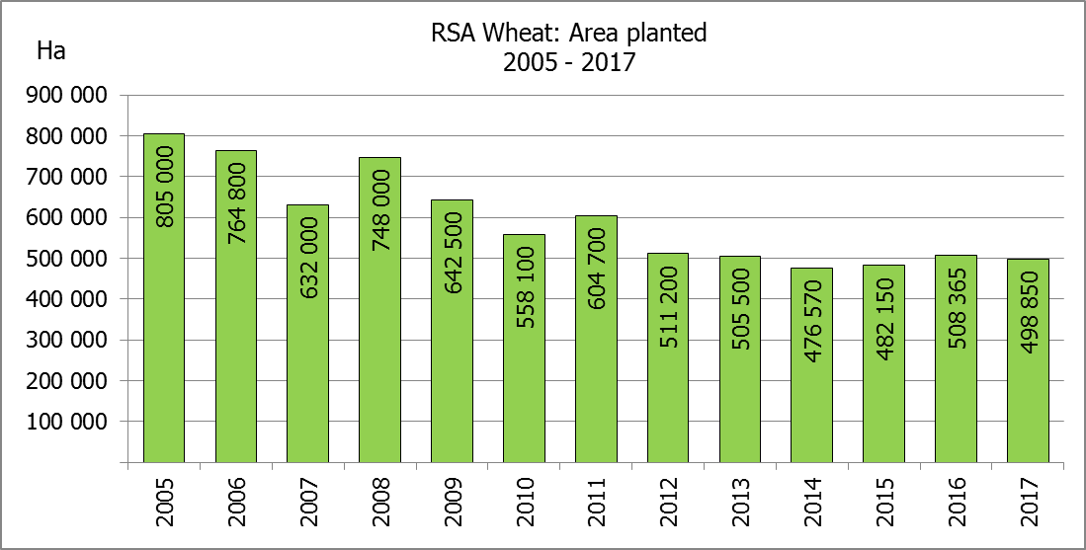
WINTERGEWASSE – VOORLOPIGE OPPERVLAKTESKATTING: 2017-PRODUKSIESEISOEN
CROP/GEWAS | Area planted/  Opp beplant  2017 | Intentions/  Voorneme*  Mid April 2017 | Area planted/  Opp beplant  2016 | Final crop/  Finale oes  2016 | Change/  Verandering
CROP/GEWAS | Ha | Ha | Ha | Tons | %
CROP/GEWAS | (A) | (B) | (C) | (D) | (A) ÷ (C)
Commercial/Kommersieel:
Wheat/Koring | 498 850 | 496 350 | 508 365 | 1 910 000 | -1,87
Malting barley/Moutgars | 98 800 | 96 000 | 88 695 | 355 000 | +11,39
Canola/Kanola | 87 000 | 90 000 | 68 075 | 105 000 | +27,80
Total/Totaal | 684 650 | 682 350 | 665 135 | 2 370 000 | 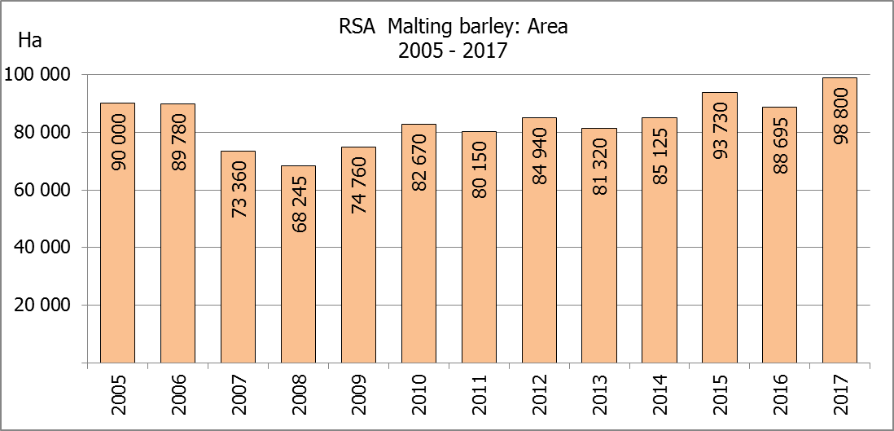  +2,93
* Intentions based on conditions at the middle of April 2017 / Voorneme gebaseer op toestande soos teen middel April 2017.

WHEAT – PRELIMINARY AREA PLANTED ESTIMATE: 2017
KORING – VOORLOPIGE OPPERVLAKTESKATTING: 2017

Province/  Provinsie | Area planted/  Opp beplant  Ha | Intentions/  Voorneme*  Ha | Area planted/  Opp beplant  Ha | Final crop/  Finale oes  Tons
Province/  Provinsie | 2017 | Mid April 2017 | 2016 | 2016
Western Cape/Wes-Kaap | 325 000 | 325 000 | 323 000 | 1 098 200
Northern Cape/Noord-Kaap | 38 000 | 35 500 | 35 000 | 266 000
Free State/Vrystaat | 90 000 | 90 000 | 110 000 | 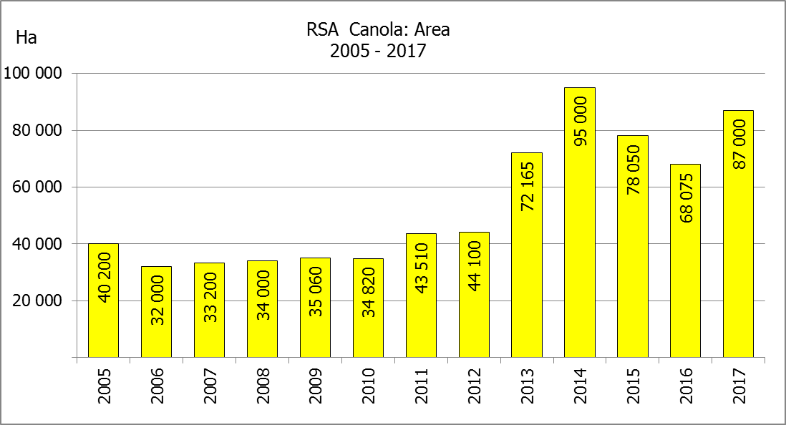  308 460
Eastern Cape/Oos-Kaap | 1 900 | 1 900 | 2 200 | 11 000
KwaZulu-Natal | 7 500 | 7 500 | 6 500 | 37 050
Mpumalanga | 3 300 | 3 300 | 2 300 | 13 800
Limpopo | 20 000 | 20 000 | 17 000 | 103 700
Gauteng | 350 | 350 | 365 | 2 190
North West/Noordwes | 12 800 | 12 800 | 12 000 | 69 600
Total/Totaal | 498 850 | 496 350 | 508 365 | 1 910 000
* Intentions based on conditions at the middle of April 2017 / Voorneme gebaseer op toestande soos teen middel April 2017.

PRELIMINARY AREA ESTIMATE OF WINTER CROPS (2017) /
VOORLOPIGE OPPERVLAKTEKSKATTING VAN WINTERGEWASSE (2017)
27 JULY/ 27 JULIE 2017

Winter cereal crops - 2017 production season  The preliminary area estimate is based on the results of a non-probability survey conducted by the Directorate: Statistics and Econ. Analysis and reflects the position as at the middle of July 2017, as well as inputs from the PDA representatives. Please note that the information from the Producer Independent Crop Estimation System (PICES), as conducted by the National Crop Statistics Consortium (NCSC), for the Western Cape will be available in August 2017 and for the Free State in September 2017.  Wheat: The preliminary area estimate for wheat is 498 850 ha, which is 1,87% or 9 515 ha less than the 508 365 ha planted for the previous season. On record, this is the third smallest area planted to wheat (since the 1930’s). The smallest area planted to wheat was during 2014, when 476 570 ha was planted, whereas the second smallest area was planted during 2015, namely 482 150 ha.  An estimated 325 000 ha is planted in the Western Cape, which is 2 000 ha more than the 323 000 ha planted for the previous season. In the Free State, 90 000 ha is planted, which is 20 000 ha less than the 110 000 ha planted for the previous season. The area planted in the Northern Cape is 38 000 ha, which is 3 000 ha more than the 35 000 ha for the previous season.  Other crops: The preliminary area estimate for malting barley is 98 800 ha, which is 11,39% or 10 105 ha more than the 88 695 ha of last season. The area planted to canola is 87 000 ha, which is 27,80% or 18 925 ha more than the 68 075 ha planted for the previous season.  Please note that the revised area planted estimate and first production forecast for winter cereals for 2017 will be released on 29 August 2017. |  | Wintergewasse - 2017 produksie-seisoen  Die voorlopige oppervlakteskatting is gebaseer op die resultate van ’n nie-ewekansige opname onderneem deur die Direktoraat: Statistiek en Ekonomiese Analise en weerspieël die situasie teen die middel van Julie 2017, sowel as insette van die PDL verteenwoordigers. Let wel, inligting van die Produsente Onafhanklike Oesskattingstelsel (“PICES”), soos gedoen deur die Nasionale Oesskattingskonsortium, sal vir die Wes-Kaap in Augustus 2017 gerapporteer word en vir die Vrystaat in September 2017.  Koring: Die voorlopige skatting van die oppervlakte onder koring beloop 498 850 ha, wat 1,87% of 9 515 ha minder is as die 508 365 ha wat verlede seisoen aangeplant is. Volgens rekords, is dit die derde kleinste oppervlakte beplant met koring (sedert die 1930’s) . Die kleinste oppervlakte beplant met koring was gedurende 2014, toe 476 570 ha geplant was, terwyl die tweede kleinste oppervlakte gedurende 2015 geplant was, naamlik 482 150 ha.  Die beraamde oppervlakte beplant in die Wes-Kaap is 325 000 ha, wat 2 000 ha meer is as die 323 000 ha wat verlede seisoen aangeplant is. Vir die Vrystaat is die aanplantings 90 000 ha, wat 20 000 ha minder is as die 110 000 ha wat verlede seisoen aangeplant is. Die oppervlakte beplant in die Noord-Kaap is 38 000 ha, wat 3 000 ha meer is as die 35 000 ha wat die vorige seisoen aangeplant is.  Ander gewasse: Die voorlopige oppervlakskatting vir moutgars is 98 800 ha, wat 11,39% of 10 105 ha meer is as die 88 695 ha van verlede seisoen. Die oppervlakte onder kanola is 87 000 ha, wat 27,80% of 18 925 ha meer is as die 68 075 ha wat verlede seisoen aangeplant is.  Neem asseblief kennis dat die hersiene oppervlakte beplant en eerste produksieskatting vir wintergewasse vir 2017 op 29 Augustus 2017 vrygestel sal word.

Information is available on the internet at http://www.daff.gov.za/links/crop estimates or http://www.sagis.org.za, as from 15:30 on the date of the relevant meeting of the Crop Estimates Committee. |  | Inligting is beskikbaar op die internet by http://www.daff.gov.za/links/crop estimates of by http://www.sagis.org.za, vanaf 15:30 op die dag van die toepaslike vergadering van die Oesskattingskomitee.

