 | crop estimates committee | 
 | oesskattingskomitee
From/Van: Mr Baldwin Netshifhefhe
Tel: 012 319 8043/32  E-mail/E-pos: BaldwinN@dalrrd.gov.za
Web page/Webblad: www.dalrrd.gov.za/old website/statistics and economic reports or
www.sagis.org.za/CEC: Crop Estimates EMBARGO: 14:30

The preliminary area planted estimate for summer crops for 2025 is hereby released.
Hiermee word die voorlopige oppervlakteskatting vir somergewasse vir 2025 vrygestel.

SUMMER CROPS – PRELIMINARY AREA PLANTED ESTIMATE: 2025
SOMERGEWASSE – VOORLOPIGE OPPERVLAKSKATTING: 2025
CROP/GEWAS | Prel area planted/  Voorl opp beplant  2025 | Intentions^{1)/}  Voorneme¹⁾  2025 | Area planted/  Opp beplant  2024 | Final estimate²⁾/  Finale skatting²⁾  2024 | Change/  Verandering/  2025 vs 2024
CROP/GEWAS | Ha | Ha | Ha | Tons | %
CROP/GEWAS | (A) | (B) | (C) | (D) | (A) ÷ (C)
Commercial/Kommersieël:
White maize/Witmielies | 1 599 700 | 1 577 600 | 1 554 750 | 6 007 100 | 2,89%
Yellow maize/Geelmielies | 1 046 500 | 1 062 500 | 1 081 500 | 6 716 950 | -3,24%
Total Maize/Totale Mielies | 2 646 200 | 2 640 100 | 2 636 250 | 12 724 050 | 0,38%
Sunflower seed/Sonneblomsaad | 552 000 | 539 700 | 529 000 | 635 750 | 4,35%
Soybeans/Sojabone | 1 122 500 | 1 153 200 | 1 150 500 | 1 840 290 | -2,43%
Groundnuts/Grondbone | 46 175 | 40 000 | 41 200 | 51 745 | 12,08%
Sorghum | 39 500 | 54 000 | 42 100 | 97 810 | -6,18%
Dry beans/Droëbone | 45 500 | 45 105 | 39 550 | 50 495 | 15,04%
TOTAL/TOTAAL | 4 451 875 | 4 472 105 | 4 438 600 | 15 400 140 | 0,30%
- Soos middel Oktober 2024/ As mid October 2024
- 27 November 2024
Note: Estimate is for calendar year, e.g. production season 2024/25 = 2025
Nota: Skatting is vir kalenderjaar, bv. produksie-seisoen 2024/25 = 2025
The Crop Estimates Committee comprises officials of the following institutions:
Department of Agriculture, Land Reform and Rural Development; Provincial Departments of Agriculture; various ARC-Institutes (Soil, Climate and Water; Small Grains Institute; and Grain Crops Institute); BFAP and Statistics SA.
28 January / Januarie 2025
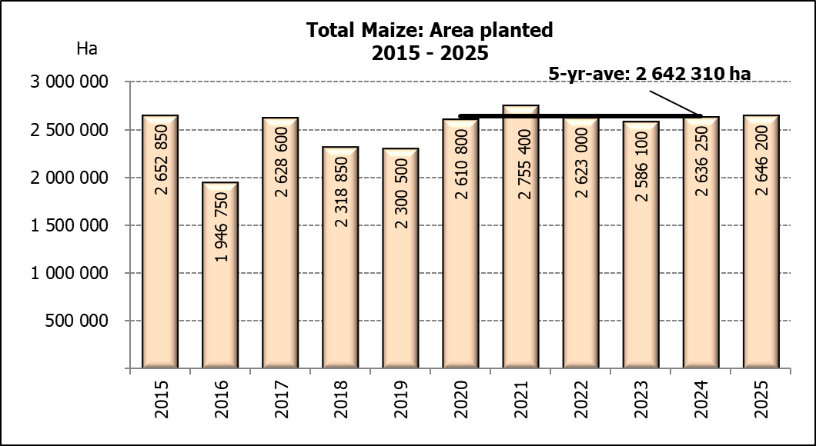

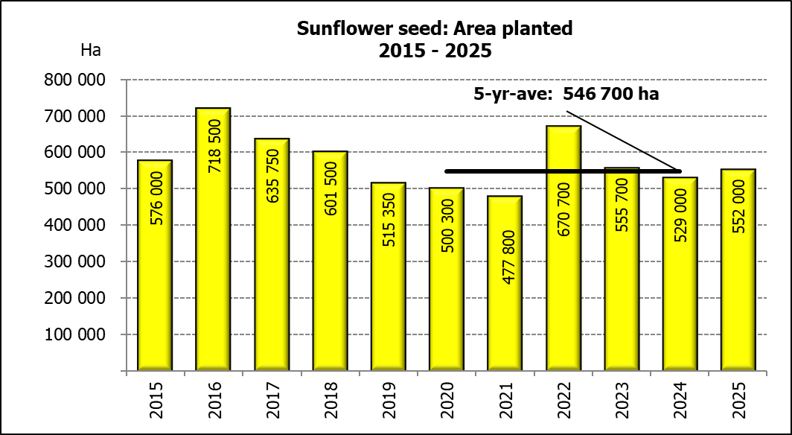
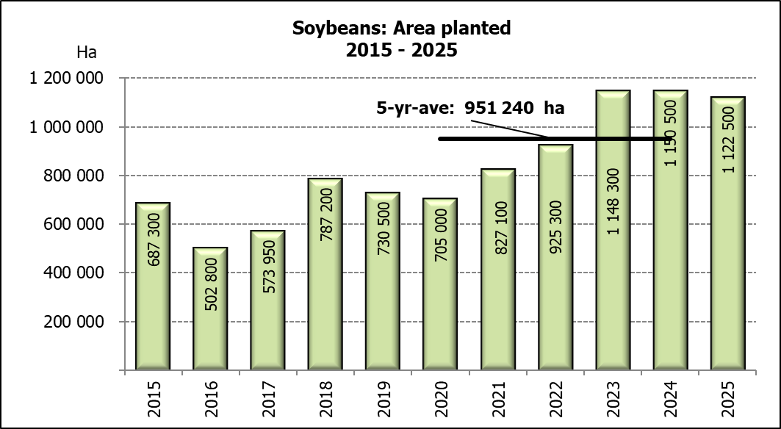

WHITE AND YELLOW MAIZE – PRELIMINARY AREA PLANTED ESTIMATE: 2025
WIT- EN GEELMIELIES – VOORLOPIGE OPPERVLAKTESKATTING: 2025
Province/  Provinsie | Preliminary area planted  Voorlopige oppervlakte beplant  2025 |  |  | Area planted/  Oppervlakte beplant  2024 |  |  | Final estimate¹⁾/  Finale skatting¹⁾  2024
Province/  Provinsie | White/  Wit  Ha | Yellow/  Geel  Ha | Totaal/  Total  Ha | White/  Wit  Ha | Yellow/  Geel  Ha | Totaal/  Total  Ha | White/  Wit  Tons | Geel/  Yellow  Tons | Totaal/  Total  Tons
Western Cape/Wes-Kaap | 200 | 3 500 | 3 700 | 250 | 3 500 | 3 750 | 2 300 | 32 200 | 34 500
Northern Cape/Noord-Kaap | 1 500 | 42 000 | 43 500 | 1 500 | 42 000 | 43 500 | 18 900 | 648 900 | 667 800
Free State/Vrystaat | 860 000 | 385 000 | 1 245 000 | 835 000 | 415 000 | 1 250 000 | 3 340 000 | 1 971 250 | 5 311 250
Eastern Cape/Oos-Kaap | 6 000 | 28 000 | 34 000 | 6 000 | 27 000 | 33 000 | 40 800 | 191 700 | 232 500
KwaZulu-Natal | 50 000 | 66 000 | 116 000 | 47 000 | 67 000 | 114 000 | 286 700 | 576 200 | 862 900
Mpumalanga | 162 000 | 362 000 | 524 000 | 160 000 | 360 000 | 520 000 | 984 000 | 2 448 000 | 3 432 000
Limpopo | 9 000 | 18 000 | 27 000 | 11 000 | 15 000 | 26 000 | 74 800 | 120 000 | 194 800
Gauteng | 56 000 | 57 000 | 113 000 | 54 000 | 62 000 | 116 000 | 291 600 | 409 200 | 700 800
North West/Noordwes | 455 000 | 85 000 | 540 000 | 440 000 | 90 000 | 530 000 | 968 000 | 319 500 | 1 287 500
Total/Totaal | 1 599 700 | 1 046 500 | 2 646 200 | 1 554 750 | 1 081 500 | 2 636 250 | 6 007 100 | 6 716 950 | 12 724 050
- 27 November 2024

SUNFLOWER SEED – PRELIMINARY AREA PLANTED ESTIMATE: 2025
SONNEBLOMSAAD – VOORLOPIGE OPPERVLAKTESKATTING: 2025

Province/  Provinsie | Prel area planted  Voorl opp beplant  Ha | Area planted/  Opp beplant  Ha | Final estimate¹⁾/  Finale skatting¹⁾  Tons
Province/  Provinsie | 2025 | 2024 | 2024
Western Cape/Wes-Kaap | 0 | 0 | 0
Northern Cape/Noord-Kaap | 1 000 | 2 000 | 4 600
Free State/Vrystaat | 275 000 | 255 000 | 357 000
Eastern Cape/Oos-Kaap | 700 | 700 | 1 400
KwaZulu-Natal | 300 | 300 | 600
Mpumalanga | 3 000 | 3 500 | 4 900
Limpopo | 85 000 | 90 000 | 63 000
Gauteng | 2 000 | 2 500 | 3 000
North West/Noordwes | 185 000 | 175 000 | 201 250
Total/Totaal | 552 000 | 529 000 | 635 750
SOYBEANS – PRELIMINARY AREA PLANTED ESTIMATE: 2025
SOJABONE – VOORLOPIGE OPPERVLAKTESKATTING: 2025

Province/  Provinsie | Prel area planted  Voorl opp beplant  Ha | Area planted/  Opp beplant  Ha | Final estimate¹⁾/  Finale skatting¹⁾  Tons
Province/  Provinsie | 2025 | 2024 | 2024
Western Cape/Wes-Kaap | 0 | 0 | 0
Northern Cape/Noord-Kaap | 1 000 | 1 200 | 4 380
Free State/Vrystaat | 535 000 | 545 000 | 681 250
Eastern Cape/Oos-Kaap | 8 000 | 5 300 | 14 310
KwaZulu-Natal | 45 000 | 47 000 | 173 900
Mpumalanga | 315 000 | 320 000 | 624 000
Limpopo | 13 500 | 21 000 | 72 450
Gauteng | 50 000 | 56 000 | 84 000
North West/Noordwes | 155 000 | 155 000 | 186 000
Total/Totaal | 1 122 500 | 1 150 500 | 1 840 290

GROUNDNUTS – PRELIMINARY AREA PLANTED ESTIMATE: 2025
GRONDBONE – VOORLOPIGE OPPERVLAKTESKATTING: 2025

Province/  Provinsie | Prel area planted  Voorl opp beplant  Ha | Area planted/  Opp beplant  Ha | Final estimate¹⁾/  Finale skatting¹⁾  Tons
Province/  Provinsie | 2025 | 2024 | 2024
Western Cape/Wes-Kaap | 0 | 0 | 0
Northern Cape/Noord-Kaap | 3 000 | 4 200 | 8 610
Free State/Vrystaat | 20 100 | 17 000 | 26 350
Eastern Cape/Oos-Kaap | 0 | 0 | 0
KwaZulu-Natal | 175 | 300 | 495
Mpumalanga | 0 | 0 | 0
Limpopo | 1 600 | 1 700 | 4 590
Gauteng | 0 | 0 | 0
North West/Noordwes | 21 300 | 18 000 | 11 700
Total/Totaal | 46 175 | 41 200 | 51 745

SORGHUM – PRELIMINARY AREA PLANTED ESTIMATE: 2025
SORGHUM – VOORLOPIGE OPPERVLAKTESKATTING: 2025

Province/  Provinsie | Prel area planted  Voorl opp beplant  Ha | Area planted/  Opp beplant  Ha | Final estimate¹⁾/  Finale skatting¹⁾  Tons
Province/  Provinsie | 2025 | 2024 | 2024
Western Cape/Wes-Kaap | 0 | 0 | 0
Northern Cape/Noord-Kaap | 0 | 0 | 0
Free State/Vrystaat | 12 000 | 11 500 | 19 550
Eastern Cape/Oos-Kaap | 200 | 100 | 300
KwaZulu-Natal | 100 | 100 | 350
Mpumalanga | 9 100 | 8 300 | 36 520
Limpopo | 13 000 | 18 000 | 35 100
Gauteng | 100 | 100 | 390
North West/Noordwes | 5 000 | 4 000 | 5 600
Total/Totaal | 39 500 | 42 100 | 97 810
- 27 November 2024

DRY BEANS – PRELIMINARY AREA PLANTED ESTIMATE: 2025
DROëBONE – VOORLOPIGE OPPERVLAKTESKATTING: 2025

Province/  Provinsie | Prel area planted  Voorl opp beplant  Ha | Area planted/  Opp beplant  Ha | Final estimate¹⁾/  Finale skatting¹⁾  Tons
Province/  Provinsie | 2025 | 2024 | 2024
Western Cape/Wes-Kaap | 100 | 100 | 220
Northern Cape/Noord-Kaap | 700 | 500 | 900
Free State/Vrystaat | 17 500 | 13 500 | 10 800
Eastern Cape/Oos-Kaap | 200 | 200 | 440
KwaZulu-Natal | 3 000 | 2 100 | 2 730
Mpumalanga | 3 000 | 2 600 | 4 680
Limpopo | 10 000 | 12 200 | 23 790
Gauteng | 1 000 | 850 | 935
North West/Noordwes | 10 000 | 7 500 | 6 000
Total/Totaal | 45 500 | 39 550 | 50 495

CONFIDENTIALITY ISSUES that CEC members are committed to adhere to on the day of the meeting
- Personal items such as laptops, handbags, cell phones, etc. are not allowed in the venue during the meeting
- No member is allowed to leave the meeting before 12:00 in order to prevent disclosure of the information
- The embargo time for the release of crop estimates information is 14:30
- No member is allowed to discuss crop estimates information with anyone other than a member of the Committee before the embargo time
- Only the Chairperson, or a member appointed by the Chairperson, may release the figures to the media
- Members must regard the detail of any information that was collected for and/or discussed during the meeting, as confidential
- Individual information received for crop estimate purposes is treated strictly confidential, and is not divulged for any other purposes

PRELIMINARY AREA ESTIMATE OF SUMMER CROPS (2025 PRODUCTION SEASON)/
VOORLOPIGE OPPERVLAKTESKATTING VIR SOMERGEWASSE (2025 PRODUKSIE-SEISOEN)
28 JANUARY / JANUARIE 2025

Summer field crops – 2025  The preliminary area estimate of today is mainly based on the results of a non-probability survey conducted by the Directorate: Statistics and Economic Analysis of the Department of Agriculture, Land Reform and Rural Development. Please note that the area planted to crops refers to the area already planted for all purposes, including grain, silage and crop damaged area(s).  Commercial maize: The preliminary area estimate for maize is 2,646 mill. ha, which is 0,38% or 9 950 ha more than the 2,636 mill. ha planted for the previous season, and also 0,23% or 6 100 ha more than the intentions to plant figure of 2,640 mill. ha released in October 2024.  The preliminary area estimate for white maize is 1,600 mill. ha, which represents an increase of 2,89% or 44 950 ha compared to the 1,555 mill. ha planted last season. In the case of yellow maize, the area estimate is 1,046 mill. ha, which is 3,24% or 35 000 ha less than the 1,082 mill. ha planted last season.  Other summer crops:  Sunflower seed: The preliminary area estimate for sunflower seed is 552 000 ha, which is 4,35% or 23 000 ha more than the 529 000 ha planted the previous season.  It is estimated that 1,122 mill. ha have been planted to soybeans, which represents a decrease of 2,43% or 28 000 ha compared to the 1,150 mill. ha planted last season.  For groundnuts, the area estimate is 46 175 ha, which is 12,08% or 4 975 ha more than the 41 200 ha planted for the previous season.  The area estimate for sorghum decreased by 6,18% or 2 600 ha, from 42 100 ha to 39 500 ha against the previous season.  For dry beans, the area estimate is 45 500 ha, which is 15,04% or 5 950 ha more than the 39 550 ha planted for the previous season.  The revised area planted and production figures, which will be released by the Crop Estimates Committee on 27 February 2025, will mainly be based on information obtained from the Producer Independent Crop Estimation System (PICES) survey for the Free State, KwaZulu-Natal, Mpumalanga, Limpopo, Gauteng and North West provinces. |  | Somergewasse – 2025  Die voorlopige oppervlakteskatting van vandag is hoofsaaklik gebaseer op die resultate van ’n nie-ewekansige opname onderneem deur die Direktoraat: Statistiek en Ekonomiese Analise van die Departement van Landbou, Grondhervorming en Landelike Ontwikkeling. Neem asseblief kennis dat die oppervlakte aangeplant met gewasse na die area verwys wat alreeds vir alle doeleindes geplant is, insluitende vir graan, kuilvoer en gewas beskadigde area(s).  Kommersiële mielies: Die voorlopige skatting van die oppervlakte onder mielies beloop 2,646 milj. ha, wat 0,38% of 9 950 ha meer is as die 2,636 milj. ha wat verlede seisoen aangeplant is, en ook 0,23% of 6 100 ha meer as die voornemens om te plant syfer van 2,640 milj. ha soos vrygestel in Oktober 2024.  Die voorlopige oppervlak onder witmielies is 1,600 milj. ha, wat ’n toename van 2,89% of 44 950 ha verteenwoordig vergeleke met die 1,555 milj. ha die vorige seisoen. In die geval van geelmielies is die oppervlakteskatting 1,046 milj. ha, wat 3,24% of 35 000 ha minder is as die 1,082 milj. ha geplant die vorige seisoen.  Ander somergewasse:  Sonneblomsaad: Die voorlopige oppervlakteskatting vir sonneblomsaad is 552 000 ha, wat 4,35% of 23 000 ha meer is as die 529 000 ha aangeplant die vorige seisoen.  Die geskatte oppervlakte beplant met sojabone is 1,122 milj. ha, wat ’n afname van 2,43% of 28 000 ha verteenwoordig vergeleke met die 1,150 milj. ha geplant die vorige seisoen.  Vir grondbone is die oppervlakteskatting 46 175 ha, wat 12,08% of 4 975 ha meer is as die 41 200 ha geplant vir die vorige seisoen.  Die oppervlakteskatting vir sorghum het afgeneem met 6,18% of 2 600 ha, van 42 100 ha tot 39 500 ha teenoor die vorige seisoen.  Vir droëbone is die geskatte oppervlakte beplant 45 500 ha, wat 15,04% of 5 950 ha meer is as die 39 550 ha geplant vir die vorige seisoen.  Die hersiene aangeplante oppervlakte en produksiesyfers sal deur die Oesskattingskomitee op 27 Februarie 2025 vrygestel word en sal hoofsaaklik gebaseer wees op inligting verkry vanaf die Produsente Onafhanklike Oesskattingstelsel (“PICES”) opname vir die Vrystaat, KwaZulu-Natal, Mpumalanga, Limpopo, Gauteng en Noordwes provinsies.
The area estimate and sixth production forecast for winter cereals for the 2024 is hereby released. /
Hiermee word die oppervlakte- en sesde produksieskatting vir wintergewasse vir 2024 vrygestel.
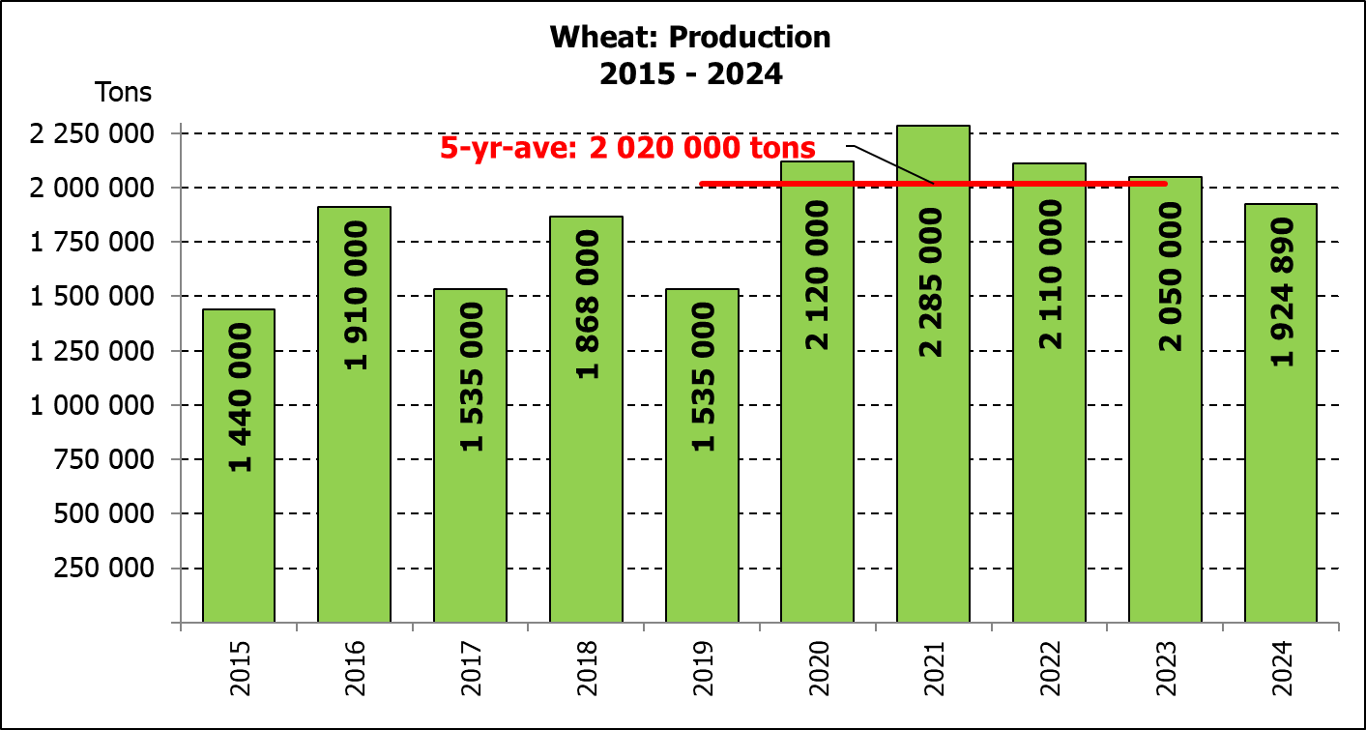
WINTER CEREALS – AREA PLANTED AND SIXTH PRODUCTION FORECAST: 2024 PRODUCTION SEASON
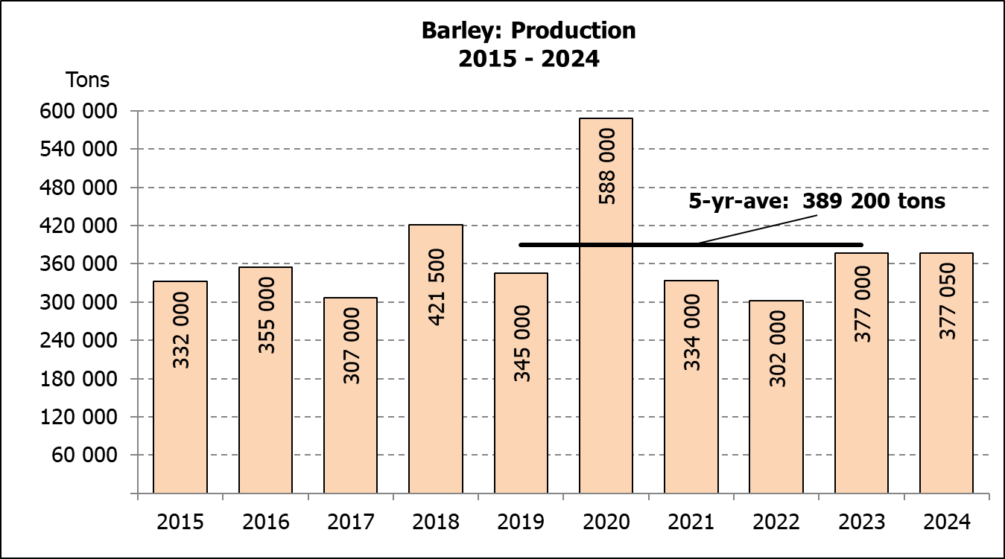
WINTERGEWASSE - OPPERVLAKTE- EN SESDE PRODUKSIESKATTING: 2024 PRODUKSIE-SEISOEN
CROP/GEWAS | Area planted/  Opp beplant  2024 | 6th forecast/  6de skatting  2024 | 5th forecast/  5de skatting  2024 | Area planted/  Opp beplant  2023 | Final crop/  Finale oes  2023 | Change/  Verandering
CROP/GEWAS | Ha | Tons | Tons | Ha | Tons | %
CROP/GEWAS | (A) | (B) | (C) | (D) | (E) | (B) ÷ (C)
Commercial/Kommersieel:
Wheat/Koring | 505 300 | 1 924 890 | 1 934 990 | 537 950 | 2 050 000 | -0,52%
Barley/Gars | 100 700 | 377 050 | 377 050 | 107 600 | 377 000 | 0,00%
Canola/Kanola | 165 750 | 287 445 | 295 445 | 131 200 | 236 300 | -2,71%
Oats/Hawer | 31 000 | 41 300 | 50 300 | 27 500 | 41 000 | -17,89%
Sweet lupines/Soetlupine | 16 000 | 19 200 | 19 200 | 16 000 | 16 000 | 0,00%
Total winter/Totaal winter | 818 750 | 2 649 885 | 2 676 985 | 820 250 | 2 720 300 | -1,01%
1) Commercial only. Excluding barley or oats used as pasture, silage, hay and/or on the farm as fodder for livestock /
Slegs kommersieël. Uitgesluit gars of hawer wat gebruik word as weiding, kuilvoer, hooi en/of op die plaas as voer vir vee.

WHEAT – AREA PLANTED AND SIXTH PRODUCTION FORECAST: 2024
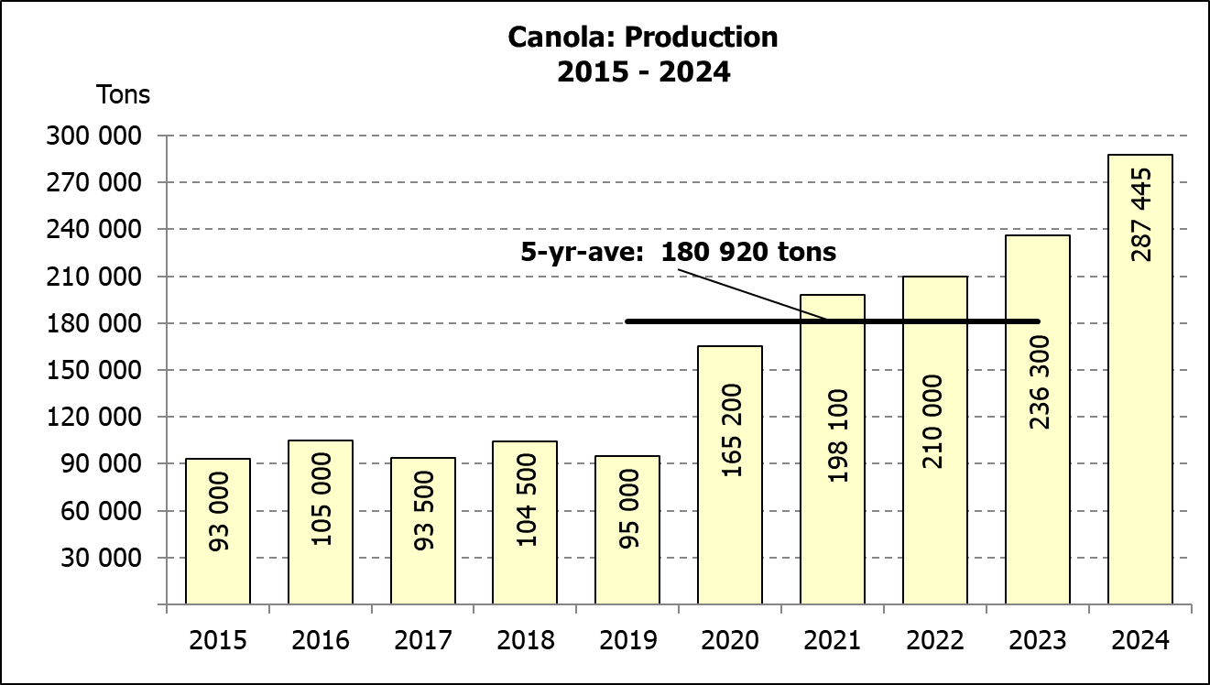
KORING – OPPERVLAKTE- EN SESDE PRODUKSIESKATTING: 2024
Province/  Provinsie | Area planted/  Opp beplant  Ha | 6th forecast/  6de skatting  Tons | Area planted/  Opp beplant  Ha | Final crop/  Finale oes  Tons
Province/  Provinsie | 2024 | 2024 | 2023 | 2023
Western Cape/Wes-Kaap | 368 000 | 1 067 200 | 365 000 | 1 084 000
Northern Cape/Noord-Kaap | 38 000 | 296 400 | 40 000 | 292 000
Free State/Vrystaat | 49 000 | 225 400 | 72 000 | 280 800
Eastern Cape/Oos-Kaap | 5 000 | 34 500 | 6 300 | 40 555
KwaZulu-Natal | 8 300 | 52 290 | 8 500 | 56 100
Mpumalanga | 3 500 | 24 500 | 4 200 | 27 720
Limpopo | 20 500 | 143 500 | 30 000 | 195 000
Gauteng | 1 000 | 6 700 | 950 | 6 175
North West/Noordwes | 12 000 | 74 400 | 11 000 | 67 650
Total/Totaal | 505 300 | 1 924 890 | 537 950 | 2 050 000

AREA ESTIMATE AND SIXTH PRODUCTION FORECAST OF WINTER CROPS (2024) /
OPPERVLAKTE- EN SESDE PRODUKSIESKATTING VAN WINTERGEWASSE (2024)
28 JANUARY / JANUARIE 2025
Winter cereal crops - 2024 production season  Wheat: The expected production of wheat is 1,925 mill. tons, which is 0,52 % or 10 100 tons less than the previous forecast of 1,935 mill. tons, whilst the expected yield is 3,81 t/ha.  The expected production in the Western Cape is 1,067 mill. tons (55%), which is 1,69% or 18 400 tons less than the previous forecast of 1,086 mill. tons. In the Northern Cape, 296 400 tons (15%) is expected to be produced – 1,30% or 3 800 tons more than the previous forecast of 292 600 tons. In the Free State, the expected production is 225 400 tons (12%) – 1,10% or 2 450 tons more than the previous forecast of 222 950 tons.  The area estimate for wheat is 505 300 ha, of which an estimated 368 000 ha or 73 % is planted in the Western Cape, 49 000 ha or 10 % in the Free State and 38 000 ha or 8 % in the Northern Cape.  Other crops: The production forecast for barley remained unchanged at 377 050 tons. The area planted is estimated at 100 700 ha, while the expected yield is 3,74 t/ha.  The expected canola crop is 287 445 tons, which is 2,71% or 8 000 tons less than the previous forecast of 295 445 tons. The area estimate for canola is 165 750 ha, with an expected yield of 1,73 t/ha.  The expected crop for oats for the 2024 season is 41 300 tons and the area planted is 31 000 ha. The expected yield is 1,33 t/ha.  In the case of sweet lupines, the production forecast is 19 200 tons. The area estimate of sweet lupines is 16 000 ha, with an expected yield of 1,20 t/ha.  Please note that the final production estimate for winter cereals for 2024 will be released on 27 February 2025. |  | Wintergewasse - 2024 produksie-seisoen  Koring: Die verwagte produksie vir koring is 1,925 milj. ton, wat 0,52 % of 10 100 ton minder is as die vorige skatting van 1,935 milj. ton, terwyl die verwagte opbrengs 3,81 t/ha is.  Die verwagte produksie in die Wes-Kaap is 1,067 mij. ton (55%), wat 1,69% of 18 400 ton minder is as die vorige skatting van 1,086 milj. ton. In die Noord-Kaap is die verwagte produksie 296 400 ton (15%) – 1,30% of 3 800 ton meer as die vorige skatting van 292 600 ton. In die Vrystaat is die verwagte produksie 225 400 ton (12%) – 1,10% of 2 450 ton meer as die vorige skatting van 222 950 ton.  Die oppervlakteskatting vir koring is 505 300 ha, waarvan ’n geraamde 368 000 ha of 73 % in die Wes-Kaap geplant is, 49 000 ha of 10% in die Vrystaat en 38 000 ha of 8 % in die Noord-Kaap.  Ander gewasse: Die produksieskatting vir gars is onveranderd gelaat op 377 050 ton. Die oppervlakte beplant word beraam op 100 700 ha, terwyl die verwagte opbrengs 3,74 t/ha beloop.  Die verwagte kanola-oes is 287 445 ton, wat 2,71% of 8 000 ton minder is as die vorige skatting van 295 445 ton. Die oppervlakteskatting vir kanola is 165 750 ha, met ŉ verwagte opbrengs van 1,73 t/ha.  Die verwagte oes vir hawer vir die 2024-seisoen is 41 300 ton en die oppervlakteskatting is 31 000 ha. Die verwagte opbrengs is 1,33 t/ha.  In die geval van soetlupine is die produksieskatting 19 200 ton. Die oppervlakte beplant met soetlupine is 16 000 ha, en die verwagte opbrengs is 1,20 t/ha.  Neem asseblief kennis dat die finale produksieskatting vir wintergewasse vir 2024 op 27 Februarie 2025 vrygestel sal word.
Information is available on the internet at http:// www.dalrrd.gov.za/old website/statistics or http://www.sagis.org.za, as from 14:30 on the date of the relevant meeting of the Crop Estimates Committee. |  | Inligting is beskikbaar op die internet by http://www.dalrrd.gov.za/old website/statistics of by http://www.sagis.org.za, vanaf 14:30 op die dag van die toepaslike vergadering van die Oesskattingskomitee.

