 | crop estimates committee | 
 | oesskattingskomitee
From/Van: Mr Baldwin Netshifhefhe
Tel: 012 319 8043  Fax/Faks: 012 319 8031  E-mail/E-pos: BaldwinN@dalrrd.gov.za
Web page/Webblad: www.dalrrd.gov.za/statistics and economic reports or
www.sagis.org.za/CEC: Crop Estimates EMBARGO: 14:30

The preliminary area planted estimate for summer crops for 2021 is hereby released.
Hiermee word die voorlopige oppervlakteskatting vir somergewasse vir 2021 vrygestel.

SUMMER CROPS – PRELIMINARY AREA PLANTED ESTIMATE: 2021
SOMERGEWASSE – VOORLOPIGE OPPERVLAKSKATTING: 2021
CROP/GEWAS | Area planted/  Opp beplant  2021 | Intentions^{1)/}  Voorneme¹⁾  2021 | Area planted/  Opp beplant  2020 | Final estimate/  Finale skatting  2020 | Change/  Verandering/  2020 vs 2021
CROP/GEWAS | Ha | Ha | Ha | Tons | %
CROP/GEWAS | (A) | (B) | (C) | (D) | (A) ÷ (C)
Commercial/Kommersieël:
White maize/Witmielies | 1 701 500 | 1 686 100 | 1 616 300 | 8 666 310 | +5,27
Yellow maize/Geelmielies | 1 075 000 | 1 059 900 | 994 500 | 6 741 870 | +8,09
Total Maize/Totale Mielies | 2 776 500 | 2 746 000 | 2 610 800 | 15 408 180 | +6,35
Sunflower seed/Sonneblomsaad | 473 300 | 480 500 | 500 300 | 785 910 | -5,40
Soybeans/Sojabone | 806 000 | 785 800 | 705 000 | 1 245 500 | +14,33
Groundnuts/Grondbone | 40 050 | 38 000 | 37 500 | 50 080 | +6,80
Sorghum | 43 300 | 44 300 | 42 500 | 155 560 | +1,88
Dry beans/Droëbone | 51 650 | 54 650 | 50 150 | 64 800 | +2,99
TOTAL/TOTAAL | 4 190 800 | 4 149 250 | 3 946 250 | 17 710 030 | +6,20
- Soos middel Oktober 2020/ As mid October 2020
Note: Estimate is for calendar year, e.g. production season 2020/21 = 2021
Nota: Skatting is vir kalenderjaar, bv. produksie-seisoen 2020/21 = 2021
The Crop Estimates Committee comprises officials of the following institutions:
Department of Agriculture, Forestry and Fisheries; Provincial Departments of Agriculture; various ARC-Institutes (Soil, Climate and Water; Small Grains Institute; and
Grain Crops Institute); BFAP and Statistics SA.
28 January / Januarie 2021
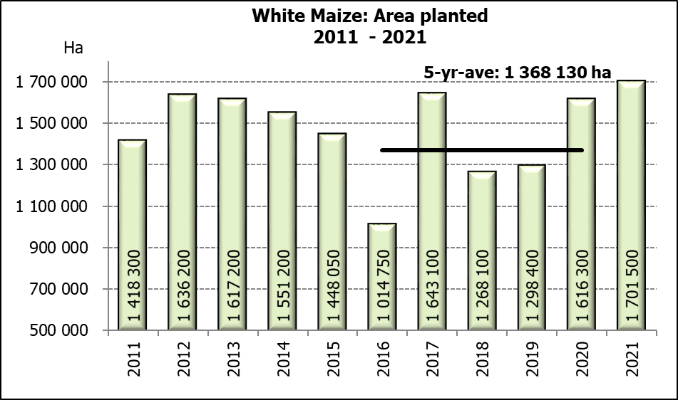

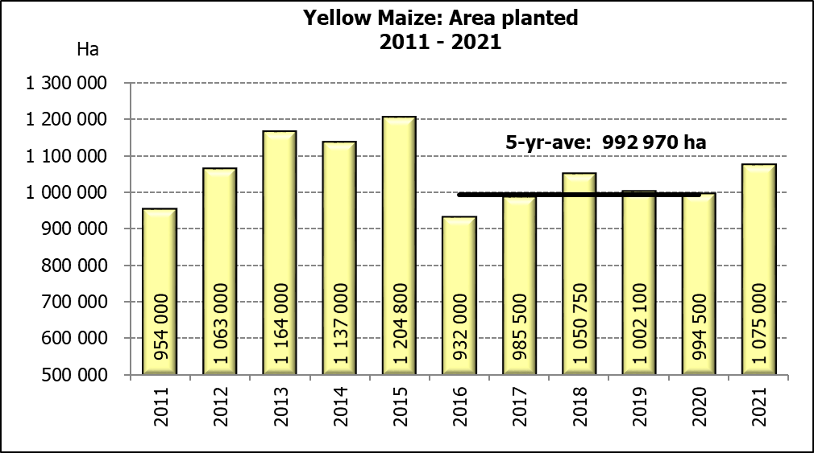
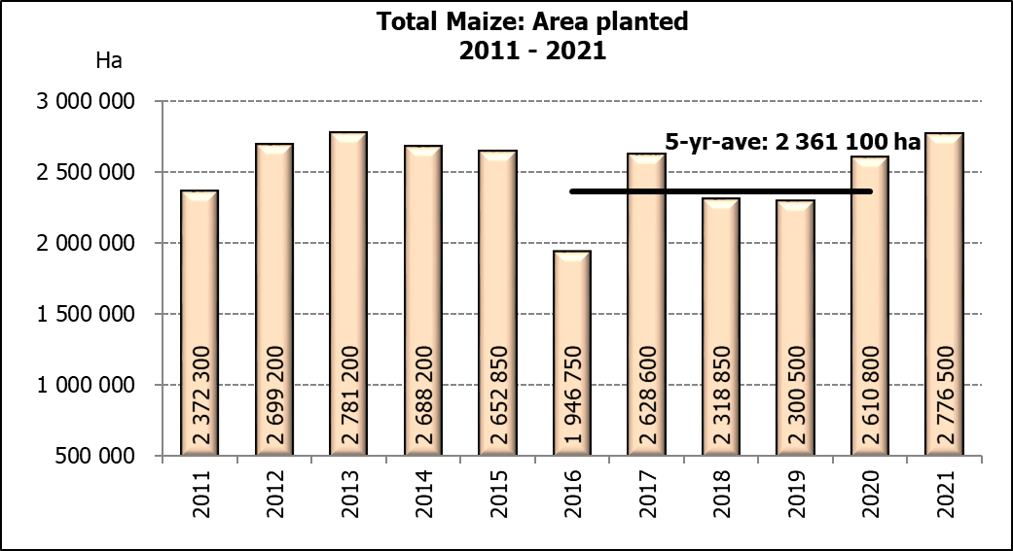

WHITE AND YELLOW MAIZE – PRELIMINARY AREA PLANTED ESTIMATE: 2021
WIT- EN GEELMIELIES – VOORLOPIGE OPPERVLAKTESKATTING: 2021
Province/  Provinsie | Preliminary area planted  Voorlopige oppervlakte beplant  2021 |  |  | Area planted/  Oppervlakte beplant  2020 |  |  | Final estimate¹⁾/  Finale skatting¹⁾  2020
Province/  Provinsie | White/  Wit  Ha | Yellow/  Geel  Ha | Totaal/  Total  Ha | White/  Wit  Ha | Yellow/  Geel  Ha | Totaal/  Total  Ha | White/  Wit  Tons | Geel/  Yellow  Tons | Totaal/  Total  Tons
Western Cape/Wes-Kaap | 500 | 3 400 | 3 900 | 400 | 3 400 | 3 800 | 3 600 | 30 600 | 34 200
Northern Cape/Noord-Kaap | 3 500 | 43 500 | 47 000 | 3 400 | 43 100 | 46 500 | 40 460 | 633 570 | 674 030
Free State/Vrystaat | 925 000 | 410 000 | 1 335 000 | 855 000 | 365 000 | 1 220 000 | 4 745 250 | 2 208 250 | 6 953 500
Eastern Cape/Oos-Kaap | 6 000 | 19 600 | 25 600 | 5 500 | 17 000 | 22 500 | 35 750 | 119 000 | 154 750
KwaZulu-Natal | 48 000 | 55 000 | 103 000 | 47 000 | 55 000 | 102 000 | 305 500 | 434 500 | 740 000
Mpumalanga | 158 000 | 370 000 | 528 000 | 160 000 | 353 000 | 513 000 | 872 000 | 2 347 450 | 3 219 450
Limpopo | 16 500 | 21 000 | 37 500 | 15 000 | 18 000 | 33 000 | 105 000 | 126 000 | 231 000
Gauteng | 56 000 | 52 500 | 108 500 | 55 000 | 50 000 | 105 000 | 302 500 | 325 000 | 627 500
North West/Noordwes | 488 000 | 100 000 | 588 000 | 475 000 | 90 000 | 565 000 | 2 256 250 | 517 500 | 2 773 750
Total/Totaal | 1 701 500 | 1 075 000 | 2 776 500 | 1 616 300 | 994 500 | 2 610 800 | 8 666 310 | 6 741 870 | 15 408 180
- 26 November 2020

SUNFLOWER SEED – PRELIMINARY AREA PLANTED ESTIMATE: 2021
SONNEBLOMSAAD – VOORLOPIGE OPPERVLAKTESKATTING: 2021

Province/  Provinsie | Prel area planted  Voorl opp beplant  Ha | Area planted/  Opp beplant  Ha | Final estimate/  Finale skatting  Tons
Province/  Provinsie | 2021 | 2020 | 2020
Western Cape/Wes-Kaap | - | - | -
Northern Cape/Noord-Kaap | 1 100 | 1 200 | 1 440
Free State/Vrystaat | 225 000 | 260 000 | 442 000
Eastern Cape/Oos-Kaap | - | 300 | 750
KwaZulu-Natal | - | - | -
Mpumalanga | 2 200 | 2 800 | 3 920
Limpopo | 70 000 | 65 000 | 65 000
Gauteng | 5 000 | 4 000 | 5 600
North West/Noordwes | 170 000 | 167 000 | 267 200
Total/Totaal | 473 300 | 500 300 | 785 910
SOYBEANS – PRELIMINARY AREA PLANTED ESTIMATE: 2021
SOJABONE – VOORLOPIGE OPPERVLAKTESKATTING: 2021

Province/  Provinsie | Prel area planted  Voorl opp beplant  Ha | Area planted/  Opp beplant  Ha | Final estimate/  Finale skatting  Tons
Province/  Provinsie | 2021 | 2020 | 2020
Western Cape/Wes-Kaap | - | - | -
Northern Cape/Noord-Kaap | 1 800 | 2 000 | 7 000
Free State/Vrystaat | 380 000 | 315 000 | 519 750
Eastern Cape/Oos-Kaap | 1 700 | 1 500 | 3 000
KwaZulu-Natal | 36 500 | 35 000 | 101 500
Mpumalanga | 270 000 | 260 000 | 416 000
Limpopo | 20 000 | 15 500 | 48 050
Gauteng | 40 000 | 36 000 | 70 200
North West/Noordwes | 56 000 | 40 000 | 80 000
Total/Totaal | 806 000 | 705 000 | 1 245 500

PRELIMINARY AREA ESTIMATE OF SUMMER CROPS (2021 PRODUCTION SEASON)/
VOORLOPIGE OPPERVLAKTESKATTING VIR SOMERGEWASSE (2021 PRODUKSIE-SEISOEN)
28 JANUARY / JANUARIE 2021

Summer field crops – 2021  The preliminary area estimate of today is mainly based on the results of a non-probability survey conducted by the Directorate: Statistics and Economic Analysis of the Department of Agriculture, Land Reform and Rural Development.  The revised area planted and production figures, which will be released by the Crop Estimates Committee on 25 February 2021, will mainly be based on information obtained from the Producer Independent Crop Estimation System (PICES) survey for the Free State, KwaZulu-Natal, Mpumalanga, Limpopo, Gauteng and North West provinces.  Commercial maize: The preliminary area estimate for maize is 2,776 mill. ha, which is 6,35% or 165 700 ha more than the 2,611 mill. ha planted for the previous season, and also 1,11% or 30 500 ha more than the intentions to plant figure of 2,746 mill. ha released in October 2020.  The preliminary area estimate for white maize is 1,702 mill. ha, which represents an increase of 5,27% or 85 200 ha compared to the 1,616 mill. ha planted last season. In the case of yellow maize the area estimate is 1,075 mill. ha, which is 8,09% or 80 500 ha more than the 994 500 ha planted last season.  Other summer crops:  Please note that only provisional national area planted figures of groundnuts, sorghum and dry beans for the current production season are being released today.  Sunflower seed: The preliminary area estimate for sunflower seed is 473 300 ha, which is 5,40% or 27 000 ha less than the 500 300 ha planted the previous season.  It is estimated that 806 000 ha have been planted to soybeans, which represents an increase of 14,33% or 101 000 ha compared to the 705 000 ha planted last season. This is the highest area planted to soybeans in the history of SA.  For groundnuts, the area estimate is 40 050 ha, which is 6,80% or 2 550 ha more than the 37 500 ha planted for the previous season.  The area estimate for sorghum increased slightly by 1,88% or 800 ha, from 42 500 ha to 43 300 ha against the previous season.  For dry beans, the area estimate is 51 650 ha, which is 2,99% or 1 500 ha more than the 50 150 ha planted for the previous season.  Please note that the revised area estimate and first production forecast for summer field crops for 2021 will be released on 25 February 2021. |  | Somergewasse – 2021  Die voorlopige oppervlakteskatting van vandag is hoofsaaklik gebaseer op die resultate van ’n nie-ewekansige opname onderneem deur die Direktoraat: Statistiek en Ekonomiese Analise van die Departement van Landbou, Grondhervorming en Landelike Ontwikkeling.  Die hersiene aangeplante oppervlakte en produksiesyfers sal deur die Oesskattingskomitee op 25 Februarie 2021 vrygestel word en sal hoofsaaklik gebaseer wees op inligting verkry vanaf die “PICES”-opname vir die Vrystaat, KwaZulu-Natal, Mpumalanga, Limpopo, Gauteng en Noordwes provinsies.  Kommersiële mielies: Die voorlopige skatting van die oppervlakte onder mielies beloop 2,776 milj. ha, wat 6,35% of 165 700 ha meer is as die 2,611 milj. ha wat verlede seisoen aangeplant is, en ook 1,11% of 30 500 ha meer as die voornemens om te plant syfer van 2,746 milj. ha soos vrygestel in Oktober 2020.  Die voorlopige oppervlak onder witmielies is 1,702 milj. ha, wat ’n toename van 5,27% of 85 200 ha verteenwoordig vergeleke met die 1,616 milj. ha die vorige seisoen. In die geval van geelmielies is die oppervlakteskatting 1,075 milj. ha, wat 8,09% of 80 500 ha meer is as die 994 500 ha geplant die vorige seisoen.  Ander somergewasse:  Let asb. daarop dat net die nasionale aangeplante area vir die voorlopige oppervlakte van die grondbone, sorghum en droëbone vir die huidige produksieseisoen vandag vrygestel word.  Sonneblomsaad: Die voorlopige oppervlakteskatting vir sonneblomsaad is 473 300 ha, wat 5,40% of 27 000 ha minder is as die 500 300 ha aangeplant die vorige seisoen.  Die geskatte oppervlakte beplant met sojabone is 806 000 ha, wat ’n toename van 14,33% of 101 000 ha verteenwoordig vergeleke met die 705 000 ha geplant die vorige seisoen. Dit is die hoogste oppervlakte beplant met sojabone in die geskiedenis van SA.  Vir grondbone is die oppervlakteskatting 40 050 ha, wat 6,80% of 2 550 ha meer is as die 37 500 ha geplant vir die vorige seisoen.  Die oppervlakteskatting vir sorghum het effens toegeneem met 1,88%, van 42 500 ha tot 43 300 ha teenoor die vorige seisoen.  Vir droëbone is die geskatte oppervlakte beplant 51 650 ha, wat 2,99% of 1 500 ha meer is as die 50 150 ha geplant vir die vorige seisoen.  Neem asseblief kennis dat die hersiene oppervlakte- en eerste produksieskatting vir somergewasse vir 2021, op 25 Februarie 2021 vrygestel sal word.
The area estimate and sixth production forecast for winter cereals for the 2020 is hereby released. /
Hiermee word die oppervlakteskatting en sesde produksieskatting vir wintergewasse vir 2020 vrygestel.
WINTER CEREALS – AREA PLANTED ESTIMATE AND SIXTH PRODUCTION FORECAST: 2020
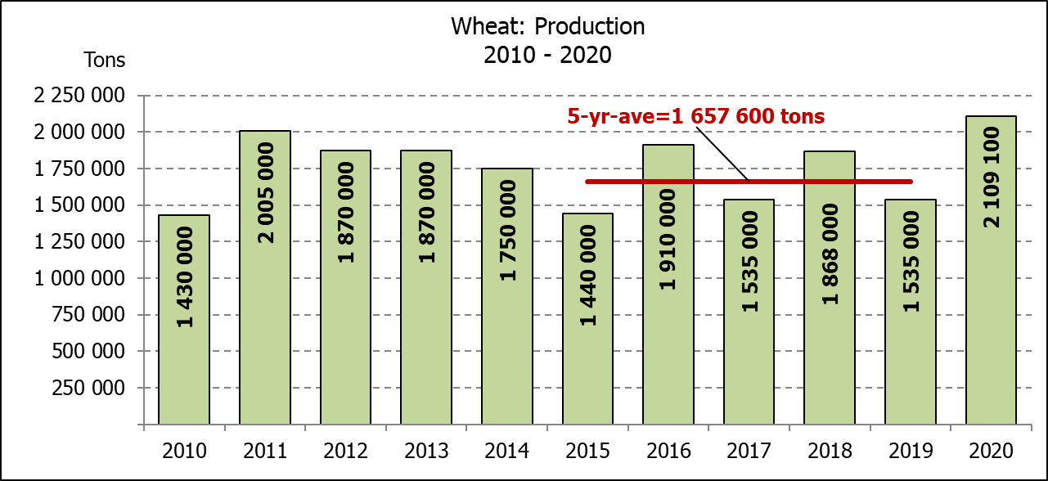
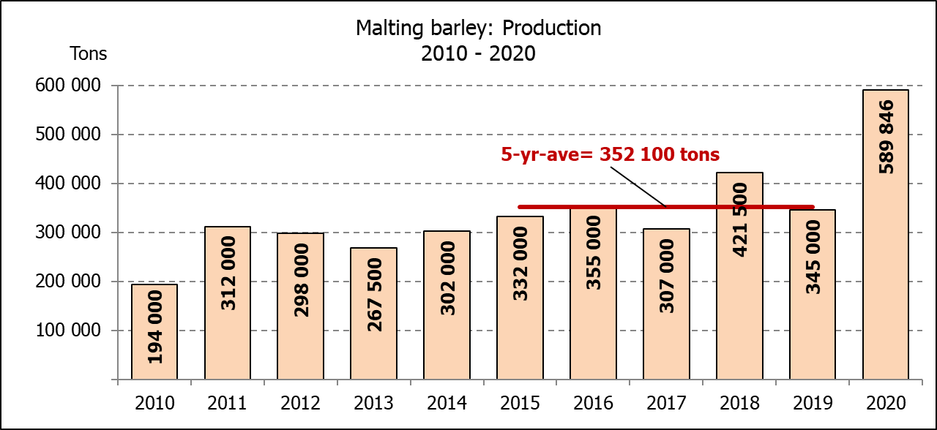
WINTERGEWASSE – OPPERVLAKTE- EN SESDE PRODUKSIESKATTING: 2020
CROP/GEWAS | Area planted/  Opp beplant  2020 | 6th forecast/  6de skatting  2020 | 5th forecast/  5de skatting  2020 | Area planted/  Opp beplant  2019 | Final crop/  Finale oes  2019 | Change/  Verandering
CROP/GEWAS | Ha | Tons | Tons | Ha | Tons | %
CROP/GEWAS | (A) | (B) | (C) | (D) | (E) | (B) ÷ (C)
Commercial/Kommersieel:
Wheat/Koring | 509 800 | 2 109 100 | 2 147 900 | 540 000 | 1 535 000 | -1,81
Malting barley/Moutgars | 141 690 | 589 846 | 550 246 | 131 960 | 345 000 | +7,20
Canola/Kanola | 74 120 | 166 956 | 163 256 | 74 000 | 95 000 | +2,27
Cereal oats/Hawermout | 26 200 | 52 400 | 47 400 | 21 000 | 16 500 | +10,55
TOTAL/TOTAAL | 751 810 | 2 918 302 | 2 908 802 | 766 960 | 1 991 500 | +0,33
* Note: Estimate is for calendar year, e.g. production season 2020/21 = 2020
* Nota: Skatting is vir kalenderjaar, bv. produksie-seisoen 2020/21 = 2020
WHEAT – AREA PLANTED ESTIMATE AND SIXTH PRODUCTION FORECAST: 2020
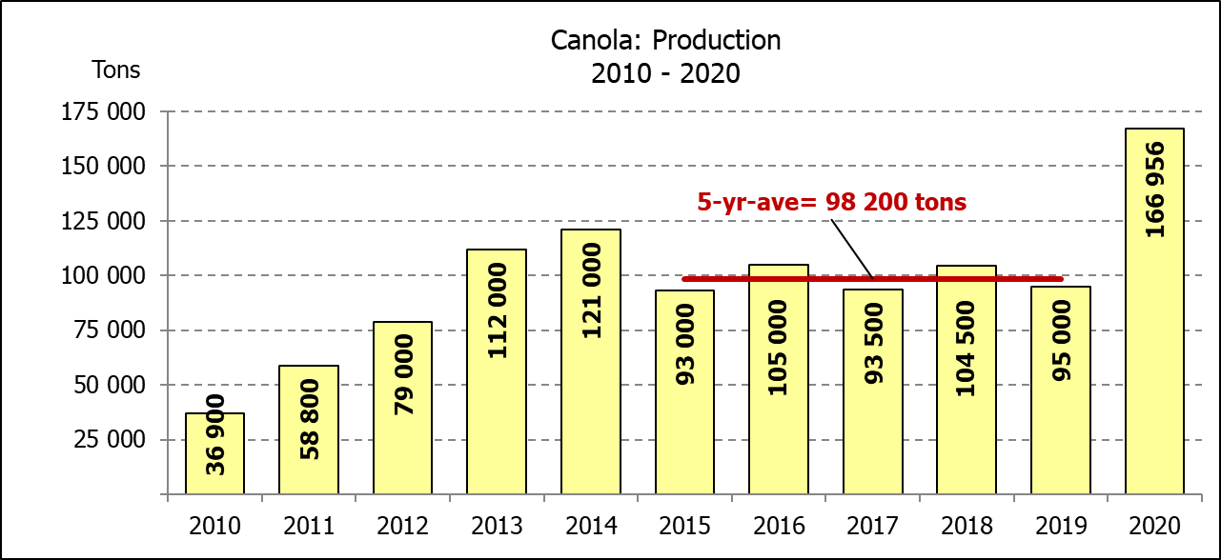
KORING – OPPERVLAKTE- EN SESDE PRODUKSIESKATTING: 2020
Province/  Provinsie | Area planted/  Opp beplant  Ha | 6th forecast/  6de skatting  Tons | Area planted/  Opp beplant  Ha | Final crop/  Finale oes  Tons
Province/  Provinsie | 2020 | 2020 | 2019 | 2019
Western Cape/Wes-Kaap | 326 000 | 1 092 100 | 325 000 | 650 000
Northern Cape/Noord-Kaap | 37 000 | 271 950 | 37 500 | 262 500
Free State/Vrystaat | 94 000 | 413 600 | 128 000 | 326 000
Eastern Cape/Oos-Kaap | 4 000 | 26 000 | 3 100 | 18 150
KwaZulu-Natal | 7 800 | 48 360 | 7 500 | 45 750
Mpumalanga | 3 000 | 19 500 | 4 000 | 25 200
Limpopo | 23 000 | 147 200 | 20 000 | 120 000
Gauteng | 1 300 | 8 190 | 1 400 | 8 400
North West/Noordwes | 13 700 | 82 200 | 13 500 | 79 000
Total/Totaal | 509 800 | 2 109 100 | 540 000 | 1 535 000

AREA ESTIMATE AND SIXTH PRODUCTION FORECAST OF WINTER CROPS (2020) /
OPPERVLAKTESKATTING EN SESDE PRODUKSIESKATTING VAN WINTERGEWASSE (2020)
28 JANUARY / JANUARIE 2021
Winter cereal crops - 2020 production season  Wheat: The expected production of wheat is 2,109 mill. tons, which is 1,81% or 38 800 tons less than the previous forecast of 2,148 mill. tons, whilst the expected yield is 4,14 t/ha. This is the largest expected wheat crop since the 2,130 mill. tons of the 2008 season.  The expected production in the Western Cape is 1,092 mill. tons (52%), in the Free State 413 600 tons (20%) and in the Northern Cape 271 950 tons (13%).  Other crops: The production forecast for malting barley is 589 846 tons, which is 7,20% or 39 600 tons more than the previous forecast of 550 246 tons. The area planted is estimated at 141 690 ha, while the expected yield is 4,16 t/ha. This is the largest expected malting barley crop recorded for SA.  The expected canola crop is 166 956 tons, which is 2,27% or 3 700 tons more than the previous forecast of 163 256 tons. The area estimate for canola is 74 120 ha, with an expected yield of 2,25 t/ha. It is also the largest expected canola crop ever recorded for SA.  The expected oats (cereals) crop for 2020 is 52 400 tons, which is 10,55% or 5 000 tons more than the previous forecast of 47 400 tons. The area estimate is 26 200 ha and the expected yield is 2,00 t/ha.  Please note that the final production estimate for winter cereals for 2020 will be released on 25 February 2021. |  | Wintergewasse - 2020 produksie-seisoen  Koring: Die verwagte produksie vir koring is 2,109 milj. ton, wat 1,81% of 38 800 ton minder is as die vorige skatting van 2,148 milj. ton, terwyl die verwagte opbrengs 4,14 t/ha is. Hierdie is die grootste verwagte koring-oes sedert die 2,130 milj. ton van die 2008 seisoen.  Die verwagte produksie in die Wes-Kaap is 1,092 milj. ton (52%), in die Vrystaat 413 600 ton (20%) en in die Noord-Kaap 271 950 ton (13%).  Ander gewasse: Die produksieskatting vir moutgars is 589 846 ton, wat 7,20% of 39 600 ton meer is as die vorige skatting van 550 246 ton. Die oppervlakte beplant word beraam op 141 690 ha, terwyl die verwagte opbrengs 4,16 t/ha beloop. Dit is die grootste verwagte moutgars-oes wat nog vir SA aangeteken is.  Die verwagte kanola-oes is 166 956 ton, wat 2,27% of 3 700 ton meer is as die vorige skatting van 163 256 ton. Die oppervlakteskatting vir kanola is 74 120 ha, met ŉ verwagte opbrengs van 2,25 t/ha. Dit is ook die grootste verwagte kanola-oes wat nog aangeteken is vir SA.  Die verwagte hawer-oes (ontbytgraan) vir die 2020-seisoen is 52 400 ton, wat 10,55% of 5 000 ton meer is as die vorige skatting van 47 400 ton. Die oppervlakteskatting is 26 200 ha en die verwagte opbrengs is 2,00 t/ha.  Neem asseblief kennis dat die finale produksieskatting vir wintergewasse vir 2020 op 25 Februarie 2021 vrygestel sal word.

Information is available on the internet at http://www.daff.gov.za/links/crop estimates or http://www.sagis.org.za, as from 14:30 on the date of the relevant meeting of the Crop Estimates Committee. |  | Inligting is beskikbaar op die internet by http://www.daff.gov.za/links/crop estimates of by http://www.sagis.org.za, vanaf 14:30 op die dag van die toepaslike vergadering van die Oesskattingskomitee.
CONFIDENTIALITY ISSUES that CEC members are committed to adhere to on the day of the meeting
- Personal items such as laptops, handbags, cell phones, etc. are not allowed in the venue during the meeting
- No member is allowed to leave the meeting before 12:00 in order to prevent disclosure of the information
- The embargo time for the release of crop estimates information is 15:30
- No member is allowed to discuss crop estimates information with anyone other than a member of the Committee before the embargo time
- Only the Chairperson, or a member appointed by the Chairperson, may release the figures to the media
- Members must regard the detail of any information that was collected for and/or discussed during the meeting, as confidential
- Individual information received for crop estimate purposes is treated strictly confidential, and is not divulged for any other purposes

