 | crop estimates committee | 
 | oesskattingskomitee
From/Van: Mr Baldwin Netshifhefhe
Tel: 012 319 8043  Fax/Faks: 012 319 8031  E-mail/E-pos: BaldwinN@daff.gov.za
Web page/Webblad: www.daff.gov.za/statistics and economic reports or www.sagis.org.za/CEC: Crop Estimates
EMBARGO: 15:30

The preliminary area planted estimate for summer crops for 2019 is hereby released.
Hiermee word die voorlopige oppervlakteskatting vir somergewasse vir 2019 vrygestel.

SUMMER CROPS – PRELIMINARY AREA PLANTED ESTIMATE: 2019
SOMERGEWASSE – VOORLOPIGE OPPERVLAKTESKATTING: 2019
CROP/GEWAS | Area planted/  Opp beplant  2019 | Intentions^{1)/}  Voorneme¹⁾  2019 | Area planted/  Opp beplant  2018 | Final estimate/  Finale skatting  2018 | Change/  Verandering/  2019 vs 2018
CROP/GEWAS | Ha | Ha | Ha | Tons | %
CROP/GEWAS | (A) | (B) | (C) | (D) | (A) ÷ (C)
Commercial/Kommersieël:
White maize/Witmielies | 1 257 000 | 1 373 400 | 1 268 100 | 6 801 560 | -0,88
Yellow maize/Geelmielies | 1 011 900 | 1 075 000 | 1 050 750 | 6 129 650 | -3,70
Total Maize/Totale Mielies | 2 268 900 | 2 448 400 | 2 318 850 | 12 931 210 | -2,15
Sunflower seed/Sonneblomsaad | 444 000 | 575 000 | 601 500 | 858 605 | -26,18
Soybeans/Sojabone | 743 600 | 851 800 | 787 200 | 1 550 800 | -5,54
Groundnuts/Grondbone | 19 200 | 50 000 | 56 300 | 53 750 | -65,90
Sorghum | 46 000 | 43 000 | 28 800 | 109 855 | +59,72
Dry beans/Droëbone | 56 000 | 60 000 | 53 360 | 69 360 | +4,95
TOTAL/TOTAAL | 3 577 700 | 4 028 200 | 3 846 010 | 15 573 580 | -6,98
- Soos middel Oktober 2018/ As mid October 2018
Note: Estimate is for calendar year, e.g. production season 2018/19 = 2019
Nota: Skatting is vir kalenderjaar, bv. produksie-seisoen 2018/19 = 2019
The Crop Estimates Committee comprises officials of the following institutions:
Department of Agriculture, Forestry and Fisheries; Provincial Departments of Agriculture; various ARC-Institutes (Soil, Climate and Water; Small Grains Institute; and
Grain Crops Institute); BFAP and Statistics SA.
29 January / Januarie 2019
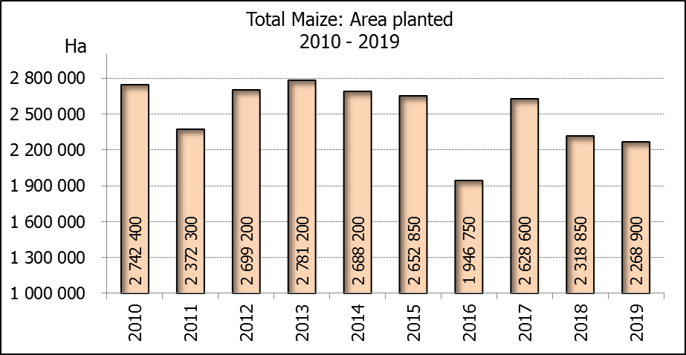

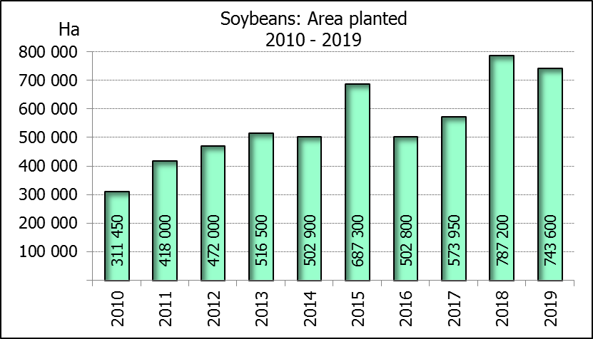
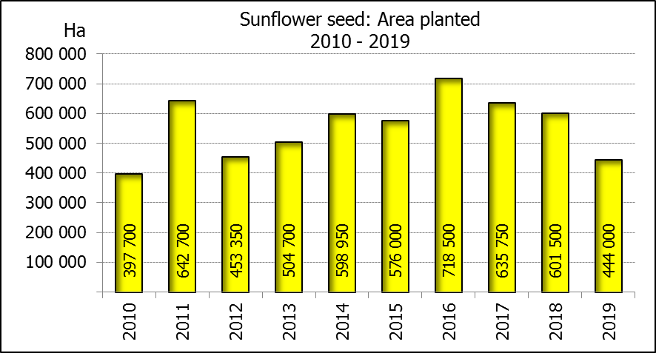

WHITE AND YELLOW MAIZE – PRELIMINARY AREA PLANTED ESTIMATE: 2019
WIT- EN GEELMIELIES – VOORLOPIGE OPPERVLAKTESKATTING: 2019
Province/  Provinsie | Preliminary area planted  Voorlopige oppervlakte beplant  2019 |  |  | Area planted/  Oppervlakte beplant  2018 |  |  | Final estimate¹⁾/  Finale skatting¹⁾  2018
Province/  Provinsie | White/  Wit  Ha | Yellow/  Geel  Ha | Totaal/  Total  Ha | White/  Wit  Ha | Yellow/  Geel  Ha | Totaal/  Total  Ha | White/  Wit  Tons | Geel/  Yellow  Tons | Totaal/  Total  Tons
Western Cape/Wes-Kaap | 400 | 3 400 | 3 800 | 0 | 3 750 | 3 750 | 0 | 33 750 | 33 750
Northern Cape/Noord-Kaap | 3 200 | 45 000 | 48 200 | 3 600 | 43 000 | 46 600 | 41 760 | 636 400 | 678 160
Free State/Vrystaat | 610 000 | 390 000 | 1 000 000 | 644 000 | 410 000 | 1 054 000 | 3 477 600 | 2 009 000 | 5 486 600
Eastern Cape/Oos-Kaap | 3 400 | 10 500 | 13 900 | 3 500 | 11 000 | 14 500 | 21 700 | 71 500 | 93 200
KwaZulu-Natal | 45 000 | 51 000 | 96 000 | 45 000 | 50 000 | 95 000 | 301 500 | 380 000 | 681 500
Mpumalanga | 150 000 | 342 000 | 492 000 | 140 000 | 340 000 | 480 000 | 840 000 | 2 040 000 | 2 880 000
Limpopo | 9 000 | 16 000 | 25 000 | 12 000 | 21 000 | 33 000 | 90 000 | 147 000 | 237 000
Gauteng | 46 000 | 57 000 | 103 000 | 50 000 | 62 000 | 112 000 | 290 000 | 372 000 | 662 000
North West/Noordwes | 390 000 | 97 000 | 487 000 | 370 000 | 110 000 | 480 000 | 1 739 000 | 440 000 | 2 179 000
Total/Totaal | 1 257 000 | 1 011 900 | 2 268 900 | 1 268 100 | 1 050 750 | 2 318 850 | 6 801 560 | 6 129 650 | 12 931 210
- 26 September 2018

SUNFLOWER SEED – PRELIMINARY AREA PLANTED ESTIMATE: 2019
SONNEBLOMSAAD – VOORLOPIGE OPPERVLAKTESKATTING: 2019

Province/  Provinsie | Prel area planted  Voorl opp beplant  Ha | Area planted/  Opp beplant  Ha | Final estimate/  Finale skatting  Tons
Province/  Provinsie | 2019 | 2018 | 2018
Western Cape/Wes-Kaap | - | 100 | 100
Northern Cape/Noord-Kaap | 900 | 1 600 | 1 920
Free State/Vrystaat | 233 000 | 314 000 | 486 700
Eastern Cape/Oos-Kaap | 100 | - | -
KwaZulu-Natal | - | - | -
Mpumalanga | 2 000 | 2 300 | 2 185
Limpopo | 40 000 | 45 000 | 36 000
Gauteng | 3 000 | 5 500 | 5 500
North West/Noordwes | 165 000 | 233 000 | 326 200
Total/Totaal | 444 000 | 601 500 | 858 605
SOYBEANS – PRELIMINARY AREA PLANTED ESTIMATE: 2019
SOJABONE – VOORLOPIGE OPPERVLAKTESKATTING: 2019

Province/  Provinsie | Prel area planted  Voorl opp beplant  Ha | Area planted/  Opp beplant  Ha | Final estimate/  Finale skatting  Tons
Province/  Provinsie | 2019 | 2018 | 2018
Western Cape/Wes-Kaap | 100 | 800 | 1 200
Northern Cape/Noord-Kaap | 1 300 | 3 000 | 10 500
Free State/Vrystaat | 315 000 | 345 000 | 552 000
Eastern Cape/Oos-Kaap | 1 200 | 2 400 | 2 400
KwaZulu-Natal | 33 000 | 40 000 | 124 000
Mpumalanga | 320 000 | 310 000 | 682 000
Limpopo | 15 000 | 20 000 | 56 000
Gauteng | 25 000 | 30 000 | 61 500
North West/Noordwes | 33 000 | 36 000 | 61 200
Total/Totaal | 743 600 | 787 200 | 1 550 800

PRELIMINARY AREA ESTIMATE OF SUMMER CROPS (2019 PRODUCTION SEASON)/
VOORLOPIGE OPPERVLAKTESKATTING VIR SOMERGEWASSE (2019 PRODUKSIE-SEISOEN)
29 JANUARY / JANUARIE 2019

Summer field crops – 2019  The preliminary area estimate of today is mainly based on the results of a non-probability survey conducted by the Directorate: Statistics and Economic Analysis of the Department of Agriculture, Forestry and Fisheries. Less favorable rainfall and warm temperatures in the western producing areas over the past few weeks prevented producers from planting their intended area with summer crops, especially in the Free State and North West provinces.  The revised area planted and production figures, which will be released by the Crop Estimates Committee on 27 February 2019, will mainly be based, on information obtained from the Producer Independent Crop Estimation System (PICES) survey for the Free State, KwaZulu-Natal, Mpumalanga, Limpopo, Gauteng and North West provinces.  Commercial maize: The preliminary area estimate for maize is 2,269 mill. ha, which is 2,15% or 49 950 ha less than the 2,319 mill. ha planted for the previous season, and also 7,33% or 179 500 ha less than the intentions to plant figure of 2,448 mill. ha released in October 2018.  The preliminary area estimate for white maize is 1,257 mill. ha, which represents a decrease of 0,88% or 11 100 ha compared to the 1,268 mill. ha planted last season. In the case of yellow maize the area estimate is 1,012 mill. ha, which is 3,70% or 38 850 ha less than the 1,051 mill. ha planted last season.  Other summer crops:  Please note that only provisional national area planted figures of groundnuts, sorghum and dry beans for the current production season are being released today.  Sunflower seed: The preliminary area estimate for sunflower seed is 444 000 ha, which is 26,18% or 157 500 ha less than the 601 500 ha planted the previous season.  It is estimated that 743 600 ha have been planted to soybeans, which represents a decrease of 5,54% or 43 600 ha compared to the 787 200 ha planted last season.  For groundnuts, the area estimate is 19 200 ha, which is 65,90% or 37 100 ha less than the 56 300 ha planted for the previous season.  The area estimate for sorghum increased by 59,72%, from 28 800 ha to 46 000 ha against the previous season.  For dry beans, the area estimate is 56 000 ha, which is 4,95% or 2 640 ha more than the 53 360 ha planted for the previous season.  Please note that the revised area estimate and first production forecast for summer field crops for 2019 will be released on 27 February 2019. |  | Somergewasse – 2019  Die voorlopige oppervlakteskatting van vandag is hoofsaaklik gebaseer op die resultate van ’n nie-ewekansige opname onderneem deur die Direktoraat: Statistiek en Ekonomiese Analise van die Departement van Landbou, Bosbou en Visserye. Minder gunstige reënvalneerslae en warm temperature in die westelike produserende gebiede die afgelope paar weke het produsente verhinder om hul beoogde oppervlakte met somergewasse aan te plant, veral in die Vrystaat en Noordwes provinsies.  Die hersiene aangeplante oppervlakte en produksiesyfers sal deur die Oesskattingskomitee op 27 Februarie 2019 vrygestel word en sal hoofsaaklik, gebaseer wees op inligting verkry vanaf die “PICES”-opname vir die Vrystaat, KwaZulu-Natal, Mpumalanga, Limpopo, Gauteng en Noordwes provinsies.  Kommersiële mielies: Die voorlopige skatting van die oppervlakte onder mielies beloop 2,269 milj. ha, wat 2,15% of 49 950 ha minder is as die 2,319 milj. ha wat verlede seisoen aangeplant is, en ook 7,33% of 179 500 ha minder as die voornemens om te plant syfer van 2,448 milj. ha soos vrygestel in Oktober 2018.  Die voorlopige oppervlak onder witmielies is 1,257 milj. ha, wat ’n afname van 0,88% of 11 100 ha verteenwoordig vergeleke met die 1,268 milj. ha die vorige seisoen. In die geval van geelmielies is die oppervlakteskatting 1,012 milj. ha, wat 3,70% of 38 850 ha minder is as die 1,051 milj. ha geplant die vorige seisoen.  Ander somergewasse:  Let asb. daarop dat net die nasionale aangeplante area vir die voorlopige oppervlakte van die grondbone, sorghum en droëbone vir die huidige produksieseisoen vandag vrygestel word.  Sonneblomsaad: Die voorlopige oppervlakteskatting vir sonneblomsaad is 444 000 ha, wat 26,18% of 157 500 ha minder is as die 601 500 ha aangeplant die vorige seisoen.  Die geskatte oppervlakte beplant met sojabone is 743 600 ha, wat ’n afname van 5,54% of 43 600 ha verteenwoordig vergeleke met die 787 200 ha geplant die vorige seisoen.  Vir grondbone is die oppervlakteskatting 19 200 ha, wat 65,90% of 37 100 ha minder is as die 56 300 ha geplant vir die vorige seisoen.  Die oppervlakteskatting vir sorghum het toegeneem met 59,72%, van 28 800 ha tot 46 000 ha teenoor die vorige seisoen.  Vir droëbone is die geskatte oppervlakte beplant 56 000 ha, wat 4,95% of 2 640 ha meer is as die 53 360 ha geplant vir die vorige seisoen.  Neem asseblief kennis dat die hersiene oppervlakte- en eerste produksieskatting vir somergewasse vir 2019, op 27 Februarie 2019 vrygestel sal word.
The area estimate and sixth production forecast for winter cereals for the 2018 is hereby released. /
Hiermee word die oppervlakteskatting en sesde produksieskatting vir wintergewasse vir 2018 vrygestel.
WINTER CEREALS – AREA PLANTED ESTIMATE AND SIXTH PRODUCTION FORECAST: 2018
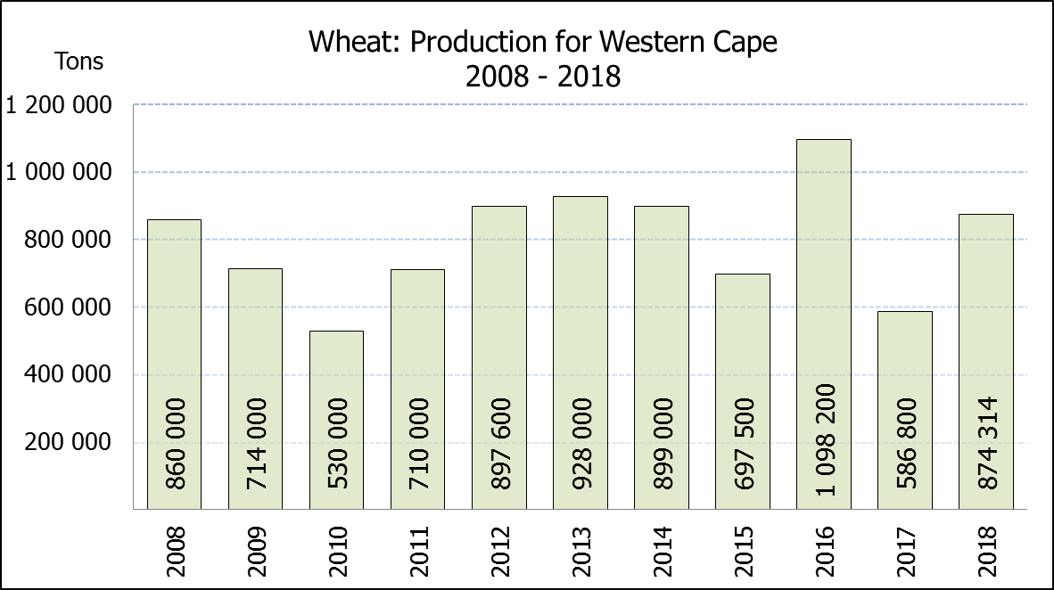
WINTERGEWASSE – OPPERVLAKTE- EN SESDE PRODUKSIESKATTING: 2018
CROP/GEWAS | Area planted/  Opp beplant  2018 | 6th forecast/  6de skatting  2018 | 5th forecast/  5de skatting  2018 | Area planted/  Opp beplant  2017 | Final crop/  Finale oes  2017 | Change/  Verandering
CROP/GEWAS | Ha | Tons | Tons | Ha | Tons | %
CROP/GEWAS | (A) | (B) | (C) | (D) | (E) | (B) ÷ (C)
Commercial/Kommersieel:
Wheat/Koring | 503 350 | 1 798 800 | 1 830 600 | 491 600 | 1 535 000 | -1,74
Malting barley/Moutgars | 119 000 | 421 790 | 401 840 | 91 380 | 307 000 | +4,96
Canola/Kanola | 77 000 | 103 950 | 103 950 | 84 000 | 93 500 | -
Total/Totaal | 699 350 | 2 324 540 | 2 336 390 | 666 980 | 1 935 500 | -0,51
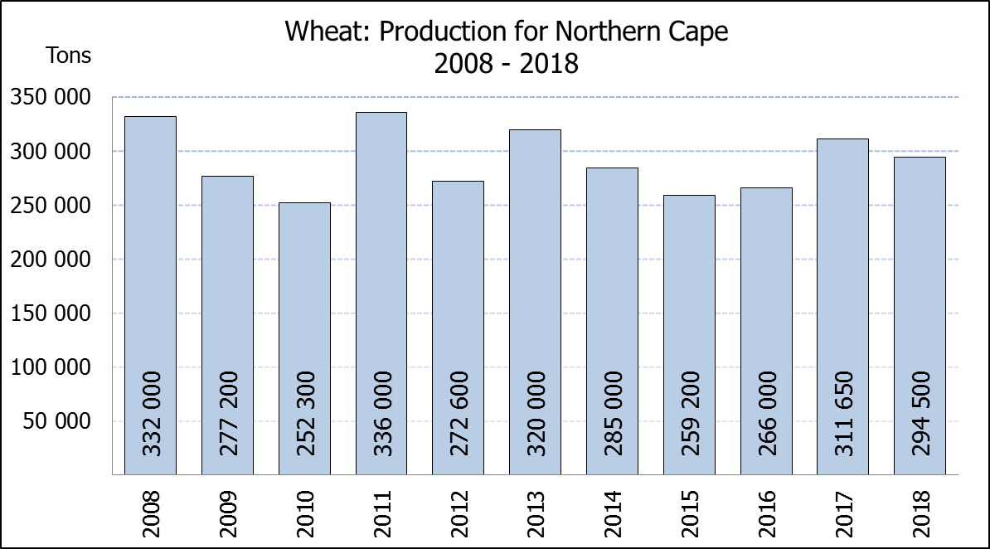
* Note: Estimate is for calendar year, e.g. production season 2018 = 2018
* Nota: Skatting is vir kalenderjaar, bv. produksie-seisoen 2018 = 2018
WHEAT – AREA PLANTED ESTIMATE AND SIXTH PRODUCTION FORECAST: 2018
KORING – OPPERVLAKTE- EN SESDE PRODUKSIESKATTING: 2018
Province/  Provinsie | Area planted/  Opp beplant  Ha | 6th forecast/  6de skatting  Tons | Area planted/  Opp beplant  Ha | Final crop/  Finale oes  Tons
Province/  Provinsie | 2018 | 2018 | 2017 | 2017
Western Cape/Wes-Kaap | 318 000 | 874 500 | 326 000 | 586 800
Northern Cape/Noord-Kaap | 38 000 | 294 500 | 38 000 | 311 650
Free State/Vrystaat | 100 000 | 340 000 | 80 000 | 336 000
Eastern Cape/Oos-Kaap | 1 650 | 10 725 | 1 900 | 9 500
KwaZulu-Natal | 7 000 | 43 400 | 7 500 | 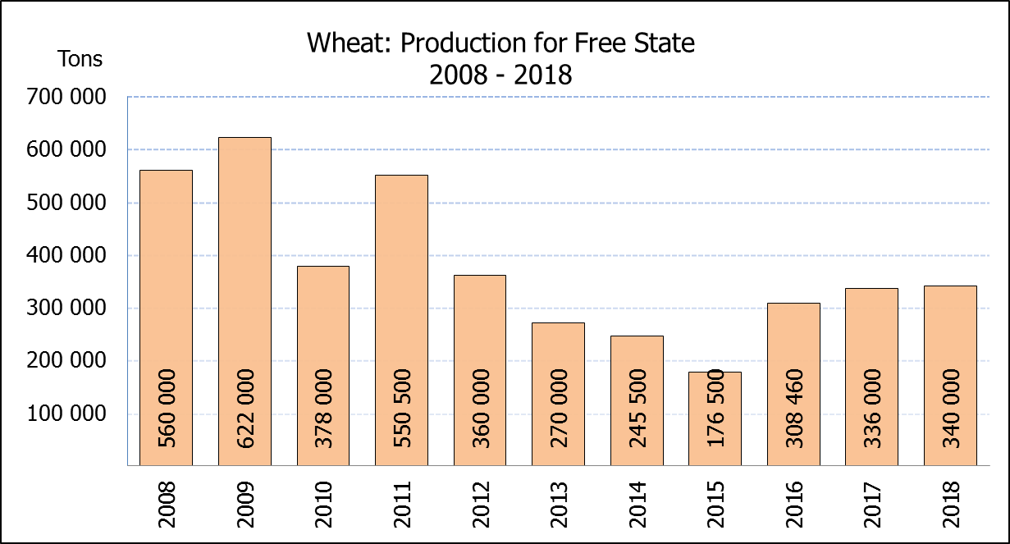  45 750
Mpumalanga | 3 500 | 21 875 | 4 000 | 25 400
Limpopo | 20 000 | 122 000 | 20 000 | 132 000
Gauteng | 1 200 | 7 800 | 700 | 4 200
North West/Noordwes | 14 000 | 84 000 | 13 500 | 83 700
Total/Totaal | 503 350 | 1 798 800 | 491 600 | 1 535 000

AREA ESTIMATE AND SIXTH PRODUCTION FORECAST OF WINTER CROPS (2018) /
OPPERVLAKTESKATTING EN SESDE PRODUKSIESKATTING VAN WINTERGEWASSE (2018)
29 JANUARY / JANUARIE 2019
Winter cereal crops - 2018 production season  Wheat: The expected commercial production of wheat is 1,799 mill. tons, which is 1,74% or 31 800 tons less than the previous forecast of 1,831 mill. tons. The expected yield is 3,57 t/ha.  The area estimate for wheat is 503 350 ha.  Other crops: The production forecast for malting barley is 421 790 tons, which is 4,96% or 19 950 tons more than the previous forecast of 401 840 tons. The current crop of 421 790 tons is the highest crop ever produced in the RSA. The area planted is estimated at 119 000 ha, while the expected yield is 3,54 t/ha.  The expected canola crop remained unchanged at 103 950 tons. The area estimate for canola is 77 000 ha, with an expected yield of 1,35 t/ha.  Please note that the final production estimate for winter cereals for 2018 will be released on 27 February 2019. |  | Wintergewasse - 2018 produksie-seisoen  Koring: Die verwagte kommersiële produksie vir koring is 1,799 milj. ton, wat 1,74% of 31 800 ton minder is as die vorige skatting van 1,831 milj. ton. Die verwagte opbrengs is 3,57 t/ha.  Die oppervlakteskatting vir koring is 503 350 ha.  Ander gewasse: Die produksieskatting vir moutgars is 421 790 ton, wat 4,96% of 19 950 ton meer is as die vorige skatting van 401 840 ton. Die huidige skatting van 421 790 ton is die hoogste oes nog ooit geproduseer in die RSA. Die oppervlakte beplant is beraam op 119 000 ha, terwyl die verwagte opbrengs 3,54 t/ha beloop.  Die verwagte kanola-oes is onveranderd gelaat op 103 950 ton. Die oppervlakteskatting vir kanola is 77 000 ha, met ŉ verwagte opbrengs van 1,35 t/ha.  Neem asseblief kennis dat die finale produksieskatting vir wintergewasse vir 2018 op 27 Februarie 2019 vrygestel sal word.

Information is available on the internet at http://www.daff.gov.za/statistics and economic reports or http://www.sagis.org.za, as from 15:30 on the date of the relevant meeting of the Crop Estimates Committee. |  | Inligting is beskikbaar op die internet by http://www.daff.gov.za/statistics and economic reports of by http://www.sagis.org.za, vanaf 15:30 op die dag van die toepaslike vergadering van die Oesskattingskomitee.
CONFIDENTIALITY ISSUES that CEC members are committed to adhere to on the day of the meeting
- Personal items such as laptops, handbags, cell phones, etc. are not allowed in the venue during the meeting
- No member is allowed to leave the meeting before 12:00 in order to prevent disclosure of the information
- The embargo time for the release of crop estimates information is 15:30
- No member is allowed to discuss crop estimates information with anyone other than a member of the Committee before the embargo time
- Only the Chairperson, or a member appointed by the Chairperson, may release the figures to the media
- Members must regard the detail of any information that was collected for and/or discussed during the meeting, as confidential
- Individual information received for crop estimate purposes is treated strictly confidential, and is not divulged for any other purposes

