 | crop estimates committee | 
 | oesskattingskomitee
From/Van: Ms Ellen Matsei
The Crop Estimates Committee comprises officials of the following institutions:
Department of Agriculture, Forestry and Fisheries; Provincial Departments of Agriculture; various ARC-Institutes (Soil, Climate and Water; Small Grains Institute; and
Grain Crops Institute); BFAP and Statistics SA.
Tel: 012 319 8454  Fax/Faks: 012 319 8031  E-mail/E-pos: DAS@daff.gov.za
Web page/Webblad: www.daff.gov.za/statistics and economic reports or www.sagis.org.za/CEC: Crop Estimates
EMBARGO: 15:30

The preliminary area planted estimate for summer crops for 2018 is hereby released.
Hiermee word die voorlopige oppervlakteskatting vir somergewasse vir 2018 vrygestel.

SUMMER CROPS – PRELIMINARY AREA PLANTED ESTIMATE: 2018
SOMERGEWASSE – VOORLOPIGE OPPERVLAKTESKATTING: 2018
CROP/GEWAS | Area planted/  Opp beplant  2018 | Intentions^{1)/}  Voorneme¹⁾  2018 | Area planted/  Opp beplant  2017 | Final estimate/  Finale skatting  2017 | Change/  Verandering/  2018 vs 2017
CROP/GEWAS | Ha | Ha | Ha | Tons | %
CROP/GEWAS | (A) | (B) | (C) | (D) | (A) ÷ (C)
Commercial/Kommersieël:
White maize/Witmielies | 1 284 700 | 1 404 100 | 1 643 100 | 9 892 750 | -21,8
Yellow maize/Geelmielies | 1 024 500 | 1 066 300 | 985 500 | 6 851 250 | +4,0
Total Maize/Totale Mielies | 2 309 200 | 2 470 400 | 2 628 600 | 16 744 000 | -12,2
Sunflower seed/Sonneblomsaad | 560 100 | 665 500 | 635 750 | 874 595 | -11,9
Soybeans/Sojabone | 701 000 | 720 000 | 573 950 | 1 316 370 | +22,1
Groundnuts/Grondbone | 53 000 | 65 500 | 56 000 | 92 050 | -5,4
Sorghum | 25 000 | 43 700 | 42 350 | 151 335 | -41,0
Dry beans/Droëbone | 52 000 | 60 000 | 45 050 | 68 525 | +15,4
TOTAL/TOTAAL | 3 700 300 | 4 025 100 | 3 981 700 | 19 246 875 | -7,1
- Soos middel Oktober 2017/ As mid October 2017
Note: Estimate is for calendar year, e.g. production season 2017/18 = 2018
Nota: Skatting is vir kalenderjaar, bv. produksie-seisoen 2017/18 = 2018

30 January / Januarie 2018
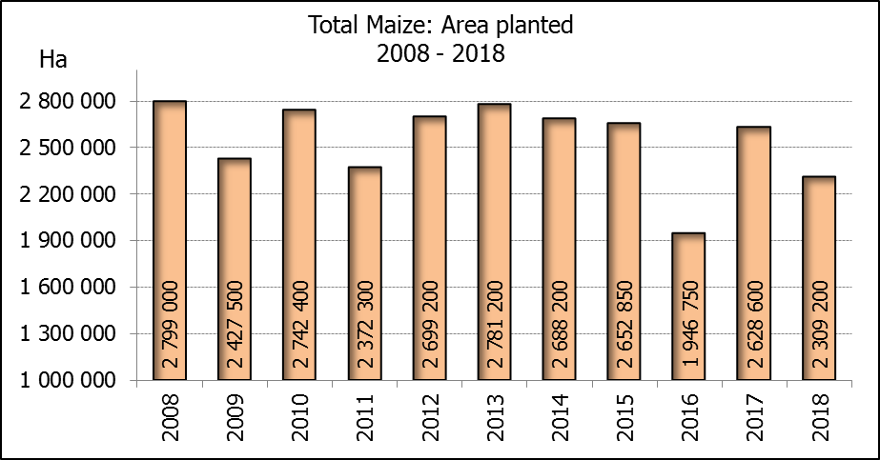

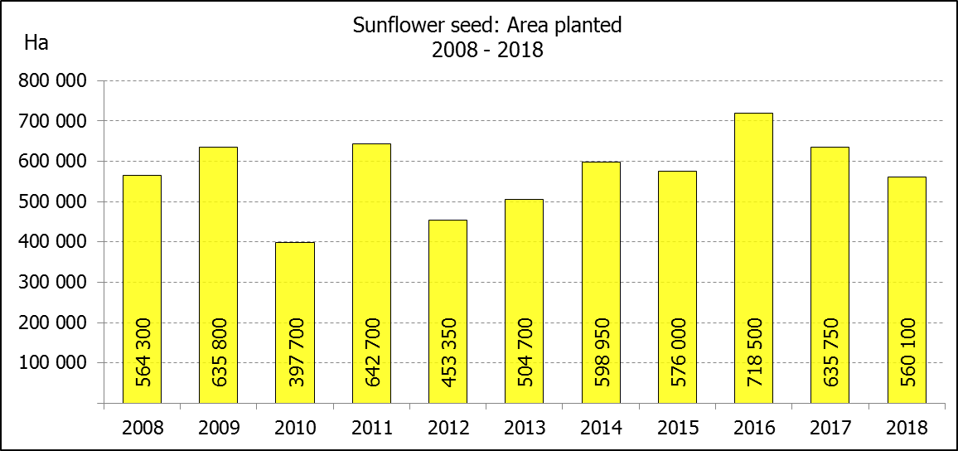
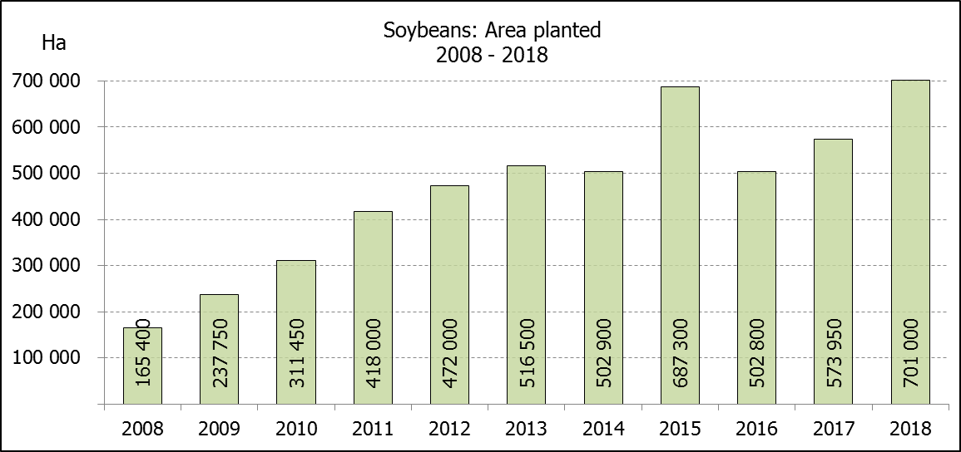

WHITE AND YELLOW MAIZE – PRELIMINARY AREA PLANTED ESTIMATE: 2018
WIT- EN GEELMIELIES – VOORLOPIGE OPPERVLAKTESKATTING: 2018
Province/  Provinsie | Preliminary area planted  Voorlopige oppervlakte beplant  2018 |  |  | Area planted/  Oppervlakte beplant  2017 |  |  | Final estimate¹⁾/  Finale skatting¹⁾  2017
Province/  Provinsie | White/  Wit  Ha | Yellow/  Geel  Ha | Totaal/  Total  Ha | White/  Wit  Ha | Yellow/  Geel  Ha | Totaal/  Total  Ha | White/  Wit  Tons | Geel/  Yellow  Tons | Totaal/  Total  Tons
Western Cape/Wes-Kaap | 0 | 1 500 | 1 500 | 200 | 2 000 | 2 200 | 2 000 | 20 000 | 22 000
Northern Cape/Noord-Kaap | 2 700 | 43 000 | 45 700 | 3 500 | 45 000 | 48 500 | 46 200 | 657 000 | 703 200
Free State/Vrystaat | 620 000 | 405 000 | 1 025 000 | 805 000 | 355 000 | 1 160 000 | 5 111 750 | 2 218 750 | 7 330 500
Eastern Cape/Oos-Kaap | 4 000 | 9 000 | 13 000 | 4 400 | 9 500 | 13 900 | 30 800 | 66 500 | 97 300
KwaZulu-Natal | 40 000 | 47 000 | 87 000 | 50 000 | 50 000 | 100 000 | 350 000 | 385 000 | 735 000
Mpumalanga | 133 000 | 330 000 | 463 000 | 160 000 | 330 000 | 490 000 | 1 088 000 | 2 343 000 | 3 431 000
Limpopo | 25 000 | 22 000 | 47 000 | 40 000 | 24 000 | 64 000 | 300 000 | 192 000 | 492 000
Gauteng | 50 000 | 62 000 | 112 000 | 60 000 | 60 000 | 120 000 | 390 000 | 408 000 | 798 000
North West/Noordwes | 410 000 | 105 000 | 515 000 | 520 000 | 110 000 | 630 000 | 2 574 000 | 561 000 | 3 135 000
Total/Totaal | 1 284 700 | 1 024 500 | 2 309 200 | 1 643 100 | 985 500 | 2 628 600 | 9 892 750 | 6 851 250 | 16 744 000
- 28 September 2017

SUNFLOWER SEED – PRELIMINARY AREA PLANTED ESTIMATE: 2018
SONNEBLOMSAAD – VOORLOPIGE OPPERVLAKTESKATTING: 2018

Province/  Provinsie | Prel area planted  Voorl opp beplant  Ha | Area planted/  Opp beplant  Ha | Final estimate/  Finale skatting  Tons
Province/  Provinsie | 2018 | 2017 | 2017
Western Cape/Wes-Kaap | - | - | -
Northern Cape/Noord-Kaap | 100 | 250 | 375
Free State/Vrystaat | 310 000 | 330 000 | 478 500
Eastern Cape/Oos-Kaap | - | - | -
KwaZulu-Natal | - | 300 | 300
Mpumalanga | 2 000 | 2 200 | 2 420
Limpopo | 75 000 | 90 000 | 85 500
Gauteng | 3 000 | 3 000 | 3 000
North West/Noordwes | 170 000 | 210 000 | 304 500
Total/Totaal | 560 100 | 635 750 | 874 595
SOYBEANS – PRELIMINARY AREA PLANTED ESTIMATE: 2018
SOJABONE – VOORLOPIGE OPPERVLAKTESKATTING: 2018

Province/  Provinsie | Prel area planted  Voorl opp beplant  Ha | Area planted/  Opp beplant  Ha | Final estimate/  Finale skatting  Tons
Province/  Provinsie | 2018 | 2017 | 2017
Western Cape/Wes-Kaap | 300 | 700 | 1 050
Northern Cape/Noord-Kaap | 3 000 | 3 000 | 10 500
Free State/Vrystaat | 310 000 | 240 000 | 504 000
Eastern Cape/Oos-Kaap | 2 000 | 1 850 | 2 775
KwaZulu-Natal | 35 000 | 30 500 | 89 975
Mpumalanga | 275 000 | 241 000 | 554 300
Limpopo | 15 000 | 8 500 | 29 750
Gauteng | 30 700 | 25 400 | 71 120
North West/Noordwes | 30 000 | 23 000 | 52 900
Total/Totaal | 701 000 | 573 950 | 1 316 370

PRELIMINARY AREA ESTIMATE OF SUMMER CROPS (2018 PRODUCTION SEASON)/
VOORLOPIGE OPPERVLAKTESKATTING VIR SOMERGEWASSE (2018 PRODUKSIE-SEISOEN)
30 JANUARY / JANUARIE 2018

Summer field crops – 2018  The preliminary area estimate of today is mainly based on the results of a non-probability survey conducted by the Directorate: Statistics and Economic Analysis of the Department of Agriculture, Forestry and Fisheries. Less favorable rainfall and warm temperatures in the western producing areas over the past few weeks prevented producers from planting their intended area with summer crops, especially in the Free State and North West provinces.  The revised area planted and production figures, which will be released by the Crop Estimates Committee on 27 February 2018, will mainly be based, on information obtained from the Producer Independent Crop Estimation System (PICES) survey for the Northern Cape, Free State, KwaZulu-Natal, Mpumalanga, Limpopo, Gauteng and North West provinces.  Commercial maize: The preliminary area estimate for maize is 2,309 mill. ha, which is 12,15% or 319 400 ha less than the 2,629 mill. ha planted for the previous season, and also 6,53% or 161 200 ha less than the intentions to plant figure of 2,470 mill. ha released in October 2017.  The preliminary area estimate for white maize is 1,285 mill. ha, which represents a decrease of 21,81% or 358 400 ha compared to the 1,643 mill. ha planted last season. In the case of yellow maize the area estimate is 1,024 mill. ha, which is 3,96% or 39 000 ha more than the 985 500 ha planted last season.  Other summer crops:  Please note that only provisional national area planted figures of groundnuts, sorghum and dry beans for the current production season are being released today.  Sunflower seed: The preliminary area estimate for sunflower seed is 560 100 ha, which is 11,90% or 75 650 ha less than the 635 750 ha planted the previous season. As some producers have not yet finished plantings, mainly because of unfavourable weather conditions, rainfall within the next two weeks can still influence farmers’ decisions to plant sunflower seed.  It is estimated that 701 000 ha have been planted to soybeans, which represents an increase of 22,14% or 127 050 ha compared to the 573 950 ha planted last season.  For groundnuts, the area estimate is 53 000 ha, which is 5,36% or 3 000 ha less than the 56 000 ha planted for the previous season.  The area estimate for sorghum decreased by 40,97%, from 42 350 ha to 25 000 ha against the previous season.  For dry beans, the area estimate is 52 000 ha, which is 15,43% or 6 950 ha more than the 45 050 ha planted for the previous season.  Please note that the revised area estimate and first production forecast for summer field crops for 2018 will be released on 27 February 2018. |  | Somergewasse – 2018  Die voorlopige oppervlakteskatting van vandag is hoofsaaklik gebaseer op die resultate van ’n nie-ewekansige opname onderneem deur die Direktoraat: Statistiek en Ekonomiese Analise van die Departement van Landbou, Bosbou en Visserye. Minder gunstige reënvalneerslae en warm temperature in die westelike produserende gebiede die afgelope paar weke het produsente verhinder om hul beoogde oppervlakte met somergewasse aan te plant, veral in die Vrystaat en Noordwes provinsies.  Die hersiene aangeplante oppervlakte en produksiesyfers sal deur die Oesskattingskomitee op 27 Februarie 2018 vrygestel word en sal hoofsaaklik, gebaseer wees op inligting verkry vanaf die “PICES”-opname vir die Noord-Kaap, Vrystaat, KwaZulu-Natal, Mpumalanga, Limpopo, Gauteng en Noordwes provinsies.  Kommersiële mielies: Die voorlopige skatting van die oppervlakte onder mielies beloop 2,309 milj. ha, wat 12,15% of 319 400 ha minder is as die 2,629 milj. ha wat verlede seisoen aangeplant is, en ook 6,53% of 161 200 ha minder as die voornemens om te plant syfer van 2,470 milj. ha soos vrygestel in Oktober 2017.  Die voorlopige oppervlak onder witmielies is 1,285 milj. ha, wat ’n afname van 21,81% of 358 400 ha verteenwoordig vergeleke met die 1,643 milj. ha die vorige seisoen. In die geval van geelmielies is die oppervlakteskatting 1,024 milj. ha, wat 3,96% of 39 000 ha meer is as die 985 500 ha geplant die vorige seisoen.  Ander somergewasse:  Let asb. daarop dat net die nasionale aangeplante area vir die voorlopige oppervlakte van die grondbone, sorghum en droëbone vir die huidige produksieseisoen vandag vrygestel word.  Sonneblomsaad: Die voorlopige oppervlakteskatting vir sonneblomsaad is 560 100 ha, wat 11,90% of 75 650 ha minder is as die 635 750 ha aangeplant die vorige seisoen. Aangesien sommige produsente nog nie klaar geplant is nie, hoofsaaklik weens ongunstige weersomstandighede, kan reënval binne die volgende twee weke steeds produsente se besluite om sonneblomsaad te plant, beïnvloed.  Die geskatte oppervlakte beplant met sojabone is 701 000 ha, wat ’n toename van 22,14% of 127 050 ha verteenwoordig vergeleke met die 573 950 ha geplant die vorige seisoen.  Vir grondbone is die oppervlakteskatting 53 000 ha, wat 5,36% of 3 000 ha minder is as die 56 000 ha geplant vir die vorige seisoen.  Die oppervlakteskatting vir sorghum het afgeneem met 40,97%, van 42 350 ha tot 25 000 ha teenoor die vorige seisoen.  Vir droëbone is die geskatte oppervlakte beplant 52 000 ha, wat 15,43% of 6 950 ha meer is as die 45 050 ha geplant vir die vorige seisoen.  Neem asseblief kennis dat die hersiene oppervlakte- en eerste produksieskatting vir somergewasse vir 2018, op 27 Februarie 2018 vrygestel sal word.
The area estimate and sixth production forecast for winter cereals for the 2017 is hereby released. /
Hiermee word die oppervlakteskatting en sesde produksieskatting vir wintergewasse vir 2017 vrygestel.
WINTER CEREALS – AREA PLANTED ESTIMATE AND SIXTH PRODUCTION FORECAST: 2017
WINTERGEWASSE – OPPERVLAKTE- EN SESDE PRODUKSIESKATTING: 2017
CROP/GEWAS | Area planted/  Opp beplant  2017 | 6th forecast/  6de skatting  2017 | 5th forecast/  5de skatting  2017 | Area planted/  Opp beplant  2016 | Final crop/  Finale oes  2016 | 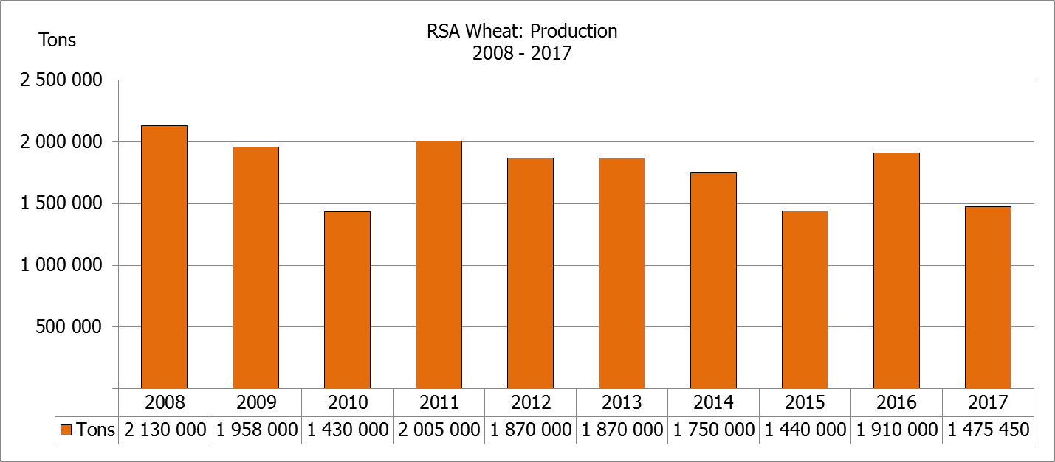  Change/  Verandering
CROP/GEWAS | Ha | Tons | Tons | Ha | Tons | %
CROP/GEWAS | (A) | (B) | (C) | (D) | (E) | (B) ÷ (C)
Commercial/Kommersieel:
Wheat/Koring | 491 600 | 1 475 450 | 1 475 450 | 508 365 | 1 910 000 | -
Malting barley/Moutgars | 91 380 | 307 064 | 298 564 | 88 695 | 355 000 | +2,8
Canola/Kanola | 84 000 | 93 468 | 92 400 | 68 075 | 105 000 | +1,2
Total/Totaal | 666 980 | 1 875 982 | 1 866 414 | 665 135 | 2 370 000 | 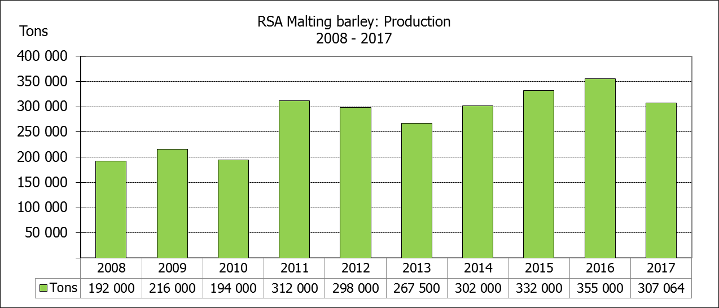  +0,5
* Note: Estimate is for calendar year, e.g. production season 2017 = 2017
* Nota: Skatting is vir kalenderjaar, bv. produksie-seisoen 2017 = 2017
WHEAT – AREA PLANTED ESTIMATE AND SIXTH PRODUCTION FORECAST: 2017
KORING – OPPERVLAKTE- EN SESDE PRODUKSIESKATTING: 2017
Province/  Provinsie | Area planted/  Opp beplant  Ha | 6th forecast/  6de skatting  Tons | Area planted/  Opp beplant  Ha | Final crop/  Finale oes  Tons
Province/  Provinsie | 2017 | 2017 | 2016 | 2016
Western Cape/Wes-Kaap | 326 000 | 586 800 | 323 000 | 1 098 200
Northern Cape/Noord-Kaap | 38 000 | 304 000 | 35 000 | 266 000
Free State/Vrystaat | 80 000 | 296 000 | 110 000 | 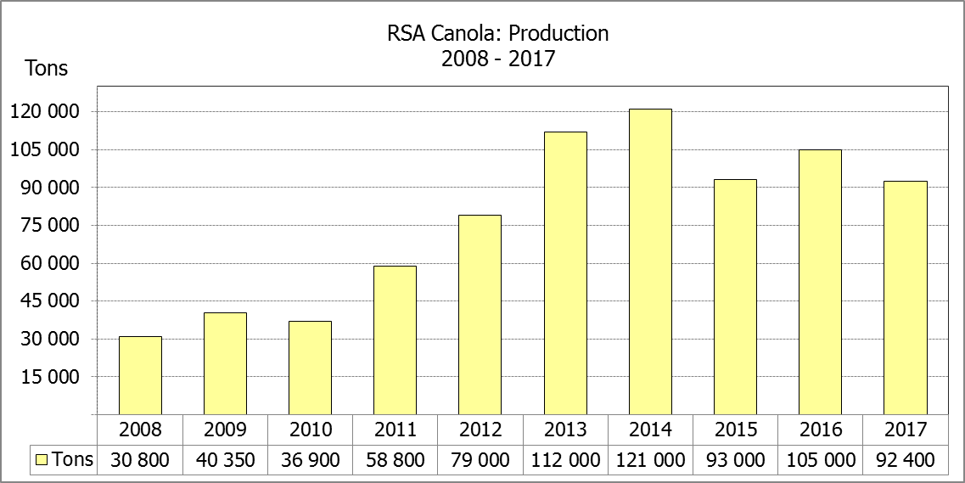  308 460
Eastern Cape/Oos-Kaap | 1 900 | 9 500 | 2 200 | 11 000
KwaZulu-Natal | 7 500 | 42 750 | 6 500 | 37 050
Mpumalanga | 4 000 | 25 200 | 2 300 | 13 800
Limpopo | 20 000 | 126 000 | 17 000 | 103 700
Gauteng | 700 | 4 200 | 365 | 2 190
North West/Noordwes | 13 500 | 81 000 | 12 000 | 69 600
Total/Totaal | 491 600 | 1 475 450 | 508 365 | 1 910 000

AREA ESTIMATE AND SIXTH PRODUCTION FORECAST OF WINTER CROPS (2017) /
OPPERVLAKTESKATTING EN SESDE PRODUKSIESKATTING VAN WINTERGEWASSE (2017)
30 JANUARY / JANUARIE 2018
Winter cereal crops - 2017 production season  Wheat: The expected commercial production of wheat remained unchanged at 1,475 mill. tons, with an expected yield of 3,00 t/ha.  The area estimate for wheat is 491 600 ha.  Other crops: The production forecast for malting barley is 307 064 tons, which is 2,85% or 8 500 tons more than the previous forecast of 298 564 tons. The area planted is estimated at 91 380 ha, while the expected yield is 3,36 t/ha.  The expected canola crop was adjusted slightly upwards by 1,16% or 1 068 tons to 93 468 tons. The area estimate for canola is 84 000 ha, with an expected yield of 1,11 t/ha.  Please note that the final production estimate for winter cereals for 2017 will be released on 27 February 2018. |  | Wintergewasse - 2017 produksie-seisoen  Koring: Die verwagte kommersiële produksie vir koring is onveranderd gelaat op 1,475 milj. ton, met ‘n verwagte opbrengs van 3,00 t/ha.  Die oppervlakteskatting vir koring is 491 600 ha.  Ander gewasse: Die produksieskatting vir moutgars is 307 064 ton, wat 2,85% of 8 500 ton meer is as die vorige skatting van 298 564 ton. Die oppervlakte beplant is beraam op 91 380 ha, terwyl die verwagte opbrengs 3,36 t/ha beloop.  Die verwagte kanola-oes is effens opwaarts aangepas met 1,16% of 1 068 ton na 93 468 ton. Die oppervlakteskatting vir kanola is 84 000 ha, met ŉ verwagte opbrengs van 1,11 t/ha.  Neem asseblief kennis dat die finale produksieskatting vir wintergewasse vir 2017 op 27 Februarie 2018 vrygestel sal word.

Information is available on the internet at http://www.daff.gov.za/statistics and economic reports or http://www.sagis.org.za, as from 15:30 on the date of the relevant meeting of the Crop Estimates Committee. |  | Inligting is beskikbaar op die internet by http://www.daff.gov.za/statistics and economic reports of by http://www.sagis.org.za, vanaf 15:30 op die dag van die toepaslike vergadering van die Oesskattingskomitee.
CONFIDENTIALITY ISSUES that CEC members are committed to adhere to on the day of the meeting
- Personal items such as laptops, handbags, cell phones, etc. are not allowed in the venue during the meeting
- No member is allowed to leave the meeting before 12:00 in order to prevent disclosure of the information
- The embargo time for the release of crop estimates information is 15:30
- No member is allowed to discuss crop estimates information with anyone other than a member of the Committee before the embargo time
- Only the Chairperson, or a member appointed by the Chairperson, may release the figures to the media
- Members must regard the detail of any information that was collected for and/or discussed during the meeting, as confidential
- Individual information received for crop estimate purposes is treated strictly confidential, and is not divulged for any other purposes

