 | crop estimates committee
 | oesskattingskomitee
From/Van: Mr Baldwin Netshifhefhe  Tel: 012 319 8043/32  Fax/Faks: 012 319 8031  E-mail/E-pos: BaldwinN@dalrrd.gov.za  Web page/Webblad: www.dalrrd.gov.za/old website/statistics and economic reports or  www.sagis.org.za/CEC: Crop Estimates EMBARGO: 14:30 |  |  | 

The revised area planted estimate and first production forecast for summer crops for 2025 is hereby released.
Hiermee word die hersiene oppervlakte- en eerste produksieskatting vir somergewasse vir 2025 vrygestel.

SUMMER CROPS – REVISED AREA PLANTED AND FIRST PRODUCTION FORECAST: 2025
SOMERGEWASSE – HERSIENE OPPERVLAKTE- EN EERSTE PRODUKSIESKATTING: 2025
CROP/GEWAS | Area planted/  Opp beplant  2025 | 1stforecast/  1ste skatting  2025 | Area planted/  Opp beplant  2024 | Final crop/  Finale oes  2024 | Change/  Verandering/
CROP/GEWAS | Ha | Tons | Ha | Tons | %
CROP/GEWAS | (A) | (B) | (C) | (D) | (B) ÷ (D)
Commercial/Kommersieël:
White maize/Witmielies | 1 599 700 | 7 395 700 | 1 554 750 | 6 055 000 | 2,89%
Yellow maize/Geelmielies | 997 000 | 6 515 450 | 1 081 500 | 6 795 000 | -7,81%
Total Maize/Totale Mielies | 2 596 700 | 13 911 150 | 2 636 250 | 12 850 000 | -1,50%
Sunflower seed/Sonneblomsaad | 555 700 | 720 050 | 529 000 | 632 000 | 5,05%
Soybeans/Sojabone | 1 151 000 | 2 325 225 | 1 150 500 | 1 848 000 | 0,04%
Groundnuts/Grondbone | 48 125 | 65 359 | 41 200 | 52 000 | 16,81%
Sorghum | 40 400 | 129 620 | 42 100 | 98 000 | -4,04%
Dry beans/Droëbone | 45 420 | 75 966 | 39 550 | 50 495 | 14,84%
TOTAL/TOTAAL | 4 437 345 | 17 227 370 | 4 438 600 | 15 530 495 | -0,03%
Note: Estimate is for calendar year, e.g. production season 2024/25 = 2025
Nota: Skatting is vir kalenderjaar, bv. produksie-seisoen 2024/25 = 2025
The Crop Estimates Committee comprises officials of the following institutions:
Department of Agriculture, Land Reform and Rural Development; Provincial Departments of Agriculture; various ARC-Institutes (Soil, Climate and Water; Small Grains Institute; and
Grain Crops Institute); BFAP and Statistics SA.

27 February / Februarie 2025

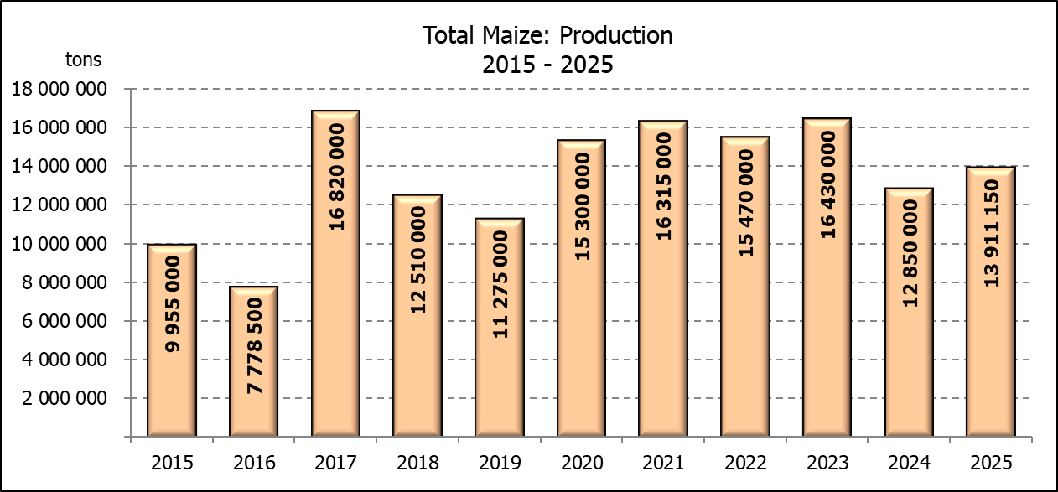

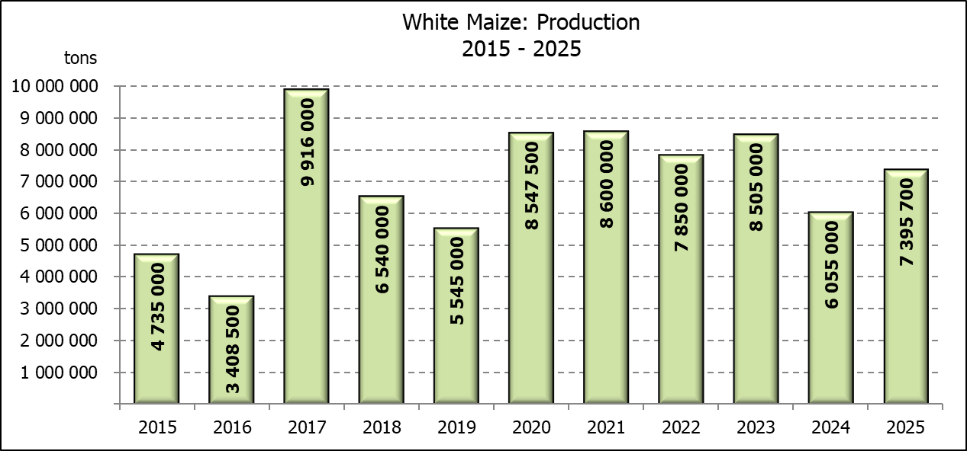
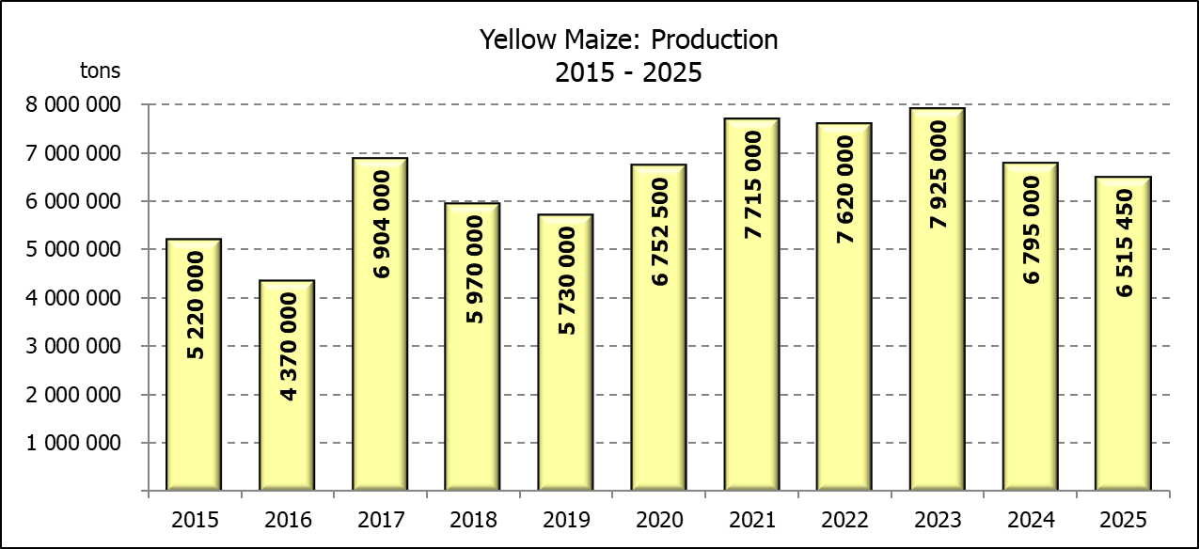

WHITE AND YELLOW MAIZE – REVISED AREA PLANTED AND FIRST PRODUCTION FORECAST: 2025
WIT- EN GEELMIELIES – HERSIENE OPPERVLAKTE EN EERSTE PRODUKSIESKATTING: 2025

Provinsie/  Province | Area planted/  Oppervlakte beplant  2025 |  |  | 1st forecast/  1ste skatting  2025 |  |  | Area planted/  Oppervlakte beplant  2024 |  |  | Final crop/  Finale oes  2024
Provinsie/  Province | White/  Wit  Ha | Yellow/  Geel  Ha | Total/  Totaal  Ha | White/  Wit  Tons | Yellow/  Geel  Tons | Total/  Totaal  Tons | White/  Wit  Ha | Yellow/  Geel  Ha | Total/  Totaal  Ha | White/  Wit  Tons | Yellow/  Geel  Tons | Total/  Totaal  Tons
Western Cape/Wes-Kaap | 200 | 3 500 | 3 700 | 1 900 | 32 900 | 34 800 | 250 | 3 500 | 3 750 | 2 300 | 32 200 | 34 500
Northern Cape/Noord-Kaap | 1 500 | 42 000 | 43 500 | 18 000 | 651 000 | 669 000 | 1 500 | 42 000 | 43 500 | 18 900 | 648 900 | 667 800
Free State/Vrystaat | 850 000 | 345 000 | 1 195 000 | 3 910 000 | 1 897 500 | 5 807 500 | 835 000 | 415 000 | 1 250 000 | 3 385 000 | 1 992 000 | 5 377 000
Eastern Cape/Oos-Kaap | 6 000 | 28 000 | 34 000 | 41 400 | 210 000 | 251 400 | 6 000 | 27 000 | 33 000 | 40 800 | 191 700 | 232 500
KwaZulu-Natal | 50 000 | 66 000 | 116 000 | 305 000 | 561 000 | 866 000 | 47 000 | 67 000 | 114 000 | 286 700 | 576 200 | 862 900
Mpumalanga | 162 000 | 362 000 | 524 000 | 923 400 | 2 226 300 | 3 149 700 | 160 000 | 360 000 | 520 000 | 984 000 | 2 490 000 | 3 474 000
Limpopo | 10 000 | 18 500 | 28 500 | 69 000 | 149 850 | 218 850 | 11 000 | 15 000 | 26 000 | 74 800 | 120 000 | 194 800
Gauteng | 55 000 | 57 000 | 112 000 | 313 500 | 381 900 | 695 400 | 54 000 | 62 000 | 116 000 | 292 500 | 415 500 | 708 000
North West/Noordwes | 465 000 | 75 000 | 540 000 | 1 813 500 | 405 000 | 2 218 500 | 440 000 | 90 000 | 530 000 | 970 000 | 328 500 | 1 298 500
Total/Totaal | 1 599 700 | 997 000 | 2 596 700 | 7 395 700 | 6 515 450 | 13 911 150 | 1 554 750 | 1 081 500 | 2 636 250 | 6 055 000 | 6 795 000 | 12 850 000

SUNFLOWER SEED – REVISED AREA PLANTED AND FIRST PRODUCTION FORECAST: 2025
SONNEBLOMSAAD – HERSIENE OPPERVLAKTE EN EERSTE PRODUKSIESKATTING: 2025

Province/  Provinsie | Area planted/  Opp beplant  Ha | 1st forecast/  1ste skatting  Tons | Area planted/  Opp beplant  Ha | Final crop/  Finale oes  Tons
Province/  Provinsie | 2025 | 2025 | 2024 | 2024
Western Cape/Wes-Kaap | 0 | 0 | 0 | 0
Northern Cape/Noord-Kaap | 1 000 | 2 400 | 2 000 | 4 600
Free State/Vrystaat | 264 500 | 370 300 | 255 000 | 354 000
Eastern Cape/Oos-Kaap | 700 | 1 400 | 700 | 1 400
KwaZulu-Natal | 1 000 | 2 000 | 300 | 600
Mpumalanga | 2 500 | 3 750 | 3 500 | 4 900
Limpopo | 90 000 | 85 500 | 90 000 | 63 000
Gauteng | 1 000 | 1 200 | 2 500 | 3 000
North West/Noordwes | 195 000 | 253 500 | 175 000 | 200 500
Total/Totaal | 555 700 | 720 050 | 529 000 | 632 000
SOYBEANS – REVISED AREA PLANTED AND FIRST PRODUCTION FORECAST: 2025
SOJABONE – HERSIENE OPPERVLAKTE EN EERSTE PRODUKSIESKATTING: 2025
Province/  Provinsie | Area planted/  Opp beplant  Ha | 1st forecast/  1ste skatting  Tons | Area planted/  Opp beplant  Ha | Final crop/  Finale oes  Tons
Province/  Provinsie | 2025 | 2025 | 2024 | 2024
Western Cape/Wes-Kaap | 0 | 0 | 0 | 0
Northern Cape/Noord-Kaap | 2 000 | 7 000 | 1 200 | 4 380
Free State/Vrystaat | 565 000 | 1 101 750 | 545 000 | 688 960
Eastern Cape/Oos-Kaap | 5 500 | 15 675 | 5 300 | 14 310
KwaZulu-Natal | 47 000 | 176 250 | 47 000 | 173 900
Mpumalanga | 315 000 | 614 250 | 320 000 | 624 000
Limpopo | 16 500 | 49 500 | 21 000 | 72 450
Gauteng | 52 000 | 109 200 | 56 000 | 84 000
North West/Noordwes | 148 000 | 251 600 | 155 000 | 186 000
Total/Totaal | 1 151 000 | 2 325 225 | 1 150 500 | 1 848 000

GROUNDNUTS – REVISED AREA PLANTED AND FIRST PRODUCTION FORECAST: 2025
GRONDBONE – HERSIENE OPPERVLAKTE EN EERSTE PRODUKSIESKATTING: 2025

Province/  Provinsie | Area planted/  Opp beplant  Ha | 1st forecast/  1ste skatting  Tons | Area planted/  Opp beplant  Ha | Final crop/  Finale oes  Tons
Province/  Provinsie | 2025 | 2025 | 2024 | 2024
Western Cape/Wes-Kaap | 0 | 0 | 0 | 0
Northern Cape/Noord-Kaap | 3 100 | 8 370 | 4 200 | 8 610
Free State/Vrystaat | 21 700 | 30 380 | 17 000 | 26 305
Eastern Cape/Oos-Kaap | 0 | 0 | 0 | 0
KwaZulu-Natal | 175 | 236 | 300 | 495
Mpumalanga | 0 | 0 | 0 | 0
Limpopo | 1 650 | 2 723 | 1 700 | 4 590
Gauteng | 0 | 0 | 0 | 0
North West/Noordwes | 21 500 | 23 650 | 18 000 | 12 000
Total/Totaal | 48 125 | 65 359 | 41 200 | 52 000

SORGHUM – REVISED AREA PLANTED AND FIRST PRODUCTION FORECAST: 2025
SORGHUM – HERSIENE OPPERVLAKTE EN EERSTE PRODUKSIESKATTING: 2025

Province/  Provinsie | Area planted/  Opp beplant  Ha | 1st forecast/  1ste skatting  Tons | Area planted/  Opp beplant  Ha | Final crop/  Finale oes  Tons
Province/  Provinsie | 2025 | 2025 | 2024 | 2024
Western Cape/Wes-Kaap | 0 | 0 | 0 | 0
Northern Cape/Noord-Kaap | 0 | 0 | 0 | 0
Free State/Vrystaat | 12 800 | 42 240 | 11 500 | 19 740
Eastern Cape/Oos-Kaap | 200 | 600 | 100 | 300
KwaZulu-Natal | 100 | 380 | 100 | 350
Mpumalanga | 9 200 | 43 700 | 8 300 | 36 520
Limpopo | 13 000 | 27 300 | 18 000 | 35 100
Gauteng | 100 | 400 | 100 | 390
North West/Noordwes | 5 000 | 15 000 | 4 000 | 5 600
Total/Totaal | 40 400 | 129 620 | 42 100 | 98 000

DRY BEANS – REVISED AREA PLANTED AND FIRST PRODUCTION FORECAST: 2025
DROëBONE – HERSIENE OPPERVLAKTE EN EERSTE PRODUKSIESKATTING: 2025

Province/  Provinsie | Area planted/  Opp beplant  Ha | 1st forecast/  1ste skatting  Tons | Area planted/  Opp beplant  Ha | Final crop/  Finale oes  Tons
Province/  Provinsie | 2025 | 2025 | 2024 | 2024
Western Cape/Wes-Kaap | 100 | 200 | 100 | 220
Northern Cape/Noord-Kaap | 950 | 2 280 | 500 | 900
Free State/Vrystaat | 17 500 | 23 625 | 13 500 | 10 800
Eastern Cape/Oos-Kaap | 200 | 440 | 200 | 440
KwaZulu-Natal | 2 800 | 4 200 | 2 100 | 2 730
Mpumalanga | 2 320 | 4 176 | 2 600 | 4 680
Limpopo | 11 100 | 24 420 | 12 200 | 23 790
Gauteng | 950 | 1 425 | 850 | 935
North West/Noordwes | 9 500 | 15 200 | 7 500 | 6 000
Total/Totaal | 45 420 | 75 966 | 39 550 | 50 495

CONFIDENTIALITY ISSUES that CEC members are committed to adhere to on the day of the meeting
- Personal items such as laptops, handbags, cell phones, etc. are not allowed in the venue during the meeting
- No member is allowed to leave the meeting before 12:00 in order to prevent disclosure of the information
- The embargo time for the release of crop estimates information is 14:30
- No member is allowed to discuss crop estimates information with anyone other than a member of the Committee before the embargo time
- Only the Chairperson, or a member appointed by the Chairperson, may release the figures to the media
- Members must regard the detail of any information that was collected for and/or discussed during the meeting, as confidential
- Individual information received for crop estimate purposes is treated strictly confidential, and is not divulged for any other purposes

REVISED AREA ESTIMATE AND FIRST PRODUCTION FORECAST OF SUMMER CROPS (2025 PRODUCTION SEASON)/
HERSIENE OPPERVLAKTE- EN EERSTE PRODUKSIESKATTING VIR SOMERGEWASSE (2025 PRODUKSIE-SEISOEN)
27 FEBRUARY / FEBRUARIE 2025

Summer field crops – 2025  Commercial maize: The revised area estimate for maize is 2 596 700 ha, which is 1,50% or 39 550 ha less than the 2 636 250 ha planted for the previous season, and 1,87% or 49 500 ha less than the preliminary area estimate of 2 646 200 ha released in January 2025.  The expected commercial maize crop is 13 911 150 tons, which is 8,26% or 1 061 150 tons more than the 12 850 000 tons of the previous season (2024). The yield for maize is 5,36 t/ha.  The area planted figures are mainly based on information obtained from the Producer Independent Crop Estimation System (PICES), conducted by the National Crop Statistics Consortium (NCSC) for Free State, KwaZulu-Natal, Mpumalanga, Limpopo, Gauteng and North West provinces.  Please note that information from the objective yield survey by the NCSC for the Mpumalanga province will be available in April 2025; and for the Free State and North West provinces in May 2025. The current yield figures are mainly obtained from producers in the different provinces.  The area estimate for white maize is 1 599 700 ha, which represents an increase of 2,89% or 44 950 ha compared to the 1 554 750 ha planted last season. The production forecast of white maize is 7 395 700 tons, which is 22,14% or 1 340 700 tons more than the 6 055 000 tons of last season. The yield for white maize is 4,62 t/ha.  In the case of yellow maize, the area estimate is 997 000 ha, which is 7,81% or 84 500 ha less than the 1 081 500 ha planted last season. The yellow maize production forecast is 6 515 450 tons, which is 4,11% or 279 550 tons less than the 6 795 000 tons of last season. The yield for yellow maize is 6,54 t/ha.  Other summer crops:  Sunflower seed: The revised area estimate for sunflower seed is 555 700 ha, which is 5,05% or 26 700 ha more than the 529 000 ha planted the previous season. The production forecast for sunflower seed is 720 050 tons, which is 13,93% or 88 050 tons more than the 632 000 tons of the previous season. The expected yield is 1,30 t/ha.  Other crops: It is estimated that 1 151 000 ha have been planted to soybeans, which represents an increase of 0,04% or 500 ha compared to the 1 150 500 ha planted last season. The production forecast is 2 325 225 tons, which is 25,82% or 477 225 tons more than the 1 848 000 tons of the previous season. The expected yield is 2,02 t/ha.  For groundnuts, the area estimate is 48 125 ha, which is 16,81% or 6 925 ha more than the 41 200 ha planted for the previous season. The expected crop is 65 359 tons – which is 25,69% or 13 359 tons more than the 52 000 tons of last season. The expected yield is 1,36 t/ha.  The area estimate for sorghum decreased by 4,04% or 1 700 ha, from 42 100 ha to 40 400 ha against the previous season. The production forecast for sorghum is 129 620 tons, which is 32,27% or 31 620 tons more than the 98 000 tons of the previous season. The expected yield is 3,21 t/ha.  For dry beans, the area estimate is 45 420 ha, which is 14,84% or 5 870 ha more than the 39 550 ha planted for the previous season. The production forecast is 75 966 tons, which is 50,44% or 25 471 tons more than the 50 495 tons of the previous season. The expected yield is 1,67 t/ha.  Please note that the second production forecast for summer field crops for 2025 will be released on 26 March 2025. |  | Somergewasse – 2025  Kommersiële mielies: Die hersiene skatting van die oppervlakte onder mielies beloop 2 596 700 ha, wat 1,50% of 39 550 ha minder is as die 2 636 250 ha wat verlede seisoen aangeplant is, en 1,87% of 49 500 ha minder as die voorlopige oppervlakteskatting van 2 646 200 ha soos vrygestel in Januarie 2025.  Die verwagte kommersiële mielie-oes is 13 911 150 ton, wat 8,26% of 1 061 150 ton meer is as die 12 850 000 ton van die vorige seisoen (2024). Die opbrengs van mielies is 5,36 t/ha.  Die oppervlakte beplant syfers is hoofsaaklik verkry vanaf die Produsente Onafhanklike Oesskattingstelsel (PICES), soos deur die Nasionale Oesskattingskonsortium gerapporteer vir Vrystaat, KwaZulu-Natal, Mpumalanga, Limpopo, Gauteng en Noordwes provinsies.  Neem kennis dat inligting van die objektiewe opbrengs-opname van die Konsortium vir die Mpumalanga provinsie, in April 2025 gerapporteer word en vir die Vrystaat en Noordwes provinsies in Mei 2025. Die huidige opbrengs syfers is hoofsaaklik verkry vanaf produsente in die verskillende provinsies.  Die oppervlak onder witmielies is 1 599 700 ha, wat ‘n toename van 2,89% of 44 950 ha verteenwoordig vergeleke met die 1 554 750 ha die vorige seisoen. Die produksieskatting van witmielies is 7 395 700 ton, wat 22,14% of 1 340 700 ton meer is as die 6 055 000 ton van die vorige seisoen. Die opbrengs van witmielies is 4,62 t/ha.  In die geval van geelmielies is die oppervlakteskatting 997 000 ha, wat 7,81% of 84 500 ha minder is as die 1 081 500 ha geplant die vorige seisoen. Die produksieskatting van geelmielies is 6 515 450 ton, wat 4,11% of 279 550 ton minder is as die 6 795 000 ton van die vorige seisoen. Die opbrengs van geelmielies is 6,54 t/ha.  Ander somergewasse:  Sonneblomsaad: Die hersiene oppervlakteskatting vir sonneblomsaad is 555 700 ha, wat 5,05% of 26 700 ha meer is as die 529 000 ha aangeplant die vorige seisoen. Die produksieskatting vir sonneblomsaad is 720 050 ton, wat 13,93% of 88 050 ton meer is as die 632 000 ton van die vorige seisoen. Die verwagte opbrengs is 1,30 t/ha.  Ander gewasse: Die geskatte oppervlakte beplant met sojabone is 1 151 000 ha, wat ’n toename van 0,04% of 500 ha verteenwoordig vergeleke met die 1 150 500 ha geplant die vorige seisoen. Die produksieskatting is 2 325 225 ton, wat 25,82% of 477 225 ton meer is as die 1 848 000 ton van die vorige seisoen. Die verwagte opbrengs is 2,02 t/ha.  Vir grondbone is die oppervlakteskatting 48 125 ha, wat 16,81% of 6 925 ha meer is as die 41 200 ha geplant vir die vorige seisoen. Die verwagte grondbone-oes is 65 359 ton – 25,69% of 13 359 ton meer as die 52 000 ton van die vorige seisoen. Die verwagte opbrengs is 1,36 t/ha.  Die oppervlakteskatting vir sorghum het afgeneem met 4,04% of 1 700 ha, van 42 100 ha tot 40 400 ha teenoor die vorige seisoen. Die produksieskatting van sorghum is 129 620 ton – 32,27% of 31 620 ton meer as die 98 000 ton van die vorige seisoen. Die verwagte opbrengs is 3,21 t/ha.  Vir droëbone is die geskatte oppervlakte beplant 45 420 ha, wat 14,84% of 5 870 ha meer is as die 39 550 ha geplant vir die vorige seisoen. Die produksieskatting is 75 966 ton, wat 50,44% of 25 471 ton meer is as die 50 495 ton van die vorige seisoen. Die verwagte opbrengs is 1,67 t/ha.  Neem asseblief kennis dat die tweede produksieskatting vir somergewasse vir 2025, op 26 Maart 2025 vrygestel sal word.
The area estimate and final production estimate for winter cereals for the 2024 is hereby released. /
Hiermee word die oppervlakte- en finale produksieskatting vir wintergewasse vir 2024 vrygestel.
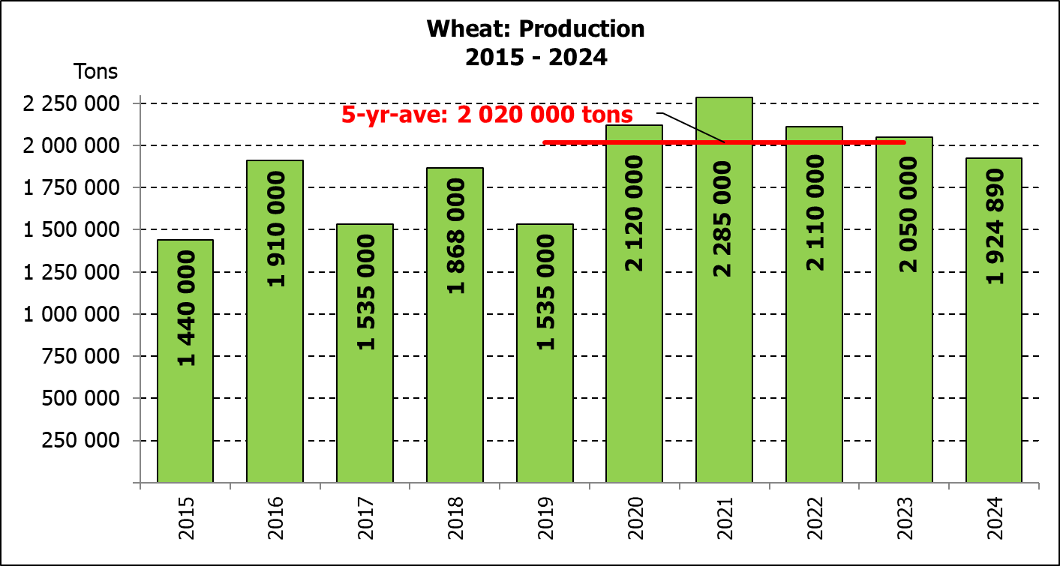
WINTER CEREALS – AREA PLANTED AND FINAL PRODUCTION ESTIMATE: 2024 PRODUCTION SEASON
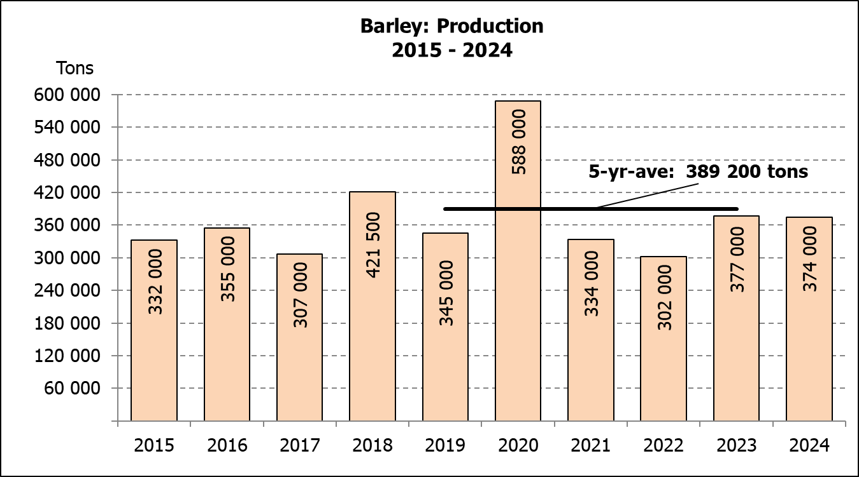
WINTERGEWASSE - OPPERVLAKTE- EN FINALE PRODUKSIESKATTING: 2024 PRODUKSIE-SEISOEN
CROP/GEWAS | Area planted/  Opp beplant  2024 | Final estimate/  Finale skatting  2024 | 6th forecast/  6de skatting  2024 | Area planted/  Opp beplant  2023 | Final crop/  Finale oes  2023 | Change/  Verandering
CROP/GEWAS | Ha | Tons | Tons | Ha | Tons | %
CROP/GEWAS | (A) | (B) | (C) | (D) | (E) | (B) ÷ (C)
Commercial/Kommersieel:
Wheat/Koring | 505 300 | 1 924 890 | 1 924 890 | 537 950 | 2 050 000 | 0,00%
Barley/Gars | 100 700 | 374 000 | 377 050 | 107 600 | 377 000 | -0,81%
Canola/Kanola | 165 750 | 288 200 | 287 445 | 131 200 | 236 300 | 0,26%
Oats/Hawer | 31 000 | 42 800 | 41 300 | 27 500 | 41 000 | 3,63%
Sweet lupines/Soetlupine | 16 000 | 19 200 | 19 200 | 16 000 | 16 000 | 0,00%
Total winter/Totaal winter | 818 750 | 2 649 090 | 2 649 885 | 820 250 | 2 720 300 | -0,03%
1) Commercial only. Excluding barley or oats used as pasture, silage, hay and/or on the farm as fodder for livestock /
Slegs kommersieël. Uitgesluit gars of hawer wat gebruik word as weiding, kuilvoer, hooi en/of op die plaas as voer vir vee.

WHEAT – AREA PLANTED AND FINAL PRODUCTION ESTIMATE: 2024
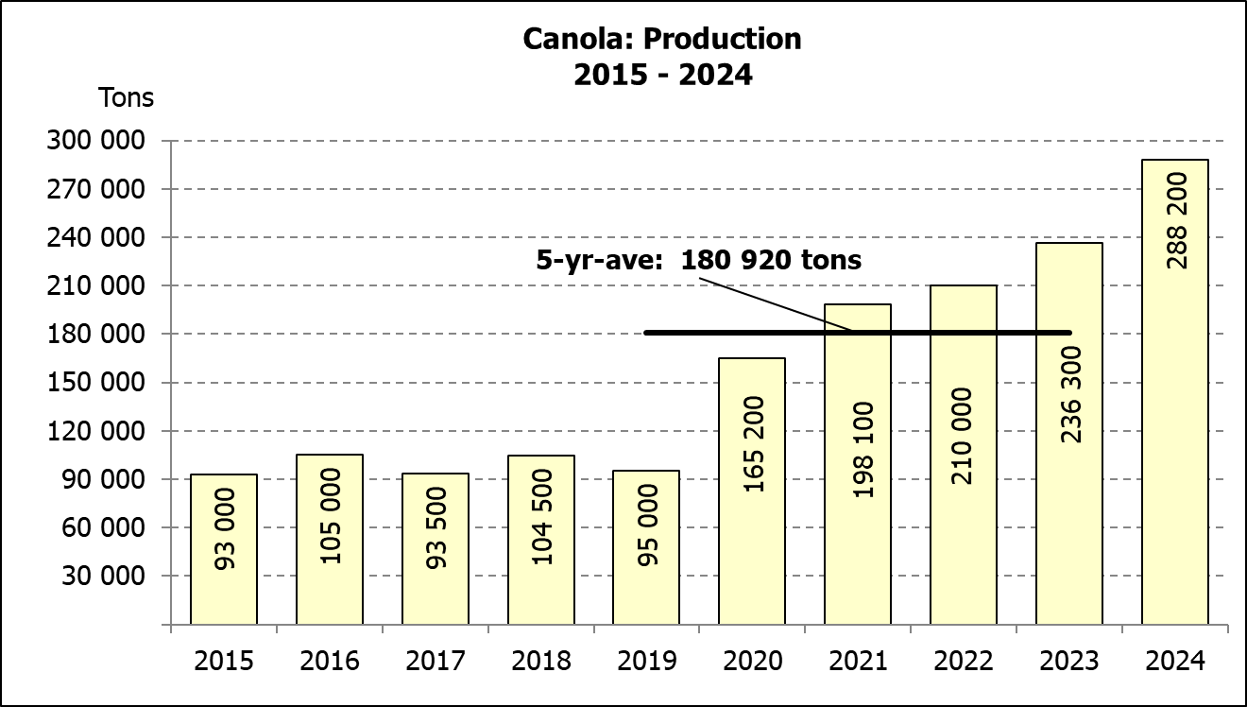
KORING – OPPERVLAKTE- EN FINALE PRODUKSIESKATTING: 2024
Province/  Provinsie | Area planted/  Opp beplant  Ha | Final estimate/  Finale skatting  Tons | Area planted/  Opp beplant  Ha | Final crop/  Finale oes  Tons
Province/  Provinsie | 2024 | 2024 | 2023 | 2023
Western Cape/Wes-Kaap | 368 000 | 1 067 200 | 365 000 | 1 084 000
Northern Cape/Noord-Kaap | 38 000 | 296 400 | 40 000 | 292 000
Free State/Vrystaat | 49 000 | 225 400 | 72 000 | 280 800
Eastern Cape/Oos-Kaap | 5 000 | 34 500 | 6 300 | 40 555
KwaZulu-Natal | 8 300 | 52 290 | 8 500 | 56 100
Mpumalanga | 3 500 | 24 500 | 4 200 | 27 720
Limpopo | 20 500 | 143 500 | 30 000 | 195 000
Gauteng | 1 000 | 6 700 | 950 | 6 175
North West/Noordwes | 12 000 | 74 400 | 11 000 | 67 650
Total/Totaal | 505 300 | 1 924 890 | 537 950 | 2 050 000

AREA ESTIMATE AND FINAL PRODUCTION ESTIMATE OF WINTER CROPS (2024) /
OPPERVLAKTE- EN FINALE PRODUKSIESKATTING VAN WINTERGEWASSE (2024)
27 FEBRUARY/FEBRUARIE 2025
Winter cereal crops - 2024 production season  Wheat: The expected production of wheat remained unchanged at 1,925 mill. tons, with the expected yield at 3,81 t/ha.  The expected production in the Western Cape is unchanged at 1,067 mill. tons (55%). In the Northern Cape, 296 400 tons (15%) is expected to be produced – unchanged from the previous forecasts. In the Free State, the expected production is unchanged at 225 400 tons (12%).  The area estimate for wheat is 505 300 ha, of which an estimated 368 000 ha or 73 % is planted in the Western Cape, 49 000 ha or 10 % in the Free State and 38 000 ha or 8 % in the Northern Cape.  Other crops: The production forecast for barley is 374 000 tons, which is 0,81% or 3 050 tons less than the previous forecast of 377 050 tons. The area planted is estimated at 100 700 ha, while the expected yield is 3,71 t/ha.  The expected canola crop is 288 200 tons, which is 0,26% or 755 tons more than the previous forecast of 287 445 tons. The area estimate for canola is 165 750 ha, with an expected yield of 1,74 t/ha.  The expected crop for oats for the 2024 season is 42 800 tons and the area planted is 31 000 ha. The expected yield is 1,38 t/ha.  In the case of sweet lupines, the production forecast is 19 200 tons. The area estimate of sweet lupines is 16 000 ha, with an expected yield of 1,20 t/ha.  Please note that the intentions to plant winter cereals for 2025 will be released on 30 April 2025. |  | Wintergewasse - 2024 produksie-seisoen  Koring: Die verwagte produksie vir koring is onveranderd gelaat op 1,925 milj. ton, met die verwagte opbrengs op 3,81 t/ha.  Die verwagte produksie in die Wes-Kaap is onveranderd gelaat op 1,067 mij. ton (55%). In die Noord-Kaap is die verwagte produksie 296 400 ton (15%) – onveranderd van die vorige skatting. In die Vrystaat is die verwagte produksie onveranderd gelaat op 225 400 ton (12%).  Die oppervlakteskatting vir koring is 505 300 ha, waarvan ’n geraamde 368 000 ha of 73 % in die Wes-Kaap geplant is, 49 000 ha of 10% in die Vrystaat en 38 000 ha of 8 % in die Noord-Kaap.  Ander gewasse: Die produksieskatting vir gars is 374 000ton, wat 0,81% of 3 050 ton minder is as die vorge skatting van 377 050 ton. Die oppervlakte beplant word beraam op 100 700 ha, terwyl die verwagte opbrengs 3,71 t/ha beloop.  Die verwagte kanola-oes is 288 200 ton, wat 0,26% of 755 ton meer is as die vorige skatting van 287 445 ton. Die oppervlakteskatting vir kanola is 165 750 ha, met ŉ verwagte opbrengs van 1,74 t/ha.  Die verwagte oes vir hawer vir die 2024-seisoen is 42 800 ton en die oppervlakteskatting is 31 000 ha. Die verwagte opbrengs is 1,38 t/ha.  In die geval van soetlupine is die produksieskatting 19 200 ton. Die oppervlakte beplant met soetlupine is 16 000 ha, en die verwagte opbrengs is 1,20 t/ha.  Neem asseblief kennis dat die voornemens om wintergewasse te plant vir 2025 op 30 April 2025 vrygestel sal word.
Information is available on the internet at http://www.daff.gov.za/links/crop estimates or http://www.sagis.org.za, as from 14:30 on the date of the relevant meeting of the Crop Estimates Committee. |  | Inligting is beskikbaar op die internet by http://www.daff.gov.za/links/crop estimates of by http://www.sagis.org.za, vanaf 14:30 op die dag van die toepaslike vergadering van die Oesskattingskomitee.

