 | crop estimates committee
 | oesskattingskomitee
From/Van: Mr Baldwin Netshifhefhe  Tel: 012 319 8043/32  Fax/Faks: 012 319 8031  E-mail/E-pos: BaldwinN@dalrrd.gov.za  Web page/Webblad: www.dalrrd.gov.za/statistics and economic reports or  www.sagis.org.za/CEC: Crop Estimates EMBARGO: 14:30 |  |  | 

The revised area planted estimate and first production forecast for summer crops for 2023 is hereby released.
Hiermee word die hersiene oppervlakte- en eerste produksieskatting vir somergewasse vir 2023 vrygestel.

SUMMER CROPS – REVISED AREA PLANTED AND FIRST PRODUCTION FORECAST: 2023
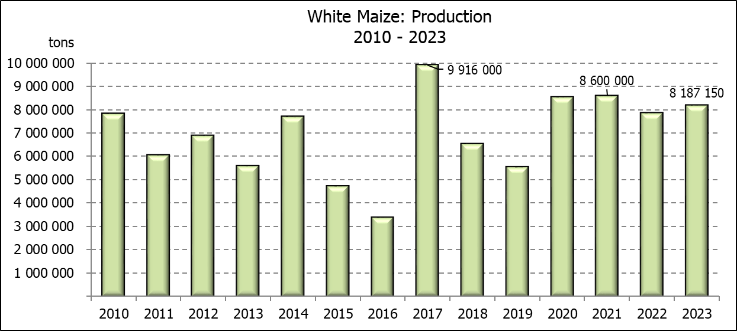
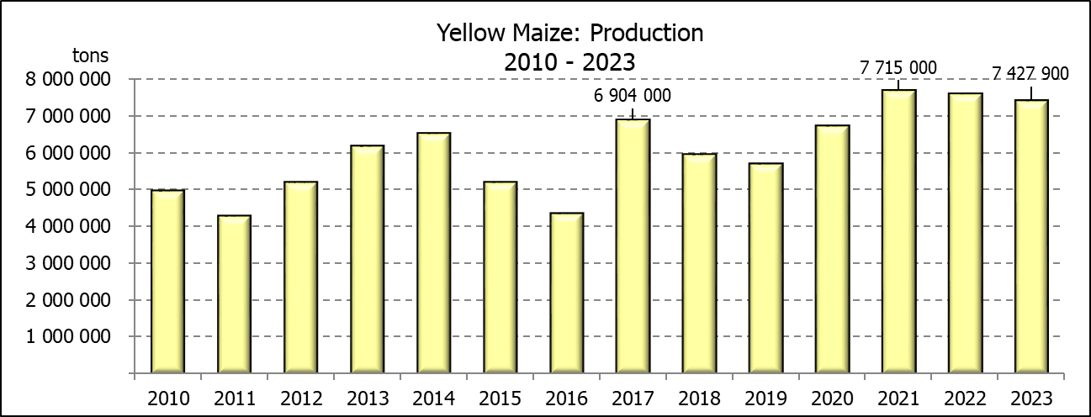
SOMERGEWASSE – HERSIENE OPPERVLAKTE- EN EERSTE PRODUKSIESKATTING: 2023
CROP/GEWAS | Area planted/  Opp beplant  2023 | 1stforecast/  1ste skatting  2023 | Area planted/  Opp beplant  2022 | Final crop/  Finale oes  2022 | Change/  Verandering/
CROP/GEWAS | Ha | Tons | Ha | Tons | %
CROP/GEWAS | (A) | (B) | (C) | (D) | (B) ÷ (D)
Commercial/Kommersieël:
White maize/Witmielies | 1 520 500 | 8 187 150 | 1 575 000 | 7 850 000 | +4,29
Yellow maize/Geelmielies | 1 062 000 | 7 427 900 | 1 048 000 | 7 620 000 | -2,52
Total Maize/Totale Mielies | 2 582 500 | 15 615 050 | 2 623 000 | 15 470 000 | +0,94
Sunflower seed/Sonneblomsaad | 555 700 | 775 260 | 670 700 | 845 550 | -8,31
Soybeans/Sojabone | 1 148 300 | 2 651 680 | 925 300 | 2 230 000 | +18,91
Groundnuts/Grondbone | 32 300 | 51 155 | 43 400 | 48 500 | +5,47
Sorghum | 34 000 | 112 330 | 37 200 | 103 140 | +8,91
Dry beans/Droëbone | 36 400 | 49 755 | 42 900 | 52 590 | -5,39
TOTAL/TOTAAL | 4 389 200 | 19 255 230 | 4 342 500 | 18 749 780 | +2,70
Note: Estimate is for calendar year, e.g. production season 2022/23 = 2023
Nota: Skatting is vir kalenderjaar, bv. produksie-seisoen 2022/23 = 2023
The Crop Estimates Committee comprises officials of the following institutions:
Department of Agriculture, Land Reform and Rural Development; Provincial Departments of Agriculture; various ARC-Institutes (Soil, Climate and Water; Small Grains Institute; and
Grain Crops Institute); BFAP and Statistics SA.

28 February / Februarie 2023
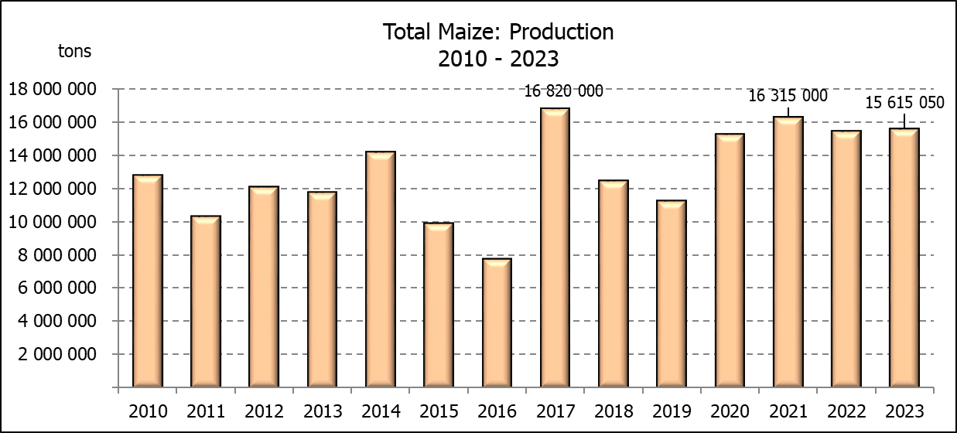

WHITE AND YELLOW MAIZE – REVISED AREA PLANTED AND FIRST PRODUCTION FORECAST: 2023
WIT- EN GEELMIELIES – HERSIENE OPPERVLAKTE EN EERSTE PRODUKSIESKATTING: 2023

Provinsie/  Province | Area planted/  Oppervlakte beplant  2023 |  |  | 1st forecast/  1ste skatting  2023 |  |  | Area planted/  Oppervlakte beplant  2022 |  |  | Final crop/  Finale oes  2022
Provinsie/  Province | White/  Wit  Ha | Yellow/  Geel  Ha | Total/  Totaal  Ha | White/  Wit  Tons | Yellow/  Geel  Tons | Total/  Totaal  Tons | White/  Wit  Ha | Yellow/  Geel  Ha | Total/  Totaal  Ha | White/  Wit  Tons | Yellow/  Geel  Tons | Total/  Totaal  Tons
Western Cape/Wes-Kaap | 250 | 3 500 | 3 750 | 2 375 | 32 900 | 35 275 | 500 | 3 500 | 4 000 | 4 750 | 32 900 | 37 650
Northern Cape/Noord-Kaap | 1 000 | 43 500 | 44 500 | 11 750 | 630 750 | 642 500 | 3 000 | 42 000 | 45 000 | 36 000 | 672 000 | 708 000
Free State/Vrystaat | 780 000 | 401 000 | 1 181 000 | 4 290 000 | 2 546 350 | 6 836 350 | 826 500 | 398 000 | 1 224 500 | 3 801 900 | 2 547 800 | 6 349 700
Eastern Cape/Oos-Kaap | 5 750 | 25 000 | 30 750 | 39 100 | 187 500 | 226 600 | 6 000 | 20 500 | 26 500 | 40 800 | 157 900 | 198 700
KwaZulu-Natal | 49 000 | 65 000 | 114 000 | 303 800 | 507 000 | 810 800 | 52 000 | 59 000 | 111 000 | 322 400 | 489 700 | 812 100
Mpumalanga | 156 500 | 352 000 | 508 500 | 978 125 | 2 464 000 | 3 442 125 | 165 000 | 350 000 | 515 000 | 1 072 500 | 2 554 000 | 3 626 500
Limpopo | 16 000 | 20 000 | 36 000 | 108 800 | 160 000 | 268 800 | 15 500 | 25 000 | 40 500 | 102 300 | 202 500 | 304 800
Gauteng | 56 000 | 52 000 | 108 000 | 355 600 | 374 400 | 730 000 | 56 500 | 56 000 | 112 500 | 361 600 | 403 200 | 764 800
North West/Noordwes | 456 000 | 100 000 | 556 000 | 2 097 600 | 525 000 | 2 622 600 | 450 000 | 94 000 | 544 000 | 2 107 750 | 560 000 | 2 667 750
Total/Totaal | 1 520 500 | 1 062 000 | 2 582 500 | 8 187 150 | 7 427 900 | 15 615 050 | 1 575 000 | 1 048 000 | 2 623 000 | 7 850 000 | 7 620 000 | 15 470 000

SUNFLOWER SEED – REVISED AREA PLANTED AND FIRST PRODUCTION FORECAST: 2023
SONNEBLOMSAAD – HERSIENE OPPERVLAKTE EN EERSTE PRODUKSIESKATTING: 2023

Province/  Provinsie | Area planted/  Opp beplant  Ha | 1st forecast/  1ste skatting  Tons | Area planted/  Opp beplant  Ha | Final crop/  Finale oes  Tons
Province/  Provinsie | 2023 | 2023 | 2022 | 2022
Western Cape/Wes-Kaap | - | - | - | -
Northern Cape/Noord-Kaap | 2 500 | 6 250 | 2 500 | 6 250
Free State/Vrystaat | 290 000 | 435 000 | 357 000 | 499 800
Eastern Cape/Oos-Kaap | 700 | 1 050 | 300 | 750
KwaZulu-Natal | 300 | 600 | - | -
Mpumalanga | 5 000 | 7 500 | 3 500 | 5 250
Limpopo | 100 000 | 105 000 | 110 000 | 77 000
Gauteng | 2 200 | 2 860 | 2 400 | 3 000
North West/Noordwes | 155 000 | 217 000 | 195 000 | 253 500
Total/Totaal | 555 700 | 775 260 | 670 700 | 845 550
SOYBEANS – REVISED AREA PLANTED AND FIRST PRODUCTION FORECAST: 2023
SOJABONE – HERSIENE OPPERVLAKTE EN EERSTE PRODUKSIESKATTING: 2023

Province/  Provinsie | Area planted/  Opp beplant  Ha | 1st forecast/  1ste skatting  Tons | Area planted/  Opp beplant  Ha | Final crop/  Finale oes  Tons
Province/  Provinsie | 2023 | 2023 | 2022 | 2022
Western Cape/Wes-Kaap | - | - | - | -
Northern Cape/Noord-Kaap | 1 000 | 3 500 | 800 | 3 000
Free State/Vrystaat | 565 000 | 1 243 000 | 415 000 | 912 500
Eastern Cape/Oos-Kaap | 4 300 | 9 030 | 3 000 | 9 000
KwaZulu-Natal | 44 000 | 154 000 | 39 000 | 150 000
Mpumalanga | 305 000 | 671 000 | 300 000 | 710 000
Limpopo | 26 000 | 85 800 | 22 500 | 76 500
Gauteng | 48 000 | 105 600 | 45 000 | 99 000
North West/Noordwes | 155 000 | 379 750 | 100 000 | 270 000
Total/Totaal | 1 148 300 | 2 651 680 | 925 300 | 2 230 000

GROUNDNUTS – REVISED AREA PLANTED AND FIRST PRODUCTION FORECAST: 2023
GRONDBONE – HERSIENE OPPERVLAKTE EN EERSTE PRODUKSIESKATTING: 2023

Province/  Provinsie | Area planted/  Opp beplant  Ha | 1st forecast/  1ste skatting  Tons | Area planted/  Opp beplant  Ha | Final crop/  Finale oes  Tons
Province/  Provinsie | 2023 | 2023 | 2022 | 2022
Western Cape/Wes-Kaap | - | - | - | -
Northern Cape/Noord-Kaap | 2 000 | 4 800 | 2 400 | 6 000
Free State/Vrystaat | 12 800 | 20 480 | 19 000 | 20 900
Eastern Cape/Oos-Kaap | - | - | - | -
KwaZulu-Natal | - | - | - | -
Mpumalanga | - | - | - | -
Limpopo | 2 500 | 6 375 | 2 000 | 4 600
Gauteng | - | - | - | -
North West/Noordwes | 15 000 | 19 500 | 20 000 | 17 000
Total/Totaal | 32 300 | 51 155 | 43 400 | 48 500

SORGHUM – REVISED AREA PLANTED AND FIRST PRODUCTION FORECAST: 2023
SORGHUM – HERSIENE OPPERVLAKTE EN EERSTE PRODUKSIESKATTING: 2023

Province/  Provinsie | Area planted/  Opp beplant  Ha | 1st forecast/  1ste skatting  Tons | Area planted/  Opp beplant  Ha | Final crop/  Finale oes  Tons
Province/  Provinsie | 2023 | 2023 | 2022 | 2022
Western Cape/Wes-Kaap | - | - | - | -
Northern Cape/Noord-Kaap | - | - | - | -
Free State/Vrystaat | 5 200 | 20 280 | 7 800 | 20 700
Eastern Cape/Oos-Kaap | - | - | - | -
KwaZulu-Natal | 100 | 400 | 200 | 740
Mpumalanga | 8 500 | 42 500 | 9 000 | 43 650
Limpopo | 15 500 | 37 200 | 15 000 | 26 250
Gauteng | 100 | 450 | 200 | 800
North West/Noordwes | 4 600 | 11 500 | 5 000 | 11 000
Total/Totaal | 34 000 | 112 330 | 37 200 | 103 140

DRY BEANS – REVISED AREA PLANTED AND FIRST PRODUCTION FORECAST: 2023
DROëBONE – HERSIENE OPPERVLAKTE EN EERSTE PRODUKSIESKATTING: 2023

Province/  Provinsie | Area planted/  Opp beplant  Ha | 1st forecast/  1ste skatting  Tons | Area planted/  Opp beplant  Ha | Final crop/  Finale oes  Tons
Province/  Provinsie | 2023 | 2023 | 2022 | 2022
Western Cape/Wes-Kaap | 100 | 180 | 100 | 150
Northern Cape/Noord-Kaap | 700 | 1 260 | 600 | 1 080
Free State/Vrystaat | 13 500 | 14 175 | 15 500 | 13 950
Eastern Cape/Oos-Kaap | 200 | 360 | 200 | 300
KwaZulu-Natal | 2 100 | 3 150 | 2 300 | 2 760
Mpumalanga | 5 000 | 7 250 | 6 000 | 6 600
Limpopo | 8 000 | 14 400 | 10 400 | 18 200
Gauteng | 800 | 880 | 800 | 800
North West/Noordwes | 6 000 | 8 100 | 7 000 | 8 750
Total/Totaal | 36 400 | 49 755 | 42 900 | 52 590

CONFIDENTIALITY ISSUES that CEC members are committed to adhere to on the day of the meeting
- Personal items such as laptops, handbags, cell phones, etc. are not allowed in the venue during the meeting
- No member is allowed to leave the meeting before 12:00 in order to prevent disclosure of the information
- The embargo time for the release of crop estimates information is 14:30
- No member is allowed to discuss crop estimates information with anyone other than a member of the Committee before the embargo time
- Only the Chairperson, or a member appointed by the Chairperson, may release the figures to the media
- Members must regard the detail of any information that was collected for and/or discussed during the meeting, as confidential
- Individual information received for crop estimate purposes is treated strictly confidential, and is not divulged for any other purposes

REVISED AREA ESTIMATE AND FIRST PRODUCTION FORECAST OF SUMMER CROPS (2023 PRODUCTION SEASON)/
HERSIENE OPPERVLAKTE- EN EERSTE PRODUKSIESKATTING VIR SOMERGEWASSE (2023 PRODUKSIE-SEISOEN)
28 FEBRUARY / FEBRUARIE 2023

Summer field crops – 2023  Commercial maize: The revised area estimate for maize is 2 582 500 ha, which is 1,54% or 40 500 ha less than the 2 623 000 ha planted for the previous season, and 1,51% or 38 500 ha more than the preliminary area estimate of 2 544 000 ha released in January 2023.  The expected commercial maize crop is 15 615 000 tons, which is 0,94% or 145 050 tons more than the 15 470 000 tons of the previous season (2022). The yield for maize is 6,05 t/ha.  The area planted figures are mainly based on information obtained from the Producer Independent Crop Estimation System (PICES), conducted by the National Crop Statistics Consortium (NCSC) for Free State, KwaZulu-Natal, Mpumalanga, Limpopo, Gauteng and North West provinces.  Please note that information from the objective yield survey by the NCSC for the Mpumalanga province will be available in April 2023; and for the Free State and North West provinces in May 2023. The current yield figures are mainly obtained from producers in the different provinces.  The area estimate for white maize is 1 520 500 ha, which represents a decrease of 3,46% or 54 500 ha compared to the 1 575 000 ha planted last season. The production forecast of white maize is 8 187 150 tons, which is 4,29% or 337 150 tons more than the 7 850 000 tons of last season. The yield for white maize is 5,38 t/ha.  In the case of yellow maize, the area estimate is 1 062 000 ha, which is 1,34% or 14 000 ha more than the 1 048 000 ha planted last season. The yellow maize production forecast is 7 427 900 tons, which is 2,52% or 192 100 tons less than the 7 620 000 tons of last season. The yield for yellow maize is 6,99 t/ha.  Other summer crops:  Sunflower seed: The revised area estimate for sunflower seed is 555 700 ha, which is 17,15% or 115 000 ha less than the 670 700 ha planted the previous season. The production forecast for sunflower seed is 775 260 tons, which is 8,31% or 70 290 tons less than the 845 550 tons of the previous season. The expected yield is 1,40 t/ha.  Other crops: It is estimated that 1 148 300 ha have been planted to soybeans, which represents an increase of 24,10% or 223 000 ha compared to the 925 300 ha planted last season. The production forecast is 2 651 680 tons, which is 18,91% or 421 680 tons more than the 2 230 000 tons of the previous season. The expected yield is 2,31 t/ha.  For groundnuts, the area estimate is 32 300 ha, which is 25,58% or 11 100 ha less than the 43 400 ha planted for the previous season. The expected crop is 51 155 tons – which is 5,47% or 2 655 tons more than the 48 500 tons of last season. The expected yield is 1,58 t/ha.  The area estimate for sorghum decreased by 8,60% or 3 200 ha, from 37 200 ha to 34 000 ha against the previous season. The production forecast for sorghum is 112 330 tons, which is 8,91% or 9 190 tons more than the 103 140 tons of the previous season. The expected yield is 3,30 t/ha.  For dry beans, the area estimate is 36 400 ha, which is 15,15% or 6 500 ha less the 42 900 ha planted for the previous season. The production forecast is 49 755 tons, which is 5,39% or 2 835 tons less than the 52 590 tons of the previous season. The expected yield is 1,37 t/ha.  Please note that the second production forecast for summer field crops for 2023 will be released on 28 March 2023. |  | Somergewasse – 2023  Kommersiële mielies: Die hersiene skatting van die oppervlakte onder mielies beloop 2 582 500 ha, wat 1,54% of 40 500 ha minder is as die 2 623 000 ha wat verlede seisoen aangeplant is, en 1,51% of 38 500 ha meer as die voorlopige oppervlakteskatting van 2 544 000 ha soos vrygestel in Januarie 2023.  Die verwagte kommersiële mielie-oes is 15 615 000 ton, wat 0,94% of 145 050 ton meer is as die 15 470 000 ton van die vorige seisoen (2022). Die opbrengs van mielies is 6,05 t/ha.  Die oppervlakte beplant syfers is hoofsaaklik verkry vanaf die Produsente Onafhanklike Oesskattingstelsel (PICES), soos deur die Nasionale Oesskattingskonsortium gerapporteer vir Vrystaat, KwaZulu-Natal, Mpumalanga, Limpopo, Gauteng en Noordwes provinsies.  Neem kennis dat inligting van die objektiewe opbrengs-opname van die Konsortium vir die Mpumalanga provinsie, in April 2023 gerapporteer word en vir die Vrystaat en Noordwes provinsies in Mei 2023. Die huidige opbrengs syfers is hoofsaaklik verkry vanaf produsente in die verskillende provinsies.  Die oppervlak onder witmielies is 1 520 500 ha, wat ‘n afname van 3,46% of 54 500 ha verteenwoordig vergeleke met die 1 575 000 ha die vorige seisoen. Die produksieskatting van witmielies is 8 187 150 ton, wat 4,29% of 337 150 ton meer is as die 7 850 000 ton van die vorige seisoen. Die opbrengs van witmielies is 5,38 t/ha.  In die geval van geelmielies is die oppervlakteskatting 1 062 000 ha, wat 1,34% of 14 000 ha meer is as die 1 048 000 ha geplant die vorige seisoen. Die produksieskatting van geelmielies is 7 427 900 ton, wat 2,52% of 192 100 ton minder is as die 7 620 000 ton van die vorige seisoen. Die opbrengs van geelmielies is 6,99 t/ha.  Ander somergewasse:  Sonneblomsaad: Die hersiene oppervlakteskatting vir sonneblomsaad is 555 700 ha, wat 17,15% of 115 000 ha minder is as die 670 700 ha aangeplant die vorige seisoen. Die produksieskatting vir sonneblomsaad is 775 260 ton, wat 8,31% of 70 290 ton minder is as die 845 550 ton van die vorige seisoen. Die verwagte opbrengs is 1,40 t/ha.  Ander gewasse: Die geskatte oppervlakte beplant met sojabone is 1 148 300 ha, wat ’n toename van 24,10% of 223 000 ha verteenwoordig vergeleke met die 925 300 ha geplant die vorige seisoen. Die produksieskatting is 2 651 680 ton, wat 18,91% of 421 680ton meer is as die 2 230 000 ton van die vorige seisoen. Die verwagte opbrengs is 2,31 t/ha.  Vir grondbone is die oppervlakteskatting 32 300 ha, wat 25,58% of 11 100 ha minder is as die 43 400 ha geplant vir die vorige seisoen. Die verwagte grondbone-oes is 51 155 ton – 5,47% of 2 655 ton meer as die 48 500 ton van die vorige seisoen. Die verwagte opbrengs is 1,58 t/ha.  Die oppervlakteskatting vir sorghum het afgeneem met 8,60% of 3 200 ha, van 37 200 ha tot 34 000 ha teenoor die vorige seisoen. Die produksieskatting van sorghum is 112 330 ton – 8,91% of 9 190 ton meer as die 103 140 ton van die vorige seisoen. Die verwagte opbrengs is 3,30 t/ha.  Vir droëbone is die geskatte oppervlakte beplant 36 400 ha, wat 15,15% of 6 500 ha minder is as die 42 900 ha geplant vir die vorige seisoen. Die produksieskatting is 49 755 ton, wat 5,39% of 2 835 ton minder is as die 52 590 ton van die vorige seisoen. Die verwagte opbrengs is 1,37 t/ha.  Neem asseblief kennis dat die tweede produksieskatting vir somergewasse vir 2023, op 28 Maart 2023 vrygestel sal word.
The area estimate and final production estimate for winter cereals for the 2022 is hereby released. /
Hiermee word die oppervlakte- en finale produksieskatting vir wintergewasse vir 2022 vrygestel.

WINTER CEREALS – AREA PLANTED AND FINAL PRODUCTION ESTIMATE: 2022 PRODUCTION SEASON
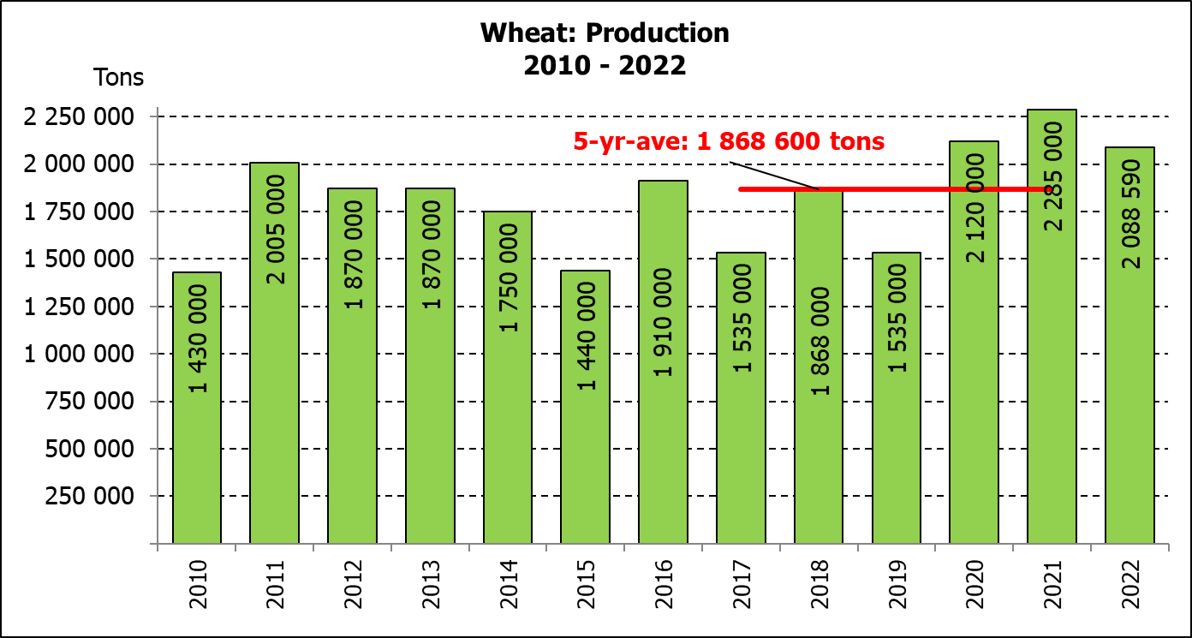
WINTERGEWASSE - OPPERVLAKTE- EN FINALE PRODUKSIESKATTING: 2022 PRODUKSIE-SEISOEN
CROP/GEWAS | Area planted/  Opp beplant  2022 | Final estimate/  Finale skatting  2022 | 6th forecast/  6de skatting  2022 | Area planted/  Opp beplant  2021 | Final crop/  Finale oes  2021 | Change/  Verandering
CROP/GEWAS | Ha | Tons | Tons | Ha | Tons | %
CROP/GEWAS | (A) | (B) | (C) | (D) | (E) | (B) ÷ (C)
Commercial/Kommersieel:
Wheat/Koring | 566 800 | 2 088 590 | 2 176 540 | 523 500 | 2 285 000 | -4,04
Malting barley/Moutgars | 101 000 | 308 675 | 337 650 | 94 730 | 334 000 | -8,58
Canola/Kanola | 123 510 | 210 530 | 210 530 | 100 000 | 198 100 | -
Cereal oats/Hawermout | 27 000 | 29 900 | 33 800 | 36 250 | 59 000 | -11,54
Sweet lupines/Soetlupine | 21 000 | 15 750 | 15 750 | 22 000 | 28 600 | -
* Note: Estimate is for calendar year, e.g. production season 2022/23 = 2022
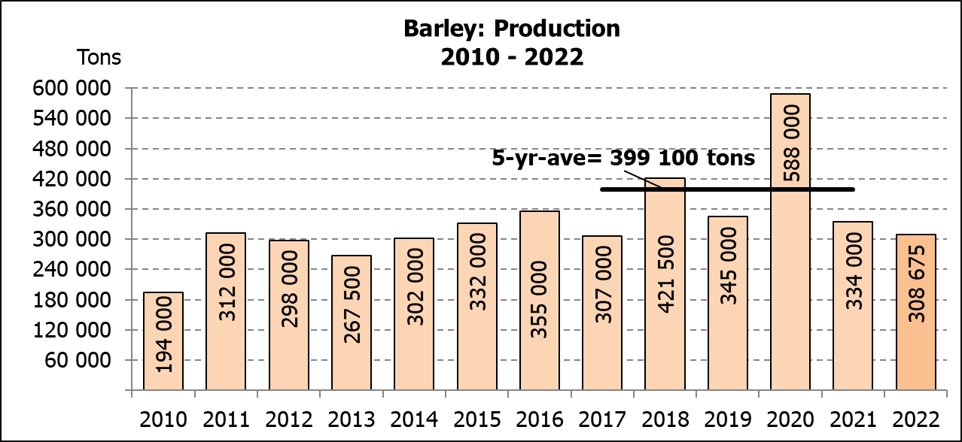
* Nota: Skatting is vir kalenderjaar, bv. produksie-seisoen 2022/23 = 2022

WHEAT – AREA PLANTED AND FINAL PRODUCTION ESTIMATE: 2022
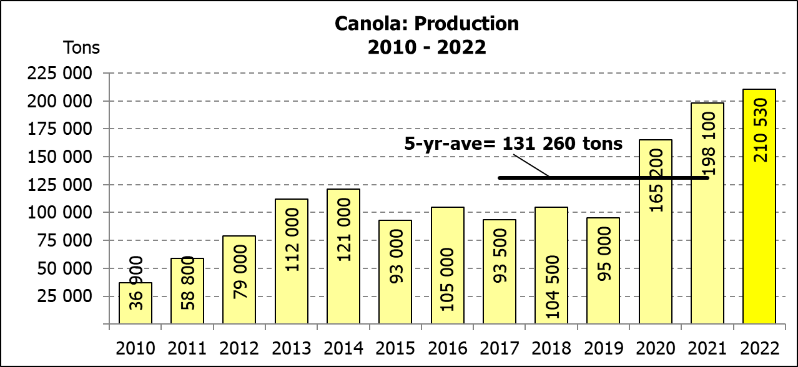
KORING – OPPERVLAKTE- EN FINALE PRODUKSIESKATTING: 2022
Province/  Provinsie | Area planted/  Opp beplant  Ha | Final estimate/  Finale skatting  Tons | Area planted/  Opp beplant  Ha | Final crop/  Finale oes  Tons
Province/  Provinsie | 2022 | 2022 | 2021 | 2021
Western Cape/Wes-Kaap | 360 000 | 918 000 | 360 000 | 1 260 000
Northern Cape/Noord-Kaap | 47 000 | 324 300 | 35 500 | 275 125
Free State/Vrystaat | 96 000 | 432 000 | 70 000 | 360 000
Eastern Cape/Oos-Kaap | 6 000 | 40 200 | 3 800 | 25 080
KwaZulu-Natal | 9 200 | 60 720 | 8 500 | 56 950
Mpumalanga | 4 000 | 27 600 | 4 100 | 28 300
Limpopo | 29 000 | 185 600 | 26 500 | 176 220
Gauteng | 1 100 | 7 370 | 1 100 | 7 425
North West/Noordwes | 14 500 | 92 800 | 14 000 | 95 900
Total/Totaal | 566 800 | 2 088 590 | 523 500 | 2 285 000

AREA ESTIMATE AND FINAL PRODUCTION ESTIMATE OF WINTER CROPS (2022) /
OPPERVLAKTE- EN FINALE PRODUKSIESKATTING VAN WINTERGEWASSE (2022)
28 FEBRUARY/FEBRUARIE 2023
Winter cereal crops - 2022 production season  Wheat: The expected production of wheat is 2,089 mill. tons, which is 4,04% or 87 950 tons less than the previous forecast of 2,176 mill. tons, whilst the expected yield is 3,68 t/ha.  The expected production in the Western Cape is 918 000 tons (44%), in the Free State 432 000 tons (21%) and in the Northern Cape 324 300 tons (16%).  The area estimate for wheat is 566 800 ha. An estimated 360 000 ha or 64% is planted in the Western Cape, 96 000 ha or 17% in the Free State and 47 000 ha or 8% in the Northern Cape.  Other crops: The production forecast for barley decreased by 8,58% or 28 975 tons from 337 650 tons to 308 675 tons. The area planted is estimated at 101 000 ha, while the expected yield is 3,06 t/ha.  The expected canola crop remained unchanged at 210 530 tons. The area estimate for canola is 123 510 ha, with an expected yield of 1,70 t/ha.  The expected crop for oats for the 2022 season is 29 900 tons and the area planted is 27 000 ha. The expected yield is 1,11 t/ha.  In the case of sweet lupines, the production forecast remained unchanged at 15 750 tons. The area estimate of sweet lupines is 21 000 ha, with an expected yield of 0,75 t/ha.  Please note that the intentions to plant winter cereals for 2023 will be released on 26 April 2023. |  | Wintergewasse - 2022 produksie-seisoen  Koring: Die verwagte produksie vir koring is 2,089 milj. ton, wat 4,04% of 87 950 ton minder is as die vorige skatting van 2,176 milj. ton, terwyl die verwagte opbrengs 3,68 t/ha is.  Die verwagte produksie in die Wes-Kaap is 918 000 ton (44%), in die Vrystaat 432 000 ton (21%) en in die Noord-Kaap 324 300 ton (16%).  Die oppervlakteskatting vir koring is 566 800 ha. Die beraamde oppervlakte geplant in die Wes-Kaap is 360 000 ha of 64%, die Vrystaat is 96 000 ha of 17% en 47 000 ha of 8% is in die Noord-Kaap.  Ander gewasse: Die produksieskatting vir gars is verminder met 8,58% of 28 975 ton van 337 650 ton na 308 675 ton. Die oppervlakte beplant word beraam op 101 000 ha, terwyl die verwagte opbrengs 3,06 t/ha beloop.  Die verwagte kanola-oes is onveranderd gelaat op 210 530 ton. Die oppervlakteskatting vir kanola is 123 510 ha, met ŉ verwagte opbrengs van 1,70 t/ha.  Die verwagte oes vir hawer vir die 2022-seisoen is 29 900 ton en die oppervlakteskatting is 27 000 ton. Die verwagte opbrengs is 1,11 t/ha.  In die geval van soetlupine is die produksieskatting onveranderd gelaat op 15 750 ton. Die oppervlakte beplant met soetlupine is 21 000 ha, met ‘n verwagte opbrengs van 0,75 t/ha.  Neem asseblief kennis dat die voornemens om wintergewasse te plant vir 2023 op 26 April 2023 vrygestel sal word.
Information is available on the internet at http://www.daff.gov.za/links/crop estimates or http://www.sagis.org.za, as from 14:30 on the date of the relevant meeting of the Crop Estimates Committee. |  | Inligting is beskikbaar op die internet by http://www.daff.gov.za/links/crop estimates of by http://www.sagis.org.za, vanaf 14:30 op die dag van die toepaslike vergadering van die Oesskattingskomitee.
CONFIDENTIALITY ISSUES that CEC members are committed to adhere to on the day of the meeting
- Personal items such as laptops, handbags, cell phones, etc. are not allowed in the venue during the meeting.
- No member is allowed to leave the meeting before 12:00 in order to prevent disclosure of the information. The embargo time for the release of crop estimates information is 14:30.
- No member is allowed to discuss crop estimates information with anyone other than a member of the Committee before the embargo time. Only the Chairperson, or a member appointed by the Chairperson, may release the figures to the media.
- Members must regard the detail of any information that was collected for and/or discussed during the meeting, as confidential. Individual information received for crop estimate purposes is treated strictly confidential, and is not divulged for any other purposes.

