 | crop estimates committee
 | oesskattingskomitee
From/Van: Mr Baldwin Netshifhefhe  Tel: 012 319 8043  Fax/Faks: 012 319 8031  E-mail/E-pos: BaldwinN@dalrrd.gov.za  Web page/Webblad: www.dalrrd.gov.za/statistics and economic reports or  www.sagis.org.za/CEC: Crop Estimates EMBARGO: 14:30 |  |  | 

The revised area planted estimate and first production forecast for summer crops for 2021 is hereby released.
Hiermee word die hersiene oppervlakte- en eerste produksieskatting vir somergewasse vir 2021 vrygestel.

SUMMER CROPS – REVISED AREA PLANTED AND FIRST PRODUCTION FORECAST: 2021
SOMERGEWASSE – HERSIENE OPPERVLAKTE- EN EERSTE PRODUKSIESKATTING: 2021
CROP/GEWAS | Area planted/  Opp beplant  2021 | 1stforecast/  1ste skatting  2021 | Area planted/  Opp beplant  2020 | Final crop/  Finale oes  2020 | Change/  Verandering/
CROP/GEWAS | Ha | Tons | Ha | Tons | %
CROP/GEWAS | (A) | (B) | (C) | (D) | (B) ÷ (D)
Commercial/Kommersieël:
White maize/Witmielies | 1 682 400 | 8 799 360 | 1 616 300 | 8 547 500 | +2,95
Yellow maize/Geelmielies | 1 068 500 | 7 049 600 | 994 500 | 6 752 500 | +4,40
Total Maize/Totale Mielies | 2 750 900 | 15 848 960 | 2 610 800 | 15 300 000 | +3,59
Sunflower seed/Sonneblomsaad | 474 800 | 712 940 | 500 300 | 788 500 | -9,58
Soybeans/Sojabone | 826 500 | 1 620 900 | 705 000 | 1 245 500 | +30,14
Groundnuts/Grondbone | 40 050 | 58 425 | 37 500 | 50 080 | +16,66
Sorghum | 46 200 | 170 590 | 42 500 | 158 000 | +7,97
Dry beans/Droëbone | 51 990 | 65 467 | 50 150 | 64 800 | +1,03
TOTAL/TOTAAL | 4 190 440 | 18 477 282 | 3 946 250 | 17 606 880 | +4,94
Note: Estimate is for calendar year, e.g. production season 2020/21 = 2021
Nota: Skatting is vir kalenderjaar, bv. produksie-seisoen 2020/210 = 2021

25 February / Februarie 2021

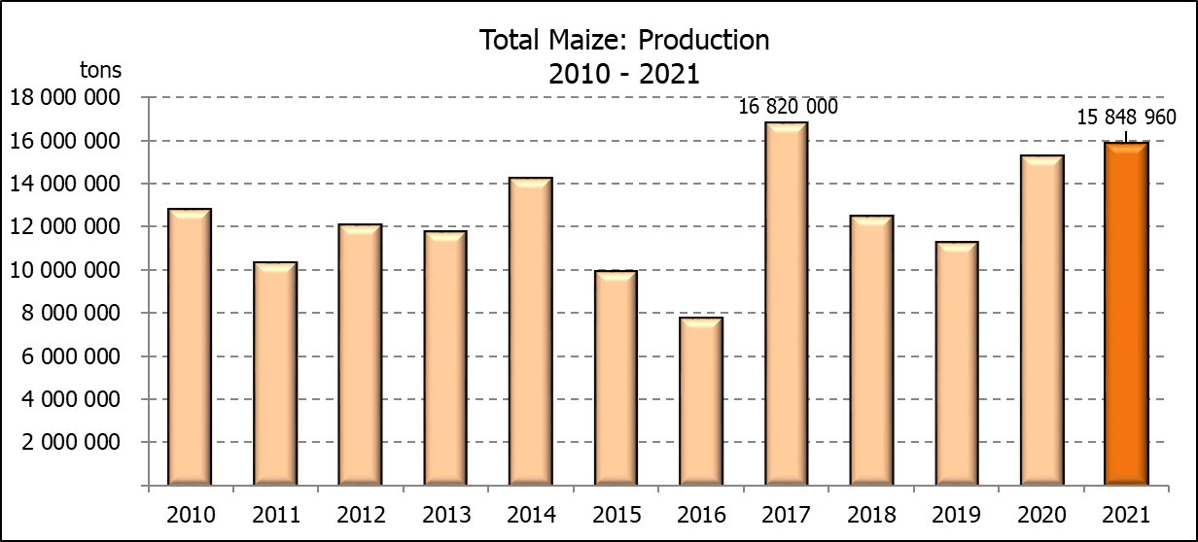

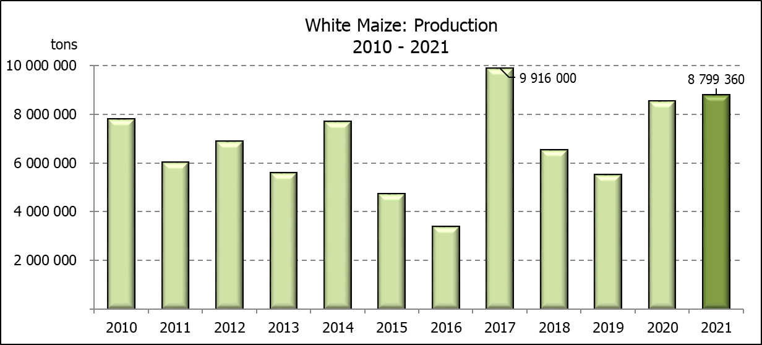

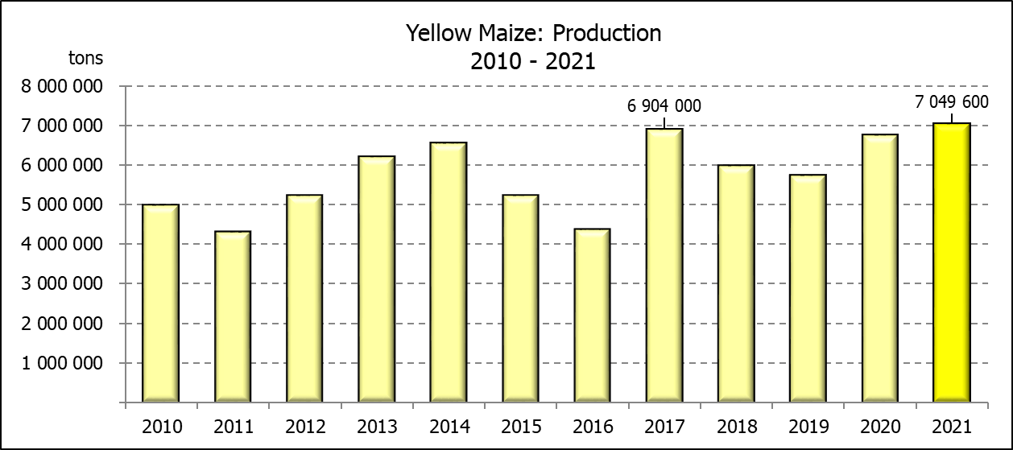

WHITE AND YELLOW MAIZE – REVISED AREA PLANTED AND FIRST PRODUCTION FORECAST: 2021
WIT- EN GEELMIELIES – HERSIENE OPPERVLAKTE EN EERSTE PRODUKSIESKATTING: 2021

Provinsie/  Province | Area planted/  Oppervlakte beplant  2021 |  |  | 1st forecast/  1ste skatting  2021 |  |  | Area planted/  Oppervlakte beplant  2020 |  |  | Final crop/  Finale oes  2020
Provinsie/  Province | White/  Wit  Ha | Yellow/  Geel  Ha | Total/  Totaal  Ha | White/  Wit  Tons | Yellow/  Geel  Tons | Total/  Totaal  Tons | White/  Wit  Ha | Yellow/  Geel  Ha | Total/  Totaal  Ha | White/  Wit  Tons | Yellow/  Geel  Tons | Total/  Totaal  Tons
Western Cape/Wes-Kaap | 500 | 3 500 | 4 000 | 4 500 | 31 500 | 36 000 | 400 | 3 400 | 3 800 | 3 600 | 30 600 | 34 200
Northern Cape/Noord-Kaap | 3 400 | 41 000 | 44 400 | 40 460 | 615 000 | 655 460 | 3 400 | 43 100 | 46 500 | 40 300 | 633 900 | 674 200
Free State/Vrystaat | 905 000 | 420 000 | 1 325 000 | 4 706 000 | 2 310 000 | 7 016 000 | 855 000 | 365 000 | 1 220 000 | 4 700 000 | 2 209 000 | 6 909 000
Eastern Cape/Oos-Kaap | 6 000 | 18 000 | 24 000 | 39 000 | 129 600 | 168 600 | 5 500 | 17 000 | 22 500 | 35 200 | 119 000 | 154 200
KwaZulu-Natal | 50 000 | 55 000 | 105 000 | 310 000 | 412 500 | 722 500 | 47 000 | 55 000 | 102 000 | 298 400 | 434 500 | 732 900
Mpumalanga | 165 000 | 360 000 | 525 000 | 1 023 000 | 2 520 000 | 3 543 000 | 160 000 | 353 000 | 513 000 | 872 000 | 2 347 500 | 3 219 500
Limpopo | 16 500 | 21 000 | 37 500 | 112 200 | 157 500 | 269 700 | 15 000 | 18 000 | 33 000 | 105 000 | 126 000 | 231 000
Gauteng | 58 000 | 55 000 | 113 000 | 365 400 | 379 500 | 744 900 | 55 000 | 50 000 | 105 000 | 297 000 | 330 000 | 627 000
North West/Noordwes | 478 000 | 95 000 | 573 000 | 2 198 800 | 494 000 | 2 692 800 | 475 000 | 90 000 | 565 000 | 2 196 000 | 522 000 | 2 718 000
Total/Totaal | 1 682 400 | 1 068 500 | 2 750 900 | 8 799 360 | 7 049 600 | 15 848 960 | 1 616 300 | 994 500 | 2 610 800 | 8 547 500 | 6 752 500 | 15 300 000

SUNFLOWER SEED – REVISED AREA PLANTED AND FIRST PRODUCTION FORECAST: 2021
SONNEBLOMSAAD – HERSIENE OPPERVLAKTE EN EERSTE PRODUKSIESKATTING: 2021

Province/  Provinsie | Area planted/  Opp beplant  Ha | 1st forecast/  1ste skatting  Tons | Area planted/  Opp beplant  Ha | Final crop/  Finale oes  Tons
Province/  Provinsie | 2021 | 2021 | 2020 | 2020
Western Cape/Wes-Kaap | - | - | - | -
Northern Cape/Noord-Kaap | 1 100 | 1 320 | 1 200 | 1 430
Free State/Vrystaat | 235 000 | 376 000 | 260 000 | 444 600
Eastern Cape/Oos-Kaap | 300 | 450 | 300 | 750
KwaZulu-Natal | - | - | - | -
Mpumalanga | 3 500 | 5 250 | 2 800 | 3 920
Limpopo | 73 500 | 80 850 | 65 000 | 65 000
Gauteng | 4 400 | 5 720 | 4 000 | 5 600
North West/Noordwes | 157 000 | 243 350 | 167 000 | 267 200
Total/Totaal | 474 800 | 712 940 | 500 300 | 788 500
SOYBEANS – REVISED AREA PLANTED AND FIRST PRODUCTION FORECAST: 2021
SOJABONE – HERSIENE OPPERVLAKTE EN EERSTE PRODUKSIESKATTING: 2021

Province/  Provinsie | Area planted/  Opp beplant  Ha | 1st forecast/  1ste skatting  Tons | Area planted/  Opp beplant  Ha | Final crop/  Finale oes  Tons
Province/  Provinsie | 2021 | 2021 | 2020 | 2020
Western Cape/Wes-Kaap | - | - | - | -
Northern Cape/Noord-Kaap | 1 000 | 3 500 | 2 000 | 7 000
Free State/Vrystaat | 365 000 | 620 500 | 315 000 | 519 750
Eastern Cape/Oos-Kaap | 2 500 | 6 250 | 1 500 | 3 000
KwaZulu-Natal | 36 000 | 111 600 | 35 000 | 101 500
Mpumalanga | 290 000 | 580 000 | 260 000 | 416 000
Limpopo | 20 500 | 67 650 | 15 500 | 48 050
Gauteng | 42 000 | 92 400 | 36 000 | 70 200
North West/Noordwes | 69 500 | 139 000 | 40 000 | 80 000
Total/Totaal | 826 000 | 1 620 900 | 705 000 | 1 245 500

GROUNDNUTS – REVISED AREA PLANTED AND FIRST PRODUCTION FORECAST: 2021
GRONDBONE – HERSIENE OPPERVLAKTE EN EERSTE PRODUKSIESKATTING: 2021

Province/  Provinsie | Area planted/  Opp beplant  Ha | 1st forecast/  1ste skatting  Tons | Area planted/  Opp beplant  Ha | Final crop/  Finale oes  Tons
Province/  Provinsie | 2021 | 2021 | 2020 | 2020
Western Cape/Wes-Kaap | - | - | - | -
Northern Cape/Noord-Kaap | 1 500 | 3 300 | 1 200 | 2 580
Free State/Vrystaat | 17 500 | 25 375 | 11 000 | 15 400
Eastern Cape/Oos-Kaap | - | - | - | -
KwaZulu-Natal | 50 | 50 | - | -
Mpumalanga | - | - | - | -
Limpopo | 3 000 | 6 300 | 2 900 | 5 220
Gauteng | - | - | - | -
North West/Noordwes | 18 000 | 23 400 | 22 400 | 26 880
Total/Totaal | 40 050 | 58 425 | 37 500 | 50 080

SORGHUM – REVISED AREA PLANTED AND FIRST PRODUCTION FORECAST: 2021
SORGHUM – HERSIENE OPPERVLAKTE EN EERSTE PRODUKSIESKATTING: 2021

Province/  Provinsie | Area planted/  Opp beplant  Ha | 1st forecast/  1ste skatting  Tons | Area planted/  Opp beplant  Ha | Final crop/  Finale oes  Tons
Province/  Provinsie | 2021 | 2021 | 2020 | 2020
Western Cape/Wes-Kaap | - | - | - | -
Northern Cape/Noord-Kaap | - | - | - | -
Free State/Vrystaat | 8 000 | 29 600 | 8 000 | 35 200
Eastern Cape/Oos-Kaap |  | - | - | -
KwaZulu-Natal | 500 | 2 000 | 1 200 | 4 200
Mpumalanga | 9 400 | 51 700 | 8 500 | 46 340
Limpopo | 16 500 | 49 500 | 16 000 | 41 950
Gauteng | 300 | 990 | 300 | 960
North West/Noordwes | 11 500 | 36 800 | 8 500 | 29 350
Total/Totaal | 46 200 | 170 590 | 42 500 | 158 000

DRY BEANS – REVISED AREA PLANTED AND FIRST PRODUCTION FORECAST: 2021
DROëBONE – HERSIENE OPPERVLAKTE EN EERSTE PRODUKSIESKATTING: 2021

Province/  Provinsie | Area planted/  Opp beplant  Ha | 1st forecast/  1ste skatting  Tons | Area planted/  Opp beplant  Ha | Final crop/  Finale oes  Tons
Province/  Provinsie | 2021 | 2021 | 2020 | 2020
Western Cape/Wes-Kaap | 100 | 150 | 100 | 150
Northern Cape/Noord-Kaap | 350 | 700 | 350 | 700
Free State/Vrystaat | 22 000 | 17 600 | 24 000 | 30 000
Eastern Cape/Oos-Kaap | 200 | 300 | 200 | 300
KwaZulu-Natal | 3 000 | 3 600 | 2 900 | 3 480
Mpumalanga | 6 500 | 10 075 | 6 600 | 8 250
Limpopo | 11 500 | 20 700 | 8 400 | 13 440
Gauteng | 840 | 1 092 | 600 | 780
North West/Noordwes | 7 500 | 11 250 | 7 000 | 7 700
Total/Totaal | 51 990 | 65 467 | 50 150 | 64 800

CONFIDENTIALITY ISSUES that CEC members are committed to adhere to on the day of the meeting
- Personal items such as laptops, handbags, cell phones, etc. are not allowed in the venue during the meeting
- No member is allowed to leave the meeting before 12:00 in order to prevent disclosure of the information
- The embargo time for the release of crop estimates information is 14:30
- No member is allowed to discuss crop estimates information with anyone other than a member of the Committee before the embargo time
- Only the Chairperson, or a member appointed by the Chairperson, may release the figures to the media
- Members must regard the detail of any information that was collected for and/or discussed during the meeting, as confidential
- Individual information received for crop estimate purposes is treated strictly confidential, and is not divulged for any other purposes

REVISED AREA ESTIMATE AND FIRST PRODUCTION FORECAST OF SUMMER CROPS (2021 PRODUCTION SEASON)/
HERSIENE OPPERVLAKTE- EN EERSTE PRODUKSIESKATTING VIR SOMERGEWASSE (2021 PRODUKSIE-SEISOEN)
25 FEBRUARY / FEBRUARIE 2021

Summer field crops – 2021  Commercial maize: The revised area estimate for maize is 2 750 900 ha, which is 5,37% or 140 100 ha more than the 2 610 800 ha planted for the previous season, and 0,92% or 25 600 ha less than the preliminary area estimate of 2 776 500 ha released in January 2021.  The expected commercial maize crop is 15 848 960 tons, which is 3,59% or 548 960 tons more than the 15 300 000 tons of the previous season (2020). The yield for maize is 5,76 t/ha. This is the second largest expected maize crop ever produced in the RSA.  The area planted figures are mainly based on information obtained from the Producer Independent Crop Estimation System (PICES), conducted by the National Crop Statistics Consortium (NCSC) for Free State, KwaZulu-Natal, Mpumalanga, Limpopo, Gauteng and North West provinces.  Please note that information from the objective yield survey by the NCSC for the Mpumalanga province will be available in April 2021; and for the Free State and North West provinces in May 2021. The current yield figures are mainly obtained from producers in the different provinces.  The area estimate for white maize is 1 682 400 ha, which represents an increase of 4,09% or 66 100 ha compared to the 1 616 300 ha planted last season. The production forecast of white maize is 8 799 360 tons, which is 2,95% or 251 860 tons more than the 8 547 500 tons of last season. The yield for white maize is 5,23 t/ha.  In the case of yellow maize, the area estimate is 1 068 500 ha, which is 7,44% or 74 000 ha more than the 994 500 ha planted last season. The yellow maize production forecast is 7 049 600 tons, which is 4,40% or 297 100 tons more than the 6 752 500 tons of last season. The yield for yellow maize is 6,60 t/ha.  Other summer crops:  Sunflower seed: The revised area estimate for sunflower seed is 474 800 ha, which is 5,10% or 25 500 ha less than the 500 300 ha planted the previous season. The production forecast for sunflower seed is 712 940 tons, which is 9,58% or 75 560 tons less than the 788 500 tons of the previous season. The expected yield is 1,50 t/ha.  Other crops: It is estimated that 826 500 ha have been planted to soybeans, which represents an increase of 17,23% or 121 500 ha compared to the 705 000 ha planted last season. The production forecast is 1 620 900 tons, which is 30,14% or 375 400 tons more than the 1 245 500 tons of the previous season. The expected yield is 1,96 t/ha. This is the largest expected soybeans crop ever produced in the RSA.  For groundnuts, the area estimate is 40 050 ha, which is 6,80% or 2 550 ha more than the 37 500 ha planted for the previous season. The expected crop is 58 425 tons – which is 16,66% or 8 345 tons more than the 50 080 tons of last season. The expected yield is 1,46 t/ha.  The area estimate for sorghum increased by 8,71% or 3 700 ha, from 42 500 ha to 46 200 ha against the previous season. The production forecast for sorghum is 170 590 tons, which is 7,97% or 12 590 tons more than the 158 000 tons of the previous season. The expected yield is 3,69 t/ha.  For dry beans, the area estimate is 51 990 ha, which is 3,67% or 1 840 ha more the 50 150 ha planted for the previous season. The production forecast is 65 467 tons, which is 1,03% or 667 tons more than the 64 800 tons of the previous season. The expected yield is 1,26 t/ha.  Please note that the second production forecast for summer field crops for 2021 will be released on 25 March 2021. |  | Somergewasse – 2021  Kommersiële mielies: Die hersiene skatting van die oppervlakte onder mielies beloop 2 750 900 ha, wat 5,37% of 140 100 ha meer is as die 2 610 800 ha wat verlede seisoen aangeplant is, en 0,92% of 25 600 ha minder as die voorlopige oppervlakteskatting van 2 776 500 ha soos vrygestel in Januarie 2021.  Die verwagte kommersiële mielie-oes is 15 848 960 ton, wat 3,59% of 548 960 ton meer is as die 15 300 000 ton van die vorige seisoen (2020). Die opbrengs van mielies is 5,76 t/ha. Dit is die tweede grootste verwagte mielie-oes wat nog ooit in die RSA geproduseer is.  Die oppervlakte beplant syfers is hoofsaaklik verkry vanaf die Produsente Onafhanklike Oesskattingstelsel (PICES), soos deur die Nasionale Oesskattingskonsortium gerapporteer vir Vrystaat, KwaZulu-Natal, Mpumalanga, Limpopo, Gauteng en Noordwes provinsies.  Neem kennis dat inligting van die objektiewe opbrengs-opname van die Konsortium vir die Mpumalanga provinsie, in April 2021 gerapporteer word en vir die Vrystaat en Noordwes provinsies in Mei 2021. Die huidige opbrengs syfers is hoofsaaklik verkry vanaf produsente in die verskillende provinsies.  Die oppervlak onder witmielies is 1 682 400 ha, wat ’n toename van 4,09% of 66 100 ha verteenwoordig vergeleke met die 1 616 300 ha die vorige seisoen. Die produksieskatting van witmielies is 8 799 360 ton, wat 2,95% of 251 860 ton meer is as die 8 547 500 ton van die vorige seisoen. Die opbrengs van witmielies is 5,23 t/ha.  In die geval van geelmielies is die oppervlakteskatting 1 068 500 ha, wat 7,44% of 74 000 ha meer is as die 994 500 ha geplant die vorige seisoen. Die produksieskatting van geelmielies is 7 049 600 ton, wat 4,40% of 297 100 ton meer is as die 6 752 500 ton van die vorige seisoen. Die opbrengs van geelmielies is 6,60 t/ha.  Ander somergewasse:  Sonneblomsaad: Die hersiene oppervlakteskatting vir sonneblomsaad is 474 800 ha, wat 5,10% of 25 500 ha minder is as die 500 300 ha aangeplant die vorige seisoen. Die produksieskatting vir sonneblomsaad is 712 940 ton, wat 9,58% of 75 560 ton minder is as die 788 500 ton van die vorige seisoen. Die verwagte opbrengs is 1,50 t/ha.  Ander gewasse: Die geskatte oppervlakte beplant met sojabone is 826 500 ha, wat ’n toename van 17,23% of 121 500 ha verteenwoordig vergeleke met die 705 000 ha geplant die vorige seisoen. Die produksieskatting is 1 620 900 ton, wat 30,14% of 375 400 ton meer is as die 1 245 500 ton van die vorige seisoen. Die verwagte opbrengs is 1,96 t/ha. Dit is die grootste verwagte sojaboon-oes wat ooit in die RSA geproduseer is.  Vir grondbone is die oppervlakteskatting 40 050 ha, wat 6,80% of 2 550 ha meer is as die 37 500 ha geplant vir die vorige seisoen. Die verwagte grondbone-oes is 58 425 ton – 16,66% of 8 345 ton meer as die 50 080 ton van die vorige seisoen. Die verwagte opbrengs is 1,46 t/ha.  Die oppervlakteskatting vir sorghum het toegeneem met 8,71% of 3 700 ha, van 42 500 ha tot 46 200 ha teenoor die vorige seisoen. Die produksieskatting van sorghum is 170 590 ton – 7,97% of 12 590 ton meer as die 158 000 ton van die vorige seisoen. Die verwagte opbrengs is 3,69 t/ha.  Vir droëbone is die geskatte oppervlakte beplant 51 990 ha, wat 3,67% of 1 840 ha meer is as die 50 150 ha geplant vir die vorige seisoen. Die produksieskatting is 65 467 ton, wat 1,03% of 667 ton meer is as die 64 800 ton van die vorige seisoen. Die verwagte opbrengs is 1,26 t/ha.  Neem asseblief kennis dat die tweede produksieskatting vir somergewasse vir 2021, op 25 Maart 2021 vrygestel sal word.
The area estimate and final production estimate for winter cereals for the 2020 is hereby released. /
Hiermee word die oppervlakteskatting en finale produksieskatting vir wintergewasse vir 2020 vrygestel.
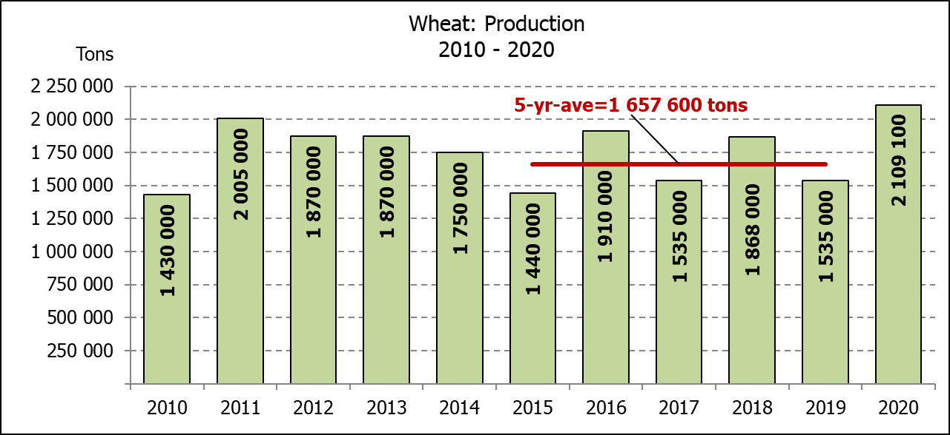
WINTER CEREALS – AREA PLANTED ESTIMATE AND FINAL PRODUCTION ESTIMATE: 2020
WINTERGEWASSE – OPPERVLAKTE- EN FINALE PRODUKSIESKATTING: 2020
CROP/GEWAS | Area planted/  Opp beplant  2020 | Final estimate/  Finale skatting  2020 | 6th forecast/  6de skatting  2020 | Area planted/  Opp beplant  2019 | Final crop/  Finale oes  2019 | Change/  Verandering
CROP/GEWAS | Ha | Tons | Tons | Ha | Tons | %
CROP/GEWAS | (A) | (B) | (C) | (D) | (E) | (B) ÷ (C)
Commercial/Kommersieel:
Wheat/Koring | 509 800 | 2 109 100 | 2 109 100 | 540 000 | 1 535 000 | -
Malting barley/Moutgars | 141 690 | 589 846 | 589 846 | 131 960 | 345 000 | -
Canola/Kanola | 74 120 | 166 956 | 166 956 | 74 000 | 95 000 | -
Cereal oats/Hawermout | 26 200 | 56 150 | 52 400 | 21 000 | 16 500 | +7,16
* Note: Estimate is for calendar year, e.g. production season 2020 = 2020
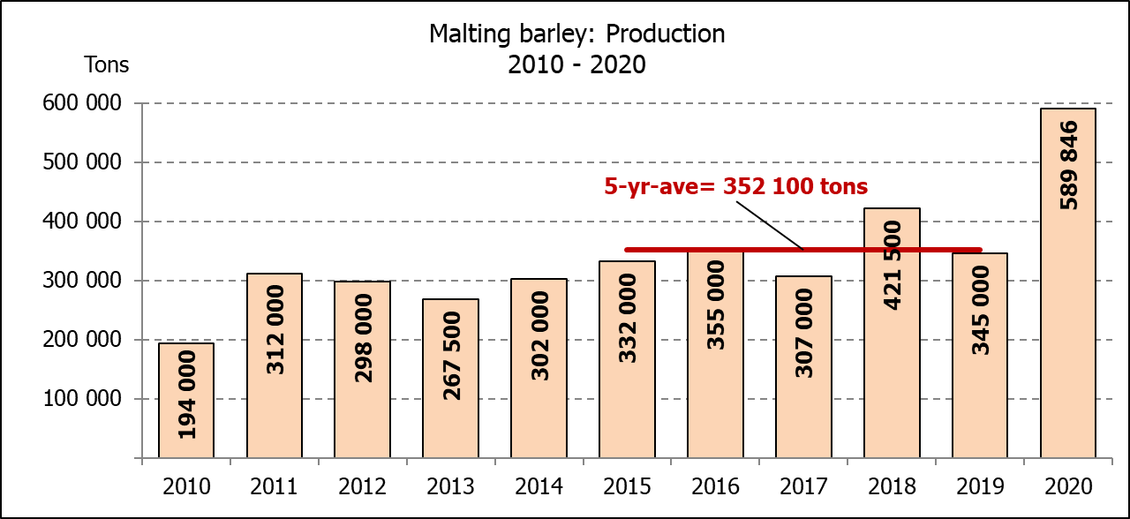
* Nota: Skatting is vir kalenderjaar, bv. produksie-seisoen 2020 = 2020
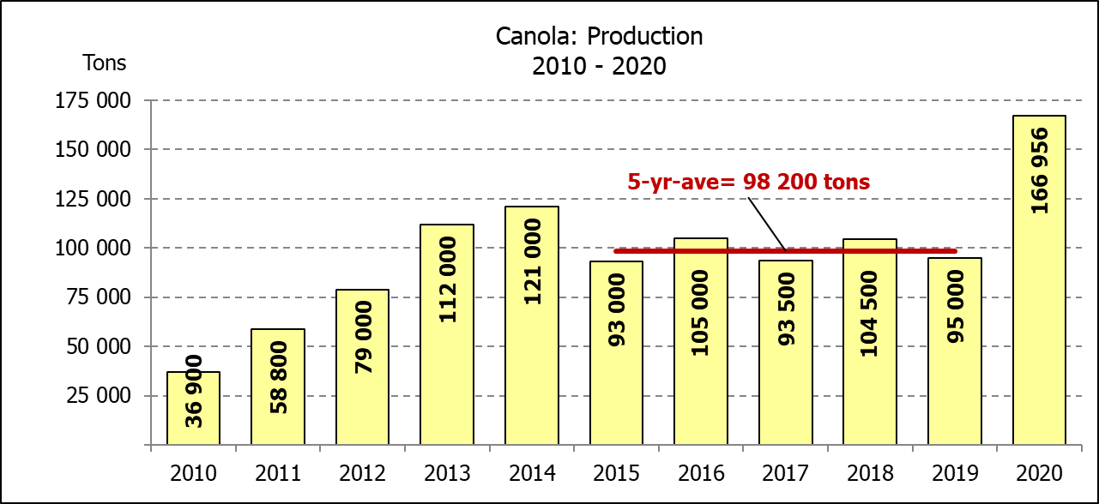
WHEAT – AREA PLANTED ESTIMATE AND FINAL PRODUCTION ESTIMATE: 2020
KORING – OPPERVLAKTE- EN FINALE PRODUKSIESKATTING: 2020
Province/  Provinsie | Area planted/  Opp beplant  Ha | Final estimate/  Finale skatting  Tons | Area planted/  Opp beplant  Ha | Final crop/  Finale oes  Tons
Province/  Provinsie | 2020 | 2020 | 2019 | 2019
Western Cape/Wes-Kaap | 326 000 | 1 092 100 | 325 000 | 650 000
Northern Cape/Noord-Kaap | 37 000 | 271 950 | 37 500 | 262 500
Free State/Vrystaat | 94 000 | 413 600 | 128 000 | 326 000
Eastern Cape/Oos-Kaap | 4 000 | 26 000 | 3 100 | 18 150
KwaZulu-Natal | 7 800 | 48 360 | 7 500 | 45 750
Mpumalanga | 3 000 | 19 500 | 4 000 | 25 200
Limpopo | 23 000 | 147 200 | 20 000 | 120 000
Gauteng | 1 300 | 8 190 | 1 400 | 8 400
North West/Noordwes | 13 700 | 82 200 | 13 500 | 79 000
Total/Totaal | 509 800 | 2 109 100 | 540 000 | 1 535 000
AREA ESTIMATE AND FINAL PRODUCTION ESTIMATE OF WINTER CROPS (2020) /
OPPERVLAKTESKATTING EN FINALE PRODUKSIESKATTING VAN WINTERGEWASSE (2020)
25 FEBRUARY / FEBRUARIE 2021
Winter cereal crops - 2020 production season  Wheat: The expected production of wheat remained unchanged at 2,109 mill. tons, whilst the expected yield is 4,14 t/ha. This is the largest expected wheat crop since the 2,130 mill. tons of the 2008 season.  The expected production in the Western Cape is 1,092 mill. tons (52%), in the Free State 413 600 tons (20%) and in the Northern Cape 271 950 tons (13%).  Other crops: The production forecast for malting barley remained unchanged at 589 846 tons. The area planted is estimated at 141 690 ha, while the expected yield is 4,16 t/ha. This is the largest expected malting barley crop recorded for SA.  The expected canola crop remained unchanged at 166 956 tons. The area estimate for canola is 74 120 ha, with an expected yield of 2,25 t/ha. It is also the largest expected canola crop ever recorded for SA.  The expected oats (cereals) crop for 2020 is 56 150 tons, which is 7,16% or 3 750 tons more than the previous forecast of 52 400 tons. The area estimate is 26 200 ha and the expected yield is 2,14 t/ha.  Please note that the intentions to plant winter cereals for 2021 will be released on 29 April 2021. |  | Wintergewasse - 2020 produksie-seisoen  Koring: Die verwagte produksie vir koring is onveranderd gelaat op 2,109 milj. ton, terwyl die verwagte opbrengs 4,14 t/ha is. Hierdie is die grootste verwagte koring-oes sedert die 2,130 milj. ton van die 2008 seisoen.  Die verwagte produksie in die Wes-Kaap is 1,092 milj. ton (52%), in die Vrystaat 413 600 ton (20%) en in die Noord-Kaap 271 950 ton (13%).  Ander gewasse: Die produksieskatting vir moutgars is onveranderd gelaat op 589 846 ton. Die oppervlakte beplant word beraam op 141 690 ha, terwyl die verwagte opbrengs 4,16 t/ha beloop. Dit is die grootste verwagte moutgars-oes wat nog vir SA aangeteken is.  Die verwagte kanola-oes is onveranderd gelaat op 166 956 ton. Die oppervlakteskatting vir kanola is 74 120 ha, met ŉ verwagte opbrengs van 2,25 t/ha. Dit is ook die grootste verwagte kanola-oes wat nog aangeteken is vir SA.  Die verwagte hawer-oes (ontbytgraan) vir die 2020-seisoen is 56 150 ton, wat 7,16% of 3 750 ton meer is as die vorige skatting van 52 400 ton. Die oppervlakteskatting is 26 200 ha en die verwagte opbrengs is 2,14 t/ha.  Neem asseblief kennis dat die voorneme om wintergewasse te plant vir 2021 op 29 April 2021 vrygestel sal word.

Information is available on the internet at http://www.dalrrd.gov.za/statistics and economic reports or http://www.sagis.org.za, as from 14:30 on the date of the relevant meeting of the Crop Estimates Committee. |  | Inligting is beskikbaar op die internet by http://www.dalrrd.gov.za/statistics and economic reports of by http://www.sagis.org.za, vanaf 14:30 op die dag van die toepaslike vergadering van die Oesskattingskomitee.
CONFIDENTIALITY ISSUES that CEC members are committed to adhere to on the day of the meeting
- Personal items such as laptops, handbags, cell phones, etc. are not allowed in the venue during the meeting
- No member is allowed to leave the meeting before 12:00 in order to prevent disclosure of the information
- The embargo time for the release of crop estimates information is 14:30
- No member is allowed to discuss crop estimates information with anyone other than a member of the Committee before the embargo time
- Only the Chairperson, or a member appointed by the Chairperson, may release the figures to the media
- Members must regard the detail of any information that was collected for and/or discussed during the meeting, as confidential
- Individual information received for crop estimate purposes is treated strictly confidential, and is not divulged for any other purposes.

