 | crop estimates committee | 
 | oesskattingskomitee
From/Van: Mr Baldwin Netshifhefhe
Tel: 012 319 8043  Fax/Faks: 012 319 8031  E-mail/E-pos: BaldwinN@daff.gov.za
Web page/Webblad: www.daff.gov.za/statistics and economic reports or www.sagis.org.za/CEC: Crop Estimates
EMBARGO: 14:30

The revised area planted estimate and first production forecast for summer crops for 2020 is hereby released.
Hiermee word die hersiene oppervlakte- en eerste produksieskatting vir somergewasse vir 2020 vrygestel.

SUMMER CROPS – REVISED AREA PLANTED AND FIRST PRODUCTION FORECAST: 2020
SOMERGEWASSE – HERSIENE OPPERVLAKTE- EN EERSTE PRODUKSIESKATTING: 2020
CROP/GEWAS | Area planted/  Opp beplant  2020 | 1stforecast/  1ste skatting  2020 | Area planted/  Opp beplant  2019 | Final crop/  Finale oes  2019 | Change/  Verandering/
CROP/GEWAS | Ha | Tons | Ha | Tons | %
CROP/GEWAS | (A) | (B) | (C) | (D) | (B) ÷ (D)
Commercial/Kommersieël:
White maize/Witmielies | 1 596 300 | 8 286 825 | 1 298 400 | 5 545 000 | +49,45
Yellow maize/Geelmielies | 1 003 500 | 6 273 335 | 1 002 100 | 5 730 000 | +9,48
Total Maize/Totale Mielies | 2 599 800 | 14 560 160 | 2 300 500 | 11 275 000 | +29,14
Sunflower seed/Sonneblomsaad | 500 300 | 699 130 | 515 350 | 678 000 | +3,12
Soybeans/Sojabone | 705 000 | 1 242 950 | 730 500 | 1 170 345 | +6,20
Groundnuts/Grondbone | 37 500 | 54 390 | 20 050 | 19 400 | +180,36
Sorghum | 45 300 | 135 090 | 50 500 | 127 000 | +6,37
Dry beans/Droëbone | 50 150 | 72 910 | 59 300 | 66 355 | +9,88
TOTAL/TOTAAL | 3 938 050 | 16 764 630 | 3 676 200 | 13 336 100 | +25,71
Note: Estimate is for calendar year, e.g. production season 2019/20 = 2020
Nota: Skatting is vir kalenderjaar, bv. produksie-seisoen 2019/20 = 2020

26 February / Februarie 2020
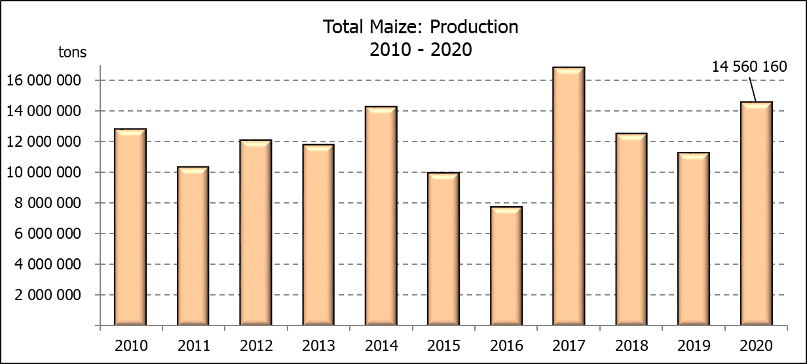

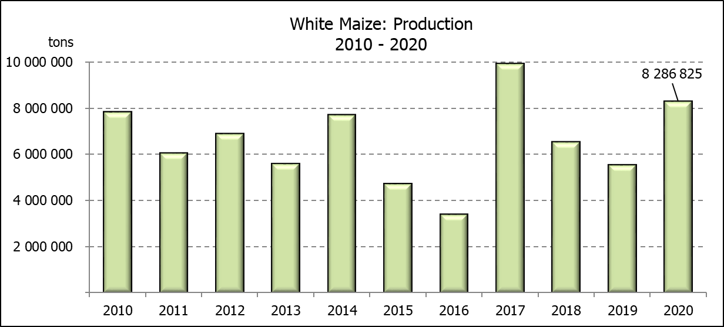
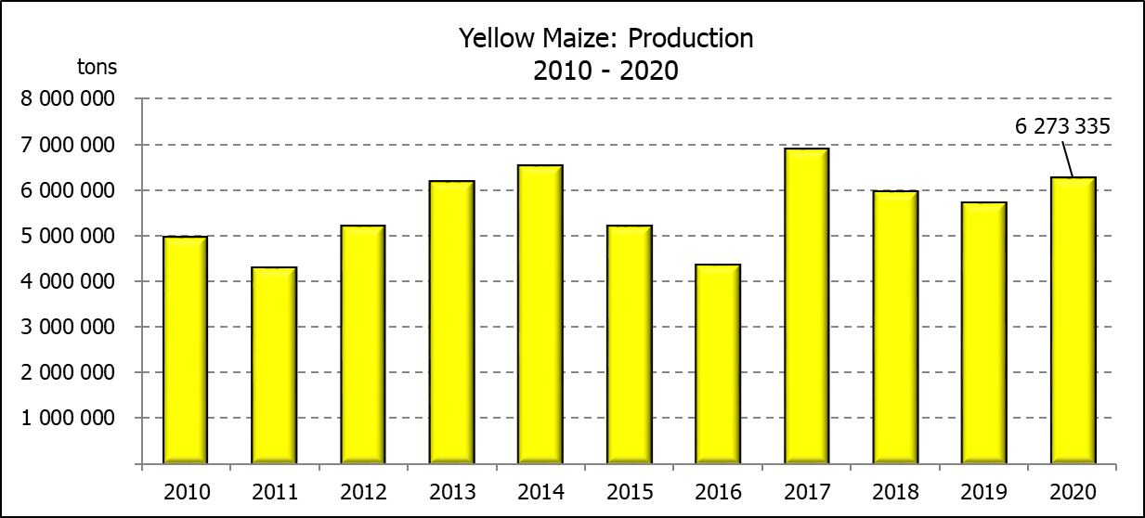

WHITE AND YELLOW MAIZE – REVISED AREA PLANTED AND FIRST PRODUCTION FORECAST: 2020
WIT- EN GEELMIELIES – HERSIENE OPPERVLAKTE EN EERSTE PRODUKSIESKATTING: 2020

Provinsie/  Province | Area planted/  Oppervlakte beplant  2020 |  |  | 1st forecast/  1ste skatting  2020 |  |  | Area planted/  Oppervlakte beplant  2019 |  |  | Final crop/  Finale oes  2019
Provinsie/  Province | White/  Wit  Ha | Yellow/  Geel  Ha | Total/  Totaal  Ha | White/  Wit  Tons | Yellow/  Geel  Tons | Total/  Totaal  Tons | White/  Wit  Ha | Yellow/  Geel  Ha | Total/  Totaal  Ha | White/  Wit  Tons | Yellow/  Geel  Tons | Total/  Totaal  Tons
Western Cape/Wes-Kaap | 400 | 3 400 | 3 800 | 3 600 | 30 600 | 34 200 | 400 | 3 400 | 3 800 | 3 600 | 30 600 | 34 200
Northern Cape/Noord-Kaap | 3 400 | 43 100 | 46 500 | 39 100 | 618 485 | 657 585 | 3 400 | 43 500 | 46 900 | 39 500 | 630 750 | 670 250
Free State/Vrystaat | 855 000 | 365 000 | 1 220 000 | 4 574 250 | 1 934 500 | 6 508 750 | 650 000 | 380 000 | 1 030 000 | 2 795 000 | 1 758 000 | 4 553 000
Eastern Cape/Oos-Kaap | 5 500 | 17 000 | 22 500 | 35 475 | 118 150 | 153 625 | 3 800 | 10 200 | 14 000 | 23 000 | 69 750 | 92 750
KwaZulu-Natal | 47 000 | 55 000 | 102 000 | 303 150 | 418 000 | 721 150 | 45 000 | 54 000 | 99 000 | 270 000 | 399 600 | 669 600
Mpumalanga | 160 000 | 358 000 | 518 000 | 928 000 | 2 255 400 | 3 184 400 | 145 000 | 338 000 | 483 000 | 797 500 | 1 977 300 | 2 774 800
Limpopo | 15 000 | 18 000 | 33 000 | 105 000 | 126 000 | 231 000 | 12 800 | 18 000 | 30 800 | 83 200 | 117 000 | 200 200
Gauteng | 55 000 | 54 000 | 109 000 | 319 000 | 340 200 | 659 200 | 48 000 | 60 000 | 108 000 | 259 200 | 348 000 | 607 200
North West/Noordwes | 455 000 | 90 000 | 545 000 | 1 979 250 | 432 000 | 2 411 250 | 390 000 | 95 000 | 485 000 | 1 274 000 | 399 000 | 1 673 000
Total/Totaal | 1 596 300 | 1 003 500 | 2 599 800 | 8 286 825 | 6 273 335 | 14 560 160 | 1 298 400 | 1 002 100 | 2 300 500 | 5 545 000 | 5 730 000 | 11 275 000

SUNFLOWER SEED – REVISED AREA PLANTED AND FIRST PRODUCTION FORECAST: 2020
SONNEBLOMSAAD – HERSIENE OPPERVLAKTE EN EERSTE PRODUKSIESKATTING: 2020

Province/  Provinsie | Area planted/  Opp beplant  Ha | 1st forecast/  1ste skatting  Tons | Area planted/  Opp beplant  Ha | Final crop/  Finale oes  Tons
Province/  Provinsie | 2020 | 2020 | 2019 | 2019
Western Cape/Wes-Kaap | - | - | - | -
Northern Cape/Noord-Kaap | 1 200 | 1 440 | 950 | 1 140
Free State/Vrystaat | 260 000 | 390 000 | 270 000 | 391 500
Eastern Cape/Oos-Kaap | 300 | 570 | 100 | 260
KwaZulu-Natal | - | - | - | -
Mpumalanga | 2 800 | 3 920 | 4 500 | 4 500
Limpopo | 65 000 | 65 000 | 61 000 | 61 000
Gauteng | 4 000 | 4 400 | 3 800 | 3 800
North West/Noordwes | 167 000 | 233 800 | 175 000 | 215 800
Total/Totaal | 500 300 | 699 130 | 515 350 | 678 000
SOYBEANS – REVISED AREA PLANTED AND FIRST PRODUCTION FORECAST: 2020
SOJABONE – HERSIENE OPPERVLAKTE EN EERSTE PRODUKSIESKATTING: 2020

Province/  Provinsie | Area planted/  Opp beplant  Ha | 1st forecast/  1ste skatting  Tons | Area planted/  Opp beplant  Ha | Final crop/  Finale oes  Tons
Province/  Provinsie | 2020 | 2020 | 2019 | 2019
Western Cape/Wes-Kaap |  |  | 100 | 10
Northern Cape/Noord-Kaap | 2 000 | 7 000 | 1 550 | 5 425
Free State/Vrystaat | 315 000 | 504 000 | 301 000 | 391 300
Eastern Cape/Oos-Kaap | 1 500 | 3 000 | 1 150 | 1 380
KwaZulu-Natal | 35 000 | 105 000 | 33 000 | 99 000
Mpumalanga | 260 000 | 429 000 | 310 000 | 511 500
Limpopo | 15 500 | 44 950 | 16 200 | 46 980
Gauteng | 36 000 | 72 000 | 31 500 | 66 150
North West/Noordwes | 40 000 | 78 000 | 36 000 | 48 600
Total/Totaal | 705 000 | 1 242 950 | 730 500 | 1 170 345

GROUNDNUTS – REVISED AREA PLANTED AND FIRST PRODUCTION FORECAST: 2020
GRONDBONE – HERSIENE OPPERVLAKTE EN EERSTE PRODUKSIESKATTING: 2020

Province/  Provinsie | Area planted/  Opp beplant  Ha | 1st forecast/  1ste skatting  Tons | Area planted/  Opp beplant  Ha | Final crop/  Finale oes  Tons
Province/  Provinsie | 2020 | 2020 | 2019 | 2019
Western Cape/Wes-Kaap | - | - | - | -
Northern Cape/Noord-Kaap | 1 200 | 3 600 | 1 200 | 2 520
Free State/Vrystaat | 8 000 | 14 400 | 8 000 | 9 775
Eastern Cape/Oos-Kaap | - | - | - | -
KwaZulu-Natal | - | - | - | -
Mpumalanga | - | - | - | -
Limpopo | 2 900 | 4 640 | 1 850 | 3 530
Gauteng | - | - | - | -
North West/Noordwes | 25 400 | 31 750 | 9 000 | 3 575
Total/Totaal | 37 500 | 54 390 | 20 050 | 19 400

SORGHUM – REVISED AREA PLANTED AND FIRST PRODUCTION FORECAST: 2020
SORGHUM – HERSIENE OPPERVLAKTE EN EERSTE PRODUKSIESKATTING: 2020

Province/  Provinsie | Area planted/  Opp beplant  Ha | 1st forecast/  1ste skatting  Tons | Area planted/  Opp beplant  Ha | Final crop/  Finale oes  Tons
Province/  Provinsie | 2020 | 2020 | 2019 | 2019
Western Cape/Wes-Kaap | - | - | - | -
Northern Cape/Noord-Kaap | - | - | - | -
Free State/Vrystaat | 9 300 | 30 690 | 8 000 | 23 600
Eastern Cape/Oos-Kaap | - | - | - | -
KwaZulu-Natal | 1 200 | 3 000 | 500 | 1 500
Mpumalanga | 8 000 | 40 800 | 7 500 | 36 000
Limpopo | 18 000 | 34 200 | 25 000 | 46 125
Gauteng | 500 | 1 500 | 1 000 | 3 200
North West/Noordwes | 8 300 | 24 900 | 8 500 | 16 575
Total/Totaal | 45 300 | 135 090 | 50 500 | 127 000

DRY BEANS – REVISED AREA PLANTED AND FIRST PRODUCTION FORECAST: 2020
DROëBONE – HERSIENE OPPERVLAKTE EN EERSTE PRODUKSIESKATTING: 2020

Province/  Provinsie | Area planted/  Opp beplant  Ha | 1st forecast/  1ste skatting  Tons | Area planted/  Opp beplant  Ha | Final crop/  Finale oes  Tons
Province/  Provinsie | 2020 | 2020 | 2019 | 2019
Western Cape/Wes-Kaap | 100 | 150 | 100 | 180
Northern Cape/Noord-Kaap | 350 | 700 | 1 000 | 1 400
Free State/Vrystaat | 24 000 | 32 400 | 27 000 | 28 350
Eastern Cape/Oos-Kaap | 200 | 300 | 400 | 720
KwaZulu-Natal | 2 900 | 3 770 | 3 500 | 4 025
Mpumalanga | 6 600 | 8 910 | 7 500 | 6 750
Limpopo | 8 400 | 16 800 | 7 800 | 12 480
Gauteng | 600 | 780 | 1 500 | 1 950
North West/Noordwes | 7 000 | 9 100 | 10 500 | 10 500
Total/Totaal | 50 150 | 72 910 | 59 300 | 66 355

CONFIDENTIALITY ISSUES that CEC members are committed to adhere to on the day of the meeting
- Personal items such as laptops, handbags, cell phones, etc. are not allowed in the venue during the meeting
- No member is allowed to leave the meeting before 12:00 in order to prevent disclosure of the information
- The embargo time for the release of crop estimates information is 14:30
- No member is allowed to discuss crop estimates information with anyone other than a member of the Committee before the embargo time
- Only the Chairperson, or a member appointed by the Chairperson, may release the figures to the media
- Members must regard the detail of any information that was collected for and/or discussed during the meeting, as confidential
- Individual information received for crop estimate purposes is treated strictly confidential, and is not divulged for any other purposes

REVISED AREA ESTIMATE AND FIRST PRODUCTION FORECAST OF SUMMER CROPS (2020 PRODUCTION SEASON)/
HERSIENE OPPERVLAKTE- EN EERSTE PRODUKSIESKATTING VIR SOMERGEWASSE (2020 PRODUKSIE-SEISOEN)
26 FEBRUARY 2019 / 26 FEBRUARIE 2020

Summer field crops – 2020  Commercial maize: The revised area estimate for maize is 2 599 800 ha, which is 13,01% or 299 300 ha more than the 2 300 500 ha planted for the previous season, and 2,54% or 64 500 ha more than the preliminary area estimate of 2 535 300 ha released in January 2020.  The expected commercial maize crop is 14 560 160 tons, which is 29,14% or 3 285 160 tons more than the 11 275 000 tons of the previous season (2019). The yield for maize is 5,60 t/ha.  The area planted figures are mainly based on information obtained from the Producer Independent Crop Estimation System (PICES), conducted by the National Crop Statistics Consortium (NCSC) for Free State, KwaZulu-Natal, Mpumalanga, Limpopo, Gauteng and North West provinces.  Please note that information from the objective yield survey by the NCSC for the Mpumalanga province will be available in April 2020; and for the Free State and North West provinces in May 2020. The current yield figures are mainly obtained from producers in the different provinces.  The area estimate for white maize is 1 596 300 ha, which represents an increase of 22,94% or 297 900 ha compared to the 1 298 400 ha planted last season. The production forecast of white maize is 8 286 825 tons, which is 49,45% or 2 741 825 tons more than the 5 545 000 tons of last season. The yield for white maize is 5,19 t/ha.  In the case of yellow maize, the area estimate is 1 003 500 ha, which is 0,14% or 1 400 ha more than the 1 002 100 ha planted last season. The yellow maize production forecast is 6 273 335 tons, which is 9,48% or 543 335 tons more than the 5 730 000 tons of last season. The yield for yellow maize is 6,25 t/ha.  Other summer crops:  Sunflower seed: The revised area estimate for sunflower seed is 500 300 ha, which is 2,92% or 15 050 ha less than the 515 350 ha planted the previous season. The production forecast for sunflower seed is 699 130 tons, which is 3,12% or 21 130 tons more than the 678 000 tons of the previous season. The expected yield is 1,40 t/ha.  Other crops: It is estimated that 705 000 ha have been planted to soybeans, which represents a decrease of 3,49% or 25 500 ha compared to the 730 500 ha planted last season. The production forecast is 1 242 950 tons, which is 6,20% or 72 605 tons more than the 1 170 345 tons of the previous season. The expected yield is 1,76 t/ha.  For groundnuts, the area estimate is 37 500 ha, which is 87,03% or 17 450 ha more than the 20 050 ha planted for the previous season. The expected crop is 54 390 tons – which is 180,36% or 34 990 tons more than the 19 400 tons of last season. The expected yield is 1,45 t/ha.  The area estimate for sorghum decreased by 10,30% or 5 200 ha, from 50 500 ha to 45 300 ha against the previous season. The production forecast for sorghum is 135 090 tons, which is 6,37% or 8 090 tons more than the 127 000 tons of the previous season. The expected yield is 2,98 t/ha.  For dry beans, the area estimate is 50 150 ha, which is 15,43% or 9 150 ha less than the 59 300 ha planted for the previous season. The production forecast is 72 910 tons, which is 9,88% or 6 555 tons more than the 66 355 tons of the previous season. The expected yield is 1,45 t/ha.  Please note that the second production forecast for summer field crops for 2020 will be released on 25 March 2020. |  | Somergewasse – 2020  Kommersiële mielies: Die hersiene skatting van die oppervlakte onder mielies beloop 2 599 800 ha, wat 13,01% of 299 300 ha meer is as die 2 300 500 ha wat verlede seisoen aangeplant is, en 2,54% of 64 500 ha meer as die voorlopige oppervlakteskatting van 2 535 300 ha soos vrygestel in Januarie 2020.  Die verwagte kommersiële mielie-oes is 14 560 160 ton, wat 29,14% of 3 285 160 ton meer is as die 11 275 000 ton van die vorige seisoen (2019). Die opbrengs van mielies is 5,60 t/ha.  Die oppervlakte beplant syfers is hoofsaaklik verkry vanaf die Produsente Onafhanklike Oesskattingstelsel (PICES), soos deur die Nasionale Oesskattingskonsortium gerapporteer vir Vrystaat, KwaZulu-Natal, Mpumalanga, Limpopo, Gauteng en Noordwes provinsies.  Neem kennis dat inligting van die objektiewe opbrengs-opname van die Konsortium vir die Mpumalanga provinsie, in April 2020 gerapporteer word en vir die Vrystaat en Noordwes provinsies in Mei 2020. Die huidige opbrengs syfers is hoofsaaklik verkry vanaf produsente in die verskillende provinsies.  Die oppervlak onder witmielies is 1 596 300 ha, wat ’n toename van 22,94% of 297 900 ha verteenwoordig vergeleke met die 1 298 400 ha die vorige seisoen. Die produksieskatting van witmielies is 8 286 825 ton, wat 49,45% of 2 741 825 ton meer is as die 5 545 000 ton van die vorige seisoen. Die opbrengs van witmielies is 5,19 t/ha.  In die geval van geelmielies is die oppervlakteskatting 1 003 500 ha, wat 0,14% of 1 400 ha meer is as die 1 002 100 ha geplant die vorige seisoen. Die produksieskatting van geelmielies is 6 273 335 ton, wat 9,48% of 543 335 ton meer is as die 5 730 000 ton van die vorige seisoen. Die opbrengs van geelmielies is 6,25 t/ha.  Ander somergewasse:  Sonneblomsaad: Die hersiene oppervlakteskatting vir sonneblomsaad is 500 300 ha, wat 2,92% of 15 050 ha minder is as die 515 350 ha aangeplant die vorige seisoen. Die produksieskatting vir sonneblomsaad is 699 130 ton, wat 3,12% of 21 130 ton meer is as die 678 000 ton van die vorige seisoen. Die verwagte opbrengs is 1,40 t/ha.  Ander gewasse: Die geskatte oppervlakte beplant met sojabone is 705 000 ha, wat ’n afname van 3,49% of 25 500 ha verteenwoordig vergeleke met die 730 500 ha geplant die vorige seisoen. Die produksieskatting is 1 242 950 ton, wat 6,20% of 72 605 ton meer is as die 1 170 345 ton van die vorige seisoen. Die verwagte opbrengs is 1,76 t/ha.  Vir grondbone is die oppervlakteskatting 37 500 ha, wat 87,03% of 17 450 ha meer is as die 20 050 ha geplant vir die vorige seisoen. Die verwagte grondbone-oes is 54 390 ton – 180,36% of 34 990 ton meer as die 19 400 ton van die vorige seisoen. Die verwagte opbrengs is 1,45 t/ha.  Die oppervlakteskatting vir sorghum het afgeneem met 10,30% of 5 200 ha, van 50 500 ha tot 45 300 ha teenoor die vorige seisoen. Die produksieskatting van sorghum is 135 090 ton – 6,37% of 8 090 ton meer as die 127 000 ton van die vorige seisoen. Die verwagte opbrengs is 2,98 t/ha.  Vir droëbone is die geskatte oppervlakte beplant 50 150 ha, wat 15,43% of 9 150 ha minder is as die 59 300 ha geplant vir die vorige seisoen. Die produksieskatting is 72 910 ton, wat 9,88% of 6 555 ton meer is as die 66 355 ton van die vorige seisoen. Die verwagte opbrengs is 1,45 t/ha.  Neem asseblief kennis dat die tweede produksieskatting vir somergewasse vir 2020, op 25 Maart 2020 vrygestel sal word.
The area estimate and final production estimate for winter cereals for the 2019 is hereby released. /
Hiermee word die oppervlakteskatting en finale produksieskatting vir wintergewasse vir 2019 vrygestel.
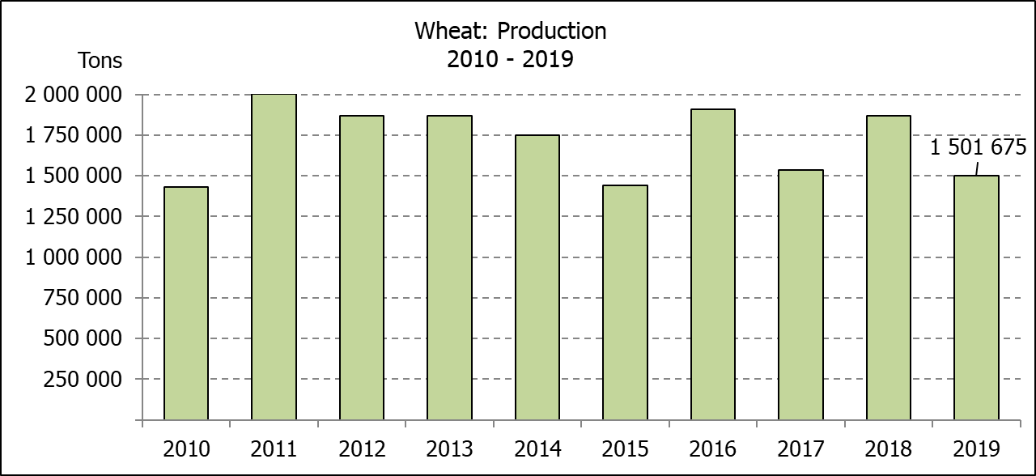
WINTER CEREALS – AREA PLANTED ESTIMATE AND FINAL PRODUCTION ESTIMATE: 2019
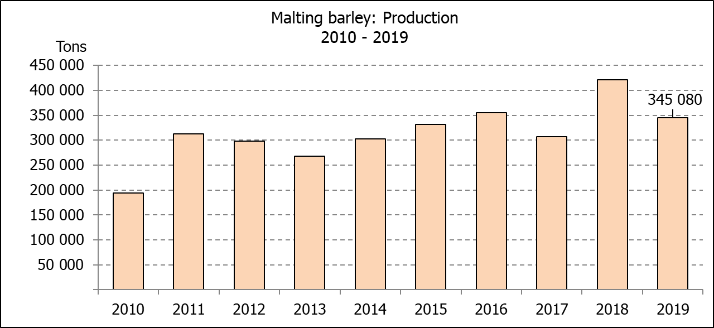
WINTERGEWASSE – OPPERVLAKTE- EN FINALE PRODUKSIESKATTING: 2019
CROP/GEWAS | Area planted/  Opp beplant  2019 | Final estimate/  Finale skatting  2019 | 6th forecast/  6de skatting  2019 | Area planted/  Opp beplant  2018 | Final crop/  Finale oes  2018 | Change/  Verandering
CROP/GEWAS | Ha | Tons | Tons | Ha | Tons | %
CROP/GEWAS | (A) | (B) | (C) | (D) | (E) | (B) ÷ (C)
Commercial/Kommersieel:
Wheat/Koring | 540 000 | 1 501 675 | 1 501 675 | 503 350 | 1 868 000 | -
Malting barley/Moutgars | 131 960 | 345 080 | 345 080 | 119 000 | 421 500 | -
Canola/Kanola | 74 000 | 96 200 | 96 200 | 77 000 | 104 500 | -
Cereal oats/Hawermout | 21 000 | 15 540 | 17 250 | 19 235 | 32 700 | -9,91
* Note: Estimate is for calendar year, e.g. production season 2019 = 2019
* Nota: Skatting is vir kalenderjaar, bv. produksie-seisoen 2019 = 2019
WHEAT – AREA PLANTED ESTIMATE AND FINAL PRODUCTION ESTIMATE: 2019
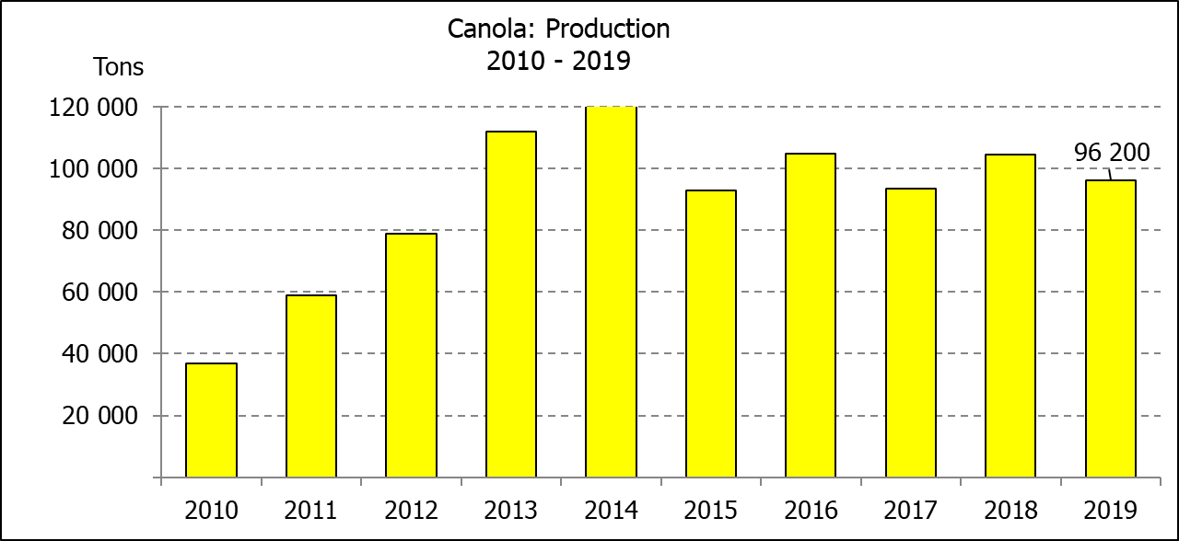
KORING – OPPERVLAKTE- EN FINALE PRODUKSIESKATTING: 2019
Province/  Provinsie | Area planted/  Opp beplant  Ha | Final estimate/  Finale skatting  Tons | Area planted/  Opp beplant  Ha | Final crop/  Finale oes  Tons
Province/  Provinsie | 2019 | 2019 | 2018 | 2018
Western Cape/Wes-Kaap | 325 000 | 633 750 | 318 000 | 890 500
Northern Cape/Noord-Kaap | 37 500 | 262 500 | 38 000 | 294 500
Free State/Vrystaat | 128 000 | 313 600 | 100 000 | 385 000
Eastern Cape/Oos-Kaap | 3 100 | 15 500 | 1 650 | 10 730
KwaZulu-Natal | 7 500 | 45 750 | 7 000 | 43 400
Mpumalanga | 4 000 | 25 200 | 3 500 | 22 740
Limpopo | 20 000 | 118 000 | 20 000 | 128 000
Gauteng | 1 400 | 8 400 | 1 200 | 7 800
North West/Noordwes | 13 500 | 78 975 | 14 000 | 85 330
Total/Totaal | 540 000 | 1 501 675 | 503 350 | 1 868 000

AREA ESTIMATE AND FINAL PRODUCTION ESTIMATE OF WINTER CROPS (2019) /
OPPERVLAKTESKATTING EN FINALE PRODUKSIESKATTING VAN WINTERGEWASSE (2019)
26 FEBRUARY / FEBRUARIE 2020
Winter cereal crops - 2019 production season  Wheat: The expected wheat crop remained unchanged at 1,502 mill. tons, whilst the expected yield is 2,78 t/ha.  The expected production in the Western Cape is 633 750 tons (42%), in the Free State 313 600 tons (21%) and in the Northern Cape 262 500 tons (17%).  An estimated 325 000 ha or 60% is planted in the Western Cape, 128 000 ha or 24% in the Free State and 37 500 ha or 7% in the Northern Cape.  Other crops: The production forecast for malting barley also remained unchanged at 345 080 tons. The area planted is estimated at 131 960 ha, whilst the expected yield is 2,62 t/ha.  The expected canola crop is 96 200 tons, whereas the area estimate is 74 000 ha, with an expected yield of 1,30 t/ha.  The area estimate for oats (cereals) for the 2019 season is 21 000 ha and the expected crop is 15 540 tons. The expected yield is 0,74 t/ha.  Please note that the intentions to plant winter cereals for 2020 will be released on 29 April 2020. |  | Wintergewasse - 2019 produksie-seisoen  Koring: Die verwagte koring-oes is onveranderd gelaat op 1,502 milj. ton, terwyl die verwagte opbrengs 2,78 t/ha is.  Die verwagte produksie in die Wes-Kaap is 633 750 ton (42%), in die Vrystaat 313 600 ton (21%) en in die Noord-Kaap 262 500 ton (17%).  Die beraamde oppervlakte geplant in die Wes-Kaap is 325 000 ha of 60%, die Vrystaat is 128 000 ha of 24% en 37 500 ha of 7% is in die Noord-Kaap.  Ander gewasse: Die produksieskatting vir moutgars is ook onveranderd gelaat op 345 080 ton. Die oppervlakte beplant word beraam op 131 960 ha, terwyl die verwagte opbrengs 2,62 t/ha beloop.  Die verwagte kanola-oes is 96 200 ton, terwyl die oppervlakteskatting 74 000 ha is, met ŉ verwagte opbrengs van 1,30 t/ha.  Die oppervlakteskatting vir hawer (ontbytgraan) vir die 2019-seisoen is 21 000 ha en die verwagte oes is 15 540 ton. Die verwagte opbrengs is 0,74 t/ha.  Neem asseblief kennis dat die voorneme om wintergewasse te plant vir 2020 op 29 April 2020 vrygestel sal word.

Information is available on the internet at http://www.daff.gov.za/statistics and economic reports or http://www.sagis.org.za, as from 14:30 on the date of the relevant meeting of the Crop Estimates Committee. |  | Inligting is beskikbaar op die internet by http://www.daff.gov.za/statistics and economic reports of by http://www.sagis.org.za, vanaf 14:30 op die dag van die toepaslike vergadering van die Oesskattingskomitee.
CONFIDENTIALITY ISSUES that CEC members are committed to adhere to on the day of the meeting
- Personal items such as laptops, handbags, cell phones, etc. are not allowed in the venue during the meeting
- No member is allowed to leave the meeting before 12:00 in order to prevent disclosure of the information
- The embargo time for the release of crop estimates information is 14:30
- No member is allowed to discuss crop estimates information with anyone other than a member of the Committee before the embargo time
- Only the Chairperson, or a member appointed by the Chairperson, may release the figures to the media
- Members must regard the detail of any information that was collected for and/or discussed during the meeting, as confidential
- Individual information received for crop estimate purposes is treated strictly confidential, and is not divulged for any other purposes

