 | crop estimates committee | 
 | oesskattingskomitee
From/Van: Ms Ellen Matsei
The Crop Estimates Committee comprises officials of the following institutions:
Department of Agriculture, Forestry and Fisheries; Provincial Departments of Agriculture; various ARC-Institutes (Soil, Climate and Water; Small Grains Institute; and
Grain Crops Institute); BFAP and Statistics SA.
Tel: 012 319 8454  Fax/Faks: 012 319 8031  E-mail/E-pos: DAS@daff.gov.za
Web page/Webblad: www.daff.gov.za/statistics and economic reports or www.sagis.org.za/CEC: Crop Estimates
EMBARGO: 15:30

The revised area planted estimate and first production forecast for summer crops for 2018 is hereby released.
Hiermee word die hersiene oppervlakte- en eerste produksieskatting vir somergewasse vir 2018 vrygestel.

SUMMER CROPS – REVISED AREA PLANTED AND FIRST PRODUCTION FORECAST: 2018
SOMERGEWASSE – HERSIENE OPPERVLAKTE- EN EERSTE PRODUKSIESKATTING: 2018
CROP/GEWAS | Area planted/  Opp beplant  2018 | 1stforecast/  1ste skatting  2018 | Area planted/  Opp beplant  2017 | Final crop/  Finale oes  2017 | Change/  Verandering/
CROP/GEWAS | Ha | Tons | Ha | Tons | %
CROP/GEWAS | (A) | (B) | (C) | (D) | (B) ÷ (D)
Commercial/Kommersieël:
White maize/Witmielies | 1 258 200 | 6 108 000 | 1 643 100 | 9 916 000 | -38,4
Yellow maize/Geelmielies | 1 044 500 | 6 114 950 | 985 500 | 6 904 000 | -11,4
Total Maize/Totale Mielies | 2 302 700 | 12 222 950 | 2 628 600 | 16 820 000 | -27,3
Sunflower seed/Sonneblomsaad | 584 900 | 731 505 | 635 750 | 874 000 | -16,3
Soybeans/Sojabone | 775 300 | 1 374 700 | 573 950 | 1 316 000 | +4,5
Groundnuts/Grondbone | 56 300 | 88 850 | 56 000 | 92 050 | -3,5
Sorghum | 24 800 | 78 200 | 42 350 | 152 000 | -48,6
Dry beans/Droëbone | 56 600 | 70 770 | 45 050 | 68 525 | +3,3
TOTAL/TOTAAL | 3 800 600 | 14 566 975 | 3 981 700 | 19 322 575 | -24,6
Note: Estimate is for calendar year, e.g. production season 2017/18 = 2018
Nota: Skatting is vir kalenderjaar, bv. produksie-seisoen 2017/18 = 2018

27 February / Februarie 2018
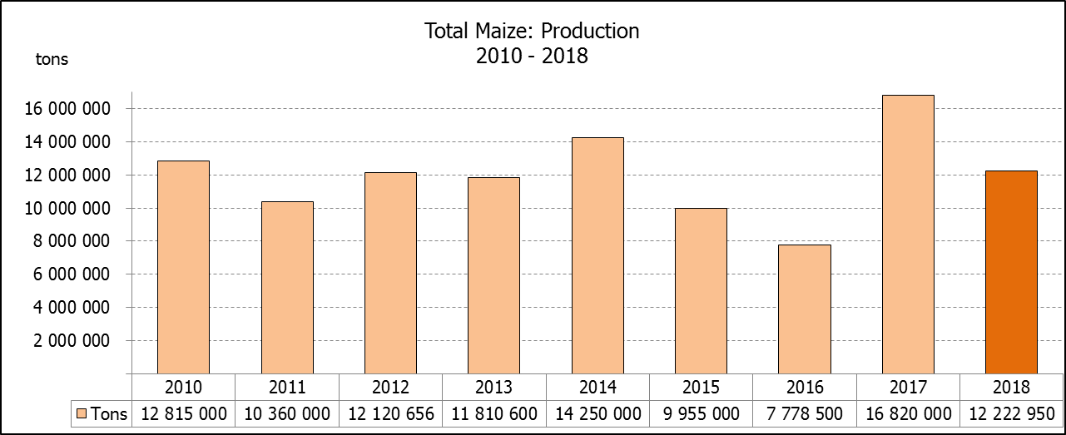

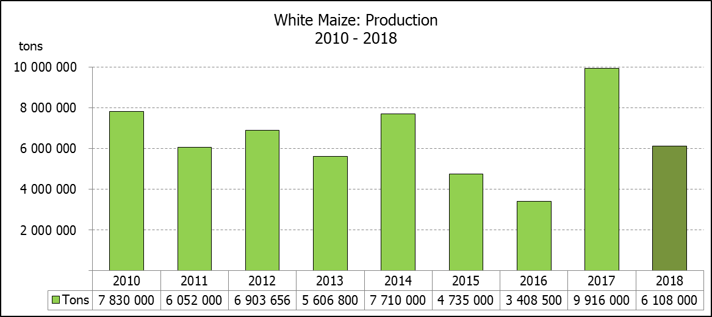
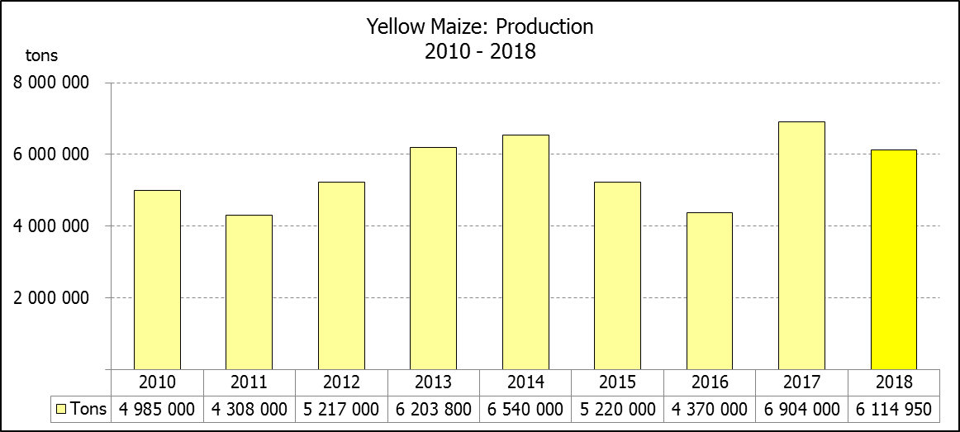

WHITE AND YELLOW MAIZE – REVISED AREA PLANTED AND FIRST PRODUCTION FORECAST: 2018
WIT- EN GEELMIELIES – HERSIENE OPPERVLAKTE EN EERSTE PRODUKSIESKATTING: 2018

Provinsie/  Province | Area planted/  Oppervlakte beplant  2018 |  |  | 1st forecast/  1ste skatting  2018 |  |  | Area planted/  Oppervlakte beplant  2017 |  |  | Final crop/  Finale oes  2017
Provinsie/  Province | White/  Wit  Ha | Yellow/  Geel  Ha | Total/  Totaal  Ha | White/  Wit  Tons | Yellow/  Geel  Tons | Total/  Totaal  Tons | White/  Wit  Ha | Yellow/  Geel  Ha | Total/  Totaal  Ha | White/  Wit  Tons | Yellow/  Geel  Tons | Total/  Totaal  Tons
Western Cape/Wes-Kaap | 0 | 1 500 | 1 500 | 0 | 13 500 | 13 500 | 200 | 2 000 | 2 200 | 2 000 | 20 000 | 22 000
Northern Cape/Noord-Kaap | 3 200 | 43 000 | 46 200 | 36 800 | 629 950 | 666 750 | 3 500 | 45 000 | 48 500 | 46 200 | 666 000 | 712 200
Free State/Vrystaat | 644 000 | 410 000 | 1 054 000 | 3 220 000 | 2 111 500 | 5 331 500 | 805 000 | 355 000 | 1 160 000 | 5 110 000 | 2 252 000 | 7 362 000
Eastern Cape/Oos-Kaap | 4 000 | 7 000 | 11 000 | 24 800 | 45 500 | 70 300 | 4 400 | 9 500 | 13 900 | 30 800 | 66 500 | 97 300
KwaZulu-Natal | 45 000 | 50 000 | 95 000 | 261 000 | 350 000 | 611 000 | 50 000 | 50 000 | 100 000 | 350 000 | 390 000 | 740 000
Mpumalanga | 140 000 | 340 000 | 480 000 | 791 000 | 2 040 000 | 2 831 000 | 160 000 | 330 000 | 490 000 | 1 088 000 | 2 342 500 | 3 430 500
Limpopo | 12 000 | 21 000 | 33 000 | 80 400 | 136 500 | 216 900 | 40 000 | 24 000 | 64 000 | 300 000 | 192 000 | 492 000
Gauteng | 50 000 | 62 000 | 112 000 | 290 000 | 403 000 | 693 000 | 60 000 | 60 000 | 120 000 | 390 000 | 414 000 | 804 000
North West/Noordwes | 360 000 | 110 000 | 470 000 | 1 404 000 | 385 000 | 1 789 000 | 520 000 | 110 000 | 630 000 | 2 599 000 | 561 000 | 3 160 000
Total/Totaal | 1 258 200 | 1 044 500 | 2 302 700 | 6 108 000 | 6 114 950 | 12 222 950 | 1 643 100 | 985 500 | 2 628 600 | 9 916 000 | 6 904 000 | 16 820 000

SUNFLOWER SEED – REVISED AREA PLANTED AND FIRST PRODUCTION FORECAST: 2018
SONNEBLOMSAAD – HERSIENE OPPERVLAKTE EN EERSTE PRODUKSIESKATTING: 2018

Province/  Provinsie | Area planted/  Opp beplant  Ha | 1st forecast/  1ste skatting  Tons | Area planted/  Opp beplant  Ha | Final crop/  Finale oes  Tons
Province/  Provinsie | 2018 | 2018 | 2017 | 2017
Western Cape/Wes-Kaap | - | - | - | -
Northern Cape/Noord-Kaap | 100 | 120 | 250 | 400
Free State/Vrystaat | 310 000 | 418 500 | 330 000 | 478 000
Eastern Cape/Oos-Kaap | - | - | - | -
KwaZulu-Natal | - | - | 300 | 300
Mpumalanga | 2 300 | 2 185 | 2 200 | 2 300
Limpopo | 45 000 | 38 250 | 90 000 | 85 500
Gauteng | 5 500 | 6 050 | 3 000 | 3 000
North West/Noordwes | 222 000 | 266 400 | 210 000 | 304 500
Total/Totaal | 584 900 | 731 505 | 635 750 | 874 000
SOYBEANS – REVISED AREA PLANTED AND FIRST PRODUCTION FORECAST: 2018
SOJABONE – HERSIENE OPPERVLAKTE EN EERSTE PRODUKSIESKATTING: 2018

Province/  Provinsie | Area planted/  Opp beplant  Ha | 1st forecast/  1ste skatting  Tons | Area planted/  Opp beplant  Ha | Final crop/  Finale oes  Tons
Province/  Provinsie | 2018 | 2018 | 2017 | 2017
Western Cape/Wes-Kaap | 300 | 450 | 700 | 1 050
Northern Cape/Noord-Kaap | 3 000 | 9 000 | 3 000 | 10 500
Free State/Vrystaat | 345 000 | 517 500 | 240 000 | 504 000
Eastern Cape/Oos-Kaap | 2 000 | 3 000 | 1 850 | 2 775
KwaZulu-Natal | 40 000 | 124 000 | 30 500 | 89 605
Mpumalanga | 300 000 | 555 000 | 241 000 | 554 300
Limpopo | 20 000 | 55 000 | 8 500 | 29 750
Gauteng | 30 000 | 60 000 | 25 400 | 71 120
North West/Noordwes | 35 000 | 50 750 | 23 000 | 52 900
Total/Totaal | 775 300 | 1 374 700 | 573 950 | 1 316 000

GROUNDNUTS – REVISED AREA PLANTED AND FIRST PRODUCTION FORECAST: 2018
GRONDBONE – HERSIENE OPPERVLAKTE EN EERSTE PRODUKSIESKATTING: 2018

Province/  Provinsie | Area planted/  Opp beplant  Ha | 1st forecast/  1ste skatting  Tons | Area planted/  Opp beplant  Ha | Final crop/  Finale oes  Tons
Province/  Provinsie | 2018 | 2018 | 2017 | 2017
Western Cape/Wes-Kaap | - | - | - | -
Northern Cape/Noord-Kaap | 2 800 | 9 800 | 4 000 | 14 000
Free State/Vrystaat | 22 000 | 37 400 | 22 000 | 34 100
Eastern Cape/Oos-Kaap | - | - | - | -
KwaZulu-Natal | - | - | - | -
Mpumalanga | - | - | - | -
Limpopo | 3 500 | 5 250 | 3 000 | 4 800
Gauteng | - | - | - | -
North West/Noordwes | 28 000 | 36 400 | 27 000 | 39 150
Total/Totaal | 56 300 | 88 850 | 56 000 | 92 050

SORGHUM – REVISED AREA PLANTED AND FIRST PRODUCTION FORECAST: 2018
SORGHUM – HERSIENE OPPERVLAKTE EN EERSTE PRODUKSIESKATTING: 2018

Province/  Provinsie | Area planted/  Opp beplant  Ha | 1st forecast/  1ste skatting  Tons | Area planted/  Opp beplant  Ha | Final crop/  Finale oes  Tons
Province/  Provinsie | 2018 | 2018 | 2017 | 2017
Western Cape/Wes-Kaap | - | - | - | -
Northern Cape/Noord-Kaap | - | - | - | -
Free State/Vrystaat | 6 300 | 18 900 | 7 700 | 24 640
Eastern Cape/Oos-Kaap | - | - | - | -
KwaZulu-Natal | 500 | 1 000 | 400 | 1 520
Mpumalanga | 7 500 | 37 500 | 12 000 | 62 400
Limpopo | 5 000 | 7 500 | 18 000 | 50 400
Gauteng | 1 500 | 4 500 | 750 | 2 400
North West/Noordwes | 4 000 | 8 800 | 3 500 | 10 640
Total/Totaal | 24 800 | 78 200 | 42 350 | 152 000

DRY BEANS – REVISED AREA PLANTED AND FIRST PRODUCTION FORECAST: 2018
DROëBONE – HERSIENE OPPERVLAKTE EN EERSTE PRODUKSIESKATTING: 2018

Province/  Provinsie | Area planted/  Opp beplant  Ha | 1st forecast/  1ste skatting  Tons | Area planted/  Opp beplant  Ha | Final crop/  Finale oes  Tons
Province/  Provinsie | 2018 | 2018 | 2017 | 2017
Western Cape/Wes-Kaap | 20 | 30 | 100 | 150
Northern Cape/Noord-Kaap | 540 | 1 080 | 650 | 1 300
Free State/Vrystaat | 30 000 | 36 000 | 20 000 | 32 000
Eastern Cape/Oos-Kaap | 40 | 60 | 300 | 450
KwaZulu-Natal | 2 500 | 3 000 | 4 500 | 5 400
Mpumalanga | 6 000 | 7 200 | 5 500 | 8 525
Limpopo | 8 000 | 12 000 | 7 000 | 12 950
Gauteng | 1 500 | 1 800 | 1 500 | 2 250
North West/Noordwes | 8 000 | 9 600 | 5 500 | 5 500
Total/Totaal | 56 600 | 70 770 | 45 050 | 68 525

CONFIDENTIALITY ISSUES that CEC members are committed to adhere to on the day of the meeting
- Personal items such as laptops, handbags, cell phones, etc. are not allowed in the venue during the meeting
- No member is allowed to leave the meeting before 12:00 in order to prevent disclosure of the information
- The embargo time for the release of crop estimates information is 15:30
- No member is allowed to discuss crop estimates information with anyone other than a member of the Committee before the embargo time
- Only the Chairperson, or a member appointed by the Chairperson, may release the figures to the media
- Members must regard the detail of any information that was collected for and/or discussed during the meeting, as confidential
- Individual information received for crop estimate purposes is treated strictly confidential, and is not divulged for any other purposes

REVISED AREA ESTIMATE AND FIRST PRODUCTION FORECAST OF SUMMER CROPS (2018 PRODUCTION SEASON)/
HERSIENE OPPERVLAKTE- EN EERSTE PRODUKSIESKATTING VIR SOMERGEWASSE (2018 PRODUKSIE-SEISOEN)
27 FEBRUARY 2018 / 27 FEBRUARIE 2018

Summer field crops – 2018  Commercial maize: The revised area estimate for maize is 2 302 700 ha, which is 12,40% or 325 900 ha less than the 2 628 600 ha planted for the previous season and also 0,28% or 6 500 ha less than the preliminary area estimate of 2 309 200 ha released in January 2018.  The expected commercial maize crop is 12 222 950 tons, which is 27,33% or 4 597 050 tons less than the 16 820 000 tons of the previous season (2017).  The area planted figures are mainly based on information obtained from the Producer Independent Crop Estimation System (PICES), conducted by the National Crop Statistics Consortium (NCSC) for Free State, KwaZulu-Natal, Mpumalanga, Limpopo, Gauteng and North West provinces.  Please note that information from the objective yield survey by the NCSC for the Mpumalanga province will be available in April 2018; and for the Free State and North West provinces in May 2018. The current yield figures are mainly obtained from producers in the different provinces.  The area estimate for white maize is 1 258 200 ha, which represents a decrease of 23,43% or 384 900 ha compared to the 1 643 100 ha planted last season. The production forecast of white maize is 6 108 000 tons, which is 38,40% or 3 808 000 tons less than the 9 916 000 tons of last season. The yield for white maize is 4,85 t/ha.  In the case of yellow maize, the area estimate is 1 044 500 ha, which is 5,99% or 59 000 ha more than the 985 000 ha planted last season. The yellow maize production forecast is 6 114 950 tons, which is 11,43% or 789 050 tons less than the 6 904 000 tons of last season. The yield for yellow maize is 5,85 t/ha.  Other summer crops:  Sunflower seed: The revised area estimate for sunflower seed is 584 900 ha, which is 8,00% or 50 850 ha less than the 635 750 ha planted the previous season. The production forecast for sunflower seed is 731 505 tons, which is 16,30% or 142 495 tons less than the 874 000 tons of the previous season. The expected yield is 1,25 t/ha.  Other crops: It is estimated that 775 300 ha have been planted to soybeans, which represents an increase of 35,08% or 201 350 ha compared to the 573 950 ha planted last season. The production forecast is 1 374 700 tons, which is 4,46% or 58 700 tons more than the 1 316 000 tons of the previous season. The expected yield is 1,77 t/ha.  For groundnuts, the area estimate is 56 300 ha, which is 0,54% or 300 ha more than the 56 000 ha planted for the previous season. The expected crop is 88 850 tons – which is 3,48% or 3 200 tons less than the 92 050 tons of last season. The expected yield is 1,58 t/ha.  The area estimate for sorghum decreased by 41,44% or 17 550 ha, from 42 350 ha to 24 800 ha against the previous season. The production forecast for sorghum is 78 200 tons, which is 48,55% or 73 800 tons less than the 152 000 tons of the previous season. The expected yield is 3,15 t/ha.  For dry beans, the area estimate is 56 600 ha, which is 25,64% or 11 550 ha more than the 45 050 ha planted for the previous season. The production forecast is 70 770 tons, which is 3,28% or 2 245 tons more than the 68 525 tons of the previous season. The expected yield is 1,25 t/ha.  Please note that the second production forecast for summer field crops for 2018 will be released on 28 March 2018. |  | Somergewasse – 2018  Kommersiële mielies: Die hersiene skatting van die oppervlakte onder mielies beloop 2 302 700 ha, wat 12,40% of 325 900 ha minder is as die 2 628 600 ha wat verlede seisoen aangeplant is, maar ook 0,28% of 6 500 ha minder as die voorlopige oppervlakteskatting van 2 309 200 ha soos vrygestel in Januarie 2018.  Die verwagte kommersiële mielie-oes is 12 222 950 ton, wat 27,33% of 4 597 050 ton minder is as die 16 820 000 ton van die vorige seisoen (2017).  Die oppervlakte beplant syfers is hoofsaaklik verkry vanaf die Produsente Onafhanklike Oesskattingstelsel (PICES), soos deur die Nasionale Oesskattingskonsortium gerapporteer vir Vrystaat, KwaZulu-Natal, Mpumalanga, Limpopo, Gauteng en Noordwes provinsies.  Neem kennis dat inligting van die objektiewe opbrengs-opname van die Konsortium vir die Mpumalanga provinsie, in April 2018 gerapporteer word en vir die Vrystaat en Noordwes provinsies in Mei 2018. Die huidige opbrengs syfers is hoofsaaklik verkry vanaf produsente in die verskillende provinsies.  Die oppervlak onder witmielies is 1 258 200 ha, wat ’n afname van 23,43% of 384 900 ha verteenwoordig vergeleke met die 1 643 100 ha die vorige seisoen. Die produksieskatting van witmielies is 6 108 000 ton, wat 38,40% of 3 808 000 ton minder is as die 9 916 000 ton van die vorige seisoen. Die opbrengs van witmielies is 4,85 t/ha.  In die geval van geelmielies is die oppervlakteskatting 1 044 500 ha, wat 5,99% of 59 000 ha meer is as die 985 000 ha geplant die vorige seisoen. Die produksieskatting van geelmielies is 6 114 950 ton, wat 11,43% of 789 050 ton minder is as die 6 904 000 ton van die vorige seisoen. Die opbrengs van geelmielies is 5,85 t/ha.  Ander somergewasse:  Sonneblomsaad: Die hersiene oppervlakteskatting vir sonneblomsaad is 584 900 ha, wat 8,00% of 50 850 ha minder is as die 635 750 ha aangeplant die vorige seisoen. Die produksieskatting vir sonneblomsaad is 731 505 ton, wat 16,30% of 142 495 ton minder is as die 874 000 ton van die vorige seisoen. Die verwagte opbrengs is 1,25 t/ha.  Ander gewasse: Die geskatte oppervlakte beplant met sojabone is 775 300 ha, wat ’n toename van 35,08% of 201 350 ha verteenwoordig vergeleke met die 573 950 ha geplant die vorige seisoen. Die produksieskatting is 1 374 700 ton, wat 4,46% of 58 700 ton meer is as die 1 316 000 ton van die vorige seisoen. Die verwagte opbrengs is 1,77 t/ha.  Vir grondbone is die oppervlakteskatting 56 300 ha, wat 0,54% of 300 ha meer is as die 56 000 ha geplant vir die vorige seisoen. Die verwagte grondbone-oes is 88 850 ton – 3,48% of 3 200 ton minder as die 92 050 ton van die vorige seisoen. Die verwagte opbrengs is 1,58 t/ha.  Die oppervlakteskatting vir sorghum het afgeneem met 41,44% of 17 550 ha, van 42 350 ha tot 24 800 ha teenoor die vorige seisoen. Die produksieskatting van sorghum is 78 200 ton – 48,55% of 73 800 ton minder as die 152 000 ton van die vorige seisoen. Die verwagte opbrengs is 3,15 t/ha.  Vir droëbone is die geskatte oppervlakte beplant 56 600 ha, wat 25,64% of 11 550 ha meer is as die 45 050 ha geplant vir die vorige seisoen. Die produksieskatting is 70 770 ton, wat 3,28% of 2 245 ton meer is as die 68 525 ton van die vorige seisoen. Die verwagte opbrengs is 1,25 t/ha.  Neem asseblief kennis dat die tweede produksieskatting vir somergewasse vir 2018, op 28 Maart 2018 vrygestel sal word.
The area estimate and final production forecast for winter cereals for the 2017 is hereby released. /
Hiermee word die oppervlakteskatting en finale produksieskatting vir wintergewasse vir 2017 vrygestel.
WINTER CEREALS – AREA PLANTED ESTIMATE AND FINAL PRODUCTION ESTIMATE: 2017
WINTERGEWASSE – OPPERVLAKTE- EN FINALE PRODUKSIESKATTING: 2017
CROP/GEWAS | Area planted/  Opp beplant  2017 | Final estimate/  Finale skatting  2017 | 6th forecast/  6de skatting  2017 | Area planted/  Opp beplant  2016 | Final crop/  Finale oes  2016 | Change/  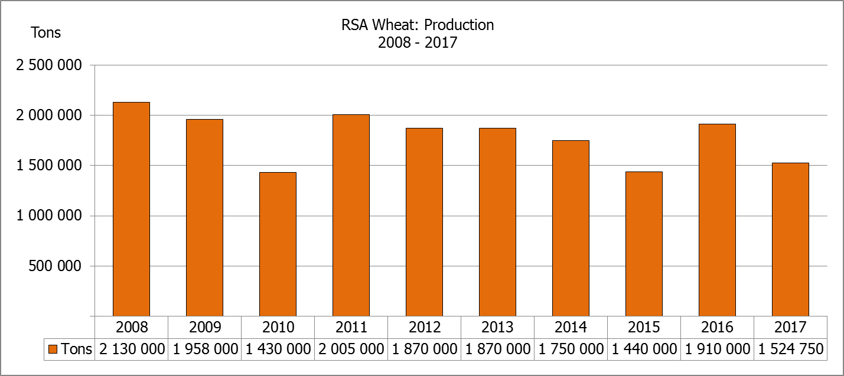  Verandering
CROP/GEWAS | Ha | Tons | Tons | Ha | Tons | %
CROP/GEWAS | (A) | (B) | (C) | (D) | (E) | (B) ÷ (C)
Commercial/Kommersieel:
Wheat/Koring | 491 600 | 1 524 750 | 1 475 450 | 508 365 | 1 910 000 | +3,3
Malting barley/Moutgars | 91 380 | 307 064 | 307 064 | 88 695 | 355 000 | -
Canola/Kanola | 84 000 | 93 468 | 93 468 | 68 075 | 105 000 | -
Total/Totaal | 666 980 | 1 925 282 | 1 875 982 | 665 135 | 2 370 000 | +2,6
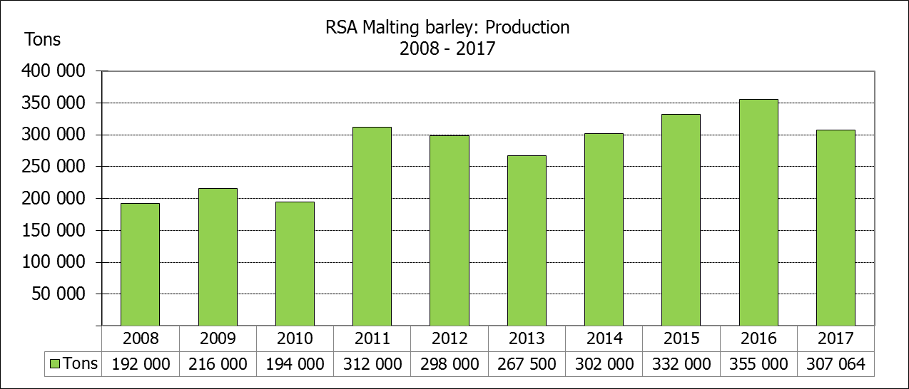
* Note: Estimate is for calendar year, e.g. production season 2017 = 2017
* Nota: Skatting is vir kalenderjaar, bv. produksie-seisoen 2017 = 2017
WHEAT – AREA PLANTED ESTIMATE AND FINAL PRODUCTION ESTIMATE: 2017
KORING – OPPERVLAKTE- EN FINALE PRODUKSIESKATTING: 2017
Province/  Provinsie | Area planted/  Opp beplant  Ha | Final estimate/  Finale skatting  Tons | Area planted/  Opp beplant  Ha | Final crop/  Finale oes  Tons
Province/  Provinsie | 2017 | 2017 | 2016 | 2016
Western Cape/Wes-Kaap | 326 000 | 586 800 | 323 000 | 1 098 200
Northern Cape/Noord-Kaap | 38 000 | 311 600 | 35 000 | 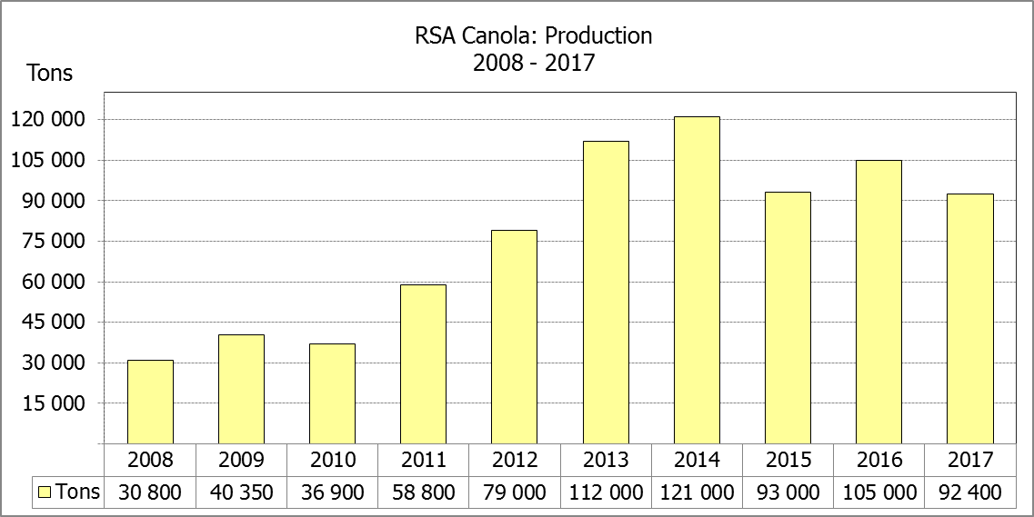  266 000
Free State/Vrystaat | 80 000 | 328 000 | 110 000 | 308 460
Eastern Cape/Oos-Kaap | 1 900 | 9 500 | 2 200 | 11 000
KwaZulu-Natal | 7 500 | 45 750 | 6 500 | 37 050
Mpumalanga | 4 000 | 25 200 | 2 300 | 13 800
Limpopo | 20 000 | 130 000 | 17 000 | 103 700
Gauteng | 700 | 4 200 | 365 | 2 190
North West/Noordwes | 13 500 | 83 700 | 12 000 | 69 600
Total/Totaal | 491 600 | 1 524 750 | 508 365 | 1 910 000

AREA ESTIMATE AND FINAL PRODUCTION ESTIMATE OF WINTER CROPS (2017) /
OPPERVLAKTESKATTING EN FINALE PRODUKSIESKATTING VAN WINTERGEWASSE (2017)
27 FEBRUARY / 27 FEBRUARIE 2018
Winter cereal crops - 2017 production season  Wheat: The expected commercial production of wheat is 1 524 750 tons, which is 3,34% or 49 300 tons more than the previous forecast of 1 475 450 tons, whilst the expected yield is 3,10 t/ha.  The expected production in the Western Cape remained unchanged at 586 800 tons. The production estimate for the Free State increased by 10,81% or 32 000 tons, from 296 000 tons to 328 000 tons; and in the Northern Cape, the expected production estimate also increased by 2,50% or 7 600 tons.  The area estimate for wheat 491 600 ha.  Other crops: The production estimate for malting barley remained unchanged at 307 064 tons. The area planted is estimated at 91 380 ha, while the expected yield is 3,36 t/ha.  The expected canola crop also remained unchanged at 93 468 tons. The area estimate for canola is 84 000 ha, with an expected yield of 1,11 t/ha.  Please note that the intentions to plant winter cereals for 2018 will be released on 25 April 2018. |  | Wintergewasse - 2017 produksie-seisoen  Koring: Die verwagte kommersiële produksie vir koring is 1 524 750 ton, wat 3,34% of 49 300 ton meer is as die vorige skatting van 1 475 450 ton, terwyl die verwagte opbrengs 3,10 t/ha is.  Die verwagte produksie in die Wes-Kaap is onveranderd gelaat op 586 800 ton. Die produksieskatting vir die Vrystaat het met 10,81 % of 32 000 ton toegeneem, van 296 000 ton tot 328 000 ton teenoor die vorige skatting; en in die Noord-Kaap het die verwagte produksie ook toegeneem met 2,50% of 7 600 ton.  Die oppervlakteskatting vir koring is 491 600 ha.  Ander gewasse: Die produksieskatting vir moutgars is onveranderd gelaat op 307 064 ton. Die oppervlakte beplant is beraam op 91 380 ha, terwyl die verwagte opbrengs 3,36 t/ha beloop.  Die verwagte kanola-oes is ook onveranderd gelaat op 93 468 ton. Die oppervlakteskatting vir kanola is 84 000 ha, met ŉ verwagte opbrengs van 1,11 t/ha.  Neem asseblief kennis dat die voorneme om wintergewasse te plant vir 2018 op 25 April 2018 vrygestel sal word.

Information is available on the internet at http://www.daff.gov.za/statistics and economic reports or http://www.sagis.org.za, as from 15:30 on the date of the relevant meeting of the Crop Estimates Committee. |  | Inligting is beskikbaar op die internet by http://www.daff.gov.za/statistics and economic reports of by http://www.sagis.org.za, vanaf 15:30 op die dag van die toepaslike vergadering van die Oesskattingskomitee.
CONFIDENTIALITY ISSUES that CEC members are committed to adhere to on the day of the meeting
- Personal items such as laptops, handbags, cell phones, etc. are not allowed in the venue during the meeting
- No member is allowed to leave the meeting before 12:00 in order to prevent disclosure of the information
- The embargo time for the release of crop estimates information is 15:30
- No member is allowed to discuss crop estimates information with anyone other than a member of the Committee before the embargo time
- Only the Chairperson, or a member appointed by the Chairperson, may release the figures to the media
- Members must regard the detail of any information that was collected for and/or discussed during the meeting, as confidential
- Individual information received for crop estimate purposes is treated strictly confidential, and is not divulged for any other purposes

