 | crop estimates committee | 
 | oesskattingskomitee
From/Van: M. Ellen Matsei
Tel: 012 319 8454  Fax/Faks: 012 319 8031  E-mail/E-pos: DAS@daff.gov.za
Web page/Webblad: www.daff.gov.za/statistics and economic reports or www.sagis.org.za/CEC: Crop Estimates
EMBARGO: 15:30

The revised area planted estimate and first production forecast for summer crops for 2017 is hereby released.
Hiermee word die hersiene oppervlakte- en eerste produksieskatting vir somergewasse vir 2017 vrygestel.

SUMMER CROPS – REVISED AREA PLANTED AND FIRST PRODUCTION FORECAST: 2017
SOMERGEWASSE – HERSIENE OPPERVLAKTE- EN EERSTE PRODUKSIESKATTING: 2017
CROP/GEWAS  The Crop Estimates Committee comprises officials of the following institutions:  Department of Agriculture, Forestry and Fisheries; Provincial Departments of Agriculture; various ARC-Institutes (Soil, Climate and Water; Small Grains Institute;  and Grain Crops Institute); and Statistics SA. | Area planted/  Opp beplant  2017 | 1stforecast/  1ste skatting  2017 | Area planted/  Opp beplant  2016 | Final crop/  Finale oes  2016 | Change/  Verandering/
 | Ha | Tons | Ha | Tons | %
 | (A) | (B) | (C) | (D) | (B) ÷ (D)
Commercial/Kommersieel:
White maize/Witmielies | 1 643 100 | 8 312 950 | 1 014 750 | 3 408 500 | +143,89
Yellow maize/Geelmielies | 985 500 | 5 605 500 | 932 000 | 4 370 000 | +28,27
Total Maize/Totale Mielies | 2 628 600 | 13 918 450 | 1 946 750 | 7 778 500 | +78,93
Sunflower seed/Sonneblomsaad | 635 750 | 928 620 | 718 500 | 755 000 | +23,00
Soybeans/Sojabone | 565 850 | 1 070 495 | 502 800 | 742 000 | +44,27
Groundnuts/Grondbone | 52 500 | 88 175 | 22 600 | 17 680 | +398,73
Sorghum | 42 350 | 140 950 | 48 500 | 70 500 | +99,93
Dry beans/Droëbone | 45 550 | 64 345 | 34 400 | 35 445 | +81,53
TOTAL/TOTAAL | 3 970 600 | 16 211 035 | 3 273 550 | 9 399 125 | +72,47
Note: Estimate is for calendar year, e.g. production season 2016/17 = 2017
Nota: Skatting is vir kalenderjaar, bv. produksie-seisoen 2016/17 = 2017

28 February 2017 / 28 Februarie 2017
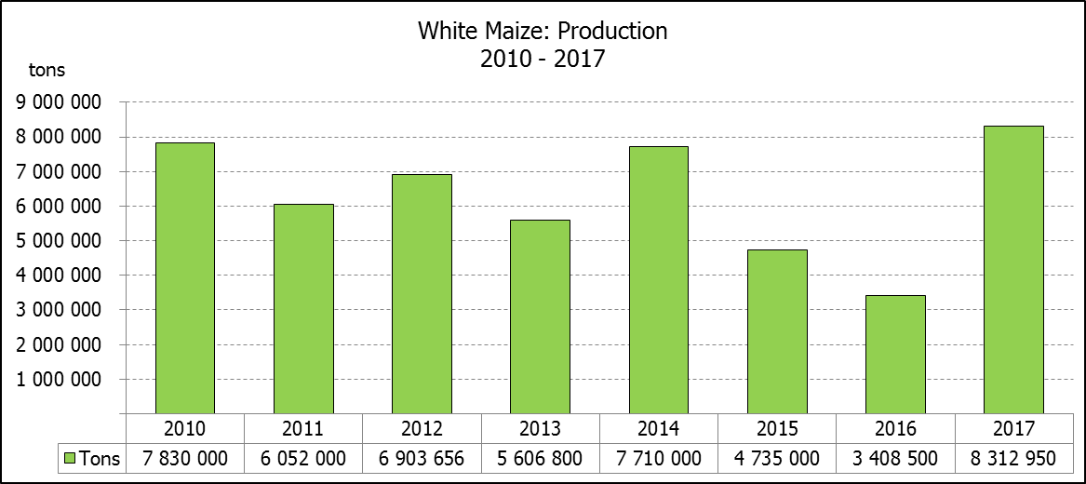

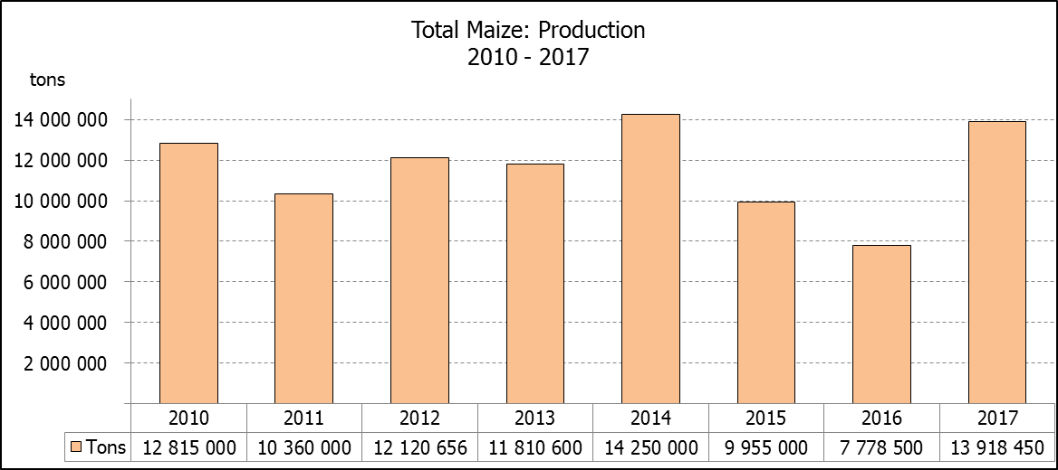
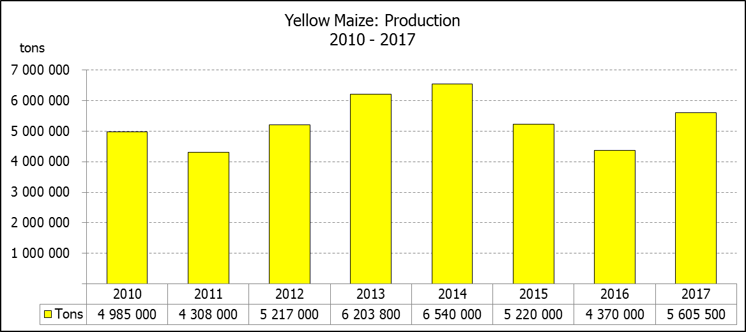

WHITE AND YELLOW MAIZE – REVISED AREA PLANTED AND FIRST PRODUCTION FORECAST: 2017
WIT- EN GEELMIELIES – HERSIENE OPPERVLAKTE EN EERSTE PRODUKSIESKATTING: 2017

Provinsie/  Province | Area planted/  Oppervlakte beplant  2017 |  |  | 1st forecast/  1ste skatting  2017 |  |  | Area planted/  Oppervlakte beplant  2016 |  |  | Final crop/  Finale oes  2016
Provinsie/  Province | White/  Wit  Ha | Yellow/  Geel  Ha | Total/  Totaal  Ha | White/  Wit  Tons | Yellow/  Geel  Tons | Total/  Totaal  Tons | White/  Wit  Ha | Yellow/  Geel  Ha | Total/  Totaal  Ha | White/  Wit  Tons | Yellow/  Geel  Tons | Total/  Totaal  Tons
Western Cape/Wes-Kaap | 200 | 2 000 | 2 200 | 1 800 | 18 000 | 19 800 | 500 | 4 000 | 4 500 | 5 000 | 40 000 | 45 000
Northern Cape/Noord-Kaap | 3 500 | 45 000 | 48 500 | 42 000 | 607 500 | 649 500 | 3 750 | 50 000 | 53 750 | 35 000 | 675 000 | 710 000
Free State/Vrystaat | 805 000 | 355 000 | 1 160 000 | 4 145 750 | 1 704 000 | 5 849 750 | 390 000 | 310 000 | 700 000 | 1 190 500 | 1 023 000 | 2 213 500
Eastern Cape/Oos-Kaap | 4 400 | 9 500 | 13 900 | 26 400 | 57 000 | 83 400 | 2 000 | 12 000 | 14 000 | 10 000 | 66 000 | 76 000
KwaZulu-Natal | 50 000 | 50 000 | 100 000 | 310 000 | 325 000 | 635 000 | 38 000 | 48 000 | 86 000 | 215 000 | 307 000 | 522 000
Mpumalanga | 160 000 | 330 000 | 490 000 | 960 000 | 1 980 000 | 2 940 000 | 160 000 | 330 000 | 490 000 | 752 000 | 1 567 000 | 2 319 000
Limpopo | 40 000 | 24 000 | 64 000 | 240 000 | 144 000 | 384 000 | 31 500 | 22 000 | 53 500 | 178 000 | 132 000 | 310 000
Gauteng | 60 000 | 60 000 | 120 000 | 351 000 | 330 000 | 681 000 | 49 000 | 56 000 | 105 000 | 207 000 | 235 000 | 442 000
North West/Noordwes | 520 000 | 110 000 | 630 000 | 2 236 000 | 440 000 | 2 676 000 | 340 000 | 100 000 | 440 000 | 816 000 | 325 000 | 1 141 000
Total/Totaal | 1 643 100 | 985 500 | 2 628 600 | 8 312 950 | 5 605 500 | 13 918 450 | 1 014 750 | 932 000 | 1 946 750 | 3 408 500 | 4 370 000 | 7 778 500

SUNFLOWER SEED – REVISED AREA PLANTED AND FIRST PRODUCTION FORECAST: 2017
SONNEBLOMSAAD – HERSIENE OPPERVLAKTE EN EERSTE PRODUKSIESKATTING: 2017

Province/  Provinsie | Area planted/  Opp beplant  Ha | 1st forecast/  1ste skatting  Tons | Area planted/  Opp beplant  Ha | Final crop/  Finale oes  Tons
Province/  Provinsie | 2017 | 2017 | 2016 | 2016
Western Cape/Wes-Kaap | - | - | - | -
Northern Cape/Noord-Kaap | 250 | 250 | 500 | 600
Free State/Vrystaat | 330 000 | 528 000 | 400 000 | 440 000
Eastern Cape/Oos-Kaap | - | - | - | -
KwaZulu-Natal | 300 | 300 | - | -
Mpumalanga | 2 200 | 2 420 | 4 000 | 4 400
Limpopo | 90 000 | 90 000 | 65 000 | 48 750
Gauteng | 3 000 | 3 150 | 4 000 | 4 000
North West/Noordwes | 210 000 | 304 500 | 245 000 | 257 250
Total/Totaal | 635 750 | 928 620 | 718 500 | 755 000

SOYBEANS – REVISED AREA PLANTED AND FIRST PRODUCTION FORECAST: 2017
SOJABONE – HERSIENE OPPERVLAKTE EN EERSTE PRODUKSIESKATTING: 2017

Province/  Provinsie | Area planted/  Opp beplant  Ha | 1st forecast/  1ste skatting  Tons | Area planted/  Opp beplant  Ha | Final crop/  Finale oes  Tons
Province/  Provinsie | 2017 | 2017 | 2016 | 2016
Western Cape/Wes-Kaap | 700 | 1 050 | 800 | 1 200
Northern Cape/Noord-Kaap | 3 000 | 10 500 | 4 000 | 13 600
Free State/Vrystaat | 230 000 | 402 500 | 174 000 | 148 000
Eastern Cape/Oos-Kaap | 1 850 | 2 775 | 1 500 | 2 100
KwaZulu-Natal | 30 500 | 85 400 | 28 000 | 66 000
Mpumalanga | 241 000 | 433 800 | 240 000 | 408 000
Limpopo | 10 400 | 31 200 | 16 000 | 38 400
Gauteng | 25 400 | 58 420 | 23 000 | 50 600
North West/Noordwes | 23 000 | 44 850 | 15 500 | 14 100
Total/Totaal | 565 850 | 1 070 495 | 502 800 | 742 000

GROUNDNUTS – REVISED AREA PLANTED AND FIRST PRODUCTION FORECAST: 2017
GRONDBONE – HERSIENE OPPERVLAKTE EN EERSTE PRODUKSIESKATTING: 2017

Province/  Provinsie | Area planted/  Opp beplant  Ha | 1st forecast/  1ste skatting  Tons | Area planted/  Opp beplant  Ha | Final crop/  Finale oes  Tons
Province/  Provinsie | 2017 | 2017 | 2016 | 2016
Western Cape/Wes-Kaap | - | - | - | -
Northern Cape/Noord-Kaap | 4 000 | 14 000 | 5 000 | 10 000
Free State/Vrystaat | 22 000 | 39 600 | 6 500 | 2 920
Eastern Cape/Oos-Kaap | - | - | - | -
KwaZulu-Natal | - | - | - | -
Mpumalanga | - | - | - | -
Limpopo | 2 500 | 3 375 | 1 600 | 1 440
Gauteng | - | - | - | -
North West/Noordwes | 24 000 | 31 200 | 9 500 | 3 320
Total/Totaal | 52 500 | 88 175 | 22 600 | 17 680

SORGHUM – REVISED AREA PLANTED AND FIRST PRODUCTION FORECAST: 2017
SORGHUM – HERSIENE OPPERVLAKTE EN EERSTE PRODUKSIESKATTING: 2017

Province/  Provinsie | Area planted/  Opp beplant  Ha | 1st forecast/  1ste skatting  Tons | Area planted/  Opp beplant  Ha | Final crop/  Finale oes  Tons
Province/  Provinsie | 2017 | 2017 | 2016 | 2016
Western Cape/Wes-Kaap | - | - | - | -
Northern Cape/Noord-Kaap | - | - | - | -
Free State/Vrystaat | 7 700 | 23 100 | 28 000 | 24 150
Eastern Cape/Oos-Kaap | - | - | - | -
KwaZulu-Natal | 400 | 1 600 | 500 | 1 650
Mpumalanga | 12 000 | 60 000 | 10 000 | 32 500
Limpopo | 18 000 | 43 200 | 7 000 | 9 800
Gauteng | 750 | 2 550 | - | -
North West/Noordwes | 3 500 | 10 500 | 3 000 | 2 400
Total/Totaal | 42 350 | 140 950 | 48 500 | 70 500

DRY BEANS – REVISED AREA PLANTED AND FIRST PRODUCTION FORECAST: 2017
DROëBONE – HERSIENE OPPERVLAKTE EN EERSTE PRODUKSIESKATTING: 2017

Province/  Provinsie | Area planted/  Opp beplant  Ha | 1st forecast/  1ste skatting  Tons | Area planted/  Opp beplant  Ha | Final crop/  Finale oes  Tons
Province/  Provinsie | 2017 | 2017 | 2016 | 2016
Western Cape/Wes-Kaap | 100 | 150 | 100 | 150
Northern Cape/Noord-Kaap | 650 | 1 495 | 350 | 630
Free State/Vrystaat | 18 000 | 25 200 | 17 000 | 17 000
Eastern Cape/Oos-Kaap | 300 | 450 | 250 | 375
KwaZulu-Natal | 4 500 | 5 400 | 2 200 | 2 640
Mpumalanga | 5 500 | 7 700 | 6 000 | 6 000
Limpopo | 5 000 | 10 000 | 3 000 | 3 750
Gauteng | 1 500 | 1 950 | 2 500 | 2 500
North West/Noordwes | 10 000 | 12 000 | 3 000 | 2 400
Total/Totaal | 45 550 | 64 345 | 34 400 | 35 445

CONFIDENTIALITY ISSUES that CEC members are committed to adhere to on the day of the meeting
- Personal items such as laptops, handbags, cell phones, etc. are not allowed in the venue during the meeting
- No member is allowed to leave the meeting before 12:00 in order to prevent disclosure of the information
- The embargo time for the release of crop estimates information is 15:30
- No member is allowed to discuss crop estimates information with anyone other than a member of the Committee before the embargo time
- Only the Chairperson, or a member appointed by the Chairperson, may release the figures to the media
- Members must regard the detail of any information that was collected for and/or discussed during the meeting, as confidential
- Individual information received for crop estimate purposes is treated strictly confidential, and is not divulged for any other purposes

REVISED AREA ESTIMATE AND FIRST PRODUCTION FORECAST OF SUMMER CROPS (2017 PRODUCTION SEASON)/
HERSIENE OPPERVLAKTE- EN EERSTE PRODUKSIESKATTING VIR SOMERGEWASSE (2017 PRODUKSIE-SEISOEN)
25 FEBRUARY 2016 / 25 FEBRUARIE 2016

Summer field crops – 2017  Commercial maize: The revised area estimate for maize is 2,629 mill. ha, which is 35,03% or 681 850 ha more than the 1,947 mill. ha planted for the previous season and also 3,11% or 79 400 ha more than the preliminary area estimate of 2,549 mill. ha released in January 2017.  The expected commercial maize crop is 13,918 mill. tons, which is 78,93% or 6,140 mill. tons more than the 7,778 mill. tons of the previous season (2016), which was a drought year.  The area planted figures are mainly based on information obtained from the Producer Independent Crop Estimation System (PICES), conducted by the National Crop Statistics Consortium (NCSC) for Free State, KwaZulu-Natal, Mpumalanga, Limpopo, Gauteng and North West provinces.  Please note that information from the objective yield survey by the NCSC for the Mpumalanga province will be available in April 2017; and for the Free State and North West provinces in May 2017. The current yield figures are mainly obtained from producers in the different provinces.  The area estimate for white maize is 1,643 mill. ha, which represents an increase of 61,92% or 628 350 ha compared to the 1,015 mill. ha planted last season. In the case of yellow maize the area estimate is 985 500 ha, which is also 5,74% or 53 500 ha more than the 932 000 ha planted last season.  The production forecast of white maize is 8,313 mill. tons, which is 143,89% or 4,904 mill. tons more than the 3,408 mill. tons of last season. The yield for white maize is 5,06 t/ha. In the case of yellow maize the production forecast is 5,605 mill. tons, which is 28,27% or 1,235 mill. tons more than the 4,370 mill. tons of last season. The yield for yellow maize is 5,69 t/ha.  Other summer crops:  Sunflower seed: The revised area estimate for sunflower seed is 635 750 ha, which is 11,52% or 82 750 ha less than the 718 500 ha planted the previous season. The production forecast for sunflower seed is 928 620 tons, which is 23,00% or 173 620 tons more than the 755 000 tons of the previous season. The expected yield is 1,46 t/ha.  Other crops: It is estimated that 565 850 ha have been planted to soybeans, which represents an increase of 12,54% or 63 050 ha compared to the 502 800 ha planted last season. The production forecast is 1,070 mill. tons, which is 44,27% or 328 495 tons more than the 742 000 tons of the previous season. The expected yield is 1,89 t/ha.  For groundnuts, the area estimate is 52 500 ha, which is 132,30% or 29 900 ha more than the 22 600 ha planted for the previous season. The expected crop is 88 175 tons – which is 398,73% or 70 495 tons more than the 17 680 tons of last season. The expected yield is 1,68 t/ha.  The area estimate for sorghum decreased by 12,68% or 6 150 ha, from 48 500 ha to 42 350 ha against the previous season. The production forecast for sorghum is 140 950 tons, which is 99,93% or 70 450 tons more than the 70 500 tons of the previous season. The expected yield is 3,33 t/ha.  For dry beans, the area estimate is 45 550 ha, which is 32,41% or 11 150 ha more than the 34 400 ha planted for the previous season. The production forecast is 64 345 tons, which is 81,53% or 28 900 tons more than the 35 445 tons of the previous season. The expected yield is 1,41 t/ha.  Please note that the second production forecast for summer field crops for 2017 will be released on 28 March 2017. |  | Somergewasse – 2017  Kommersiële mielies: Die hersiene skatting van die oppervlakte onder mielies beloop 2,629 milj. ha, wat 35,03% of 681 850 ha meer is as die 1,947 milj. ha wat verlede seisoen aangeplant is, maar ook 3,11% of 79 400 ha meer as die voorlopige oppervlakteskatting van 2,549 milj. ha soos vrygestel in Januarie 2017.  Die verwagte kommersiële mielie-oes is 13,918 milj. ton wat 78,93% of 6,140 milj. ton meer is as die 7,778 milj. ton van die vorige seisoen (2016), wat ’n droogte jaar was.  Die oppervlakte beplant syfers is hoofsaaklik verkry vanaf die Produsente Onafhanklike Oesskattingstelsel (PICES), soos deur die Nasionale Oesskattingskonsortium gerapporteer vir Vrystaat, KwaZulu-Natal, Mpumalanga, Limpopo, Gauteng en Noordwes provinsies.  Neem kennis dat inligting van die objektiewe opbrengs-opname van die Konsortium vir die Mpumalanga provinsie, in April 2017 gerapporteer word en vir die Vrystaat en Noordwes provinsies in Mei 2017. Die huidige opbrengs syfers is hoofsaaklik verkry vanaf produsente in die verskillende provinsies.  Die oppervlak onder witmielies is 1,643 milj. ha, wat ’n toename van 61,92% of 628 350 ha verteenwoordig vergeleke met die 1,015 milj. ha die vorige seisoen. In die geval van geelmielies is die oppervlakteskatting 985 500 ha, wat ook 5,74% of 53 500 ha meer is as die 932 000 ha geplant die vorige seisoen.  Die produksieskatting van witmielies is 8,313 milj. ton, 143,89% of 4,904 milj. ton meer is as die 3,408 milj. ton van die vorige seisoen. Die opbrengs van witmielies is 5,06 t/ha. In die geval van geelmielies is die produksieskatting 5,605 miljoen ton, wat 28,27% of 1,235 milj. ton meer is as die 4,370 milj. ton van die vorige seisoen. Die opbrengs van geelmielies is 5,69 t/ha.  Ander somergewasse:  Sonneblomsaad: Die voorlopige oppervlakteskatting vir sonneblomsaad is 635 750 ha, wat 11,52% of 82 750 ha minder is as die 718 500 ha aangeplant die vorige seisoen. Die produksieskatting vir sonneblomsaad is 928 620 ton, wat 23,00% of 173 620 ton meer is as die 755 000 ton van die vorige seisoen. Die verwagte opbrengs is 1,46 t/ha.  Ander gewasse: Die geskatte oppervlakte beplant met sojabone is 565 850 ha, wat ’n toename van 12,54% of 63 050 ha verteenwoordig vergeleke met die 502 800 ha geplant die vorige seisoen. Die produksieskatting is 1,070 mill. tons, wat 44,27% of 328 495 ton meer is as die 742 000 ton van die vorige seisoen. Die verwagte opbrengs is 1,89 t/ha.  Vir grondbone is die oppervlakteskatting 52 500 ha, wat 132,30% of 29 900 ha meer is as die 22 600 ha geplant vir die vorige seisoen. Die verwagte grondbone-oes is 88 175 ton – 398,73% of 70 495 ton meer is as die 17 680 ton van die vorige seisoen. Die verwagte opbrengs is 1,68 t/ha.  Die oppervlakteskatting vir sorghum het afgeneem met 12,68% of 6 150 ha, van 48 500 ha tot 42 350 ha teenoor die vorige seisoen. Die produksieskatting van sorghum is 140 950 ton – 99,93% of 70 450 ton meer is as die 70 500 ton van die vorige seisoen. Die verwagte opbrengs is 3,33 t/ha.  Vir droëbone is die geskatte oppervlakte beplant 45 550 ha, wat 32,41% of 11 150 ha meer is as die 34 400 ha geplant vir die vorige seisoen. Die produksieskatting is 64 345 ton, wat 81,53% of 28 900 ton meer is as die 35 445 ton van die vorige seisoen. Die verwagte opbrengs is 1,41 t/ha.  Neem asseblief kennis dat die tweede produksieskatting vir somergewasse vir 2016, op 28 Maart 2017 vrygestel sal word.
The area estimate and final production estimate for winter cereals for the 2016 is hereby released. /
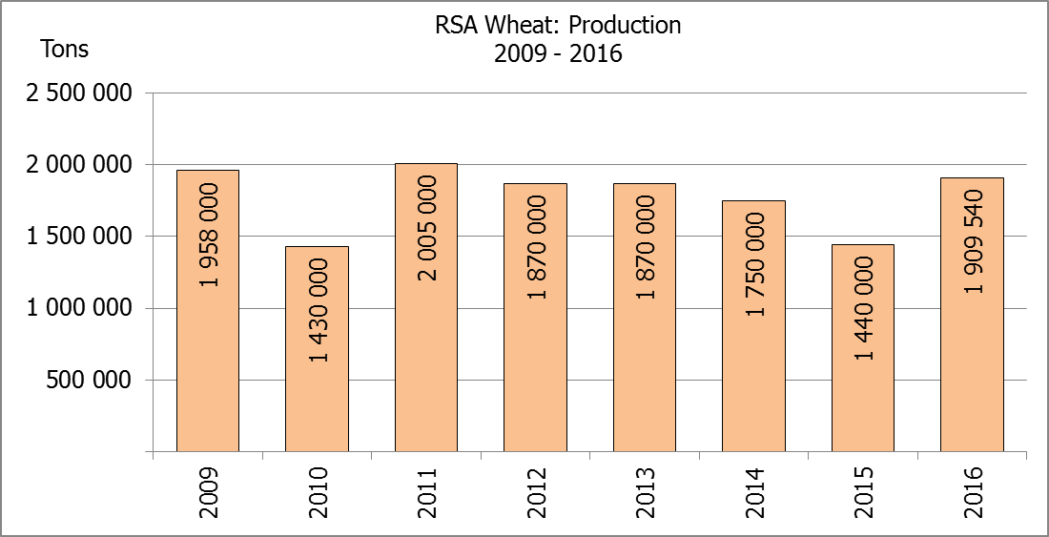
Hiermee word die oppervlakteskatting en finale produksieskatting vir wintergewasse vir 2016 vrygestel.
WINTER CEREALS – AREA PLANTED ESTIMATE AND FINAL PRODUCTION ESTIMATE: 2016
WINTERGEWASSE – OPPERVLAKTE- EN FINALE PRODUKSIESKATTING: 2016
CROP/GEWAS | Area planted/  Opp beplant  2016 | Final estimate/  Finale skatting  2016 | 6th forecast/  6de skatting  2016 | Area planted/  Opp beplant  2015 | Final crop/  Finale oes  2015 | Change/  Verandering
CROP/GEWAS | Ha | Tons | Tons | Ha | Tons | %
CROP/GEWAS | (A) | (B) | (C) | (D) | (E) | (B) ÷ (C)
Commercial/Kommersieel:
Wheat/Koring | 508 365 | 1 909 540 | 1 893 390 | 482 150 | 1 440 000 | +0,85
Malting barley/Moutgars | 88 695 | 354 065 | 354 065 | 93 730 | 332 000 | 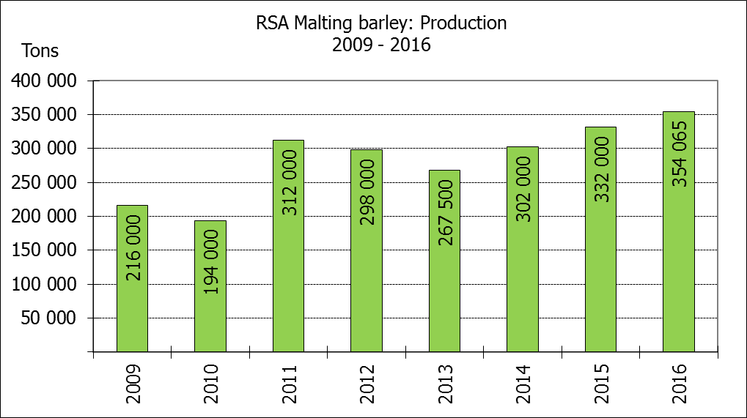  -
Canola/Kanola | 68 075 | 105 460 | 105 460 | 78 050 | 93 000 | -
Total/Totaal | 665 135 | 2 369 065 | 2 352 915 | 653 930 | 1 865 000 | +0,69
* Note: Estimate is for calendar year, e.g. production season 2016 = 2016
* Nota: Skatting is vir kalenderjaar, bv. produksie-seisoen 2016 = 2016
WHEAT – AREA PLANTED ESTIMATE AND FINAL PRODUCTION ESTIMATE: 2016
KORING – OPPERVLAKTE- EN FINALE PRODUKSIESKATTING: 2016
Province/  Provinsie | Area planted/  Opp beplant  Ha | Final estimate/  Finale skatting  Tons | Area planted/  Opp beplant  Ha | Final crop/  Finale oes  Tons
Province/  Provinsie | 2016 | 2016 | 2015 | 2015
Western Cape/Wes-Kaap | 323 000 | 1 098 200 | 310 000 | 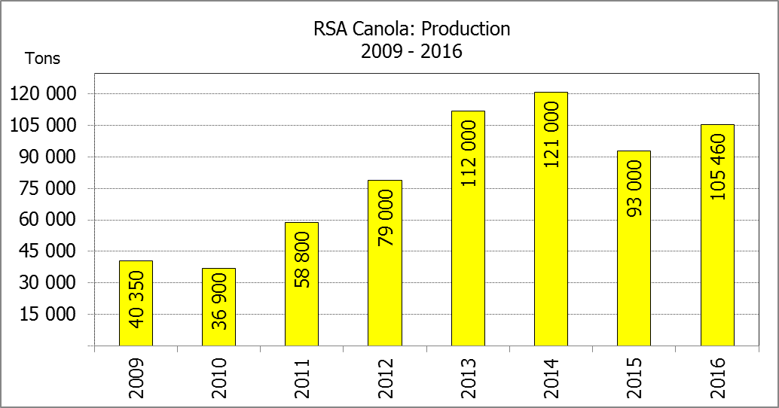  697 500
Northern Cape/Noord-Kaap | 35 000 | 266 000 | 36 000 | 259 200
Free State/Vrystaat | 110 000 | 308 000 | 80 000 | 176 500
Eastern Cape/Oos-Kaap | 2 200 | 11 000 | 3 100 | 14 880
KwaZulu-Natal | 6 500 | 37 050 | 7 300 | 41 000
Mpumalanga | 2 300 | 13 800 | 3 500 | 19 500
Limpopo | 17 000 | 103 700 | 27 000 | 144 420
Gauteng | 365 | 2 190 | 250 | 1 500
North West/Noordwes | 12 000 | 69 600 | 15 000 | 85 500
Total/Totaal | 508 365 | 1 909 540 | 482 150 | 1 440 000

AREA ESTIMATE AND FINAL PRODUCTION ESTIMATE OF WINTER CROPS (2016) /
OPPERVLAKTESKATTING EN FINALE PRODUKSIESKATTING VAN WINTERGEWASSE (2016)
28 FEBRUARY 2017 / 28 FEBRUARIE 2017

Winter cereal crops - 2016 production season  Wheat: The expected commercial production of wheat is 1,910 mill. tons, which is 0,85% or 16 150 tons more than the previous forecast of 1,893 mill. tons, whilst the expected yield is 3,76 t/ha.  The expected production in the Western Cape increased by 1,49 % or 16 150 tons, from 1,082 mill. tons to 1,098 mill. tons against the previous forecast.  The production forecast for the Free State remained unchanged at 308 000 tons. In the Northern Cape, the expected production forecast also remained unchanged at 266 000 tons.  The area estimate for wheat 508 365 ha.  Other crops: The production forecast for malting barley remained unchanged at 354 065 tons. The area planted is estimated at 88 695 ha, while the expected yield is 3,99 t/ha.  The expected canola crop also remained unchanged at 105 460 tons. The area estimate for canola is 68 075 ha, with an expected yield of 1,55 t/ha.  Please note that the intentions to plant winter cereals for 2017 will be released on 25 April 2017. |  | Wintergewasse - 2016 produksie-seisoen  Koring: Die verwagte kommersiële produksie vir koring is 1,910 milj. ton, wat 0,85% of 16 150 ton meer is as die vorige skatting van 1,893 milj. ton, terwyl die verwagte opbrengs 3,76 t/ha is.  Die verwagte produksie in die Wes-Kaap het met 1,49 % of 16 150 ton toegeneem, van 1,082 milj. ton tot 1,098 milj. ton teenoor die vorige skatting.  Die produksieskatting vir die Vrystaat is onveranderd gelaat op 308 000 ton. In die Noord-Kaap is die verwagte produksie ook onveranderd gelaat op 266 000 ton.  Die oppervlakteskatting vir koring is 508 365 ha.  Ander gewasse: Die produksieskatting vir moutgars is onveranderd gelaat op 354 065 ton. Die oppervlakte beplant is beraam op 88 695 ha, terwyl die verwagte opbrengs 3,99 t/ha beloop.  Die verwagte kanola-oes is ook onveranderd gelaat op 105 460 ton. Die oppervlakteskatting vir kanola is 68 075 ha, met ŉ verwagte opbrengs van 1,55 t/ha.  Neem asseblief kennis dat die voorneme om wintergewasse te plant vir 2017 op 25 April 2017 vrygestel sal word.

Information is available on the internet at http://www.daff.gov.za/statistics and economic reports or http://www.sagis.org.za, as from 15:30 on the date of the relevant meeting of the Crop Estimates Committee. |  | Inligting is beskikbaar op die internet by http://www.daff.gov.za/statistics and economic reports of by http://www.sagis.org.za, vanaf 15:30 op die dag van die toepaslike vergadering van die Oesskattingskomitee.

