 | crop estimates committee | 
 | oesskattingskomitee
From/Van: Baldwin Netshifhefhe
Tel: 012 319 8043  Fax/Faks: 012 319 8031/5  E-mail/E-pos: BaldwinN@daff.gov.za
Web page/Webblad: www.daff.gov.za/statistics and economic reports or www.sagis.org.za/CEC: Crop Estimates
EMBARGO: 15:30
20 December/Desember 2018
The area estimate and fifth production forecast for winter cereals for the 2018 is hereby released. /
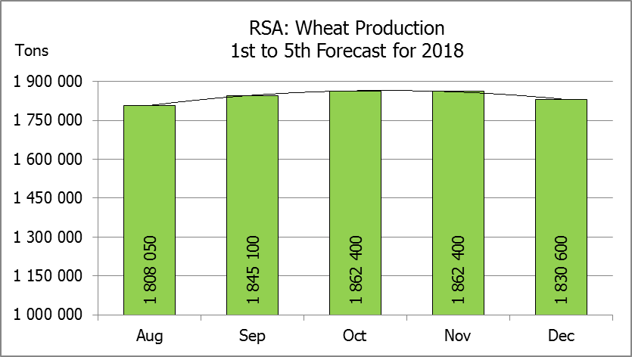
Hiermee word die oppervlakteskatting en vyfde produksieskatting vir wintergewasse vir 2018 vrygestel.
WINTER CEREALS – AREA PLANTED ESTIMATE AND FIFTH PRODUCTION FORECAST: 2018
WINTERGEWASSE – OPPERVLAKTE- EN VYFDE PRODUKSIESKATTING: 2018
CROP/GEWAS | Area planted/  Opp beplant  2018 | 5th forecast/  5de skatting  2018 | 4th forecast/  4de skatting  2018 | Area planted/  Opp beplant  2017 | Final crop/  Finale oes  2017 | Change/  Verandering
CROP/GEWAS | Ha | Tons | Tons | Ha | Tons | %
CROP/GEWAS | (A) | (B) | (C) | (D) | (E) | (B) ÷ (C)
Commercial/Kommersieel:
Wheat/Koring | 503 350 | 1 830 600 | 1 862 400 | 491 600 | 1 535 000 | -1,71
Malting barley/Moutgars | 119 000 | 401 840 | 401 840 | 91 380 | 307 000 | 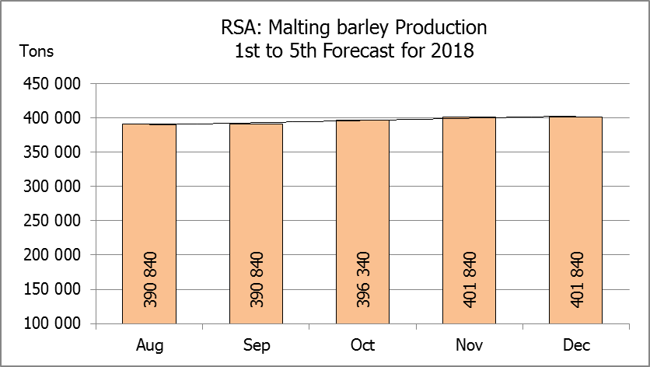  -
Canola/Kanola | 77 000 | 103 950 | 115 500 | 84 000 | 93 500 | -10,00
Total/Totaal | 699 350 | 2 336 390 | 2 379 740 | 666 980 | 1 935 500 | -1,82
* Note: Estimate is for calendar year, e.g. production season 2018 = 2018
* Nota: Skatting is vir kalenderjaar, bv. produksie-seisoen 2018 = 2018
WHEAT – AREA PLANTED ESTIMATE AND FIFTH PRODUCTION FORECAST: 2018
KORING – OPPERVLAKTE- EN VYFDE PRODUKSIESKATTING: 2018
Province/  Provinsie | Area planted/  Opp beplant  Ha | 5th forecast/  5de skatting  Tons | Area planted/  Opp beplant  Ha | Final crop/  Finale oes  Tons
Province/  Provinsie | 2018 | 2018 | 2017 | 2017
Western Cape/Wes-Kaap | 318 000 | 906 300 | 326 000 | 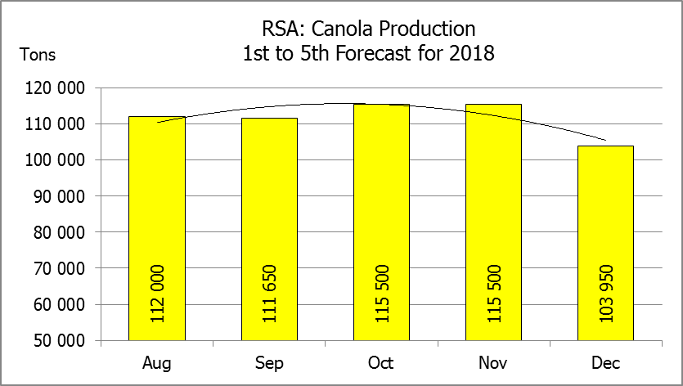  586 800
Northern Cape/Noord-Kaap | 38 000 | 294 500 | 38 000 | 311 650
Free State/Vrystaat | 100 000 | 340 000 | 80 000 | 336 000
Eastern Cape/Oos-Kaap | 1 650 | 10 725 | 1 900 | 9 500
KwaZulu-Natal | 7 000 | 43 400 | 7 500 | 45 750
Mpumalanga | 3 500 | 21 875 | 4 000 | 25 400
Limpopo | 20 000 | 122 000 | 20 000 | 132 000
Gauteng | 1 200 | 7 800 | 700 | 4 200
North West/Noordwes | 14 000 | 84 000 | 13 500 | 83 700
Total/Totaal | 503 350 | 1 830 600 | 491 600 | 1 535 000

AREA ESTIMATE AND FIFTH PRODUCTION FORECAST OF WINTER CROPS (2018) /
OPPERVLAKTESKATTING EN VYFDE PRODUKSIESKATTING VAN WINTERGEWASSE (2018)
20 DECEMBER/DESEMBER 2018

Winter cereal crops - 2018 production season  Wheat: The expected commercial production of wheat is 1,831 mill. tons, which is 1,71% or 31 800 tons less than the previous forecast of 1,862 mill. tons, with an expected yield of 3,64 t/ha.  The expected production in the Western Cape is 906 300 tons (50%), in the Free State 340 000 tons (19%) and in the Northern Cape 294 500 tons (16%).  The area estimate for wheat is 503 350 ha. An estimated 318 000 ha or 63% is planted in the Western Cape, 100 000 ha or 20% in the Free State and 38 000 ha or 8% in the Northern Cape.  Other crops: The production forecast for malting barley is 401 840 tons, which is the same as the previous month’s forecast. The area planted is estimated at 119 000 ha, while the expected yield is 3,38 t/ha.  The expected canola crop decreased by 10,0% or 11 550 tons to 103 950 tons. The area estimate for canola is 77 000 ha and the expected yield is 1,35 t/ha.  Please note that the sixth production forecast for winter cereals for 2018 will be released on 29 January 2019. |  | Wintergewasse - 2018 produksie-seisoen  Koring: Die verwagte kommersiële produksie vir koring is 1,831 milj. ton, wat 1,71% of 31 800 ton minder is as die vorige skatting van 1,862 milj. ton, met ‘n verwagte opbrengs van 3,64 t/ha.  Die verwagte produksie in die Wes-Kaap is 906 300 ton (50%), in die Vrystaat 340 000 ton (19%) en in die Noord-Kaap 294 500 ton (16%).  Die oppervlakteskatting vir koring is 503 350 ha. Die beraamde oppervlakte geplant in die Wes-Kaap is 318 000 ha of 63%, die Vrystaat is 100 000 ha of 20% en 38 000 ha of 8% is in die Noord-Kaap.  Ander gewasse: Die produksieskatting vir moutgars is 401 840 ton, wat dieselfde is as die vorige maand se skatting. Die oppervlakte beplant word beraam op 119 000 ha, terwyl die verwagte opbrengs 3,38 t/ha beloop.  Die verwagte kanola-oes is met 10,0% of 11 550 ton verminder na 103 950 ton. Die oppervlakteskatting vir kanola is 77 000 ha en die verwagte opbrengs is 1,35 t/ha.  Neem asseblief kennis dat die sesde produksieskatting vir wintergewasse vir 2018 op 29 Januarie 2019 vrygestel sal word.

Information is available on the internet at http://www.daff.gov.za/statistics and economic reports or http://www.sagis.org.za, as from 15:30 on the date of the relevant meeting of the Crop Estimates Committee. |  | Inligting is beskikbaar op die internet by http://www.daff.gov.za/statistics and economic reports of by http://www.sagis.org.za, vanaf 15:30 op die dag van die toepaslike vergadering van die Oesskattingskomitee.
CONFIDENTIALITY ISSUES that CEC members are committed to adhere to on the day of the meeting
- Personal items such as laptops, handbags, cell phones, etc. are not allowed in the venue during the meeting
- No member is allowed to leave the meeting before 12:00 in order to prevent disclosure of the information
- The embargo time for the release of crop estimates information is 15:30
- No member is allowed to discuss crop estimates information with anyone other than a member of the Committee before the embargo time
- Only the Chairperson, or a member appointed by the Chairperson, may release the figures to the media
- Members must regard the detail of any information that was collected for and/or discussed during the meeting, as confidential
- Individual information received for crop estimate purposes is treated strictly confidential, and is not divulged for any other purposes

