 | crop estimates committee | 
 | oesskattingskomitee
From/Van: Mr Baldwin Netshifhefhe
Tel: 012 319 8043/32  E-mail/E-pos: BaldwinN@dalrrd.gov.za
Web page/Webblad: www.dalrrd.gov.za/old website/statistics and economic reports or
www.sagis.org.za/CEC: Crop Estimates EMBARGO: 14:30

19 December/ Desember 2023
The area estimate and fifth production forecast for winter cereals for the 2023 is hereby released. /
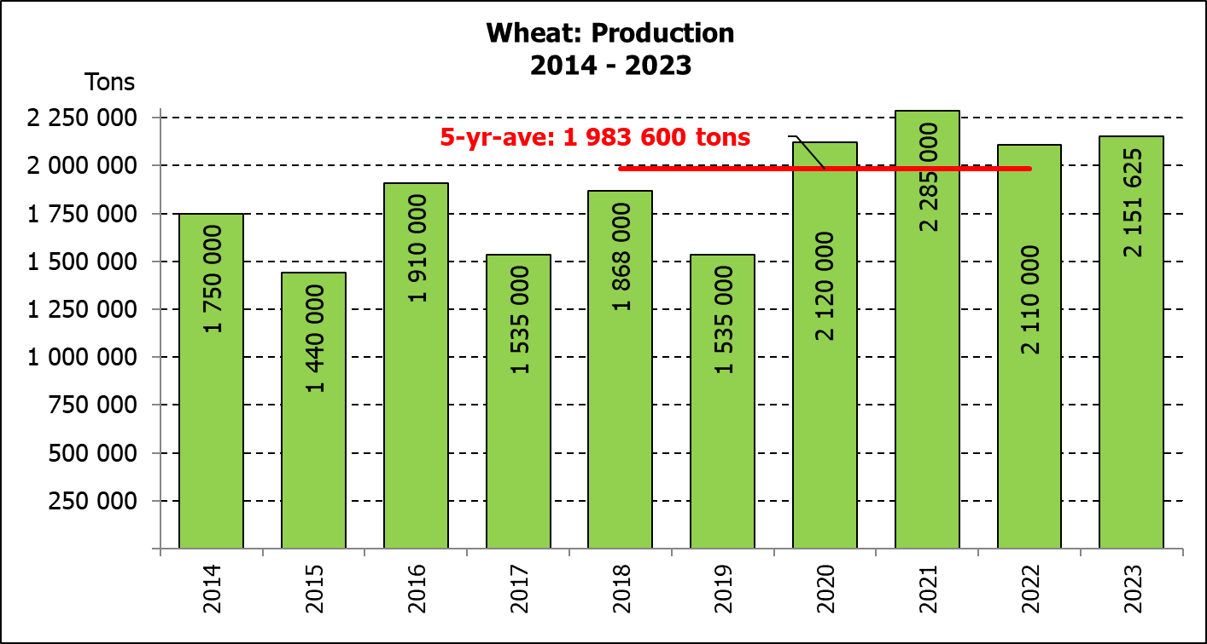
Hiermee word die oppervlakte- en vyfde produksieskatting vir wintergewasse vir 2023 vrygestel.

WINTER CEREALS – AREA PLANTED AND FIFTH PRODUCTION FORECAST: 2023 PRODUCTION SEASON
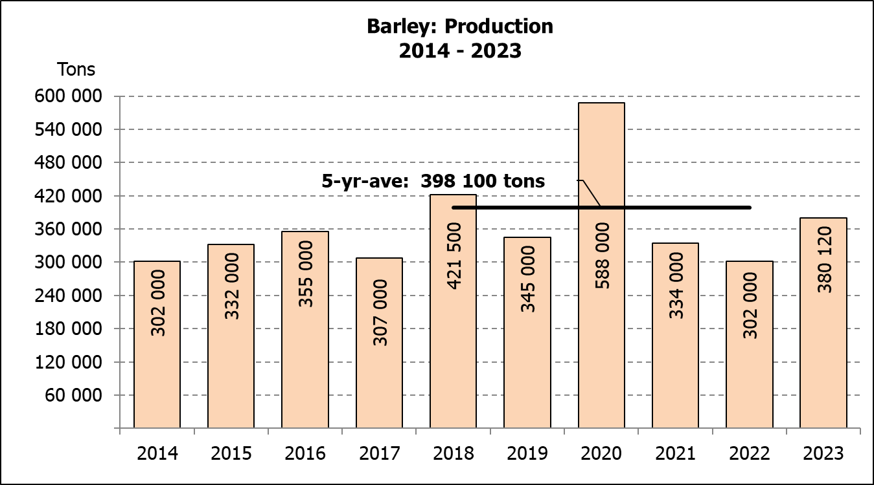
WINTERGEWASSE - OPPERVLAKTE- EN VYFDE PRODUKSIESKATTING: 2023 PRODUKSIE-SEISOEN
CROP/GEWAS | Area planted/  Opp beplant  2023 | 5th forecast/  5de skatting  2023 | 4th forecast/  4de skatting  2023 | Area planted/  Opp beplant  2022 | Final crop/  Finale oes  2022 | Change/  Verandering
CROP/GEWAS | Ha | Tons | Tons | Ha | Tons | %
CROP/GEWAS | (A) | (B) | (C) | (D) | (E) | (B) ÷ (C)
Commercial/Kommersieel:
Wheat/Koring | 537 950 | 2 151 625 | 2 151 625 | 566 800 | 2 110 000 | -
Barley/Gars | 107 600 | 360 220 | 360 220 | 101 000 | 302 000 | -
Canola/Kanola | 131 200 | 237 450 | 237 450 | 123 510 | 210 000 | -
Oats/Hawer | 27 500 | 36 200 | 36 200 | 27 000 | 27 550 | -
Sweet lupines/Soetlupine | 16 000 | 16 800 | 16 800 | 21 000 | 15 750 | -
1) Commercial only. Excluding barley or oats used as pasture, silage, hay and/or on the farm as fodder for livestock /
Slegs kommersieël. Uitgesluit gars of hawer wat gebruik word as weiding, kuilvoer, hooi en/of op die plaas as voer vir vee.

WHEAT – AREA PLANTED AND FIFTH PRODUCTION FORECAST: 2023
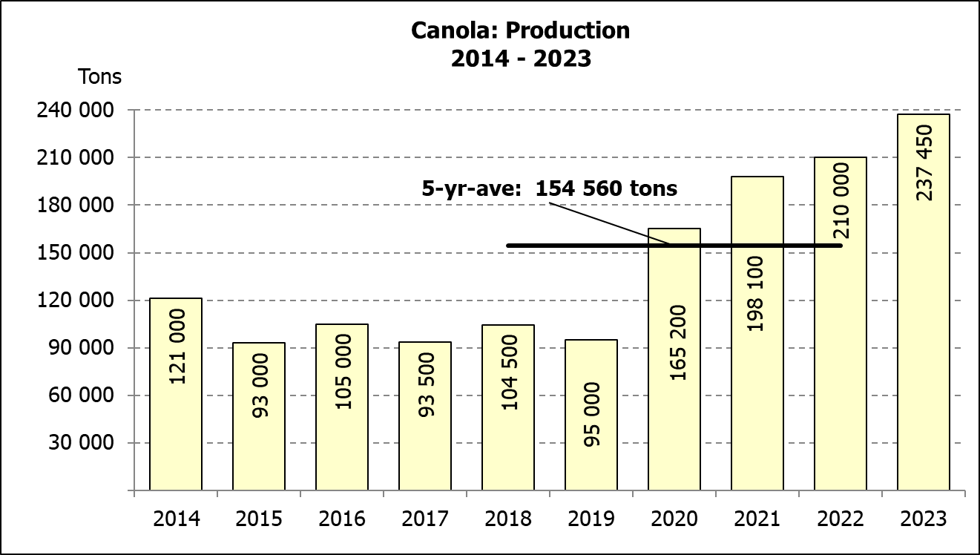
KORING – OPPERVLAKTE- EN VYFDE PRODUKSIESKATTING: 2023
Province/  Provinsie | Area planted/  Opp beplant  Ha | 5th forecast/  5de skatting  Tons | Area planted/  Opp beplant  Ha | Final crop/  Finale oes  Tons
Province/  Provinsie | 2023 | 2023 | 2022 | 2022
Western Cape/Wes-Kaap | 365 000 | 1 131 500 | 360 000 | 918 000
Northern Cape/Noord-Kaap | 40 000 | 310 000 | 47 000 | 338 500
Free State/Vrystaat | 72 000 | 309 600 | 96 000 | 436 800
Eastern Cape/Oos-Kaap | 6 300 | 40 950 | 6 000 | 40 200
KwaZulu-Natal | 8 500 | 56 950 | 9 200 | 60 730
Mpumalanga | 4 200 | 28 560 | 4 000 | 27 600
Limpopo | 30 000 | 199 500 | 29 000 | 187 000
Gauteng | 950 | 6 365 | 1 100 | 7 370
North West/Noordwes | 11 000 | 68 200 | 14 500 | 93 800
Total/Totaal | 537 950 | 2 151 625 | 566 800 | 2 110 000

AREA ESTIMATE AND FIFTH PRODUCTION FORECAST OF WINTER CROPS (2023) /
OPPERVLAKTE- EN VYFDE PRODUKSIESKATTING VAN WINTERGEWASSE (2023)
19 DECEMBER/DESEMBER 2023
Winter cereal crops - 2023 production season  Wheat: The production forecast for wheat is 2,152 mill. tons, which is the same as the previous month’s forecast. The area planted is estimated at 537 950 ha, while the expected yield is 4,00 t/ha.  The expected production in the Western Cape is 1,131 mill. tons (53%), in the Northern Cape 310 000 tons (14%) and in the Free State 309 600 tons (14%).  The estimated area estimate for wheat in the Western Cape is 365 000 ha or 68 %, 72 000 ha or 13 % in the Free State and 40 000 ha or 7 % in the Northern Cape.  Other crops: The production forecast for barley remained unchanged at 360 220 tons. The area planted is estimated at 107 600 ha, while the expected yield is 3,35 t/ha.  The expected canola crop remained unchanged at 237 450 tons. The area estimate for canola is 131 200 ha, with an expected yield of 1,81 t/ha.  The expected crop for oats for the 2023 season is 36 200 tons and the area planted is 27 500 ha. The expected yield is 1,32 t/ha.  In the case of sweet lupines, the production forecast is 16 800 tons, which is also the same as the previous month’s forecast. The area estimate of sweet lupines is 16 000 ha, with an expected yield of 1,05 t/ha.  Please note that the sixth production forecast for winter cereals for 2023 will be released on 30 January 2024. |  | Wintergewasse - 2023 produksie-seisoen  Koring: Die produksieskatting vir koring is 2,152 milj. ton, wat dieselfde is as die vorige maand se skatting. Die oppervlakte beplant word beraam op 537 950 ha, terwyl die verwagte opbrengs 4,00 t/ha beloop.  Die verwagte produksie in die Wes-Kaap is 1,131 milj. ton (53%), in die Noord-Kaap 310 000 ton en in die Vrystaat 309 600 ton (14%).  Die geraamde oppervlakteskatting vir koring in die Wes-Kaap is 365 000 ha of 68 %, 72 000 ha of 13 % in die Vrystaat en 40 000 ha of 7 % in die Noord-Kaap.  Ander gewasse: Die produksieskatting vir gars is onveranderd gelaat op 360 220 ton. Die oppervlakte beplant word beraam op 107 600 ha, terwyl die verwagte opbrengs 3,35 t/ha beloop.  Die verwagte kanola-oes is onveranderd gelaat op 237 450 ton. Die oppervlakteskatting vir kanola is 131 200 ha, met ŉ verwagte opbrengs van 1,81 t/ha.  Die verwagte oes vir hawer vir die 2023-seisoen is 36 200 ton en die oppervlakteskatting is 27 500 ha. Die verwagte opbrengs is 1,32 t/ha.  In die geval van soetlupine is die produksieskatting 16 800 ton, wat ook dieselfde is as die vorige maand se skatting. Die oppervlakte beplant met soetlupine is 16 000 ha, met ‘n verwagte opbrengs van 1,05 t/ha.  Neem asseblief kennis dat die sesde produksieskatting vir wintergewasse vir 2023 op 30 Januarie 2024 vrygestel sal word.
Information is available on the internet at http:// www.dalrrd.gov.za/old website/statistics or http://www.sagis.org.za, as from 14:30 on the date of the relevant meeting of the Crop Estimates Committee. |  | Inligting is beskikbaar op die internet by http://www.dalrrd.gov.za/old website/statistics of by http://www.sagis.org.za, vanaf 14:30 op die dag van die toepaslike vergadering van die Oesskattingskomitee.
The Crop Estimates Committee comprises officials of the following institutions:
Department of Agriculture, Land Reform and Rural Development, Provincial Departments of Agriculture; various ARC-Institutes (Soil, Climate and Water; Small Grains Institute,
Grain Crops Institute), BFAP and Statistics SA.

