 | crop estimates committee | 
 | oesskattingskomitee
From/Van: Mr Baldwin Netshifhefhe
Tel: 012 319 8043  Fax/Faks: 012 319 8031  E-mail/E-pos: BaldwinN@dalrrd.gov.za
Web page/Webblad: www.dalrrd.gov.za/statistics and economic reports or www.sagis.org.za/CEC: Crop Estimates EMBARGO: 14:30

18 December/Desember 2020
The area estimate and fifth production forecast for winter cereals for the 2020 is hereby released. /
Hiermee word die oppervlakte- en vyfde produksieskatting vir wintergewasse vir 2020 vrygestel.

WINTER CEREALS – AREA PLANTED AND FIFTH PRODUCTION FORECAST: 2020 PRODUCTION SEASON
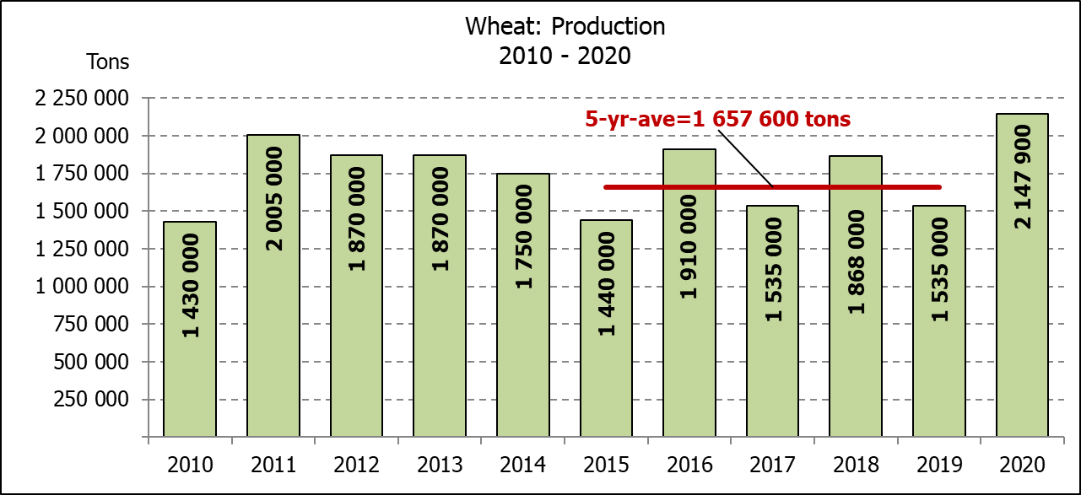
WINTERGEWASSE - OPPERVLAKTE- EN VYFDE PRODUKSIESKATTING: 2020 PRODUKSIE-SEISOEN
CROP/GEWAS | Area planted/  Opp beplant  2020 | 5th forecast/  5de skatting  2020 | 4th forecast/  4de skatting  2020 | Area planted/  Opp beplant  2019 | Final crop/  Finale oes  2019 | Change/  Verandering
CROP/GEWAS | Ha | Tons | Tons | Ha | Tons | %
CROP/GEWAS | (A) | (B) | (C) | (D) | (E) | (B) ÷ (C)
Commercial/Kommersieel:
Wheat/Koring | 509 800 | 2 147 900 | 2 149 270 | 540 000 | 1 535 000 | -0,06
Malting barley/Moutgars | 141 690 | 550 246 | 552 766 | 131 960 | 345 000 | -0,46
Canola/Kanola | 74 120 | 163 256 | 148 456 | 74 000 | 95 000 | +9,97
Cereal oats/Hawermout | 26 200 | 47 400 | 47 400 | 21 000 | 16 500 | -
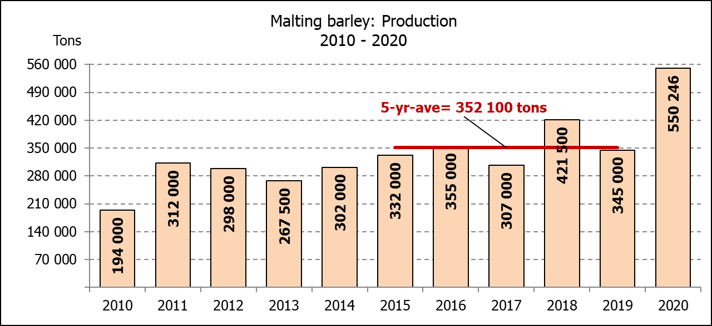
* Note: Estimate is for calendar year, e.g. production season 2020/21 = 2020
* Nota: Skatting is vir kalenderjaar, bv. produksie-seisoen 2020/21 = 2020

WHEAT – AREA PLANTED AND FIFTH PRODUCTION FORECAST: 2020
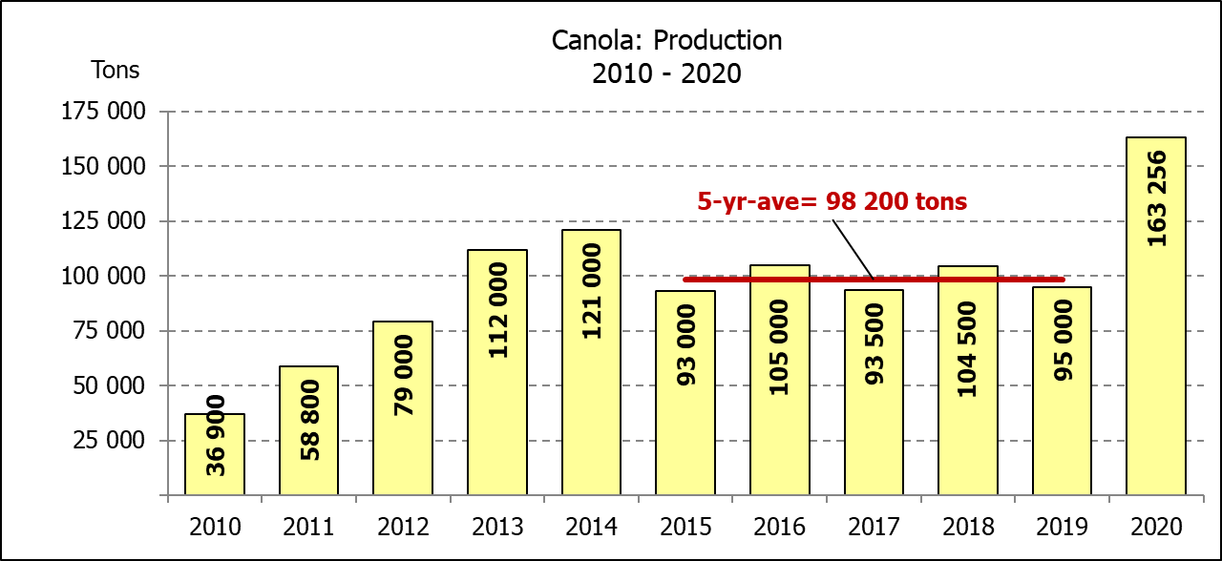
KORING – OPPERVLAKTE- EN VYFDE PRODUKSIESKATTING: 2020
Province/  Provinsie | Area planted/  Opp beplant  Ha | 5th forecast/  5de skatting  Tons | Area planted/  Opp beplant  Ha | Final crop/  Finale oes  Tons
Province/  Provinsie | 2020 | 2020 | 2019 | 2019
Western Cape/Wes-Kaap | 326 000 | 1 108 400 | 325 000 | 650 000
Northern Cape/Noord-Kaap | 37 000 | 275 650 | 37 500 | 262 500
Free State/Vrystaat | 94 000 | 432 400 | 128 000 | 326 000
Eastern Cape/Oos-Kaap | 4 000 | 26 000 | 3 100 | 18 150
KwaZulu-Natal | 7 800 | 48 360 | 7 500 | 45 750
Mpumalanga | 3 000 | 19 500 | 4 000 | 25 200
Limpopo | 23 000 | 147 200 | 20 000 | 120 000
Gauteng | 1 300 | 8 190 | 1 400 | 8 400
North West/Noordwes | 13 700 | 82 200 | 13 500 | 79 000
Total/Totaal | 509 800 | 2 147 900 | 540 000 | 1 535 000

AREA ESTIMATE AND FIFTH PRODUCTION FORECAST OF WINTER CROPS (2020) /
OPPERVLAKTE- EN VYFDE PRODUKSIESKATTING VAN WINTERGEWASSE (2020)
18 DECEMBER/DESEMBER 2020
Winter cereal crops - 2020 production season  Wheat: The expected production of wheat is 2,148 mill. tons, which is 0,06% or 1 370 tons less than the previous forecast of 2,149 mill. tons, whilst the expected yield is 4,21 t/ha. This is the largest expected wheat crop since the 2,427 mill. tons of the 2002 season.  The expected production in the Western Cape is 1,108 mill. tons (52%), in the Free State 432 400 tons (20%) and in the Northern Cape 275 650 tons (13%).  Other crops: The production forecast for malting barley is 550 246 tons, which is 0,46% or 2 520 tons less than the previous forecast of 552 766 tons. The area planted is estimated at 141 690 ha, while the expected yield is 3,88 t/ha. This is the largest expected malting barley crop recorded for SA.  The expected canola crop is 163 256 tons, which is 9,97% or 14 800 tons more than the previous forecast of 148 456 tons. The area estimate for canola is 74 120 ha, with an expected yield of 2,20 t/ha. It is also the largest expected canola crop ever recorded for SA.  The expected oats (cereals) crop for 2020 remained unchanged at 47 400 tons. The area estimate is 26 200 ha and the expected yield is 1,81 t/ha.  Please note that the sixth production forecast for winter cereals for 2020 will be released on 28 January 2021. |  | Wintergewasse - 2020 produksie-seisoen  Koring: Die verwagte produksie vir koring is 2,148 milj. ton, wat 0,06% of 1 370 ton minder is as die vorige skatting van 2,149 milj. ton, terwyl die verwagte opbrengs 4,21 t/ha is. Hierdie is die grootste verwagte koring-oes sedert die 2,427 milj. ton van die 2002 seisoen.  Die verwagte produksie in die Wes-Kaap is 1,108 milj. ton (52%), in die Vrystaat 432 400 ton (20%) en in die Noord-Kaap 275 650 ton (13%).  Ander gewasse: Die produksieskatting vir moutgars is 550 246 ton, wat 0,46% of 2 520 ton minder is as die vorige skatting van 552 766 ton. Die oppervlakte beplant word beraam op 141 690 ha, terwyl die verwagte opbrengs 3,88 t/ha beloop. Dit is die grootste verwagte moutgars-oes wat nog vir SA aangeteken is.  Die verwagte kanola-oes is 163 256 ton, wat 9,97% of 14 800 ton meer is as die vorige skatting van 148 456 ton. Die oppervlakteskatting vir kanola is 74 120 ha, met ŉ verwagte opbrengs van 2,20 t/ha. Dit is ook die grootste verwagte kanola-oes wat nog aangeteken is vir SA.  Die verwagte hawer-oes (ontbytgraan) vir die 2020-seisoen is onveranderd gelaat op 47 400 ton. Die oppervlakteskatting is 26 200 ha en die verwagte opbrengs is 1,81 t/ha.  Neem asseblief kennis dat die sesde produksieskatting vir wintergewasse vir 2020 op 28 Januarie 2021 vrygestel sal word.
Information is available on the internet at http://www.daff.gov.za/links/crop estimates or http://www.sagis.org.za, as from 14:30 on the date of the relevant meeting of the Crop Estimates Committee. |  | Inligting is beskikbaar op die internet by http://www.daff.gov.za/links/crop estimates of by http://www.sagis.org.za, vanaf 14:30 op die dag van die toepaslike vergadering van die Oesskattingskomitee.
CONFIDENTIALITY ISSUES that CEC members are committed to adhere to on the day of the meeting
- Personal items such as laptops, handbags, cell phones, etc. are not allowed in the venue during the meeting.
- No member is allowed to leave the meeting before 12:00 in order to prevent disclosure of the information. The embargo time for the release of crop estimates information is 14:30.
- No member is allowed to discuss crop estimates information with anyone other than a member of the Committee before the embargo time. Only the Chairperson, or a member appointed by the Chairperson, may release the figures to the media.
- Members must regard the detail of any information that was collected for and/or discussed during the meeting, as confidential. Individual information received for crop estimate purposes is treated strictly confidential, and is not divulged for any other purposes.

