 | crop estimates committee | 
 | oesskattingskomitee
From/Van: Ellen Matsei
Tel: 012 319 8454  Fax/Faks: 012 319 8031  E-mail/E-pos: DAS@daff.gov.za
Web page/Webblad: www.daff.gov.za/statistics and economic reports or www.sagis.org.za/CEC: Crop Estimates
EMBARGO: 15:30
19 December/Desember 2017
The area estimate and fifth production forecast for winter cereals for the 2017 is hereby released. /
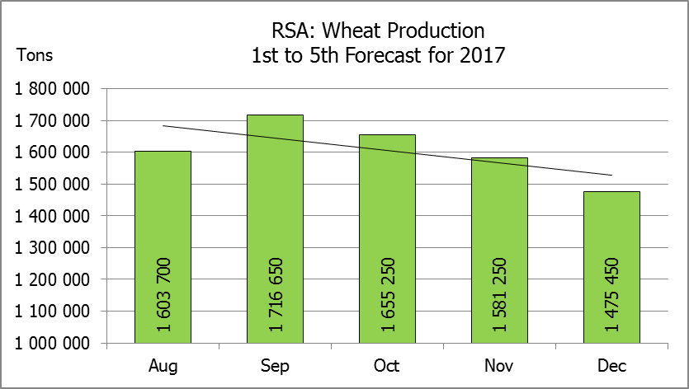
Hiermee word die oppervlakteskatting en vyfde produksieskatting vir wintergewasse vir 2017 vrygestel.
WINTER CEREALS – AREA ESTIMATE AND FIFTH PRODUCTION FORECAST: 2017
WINTERGEWASSE – OPPERVLAKTE- EN VYFDE PRODUKSIESKATTING: 2017
CROP/GEWAS | Area planted/  Opp beplant  2017 | 5th forecast/  5de skatting  2017 | 4th forecast/  4de skatting  2017 | Area planted/  Opp beplant  2016 | Final crop/  Finale oes  2016 | Change/  Verandering
CROP/GEWAS | Ha | Tons | Tons | Ha | Tons | %
CROP/GEWAS | (A) | (B) | (C) | (D) | (E) | (B) ÷ (C)
Commercial/Kommersieel:
Wheat/Koring | 491 600 | 1 475 450 | 1 581 250 | 508 365 | 1 910 000 | -6,69
Malting barley/Moutgars | 91 380 | 298 564 | 281 059 | 88 695 | 355 000 | +6,23
Canola/Kanola | 84 000 | 92 400 | 96 600 | 68 075 | 105 000 | 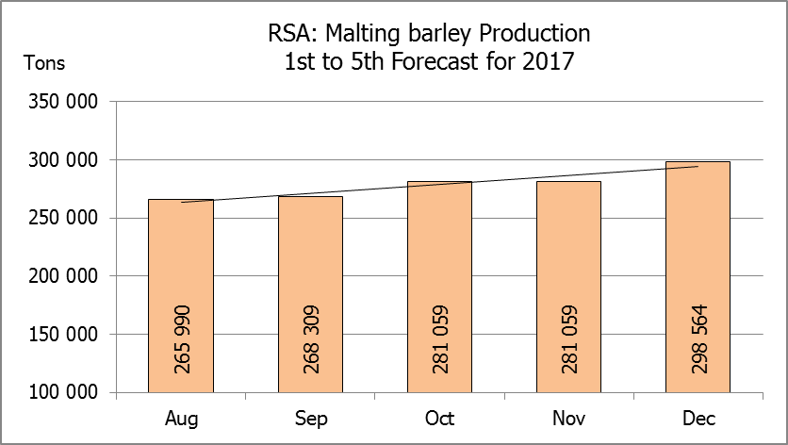  -4,35
Total/Totaal | 666 980 | 1 866 414 | 1 958 909 | 665 135 | 2 370 000 | -4,72
* Note: Estimate is for calendar year, e.g. production season 2017 = 2017
* Nota: Skatting is vir kalenderjaar, bv. produksie-seisoen 2017 = 2017
WHEAT – AREA ESTIMATE AND FIFTH PRODUCTION FORECAST: 2017
KORING – OPPERVLAKTE- EN VYFDE PRODUKSIESKATTING: 2017
Province/  Provinsie | Area planted/  Opp beplant  Ha | 5th forecast/  5de skatting  Tons | Area planted/  Opp beplant  Ha | Final crop/  Finale oes  Tons
Province/  Provinsie | 2017 | 2017 | 2016 | 2016
Western Cape/Wes-Kaap | 326 000 | 586 800 | 323 000 | 1 098 200
Northern Cape/Noord-Kaap | 38 000 | 304 000 | 35 000 | 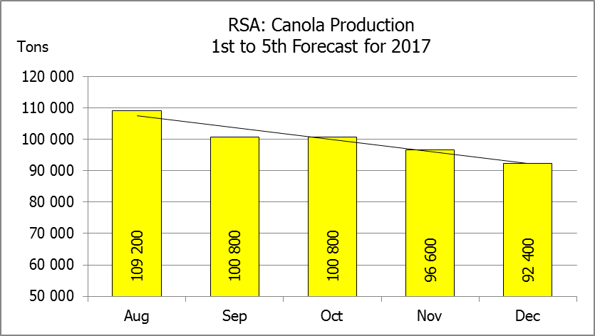  266 000
Free State/Vrystaat | 80 000 | 296 000 | 110 000 | 308 460
Eastern Cape/Oos-Kaap | 1 900 | 9 500 | 2 200 | 11 000
KwaZulu-Natal | 7 500 | 42 750 | 6 500 | 37 050
Mpumalanga | 4 000 | 25 200 | 2 300 | 13 800
Limpopo | 20 000 | 126 000 | 17 000 | 103 700
Gauteng | 700 | 4 200 | 365 | 2 190
North West/Noordwes | 13 500 | 81 000 | 12 000 | 69 600
Total/Totaal | 491 600 | 1 475 450 | 508 365 | 1 910 000

AREA ESTIMATE AND FIFTH PRODUCTION FORECAST OF WINTER CROPS (2017) /
OPPERVLAKTESKATTING EN VYFDE PRODUKSIESKATTING VAN WINTERGEWASSE (2017)
19 DECEMBER / DESEMBER 2017
Winter cereal crops - 2017 production season  Wheat: The expected commercial production of wheat is 1,475 mill. tons, which is 6,7% or 105 800 tons less than the previous forecast of 1,581 mill. tons, whilst the expected yield is 3,00 t/ha. The main reason for the decrease in wheat production is that farmers harvested poorer than expected yields, especially in the Western Cape, as they experienced drought during the past season.  The expected production in the Western Cape decreased by 14,3 % or 97 800 tons, from 684 600 tons to 586 800 tons against the previous forecast.  The production forecast for the Free State also decreased slightly by 2,6% or 8 000 tons, from 304 000 tons to 296 000 tons. In the Northern Cape, the expected production forecast remained unchanged at 304 000 tons.  The area estimate for wheat is 491 600 ha.  Other crops: The production forecast for malting barley is 298 564 tons, which is 6,2% or 17 505 tons more than the previous forecast of 281 059 tons. The area planted is estimated at 91 380 ha, while the expected yield is 3,27 t/ha.  The expected canola crop was adjusted downwards by 4,4% or 4 200 tons to 92 400 tons. The area estimate for canola is 84 000 ha, with an expected yield of 1,10 t/ha.  Please note that the sixth production forecast for winter cereals for 2017 will be released on 30 January 2018. |  | Wintergewasse - 2017 produksie-seisoen  Koring: Die verwagte kommersiële produksie vir koring is 1,475 milj. ton, wat 6,7% of 105 800 ton minder is as die vorige skatting van 1,581 milj. ton, terwyl die verwagte opbrengs 3,00 t/ha is. Die hoofrede vir die afname in koringproduksie is as gevolg van produsente wat swakker as verwagte opbrengste gestroop het, veral in die Wes-Kaap, aangesien hulle gedurende die afgelope seisoen droogte ervaar het.  Die verwagte produksie in die Wes-Kaap het met 14,3 % of 97 800 ton afgeneem, van 684 600 ton tot 586 800 ton teenoor die vorige skatting.  Die produksieskatting vir die Vrystaat is effens afwaarts aangepas met 2,6% of 8 000 ton, van 304 000 ton na 296 000 ton. In die Noord-Kaap is die verwagte produksie onveranderd gelaat op 304 000 ton.  Die oppervlakteskatting vir koring is 491 600 ha.  Ander gewasse: Die produksieskatting vir moutgars is 298 564 ton, wat 6,2% of 17 505 ton meer is as die vorige skatting van 281 059 ton. Die oppervlakte beplant is beraam op 91 380 ha, terwyl die verwagte opbrengs 3,27 t/ha beloop.  Die verwagte kanola-oes is afwaarts aangepas met 4,4% of 4 200 ton na 92 400 ton. Die oppervlakteskatting vir kanola is 84 000 ha, met ŉ verwagte opbrengs van 1,10 t/ha.  Neem asseblief kennis dat die sesde produksieskatting vir wintergewasse vir 2017 op 30 Januarie 2018 vrygestel sal word.

Information is available on the internet at http://www.daff.gov.za/statistics and economic reports or http://www.sagis.org.za, as from 15:30 on the date of the relevant meeting of the Crop Estimates Committee. |  | Inligting is beskikbaar op die internet by http://www.daff.gov.za/statistics and economic reports of by http://www.sagis.org.za, vanaf 15:30 op die dag van die toepaslike vergadering van die Oesskattingskomitee.
CONFIDENTIALITY ISSUES that CEC members are committed to adhere to on the day of the meeting
- Personal items such as laptops, handbags, cell phones, etc. are not allowed in the venue during the meeting
- No member is allowed to leave the meeting before 12:00 in order to prevent disclosure of the information
- The embargo time for the release of crop estimates information is 15:30
- No member is allowed to discuss crop estimates information with anyone other than a member of the Committee before the embargo time
- Only the Chairperson, or a member appointed by the Chairperson, may release the figures to the media
- Members must regard the detail of any information that was collected for and/or discussed during the meeting, as confidential
- Individual information received for crop estimate purposes is treated strictly confidential, and is not divulged for any other purposes

