 | crop estimates committee | 
 | oesskattingskomitee
From/Van: Mr Baldwin Netshifhefhe
Tel: 012 319 8043/32  Fax/Faks: 012 319 8031  E-mail/E-pos: BaldwinN@dalrrd.gov.za
Web page/Webblad: www.dalrrd.gov.za/statistics and economic reports or www.sagis.org.za/CEC: Crop Estimates EMBARGO: 14:30

15 December/15 Desember 2021
The area estimate and fifth production forecast for winter cereals for the 2021 is hereby released. /
Hiermee word die oppervlakte- en vyfde produksieskatting vir wintergewasse vir 2021 vrygestel.

WINTER CEREALS – AREA PLANTED AND FIFTH PRODUCTION FORECAST: 2021 PRODUCTION SEASON
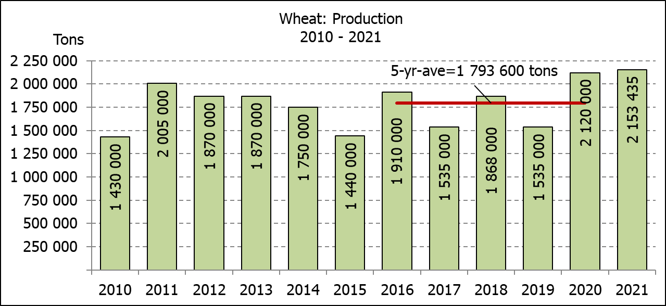
WINTERGEWASSE - OPPERVLAKTE- EN VYFDE PRODUKSIESKATTING: 2021 PRODUKSIE-SEISOEN
CROP/GEWAS | Area planted/  Opp beplant  2021 | 5th forecast/  5de skatting  2021 | 4th forecast/  4de skatting  2021 | Area planted/  Opp beplant  2020 | Final crop/  Finale oes  2020 | Change/  Verandering
CROP/GEWAS | Ha | Tons | Tons | Ha | Tons | %
CROP/GEWAS | (A) | (B) | (C) | (D) | (E) | (B) ÷ (C)
Commercial/Kommersieel:
Wheat/Koring | 523 500 | 2 153 435 | 2 117 435 | 509 800 | 2 120 000 | +1,70
Malting barley/Moutgars | 94 730 | 339 800 | 339 800 | 141 690 | 588 000 | -
Canola/Kanola | 100 000 | 190 000 | 190 000 | 74 120 | 165 200 | -
Cereal oats/Hawermout | 36 250 | 80 450 | 80 450 | 26 200 | 57 000 | -
Sweet lupines/Soetlupine | 22 000 | 29 700 | 30 800 | N/a | N/a | -3,57
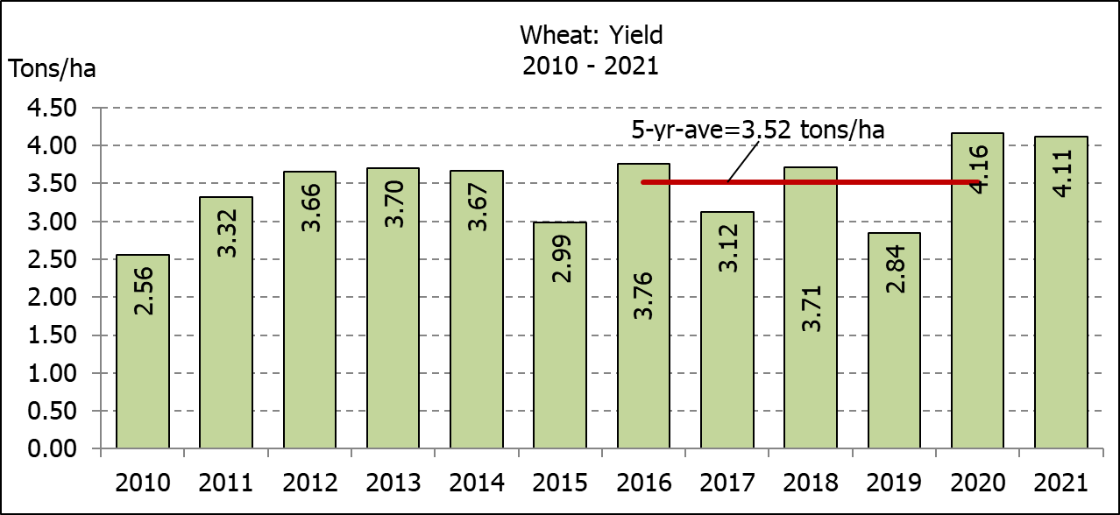
* Note: Estimate is for calendar year, e.g. production season 2021/22 = 2021
* Nota: Skatting is vir kalenderjaar, bv. produksie-seisoen 2021/22 = 2021

WHEAT – AREA PLANTED AND FIFTH PRODUCTION FORECAST: 2021
KORING – OPPERVLAKTE- EN VYFDE PRODUKSIESKATTING: 2021
Province/  Provinsie | Area planted/  Opp beplant  Ha | 5th forecast/  5de skatting  Tons | Area planted/  Opp beplant  Ha | Final crop/  Finale oes  Tons
Province/  Provinsie | 2021 | 2021 | 2020 | 2020
Western Cape/Wes-Kaap | 360 000 | 1 188 000 | 326 000 | 1 103 000
Northern Cape/Noord-Kaap | 35 500 | 259 150 | 37 000 | 271 950
Free State/Vrystaat | 70 000 | 346 500 | 94 000 | 413 600
Eastern Cape/Oos-Kaap | 3 800 | 24 700 | 4 000 | 26 000
KwaZulu-Natal | 8 500 | 53 125 | 7 800 | 48 360
Mpumalanga | 4 100 | 27 060 | 3 000 | 19 500
Limpopo | 26 500 | 164 300 | 23 000 | 147 200
Gauteng | 1 100 | 6 600 | 1 300 | 8 190
North West/Noordwes | 14 000 | 84 000 | 13 700 | 82 200
Total/Totaal | 523 500 | 2 153 435 | 509 800 | 2 120 000

AREA ESTIMATE AND FIFTH PRODUCTION FORECAST OF WINTER CROPS (2021) /
OPPERVLAKTE- EN VYFDE PRODUKSIESKATTING VAN WINTERGEWASSE (2021)
15 DECEMBER/DESEMBER 2021
Winter cereal crops - 2021 production season  Wheat: The expected production of wheat is 2,153 mill. tons, which is 1,70% or 36 000 tons more than the previous forecast of 2,117 mill. tons, whilst the expected yield is 4,11 t/ha. This is the largest expected wheat crop produced since 2002, when it was 2,427 mill. tons.  The expected production in the Western Cape is 1,188 mill. tons (55%), in the Free State 346 500 tons (16%) and in the Northern Cape 259 150 tons (12%).  Other crops: The production forecast for malting barley remained unchanged at 339 800 tons. The area planted is estimated at 94 730 ha, while the expected yield is 3,59 t/ha.  The expected canola crop also remained unchanged at 190 000 tons. This is the largest expected canola crop produced in the history of SA. The area estimate for canola is 100 000 ha, with an expected yield of 1,90 t/ha.  The expected crop for oats (cereals) for the 2021 season is 80 450 tons and the area planted is 36 250 ha. The expected yield is 2,22 t/ha.  In the case of sweet lupines, the production forecast decreased slightly by 3,57% or 1 100 tons, from 30 800 tons to 29 700 tons. The area estimate of sweet lupines is 22 000 ha, with an expected yield of 1,35 t/ha.  Please note that the sixth production forecast for winter cereals for 2021 will be released on 27 January 2022. |  | Wintergewasse - 2021 produksie-seisoen  Koring: Die verwagte produksie vir koring is 2,153 milj. ton, wat 1,70% of 36 000 ton meer is as die vorige skatting van 2,117 milj. ton, terwyl die verwagte opbrengs 4,11 t/ha is. Dit is die grootste verwagte koringoes sedert 2002, toe dit 2,427 milj. ton was.  Die verwagte produksie in die Wes-Kaap is 1,188 milj. ton (55%), in die Vrystaat 346 500 ton (16%) en in die Noord-Kaap 259 150 ton (12%).  Ander gewasse: Die produksieskatting vir moutgars is onveranderd gelaat op 339 800 ton. Die oppervlakte beplant word beraam op 94 730 ha, terwyl die verwagte opbrengs 3,59 t/ha beloop.  Die verwagte kanola-oes is ook onveranderd gelaat op 190 000 ton. Dit is die grootste kanola-oes wat nόg geproduseer is in die geskiedenis van SA. Die oppervlakteskatting vir kanola is 100 000 ha, met ŉ verwagte opbrengs van 1,90 t/ha.  Die verwagte oes vir hawer (ontbytgraan) vir die 2021-seisoen is 80 450 ton en die oppervlakteskatting is 36 250 ton. Die verwagte opbrengs is 2,22 t/ha.  In die geval van soetlupine is die produksieskatting effens verlaag met 3,57% of 1 100 ton, van 30 800 ton na 29 700 ton. Die oppervlakte beplant met soetlupine is 22 000 ha, en die verwagte opbrengs is 1,35 t/ha.  Neem asseblief kennis dat die sesde produksieskatting vir wintergewasse vir 2021 op 27 Januarie 2022 vrygestel sal word.
Information is available on the internet at http://www.daff.gov.za/links/crop estimates or http://www.sagis.org.za, as from 14:30 on the date of the relevant meeting of the Crop Estimates Committee. |  | Inligting is beskikbaar op die internet by http://www.daff.gov.za/links/crop estimates of by http://www.sagis.org.za, vanaf 14:30 op die dag van die toepaslike vergadering van die Oesskattingskomitee.
CONFIDENTIALITY ISSUES that CEC members are committed to adhere to on the day of the meeting
- Personal items such as laptops, handbags, cell phones, etc. are not allowed in the venue during the meeting.
- No member is allowed to leave the meeting before 12:00 in order to prevent disclosure of the information. The embargo time for the release of crop estimates information is 14:30.
- No member is allowed to discuss crop estimates information with anyone other than a member of the Committee before the embargo time. Only the Chairperson, or a member appointed by the Chairperson, may release the figures to the media.
- Members must regard the detail of any information that was collected for and/or discussed during the meeting, as confidential. Individual information received for crop estimate purposes is treated strictly confidential, and is not divulged for any other purposes.

