 | crop estimates committee
 | oesskattingskomitee
From/Van: Mr Baldwin Netshifhefhe  Tel: 012 319 8043/32 E-mail/E-pos: BaldwinN@dalrrd.gov.za  Web page/Webblad: www.dalrrd.gov.za/old website/statistics and economic reports or  www.sagis.org.za/CEC: Crop Estimates EMBARGO: 14:30 |  |  | 

The area planted estimate and seventh production forecast for summer crops for 2023 is hereby released.
Hiermee word die oppervlakte- en sewende produksieskatting vir somergewasse vir 2023 vrygestel.

SUMMER CROPS – AREA PLANTED AND SEVENTH PRODUCTION FORECAST: 2023
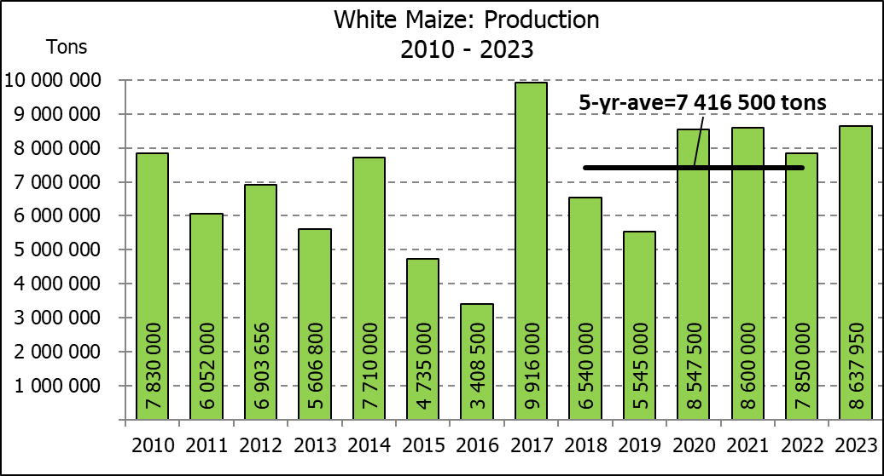
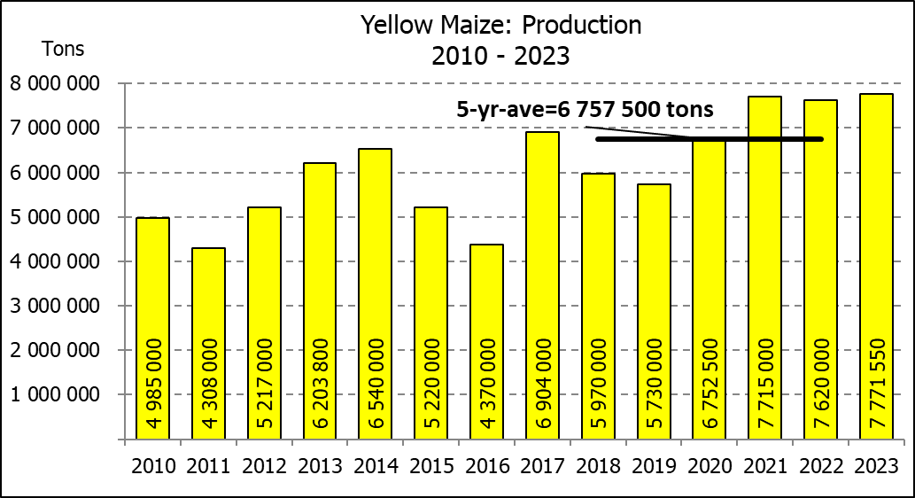
SOMERGEWASSE – OPPERVLAKTE- EN SEWENDE PRODUKSIESKATTING: 2023
CROP/GEWAS | Area planted/  Opp beplant  2023 | 7th forecast/  7de skatting  2023 | 6th forecast/  6de skatting  2023 | Area planted/  Opp beplant  2022 | Final crop/  Finale oes  2022 | Change/  Verandering/
CROP/GEWAS | Ha | Tons | Tons | Ha | Tons | %
CROP/GEWAS | (A) | (B) | (C) | (D) | (E) | (B) ÷ (C)
Commercial/Kommersieël:
White maize/Witmielies | 1 521 300 | 8 637 950 | 8 637 950 | 1 575 000 | 7 850 000 | -
Yellow maize/Geelmielies | 1 064 800 | 7 771 550 | 7 716 150 | 1 048 000 | 7 620 000 | +0,72
Total Maize/Totale Mielies | 2 586 100 | 16 409 500 | 16 354 100 | 2 623 000 | 15 470 000 | +0,34
Sunflower seed/Sonneblomsaad | 555 700 | 743 610 | 758 610 | 670 700 | 845 550 | -1,98
Soybeans/Sojabone | 1 148 300 | 2 755 300 | 2 755 300 | 925 300 | 2 230 000 | -
Groundnuts/Grondbone | 31 300 | 51 910 | 51 910 | 43 400 | 48 500 | -
Sorghum | 34 000 | 97 740 | 100 525 | 37 200 | 103 140 | -2,77
Dry beans/Droëbone | 36 650 | 50 260 | 48 560 | 42 900 | 52 590 | +3,50
Non-Commercial Maize/Nie-Kommersiële Mielies
Total Maize/Totale Mielies | 358 620 | 664 040 | 664 040 | 378 800 | 667 000 | -
Maize/Mielies: Commercial/Kommersieël + Non-Commercial/Nie-Kommersieël
Total Maize RSA/Totaal Mielies RSA | 2 944 720 | 17 073 540 | 17 018 140 | 3 001 800 | 16 137 000 | +0,33
Note: Estimate is for calendar year, e.g. production season 2022/23 = 2023
Nota: Skatting is vir kalenderjaar, bv. produksie-seisoen 2022/23 = 2023

The Crop Estimates Committee comprises officials of the following institutions:
Department of Agriculture, Land Reform and Rural Development; Provincial Departments of Agriculture; various ARC-Institutes (Soil, Climate and Water; Small Grains Institute; and
Grain Crops Institute); BFAP and Statistics SA.
29 August/Augustus 2023
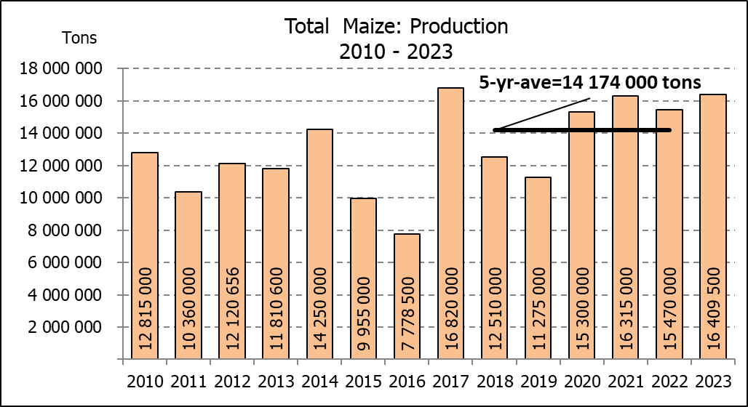

WHITE AND YELLOW MAIZE – AREA PLANTED AND SEVENTH PRODUCTION FORECAST: 2023
WIT- EN GEELMIELIES – OPPERVLAKTE EN SEWENDE PRODUKSIESKATTING: 2023

Provinsie/  Province | Area planted/  Oppervlakte beplant  2023 |  |  | 7th forecast/  7de skatting  2023 |  |  | Area planted/  Oppervlakte beplant  2022 |  |  | Final crop/  Finale oes  2022
Provinsie/  Province | White/  Wit  Ha | Yellow/  Geel  Ha | Total/  Totaal  Ha | White/  Wit  Tons | Yellow/  Geel  Tons | Total/  Totaal  Tons | White/  Wit  Ha | Yellow/  Geel  Ha | Total/  Totaal  Ha | White/  Wit  Tons | Yellow/  Geel  Tons | Total/  Totaal  Tons
Western Cape/Wes-Kaap | 250 | 3 500 | 3 750 | 2 375 | 32 900 | 35 275 | 500 | 3 500 | 4 000 | 4 750 | 32 900 | 37 650
Northern Cape/Noord-Kaap | 1 000 | 43 500 | 44 500 | 12 500 | 669 900 | 682 400 | 3 000 | 42 000 | 45 000 | 36 000 | 672 000 | 708 000
Free State/Vrystaat | 780 000 | 401 000 | 1 181 000 | 4 563 000 | 2 666 650 | 7 229 650 | 826 500 | 398 000 | 1 224 500 | 3 801 900 | 2 547 800 | 6 349 700
Eastern Cape/Oos-Kaap | 5 750 | 25 000 | 30 750 | 40 250 | 187 500 | 227 750 | 6 000 | 20 500 | 26 500 | 40 800 | 157 900 | 198 700
KwaZulu-Natal | 49 000 | 65 000 | 114 000 | 308 700 | 533 000 | 841 700 | 52 000 | 59 000 | 111 000 | 322 400 | 489 700 | 812 100
Mpumalanga | 156 500 | 352 000 | 508 500 | 1 040 725 | 2 534 400 | 3 575 125 | 165 000 | 350 000 | 515 000 | 1 072 500 | 2 554 000 | 3 626 500
Limpopo | 16 800 | 22 800 | 39 600 | 117 600 | 182 400 | 300 000 | 15 500 | 25 000 | 40 500 | 102 300 | 202 500 | 304 800
Gauteng | 56 000 | 52 000 | 108 000 | 364 000 | 384 800 | 748 800 | 56 500 | 56 000 | 112 500 | 361 600 | 403 200 | 764 800
North West/Noordwes | 456 000 | 100 000 | 556 000 | 2 188 800 | 580 000 | 2 768 800 | 450 000 | 94 000 | 544 000 | 2 107 750 | 560 000 | 2 667 750
Total/Totaal | 1 521 300 | 1 064 800 | 2 586 100 | 8 637 950 | 7 771 550 | 16 409 500 | 1 575 000 | 1 048 000 | 2 623 000 | 7 850 000 | 7 620 000 | 15 470 000

SUNFLOWER SEED – AREA PLANTED AND SEVENTH PRODUCTION FORECAST: 2023
SONNEBLOMSAAD – OPPERVLAKTE EN SEWENDE PRODUKSIESKATTING: 2023

Province/  Provinsie | Area planted/  Opp beplant  Ha | 7th forecast/  7de skatting  Tons | Area planted/  Opp beplant  Ha | Final crop/  Finale oes  Tons
Province/  Provinsie | 2023 | 2023 | 2022 | 2022
Western Cape/Wes-Kaap | - | - | - | -
Northern Cape/Noord-Kaap | 2 500 | 6 250 | 2 500 | 6 250
Free State/Vrystaat | 290 000 | 420 500 | 357 000 | 499 800
Eastern Cape/Oos-Kaap | 700 | 1 400 | 300 | 750
KwaZulu-Natal | 300 | 600 | - | -
Mpumalanga | 5 000 | 7 250 | 3 500 | 5 250
Limpopo | 100 000 | 80 000 | 110 000 | 77 000
Gauteng | 2 200 | 2 860 | 2 400 | 3 000
North West/Noordwes | 155 000 | 224 750 | 195 000 | 253 500
Total/Totaal | 555 700 | 743 610 | 670 700 | 845 550
SOYBEANS – AREA PLANTED AND SEVENTH PRODUCTION FORECAST: 2023
SOJABONE – OPPERVLAKTE EN SEWENDE PRODUKSIESKATTING: 2023

Province/  Provinsie | Area planted/  Opp beplant  Ha | 7th forecast/  7de skatting Tons | Area planted/  Opp beplant  Ha | Final crop/  Finale oes  Tons
Province/  Provinsie | 2023 | 2023 | 2022 | 2022
Western Cape/Wes-Kaap | - | - | - | -
Northern Cape/Noord-Kaap | 1 000 | 3 750 | 800 | 3 000
Free State/Vrystaat | 565 000 | 1 327 750 | 415 000 | 912 500
Eastern Cape/Oos-Kaap | 4 300 | 12 900 | 3 000 | 9 000
KwaZulu-Natal | 44 000 | 158 400 | 39 000 | 150 000
Mpumalanga | 305 000 | 671 000 | 300 000 | 710 000
Limpopo | 26 000 | 88 400 | 22 500 | 76 500
Gauteng | 48 000 | 105 600 | 45 000 | 99 000
North West/Noordwes | 155 000 | 387 500 | 100 000 | 270 000
Total/Totaal | 1 148 300 | 2 755 300 | 925 300 | 2 230 000

GROUNDNUTS – AREA PLANTED AND SEVENTH PRODUCTION FORECAST: 2023
GRONDBONE – OPPERVLAKTE EN SEWENDE PRODUKSIESKATTING: 2023

Province/  Provinsie | Area planted/  Opp beplant  Ha | 7th forecast/  7de skatting Tons | Area planted/  Opp beplant  Ha | Final crop/  Finale oes  Tons
Province/  Provinsie | 2023 | 2023 | 2022 | 2022
Western Cape/Wes-Kaap | - | - | - | -
Northern Cape/Noord-Kaap | 2 000 | 5 300 | 2 400 | 6 000
Free State/Vrystaat | 12 300 | 20 910 | 19 000 | 20 900
Eastern Cape/Oos-Kaap | - | - | - | -
KwaZulu-Natal | - | - | - | -
Mpumalanga | - | - | - | -
Limpopo | 2 000 | 4 700 | 2 000 | 4 600
Gauteng | - | - | - | -
North West/Noordwes | 15 000 | 21 000 | 20 000 | 17 000
Total/Totaal | 31 300 | 51 910 | 43 400 | 48 500

SORGHUM – AREA PLANTED AND SEVENTH PRODUCTION FORECAST: 2023
SORGHUM – OPPERVLAKTE EN SEWENDE PRODUKSIESKATTING: 2023

Province/  Provinsie | Area planted/  Opp beplant  Ha | 7th forecast/  7de skatting  Tons | Area planted/  Opp beplant  Ha | Final crop/  Finale oes  Tons
Province/  Provinsie | 2023 | 2023 | 2022 | 2022
Western Cape/Wes-Kaap | - | - | - | -
Northern Cape/Noord-Kaap | - | - | - | -
Free State/Vrystaat | 5 200 | 15 600 | 7 800 | 20 700
Eastern Cape/Oos-Kaap | - | - | - | -
KwaZulu-Natal | 100 | 400 | 200 | 740
Mpumalanga | 8 500 | 35 700 | 9 000 | 43 650
Limpopo | 15 500 | 34 100 | 15 000 | 26 250
Gauteng | 100 | 440 | 200 | 800
North West/Noordwes | 4 600 | 11 500 | 5 000 | 11 000
Total/Totaal | 34 000 | 97 740 | 37 200 | 103 140

DRY BEANS – AREA PLANTED AND SEVENTH PRODUCTION FORECAST: 2023
DROëBONE – OPPERVLAKTE EN SEWENDE PRODUKSIESKATTING: 2023

Province/  Provinsie | Area planted/  Opp beplant  Ha | 7th forecast/  7de skatting Tons | Area planted/  Opp beplant  Ha | Final crop/  Finale oes  Tons
Province/  Provinsie | 2023 | 2023 | 2022 | 2022
Western Cape/Wes-Kaap | 100 | 180 | 100 | 150
Northern Cape/Noord-Kaap | 450 | 990 | 600 | 1 080
Free State/Vrystaat | 14 000 | 13 300 | 15 500 | 13 950
Eastern Cape/Oos-Kaap | 200 | 360 | 200 | 300
KwaZulu-Natal | 2 100 | 3 150 | 2 300 | 2 760
Mpumalanga | 5 000 | 7 000 | 6 000 | 6 600
Limpopo | 8 000 | 16 000 | 10 400 | 18 200
Gauteng | 800 | 880 | 800 | 800
North West/Noordwes | 6 000 | 8 400 | 7 000 | 8 750
Total/Totaal | 36 650 | 50 260 | 42 900 | 52 590

CONFIDENTIALITY ISSUES that CEC members are committed to adhere to on the day of the meeting
- Personal items such as laptops, handbags, cell phones, etc. are not allowed in the venue during the meeting
- No member is allowed to leave the meeting before 12:00 in order to prevent disclosure of the information
- The embargo time for the release of crop estimates information is 14:30
- No member is allowed to discuss crop estimates information with anyone other than a member of the Committee before the embargo time
- Only the Chairperson, or a member appointed by the Chairperson, may release the figures to the media
- Members must regard the detail of any information that was collected for and/or discussed during the meeting, as confidential
- Individual information received for crop estimate purposes is treated strictly confidential, and is not divulged for any other purposes

AREA ESTIMATE AND SEVENTH PRODUCTION FORECAST OF SUMMER CROPS (2023 PRODUCTION SEASON)/
OPPERVLAKTE- EN SEWENDE PRODUKSIESKATTING VIR SOMERGEWASSE (2023 PRODUKSIE-SEISOEN)
29 AUGUST/AUGUSTUS 2023

Summer field crops – 2023  Commercial maize: The size of the expected commercial maize crop is 16,410 mill. tons, which is 0,34% or 55 400 tons more than the 16,354 mill. tons of the previous forecast . The area estimate for maize is 2,586 mill. ha and the expected yield is 6,35 t/ha.  The estimated maize crop is 6,07% or 939 500 tons larger than the 2022 crop. The three main maize producing areas, namely the Free State, Mpumalanga and North West provinces are expected to produce 83% of the 2023 crop.  The production forecast of white maize remained unchanged at 8,638 mill. tons. The area estimate for white maize is 1,521 mill. ha and the expected yield is 5,68 t/ha.  In the case of yellow maize, the production forecast is 7,716 mill. tons, which is 0,72% or 55 400 tons more than the 7,716 mill. tons of the previous forecast. The area estimate for yellow maize is 1,065 mill. ha and the yield is 7,30 t/ha.  Other summer crops:  Sunflower seed: The production forecast for sunflower seed is set at 743 610 tons, which is 1,98% or 15 000 tons less than the 758 610 tons of the previous forecast. The area estimate for sunflower seed is 555 700 ha, while the expected yield is 1,34 t/ha.  Other crops: The production forecast for soybeans remained unchanged at 2,755 mill. tons. The estimated area planted to soybeans is 1,148 mill. ha and the expected yield is 2,40 t/ha.  The expected groundnut crop also remained unchanged at 51 910 tons. For groundnuts, the area estimate is 31 300 ha, with an expected yield of 1,66 t/ha.  The production forecast for sorghum is now 97 740 tons, which is 2,77% or 2 785 tons less than the 100 525 tons of the previous forecast. The area estimate for sorghum is 34 000 ha and the expected yield is 2,87 t/ha.  In the case of dry beans, the production forecast is 50 260 tons, which is 3,50% or 1 700 tons more than the 48 560 tons of the previous forecast. The area estimate of dry beans is 36 650 ha, with an expected yield of 1,37 t/ha.  Please note that the eighth production forecast for summer field crops for 2023 will be released on 27 September 2023. |  | Somergewasse – 2023  Kommersiële mielies: Die grootte van die verwagte kommersiële mielie-oes is 16,410 milj. ton, wat 0,34% of 55 400 ton meer is as die 16,354 milj. ton van die vorige skatting. Die oppervlakteskatting vir mielies is 2,586 milj. ha en die verwagte opbrengs is 6,35 t/ha.  Die geskatte mielie-oes is 6,07% of 939 500 ton groter as die 2022-oes. Die drie belangrikste mielieproduserende gebiede, nl. die Vrystaat, Mpumalanga en Noordwes provinsies, gaan na verwagting 83% van die 2023-oes produseer.  Die produksieskatting van witmielies is onveranderd gelaat op 8,638 milj. ton. Die oppervlakteskatting vir witmielies is 1,521 milj. ha en die verwagte opbrengs is 5,68 t/ha.  In die geval van geelmielies is die produksieskatting 7,716 milj. ton, wat 0,72% of 55 400 ton meer is as die 7,716 milj. ton van die vorige skatting. Die oppervlakteskatting vir geelmielies is 1,065 milj. ha en die opbrengs is 7,30 t/ha.  Ander somergewasse:  Sonneblomsaad: Die produksieskatting vir sonneblomsaad is op 743 610 ton gestel, wat 1,98% of 15 000 ton minder is as die 758 610 ton van die vorige skatting. Die oppervlakteskatting vir sonneblomsaad is 555 700 ha, terwyl die verwagte opbrengs 1,34 t/ha is.  Ander gewasse: Die produksieskatting van sojabone is onveranderd gelaat op 2,755 milj. ton. Die geskatte oppervlakte beplant met sojabone is 1,148 milj. ha en die verwagte opbrengs is 2,40 t/ha.  Die verwagte grondbone-oes is ook onveranderd gelaat op 51 910 ton. Vir grondbone is die oppervlakteskatting 31 300 ha, terwyl the verwagte opbrengs 1,66 t/ha is.  Die produksieskatting van sorghum is nou 97 740 ton, wat 2,77% of 2 785 ton minder is as die 100 525 ton van die vorige skatting. Die oppervlakteskatting vir sorghum is 34 000 ha, en die verwagte opbrengs is 2,87 t/ha.  In die geval van droëbone is die produksieskatting 50 260 ton, wat 3,50% of 1 700 ton meer is as die 48 560 ton van die vorige skatting. Die oppervlakte beplant met droëbone is 36 650 ha, en die verwagte opbrengs is 1,37 t/ha.  Neem asseblief kennis dat die agtste produksieskatting vir somergewasse vir 2023, op 27 September 2023 vrygestel sal word.

The non-commercial agricultural sectors’ production estimate for maize for 2023 is hereby released. /
Hiermee word die nie-kommersiële landbou-sektor se produksieskatting vir mielies vir 2023 vrygestel.

NON-COMMERCIAL MAIZE – AREA PLANTED AND PRODUCTION ESTIMATE: 2023
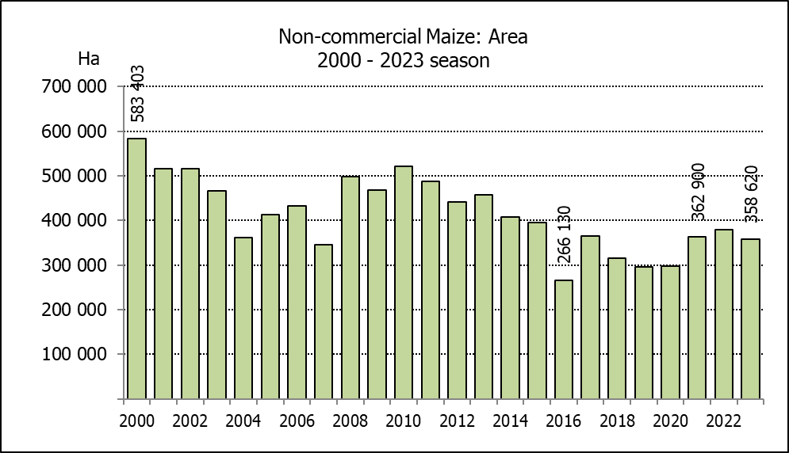
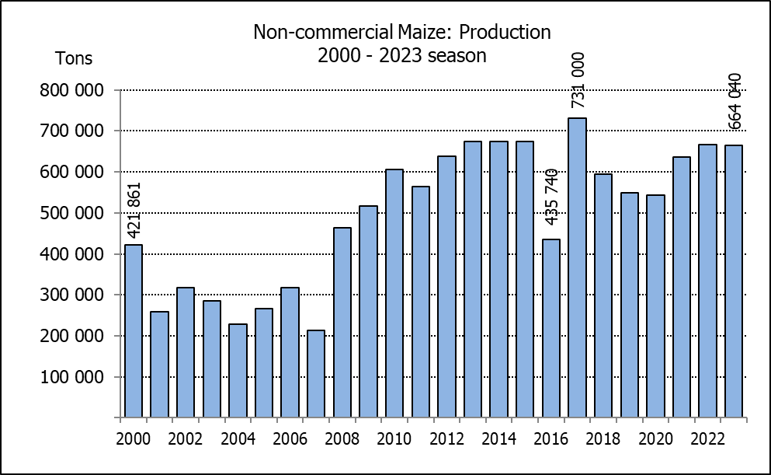
NIE-KOMMERSIëLE MIELIES – OPPERVLAKTE- EN PRODUKSIESKATTING: 2023
CROP/GEWAS | Area planted/  Opp beplant  2023 | Production/  Produksie  2023 | Area planted/  Opp beplant  2022 | Final crop/  Finale oes  2022 | Change/  Verandering
CROP/GEWAS | Ha | Tons | Ha | Tons | %
CROP/GEWAS | (A) | (B) | (C) | (D) | (B) ÷ (D)
Non-commercial agriculture/Nie-kommersiële landbou:
White maize/Witmielies | 278 655 | 472 765 | 296 950 | 482 000 | -1,92
Yellow maize/Geelmielies | 79 965 | 191 275 | 81 850 | 185 000 | +3,39
Maize/Mielies | 358 620 | 664 040 | 378 800 | 667 000 | -0,44
The preliminary area planted to maize in the non-commercial agricultural sector is estimated at 358 620 ha, which represents a decrease of 5,33%, compared to the 378 800 ha of the previous season. The expected maize crop for this sector is 664 040 tons, which is 0,44% less than the 667 000 tons of last season. It is important to note that about 48% of the maize produced in the non-commercial sector, is planted in the Eastern Cape, followed by KwaZulu-Natal with 21%.
Die voorlopige oppervlakte beplant met mielies in die nie-kommersiële landbou-sektor word geskat op 358 620 ha, wat ’n afname van 5,33% verteenwoordig in vergelyking met die 378 800 ha van die vorige seisoen. Die verwagte mielie-oes van dié sektor is 664 040 ton, wat 0,44% minder is as die 667 000 ton van die vorige seisoen. Dit is belangrik om daarop te let dat ongeveer 48% van die mielies wat geproduseer word in die nie-kommersiële sektor, in die Oos-Kaap geplant word, gevolg deur KwaZulu-Natal met 21%.

The revised area estimate and first production forecast for winter cereals for the 2023 is hereby released. /
Hiermee word die hersiene oppervlakteskatting en eerste produksieskatting vir wintergewasse vir 2023 vrygestel.
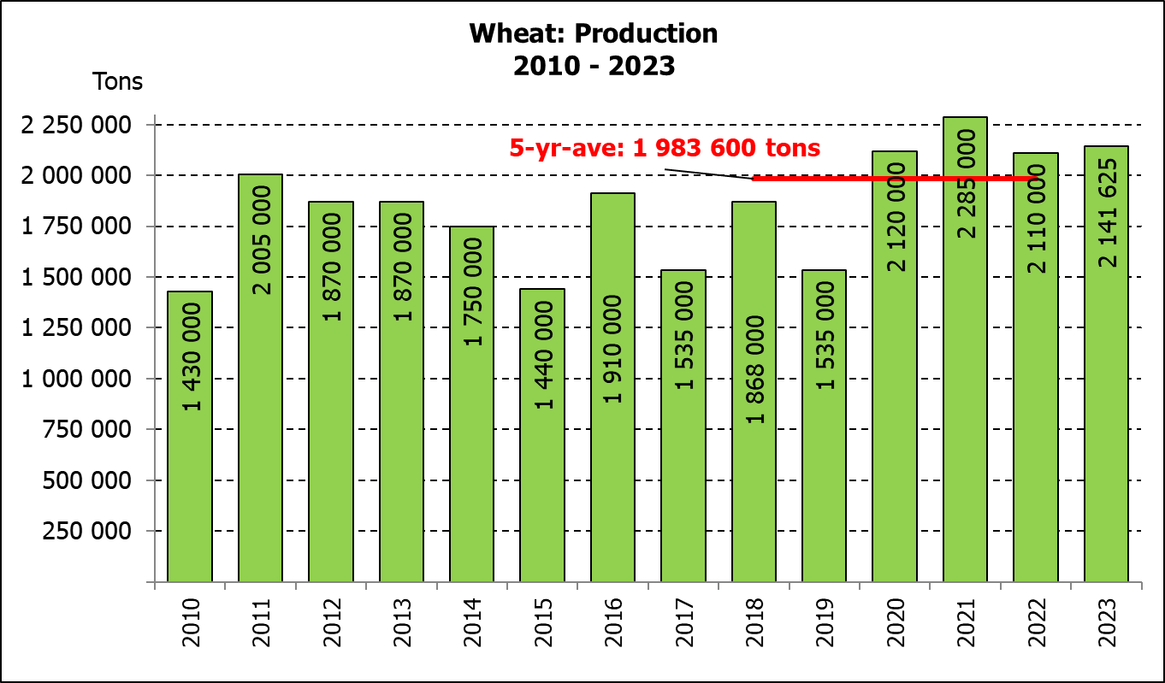
WINTER CEREALS – REVISED AREA PLANTED ESTIMATE AND FIRST PRODUCTION FORECAST: 2023 PRODUCTION SEASON
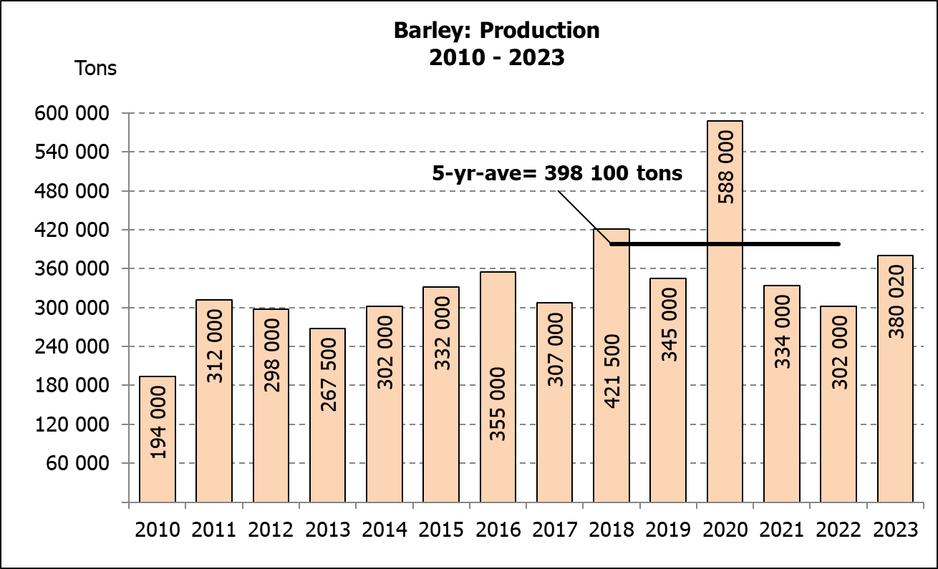
WINTERGEWASSE – HERSIENE OPPERVLAKTESKATTING EN EERSTE PRODUKSIESKATTING: 2023-PRODUKSIESEISOEN
CROP/GEWAS | Area planted/  Opp beplant  2023 | 1st forecast/  1ste skatting  2023 | Area planted/  Opp beplant  2022 | Final crop/  Finale oes  2022 | Change/  Verandering
CROP/GEWAS | Ha | Tons | Ha | Tons | %
CROP/GEWAS | (A) | (B) | (C) | (D) | (B) ÷ (D)
Commercial/Kommersieel:
Wheat/Koring | 537 050 | 2 141 625 | 566 800 | 2 110 000 | +1,50
Barley/Gars¹⁾ | 104 600 | 380 020 | 101 000 | 302 000 | +25,83
Canola/Kanola | 131 200 | 243 950 | 123 510 | 210 000 | +16,17
Oats/Hawer¹⁾ | 30 000 | 60 200 | 27 000 | 27 550 | +118,51
Sweet lupines/Soetlupine | 16 000 | 19 200 | 21 000 | 15 750 | +21,90
1) Commercial only. Excluding barley or oats used as pasture, silage, hay and/or on the farm as fodder for livestock /
Slegs kommersieël. Uitgesluit gars of hawer wat gebruik word as weiding, kuilvoer, hooi en/of op die plaas as voer vir vee.

WHEAT – REVISED AREA PLANTED ESTIMATE AND FIRST PRODUCTION FORECAST: 2023
KORING – HERSIENE OPPERVLAKTESKATTING EN EERSTE PRODUKSIESKATTING: 2023
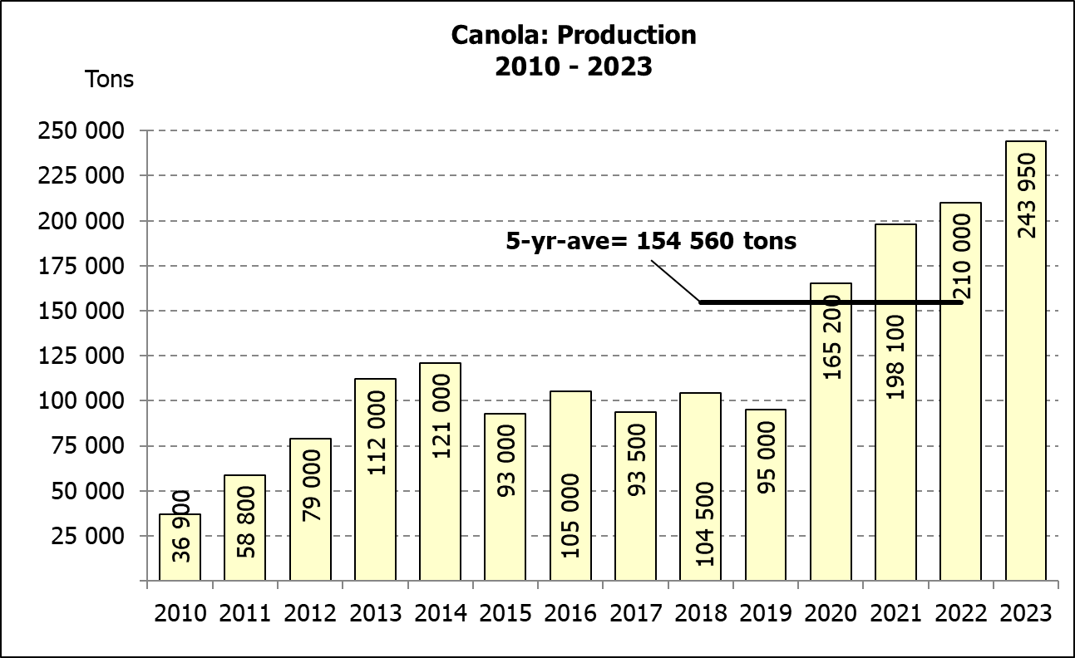
Province/  Provinsie | Area planted/  Opp beplant  Ha | 1st forecast/  1ste skatting  Tons | Area planted/  Opp beplant  Ha | Final crop/  Finale oes  Tons
Province/  Provinsie | 2023 | 2023 | 2022 | 2022
Western Cape/Wes-Kaap | 365 000 | 1 095 000 | 360 000 | 918 000
Northern Cape/Noord-Kaap | 40 000 | 310 000 | 47 000 | 338 500
Free State/Vrystaat | 71 000 | 340 800 | 96 000 | 436 800
Eastern Cape/Oos-Kaap | 6 400 | 41 600 | 6 000 | 40 200
KwaZulu-Natal | 8 500 | 56 100 | 9 200 | 60 730
Mpumalanga | 4 200 | 28 560 | 4 000 | 27 600
Limpopo | 30 000 | 195 000 | 29 000 | 187 000
Gauteng | 950 | 6 365 | 1 100 | 7 370
North West/Noordwes | 11 000 | 68 200 | 14 500 | 93 800
Total/Totaal | 537 050 | 2 141 625 | 566 800 | 2 110 000
REVISED AREA ESTIMATE AND FIRST PRODUCTION FORECAST OF WINTER CROPS (2023) /
HERSIENE OPPERVLAKTESKATTING EN EERSTE PRODUKSIESKATTING VAN WINTERGEWASSE (2023)
29 AUGUST/ 29 AUGUSTUS 2023

Winter cereal crops - 2023 production season  Wheat: The expected production of wheat is 2,142 mill. tons, which is 1,50% or 31 625 tons more than the previous seasons’ crop of 2,110 mill. tons, whilst the expected yield is 3,99 t/ha.  The expected production in the Western Cape is 1,095 mill. tons (51%), which is 177 000 tons more than the 918 000 tons produced in the previous season. In the Free State, the expected production is 340 800 tons (16%), which is 96 000 tons less than the previous seasons’ crop of 436 800 tons. In the Northern Cape, 310 000 tons (14%) is expected to be produced – 28 500 tons less than the 338 500 tons produced in the previous season.  The area estimate for wheat was revised to 537 050 ha, which is 4 750 ha more than the 532 300 ha of the previous forecast. An estimated 365 000 ha or 68 % is planted in the Western Cape, 71 000 ha or 13 % in the Free State and 40 000 ha or 7 % in the Northern Cape.  Other crops: The production forecast for barley is 380 020 tons, which is 25,83% or 78 020 tons more than the previous seasons’ crop of 302 000 tons. The area planted is estimated at 104 600 ha, while the expected yield is 3,63 t/ha.  The expected canola crop is 243 950 tons, which is 16,17% or 33 950 tons more than the previous seasons’ crop of 210 000 tons. The area estimate for canola is 131 200 ha, with an expected yield of 1,86 t/ha.  The expected crop for oats for the 2023 season is 60 200 tons and the revised area planted is 30 000 ha. The expected yield is 2,01 t/ha.  In the case of sweet lupines, the production forecast is 19 200 tons. The area estimate of sweet lupines is 16 000 ha, with an expected yield of 1,20 t/ha.  Please note that the second production forecast for winter cereals for 2023 will be released on 27 September 2023. |  | Wintergewasse - 2023 produksie-seisoen  Koring: Die verwagte produksie vir koring is 2,142 milj. ton, wat 1,50% of 31 625 ton meer is as die vorige seisoen se oes van 2,110 milj. ton, terwyl die verwagte opbrengs 3,99 t/ha is.  Die verwagte produksie in die Wes-Kaap is 1,095 mij. ton (51%), wat 177 000 ton meer is as die 918 000 ton geproduseer in die vorige seisoen. In die Vrystaat is die verwagte produksie 340 800 ton (16%), wat 96 000 ton minder is as die vorige seisoen se oes van 436 800 ton. In die Noord-Kaap is die beraamde produksie 310 000 ton (14%) – 28 500 ton minder as die 338 500 ton geproduseer in die vorige seisoen.  Die oppervlakteskatting vir koring is hersien na 537 050 ha, wat 4 750 ha meer is as die 532 300 ha teenoor die vorige skatting. Die beraamde oppervlakte geplant in die Wes-Kaap is 365 000 ha of 68 %, die Vrystaat is 71 000 ha of 13 % en 40 000 ha of 7 % is in die Noord-Kaap.  Ander gewasse: Die produksieskatting vir gars is 380 020 ton, wat 25,83% of 78 020 ton meer is as die vorige seisoen se oes van 302 000 ton. Die oppervlakte beplant word beraam op 104 600 ha, terwyl die verwagte opbrengs 3,63 t/ha beloop.  Die verwagte kanola-oes is 243 950 ton, wat 16,17% of 33 950 ton meer is as die vorige seisoen se oes van 210 000 ton. Die oppervlakteskatting vir kanola is 131 200 ha, met ŉ verwagte opbrengs van 1,86 t/ha.  Die verwagte oes vir hawer vir die 2023-seisoen is 60 200 ton en die hersiene oppervlakteskatting is 30 000 ha. Die verwagte opbrengs is 2,01 t/ha.  In die geval van soetlupine is die produksieskatting 19 200 ton. Die oppervlakte beplant met soetlupine is 16 000 ha, en die verwagte opbrengs is 1,20 t/ha.  Neem asseblief kennis dat die tweede produksieskatting vir wintergewasse vir 2023 op 27 September 2023 vrygestel sal word.

Information is available on the internet at http:// www.dalrrd.gov.za/old website/statistics or http://www.sagis.org.za, as from 14:30 on the date of the relevant meeting of the Crop Estimates Committee. |  | Inligting is beskikbaar op die internet by http://www.dalrrd.gov.za/old website/statistics of by http://www.sagis.org.za, vanaf 14:30 op die dag van die toepaslike vergadering van die Oesskattingskomitee.

