 | crop estimates committee
 | oesskattingskomitee
From/Van: Mr Baldwin Netshifhefhe  Tel: 012 319 8043/32 E-mail/E-pos: BaldwinN@dalrrd.gov.za  Web page/Webblad: www.dalrrd.gov.za/statistics and economic reports or  www.sagis.org.za/CEC: Crop Estimates EMBARGO: 14:30 |  |  | 

The area planted estimate and seventh production forecast for summer crops for 2022 is hereby released.
Hiermee word die oppervlakte- en sewende produksieskatting vir somergewasse vir 2022 vrygestel.

SUMMER CROPS – AREA PLANTED AND SEVENTH PRODUCTION FORECAST: 2022
SOMERGEWASSE – OPPERVLAKTE- EN SEWENDE PRODUKSIESKATTING: 2022
CROP/GEWAS | Area planted/  Opp beplant  2022 | 7th forecast/  7de skatting  2022 | 6th forecast/  6de skatting  2022 | Area planted/  Opp beplant  2021 | Final crop/  Finale oes  2021 | Change/  Verandering/
CROP/GEWAS | Ha | Tons | Tons | Ha | Tons | %
CROP/GEWAS | (A) | (B) | (C) | (D) | (E) | (B) ÷ (C)
Commercial/Kommersieel:
White maize/Witmielies | 1 575 000 | 7 637 050 | 7 470 400 | 1 691 900 | 8 600 000 | +2,23
Yellow maize/Geelmielies | 1 048 000 | 7 367 050 | 7 243 400 | 1 063 500 | 7 715 000 | +1,71
Total Maize/Totale Mielies | 2 623 000 | 15 004 100 | 14 713 800 | 2 755 400 | 16 315 000 | +1,97
Sunflower seed/Sonneblomsaad | 670 700 | 876 050 | 922 750 | 477 800 | 678 000 | -5,06
Soybeans/Sojabone | 925 300 | 2 172 100 | 2 151 350 | 827 100 | 1 897 000 | +0,96
Groundnuts/Grondbone | 43 400 | 49 000 | 49 000 | 38 550 | 64 300 | -
Sorghum | 37 200 | 123 700 | 136 200 | 49 200 | 215 000 | -9,18
Dry beans/Droëbone | 42 900 | 52 590 | 51 720 | 47 390 | 57 672 | +1,68
Non-Commercial Maize/Nie-Kommersiële Mielies
Total Maize/Totale Mielies | 378 800 | 667 000 | 667 000 | 362 900 | 636 440 | -
Maize/Mielies: Commercial/Kommersieël + Non-Commercial/Nie-Kommersieël
Total Maize RSA/Totaal Mielies RSA | 3 001 800 | 15 671 100 | 15 380 800 | 3 118 300 | 16 951 440 | +1,89

Note: Estimate is for calendar year, e.g. production season 2021/22 = 2022
Nota: Skatting is vir kalenderjaar, bv. produksie-seisoen 2021/22 = 2022

30 August/Augustus 2022

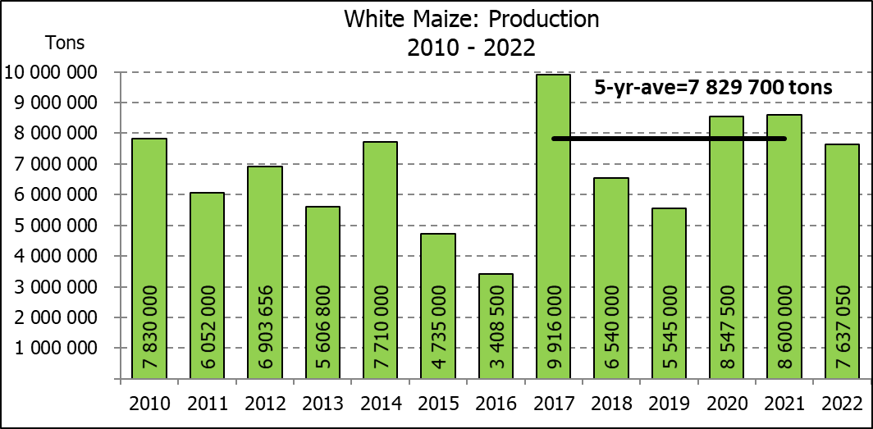

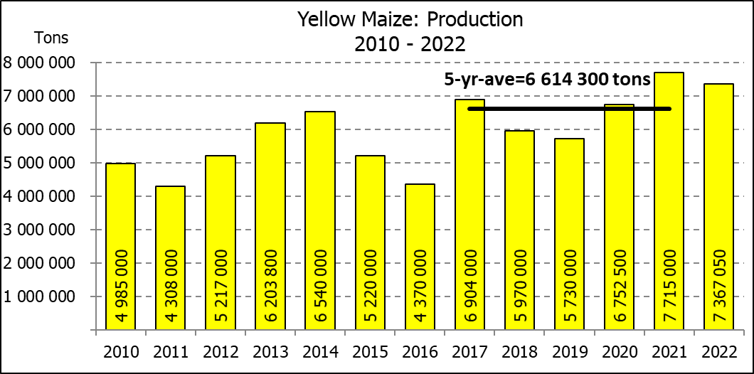
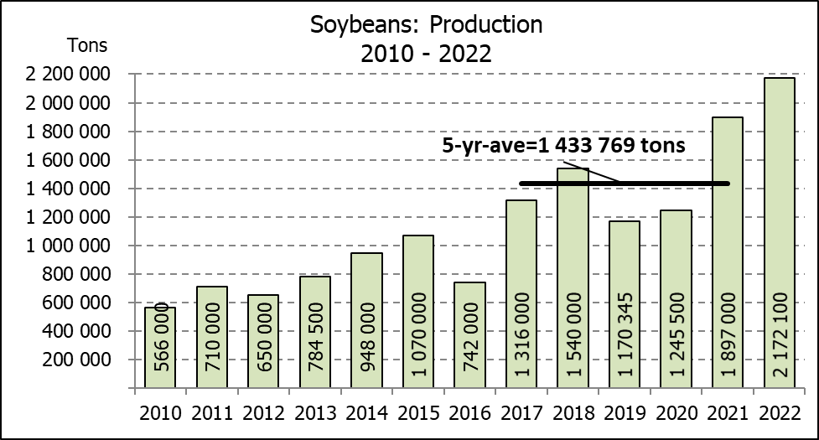

WHITE AND YELLOW MAIZE – AREA PLANTED AND SEVENTH PRODUCTION FORECAST: 2022
WIT- EN GEELMIELIES – OPPERVLAKTE EN SEWENDE PRODUKSIESKATTING: 2022

Provinsie/  Province | Area planted/  Oppervlakte beplant  2022 |  |  | 7th forecast/  7de skatting  2022 |  |  | Area planted/  Oppervlakte beplant  2021 |  |  | Final crop/  Finale oes  2021
Provinsie/  Province | White/  Wit  Ha | Yellow/  Geel  Ha | Total/  Totaal  Ha | White/  Wit  Tons | Yellow/  Geel  Tons | Total/  Totaal  Tons | White/  Wit  Ha | Yellow/  Geel  Ha | Total/  Totaal  Ha | White/  Wit  Tons | Yellow/  Geel  Tons | Total/  Totaal  Tons
Western Cape/Wes-Kaap | 500 | 3 500 | 4 000 | 4 750 | 32 900 | 37 650 | 500 | 3 500 | 4 000 | 4 800 | 33 300 | 38 100
Northern Cape/Noord-Kaap | 3 000 | 42 000 | 45 000 | 36 000 | 651 000 | 687 000 | 3 400 | 41 000 | 44 400 | 40 300 | 627 300 | 667 600
Free State/Vrystaat | 826 500 | 398 000 | 1 224 500 | 3 719 250 | 2 507 400 | 6 226 650 | 907 500 | 420 000 | 1 327 500 | 4 492 000 | 2 542 000 | 7 034 000
Eastern Cape/Oos-Kaap | 6 000 | 20 500 | 26 500 | 39 000 | 153 750 | 192 750 | 6 000 | 18 000 | 24 000 | 39 000 | 133 200 | 172 200
KwaZulu-Natal | 52 000 | 59 000 | 111 000 | 312 000 | 489 700 | 801 700 | 50 000 | 55 000 | 105 000 | 310 000 | 451 000 | 761 000
Mpumalanga | 165 000 | 350 000 | 515 000 | 1 072 500 | 2 415 000 | 3 487 500 | 165 000 | 360 000 | 525 000 | 1 100 500 | 2 820 000 | 3 920 500
Limpopo | 15 500 | 25 000 | 40 500 | 100 750 | 202 500 | 303 250 | 16 500 | 21 000 | 37 500 | 112 200 | 172 200 | 284 400
Gauteng | 56 500 | 56 000 | 112 500 | 350 300 | 369 600 | 719 900 | 58 000 | 50 000 | 108 000 | 371 200 | 380 000 | 751 200
North West/Noordwes | 450 000 | 94 000 | 544 000 | 2 002 500 | 545 200 | 2 547 700 | 485 000 | 95 000 | 580 000 | 2 130 000 | 556 000 | 2 686 000
Total/Totaal | 1 575 000 | 1 048 000 | 2 623 000 | 7 637 050 | 7 367 050 | 15 004 100 | 1 691 900 | 1 063 500 | 2 755 400 | 8 600 000 | 7 715 000 | 16 315 000

SUNFLOWER SEED – AREA PLANTED AND SEVENTH PRODUCTION FORECAST: 2022
SONNEBLOMSAAD – OPPERVLAKTE EN SEWENDE PRODUKSIESKATTING: 2022

Province/  Provinsie | Area planted/  Opp beplant  Ha | 7th forecast/  7de skatting  Tons | Area planted/  Opp beplant  Ha | Final crop/  Finale oes  Tons
Province/  Provinsie | 2022 | 2022 | 2021 | 2021
Western Cape/Wes-Kaap | - | - | - | -
Northern Cape/Noord-Kaap | 2 500 | 6 250 | 1 100 | 1 320
Free State/Vrystaat | 357 000 | 499 800 | 235 000 | 352 500
Eastern Cape/Oos-Kaap | 300 | 750 | 300 | 450
KwaZulu-Natal | - | - | - | -
Mpumalanga | 3 500 | 5 250 | 3 500 | 5 250
Limpopo | 110 000 | 88 000 | 76 500 | 76 500
Gauteng | 2 400 | 3 000 | 4 400 | 5 720
North West/Noordwes | 195 000 | 273 000 | 157 000 | 236 260
Total/Totaal | 670 700 | 876 050 | 477 800 | 678 000
SOYBEANS – AREA PLANTED AND SEVENTH PRODUCTION FORECAST: 2022
SOJABONE – OPPERVLAKTE EN SEWENDE PRODUKSIESKATTING: 2022

Province/  Provinsie | Area planted/  Opp beplant  Ha | 7th forecast/  7de skatting  Tons | Area planted/  Opp beplant  Ha | Final crop/  Finale oes  Tons
Province/  Provinsie | 2022 | 2022 | 2021 | 2021
Western Cape/Wes-Kaap | - | - | - | -
Northern Cape/Noord-Kaap | 800 | 3 000 | 1 000 | 3 500
Free State/Vrystaat | 415 000 | 892 250 | 365 000 | 766 500
Eastern Cape/Oos-Kaap | 3 000 | 9 000 | 3 100 | 9 300
KwaZulu-Natal | 39 000 | 142 350 | 36 000 | 129 600
Mpumalanga | 300 000 | 690 000 | 290 000 | 644 550
Limpopo | 22 500 | 76 500 | 20 500 | 71 750
Gauteng | 45 000 | 99 000 | 42 000 | 105 000
North West/Noordwes | 100 000 | 260 000 | 69 500 | 166 800
Total/Totaal | 925 300 | 2 172 100 | 827 100 | 1 897 000

GROUNDNUTS – AREA PLANTED AND SEVENTH PRODUCTION FORECAST: 2022
GRONDBONE – OPPERVLAKTE EN SEWENDE PRODUKSIESKATTING: 2022

Province/  Provinsie | Area planted/  Opp beplant  Ha | 7th forecast/  7de skatting  Tons | Area planted/  Opp beplant  Ha | Final crop/  Finale oes  Tons
Province/  Provinsie | 2022 | 2022 | 2021 | 2021
Western Cape/Wes-Kaap | - | - | - | -
Northern Cape/Noord-Kaap | 2 400 | 6 000 | 1 500 | 3 900
Free State/Vrystaat | 19 000 | 20 900 | 16 000 | 26 450
Eastern Cape/Oos-Kaap | - | - | - | -
KwaZulu-Natal | - | - | 50 | 50
Mpumalanga | - | - | - | -
Limpopo | 2 000 | 5 100 | 3 000 | 6 900
Gauteng | - | - | - | -
North West/Noordwes | 20 000 | 17 000 | 18 000 | 27 000
Total/Totaal | 43 400 | 49 000 | 38 550 | 64 300

SORGHUM – AREA PLANTED AND SEVENTH PRODUCTION FORECAST: 2022
SORGHUM – OPPERVLAKTE EN SEWENDE PRODUKSIESKATTING: 2022

Province/  Provinsie | Area planted/  Opp beplant  Ha | 7th forecast/  7de skatting  Tons | Area planted/  Opp beplant  Ha | Final crop/  Finale oes  Tons
Province/  Provinsie | 2022 | 2022 | 2021 | 2021
Western Cape/Wes-Kaap | - | - | - | -
Northern Cape/Noord-Kaap | - | - | - | -
Free State/Vrystaat | 7 800 | 19 500 | 10 500 | 45 675
Eastern Cape/Oos-Kaap | - | - | - | -
KwaZulu-Natal | 200 | 800 | 500 | 2 300
Mpumalanga | 9 000 | 48 600 | 9 400 | 57 325
Limpopo | 15 000 | 39 000 | 17 000 | 61 200
Gauteng | 200 | 800 | 300 | 1 350
North West/Noordwes | 5 000 | 15 000 | 11 500 | 47 150
Total/Totaal | 37 200 | 123 700 | 49 200 | 215 000

DRY BEANS – AREA PLANTED AND SEVENTH PRODUCTION FORECAST: 2022
DROëBONE – OPPERVLAKTE EN SEWENDE PRODUKSIESKATTING: 2022

Province/  Provinsie | Area planted/  Opp beplant  Ha | 7th forecast/  7de skatting  Tons | Area planted/  Opp beplant  Ha | Final crop/  Finale oes  Tons
Province/  Provinsie | 2022 | 2022 | 2021 | 2021
Western Cape/Wes-Kaap | 100 | 150 | 100 | 150
Northern Cape/Noord-Kaap | 600 | 1 080 | 350 | 700
Free State/Vrystaat | 15 500 | 13 950 | 22 000 | 16 500
Eastern Cape/Oos-Kaap | 200 | 300 | 200 | 300
KwaZulu-Natal | 2 300 | 2 760 | 3 000 | 3 900
Mpumalanga | 6 000 | 6 600 | 6 500 | 9 750
Limpopo | 10 400 | 18 200 | 8 000 | 16 000
Gauteng | 800 | 800 | 840 | 1 092
North West/Noordwes | 7 000 | 8 750 | 6 400 | 9 280
Total/Totaal | 42 900 | 52 590 | 47 390 | 57 672

CONFIDENTIALITY ISSUES that CEC members are committed to adhere to on the day of the meeting
- Personal items such as laptops, handbags, cell phones, etc. are not allowed in the venue during the meeting
- No member is allowed to leave the meeting before 12:00 in order to prevent disclosure of the information
- The embargo time for the release of crop estimates information is 14:30
- No member is allowed to discuss crop estimates information with anyone other than a member of the Committee before the embargo time
- Only the Chairperson, or a member appointed by the Chairperson, may release the figures to the media
- Members must regard the detail of any information that was collected for and/or discussed during the meeting, as confidential
- Individual information received for crop estimate purposes is treated strictly confidential, and is not divulged for any other purposes

AREA ESTIMATE AND SEVENTH PRODUCTION FORECAST OF SUMMER CROPS (2022 PRODUCTION SEASON)/
OPPERVLAKTE- EN SEWENDE PRODUKSIESKATTING VIR SOMERGEWASSE (2022 PRODUKSIE-SEISOEN)
30 AUGUST/AUGUSTUS 2022

Summer field crops – 2022  Commercial maize: The size of the expected commercial maize crop has been set at 15,004 mill. tons. The area estimate for maize is 2,623 mill. ha, while the expected yield is 5,72 t/ha.  The estimated maize crop is 8% smaller than the 2021 crop. The three main maize producing areas, namely the Free State, Mpumalanga and North West provinces are expected to produce 82% of the 2022 crop.  The area estimate for white maize is 1,575 mill. ha and for yellow maize the area estimate is 1,048 mill. ha.  The production forecast for white maize has been set at 7,637 mill. tons, which is 2,23% or 166 650 tons more than the previous forecast of 7,470 mill. tons. The yield for white maize is 4,85 t/ha. In the case of yellow maize the production forecast is 7,367 mill. tons, which is 1,71% or 123 650 tons more than the previous forecast of 7,243 mill. tons. The yield for yellow maize is 7,03 t/ha.  Sunflower seed: The production forecast for sunflower seed is 876 050 tons, which is 5,06% or 46 700 tons lower than the previous forecast of 922 750 tons. The area estimate for sunflower seed is 670 700 ha, while the expected yield is 1,31 t/ha.  Other crops: The production forecast for soybeans has been set at 2,172 mill. tons, which is 0,96 % or 20 750 tons more than the previous forecast of 2,151 mill. tons. The estimated area planted to soybeans is 925 300 ha and the expected yield is 2,35 t/ha.  The expected groundnut crop remained unchanged at 49 000 tons. For groundnuts, the area estimate is 43 400 ha, with an expected yield of 1,13 t/ha.  The production forecast for sorghum is 123 700 tons, which is 9,18 % or 12 500 tons less than the previous forecast of 136 200 tons. The area estimate for sorghum is 37 200 ha and the expected yield is 3,33 t/ha.  In the case of dry beans, the production forecast was adjusted upwards by 1,68 % or 870 tons, from 51 720 tons to 52 590 tons. The area estimate of dry beans is 42 900 ha, with an expected yield of 1,23 t/ha.  Please note that the eighth production forecast for summer field crops for 2022 will be released on 28 September 2022. |  | Somergewasse – 2022  Kommersiële mielies: Die grootte van die verwagte kommersiële mielie-oes is 15,004 milj. ton. Die skatting van die oppervlakte onder mielies is 2,623 milj. ha, terwyl die verwagte opbrengs 5,72 t/ha is.  Die geskatte mielie-oes is 8% kleiner as die 2021-oes. Die drie belangrikste mielieproduserende gebiede, nl. die Vrystaat, Mpumalanga en Noordwes provinsies, gaan na verwagting 82% van die 2022-oes produseer.  Die oppervlak onder witmielies is 1,575 milj. ha en vir geelmielies is die oppervlak 1,048 milj. ha.  Die produksieskatting van witmielies is 7,637 milj. ton, wat 2,23% of 166 650 ton meer is as die vorige skatting van 7,470 milj. ton. Die opbrengs van witmielies is 4,85 t/ha. In die geval van geelmielies is die produksieskatting 7,367 milj. ton, wat 1,71% of 123 650 ton meer is as die vorige skatting van 7,243 milj. ton. Die opbrengs van geelmielies is 7,03 t/ha.  Sonneblomsaad: Die produksieskatting vir sonneblomsaad is 876 050 ton, wat 5,06% of 46 700 ton minder is as die vorige skatting van 922 750 ton. Die oppervlakteskatting vir sonneblomsaad is 670 700 ha, terwyl die verwagte opbrengs 1,31 t/ha is.  Ander gewasse: Die produksieskatting van sojabone is op 2,172 milj. ton gestel, wat 0,96% of 20 750 ton meer is as die vorige skatting van 2,151 milj. ton. Die geskatte oppervlakte beplant met sojabone is 925 300 ha en die verwagte opbrengs is 2,35 t/ha.  Die verwagte grondbone-oes is onveranderd gelaat op 49 000 ton. Vir grondbone is die oppervlakteskatting 43 400 ha, terwyl the verwagte opbrengs 1,13 t/ha is.  Die produksieskatting van sorghum is 123 700 ton, wat 9,18 % of 12 500 ton minder is as die vorige skatting van 136 200 ton. Die oppervlakteskatting vir sorghum is 37 200 ha, en die verwagte opbrengs is 3,33 t/ha.  In die geval van droëbone is die produksieskatting ook opwaarts aangepas met 1,68 % of 870 ton, vanaf 51 720 ton tot 52 590 ton. Die oppervlakte beplant met droëbone is 42 900 ha en die verwagte opbrengs is 1,23 t/ha.  Neem asseblief kennis dat die agtste produksieskatting vir somergewasse vir 2022, op 28 September 2022 vrygestel sal word.

The non-commercial agricultural sectors’ production estimate for maize for 2022 is hereby released. /
Hiermee word die nie-kommersiële landbou-sektor se produksieskatting vir mielies vir 2022 vrygestel.

NON-COMMERCIAL MAIZE – AREA PLANTED AND PRODUCTION ESTIMATE: 2022
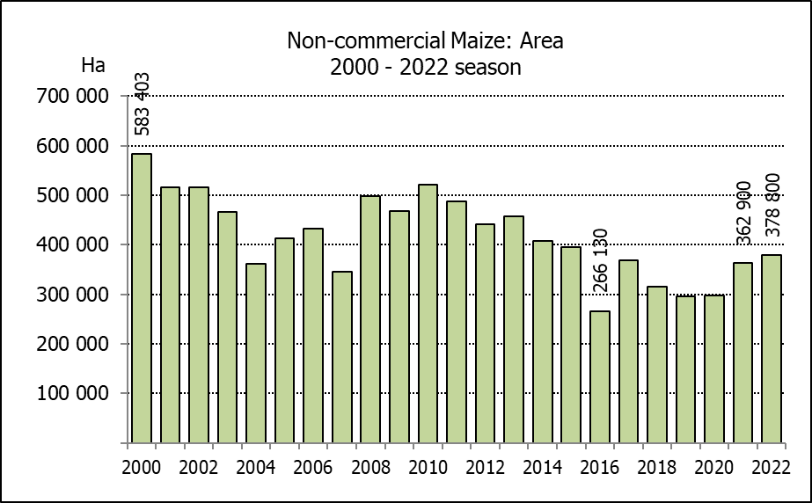
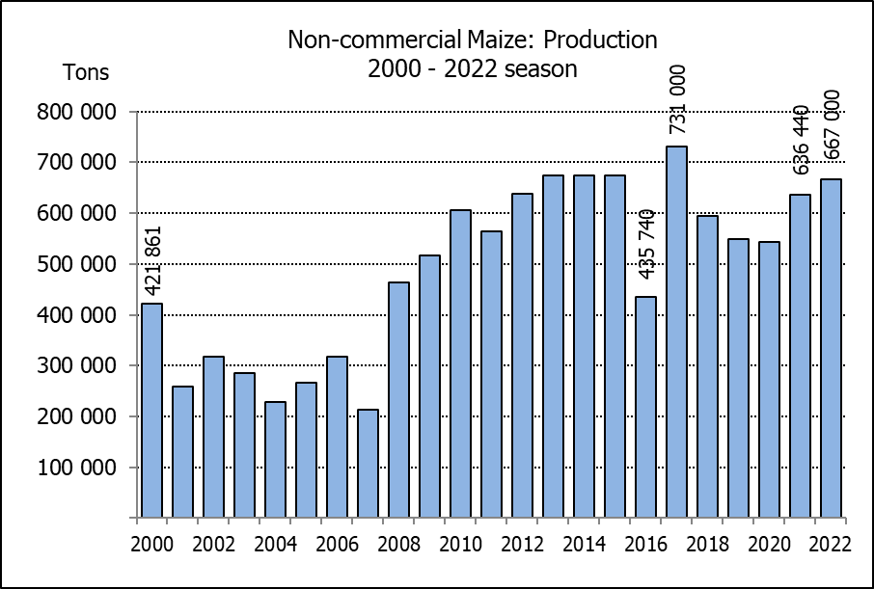
NIE-KOMMERSIëLE MIELIES – OPPERVLAKTE- EN PRODUKSIESKATTING: 2022
CROP/GEWAS | Area planted/  Opp beplant  2022 | Production/  Produksie  2022 | Area planted/  Opp beplant  2021 | Final crop/  Finale oes  2021 | Change/  Verandering
CROP/GEWAS | Ha | Tons | Ha | Tons | %
CROP/GEWAS | (A) | (B) | (C) | (D) | (B) ÷ (D)
Non-commercial agriculture/Nie-kommersiële landbou:
White maize/Witmielies | 296 950 | 482 000 | 276 100 | 445 335 | +8,23
Yellow maize/Geelmielies | 81 850 | 185 000 | 86 800 | 191 105 | -3,19
Maize/Mielies | 378 800 | 667 000 | 362 900 | 636 440 | +4,80
The area planted to maize in the non-commercial agricultural sector is estimated at 378 800 ha, which represents an increase of 4,38%, compared to the 362 900 ha of the previous season. The expected maize crop for this sector is 667 000 tons, which is 4,80% more than the 636 440 tons of last season. It is important to note that about 47% of the maize produced in the non-commercial sector, is planted in the Eastern Cape, followed by KwaZulu-Natal with 22%.
Die oppervlakte beplant met mielies in die nie-kommersiële landbou-sektor word geskat op 378 800 ha, wat ’n toename van 4,38% verteenwoordig in vergelyking met die 362 900 ha van die vorige seisoen. Die verwagte mielie-oes van dié sektor is 667 000 ton, wat 4,80% meer is as die 636 440 ton van die vorige seisoen. Dit is belangrik om daarop te let dat ongeveer 47% van die mielies wat geproduseer word in die nie-kommersiële sektor, in die Oos-Kaap geplant word, gevolg deur KwaZulu-Natal met 22%.

The revised area estimate and first production forecast for winter cereals for 2022 is hereby released. /
Hiermee word die hersiene oppervlakteskatting en eerste produksieskatting vir wintergewasse vir 2022 vrygestel.

WINTER CEREALS – REVISED AREA PLANTED ESTIMATE AND FIRST PRODUCTION FORECAST: 2022 PRODUCTION SEASON
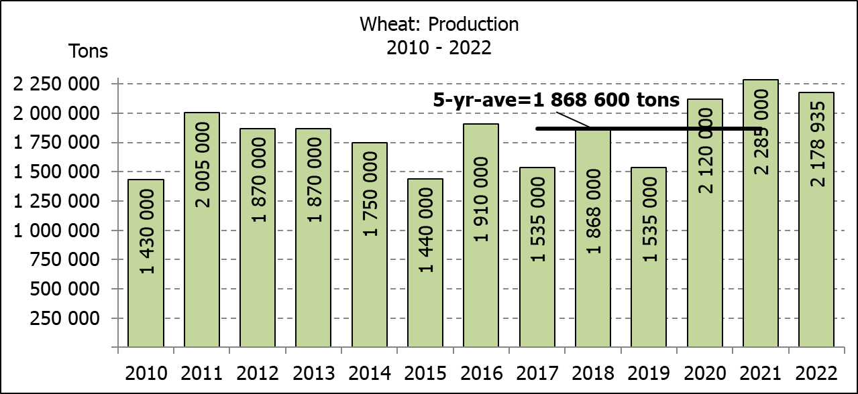
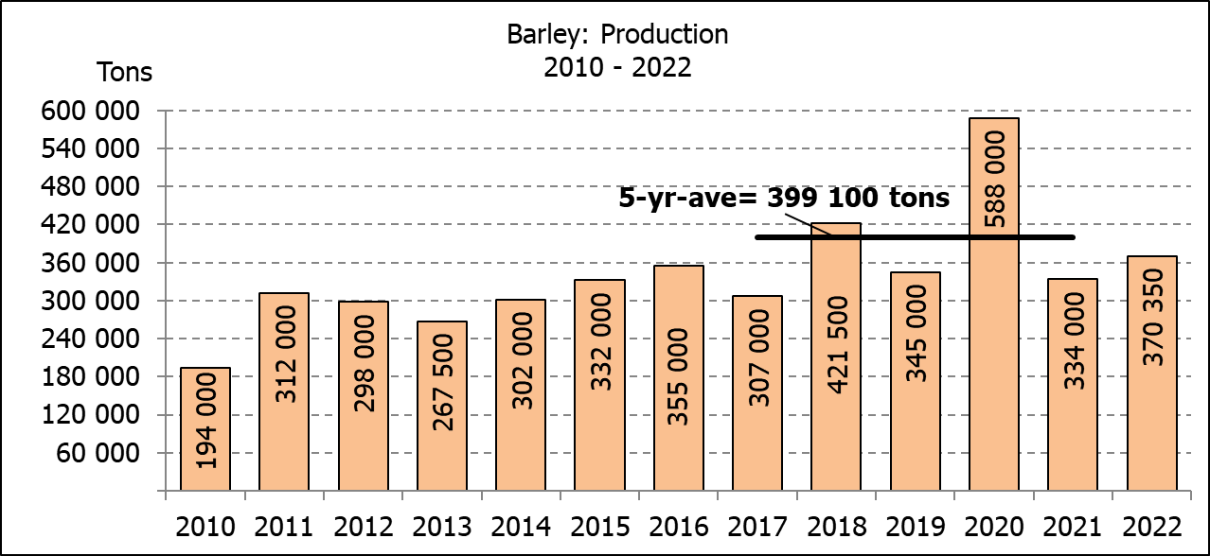
WINTERGEWASSE – HERSIENE OPPERVLAKTESKATTING EN EERSTE PRODUKSIESKATTING: 2022-PRODUKSIESEISOEN
CROP/GEWAS | Area planted/  Opp beplant  2022 | 1st forecast/  1ste skatting  2022 | Area planted/  Opp beplant  2021 | Final crop/  Finale oes  2021 | Change/  Verandering
CROP/GEWAS | Ha | Tons | Ha | Tons | %
CROP/GEWAS | (A) | (B) | (C) | (D) | (B) ÷ (D)
Commercial/Kommersieel:
Wheat/Koring | 560 100 | 2 178 935 | 523 500 | 2 285 000 | -4,64
Barley/Gars¹⁾ | 101 000 | 370 350 | 94 730 | 334 000 | +10,88
Canola/Kanola | 123 360 | 197 880 | 100 000 | 198 100 | -0,11
Oats/Hawer¹⁾ | 28 150 | 43 880 | 36 250 | 59 000 | +7,16
Sweet lupines/Soetlupine | 21 000 | 21 000 | 22 000 | 28 600 | -26,57
1) Commercial only. Excluding barley or oats used as pasture, silage, hay and/or on the farm as fodder for livestock /
Slegs kommersieël. Uitgesluit gars of hawer wat gebruik word as weiding, kuilvoer, hooi en/of op die plaas as voer vir vee.

WHEAT – REVISED AREA PLANTED ESTIMATE AND FIRST PRODUCTION FORECAST: 2022 PRODUCTION SEASON
KORING – HERSIENE OPPERVLAKTESKATTING EN EERSTE PRODUKSIESKATTING: 2022-PRODUKSIESEISOEN
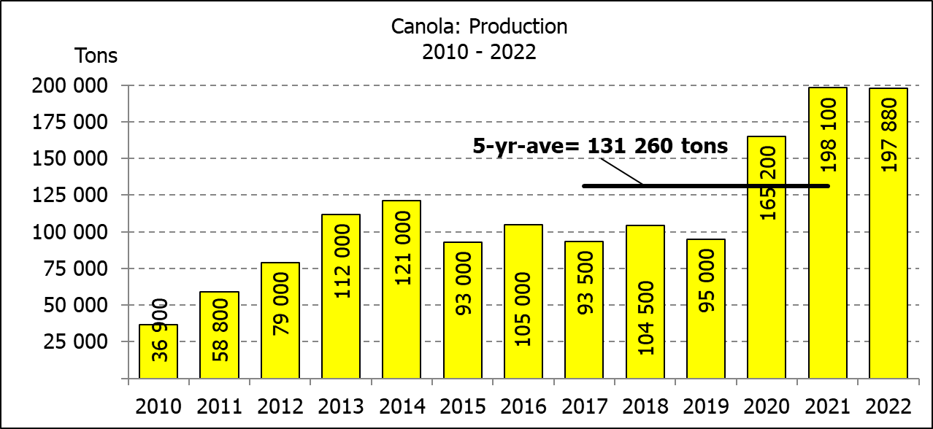
Province/  Provinsie | Area planted/  Opp beplant  Ha | 1st forecast/  1ste skatting  Tons | Area planted/  Opp beplant  Ha | Final crop/  Finale oes  Tons
Province/  Provinsie | 2022 | 2022 | 2021 | 2021
Western Cape/Wes-Kaap | 360 000 | 1 008 000 | 360 000 | 1 260 000
Northern Cape/Noord-Kaap | 38 000 | 285 000 | 35 500 | 275 125
Free State/Vrystaat | 100 000 | 490 000 | 70 000 | 360 000
Eastern Cape/Oos-Kaap | 4 300 | 27 520 | 3 800 | 25 080
KwaZulu-Natal | 9 200 | 57 040 | 8 500 | 56 950
Mpumalanga | 4 000 | 27 000 | 4 100 | 28 300
Limpopo | 29 000 | 182 700 | 26 500 | 176 220
Gauteng | 1 100 | 7 425 | 1 100 | 7 425
North West/Noordwes | 14 500 | 94 250 | 14 000 | 95 900
Total/Totaal | 560 100 | 2 178 935 | 523 500 | 2 285 000
REVISED AREA ESTIMATE AND FIRST PRODUCTION FORECAST OF WINTER CROPS (2022) /
HERSIENE OPPERVLAKTESKATTING EN EERSTE PRODUKSIESKATTING VAN WINTERGEWASSE (2022)
30 AUGUST/ 30 AUGUSTUS 2022

Winter cereal crops - 2022 production season  Wheat: The expected production of wheat is 2,179 mill. tons, which is 4,64% or 106 065 tons less than the previous seasons’ crop of 2,285 mill. tons, whilst the expected yield is 3,89 t/ha.  The expected production in the Western Cape is 1,008 mill. tons (46%), which is 252 000 tons less than the 1,260 mill. tons produced in the previous season. In the Free State, the expected production is 490 000 tons (22%), which is 130 000 tons more than the previous seasons’ crop of 360 000 tons. In the Northern Cape, 285 000 tons (13%) is expected to be produced – 9 875 tons more than the 275 125 tons produced in the previous season.  The area estimate for wheat was revised to 560 100 ha, which is 6 200 ha more than the 553 900 ha of the previous forecast. An estimated 360 000 ha or 64 % is planted in the Western Cape, 100 000 ha or 18 % in the Free State and 38 000 ha or 7 % in the Northern Cape.  Other crops: The production forecast for barley is 370 350 tons, which is 10,88% or 36 350 tons more than the previous seasons’ crop of 334 000 tons. The area planted is estimated at 101 000 ha, while the expected yield is 3,67 t/ha.  The expected canola crop is 197 880 tons, which is 0,11% or 220 tons less than the previous seasons’ crop of 198 100 tons. The area estimate for canola is 123 360 ha, with an expected yield of 1,56 t/ha.  The expected crop for oats for the 2022 season is 43 880 tons and the revised area planted is 28 150 ha. The expected yield is 1,56 t/ha.  In the case of sweet lupines, the production forecast is 21 000 tons. The area estimate of sweet lupines is 21 000 ha, with an expected yield of 1,00 t/ha.  Please note that the second production forecast for winter cereals for 2022 will be released on 28 September 2022. |  | Wintergewasse - 2022 produksie-seisoen  Koring: Die verwagte produksie vir koring is 2,179 milj. ton, wat 4,64% of 106 065 ton minder is as die vorige seisoen se oes van 2,285 milj. ton, terwyl die verwagte opbrengs 3,89 t/ha is.  Die verwagte produksie in die Wes-Kaap is 1,008 milj. ton (46%), wat 252 000 ton minder is as die 1,260 milj. ton geproduseer in die vorige seisoen. In die Vrystaat is die verwagte produksie 490 000 ton (22%), wat 130 000 ton meer is as die vorige seisoen se oes van 360 000 ton. In die Noord-Kaap is die beraamde produksie 285 000 ton (13%) – 9 875 ton meer as die 275 125 ton geproduseer in die vorige seisoen.  Die oppervlakteskatting vir koring is hersien na 560 100 ha, wat 6 200 ha meer is as die 553 900 ha teenoor die vorige skatting. Die beraamde oppervlakte geplant in die Wes-Kaap is 360 000 ha of 64 %, die Vrystaat is 100 000 ha of 18 % en 38 000 ha of 7 % is in die Noord-Kaap.  Ander gewasse: Die produksieskatting vir gars is 370 350 ton, wat 10,88% of 36 350 ton meer is as die vorige seisoen se oes van 334 000 ton. Die oppervlakte beplant word beraam op 101 000 ha, terwyl die verwagte opbrengs 3,67 t/ha beloop.  Die verwagte kanola-oes is 197 880 ton, wat 0,11% of 220 ton minder is as die vorige seisoen se oes van 198 100 ton. Die oppervlakteskatting vir kanola is 123 360 ha, met ŉ verwagte opbrengs van 1,56 t/ha.  Die verwagte oes vir hawer vir die 2022-seisoen is 43 880 ton en die hersiene oppervlakteskatting is 28 150 ton. Die verwagte opbrengs is 1,56 t/ha.  In die geval van soetlupine is die produksieskatting 21 000 ton. Die oppervlakte beplant met soetlupine is 21 000 ha, en die verwagte opbrengs is 1,00 t/ha.  Neem asseblief kennis dat die tweede produksieskatting vir wintergewasse vir 2022 op 28 September 2022 vrygestel sal word.

Information is available on the internet at http://www.dalrrd.gov.za/links/crop estimates or http://www.sagis.org.za, as from 14:30 on the date of the relevant meeting of the Crop Estimates Committee. |  | Inligting is beskikbaar op die internet by http://www.dalrrd.gov.za/links/crop estimates of by http://www.sagis.org.za, vanaf 14:30 op die dag van die toepaslike vergadering van die Oesskattingskomitee.

